3GPP TSG-SA5 Meeting #142e S5-222475rev1

4 April to 12 April 2022, E-meeting

Source: China Telecom

Title: Add new key issue for the performance management of the NWDAF on the interaction aspect

Document for: Approval

Agenda Item: 6.5.6

1 Decision/action requested
The group is asked to discuss and agree on the proposal.

2 References
[1] 3GPP TS 23.288: "Architecture enhancements for 5G System (5GS) to support network data analytics services".

3 Rationale

3.1 Discussion
In TS 23.288 [1], the procedure for analytics exposure has been defined in clause 6.1. The NWDAF service consumer use the procedure defined in clause 6.1.1 to subscribe/unsubscribe at NWDAF to be notified on analytics information. The NWDAF service consumer use the procedure defined in clause 6.1.2 to request and get from NWDAF analytics information.
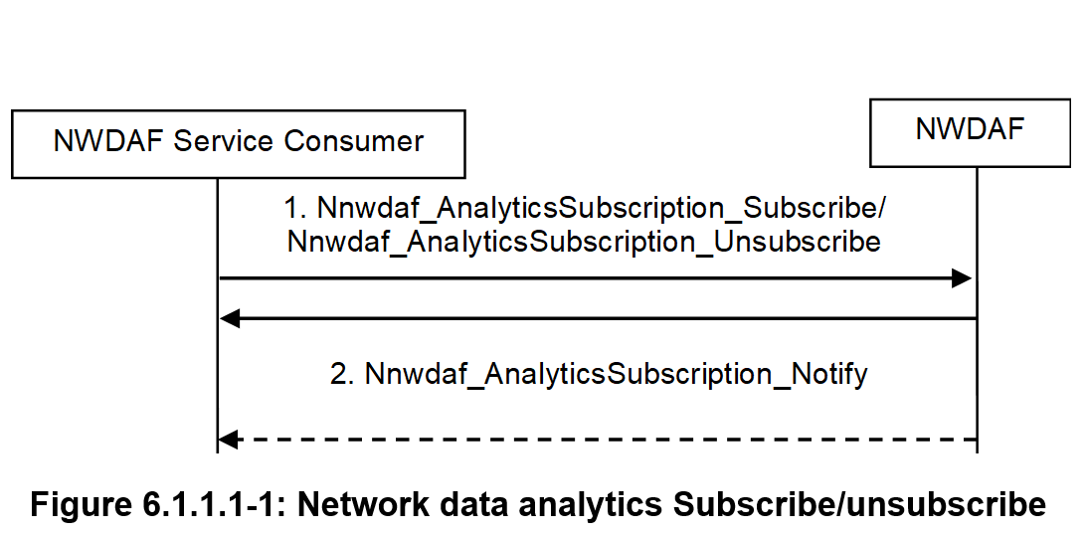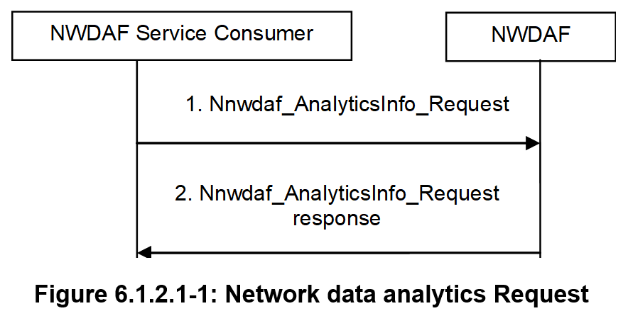
Observation 1: Subscribing/unsubscribing and requesting network data analytics from the NWDAF is the part of interaction between the NWDAF and NWDAF consumers.
As described in TS 23.288 [1], the NWDAF architecture allows for arranging multiple NWDAF instances in a hierarchy/tree with a flexible number of layers/branches.
If multiple NWDAF instances are deployed, an NWDAF can act as an aggregate point and collect analytics information from other NWDAFs to produce the aggregated analytics. The aggregate point has "analytics aggregation capability" registered in its NF Profile within the NRF. The analytics aggregation from multiple NWDAFs is used to address cases where an NWDAF service consumer requests Analytics ID(s) that requires multiple NWDAFs to serve the request collectively.
Observation 2: In case where multiple NWDAF instances are deployed, an NWDAF can act as Aggregator NWDAF, while the other NWDAFs play the role that provides analytics information to this Aggregator NWDAF.
Observation 3: There are interactions between NWDAFs where the Aggregator NWDAF acts as the service consumer of the other NWDAF(s) and requests "Analytics Metadata Information" to aggregate the output analytics for the requested Analytics ID(s).
With the observation above, we propose to study the following KIs on the performance management on interaction aspect of NWDAF.

4 Detailed proposal
Start of 1st Change

2 References
[x] 3GPP TS 23.288: "Architecture enhancements for 5G System (5GS) to support network data analytics services".

4 Key Issues and potential solutions

4.Y Key Issue #X: Performance Management of the NWDAF on the Interaction Aspect

4.Y.1 Description
The NWDAF was firstly introduced in Rel-15 and it follows the SBA concept. The interaction between the producer and consumer of the services provided by NWDAF are defined in TS 23.288 [x].

As the requirement on network automation kept increasing, the NWDAF is expected to provide a variety of services to the other NFs and play a very important role in the future. Moreover, in the scenario where multiple NWDAFs are deployed, the NWDAF is also able to act as an Aggregator NWDAF to interact with one to multiple other NWDAFs.
From the perspective of management, it is necessary for the operator to monitor the performance of NWDAF based on the interaction between the producer and consumer of the services provided by the NWDAF. The interaction may include the requests, subscriptions, responses and notifications received and/or generated by NWDAF.
However, in the management domain, the performance management of NWDAF on this aspect is missing.
In this key issue, the potential solution(s) is provided on the metrics and KPIs for performance management of the NWDAF based on the interaction between the producer and consumer of the services provided by the NWDAF.
End of Modified Sections

