3GPP TSG-SA5 Meeting #142-e S5-222254

e-meeting, 4 - 12 April 2022

Source: Huawei,AsiaInfo,China Mobile

Title: Add autonomous network level for RAN energy saving scenario

Document for: Approval
Agenda Item: 6.5.1

1 Decision/action requested
The group is asked to discuss and approval.

2 References
[1] 3GPP draft TR 28.910: “Management and orchestration; Study on enhancement of autonomous network levels v0.0.0”.

3 Rationale
This contribution proposes to add the generic autonomous network level for RAN energy saving scenario.
RAN energy saving is an important topic for operators. In the RAN energy saving scenario, it is a critical issue to maximize energy saving while still ensuring the network performance and service experience. Several factors need to be considered for energy saving, e.g. the PRB usage, number of UEs, co-coverage areas, weather, which make it difficult for human to select an optimal energy saving solution to balance the energy consumption and network performance. So it will be beneficial for the operator to introduce autonomy mechanism (e.g. AI/ML) to achieve the full autonomy of RAN energy saving step by step, and have clear view on which typical issues can be addressed by utilizing network autonomy mechanisms in corresponding steps.
Several existing specifications includes the description for energy saving, for examples:
- TS 28.310 introduce the concept and solutions for energy efficiency
- TS 28.104 introduce the MDA capability providing the energy saving analysis.

4 Detailed proposal
It proposes to make the following changes to TR 28.910 [1].
1st Change

6.X Key Issue# X: Autonomous network level for RAN energy saving use case

6.X.1 Description
The massive deployment of mobile network has brought about a rapid increase in energy consumption. The energy cost and carbon emission also become great challenges for the NOP. Operators are aiming at reducing power consumption in 5G networks to lower their OPEX with energy saving solutions. Currently the RAN energy saving is achieved through setting up some cell (e.g. NR capacity booster cell) into energy saving mode, based on the policies (e.g. analysis and predict the traffic load, analysis the coverage relationship of cells).. In the RAN energy saving scenario, it is a critical issue to maximize energy saving effect while performance (including network performance and service experience) is still being guaranteed. The variety of mobile user activity (varies significantly in different places and at different times of day) and complexity of radio network environment make it difficult to formulate appropriate energy saving solution (a set of energy saving actions) to achieve the optimal balance between the energy consumption and the performance assurance. Introducing the autonomy capability (e.g. intelligence mechanism) for energy saving will benefit to maximize energy saving effect while performance is still being guaranteed. Currently, there are many autonomous energy saving solutions are investigated, but it is not clear how to achieve the full autonomy for RAN energy saving. So, introducing the autonomous network level for energy saving will benefit for operator to achieve the full autonomy goal step by step and have clear view on which typical issues can be addressed by utilizing autonomy mechanism in corresponding steps. The requirements for each autonomous level for energy saving are different.
6.X.2 Potential solutions
6.X.2.1 Generic workflow
Following is the entire workflow for RAN energy saving:
Intent handling:
- Task A: RAN energy saving control information generation and determination. The tasks of generating and determining the RAN energy saving related control information (e.g., control information for RAN energy efficiency issues analysis and RAN energy saving actions generation) based on received RAN energy saving intent (e.g. expectation on energy saving targets in the specified areas).
- Task B: RAN energy saving intent fulfilment evaluation. The tasks of evaluating RAN energy saving intent fulfilment information (e.g. energy saving targets in the specified area are satisfied or not).
Awareness:
- Task C: RAN energy saving related information collection. The tasks of collecting energy efficiency measurements (e.g., Data Volume measurement, PEE (Power, Energy and Environmental) measurements, performance data (e.g., UE throughput), network configuration data (e.g. energy saving state of the cell), environment data (e.g. electronic map, site location) and alarm data).
Analysis:
- Task D: RAN energy saving issues identification. The tasks of identifying energy saving issues (including energy efficiency issues (e.g., high energy consumption, low energy efficiency) and performance issue (e.g. low UE throughput) which may be caused by energy saving actions.
- Task E: RAN traffic and performance prediction. The tasks of analysing current and historical RAN traffic load (e.g., PRB utilization rate, RRC connection number, etc.) and performance (including service experience (e.g. RAN UE throughput)) to predict the traffic load trend and performance trend over a period of time which could be used as references for energy saving solutions, analysis evaluation and determination.
- Task F: RAN energy saving issue demarcation. The tasks of analysing the RAN energy saving issues and determine the RAN energy efficiency issue categories (e.g., high energy consumption during off-peak hours, high energy consumption in co-coverage areas, high energy consumption of multi-RAT) and corresponding area (which can be identified by geographical area, list of RAN NEs or cells), as well as determining the performance issue is caused by energy saving actions.
- Task G: RAN energy saving issue root cause analysis. The tasks of analysing the root cause of the RAN energy saving issue, including RAN energy efficiency issues and performance issues caused by energy saving actions (e.g. the configured energy saving time period is not suitable for corresponding ES cells, the energy saving activation threshold for activating capacity booster cell in energy saving state is too high or low, the user geographically distribution changing and user activities variation in corresponding cell).
- Task H: RAN energy saving solutions analysis. The tasks of generating the recommended energy saving solution which can address the identified energy saving issues (e.g. activate or deactivate energy saving state for the capacity booster cell, recommended candidate cells with precedence for taking over the traffic of the ES-Cell, adjust the carrier configuration or transmit power.)
Decision:
- Task I: RAN energy saving solutions evaluation and determination. The tasks of evaluating the energy saving gains, as well as evaluating the RAN performance if such energy saving actions to be executed, and determining the optimal energy saving solutions (a set of energy saving actions) to be executed.
Execution:
- Task J: RAN energy saving solutions execution. The tasks of adjusting the RAN energy saving actions (e.g., configuring energy saving state and energy saving activation threshold and time period, cell handover parameter (e.g., changing the serving cell of UEs from energy-saving cells to non-energy-saving cells), configure the carrier configuration or transmit power).

6.X.2.2 Generic autonomous network level
Level 0:
- All the tasks in the RAN energy saving workflow (Task A, Task B, Task C, Task D, Task E, Task F, Task G, Task H, Task I, Task J) are accomplished by human.
Level 1:
- Telecom system executes the tasks of RAN energy saving execution based on the specified RAN energy saving solutions (Task J). Telecom system also can execute the tasks of collecting part of energy efficiency related information (including Data Volume measurement, PEE (Power, Energy and Environmental) measurements etc.), network performance data,configuration data and alarm data based on the specified collection control information (Task C). At this level, telecom system can assist human to improve the execution and awareness efficiency for RAN energy saving.
- All the other tasks in the RAN energy saving workflow (Task A, Task B, Task D, Task E, Task F, Task G, Task H, Task I) are accomplished by human.
Level 2:
- Compared to Level 1, telecom system additionally executes the tasks of RAN energy saving issues identification, part of RAN energy saving demarcation and RAN energy saving issue root cause analysis for the energy efficiency issues based on the specified RAN energy saving issue analysis control information (Task D, Task F, Task G). In this level, telecom system also can execute the task of collecting all RAN energy saving related information (including energy efficiency data and performance data, network configuration data,environment data and alarm data) based on the specified collection control information (Task C), The tasks of RAN energy saving solutions execution (Task I) are fully accomplished by telecom system. At this level, telecom system can assist human to achieve the closed loop for RAN energy saving based on human defined control information.
- All the other tasks in the RAN energy saving workflow (Task A, Task B, Task E, Task H, Task I) are accomplished by human.
Level 3:
- Compared to Level 2, telecom system additionally executes the tasks of RAN energy saving solutions analysis (Task H) and RAN energy saving solutions evaluation and determination (Task I) based on the specified RAN energy saving solution analysis and decision control information. In this level, telecom system also can execute the tasks of RAN traffic load and performance prediction (Task E) based on the specified RAN traffic load and performance prediction control information. The tasks of RAN energy saving related information collection (Task C), RAN energy saving issues identification (Task D) and RAN energy saving demarcation (including RAN energy efficiency issues demarcation and RAN performance issues caused by energy saving actions demarcation) (Task F) are fully accomplished by telecom system. At this level, the telecom system can achieve the closed loop automation for RAN energy saving based on the human defined control information.
- All the other tasks in the RAN energy saving workflow (Task A, Task B) are accomplished by human.
Level 4:
- Compared to Level 3, the telecom system additionally executes the tasks of RAN energy saving control information determination (Task A), and RAN energy saving intent evaluation (Task B) based on received RAN energy saving intent and intent handling control information. The tasks of RAN energy saving issue root cause analysis (including root cause analysis for energy efficiency issues and performance issues caused by energy saving actions) (Task G), RAN energy saving solutions analysis (Task H), RAN energy saving solutions evaluation and determination (Task I), and RAN traffic load and performance prediction (Task E) are fully accomplished by telecom system. At this level, telecom system can achieve the intent driven closed loop automation for RAN energy saving based on human defined intent handling control information.
- The intent handling control information maybe pre-defined and specified by human to assist the telecom system.
Level 5:
- Telecom system can autonomously execute the entire workflow of RAN energy saving for all scenarios, which means the telecom system can achieve the full autonomy for RAN energy saving for full scenarios.
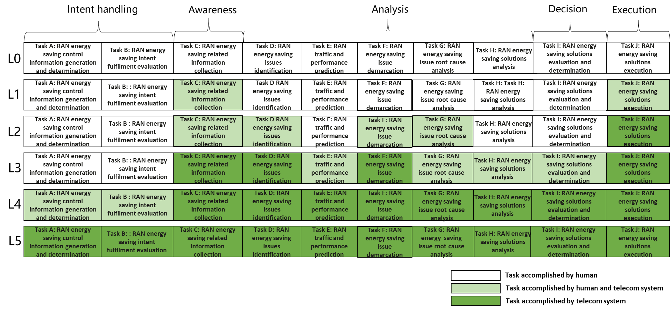
Figure 6.X.2.2-1 Autonomous network level for RAN energy saving use case

End of changes

