3GPP TSG-SA5 Meeting #132e S5-204437rev1

e-meeting 17th 28th August 2020
CR-Form-v12.0
CHANGE REQUEST
 | 28.532 | CR | 0147 | rev | - | Current version: | 16.4.0
For HELP on using this form: comprehensive instructions can be found at
http://www.3gpp.org/Change-Requests.

Proposed change affects: | UICC apps |  | ME |  | Radio Access Network | x | Core Network | x

Title: | Rel-16 CR TS 28.532 Remove unintended normative statement from informative clause
Source to WG: | Nokia, Nokia Shanghai Bell
Source to TSG: | S5
Work item code: | ONAP3GPP |  |  |  |  |  | Date: |  |  | 14-08-2020
Category: | F |  |  |  |  |  | Release: |  |  | Rel-16
 | Use one of the following categories:  F (correction)  A (mirror corresponding to a change in an earlier release)  B (addition of feature),  C (functional modification of feature)  D (editorial modification)  Detailed explanations of the above categories can  be found in 3GPP TR 21.900. |  |  |  |  |  |  |  | Use one of the following releases:  Rel-8 (Release 8)  Rel-9 (Release 9)  Rel-10 (Release 10)  Rel-11 (Release 11)  Rel-12 (Release 12)  Rel-13 (Release 13)  Rel-14 (Release 14)  Rel-15 (Release 15)  Rel-16 (Release 16)
Reason for change: |  | Informative Annex B contains normative text giving an impression that 3GPP imposes a restriction on the values that may be used in ONAP VES name spaces
Summary of change: |  | Convert normative text into informative description
Consequences if not approved: |  | Mis-interpretation of the standard leading to incorrect implementations
Clauses affected: |  | Annex B
 |  | Y | N
Other specs |  |  | x | Other core specifications |  |  |  | TS/TR ... CR ...
affected: |  |  | x | Test specifications |  |  |  | TS/TR ... CR ...
(show related CRs) |  |  | x | O&M Specifications |  |  |  | TS/TR ... CR ...
Other comments:
This CR's revision history:

1st Modified Section

Annex B (Informative):
Guidelines for the integration of 3GPP MnS notifications with ONAP VES
In case the consumer of the 3GPP MnS notifications specified in the present document is an ONAP VES collector, the following guidelines are for the developer of the corresponding 3GPP MnS notification producer:
- The produced notification conforms to ONAP-defined VES specification;
- The VES Common Event Header fields are populated by the producer is as follows:
- The domain "stndDefined"
is used,
- The "stndDefinedNamespace" field value is the concatenation of "3GPP-" and the name of the 3GPP MnS which the 3GPP IS notification is part of. Based on the MnS names defined in the present document, VES name space values corresponding to 3GPP MnS could be:
- "3GPP-Provisioning",
- "3GPP-FaultSupervision",
- "3GPP-PerformanceAssurance",
- "3GPP-Heartbeat",
- "3GPP-Streaming";
- How the other fields of the Common Event Header are populated is not in the scope of the present document;
- The payload part of the VES event specification conforms to definitions of clause A.1.2 (for provisioning MnS notifications), A.2.2 (for the fault supervision MnS notifications) and A.5.2 (for the heartbeat notifications) of the present document.

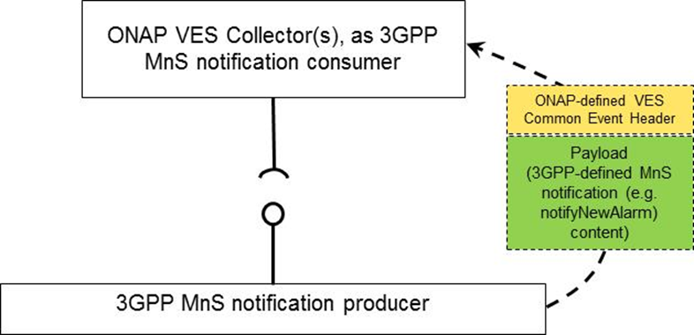
Figure X-1. 3GPP MnS notifications consumed by ONAP VES Collector(s).

End of Modifications

