3GPP TSG-SA5 Meeting #130e S5-202281

e-meeting, 20 – 28 April 2020

Source: Nokia, Nokia Shanghai Bell, China Mobile

Title: TD proposal of NRM change to support RIM

Document for: Discussion and Endorsement
Agenda Item: 6.4.5

1 Decision/action requested
Please discuss and endorse

2 References
[1] 3GPP TS 28.540: "Management and orchestration; 5G Network Resource Model (NRM); Stage 1".
[2] 3GPP TS 28.541: "Management and orchestration; 5G Network Resource Model (NRM); Stage 2 and Stage 3".
[3] R1-1903676 LS on completion of CLI-RIM in RAN1.doc
[4] R3-193245 LS on OAM requirements for RIM.doc
[5] S5-196514 R1-1909904 LS response to SA5 LS on clarification of OAM requirements for RIM.doc
[6] R3-197540 LS RIM OAM.docx
[7] R1-1903833 OAM configuration parameters for NR RIM (Attachment of R1-1903676).xlsx
[8] 3GPP TR 38.866: "RAN; Study on remote interference management for NR".

3 Rationale
Remote Interference Management (RIM) for NR was agreed and developed in RAN as important feature of REL16. RAN1 and RAN3 send LSs to SA5 to ask SA5 to specify the OAM configurations for RIM Reference Signal (RS) and other OAM functions to support RIM operation.
The following OAM configurations are required:
- Common Configuration (across all gNBs of a network):
- RIM-RS resource configuration
- Sequence domain resource
- Time domain resource
- Frequency resource
- Set Specific configuration/parameters (applied on one specific aggressor or victim Set)
Note: gNBs/Cells are grouped into aggressor and victim sets. Each aggressor/victim gNB can be configured with multiple Set IDs, each cell can have one aggressor and one victim Set ID
- turn ON or OFF RIM-RS monitoring
- information required for periodic RIM-RS monitoring
- Aggressor set ID (can be used to configure RIM-RS2) /Victim set ID (can be used to configure RIM-RS1)
- gNBs / cells associated with the set

- Set ID to Backhaul address mapping
Below picture shows the relationship between gNBs, Cells, RIM RS Resources and Sets, as well as related configurations and parameters need to be supported by OAM.

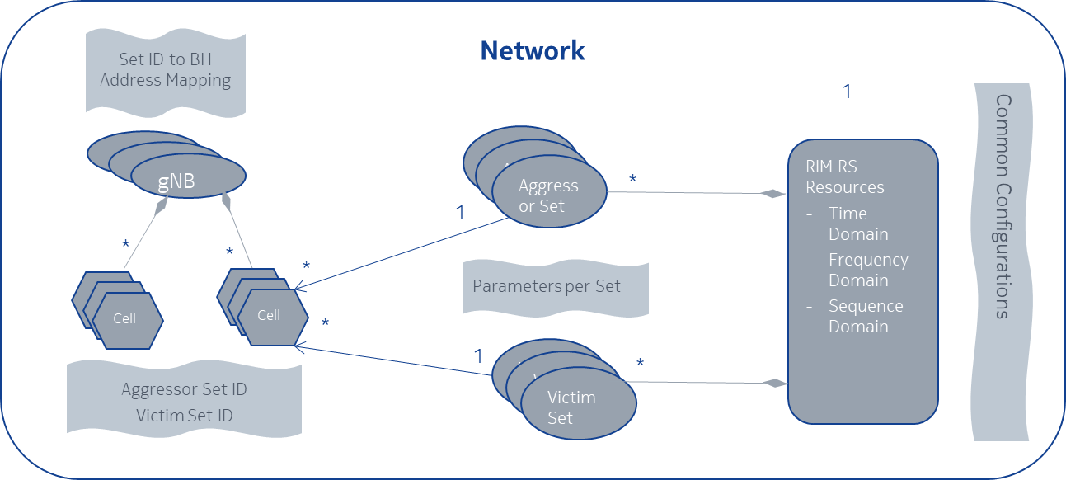
Figure 1: relationship between gNBs, Cells, RIM RS Resources and Sets for RIM solution

4 Detailed proposal

4.1 Add new IOC to model global RIM RS resource
This IOC is used to represent RIM RS resource planned for the whole network.
Attributes
Attribute name | Support Qualifier | isReadable | isWritable | isInvariant | isNotifyable
frequencyDomainPara | M | T | T | F | T
sequenceDomainPara | M | T | T | F | T
timeDomainPara | M | T | T | F | T

Please see CR S5-202282 for the concrete IOC definition

4.2 Add new IOC to model aggressor/victim Set
This IOC is used to represent aggressor/victim Set organized by OAM.
Attributes
Attribute name | Support Qualifier | isReadable | isWritable | isInvariant | isNotifyable
setID | M | T | T | F | T
setType | M | T | T | F | T
rimRSMonitoringOnTime | M | T | T | F | T
rimRSMonitoringOffTime | M | T | T | F | T
rimRSMonitoringInfo | M | T | T | F | T
Attribute related to role
nRCellRef | M | T | F | F | T

Please see CR S5-202282 for the concrete IOC and attributes definition

4.3 Update NRCellDU IOC to support aggressor/victim Set
Attributes
Attribute name | Support Qualifier | isReadable | isWritable | isInvariant | isNotifyable
rim-RS-SetId-of-RS1 | CM | T | T | F | T
rim-RS-SetId-of-RS2 | O | T | T | F | T
Attribute related to role
victimSetRef | O | T | F | F | T
aggressorSetRef | O | T | F | F | T

Please see CR S5-202282 for the concrete IOC and attributes definition

