3GPP TSG-SA5 Meeting #130e S5-202246Rev2

e-meeting 20-28 April 2020

Source: China Mobile, Huawei

Title: pCR 28.810 Update Clause 4.4 Potential dimensions for classification of network autonomy

Document for: Approval

Agenda Item: 6.6.4

1 Decision/action requested
The group is asked to discuss and approval.

2 References
[1] 3GPP TR 28.810: “Study on concept, requirements and solutions for levels of autonomous network v0.3.0”.

3 Rationale
This contribution proposes to update the following aspects:
- Update Clause 3.1 Terms.
- Update Clause 4.4.2 by adding figure to describe the workflow intuitively.
- Add Clause 4.4.X Scenarios.
- Rename Clause 5 and update the relevant texts.

4 Detailed proposal
It proposes to make the following changes to TR 28.810[1].
1st Change

3 Definitions of terms, symbols and abbreviations

3.1 Terms
For the purposes of the present document, the terms given in 3GPP TR 21.905 [1] and the following apply. A term defined in the present document takes precedence over the definition of the same term, if any, in 3GPP TR 21.905 [1].
Intent: See definition in TR 28.812[5].
Next Change

4.4 Potential dimensions for classification of network autonomy

4.4.1 Introduction
This clause describes the potential dimensions for classification of network autonomy.

4.4.2 Workflow
Workflow is used to describe the necessary steps to fulfil certain management purposes. A workflow is composed of one or more management tasks. The autonomy capabilities of the tasks in the workflow may impact the network autonomy level.
Following are the potential categorization of the tasks in a workflow.
- Intent translation: The group of tasks which translate network or service intent from operator or customer into detailed management operations which may affect one or more of the following groups of tasks, i.e. awareness, analysis, decision, execution.

- Awareness: The group of tasks which monitor network by collecting network information.
- Analysis: The group of tasks which analyse the collected information (e.g. information about network status, network issues and so on) or based on the historical data to further predict the future change trend of the above network status, and make recommendation for decision.
- Decision: The group of tasks which decide the necessary management operation for execution, e.g. network configuration or adjustment.
- Execution: The group of tasks which execute the management operations.
Figure 4.4.2-X illustrate the general workflow for network autonomy.
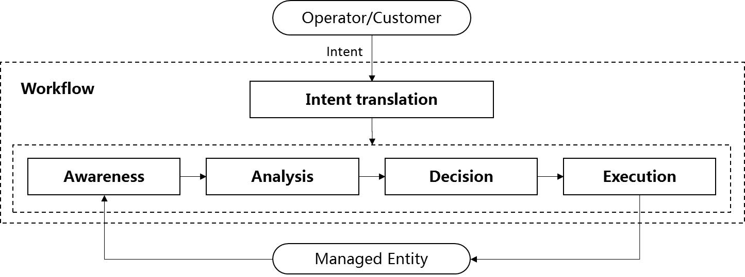Figure 4.4.2-X General workflow for network autonomy

4.4.3 Management scope
The network autonomy can be implemented in different management scopes, the complexity of network autonomy depends on the management scope. For example, it will be more challenge for the telecom system to achieve the network autonomy on cross domain layer than domain layer, because more autonomy mechanism needs to be introduced for the coordination between different domains.
Following are potential scopes of network autonomy:
- Autonomy in NE layer, which means the autonomy mechanism is executed in the NE.
- Autonomy in domain layer, which means the autonomy mechanism is executed in the MnF(s) in domain.
- Autonomy in cross domain layer, which means the autonomy mechanism is executed in the MnF(s) in cross domain.
- Autonomy in communication service layer, how to execute the autonomy mechanism in communication service layer is FFS.
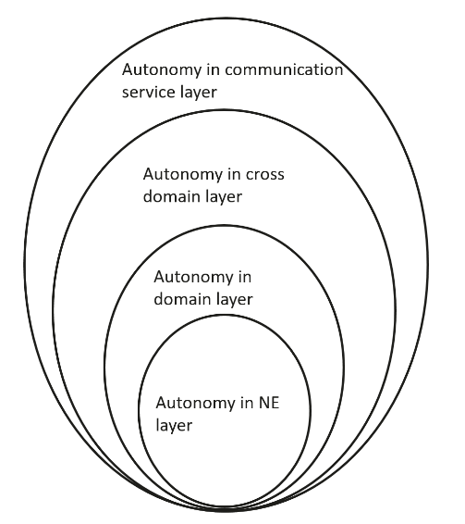
Figure 4.4.3-1 Autonomy for different management scope

4.4.X Scenarios
The network autonomy can be implemented for different scenarios, the complexity of network autonomy depends on the detailed scenarios it applied. Also it will be more challenge for the telecom system to achieve the network autonomy for full scenarios than for certain scenarios. For example, autonomy applicability of network deployment will be more challenge for outdoor combine indoor scenario than only outdoor scenario.
Next Change

5 Use case
Editor's note: this clause will contain typical use case and potential requirements for managing and operating the network and service that need autonomous support.

5.1 Fault RCA and recovery use case example for network autonomy level

5.1.1 Introduction
Fault root cause analysis (RCA) and recovery use case refers to the entire workflow of network fault management, full autonomy of fault RCA and recovery can help the network operator to reduce OPEX by reducing manual involvement in such tasks and to enhance user experience by reducing the time for network fault recovery. However, full autonomy of fault RCA and recovery is a long term goal, it will be beneficial for operator to achieve this goal step by step and have clear view on which typical issues can be addressed by utilizing network autonomy mechanism in corresponding steps.

5.1.2 Entire workflow
The entire close-loop workflow of fault RCA and recovery is as following:
- Task A: Fault RCA and recovery intent translation. The task which translate the fault RCA and recovery intent to the detailed fault management operations.
NOTE: the examples of fault RCA and recovery intent are alarm compression rate increasing, fault recovery response time reducing, etc.
- Task B: Fault related information collection. The task which collect the alarm information and other fault related information (e.g. performance information and configuration information etc.).
- Task C: Alarm filtering. The task which filter the alarms collected in Task B based on the filtering rules specified. A single network fault may generate a large number of correlative alarms over space and time, therefore it is considered advantageous to have methods filtering the redundant alarms. Reporting only effective alarms without redundant alarms would improve the efficiency of alarm management.
- Task D: Fault recognition. The task which recognize the fault and its category based on the alarm information and other fault related information.
- Task E: Fault RCA. The task which analyse the detailed root cause of the network fault.
- Task F: Fault recovery mechanism analysis. The task which analyze the possible fault recovery mechanisms and corresponding solutions for support of maintenance based on the fault root cause, thereby generate the feasible options (e.g. self-healing procedures).
- Task G: Fault recovery action generation. The task which determine the fault recovery action.
- Task H: Fault recovery execution. The task which execute the fault recovery actions (e.g. reconfiguring the network), and other corresponding actions (e.g. clearing of alarms, storage and retrieval of alarms).

5.1.3 Potential classification of network autonomy for fault RCA and recovery
Each of the detailed task in clause 5.1.2 can be accomplished either manually by the operator or automatically by the network system. Following are the potential classifications of network autonomy for fault RCA and recovery based on the participation degree of the human operator and the network system:
Level 1:
- Fault related information are collected (Task B) automatically by network system based on human predefined rules or configurations. Fault recovery actions (Task H) which can be executed without human intervention (e.g. system initialisations, activation of a backup or fall back software load) are partly triggered by human and executed by network system based on human defined rules.
- All the other tasks in the fault RCA and recovery workflow are accomplished by human.
Level 2:
- Compared to Level 1, network system additionally assist human operator to filter the alarms (Task C) based on the filtering rules predefined by human operator. Fault recovery actions (only the actions that can be executed without human intervention) (Task H) are triggered by human and fully executed by network system based on human defined rules.
- All the other tasks (Task A, Task D, Task E, Task F and Task G) are accomplished by human.
Level 3:
- Compared to Level 2, network system can accomplish fault related information collection (Task B) without human defined rules. Network system additionally assist human operator to identify the fault domain and type (Task D) and analyse the root cause of the network fault (Task E).
- Fault RCA and recovery intent translation (Task A) is accomplished by human, and all the other tasks (Task F, Task G and Task H) are accomplished by human operator for most of the faults except several conventional ones.
Level 4:
- Compared to Level 3, the fault recovery mechanism analysis (Task F), decision (Task G) and execution (Task H) are accomplished automatically by network system without intervention. And network system additionally assist human operator to translate the fault RCA and recovery intent (Task A) based on human predefined rules.
- Intent translation rules are specified by human.
Level 5:
- The whole close-loop of fault RCA and recovery workflow is accomplished automatically by network system without human intervention and human defined rules.
- Human can but not have to supervise the fault recovery decision generated by network system.

5.2 Network optimization use case example for classification of network autonomy
Editor's note: the detailed classification of network autonomy for this use case is FFS.

5.2.1 Coverage optimization use case example for classification of network autonomy
Coverage is critical for good user experience, however, coverage optimization is complexity. Full autonomy of coverage optimization for whole network is a long term goal, it will be beneficial for operator to achieve this goal step by step and have clear view on which typical issues can be addressed by utilizing network autonomy mechanism in corresponding steps.
Editor's note: the detailed classification of network autonomy for this use case is FFS.

5.2.2 Capacity optimization use case for classification of network autonomy

5.3 RAN NE provisioning use case example for classification of network autonomy

5.3.1 Introduction
RAN NE provisioning use case refers to the entire workflow of deploying an RAN NE, full autonomy of RAN NE provisioning can help the network operator to reduce OPEX by reducing manual involvement in such tasks. However, full autonomy of RAN NE provisioning is a long term goal, it will be beneficial for operator to achieve this goal step by step and have clear view on which typical issues can be addressed by utilizing network autonomy mechanism in corresponding steps.

5.3.2 Entire workflow
Following are the entire workflow for RAN NE provisioning:
- Task A: RAN NE provisioning decision making.
- Task B: Analysing and determining the network planning data (i.e. radio planning data, transport planning data) for the new RAN NE to be provisioned.
- Task C: Generating the network configuration data for the RAN NE based on the network planning data for the RAN NE and hardware information collected.
- Task D: Connecting the RAN NE to the management system (including NE acquire its IP address and corresponding management system IP address) and collecting the RAN NE information (e.g. hardware information).
- Task E: Downloading and activating network configuration data and software in RAN NE.

5.3.3 Potential classification of network autonomy for RAN NE provisioning
Following are the potential classification of network autonomy for RAN NE provisioning:
- Level 1:
  - Network system executes tasks of downloading and activating the available RAN NE network configuration data (i.e. transport and radio configuration data) and software prepared by human (Task E).
  - Human makes the RAN NE provisioning decision and prepares the network configuration data for the RAN NE (Task A, Task B, Task C). Human connects the RAN NE to the management system and collect the RAN NE information (Task D).
- level 2:
  - Compared to Level 1, network system additionally executes the tasks of connecting RAN NE to the management system and collecting the RAN NE information (Task D).
  - Human makes the RAN NE provisioning decision and prepares the network configuration data for the RAN NE (Task A, Task B, Task C).
- Level 3:
  - Compared to Level 2, network system additionally executes tasks of analysing and determining the network configuration data for the RAN NE based on the network planning data specified by human (Tack C).
  - Human makes the RAN NE provisioning decision and prepares the network planning data (Task A and Task B).
- Level 4:
  - Compared to Level 3, network system additionally execute the task of analysing and determining network planning data for the RAN NE to be provisioned (Task B).
  - Human makes the RAN NE decision (Task A).
- Level 5: network system can autonomously execute the entire workflow of provisioning an RAN NE, which means the network system can achieve the full autonomy for RAN NE provisioning.

5.4 Multi-domain/layer/technology management service coordination automation use case example
The goal of this use case is to enable automation of end-to-end joint coordination of management services across multiple domains (e.g. AN, CN), multi-layers (packet and optical transport), and multi-technology (wireless and wireline, x-haul, mobile core, data network, physical and virtual functions).
The following functions and services are assumed to be deployed and active:
- NG-RAN, 5GC, NSI(s),
- The performance assurance (PM), fault supervision (FM) and provisioning (CM) services are available across multi-domain, multi-layer, and multi-technology.
- The provider of multi-domain, multi-layer, and multi-technology coordination of management services.
The provisioning, assurance and supervision services provide information on the multi-domain, layer, and technology, the information characterized by:
- Status details on domain/layer/technology specific network resources, e.g. NG-RAN and 5GC, packet and transport networks, physical network resources and virtual resources
- Information from one or multiple network slices and slice subnets in relation with multi-domain, layer, and technology
- For each domain, layer, and technology, information on allocated resources and their utilization, event history (e.g. recent orchestration actions taken per domain, layer, and technology), history of actions taken (e.g. recent orchestration actions taken per domain, layer, and technology)
The following scopes of network autonomy is applied to meet the objectives of automation of the multi-domain, layer, and technology coordination of management services:
- Network autonomy in NE layer
- Network autonomy in domain layer
- Network autonomy in cross domain layer
Based on the assumptions described above, the provider of multi-domain, multi-layer, and multi-technology coordination of management services is running jointly with individual coordination providers of domain, layer, and technology to automate end-to-end vertical and horizontal management coordination processes across multiple domain, layers, and technologies.
The provider of multi-domain, multi-layer, and multi-technology coordination of management services utilizes provisioning, assurance and supervision services to achieve optimal management coordination across multiple domains, layers, and technologies.
The provider of multi-domain, multi-layer, and multi-technology coordination of management services may utilize AI technologies (e.g., machine learning, deep learning algorithms, etc.) to achieve an optimal coordination.
The provider of multi-domain, multi-layer, and multi-technology coordination of management services offers management capabilities on the resource parameters configuration.
The coordination of management services consists of different levels of network autonomy as follows:
-Automation of coordination across multiple layer, technology, or domain individually
-Automation of coordination across a combination of multiple-layer and technology, multiple-layer and domain, or multiple-technology and domain
- Automation of coordination across multiple-layer, technology, and domain as a whole

5.5 Capacity optimization use case example for classification of network autonomy
Network resources are limited, in order to utilize radio resources in the most efficient way and improve user service experience, it is important to achieve higher system capacity by distributing user traffic across the system radio resources. Currently the flow of traffic simply follows the physical topology of the network or network slice, and resource usage may be unreasonable. Capacity optimization can help to improve resource usage efficiency greatly by taking into account the direction of traffic flow when scheduling the network or network slice. For example, by creating a traffic prediction model, 3GPP management system can provide precise traffic prediction and the optimal network topology, and the network paths can be determined by traffic instead of just by physical connections.
The long-term goal of capacity optimization is to allocate resources needed on demand. It will be beneficial for operator to achieve this goal step by step and have clear view on which typical issues can be addressed by utilizing network autonomy mechanisms in corresponding steps.
Editor's note: the detailed classification of network autonomy for this use case is FFS.
End of changes

