3GPP TSG-SA5 Meeting #130e S5-202246Rev1

e-meeting 20-28 April 2020

Source: China Mobile, Huawei

Title: pCR 28.810 Update Clause 4.4 Potential dimensions for classification of network autonomy

Document for: Approval

Agenda Item: 6.6.4

1 Decision/action requested
The group is asked to discuss and approval.

2 References
[1] 3GPP TR 28.810: “Study on concept, requirements and solutions for levels of autonomous network v0.3.0”.

3 Rationale
This contribution proposes to update Clause 4.4 Potential dimensions for classification of network autonomy in the following aspects:
- Update Clause 4.4.2 by adding figure to describe the workflow intuitively.
- Add Clause 4.4.X Scenarios.

4 Detailed proposal
It proposes to make the following changes to TR 28.810[1].
1st Change

4.4 Potential dimensions for classification of network autonomy

4.4.1 Introduction
This clause describes the potential dimensions for classification of network autonomy.

4.4.2 Workflow
Workflow is used to describe the necessary steps to fulfil certain management purposes. A workflow is composed of one or more management tasks. The autonomy capabilities of the tasks in the workflow may impact the network autonomy level.
Following are the potential categorization of the tasks in a workflow.
- Intent translation: The group of tasks which translate network or service intent from operator or customer into detailed management operations which may affect one or more of the following groups of tasks, i.e. awareness, analysis, decision, execution. Intent is a desire to reach a certain state/position for a specific entity for instance for a service assurance or network deployment task.
Note: the definition of intent is refer to TR 28.812[5].
- Awareness: The group of tasks which monitor network by collecting network information.
- Analysis: The group of tasks which analyse the collected information (e.g. information about network status, network issues and so on) or based on the historical data to further predict the future change trend of the above network status, and make recommendation for decision.
- Decision: The group of tasks which decide the necessary management operation for execution, e.g. network configuration or adjustment.
- Execution: The group of tasks which execute the management operations.
Figure 4.4.2-X illustrate the general workflow for network autonomy.
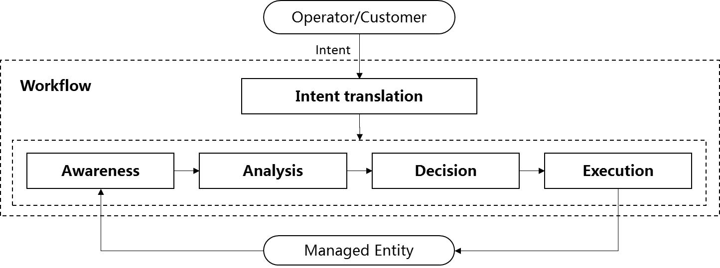Figure 4.4.2-X General workflow for network autonomy

4.4.3 Management scope
The network autonomy can be implemented in different management scopes, the complexity of network autonomy depends on the management scope. For example, it will be more challenge for the telecom system to achieve the network autonomy on cross domain layer than domain layer, because more autonomy mechanism needs to be introduced for the coordination between different domains.
Following are potential scopes of network autonomy:
- Autonomy in NE layer, which means the autonomy mechanism is executed in the NE.
- Autonomy in domain layer, which means the autonomy mechanism is executed in the MnF(s) in domain.
- Autonomy in cross domain layer, which means the autonomy mechanism is executed in the MnF(s) in cross domain.
- Autonomy in communication service layer, how to execute the autonomy mechanism in communication service layer is FFS.
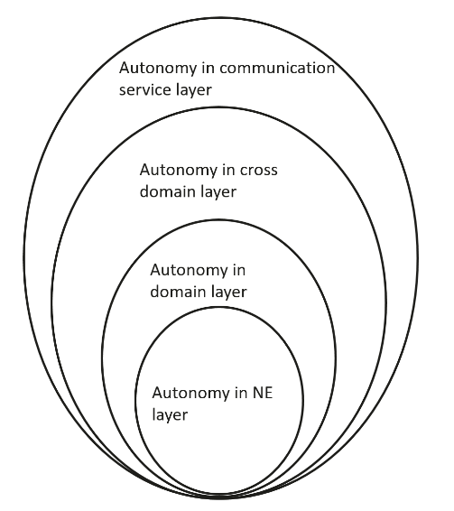
Figure 4.4.3-1 Autonomy for different management scope

4.4.X Scenarios
The network autonomy can be implemented for different scenarios, the complexity of network autonomy depends on the detailed scenarios it applied. Also it will be more challenge for the telecom system to achieve the network autonomy for full scenarios than for certain scenarios. For example, autonomy applicability of network deployment will be more challenge for outdoor combine indoor scenario than only outdoor scenario.
End of changes

