3GPP TSG-SA5 Meeting #130e S5-202154rev

e-meeting 20-28 April 2020

Source: Huawei

Title: Discussion paper on CSI clarification in close loop control context

Document for: Approval
Agenda Item: 6.4.7

1 Decision/action requested
In this box give a very clear / short /concise statement of what is wanted.

2 References
[1] 3GPP TR 28.805
[2] 3GPP TS 28.530
[3] S5-201354: https://www.3gpp.org/ftp/tsg_sa/WG5_TM/TSGS5_129e/docs/S5-201354.zip

3 Rationale

3.1 Background for this discussion
The closed loop control for CSI brings the discussions to service level. The CSI role in service level is one of the topic might be disussed further according to previous observation in the last SA5 e-meeting. In release 16, SA5 WG finished a study on management aspects of communication services as described in TR 28.805 [1]. The communication service is offered by a communication service provider to its customers to fulfil their requested communication service requirements as described in TR 28.805 [1] and TS 28.530 [2]. The analysis of the allocation to the role of communication service instance and related role of CSMF is the topic in this discussion paper.

3.2 Existing descriptions related to communication service instance
3.2.1 The role of communication service instance
As described in TS 28.530 [2], a communication service offered by CSPs can include a bundle of specific B2C, B2B, B2H or B2B2X type of services. TR 28.805 also describes that a communication service can be described from the perspective of a customer that orders and consumes the communication service and from the perspective of a CSP that offers and provides the communication service.
Furthermore, a communication service can be realized by the instantiation of a communication service, for example a CSI (communication service instance). The communication service information is mapped to resource information to realize the communication service. The CSMF is described to be involved in provisioning and management of communication service instances. Part of its role is to request the necessary resources to realize the communication service instances. The request for the resources includes service specific instance information to be used by the resource management to realize the communication service instance.
For example, the CSMF is described to be split into two parts where one of them is related to customer aspects and the other is related to the service and resource aspects, as depicted in figure 3.2.
Service Design
Service SLA
Input/Translation
Service
Catalogue
Capability Exposure
CFCS
CSI Resource Inventory
CSI LCM
Fault Supervision of CSI
Performance Assurance of CSI
RFCS
CSMF
Ordercare
CSC
Figure 3.2.1: CSMF functionalities

3.3.2 Management aspect of a CSI
The management aspect of communication service instance is also described in TR 28.805 [1] as following:
- CSI resource inventory
- CSI LCM
- Fault Supervision of CSI
- Performance Assurance of CSI
The lifecycle management of CSI includes Preparation phase, CSI commissioning phase, CSI operation phase and CSI decommissioning phase. The relationship of CSI LCM to NSI LCM is described in clause 4.2.4 of TR 28.805 [1].

3.3.3 Management layers and communications applies to network slice
An applicable modelling management layers and resource perspective diagram is given in TR 28.805 [1] as following.
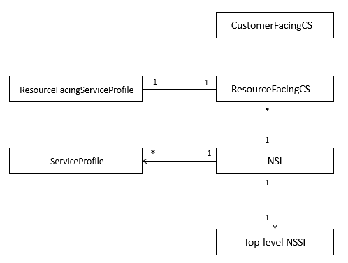
Figure 3.3.1: Example of relationships shown between different entities
In a network slicing scenario, the resources used by an RFCS (resource facing communciations service) are captured and provided by the network slicing model.

3.3 The discussion
There are at least two alternatives for modelling the relation between CSI and NSI:
Option 1: Communication layer is modelled as separate NRM fragment.
Option 2: Network slice layer supports CS closed loop assurance (i.e. through assurance of service profile properties)
The preferred choice for rel-16 work is option 2.
As part of option 2: RFCS service profile might be mapped to NSI service profile and CSI LCM mapped to NSI LCM. The LCM operations of CSI may use NSI management capabilities for control (e.g. initiate a NSI LCM operation, NSI closed loop control operation etc.).

4 Detailed proposal
SA5 WG is asked to endorse the following for Closed loop SLS assurance WI scope in release 16:
- Closed loop SLS control and assurance solution
- Closed loop SLS assurance of network slice service profile properties
SA5 WG is asked to endorse the following as starting points to discuss Closed loop SLS assurance WI scope in release 17:
- Closed loop SLS assurance of communications service

LCM aspect of Closed loop SLS assurance of communications service

