3GPP TSG-SA5 Meeting #130e S5-202119Rev1

e-meeting, 20th Apr 2020 - 28th Apr 2020

Source: CATT, China Mobile

Title: pCR 28.810 Update capacity optimization scenario example for network autonomy level

Document for: Approval
Agenda Item: 6.6.4

1 Decision/action requested
The group is asked to discuss and approval.

2 References
[1] 3GPP TR 28.810: “Study on concept, requirements and solutions for levels of autonomous network v0.3.0”.

3 Rationale
This contribution proposes to update Clause 5.5 Capacity Optimization scenario example for network autonomy level to make this scenario clearer and easier to understand.

4 Detailed proposal
It proposes to make the following changes to TR 28.810[1].
1st Change

5.5 Capacity optimization scenario for classification of network autonomy

5.5.X Introduction
Network resources, especially radio resources are limited, in order to utilize radio resources in the most efficient way and improve user service experience, it is important to achieve higher system capacity by distributing user traffic across the system radio resources. Currently the flow of traffic simply follows the physical topology of the network or network slice, or static radio resource management policies, and resource usage may be unreasonable. Autonomous capacity optimization can help to improve resource usage efficiency greatly by taking into account the traffic steering when scheduling the network or network slice. For example, by creating a traffic prediction model, 3GPP management system can provide precise traffic prediction and the optimal network topology and traffic distribution.

5.5.Y Entire workflow
The entire workflow of capacity optimization is as following:
- Task A: Capacity optimization intent translation. Translate the intent to the capacity optimization target information (e.g., capacity planning data, network topology, traffic model, etc.).
- Task B: Capacity information collection. Collect the current and historical performance data related to resource usage (e.g., PRB usage, RRC connection number, QoS flows, etc.) and network traffic (e.g., composite available capacity per cell (DL/UL), cell level load (DL/UL/SUL), TNL Load, etc.) for the network.
- Task C: Capacity data analysis. Analyze the current and historical performance data related to resource usage and network traffic for the network or network slices.
- Task D: Capacity issues identification and/or prediction. Identify the ongoing issues on resource utilization and predict the potential issues, and generate the capacity or resource utilization possible solutions (e.g., RRM policy adjustment, user migration, handover policy adjustment).
- Task E: Capacity optimization decision. Decide recommended solutions to optimize capacity and resource utilization.
- Task F: Capacity optimization execution. Apply capacity optimization solutions to telecom system (e.g., configuration of parameters and/or policies).

5.5.Z Potential classification of network autonomy for capacity optimization
Each of the detailed tasks in clause 5.5.Y can be accomplished either manually by the operator or automatically by the telecom system. Following are the potential classifications of network autonomy for capacity optimization based on the participation degree of the human operator and the telecom system:
Level 0:
- All the tasks in the capacity optimization workflow are accomplished by human.
Level 1:
- Capacity related information is collected (Task B) automatically by telecom system based on human predefined rules or configurations. Capacity optimization solutions can be triggered by human and executed by telecom system based on human-defined rules (Task F).
- All the other tasks in the capacity optimization workflow are accomplished by human.
Level 2:
- Compared to Level 1, telecom system additionally assists human to execute tasks of analyzing the current and historical performance data (Task C) related to resource usage and network traffic for the network or network slices, and identifying the ongoing issues on resource utilization and predict the potential issues (Task D) based on human-defined rules. Capacity optimization solutions (Task F) are executed by telecom system without human intervention.
- Task A and Task E are accomplished by human.
Level 3:
- Compared to Level 2, the telecom system can automatically collect the current and historical performance data related to resource usage and network traffic (Task B). Telecom system could additionally assist human to review the capacity optimization solutions (Task E), which will finally be decided by human (operator).
- Task A is accomplished by human.
Level 4:
- Compared to Level 3, the capacity data analysis (Task C), capacity issues identification and/or prediction (Task D), and decision making (Task E) are accomplished automatically by telecom system without human intervention. Telecom system could additionally assist human to translate the intent to capacity optimization target information (Task A).
- The intent translation policies may be pre-defined and specified by human to assist the telecom system.
Level 5:
- The entire workflow of capacity optimization is accomplished automatically by telecom system without human intervention and human-defined rules.
Figure 5.5.Z-1 illustrate the classification of network autonomy for capacity optimization.
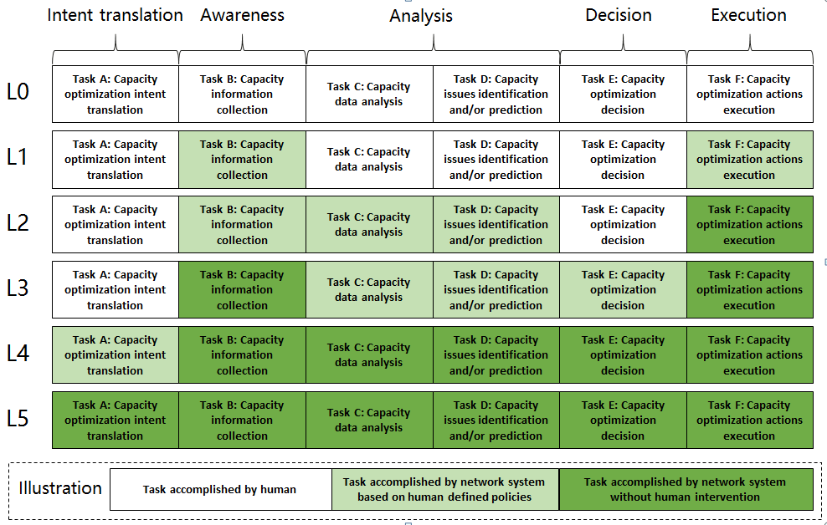
Figure 5.5.Z-1 illustrate the classification of network autonomy for capacity optimization
End of changes

