3GPP TSG-SA5 Meeting #129-e S5-201416

February 24 – 28, 2020 s5-2abcde
CR-Form-v11.4
CHANGE REQUEST
 | 28.541 | CR | 0257 | rev | - | Current version: | 16.3.0
For HELP on using this form: comprehensive instructions can be found at
http://www.3gpp.org/Change-Requests.

Proposed change affects: | UICC apps |  | ME |  | Radio Access Network | X | Core Network

Title: | Add IOCs to support SON functions
Source to WG: | Intel
Source to TSG: | S5
Work item code: | SON_5G |  |  |  |  |  | Date: |  |  | 2020-02-14
Category: | B |  |  |  |  |  | Release: |  |  | Rel-16
 | Use one of the following categories:  F (correction)  A (mirror corresponding to a change in an earlier release)  B (addition of feature),  C (functional modification of feature)  D (editorial modification)  Detailed explanations of the above categories can  be found in 3GPP TR 21.900. |  |  |  |  |  |  |  | Use one of the following releases:  Rel-8 (Release 8)  Rel-9 (Release 9)  Rel-10 (Release 10)  Rel-11 (Release 11)  Rel-12 (Release 12)  Rel-13 (Release 13)  Rel-14 (Release 14)  Rel-15 (Release 15)  Rel-16 (Release 16)
Reason for change: |  | The NRM to support SON functions as defined in TS 28.313 is needed.
Summary of change: |  | Add the following changes:  - SON functions NRM fragment  - IOC MobilityRobustnessOptimization  - IOC RachOptimization  - IOC PCIConfiguration  - SON attributes
Consequences if not approved: |  | The 5G SON functions are not complete.
Clauses affected: |  | 2, 4.2, 4.3, 4.4
 |  | Y | N
Other specs |  |  | X | Other core specifications |  |  |  | TS/TR ... CR ...
affected: |  |  | X | Test specifications |  |  |  | TS/TR ... CR ...
(show related CRs) |  |  | X | O&M Specifications |  |  |  | TS/TR ... CR ...
Other comments:

1st Modified Section

2 References
The following documents contain provisions which, through reference in this text, constitute provisions of the present document.
- References are either specific (identified by date of publication, edition number, version number, etc.) or non-specific.
- For a specific reference, subsequent revisions do not apply.
- For a non-specific reference, the latest version applies. In the case of a reference to a 3GPP document (including a GSM document), a non-specific reference implicitly refers to the latest version of that document in the same Release as the present document.
[1] 3GPP TR 21.905: "Vocabulary for 3GPP Specifications".
[2] 3GPP TS 23.501: "System Architecture for the 5G System".
[3] 3GPP TS 38.300: "NR; Overall description; Stage-2".
[4] 3GPP TS 38.401: "NG-RAN; Architecture description".
[5] 3GPP TS 38.413: "NG-RAN; NG Application Protocol (NGAP)".
[6] 3GPP TS 38.420: "NG-RAN; Xn general aspects and principles".
[7] 3GPP TS 38.470: "NG-RAN; F1 general aspects and principles".
[8] 3GPP TS 38.473: "NG-RAN; F1 application protocol (F1AP)".
[9] 3GPP TS 37.340: "NR; Multi-connectivity; Overall description; Stage 2".
[10] 3GPP TS 28.540: "Management and orchestration; 5G Network Resource Model (NRM);Stage 1".
[11] 3GPP TS 28.662: "Telecommunication management; Generic Radio Access Network (RAN) Network Resource Model (NRM) Integration Reference Point (IRP); Information Service (IS) ".
[12] 3GPP TS 38.104: "NR; Base Station (BS) radio transmission and reception".
[13] 3GPP TS 23.003: "Numbering, Addressing and Identification".
[14] 3GPP TS 36.410: "Evolved Universal Terrestrial Radio Access Network (E-UTRAN); S1 general aspects and principles".
[15] 3GPP TS 36.423: "Evolved Universal Terrestrial Radio Access Network (E-UTRAN); X2 application protocol".
[16] 3GPP TS 36.425: "Evolved Universal Terrestrial Radio Access Network (E-UTRAN); X2 interface user plane protocol".
[17] 3GPP TS 28.625: "State Management Data Definition Integration Reference Point (IRP); Information Service (IS)".
[18] ITU-T Recommendation X.731: "Information technology - Open Systems Interconnection - Systems Management: State management function".
[19] 3GPP TS 28.658: "Telecommunications management; Evolved Universal Terrestrial Radio Access Network (E-UTRAN) Network Resource Model (NRM) Integration Reference Point (IRP): Information Service (IS)".
[20] 3GPP TS 28.702: "Core Network (CN) Network Resource Model (NRM) Integration Reference Point (IRP); Information Service (IS)".
[21] 3GPP TS 28.708: "Telecommunication management; Evolved Packet Core (EPC) Network Resource Model (NRM) Integration Reference Point (IRP): Information Service (IS)".
[22] 3GPP TS 23.040: "Technical realization of the Short Message Service (SMS)".
[23] 3GPP TS 29.510: "5G system; Network Function Repository Services; Stage 3".
[24] 3GPP TS 29.531: "5G System; Network Slice Selection Services Stage 3".
[25] Void.
[26] 3GPP TS 28.531: "Management and orchestration; Provisioning".
[27] 3GPP TS 28.554: "Management and orchestration; 5G End to end Key Performance Indicators (KPI)".
[28] 3GPP TS 22.261: "Service requirements for next generation new services and markets".
[29] ETSI GS NFV-IFA 013 V2.4.1 (2018-02) "Network Function Virtualisation (NFV); Management and Orchestration; Os-Ma-nfvo Reference Point - Interface and Information Model Specification".
[30] 3GPP TS 28.622: "Telecommunication management; Generic Network Resource Model (NRM) Integration Reference Point (IRP); Information Service (IS)".
[31] Void.
[32] 3GPP TS 38.211: "NR; Physical channels and modulation".
[33] 3GPP TS 32.616: "Telecommunication management; Configuration Management (CM); Bulk CM Integration Reference Point (IRP); Solution Set (SS) definitions".
[34] 3GPP TS 28.623: "Telecommunication management; Generic Network Resource Model (NRM) Integration Reference Point (IRP); Solution Set (SS) definitions".
[35] 3GPP TS 28.532: "Management and orchestration; Management services".
[36] Void.
[37] IETF RFC 791: "Internet Protocol".
[38] IETF RFC 2373: "IP Version 6 Addressing Architecture".
[39] IEEE 802.1Q: "Media Access Control Bridges and Virtual Bridged Local Area Networks".
[40] ETSI GR NFV-IFA 015 (V2.4.1): "Network Function Virtualisation (NFV) Release 2; Management and Orchestration; Report on NFV Information Model".
[41] 3GPP TS 38.213: "NR; Physical layer procedures for control".
[42] 3GPP TS 38.101-1: "NR; User Equipment (UE) radio transmission and reception; Part 1: Range 1 Standalone".
[43] 3GPP TS 32.156: "Telecommunication management; Fixed Mobile Convergence (FMC) model repertoire".
[44] IETF RFC 4122: "A Universally Unique IDentifier (UUID) URN Namespace".
[45] IETF RFC 8528: "YANG Schema Mount".
[46] IETF RFC 8340: "YANG Tree Diagrams".
[47] 3GPP TS 32.160: "Management and orchestration; Management Service Template".
[48] 3GPP TS 38.463: "NG-RAN; E1 application protocol (E1AP)".
[x] 3GPP TS 28.313: "Self-Organizing Networks (SON) for 5G networks".

Next Modified Section

4.2 Class diagram

4.2.1 Class diagram for gNB and en-gNB

4.2.1.1 Relationships
This clause depicts the set of classes (e.g. IOCs) that encapsulates the information relevant for this gNB and en-gNB. For the UML semantics, see 3GPP TS 32.156 [43]. Subsequent clauses provide more detailed specification of various aspects of these classes.
The model fragments are for management representation of gNB and en-gNB for all NG-RAN deployment scenario as listed below.
- Non-split NG-RAN deployment senario, represents the gNB defined in TS 38.401[4].
- 2-split NG-RAN deployment scenario, represents the gNB consist of gNB-CU and gNB-DU defined in TS 38.401[4] clause 6.1.1.
- 3-split NG-RAN deployment scenario, represents the gNB consist of gNB-CU-CP, gNB-CU-UP and gNB-DU defined in TS 38.401[4] clause 6.1.2.

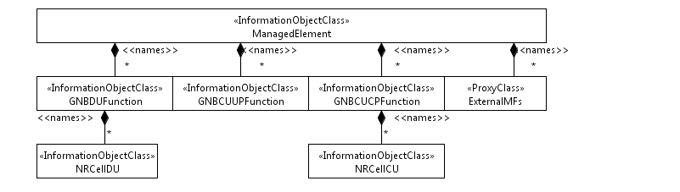
Figure 4.2.1.1-1: NRM for all deployment scenarios
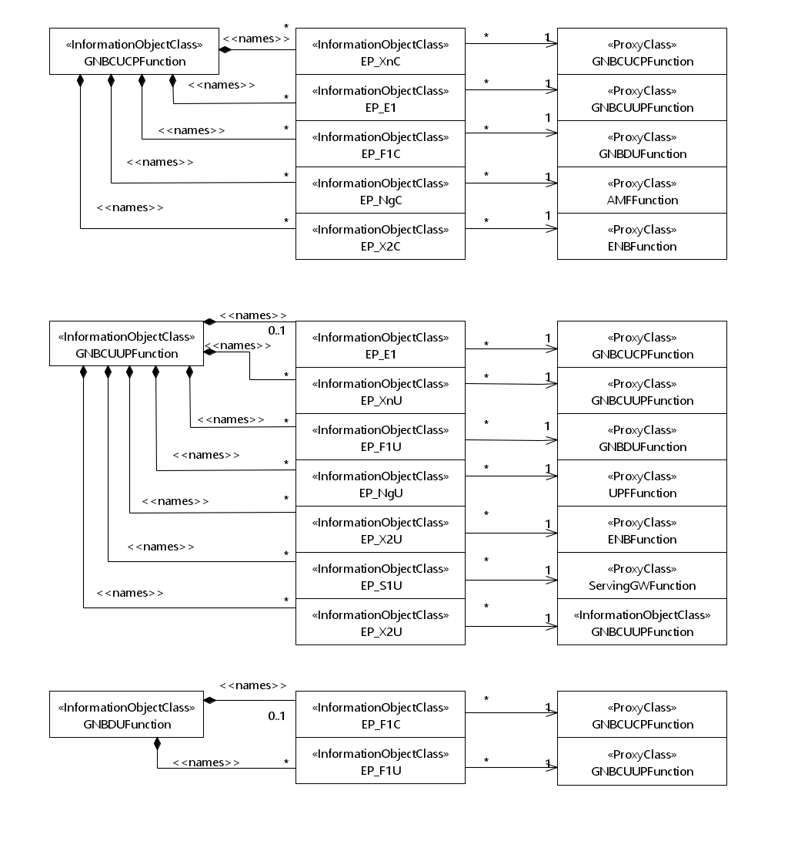
Figure 4.2.1.1-2: NRM for EPs for all deployment scenarios

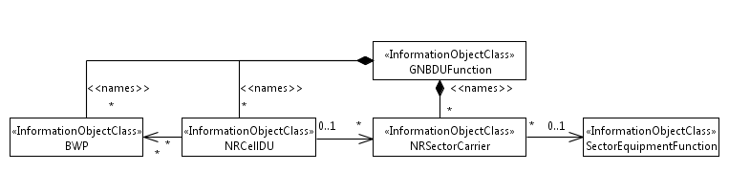
Figure 4.2.1.1-3: NRM for <<IOC>>NRSectorCarrier and <<IOC>>BWP for all deployment scenarios
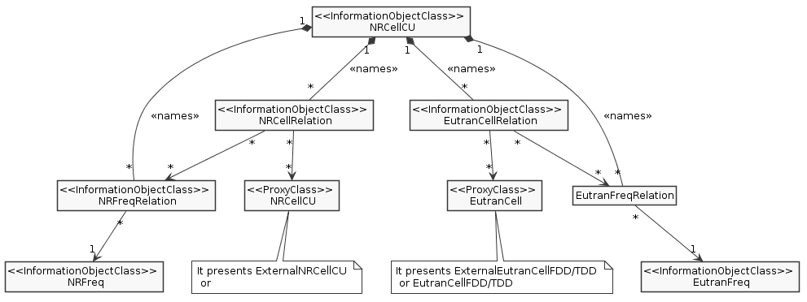
Figure 4.2.1.1-4: Cell Relation view for all deployment scenarios

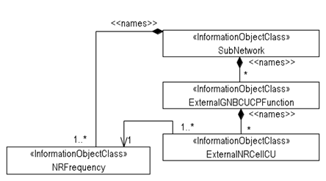
Figure 4.2.1.1-5: View on frequencies and external entities

Figure 4.2.1.1-x: SON functions NRM fragment
NOTE: in the case where an IOC (e.g. RachOptimizationFunction) contained under multiple level of containment tree, IOC at the lowest level (e.g. NRCellCU) overrides the IOCs at higher level(s) of the same containment tree.

4.2.1.2 Inheritance

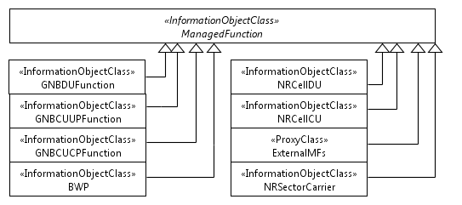
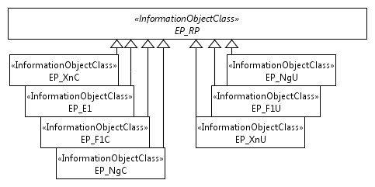
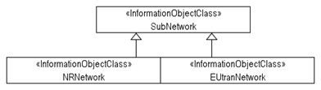

Figure 4.2.1.2-1: Inheritance Hierarchy

Next Modified Section

4.3 Class definitions

4.3.x RachOptimizationFunction

4.3.x.1 Definition
This IOC contains attributes to support the SON function of RACH optimization (See clause 7.1.1 in TS 28.313 [x]).

4.3.x.2 Attributes

Attribute name | Support Qualifier | isReadable | isWritable | isInvariant | isNotifyable
ueAccProbilityDistPerSSB | CM | M | M | - | M
ueAccProbilityDistPerCSI | CM | M | M | - | M
ueAccDelayProbilityDistPerSSB | CM | M | M | - | M
ueAccDelayProbilityDistPerCSI | CM | M | M | - | M
contentiousRACHAttemptsPerSSB | CM | M | M | - | M
contentiousRACHAttemptsPerCSI | CM | M | M | - | M
rachOptimizationControl | CM | M | M | - | M

4.3.x.3 Attribute constraints

Name | Definition
ueAccProbilityDistPerSSB CM Support Qualifier | RACH Optimization is supported
ueAccProbilityDistPerCSI CM Support Qualifier | RACH Optimization is supported
ueAccDelayProbilityDistPerSSB CM Support Qualifier | RACH Optimization is supported
ueAccDelayProbilityDistPerCSI CM Support Qualifier | RACH Optimization is supported
contentiousRACHAttemptsPerSSB CM Support Qualifier | RACH Optimization is supported
contentiousRACHAttemptsPerCSI CM Support Qualifier | RACH Optimization is supported
rachOptimizationControl CM Support Qualifier | RACH Optimization is supported.

4.3.x.4 Notifications
The common notifications defined in subclause 4.5 are valid for this IOC, without exceptions or additions

4.3.y MobilityRobustnessOptimizationFunction

4.3.y.1 Definition
This IOC contains attributes to support the SON function of MRO (See clause 7.1.2 in TS 28.313 [x]).

4.3.y.2 Attributes

Attribute name | Support Qualifier | isReadable | isWritable | isInvariant | isNotifyable
totalHoFailureRate | CM | M | M | - | M
intraRATHoFailureRate | CM | M | M | - | M
intraRATTooEarlyHoFailureRate | CM | M | M | - | M
intraRATTooLateHoFailureRate | CM | M | M | - | M
intraRATHoToWrongCellFailureRate | CM | M | M | - | M
interRATHoFailureRate | CM | M | M | - | M
interRATTooEarlyHoFailureRate | CM | M | M | - | M
interRATTooLateHoFailureRate | CM | M | M | - | M
interRATUnnecessaryHoFailureRate | CM | M | M | - | M
interRATPingPongHoFailureRate | CM | M | M | - | M
mroControl | CM | M | M | - | M

4.3.y.3 Attribute constraints

Name | Definition
totalHoFailureRate CM Support Qualifier | MRO is supported
intraRATHoFailureRate CM Support Qualifier | MRO is supported
intraRATTooEarlyHoFailureRate CM Support Qualifier | MRO is supported
intraRATTooLateHoFailureRate CM Support Qualifier | MRO is supported
intraRATHoToWrongCellFailureRate CM Support Qualifier | MRO is supported
interRATHoFailureRate CM Support Qualifier | MRO is supported
interRATTooEarlyHoFailureRate CM Support Qualifier | MRO is supported
interRATTooLateHoFailureRate CM Support Qualifier | MRO is supported
interRATUnnecessaryHoFailureRate CM Support Qualifier | MRO is supported
interRATPingPongHoFailureRate CM Support Qualifier | MRO is supported
mroControl CM Support Qualifier | MRO is supported

4.3.y.4 Notifications
The common notifications defined in subclause 4.5 are valid for this IOC, without exceptions or additions

4.3.z DSONPciCIConfigurationFunction

4.3.z.1 Definition
This IOC contains attributes to support the D-SON function of PCI configuration (See clause 7.1.3 in TS 28.313 [x]).

4.3.z.2 Attributes

Attribute name | Support Qualifier | isReadable | isWritable | isInvariant | isNotifyable
dSONpPciConfigurationControl | CM | M | M | - | M
pciList | CM | M | M | - | M

4.3.z.3 Attribute constraints

Name | Definition
dSONPpciConfigurationControl CM Support Qualifier | D-SON PCI configuration is supported
pciList CM Support Qualifier | D-SON PCI configuration is supported

4.3.z.4 Notifications
The common notifications defined in subclause 4.5 are valid for this IOC, without exceptions or additions

4.3.w CSONPciConfigurationFunction

4.3.w.1 Definition
This IOC contains attributes to support the C-SON function of PCI configuration (See clause 7.1.3 in TS 28.313 [x]).

4.3.w.2 Attributes

Attribute name | Support Qualifier | isReadable | isWritable | isInvariant | isNotifyable
cSONPciConfigurationControl | CM | M | M | - | M
nrCellpciValue | CM | M | M | - | M
csonPciList | CM | M | M | - | M

4.3.w.3 Attribute constraints

Name | Definition
cSONPciConfigurationControl CM Support Qualifier | C-SON PCI configuration is supported
nrCellpciValue CM Support Qualifier | C-SON PCI configuration is supported
csonPciList CM Support Qualifier | C-SON PCI configuration is supported

4.3.w.4 Notifications
The common notifications defined in subclause 4.5 are valid for this IOC, without exceptions or additions

4.3.v DSONPciConfigControlFunction

4.3.v.1 Definition
This <<IOC>> DSONPciConfigControlFunction represents the control information of D-SON PCI configuration.

4.3.v.2 Attributes
The DSONPciConfigControlFunction IOC includes attributes inherited from Top IOC (defined in TS 28.622[30]) and the following attributes:
Attribute name | Support Qualifier | isReadable | isWritable | isInvariant | isNotifyable
dsonPciConfigurationSwitch | CM | M | M | - | M

4.3.v.3 Attribute constraints
Name | Definition
dsonPciConfigurationSwitch CM Support Qualifier | D-SON PCI configuration is supported
.

4.3.v.4 Notifications
The common notifications defined in subclause X.1.5 are valid for this IOC, without exceptions or additions.

Next Modified Section

4.4 Attribute definitions

4.4.1 Attribute properties
Attribute Name | Documentation and Allowed Values | Properties
administrativeState | It indicates the administrative state of the NRCellDU. It describes the permission to use or prohibition against using the cell, imposed through the OAM services.  allowedValues: "LOCKED", "SHUTTING DOWN", "UNLOCKED".  The meaning of these values is as defined in ITU-T Recommendation X.731 [18].  See Annex A for Relation between the "Pre-operation state of the gNB-DU Cell" and administrative state relevant in case of 2-split and 3-split deployment scenarios. | type: ENUM  multiplicity: 1  isOrdered: N/A  isUnique: N/A  defaultValue: Locked  isNullable: False
operationalState | It indicates the operational state of the NRCellDU instance. It describes whether the resource is installed and partially or fully operable (Enabled) or the resource is not installed or not operable (Disabled).  allowedValues: "ENABLED", "DISABLED". | type: ENUM  multiplicity: 1  isOrdered: N/A  isUnique: N/A  defaultValue: None  isNullable: False
cellState | It indicates the usage state of the NRCellDU instance. It describes whether the cell is not currently in use (Idle), or currently in use but not configured to carry traffic (Inactive) or is currently in use and is configured to carry traffic (Active).  The Inactive and Active definitions are in accordance with TS 38.401 [4]:  "Inactive: the cell is known by both the gNB-DU and the gNB-CU. The cell shall not serve UEs;  Active: the cell is known by both the gNB-DU and the gNB-CU. The cell should be able to serve UEs."  "allowedValues: "IDLE", "INACTIVE", "ACTIVE". | type: ENUM  multiplicity: 1  isOrdered: N/A  isUnique: N/A  defaultValue: None  isNullable: False
arfcnDL | NR Absolute Radio Frequency Channel Number (NR-ARFCN) for downlink  allowedValues:  See TS 38.104 [12] subclause 5.4.2. Note that allowed values of NR-ARFCN are specified for each band in subclause 5.4.2.3. | type: Integer  multiplicity: 1  isOrdered: N/A  isUnique: N/A  defaultValue: None  isNullable: False
arfcnUL | NR Absolute Radio Frequency Channel Number (NR-ARFCN) for uplink  allowedValues:  See TS 38.104 [12] subclause 5.4.2. Note that allowed values of NR-ARFCN are specified for each band in subclause 5.4.2.3. | type: Integer  multiplicity: 1  isOrdered: N/A  isUnique: N/A  defaultValue: None  isNullable: False
arfcnSUL | NR Absolute Radio Frequency Channel Number (NR-ARFCN) for supplementary uplink  allowedValues:  See TS 38.104 [12] subclause 5.4.2. Note that allowed values of NR-ARFCN are specified for each band in subclause 5.4.2.3. | type: Integer  multiplicity: 1  isOrdered: N/A  isUnique: N/A  defaultValue: None  isNullable: False
bSChannelBwDL | BS Channel BW in MHz. for downlink  allowedValues:  See BS Channel BW in TS 38.104 [12], subclause 5.3.​ | type: Integer  multiplicity: 1  isOrdered: N/A  isUnique: N/A  defaultValue: None  isNullable: False
bSChannelBwUL | BS Channel BW in MHz.for uplink  allowedValues:  See BS Channel BW in TS 38.104 [12], subclause 5.3.​ | type: Integer  multiplicity: 1  isOrdered: N/A  isUnique: N/A  defaultValue: None  isNullable: False
bSChannelBwSUL | BS Channel BW in MHz.for supplementary uplink  allowedValues:  See BS Channel BW in TS 38.104 [12], subclause 5.3.​ | type: Integer  multiplicity: 1  isOrdered: N/A  isUnique: N/A  defaultValue: None  isNullable: False
configuredMaxTxPower | This is the maximum possible for all downlink channels, used simultaneously in a cell, added together.  allowedValues:TBD | type: Integer  multiplicity: 1  isOrdered: N/A  isUnique: N/A  defaultValue: None  isNullable: False
cyclicPrefix | Cyclic prefix as defined in TS 38.211 [32], subclause 4.2.  allowedValues:  "NORMAL", "EXTENDED". | type: enumeration  multiplicity: 1  isOrdered: N/A  isUnique: N/A  defaultValue: None  isNullable: False
localAddress | This parameter specifies the localAddress including IP address and VLAN ID used for initialization of the underlying transport.  First string is IP address, IP address can be an IPv4 address (See RFC 791 [37]) or an IPv6 address (See RFC 2373 [38]).  Second string is VLAN Id. (See IEEE 802.1Q [39]), | type: String  multiplicity: 2  isOrdered: True  isUnique: N/A  defaultValue: None  isNullable: False
remoteAddress | Remote address including IP address used for initialization of the underlying transport.  IP address can be an IPv4 address (See RFC 791 [37]) or an IPv6 address (See RFC 2373 [38]). | type: String  multiplicity: 1  isOrdered: N/A  isUnique: N/A  defaultValue: None  isNullable: False
gNBId | It identifies a gNB within a PLMN. The gNB ID is part of the NR Cell Identifier (NCI) of the gNB cells.  See "gNB Identifier (gNB ID)" of subclause 8.2 of TS 38.300 [3]). See "Global gNB ID" in subclause 9.3.1.6 of TS 38.413 [5].  allowedValues: 0..4294967295 | type: Integer  multiplicity: 1  isOrdered: N/A  isUnique: N/A  defaultValue: None  isNullable: False
gNBIdLength | This indicates the number of bits for encoding the gNB ID. See "Global gNB ID" in subclause 9.3.1.6 of TS 38.413 [5].  allowedValues: 22 .. 32. | type: Integer  multiplicity: 1  isOrdered: N/A  isUnique: N/A  defaultValue: None  isNullable: False
gNBDUId | It uniquely identifies the DU at least within a gNB-CU. See 'gNB-DU ID' in subclause 9.3.1.9 of 3GPP TS 38.473 [8].  allowedValues: 0..2³⁶-1 | type: Integer  multiplicity: 1  isOrdered: N/A  isUnique: N/A  defaultValue: None  isNullable: False
gNBCUUPId | It uniquely identifies the gNB-CU-UP at least within a gNB-CU-CP. See 'gNB-CU-UP ID' in subclause 9.3.1.15 of 3GPP TS 38.463 [48].  allowedValues: 0..2³⁶-1 | type: Integer  multiplicity: 1  isOrdered: N/A  isUnique: N/A  defaultValue: None  isNullable: False
gNBCUName | It identifies the Central Entity of a NR node, see subclause 9.2.1.4 of 3GPP TS 38.473 [8].  allowedValues: Not applicable | type: String  multiplicity: 1  isOrdered: N/A  isUnique: N/A  defaultValue: None  isNullable: False
gNBDUName | It identifies the Distributed Entity of a NR node, see subclause 9.2.1.5 of 3GPP TS 38.473 [8].  allowedValues: Not applicable | type: String  multiplicity: 1  isOrdered: N/A  isUnique: N/A  defaultValue: None  isNullable: False
cellLocalId | It identifies a NR cell of a gNB.  It, together with the gNB Identifier (using gNBId of the parent GNBCUCPFunction or GNBDUFunction or ExternalCUCPFunction), identifies a NR cell within a PLMN. This is the NR Cell Identity (NCI). See subclause 8.2 of TS 38.300 [3]),  The NCI can be constructed by encoding the gNB Identifier using gNBId (of the parent GNBCUCPFunction or GNBDUFunction or ExternalCUCPFunction) and cellLocalId where the gNB Identifier field is of length specified by gNBIdLength (of the parent GNBCUCPFunction or GNBDUFunction or ExternalCUCPFunction). See "Global gNB ID" in subclause 9.3.1.6 of TS 38.413 [5].  The NR Cell Global identifier (NCGI) is constructed from the PLMN identity the cell belongs to and the NR Cell Identifier (NCI) of the cell.  See relation between NCI and NCGI subclause 8.2 of TS 38.300 [3].  allowedValues: Not applicable | type: Integer  multiplicity: 1  isOrdered: N/A  isUnique: True  defaultValue: None  isNullable: False
nRPCI | This holds the Physical Cell Identity (PCI) of the NR cell.  allowedValues:  See 3GPP TS 38.211 [32] subclause 7.4.2 for legal values of pci. | type: Integer  multiplicity: 1  isOrdered: N/A  isUnique: N/A  defaultValue: None  isNullable: False
nRTAC | This holds the identity of the common Tracking Area Code for the PLMNs.  allowedValues:  a) It is the TAC or Extended-TAC.  b) A cell can only broadcast one TAC or Extended-TAC. See TS 36.300, subclause 10.1.7 (PLMNID and TAC relation).  c) TAC is defined in subclause 19.4.2.3 of 3GPP TS 23.003 [13] and Extended-TAC is defined in subclause 9.3.1.29 of 3GPP TS 38.473 [8]. | type: Bitstring  multiplicity: 1  isOrdered: N/A  isUnique: N/A  defaultValue: None  isNullable: False
GNBCUCPFunction.pLMNId | It specifies the PLMN identifier to be used as part of the global RAN node identity.  allowedValues: Not applicable. | Type: PLMNId  multiplicity: 1  isOrdered: N/A  isUnique: N/A  defaultValue: None  isNullable: False
GNBCUUPFunction.pLMNIdList | This is a list of PLMN identifiers. It defines from which set of PLMNs an UE must have as its serving PLMN to be allowed to use the GNB-CU-UP.  allowedValues: Not applicable. | type: PLMNId  multiplicity: 1..12  isOrdered: N/A  isUnique: True  defaultValue: None  isNullable: False
NRCellCU.pLMNIdList | It defines which PLMNs that can be served by the NR cell.  allowedValues: Not applicable. | type: PLMNId  multiplicity: 1..12  isOrdered: N/A  isUnique: True  defaultValue: None  isNullable: False
NRCellDU.pLMNIdList | It defines which PLMNs that can be served by the NR cell. The first entry of the list is the PLMN used to construct the nCGI for the NR cell.  allowedValues: Not applicable. | type: PLMNId  multiplicity: 1..12  isOrdered: N/A  isUnique: True  defaultValue: None  isNullable: False
ExternalNRCellCU.pLMNIdList | It defines which PLMNs that are assumed to be served by the NR Cell in another gNB-CU-CP. This list is either updated by the managed element itself (e.g. due to ANR, signalling over Xn etc) or by consumer over the standard interface.  allowedValues: Not applicable. | Type: PLMNId  multiplicity: 1..12  isOrdered: N/A  isUnique: True  defaultValue: None  isNullable: False
sNSSAIList | It represents the list of S-NSSAI the managed object is supporting. The S-NSSAI is defined in 3GPP TS 23.003 [13].  allowedValues: See 3GPP TS 23.003 [13] | type: S-NSSAI  multiplicity: *  isOrdered: N/A  isUnique: N/A  defaultValue: None  allowedValues: N/A  isNullable: False
sST | This attribute specifies the Slice/Service type (SST) of the network slice.  See clause 5.15.2 of 3GPP TS 23.501 [2]. | type: Integer  multiplicity: 1  isOrdered: N/A  isUnique: N/A  defaultValue: None  allowedValues: N/A  isNullable: False
sD | This attribute specifies the Slice Differentiator (SD), which is optional information that complements the slice/service type(s) to differentiate amongst multiple Network Slices.  See clause 5.15.2 of 3GPP TS 23.501 [2]. | type: Integer  multiplicity: 1  isOrdered: N/A  isUnique: N/A  defaultValue: None  allowedValues: N/A  isNullable: False
totalHoFailureRate | This indicates the target of the number of handover failure events divided by the total number of handover events, together with its targetWeight.  This target is suitable for MRO or LBO.  allowedValues:  hoFailureRate:  Integer 1..100 (percentage).  targetWeight:  Integer 1..N. The higher the number the higher the weight. | type: <<data type>>  multiplicity: 0..*  isOrdered: N/A  isUnique: N/A  defaultValue: None  isNullable: True
intraRATHoFailureRate | This indicates the assigned target of the number of handover failure events divided by the total number of intra-RAT handover events, together with its targetWeight.  This target is suitable for MRO or LBO.  allowedValues:  hoFailureRate:  Integer 1..100 (percentage).  targetWeight:  Integer 1..N. The higher the number the higher the weight. | type: <<data type>>  multiplicity: 0..*  isOrdered: N/A  isUnique: N/A  defaultValue: None  isNullable: True
intraRATTooEarlyHoFailureRate | This indicates the assigned target of the number of too early handover failure events divided by the total number of intra-RAT handover events, together with its targetWeight.  This target is suitable for MRO or LBO.  allowedValues:  hoFailureRate:  Integer 1..100 (percentage).  targetWeight:  Integer 1..N. The higher the number the higher the weight. | type: <<data type>>  multiplicity: 0..*  isOrdered: N/A  isUnique: N/A  defaultValue: None  isNullable: True
intraRATTooLateHoFailureRate | This indicates the assigned target of the number of too late handover failure events divided by the total number of intra-RAT handover events, together with its targetWeight.  This target is suitable for MRO or LBO.  allowedValues:  hoFailureRate:  Integer 1..100 (percentage).  targetWeight:  Integer 1..N. The higher the number the higher the weight. | type: <<data type>>  multiplicity: 0..*  isOrdered: N/A  isUnique: N/A  defaultValue: None  isNullable: True
intraRATHoToWrongCellFailureRate | This indicates the assigned target of the number of handover to wrong cell failure events divided by the total number of intra-RAT handover events, together with its targetWeight.  This target is suitable for MRO or LBO.  allowedValues:  hoFailureRate:  Integer 1..100 (percentage).  targetWeight:  Integer 1..N. The higher the number the higher the weight. | type: <<data type>>  multiplicity: 0..*  isOrdered: N/A  isUnique: N/A  defaultValue: None  isNullable: True
interRATHoFailureRate | This indicates the assigned target of the number of handover failure events divided by the total number of inter-RAT handover events, together with its targetWeight.  This target is suitable for MRO or LBO.  allowedValues:  hoFailureRate:  Integer 1..100 (percentage).  targetWeight:  Integer 1..N. The higher the number the higher the weight. | type: <<data type>>  multiplicity: 0..*  isOrdered: N/A  isUnique: N/A  defaultValue: None  isNullable: True
interRATTooEarlyHoFailureRate | This indicates the assigned target of the number of too early handover failure events divided by the total number of inter-RAT handover events, together with its targetWeight.  This target is suitable for MRO or LBO.  allowedValues:  hoFailureRate:  Integer 1..100 (percentage).  targetWeight:  Integer 1..N. The higher the number the higher the weight. | type: <<data type>>  multiplicity: 0..*  isOrdered: N/A  isUnique: N/A  defaultValue: None  isNullable: True
interRATTooLateHoFailureRate | This indicates the assigned target of the number of too late handover failure events divided by the total number of inter-RAT handover events, together with its targetWeight.  This target is suitable for MRO or LBO.  allowedValues:  hoFailureRate:  Integer 1..100 (percentage).  targetWeight:  Integer 1..N. The higher the number the higher the weight. | type: <<data type>>  multiplicity: 0..*  isOrdered: N/A  isUnique: N/A  defaultValue: None  isNullable: True
interRATUnnecessaryHoFailureRate | This indicates the assigned target of the number of unnecessary handover failure events divided by the total number of inter-RAT handover events, together with its targetWeight.  This target is suitable for MRO or LBO.  allowedValues:  hoFailureRate:  Integer 1..100 (percentage).  targetWeight:  Integer 1..N. The higher the number the higher the weight. | type: <<data type>>  multiplicity: 0..*  isOrdered: N/A  isUnique: N/A  defaultValue: None  isNullable: True
interRATPingPongHoFailureRate | This indicates the assigned target of the number of ping-pong handover failure events divided by the total number of inter-RAT handover events, together with its targetWeight.  This target is suitable for MRO or LBO.  allowedValues:  hoFailureRate:  Integer 1..100 (percentage).  targetWeight:  Integer 1..N. The higher the number the higher the weight. | type: <<data type>>  multiplicity: 0..*  isOrdered: N/A  isUnique: N/A  defaultValue: None  isNullable: True
mroControl | This attribute determines whether the MRO function is enabled or disabled.  allowedValues: On, Off | type: <<enumeration>>  multiplicity: 1  isOrdered: N/A  isUnique: N/A  defaultValue: None  isNullable: True
pciList | This holds a list of physical cell identities that can be assigned to the NR cells.  This attribute shall be supported if D-SON PCI configuration function is supported. See subclause 8.2.3, 8.3.1 in TS 28.313 [x].  allowedValues: See TS 38.211 [32] subclause 7.4.2 for legal values of pci. The number of pci in the list is 0 to 1007. | type: Integer  multiplicity: 1..*  isOrdered: N/A  isUnique: N/A  defaultValue: None  isNullable: False
dSONPciConfigurationControl | This attribute determines whether the D-SON PCI configuration function at NR cell DU is enabled or disabled.  allowedValues: On, Off | type: <<enumeration>>  multiplicity: 1  isOrdered: N/A  isUnique: N/A  defaultValue: None  isNullable: True
nrCellpciValue | This holds the physical cell identities that can be assigned to a NR cell.  This attribute shall be supported if C-SON PCI configuration function is supported. See subclause 8.2.3, 8.3.1 in TS 28.313 [x].  allowedValues: See TS 38.211 [32] subclause 7.4.2 for legal values of pci. The number of pci in the list is 0 to 1007. | type: Integer  multiplicity: 1  isOrdered: N/A  isUnique: N/A  defaultValue: None  isNullable: False
cSONPciConfigurationControl | This attribute determines whether the C-SON PCI configuration function is enabled or disabled.  allowedValues: On, Off | type: <<enumeration>>  multiplicity: 1  isOrdered: N/A  isUnique: N/A  defaultValue: None  isNullable: True
dsonPciConfigurationSwitch | This attribute determines whether the D-SON PCI configuration Function at NR cell CU is activated or deactivated.  allowedValues: On, Off | type: boolean  multiplicity: 1  isOrdered: N/A  isUnique: N/A  defaultValue: None  isNullable: True
csonPciList | This holds a list of physical cell identities that can be assigned to the pci attribute by gNB. The assignment algorithm is not specified.  This attribute shall be supported if and only if the Domain-Centralized is supported. See TS 28.313, ref [X] subclause 7.1.3.  allowedValues: See TS 38.211 [32] subclause 7.4.2.1 for legal values of pci. The number of pci in the list is 1 to 100X. | type: Integer  multiplicity: 1..*  isOrdered: N/A  isUnique: N/A  defaultValue: None  isNullable: False
ueAccProbilityDistPerSSB | This is a list of target Access Probability (AP_{n}) for the RACH optimization function.  Each instance AP_{n} of the list is the probability that the UE gets access on the RACH channel per SSB within n number of preambles sent over an unspecified sampling period.  This target is suitable for RACH optimization.  allowedValues: Each element of the list, AP_{n,} is a pair (a, n) where a is the targetProbability (in %) and n is the number of preambles sent.  The legal values for a are 25, 50, 75, 90.  The legal values for n are 1 to 200.  The number of elements specified is 4. The number of elements supported is vendor specific. The choice of supported values for a and n is vendor-specific. | type: <<data type>>  multiplicity: 0..*  isOrdered: N/A  isUnique: N/A  defaultValue: None  isNullable: True
ueAccProbilityDistPerCSI | This is a list of target Access Probability (AP_{n}) for the RACH optimization function.  Each instance AP_{n} of the list is the probability that the UE gets access on the RACH channel per CSI within n number of preambles sent over an unspecified sampling period.  This target is suitable for RACH optimization.  allowedValues: Each element of the list, AP_{n,} is a pair (a, n) where a is the targetProbability (in %) and n is the number of preambles sent.  The legal values for a are 25, 50, 75, 90.  The legal values for n are 1 to 200.  The number of elements specified is 4. The number of elements supported is vendor specific. The choice of supported values for a and n is vendor-specific. | type: <<data type>>  multiplicity: 0..*  isOrdered: N/A  isUnique: N/A  defaultValue: None  isNullable: True
ueAccDelayProbilityDistPerSSB | This is a list of target Access Delay probability (AD_{P}) for the RACH optimization function.  Each instance AD_{P} of the list is the target time before the UE gets access on the RACH channel per SSB, for the P percent of the successful RACH Access attempts with lowest access delay, over an unspecified sampling period.  This target is suitable for RACH optimization.  allowedValues: Each element of the list, AD_{p,} is a pair (p, d) where p is the targetProbability (in %) and d is the access delay (in milliseconds).  The legal values for p are 25, 50, 75, 90.  The legal values for d are 10 to 560.  The number of elements specified is 4. The number of elements supported is vendor specific. The choice of supported values for a and b is vendor-specific. | type: <<data type>>  multiplicity: 0..*  isOrdered: N/A  isUnique: N/A  defaultValue: None  isNullable: True
ueAccDelayProbilityDistPerCSI | This is a list of target Access Delay probability (AD_{P}) for the RACH optimization function.  Each instance AD_{P} of the list is the target time before the UE gets access on the RACH channel per CSI, for the P percent of the successful RACH Access attempts with lowest access delay, over an unspecified sampling period.  This target is suitable for RACH optimization.  allowedValues: Each element of the list, AD_{p,} is a pair (p, d) where p is the targetProbability (in %) and d is the access delay (in milliseconds).  The legal values for p are 25, 50, 75, 90.  The legal values for d are 10 to 560.  The number of elements specified is 4. The number of elements supported is vendor specific. The choice of supported values for a and b is vendor-specific. | type: <<data type>>  multiplicity: 0..*  isOrdered: N/A  isUnique: N/A  defaultValue: None  isNullable: True
contentiousRACHAttemptsPerSSB | This indicates the assigned target of the number of RACH attempts with contention detected divided by the total number of RACH attempts for each SSB.  This target is suitable for RACH optimization.  allowedValues:  Integer 1..100 | type: <<data type>>  multiplicity: 0..*  isOrdered: N/A  isUnique: N/A  defaultValue: None  isNullable: True
contentiousRACHAttemptsPerCSI | This indicates the assigned target of the number of RACH attempts with contention detected divided by the total number of RACH attempts for each CSI.  This target is suitable for RACH optimization.  allowedValues:  Integer 1..100 | type: <<data type>>  multiplicity: 0..*  isOrdered: N/A  isUnique: N/A  defaultValue: None  isNullable: True
rachOptimizationControl | This attribute determines whether the RACH Optimization function is enabled or disabled.  allowedValues: On, Off | type: <<enumeration>>  multiplicity: 1  isOrdered: N/A  isUnique: N/A  defaultValue: None  isNullable: True
rRMPolicyType | Type of the RRM policy.  The value 0 denotes use of the rRMPolicy.  The value 1 denotes use of the rRMPolicyNSSIId, rRMPolicyRatio  The value 2 denotes use of the rRMPolicyRatio2.  allowedValues: 0 : 65535. | type: Integer  multiplicity: 1  isOrdered: N/A  isUnique: N/A  defaultValue: None  isNullable: False
rRMPolicyNSSIId | The list of S-NSSAIs for which a rRMPolicyRatio value is specified  allowedValues: Not applicable. | type: DN  multiplicity: 1..*  isOrdered: N/A  isUnique: N/A  defaultValue: None  allowedValues: N/A  isNullable: False
rRMPolicyRatio | The RRM policy setting the ratio for the split of the Radio resources between the supported S-NSSAI lists A S-NSSAI list is defined in rRMPolicyNSSIId. rRMPolicyRatio is the list of target percentage values assigned to the corresponding rRMPolicyNSSIId values. Every value specifies the percentage of PRBs to be allocated to the corresponding S-NSSAIs, in average over time. The sum of the values shall be less or equal 100.  allowedValues:  0 : 100  See NOTE 3 and NOTE 4. | type: Integer  multiplicity: 1..*  isOrdered: N/A  isUnique: N/A  defaultValue: None  allowedValues: N/A  isNullable: False
rRMPolicyRatio2List | The attribute specifies a list of RRMPolicyRatio2 which is defined as a datatype. The attribute is used to set the ratios for the split of the Radio resources between the sNSSAILists for radio resources (e.g. RRC connected users, PDCP resource, etc.) in average time (see NOTE 2 and NOTE 3).  The sum of the values included in the item of rRMPolicyRatio2 shall be less or equal 100 (see NOTE 4).  allowedValues: Not applicable. | type: RRMPolicyRatio2  multiplicity: 1..*  isOrdered: N/A  isUnique: N/A  defaultValue: None  allowedValues: N/A  isNullable: False
groupId | The attribute identifies one sNSSAIList group inside NRCellCU. The rRMPolicyRatio2 is configured for each group. The value of the groupId is unique inside one NRCellCU instance | type: Integer  multiplicity: 1  isOrdered: N/A  isUnique: N/A  defaultValue: None  allowedValues: N/A  isNullable: False
quotaType | The attribute indicates the type of the quota which allows to allocate resources as strictly usable for defined slice(s) ( “strict quota”) or allows that resources to be used by other slice(s) when defined slice(s) do not need them ( “float quota”).  allowedValues: "STRICT", "FLOAT". | type: ENUM  multiplicity: 1  isOrdered: N/A  isUnique: N/A  defaultValue: None  isNullable: False
rRMPolicyMaxRatio | The RRM policy setting the maximum percentage of radio resources to be allocated to the corresponding S-NSSAIList.  This quota can be strict or float quota. Strict quota means resources are not allowed for other sNSSAIs even when they are not used by the defined sNSSAIList. Float quota resources can be used by other sNSSAIs when the defined sNSSAIList do not need them.  Value 0 indicates that there is no maximum limit.  allowedValues:  0 : 100 | type: Integer  multiplicity: 0..1  isOrdered: N/A  isUnique: N/A  defaultValue: None  allowedValues: N/A  isNullable: False
rRMPolicyMarginMaxRatio | Maximum quota margin ratio is applicable when maximum quota policy ratio is of type “float quota”. It defines the resource quota within maximum quota to reserve buffers for new resource requirements for the specified S-NSSAIList. With the margin ratio, unused resources of the maximum resource quota can be allocated to other S-NSSAIs when the free resources are more than resource amount indicated by the margin. The margin resource quota can only be used for the specific S-NSSAIList. Value 0 indicates that no margin is used.  allowedValues:  0 : 100 | type: Integer  multiplicity: 0..1  isOrdered: N/A  isUnique: N/A  defaultValue: None  allowedValues: N/A  isNullable: False
rRMPolicyMinRatio | The RRM policy setting the minimum percentage of radio resources to be allocated to the corresponding S-NSSAIList.  This quota can be strict or float quota. Strict quota means resources are not allowed for other sNSSAIs even when they are not used by the defined sNSSAIList. Float quota resources can be used by other sNSSAIs when the defined sNSSAIList do not need them.  Value 0 indicates that there is no minimum limit.  allowedValues:  0 : 100  NOTE: The averaging time interval is implementation dependent. | type: Integer  multiplicity: 0..1  isOrdered: N/A  isUnique: N/A  defaultValue: None  allowedValues: N/A  isNullable: False
rRMPolicyMarginMinRatio | Minimum quota margin ratio is applicable when minimum quota policy ratio is of type “float quota”. It defines the resource quota within minimum quota to reserve buffers for new resource requirements for the specified S-NSSAIList. With the margin ratio, unused resources of the minimum resource quota can be allocated to other S-NSSAIs when the free resources are more than resource amount indicated by the margin. The margin resource quota can only be used for the specific S-NSSAIList. Value 0 indicates that no margin is used.  allowedValues:  0 : 100 | type: Integer  multiplicity: 0..1  isOrdered: N/A  isUnique: N/A  defaultValue: None  allowedValues: N/A  isNullable: False
rRMPolicy | It represents RRM policy which includes guidance for split of radio resources between the S-NSSAIs that the cell supports in case when the rRMPolicyType is absent or equal to 0. The RRM policy is implementation dependent.  allowedValues: Not applicable | type: String  multiplicity: 1  isOrdered: N/A  isUnique: N/A  defaultValue: None  isNullable: False
subcarrierSpacing | Subcarrier spacing configuration for a BWP. See subclause 5 in TS 38.104 [12].  AllowedValues: [15, 30, 60, 120] depending on the frequency range FR1 or FR2. | type: Integer  multiplicity: 1  isOrdered: N/A  isUnique: N/A  defaultValue: None  isNullable: False
txDirection | Indicates if the transmission direction is downlink (DL), uplink (UL) or both downlink and uplink (DL and UL).  allowedValues:  "DL", "UL", "DL and UL" | type: Enum  multiplicity: 1  isOrdered: N/A  isUnique: N/A  defaultValue: None  isNullable: False
bwpContext | It identifies whether the object is used for downlink, uplink or supplementary uplink.  allowedValues:  "DL", "UL", "SUL" | type: Enum  multiplicity: 1  isOrdered: N/A  isUnique: N/A  defaultValue: None  isNullable: False
isInitialBwp | It identifies whether the object is used for initial or other BWP.  allowedValues:  "INITIAL", "OTHER" | type: Enum  multiplicity: 1  isOrdered: N/A  isUnique: N/A  defaultValue: None  isNullable: False
startRB | Offset in common resource blocks to common resource block 0 for the applicable subcarrier spacing for a BWP. This corresponds to N_BWP_start, see subclause 4.4.5 in TS 38.211 [32].  allowedValues:  0 to N_grid_size – 1, where N_grid_size equals the number of resource blocks for the BS channel bandwidth, given the subcarrier spacing of the BWP. | type: Integer  multiplicity: 1  isOrdered: N/A  isUnique: N/A  defaultValue: None  isNullable: False
numberOfRBs | Number of physical resource blocks for a BWP. This corresponds to N_BWP_size, see subclause 4.4.5 in TS 38.211 [32].  allowedValues:  1 to N_grid_size – startRB of the BWP. Se startRB for definition of N_grid_size. | type: Integer  multiplicity: 1  isOrdered: N/A  isUnique: N/A  defaultValue: None  isNullable: False
nRTCI | This is the Target NR Cell Identifier. It consists of NR Cell Identifier (NCI) and Physical Cell Identifier of the target NR cell (nRPCI).  The NRRelation.nRTCI identifies the target cell from the perspective of the NRCell, the name-containing instance of the subject NRCellCU instance. | type: Integer  multiplicity: 1  isOrdered: N/A  isUnique: N/A  defaultValue: None  isNullable: False
adjacentCell | This attribute contains the DN of an AdjacentNRCell (NRCellCU or ExternalNRCellCU) or AdjacentEutranCell (EutranCellFDD or EutranCellTDD or ExternalEutranCellFDD or ExternalEutranCellTDD)  allowedValues: Not applicable. | type: DN  multiplicity: 1  isOrdered: N/A  isUnique: True  defaultValue: None  isNullable: False
ssbFrequency | Indicates cell defining SSB frequency domain position  Frequency of the cell defining SSB transmission. The frequency provided in this attribute identifies the position of resource element RE=#0 (subcarrier #0) of resource block RB#10 of the SS block. The frequency must be positioned on the NR global frequency raster, as defined in TS 38.101 [42] subclause 5.4.2. and within bSChannelBwDL.  allowedValues: 0..3279165 | type: Integer  multiplicity: 1  isOrdered: N/A  isUnique: N/A  defaultValue: None  isNullable: False
ssbPeriodicity | Indicates cell defined SSB periodicity in number of subframes (ms).  The SSB periodicity in msec is used for the rate matching purpose.  allowedValues: 5, 10, 20, 40, 80, 160. | type: Integer  multiplicity: 1  isOrdered: N/A  isUnique: N/A  defaultValue: None  isNullable: False
ssbSubCarrierSpacing | Subcarrier spacing of SSB. See subclause 7.4.3.1 of TS 38.211 [32].  allowedValues:  Only the values 15kHz or 30 kHz (<6GHz), 120 kHz or 240 kHz (>6GHz) are applicable. | type: Integer  multiplicity: 1  isOrdered: N/A  isUnique: N/A  defaultValue: None  isNullable: False
ssbOffset | Indicates cell defining SSB time domain position. Defined as the offset of the measurement window, in number of subframes (ms), in which to receive SS/PBCH blocks, where allowed values depend on the ssbPeriodicity.  allowedValues:  ssbPeriodicity5 ms 0..4,  ssbPeriodicity10 ms 0..9,  ssbPeriodicity20 ms 0..19,  ssbPeriodicity40 ms 0..39,  ssbPeriodicity80 ms 0..79,  ssbPeriodicity160 ms 0..159. | type: Integer  multiplicity: 1  isOrdered: N/A  isUnique: N/A  defaultValue: None  isNullable: False
ssbDuration | Duration of the measurement window in which to receive SS/PBCH blocks. It is given in number of subframes (ms) (see 38.213 [41], subclause 4.1.  allowedValues: 1, 2, 3, 4, 5. | type: Integer  multiplicity: 1  isOrdered: N/A  isUnique: N/A  defaultValue: None  isNullable: False
NOTE 1: Void
NOTE 2: The radio resource can be signaling resources (e.g. RRC connected users) or user plane resources (e.g. PDCP). The detail resource and how to map the ratio to exact number of resources is implementation dependant.
NOTE 3: The averaging time interval is implementation dependent.
NOTE 4: How to calculate the sum of the ratio is implementation dependent.

End of Modified Sections

