3GPP TSG-SA5 Meeting #129e S5-201187rev1

e-meeting, 24 February – 4 March 2020
CR-Form-v11.4
CHANGE REQUEST
 | 28.550 | CR | 0045 | rev | 1 | Current version: | 16.3.0
For HELP on using this form: comprehensive instructions can be found at
http://www.3gpp.org/Change-Requests.

Proposed change affects: | UICC apps |  | ME |  | Radio Access Network | X | Core Network | X

Title: | Add streaming procedure for measurement collection termination
Source to WG: | Intel
Source to TSG: | S5
Work item code: | NETSLICE-ADPM5G |  |  |  |  |  | Date: |  |  | 2020-02-25
Category: | A |  |  |  |  |  | Release: |  |  | Rel-16
 | Use one of the following categories:  F (correction)  A (mirror corresponding to a change in an earlier release)  B (addition of feature),  C (functional modification of feature)  D (editorial modification)  Detailed explanations of the above categories can  be found in 3GPP TR 21.900. |  |  |  |  |  |  |  | Use one of the following releases:  Rel-8 (Release 8)  Rel-9 (Release 9)  Rel-10 (Release 10)  Rel-11 (Release 11)  Rel-12 (Release 12)  Rel-13 (Release 13)  Rel-14 (Release 14)  Rel-15 (Release 15)  Rel-16 (Release 16)
Reason for change: |  | The peformance data streaming procedure for measurement collection/job termination is missing. It is unclear that how the streaming works in connection with the measurement collection/job termination.
Summary of change: |  | Add the peformance data streaming procedure for measurement collection/job termination.
Consequences if not approved: |  | Missing of the peformance data streaming procedure for measurement collection/job termination may lead to wrong implementations.
Clauses affected: |  | Annex D.x (new)
 |  | Y | N
Other specs |  |  | X | Other core specifications |  |  |  | TS/TR ... CR ...
affected: |  |  | X | Test specifications |  |  |  | TS/TR ... CR ...
(show related CRs) |  |  | X | O&M Specifications |  |  |  | TS/TR ... CR ...
Other comments:

1st Modified Section

D.x Performance data streaming for stopping measurement collection

D.x.1 Sequence flow
This annex shows the holistic sequence for performance data streaming in connection with the measurement collection termination.
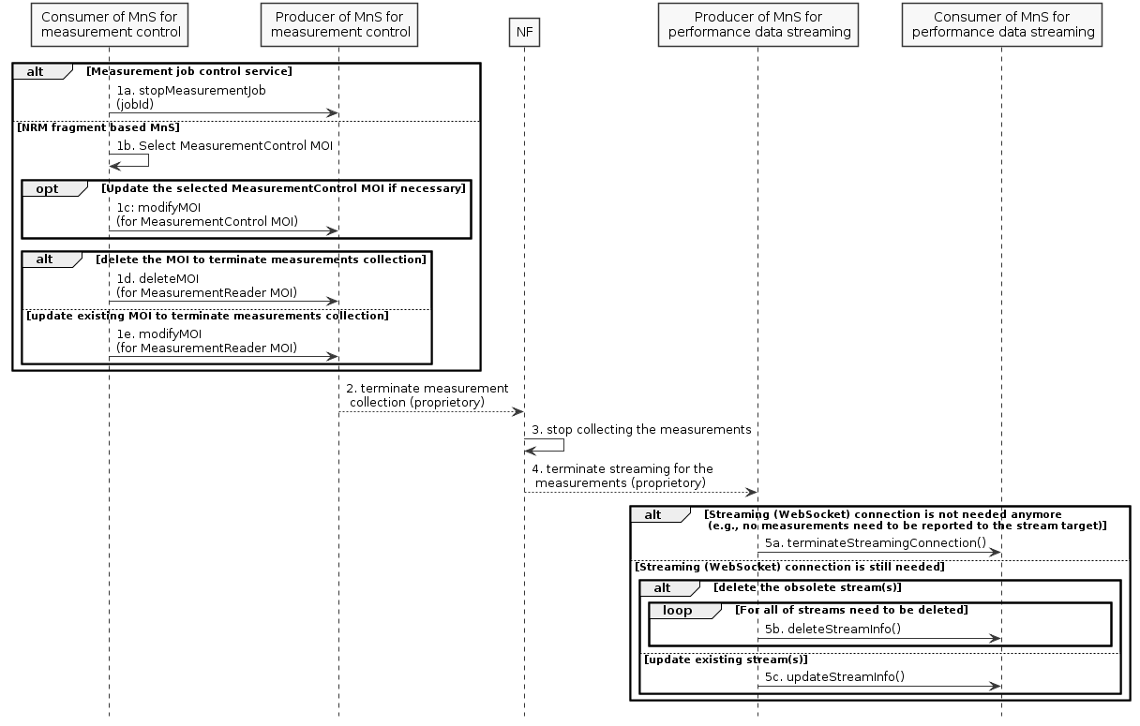
Figure D.x.1-1
1. The consumer of MnS for measurement control requests the MnS producer to stop the measurement collection by the following two alternatives:
1) by the measurement job control service
1a. The MnS consumer invokes the stopMeasurementJob operation towards the MnS producer;
2) by the NRM fragment-based measurement control service
1b. The MnS consumer selects the correct MeasurementControl MOI for terminating the measurement collection, as a system may have multiple MeasurementControl MOIs;
1c. If necessary, the MnS consumer modifies the MeasurementControl MOI by invoking the modifyMOI operation towards the MnS producer;
1d. The MnS consumer deletes an MeasurementReader MOI under the selected MeasurementControl MOI for terminating the measurements collection, by invoking the deleteMOI operation towards the MnS producer;
1e. The MnS consumer modifies an MeasurementReader MOI with deletion of the measurements that do not need to be collected anymore, by invoking the modifyMOI operation towards the MnS producer.
2. The producer of MnS for measurement control requests the NF to stop collecting the measurements. The mechanism of this step is vendor specific. If producer of MnS for measurement control is in the NF, this step can be skipped.
3. The NF stops collecting the measurements. This step is the internal behaviour of the NF.
4. The NF triggers the producer of MnS for performance data streaming to terminate streaming for the measurements. The mechanism of this step is vendor specific. If producer of MnS for performance data streaming is in the NF, this step can be skipped.
5. The producer of MnS for performance data streaming communicates with the consumer to:
5a. terminate the streaming (WebSocket) connection if no measurements need to be reported to the consumer anymore, by invoking the terminateStreamingConnection operation;
5b. delete the information for the stream(s) obsoleted due to the termination of the measruements collection if the streaming connection still needs to be retained, by invoking the deleteStreamInfo operation;
5c. update the information for the stream(s) partially affected by the termination of the measurements collection, by invoking the updateStreamInfo operation.

D.x.2 PlantUML codes
@startuml
skinparam shadowing false
skinparam monochrome true
hide footbox

participant "Consumer of MnS for\n measurement control" as MC
participant "Producer of MnS for\n measurement control" as MP
participant "NF" as NF
participant "Producer of MnS for\n performance data streaming" as SP
participant "Consumer of MnS for\n performance data streaming" as SC

alt Measurement job control service
MC -> MP : 1a. stopMeasurementJob\n(jobId)
else NRM fragment based MnS
MC –> MC: 1b. Select MeasurementControl MOI
Opt Update the selected MeasurementControl MOI if necessary
MC -> MP: 1c: modifyMOI\n(for MeasurementControl MOI)
end
alt delete the MOI to terminate measurements collection
MC -> MP : 1d. deleteMOI\n(for MeasurementReader MOI)
Else update existing MOI to terminate measurements collection
MC -> MP : 1e. modifyMOI\n(for MeasurementReader MOI)
end
end

MP --> NF: 2. terminate measurement\n collection (proprietory)

NF -> NF: 3. stop collecting the measurements
NF --> SP: 4. terminate streaming for the\n measurements (proprietory)
alt Streaming (WebSocket) connection is not needed anymore\n (e.g., no measurements need to be reported to the stream target)
SP->SC: 5a. terminateStreamingConnection()

else Streaming (WebSocket) connection is still needed
alt delete the obsolete stream(s)
loop For all of streams need to be deleted
SP->SC: 5b. deleteStreamInfo()
end
else update existing stream(s)
SP->SC: 5c. updateStreamInfo()
end
end

@enduml

End of Modified Sections

