3GPP TSG-SA5 Meeting #129-e S5-201129

Online, , 24th Feb 2020 - 4th Mar 2020
CR-Form-v12.0
CHANGE REQUEST
 | 28.530 | CR | 0017 | rev | - | Current version: | 16.1.0
For HELP on using this form: comprehensive instructions can be found at
http://www.3gpp.org/Change-Requests.

Proposed change affects: | UICC apps |  | ME |  | Radio Access Network | x | Core Network | x

Title: | Clarify NSI can be RAN resource only
Source to WG: | Ericsson Limited
Source to TSG: | S5
Work item code: | NETSLICE-PRO_NS |  |  |  |  |  | Date: |  |  | 2020-02-12
Category: | F |  |  |  |  |  | Release: |  |  | Rel-16
 | Use one of the following categories:  F (correction)  A (mirror corresponding to a change in an earlier release)  B (addition of feature),  C (functional modification of feature)  D (editorial modification)  Detailed explanations of the above categories can  be found in 3GPP TR 21.900. |  |  |  |  |  |  |  | Use one of the following releases:  Rel-8 (Release 8)  Rel-9 (Release 9)  Rel-10 (Release 10)  Rel-11 (Release 11)  Rel-12 (Release 12)  Rel-13 (Release 13)  Rel-14 (Release 14)  Rel-15 (Release 15)  Rel-16 (Release 16)
Reason for change: |  | The specification is not clear if a SA5 defined NSI can hold RAN resources only.
Summary of change: |  | Provide an example where the SA5 defined NSI can hold RAN resources only.
Consequences if not approved: |  | The specification remains ambiguous if SA5 defined NSI can or cannot hold RAN resources only.
Clauses affected: |  | 4.1.6
 |  | Y | N
Other specs |  |  | X | Other core specifications |  |  |  | TS/TR ... CR ...
affected: |  |  | X | Test specifications |  |  |  | TS/TR ... CR ...
(show related CRs) |  |  | x | O&M Specifications |  |  |  | TS/TR ... CR ...
Other comments:
This CR's revision history:

Start of modification

4.1.6 Network Slice as a Service (NSaaS)
Network Slice as a Service (NSaaS) can be offered by a CSP to its CSC in the form of a service. This service allows CSC to use the network slice instance as the end user or optionally allows CSC to manage the network slice instance as manager via management interface exposed by the CSP. In turn, these CSC can play the role of CSP and offer their own services (e.g. communication services) on top of the network slice instance obtained from the CSP. For example, a network slice customer can also play the role of NOP and could build their own network containing the network slice obtained from the CSP as a "building block". In this model, both CSP offering NSaaS and CSC consuming NSaaS have the knowledge of the existence of network slice instances. Depending on service offering, CSP offering NSaaS may impose limits on the NSaaS management capabilities exposure to the CSC, and the CSC can manage the network slice instance according to NSaaS management capabilities exposed and agreed upon limited level of management by the CSP.
The network slice instance can be realised by radio resources only, core resources only or a mixture of the two resource kinds. The NSaaS offered by the CSP could be characterized by certain properties (capabilities to satisfy service level requirements), e.g.
- radio access technology,
- bandwidth,
- end-to-end latency,
- reliability,
- guaranteed / non-guaranteed QoS,
- security level, etc.
Figure 4.1.6.1 illustrates some examples on how network slices can be utilized to deliver communication services, including Network Slice as a Service. For simplicity this figure omits the details of how NFs are being managed and does not show their groupings into NSSI:
a) A Network Slice as a Service is provided to CSC-A by CSP-A. Unlike the communication service delivered to end customers, in NSaaS, the offered service is the actual network slice.

b) NOP-A operates a network slice instance providing its CSP-A NSaaS (see the left stack of Figure 4.1.6.1 below)，NOP-B operates a network slice instance providing its CSP-B CS (see the right stack of Figure 4.1.6 below). The CSP-A NSaaS can be shared by (or offered to) multiple NOPs CSCs.CSC-A can use the network slice obtained from CSP-A to support own Communication Services or may add additional network functions to the obtained NSaaS and offer the resulting combination as a new network slice to CSP-B. In this case, CSC-A plays the role of NOP-B and builds his own network. The Network Slice obtained by CSC-A from CSP-A becomes a "building block" or an NSSI of CSC-A in its role of NOP-B. The NOP-B (a.k.a. CSC-A) combines this NSSI with other NSSIs and offers the new NSSI as Network Slice to CSP-B.
c) CSP-B can use the network slice obtained from CSC-A / NOP-B to deliver Communication Services to its end customers (as CSC-B).

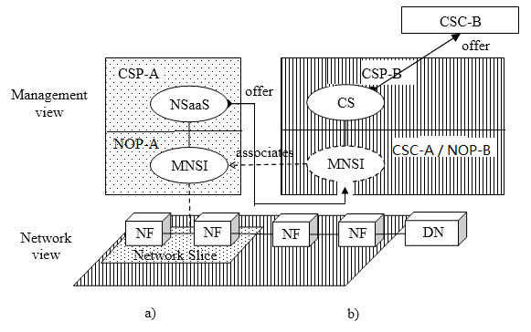
NSI
NSI
Figure 4.1.6.1: Examples of Network Slice as a Service being utilized to deliver communication services to end customers

End of modification

