



have the pleasure of inviting you to 3GPP SA5#106 in Kanazawa, Japan, from Monday 11 to Friday 15, April 2016

3GPPSA5#106 | 11-15 April 2016

3GPP SA5#106

Dear Delegates,

The Japanese Friends of 3GPP, Ericsson Japan, Fujitsu, Hitachi, Huawei Technologies Japan, KDDI, KYOCERA, MITSUBISHI ELECTRIC, NEC, Nokia Networks Japan, NTC, NTT DOCOMO, OKI, Panasonic, Qualcomm Japan, SHARP, SoftBank, and Sony Mobile Communications Japan have the pleasure of inviting you to the above-mentioned meeting.

The meeting will start on Monday at 9:00 and is expected to end on Friday at Chairman's discretion.

We look forward to seeing you all in Kanazawa.

Yours sincerely,
"Japanese Friends of 3GPP"

Meeting Registration
Please register for the meeting online via 3GPP website.
SA5#106 https://portal.etsi.org/webapp/MeetingCalendar/MeetingDetails.asp?m_id=31729

Meeting Venue
“Shiinoki Geihinkan” (Shiinoki Cultural Complex)
2-1-1 Hirosaka, Kanazawa Ishikawa 920-0962, Japan
TEL: +81-76-261-1111

English Page: http://www.shiinoki-geihinkan.jp/about/english.html

Meeting Rooms
 |  | Room
SA5#106 | Main | Garden Room
SA5#106 | Breakout | Seminar room A

Host Contacts
For any questions about the meeting, please contact our meeting coordinator.

ILCC Co., Ltd
Ms. Tomoko Sudo
E-mail: jf3wgs_sec@ilcc.com Tel: +81-3-5562-3665

Accommodation
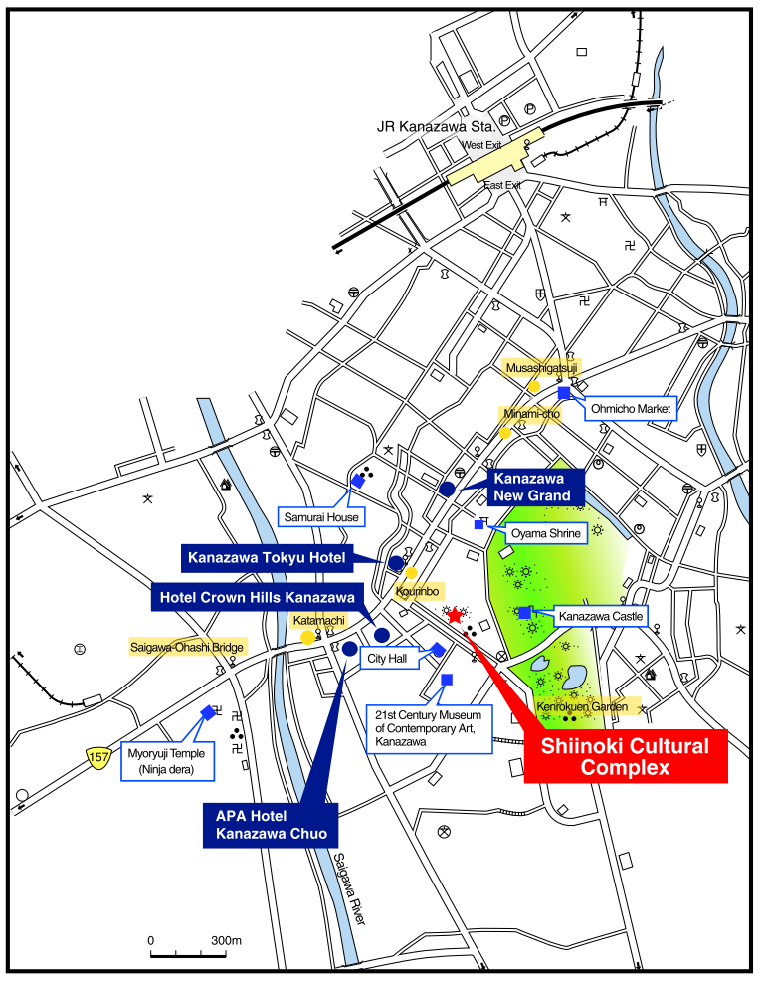
“Shiinoki Geihinkan”
JTB Global Marketing & Travel Inc. (JTB GMT) has been appointed the official travel agent for the meeting and will handle accommodation.

Block bookings have been arranged at the following hotels for the meetings. Note that the ‘Japanese Friends of 3GPP (JF3)’ is not responsible for reservation confirmations, cancelled or changed reservations or no-shows.

No. | Hotel Name  (Check-in & out time) | Room Type | Rate per night  Single Occupancy | 1) Address  2) Phone  3) Access to the airport  4) Access to the venue
1 | Kanazawa Tokyu Hotel  (14:00/12:00)  Complimentary internet access  (Wi-Fi) | Single Room  (18.7 m²) | 18,360 JPY  (Sun-Fri) | 1) 2-1-1 Korinbo, Kanazawa-shi  2) +81-76-231-2411  3) 10 min. from JR Kanazawa Sta. by car  4) 8 minutes’ walk to the venue
1 |  | Single Room  (18.7 m²) | 20,520 JPY  (Sat)
2 | Kanazawa New Grand Hotel  (14:00/11:00)  Complimentary internet access (LAN, cable NOT provided) | Single Room  (16 m²) | 12,000 JPY | 1) 4-1 Minamicho, Kanazawa-shi  2) +81-76-233-1311  3) 8 min. from JR Kanazawa Sta. by car  4) 10 minutes’ walk to the venue
2 |  | Double Room  (20 m²) | 16,000 JPY
3 | APA Hotel Kanazawa-Chuo  (15:00/11:00)  Complimentary internet access (LAN/Wi-Fi)  (LAN cable provided) | Single Room  (11.5 m²) | 9,000 JPY | 1) 1-5-24 Katamachi, Kanazawa-shi  2) +81-76-235-2111  3) 11 min. from JR Kanazawa Sta. by car  4) 8 minutes’ walk to the venue
3 |  | Twin Room  (16m²) | 11,000 JPY
4 | Hotel Crown Hills Kanazawa  (15:00/10:00)  Complimentary internet access  (Wi-Fi) | Single Room  (13m²) | 6,480 JPY | 1) 1-2-44 Katamachi, Kanazawa-shi  2) +81-76-261-3100  3) 12 min. from JR Kanazawa Sta. by car  4) 5 minutes’ walk to the venue
Note: Room rates include breakfast, service charge and an 8% consumption tax.
The above room rates are only applicable to reservations handled by JTB GMT. Please do NOT contact the hotels directly regarding your reservations and the above room rates – all enquiries and booking requests should be made directly to JTB GMT.

Online Reservation
Please access the URL below for online application operated by JTB Global Marketing & Travel Inc. (JTB GMT) to make your hotel reservations.

https://mice3.jtbgmt.com/3gpp2016april/

Application and Payment for Hotel
Participants wishing to reserve hotel accommodation should apply online no later than 12:00 (JST=UTC+9) 30 March, 2016.
Application should be accompanied by the details of your credit card to guarantee your reservation. No deposit will be charged to the credit card. Please pay all hotel expenses directly to the hotel. No reservation will be confirmed in the absence of your credit card details.

*Delegates are strongly advised to make their reservations as early as possible. Reservations will be accepted on a first-come, first-served basis.

Confirmation
Your reservation would be completed upon receipt of your credit card details.
The Confirmation button will be displayed when you complete your reservation.
Please print your confirmation slip by clicking the Confirmation button and bring it with you to the reception desk upon checking-in at the hotel.

Cancellation
In the event of cancellation, the following cancellation fees will be deducted before any refund is made.
Up to 10 days before the first night of stay -------------------------------------------------- None
9 to 2 days before ------------------------------------------------------ 20% of daily room charge
1 day before---------------------------------------------------------------80% of daily room charge
On the day of arrival or no notice given ------------------------- 100% of daily room charge
*Please revise and/or cancel your reservation by logging in to your Personal Page.

Inquiry Desk for Online Hotel Reservation
JTB Global Marketing & Travel Inc.
Convention Center (CR146986-042) Fax: +81-3-5495-0685
2-3-11 Higashi-Shinagawa, Shinagawa-ku, Phone: +81-3-5796-5445
Tokyo 140-8604 Japan E-mail: 3gpp2016april@gmt.jtb.jp
Office hours: 10:00 – 17:30
Except Saturdays, Sundays and National Holidays
*New Year holidays in Japan start from 28 December and last till 4 January.

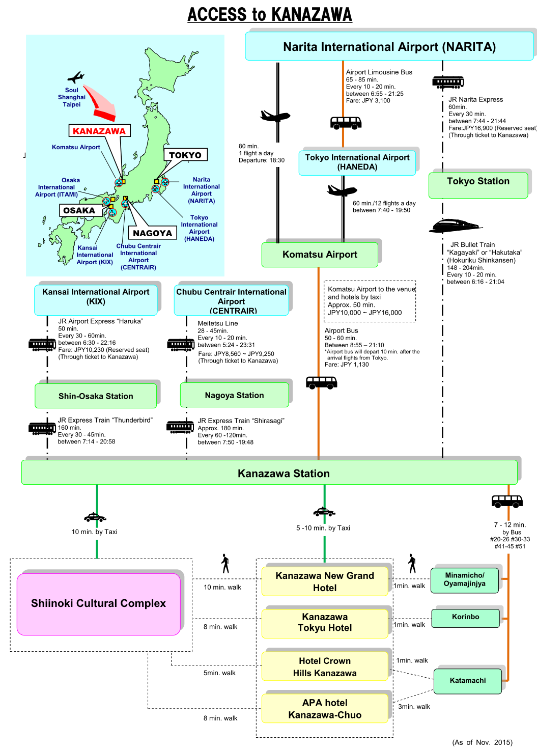
Shiinoki Geihinkan
Transportation to the Venue
“Shiinoki Geihinkan” (Shiinoki Cultural Complex) (meeting venue) is located approx. 2.5 kilometers (4 miles) away from JR Kanazawa Station.

From JR Kanazawa Station
①Take buses departing from bus stops Nos.7-10 of the East Exit Bus Terminal . Get off at “Korinbo” (10- min. ride). Walk 5 min.
②Take a taxi from East Exit taxi stand (10-min ride).

There are several ways to access JR Kanazawa Station.

1) From Narita International Airport (Narita)
The most convenient way to access JR Kanazawa Station is to take Hokuriku Shinkansen (JR Bullet Train) from Tokyo Station. To reach Tokyo Station, take JR Narita Express. Narita Express is operated every 30 minutes and Hokuriku Shinkansen is operated every 10-20 minutes. Both trains are operated by Japan Railway Company (JR) and you can buy through ticket to take both trains.

There are other ways to reach Kanazawa Station, such as taking an airport bus from Komatsu Airport, a domestic airport.
a) Take Airport Limousine Bus to Haneda Airport, and fly by domestic flight to Komatsu Airport.(*/**)
b) Take a connected flight from Narita Airport to Komatsu Airport (1 flight per day).

2) From Kansai International Airport (KIX)
From KIX, access Shin-Osaka Station by JR Airport Express “Haruka”, change to JR Express Train “Thunderbird” and get off at JR Kanazawa Station. Airport Express “Haruka” is operated every 30-60 minutes and JR Express Train “Thunderbird” is operated every 30-45 minutes. Both trains are operated by Japan Railway Company (JR) and you can buy through ticket to take both trains.

3) From Chubu Centrair International Airport (Centrair)
From Centrair, access Nagoya Station by Kintetsu Line, change to JR Express Train “Shirasagi” and get off at JR Kanazawa Station, a terminal station. Kintetsu Line is operated every 10-20 minutes, and JR Express Train “Shirasagi” every 60-120 minutes. Both trains are operated by Japan Railway Company (JR) and you can buy through ticket to take both trains.

For information on local buses from Kanazawa Station, refer to;
Hokuriku Railroad Co., Ltd. http://www.hokutetsu.co.jp/en/en_round

Note:
* There is a limited number of international flights to Komatsu Airport directly from Seoul, Shanghai and Taipei.
** Japanese and several foreign airlines provide flights to Haneda Airport from hub-airports.
Visa Request
To find out whether you need a visa for entry to Japan, please consult http://www.mofa.go.jp/j_info/visit/visa/faq.html#q1-1 and click the link "the List of Countries and Regions That Have Visa Exemption Arrangements with Japan" in the Q&A No.1. The list shows "Arrangements of Exemption of Visas". If your home country’s name is not shown on the list, you need a visa.

If you need a visa, please fill out the attached invitation letter request form (Annex 1) and send it to visa1@ttc.or.jp by 12:00 (JST=UTC+9), 26 February 2016

For any questions, please contact visa1@ttc.or.jp (attn. Mobile WGs secretary in TTC).
For members in a company who are in the same office facility, it is suggested that you make your requests as a group, if possible.

If you prefer, you can obtain a public key for e-mail encryption simply by sending an e-mail to visa1@ttc.or.jp with the subject "Public Key request" BEFORE sending your personal information in an attachment.

WLAN
Wireless LAN (802.11 g/b) is available in the meeting rooms.

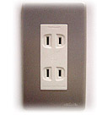
Voltage
100V/60Hz. Japanese plugs are two flat pin type (A-type) plugs. Please make sure you have correct adapters. Voltage converters or adapters will NOT be provided at the meetings.
Please bring your voltage converters and plug adapters! (100 volts/60hertz)

Currency
Yen (\) http://finance.yahoo.com/currency?u
ATTENTION!!
Credit cards can be taken at hotels in Kanazawa, but not at some restaurants, taxis, and small shops.

Time Zone
JST=UTC +9 hours

GSM / W-CDMA/LTE coverage
Only W-CDMA and/or LTE are available. For availability of GSM chip-roaming, please check with your operator. cdma2000 and/or LTE are also available in the area.

Weather
http://www.jma.go.jp/en/yoho/209.html

Sightseeing
Japan National Tourism Organization : http://www.jnto.go.jp/eng/
Kanazawa Travel Guide: http://www.kanazawa-tourism.com/
(ANNEX 1)
Visa support letter application form

Please fill in the form below and e-mail it to visa1@ttc.or.jp by 12:00 (JST=UTC+9), 26 February 2016.
(Note: you can obtain a public key for e-mail encryption simply by sending an e-mail to visa1@ttc.or.jp with the subject "Public Key request" BEFORE sending your personal information in an attachment.)

Given name (First name) | alphabetical
Given name (Last name) | alphabetical
Date of Birth (dd/mm/yy)
Gender (Male/Female)
Nationality
Valid passport number
Passport Valid until (dd/mm/yy)
Address (Home Country)
Occupation and Job title
Name of Company/Organization
Company/Organization mailing address |  | Address
 |  | Postal Code
 |  | Country
Telephone number |  |  | +
Fax number |  |  | +
Email address
Schedule for your stay |  |  | Please fill in your itinerary below

Itinerary (refer to examples shown in the table.)
D/M/Y | Schedule | Address and Phone number to reach | Hotel
ex) 10/ April/ 2016 | Arrival from Paris to Narita Airport, Flight xxx | *1 | *1
ex) 11-15/ April / 2016 | Attending SA5#106 meeting | *1 | *1
ex) 16/ April / 2016 | Departure from Narita Airport to Paris, Flight xxx
Fill in your Itinerary below
*1 Kanazawa Tokyu Hotel:
Address 2-1-1 Korinbo, Kanazawa-shi
Phone: +81-76-231-2411
Fax: +81-76-263-0154

