3GPP TSG-SA4 Meeting #134 S4-252103

Dallas, United States, 17th Nov 2025 - 21st Nov 2025 revision of S4-251818
CR-Form-v12.4
CHANGE REQUEST
 | 26.942 | CR | 0008 | rev | 3 | Current version: | 19.0.0
For HELP on using this form: comprehensive instructions can be found at
https://www.3gpp.org/Change-Requests.

Proposed change affects: | UICC apps |  | ME | x | Radio Access Network |  | Core Network | x

Title: | [FS_Energy_Ph2_MED]: Solution for KI1 for collecting and reporting an Energy of Service Metric to authorized 3rd parties
Source to WG: | InterDigital France R&D, SAS
Source to TSG: | S4
Work item code: | FS_Energy_Ph2_MED |  |  |  |  |  | Date: |  |  | 2025-11-10
Category: | B |  |  |  |  |  | Release: |  |  | Rel-19
 | Use one of the following categories:  F (correction)  A (mirror corresponding to a change in an earlier release)  B (addition of feature),  C (functional modification of feature)  D (editorial modification)  Detailed explanations of the above categories can  be found in 3GPP TR 21.900. |  |  |  |  |  |  |  | Use one of the following releases:  Rel-8 (Release 8)  Rel-9 (Release 9)  Rel-10 (Release 10)  Rel-11 (Release 11)  …  Rel-17 (Release 17)  Rel-18 (Release 18)  Rel-19 (Release 19)  Rel-20 (Release 20)
Reason for change: |  | TBD
Summary of change: |  | TBD
Consequences if not approved: |  | No collection and reporting mechanisms for Energy-related information
Clauses affected:
 |  | Y | N
Other specs |  |  | x | Other core specifications |  |  |  | TS/TR ... CR ...
affected: |  |  | x | Test specifications |  |  |  | TS/TR ... CR ...
(show related CRs) |  |  | x | O&M Specifications |  |  |  | TS/TR ... CR ...
Other comments:
This CR's revision history: |  | Revision of S4aI250197  Revision of S4-251818

1ST Change
…
[88] 3GPP TS 26.510: "Media delivery; interactions and APIs for provisioning and media session handling".
[89] 3GPP TS 26.531: "Data Collection and Reporting".
2nd Change

7.1 Mapping of Solutions to Key Issues
Table 7.1-1: Mapping of solutions to Key Issues
Solutions
 | KI#1 | KI#2 | KI#3 | KI#4
#1 |  |  | X
#2 |  |  | X
#3 |  | X
#4 | X
#5 | X
#6 | X | X
#7 | X
#8 |  | X
#9 | X
#10 | X |  |  | X
#11 | X |  |  | X
#12 | X |  |  | X

(All new text)

7.11 Solution #10: Media Application Service Energy Metrics Reporting Configuration

7.11.1 Key Issue mapping
This Candidate Solution addresses Key Issue #1 described in clause 6.2and Key Issue #4.

7.11.2 Functional description

7.11.2.1 Introduction
This Candidate Solution ddresses the definition of the Energy Information Exposure Specification of the solution #7 in clause 7.8 by proposing to reuse the existing 3GPP Metrics Reporting configuration and extend it for reporting some Media-Application-Service-Energy metrics.
Similar to QoE metrics, the new Media-Application-Service-Energy metrics are defined in the context of the Metrics Reporting provisioning feature at reference point M1 (see [88]). The Metrics Reporting Configurations provided by the Media Application Provider determines what energy-related information associated with a downlink or uplink direction is to be collected and reported (to the instances listed) by the UE, Application Server and the Core Network, and how often . The Media Application Provider shall use the operations specified in clause 5.2.11 of [88].

7.11.2.2 Metrics Reporting Configuration: extensions for Media-Application-Service-Energy
Up to and including Release 19, the Metrics Reporting Configuration resource defined in TS 26.501 [26501] is limited to configuring the reporting of Quality of Experience (QoE) metrics. This clause specifies extensions enabling Energy-related reporting in addition to QoE in table 7.5.2.2-1. Consequently, the scope of the Metrics Reporting Configuration is extended to cover either QoE metrics reporting or EoS metrics reporting.
Table 7.11.2.2-1: Baseline EoS Metrics Reporting Configuration parameters
Abstract element | Semantics / constraints (abstract)
Metrics scheme | Three additional EoS schemes are defined:  - carbon intensity; for which metrics are reported in $g CO_{2}$-e / $Wh$  - energy consumption for which metrics are reported in $Wh$  - power consumption, for which metrics are reported in. $W$.  The Media Application Provider may provision any number of the above metrics schemes, each with the separate set of Metrics Reporting Configuration parameters.  All three schemes indicate that the metrics to be collected and reported pertain to energy-related information reporting and determine the format of the Energy-Related metrics report submitted by the Energy Information Collector for the UE energy information, by the EIF for the Core Network energy information and by the Media AS for the Application Server energy information. (See clauses 7.5.2.2.1 and 7.5.2.2.2 for architecture mapping proposal.)
Reporting scope | Scope of EoS metrics to be collected and reported:  - For each media delivery session, the sum of the energy metric value of all the components of the session during the sampling period.  - For each media delivery session, the energy metric value of all the components of the session or only the ones of content type given by the element “component content type” below,  - Aggregated energy metric value across all the active sample media delivery sessions.
Component content types filter | MIME content types (e.g., video/mp4) used to filter components included in per‑component reporting (NOTE 2).
Contribution ratio flag | If true, include contribution ratio information across UE, RAN, and CN in the report.
Metrics to be reported | A controlled vocabulary of EoS energy metrics to be reported. All three EoS schemes indicated by Metrics scheme share the same controlled vocabulary of metrics.
NOTE 1: When the metrics scheme of the Metrics Reporting Configuration indicates a QoE metrics scheme, behaviour remains as specified in Release 19; the EoS specific constraints above do not apply.
NOTE 2: The applicability of the Component content types filter to any metrics reporting scheme, not just energy-related ones, is for further study.

7.11.2 Procedures
Procedures for handling Energy-of media application service Metrics Reporting Configuration are proposed in clause 7.12.3 and 7.13.3.
(All new text)

7.12 Solution #11: Media-Application-Service-Energy metrics collection and reporting using existing reference points

7.12.1 Key Issue mapping
This Candidate Solution addresses Key Issue #1.described in clause 6.2 and Key Issue #4.

7.12.2 Functional description

7.12.2.1 Introduction
In line with [PR 1-1] of TR 26.942, this Candidate Solution to Key Issue #1intends to reuse existing 3GPP mechanisms for reporting Media-Application-Service-Energy Metrics after provisioning the Metrics Reporting Configuration of solution #10 provided by the Media Application Provider.

7.12.2.2 Architecture mapping
The approach combines the metrics reporting architecture of Release 19, a part of the architecture for collection and exposure of energy (see clause 7.6.2.2) and an additional reference point E4 to expose Energy-of-media Service reports to Data Collection AF.
Figure 7.12.2.2-1 illustrates how the approach could be instantiated.

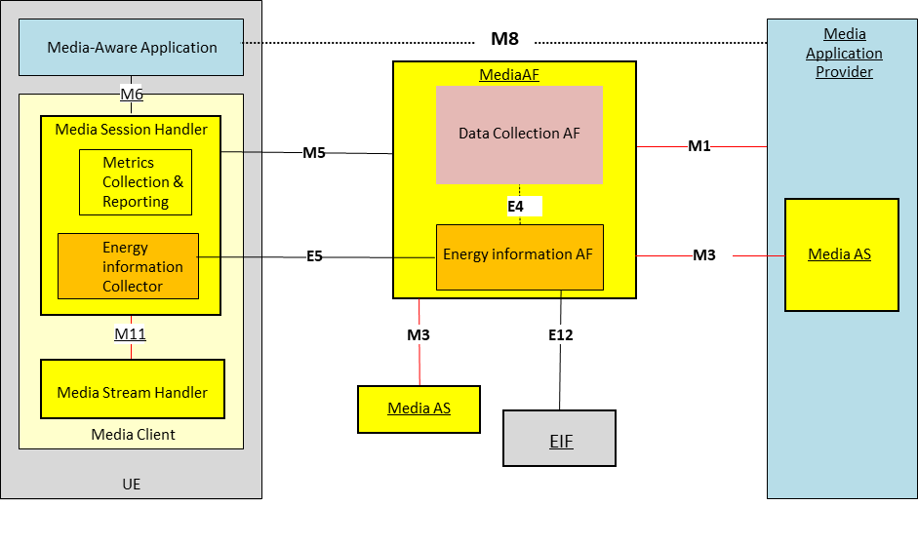
Figure 7.12.2.2-1: Metrics reporting feature in the Release 19 Metrics Reporting architecture updated with the generic reference architecture for collection and exposure of energy-related information (clause 7.6.2.2)
The following reference points are involved in the proposed approach Metrics Reporting:
M1 Network API used by the Media Application Provider to provision the Media-Application-Service-Energy Metrics Reporting Configuration to the Media AF. This determines whether and which energy-related information submitted by the Media Session Handler for the UE, the Media AS and the EIF for the Core Network. The Energy Information AF collects the Energy-related information and creates Energy-related information reports as it is in the Release 19 architecture.
E12 This reference point is used by the EIF to provide Energy-related information reports to the Energy Information AF instantiated in the Media AF. The Energy Information AF receives the information and creates the report aligned with the Media-Application-Service-Energy scheme of the configuration.
M3 After provisioning of Metrics Reporting in the Media AF and the configuration of Content Hosting in the Media AS, the Media AS obtains a client metrics reporting configuration embedded in the Service Access Information. Based on this configuration, the Media AS collects Media-Application-Service-Energy metrics, creates metrics reports aligned with the Media-Application-Service-Energy scheme of the configuration, and uses this reference point to transmit metrics reports to the Media AF which are passed to the Energy Information AF instantiated in the Media AF.
M5 Network API used by the Media Session Handler to obtain an Media-Application-Service-Energy Metrics Reporting configuration from the Media AF. The configuration information is embedded in Service Access Information.
E5 Network API used by the Energy Information Collector in the UE to subscribe to and receive Network Energy Information from the Energy Information Media AF. Network Energy Information exposed to the Energy Information Collector relates to a specific Application Service Provider. In particular, this API allows the UE to receive reports aligned with the Media-Application-Service-Energy scheme of the configuration from the Energy Information AF and propagate them to the Media-aware Application (via reference point M6) and, optionally, to the Media Application Provider (via reference point M8).
E4 Network API used by the Data Collection AF instantiated in the Media AF to subscribe to and receive Network Energy Information from the Energy Information AF instantiated in the Media AF. Network Energy Information exposed to the Data Collection AF relates to a specific Application Service Provider. In particular, this API allows the Data Collection AF to receive the reports aligned with the Media-Application-Service-Energy scheme of the configuration from the Energy Information AF instantiated in the Media AF, and to expose them to event consumers via reference points R5 and/or R6 (not illustrated) (see TS 26.531 specification).
M6 Client API used by the Media-aware Application to subscribe to the Media-Application-Service-Energy Metrics notifications from the Energy Information Collector, instantiated in the Media Session Handler.

7.12.3 Procedures
Figure 7.12.3-1 below details the different steps for Media-Application-Service-Energy Metrics Reporting for the Approach in the system outlined in clause 7.12.2.2 (based on figure 5.5.3-1 of TS 26.501 [26501] but updated to generalise).
The step 1 of the sequence is based on the solution #10 in clause 7.11.

Figure 7.12.3-1: Procedures for Energy-of media-Service collection and reporting
The steps of the call flow are as follows:
1: The Media AF is provisioned with the Media-Application-Service-Energy Metrics Reporting configuration by the Media Application Provider, each pertaining to metrics collection by the Media Player and the EIF and the Media AS functions. The configuration is transmitted to the Energy Information AF to collect and generate the metrics reports regarding required post-processing functionality and deliver to the Media Application Provider. The Energy Information AF subscribe to the EIF network function to get the Energy-related information from the Core Network.
2: The Media-Aware Application triggers the Service Announcement and Content Discovery procedure. The Service Announcement includes the whole Service Access Information that contains metric configuration information for Media-Application-Service-Energy scheme.
3: Time passes until the UE initiates session establishment and media playback.
4: The Media-Aware Application informs the Media Player of impending media playback.
5: The Media Session Handler requests the establishment of a streaming session with the Media AF which confirms the streaming session establishment.
6: Media playback pipeline is set up between the Media Player, the Media AS and the Application Provider.
7: The Service Access Information is retrieved by the Media AS to get the Media-Application-Service-Energy Metrics Reporting configuration.
8: The Service Access Information is retrieved by the Media Session Handler to get the Media-Application-Service-Energy Metrics Reporting configuration.
9: The Media Session Handler queries the Media Player on its capability to perform metrics collection (measurement and logging function) in accordance with Media-Application-Service-Energy scheme as defined by its Metrics Reporting configuration. At this step it is checked if the Media player can support the reporting of Media-Application-Service-Energy metric.
10: The Media Player acknowledges its support for the collection of the required metric of the configured scheme.
11: The Media Player notifies the Media Session Handler of the start of media playback, causing the Media Session Handler to initialize and begin countdown of separate metrics reporting interval timers for the Media-Application-Service-Energy scheme.
During the course of media playback, steps 12–28 below may be repeated, depending on the duration of the playback and the frequency of metrics reporting as set by the metrics configuration for the Media-Application-Service-Energy scheme.
12: Causing the Media AS to initialize and begin countdown of Media-Application-Service-Energy metrics reporting interval timer for Media-Application-Service-Energy scheme.
13: Causing the Media Session Handler to initialize and begin countdown of Media-Application-Service-Energy metrics reporting interval timer for Media-Application-Service-Energy scheme.
14: The Media Player fetches media content from the Media AS and begins media playback.
15: Upon expiration of the timer (associated with the Media-Application-Service-Energy scheme), the Media AS retrieves the logged metrics according to scheme.
16: The Media AS reports the logged metrics to the Media AF and subsequently to the Energy Information AF sub-entity.
17: The Energy Information AF processes the information according to the Media-Application-Service-Energy scheme
18:The timer associated with the Media-Application-Service-Energy scheme expires.
19: The Media Session Handler retrieves the energy metrics from the Media Player according to Media-Application-Service-Energy scheme.
20: In accordance with its metrics reporting configuration as provisioned in step 1, a metrics report for Media-Application-Service-Energy scheme is sent from the Media Session Handler to the Energy Information Collector.
21: The Energy Information Collector processes the information according to the Media-Application-Service-Energy scheme
22: The EIF network function of the Core Network publishes the Energy related Information to the Energy Information AF sub-entity.
23: The Energy Information AF publishes the final Media-Application-Service-Energy Metric reports to the Media Application Provider.
24: Optionally, the Energy Information AF publishes the final Media-Application-Service-Energy Metric reports to the UE Energy Information Collector via reference point E5 reference point to allow the UE to report to the Application.
25: Optionally, the Energy Information Collector aggregates the Media-Application-Service-Energy Metric reports of the Media Client and the ones received from the Energy Information AF and publishes the final Media-Application-Service-Energy Metrics reports to the Application at M6 reference point.
26: Optionally, the Application publishes the final Media-Application-Service-Energy Metric reports to the Media Application Provider at M8 reference point
27: Optionally, the Energy Information AF publishes the final Media-Application-Service-Energy Metric reports to the Data Collection AF at E4 reference point to allow the existing Data Collection function to expose the Media-Application-Service-Energy Metrics reports as it is in the release 19.
28: Optionally, the Data Collection AF at R6 reference point exposes the Media-Application-Service-Energy Metrics reports to the Event Consumer AF as it is in the release 19.

Upon the termination of media playback (as notified by the Media-Aware Application to the Media Player) a final round of metrics collection and reporting is performed.

7.12.4 Impacts on existing services, entities and interfaces

7.12.4.1 Media AF
The Media AF would be required to support a Media-Application-Service-Energy Metrics Reporting Configuration as part of the Metrics Reporting Configuration.

7.12.4.2 Energy Information AF
The Energy Information AF is instantiated as a subfunction of the Media AF to collect energy-related information per application, per media session, and per media component, at multiple granularities and across CN and AS domains at reference points M3, and E12. For UE, partial energy-related information is retrieved from the EIF network function at reference point E12.
Collected information can be reported by the existing mechanisms of the Release 19 architecture.
Collected information can be reported to the UE Energy Information Collector instantiated within the Media Session Handler at reference point E5 to be propagated to the Media-aware Application at reference point M6 and, optionally, to the Media Application Provider at reference point M8.
Collected information can be reported to a Data Collection AF instantiated within the Media AF via the reference point E4 prior to exposure to authorized third parties at reference point R6, privacy-preserving post-processing being applied.

7.12.4.3 Reference point M1
A reference point M1, the Media Application Provider shall instantiate a Metrics Reporting Configuration resource associated with the target Provisioning Session to enable Media-Application-Service-Energy- collection and reporting.
(All new text)

7.13 Solution #12: Media-Application-Service-Energy metrics collection and reporting using new reference points

7.13.1 Key Issue mapping
This Candidate Solution addresses Key Issue #1 described in clause 6.2 and Key Issue #4.
.

7.13.2 Functional description

7.13.2.1 Introduction
At the difference of the solution #11, this solution is based on the architecture for collection and exposure of energy (see clause 7.6.2.2) for Media-Application-Service-Energy metrics reporting at the exception of the M1 reference point for provisioning the Media-Application-Service-Energy Metrics Reporting configuration of solution #10 to keep existing mechanism for the Media Application Provider.
Figure 7.13.2.1-1 illustrates how the approach could be instantiated.

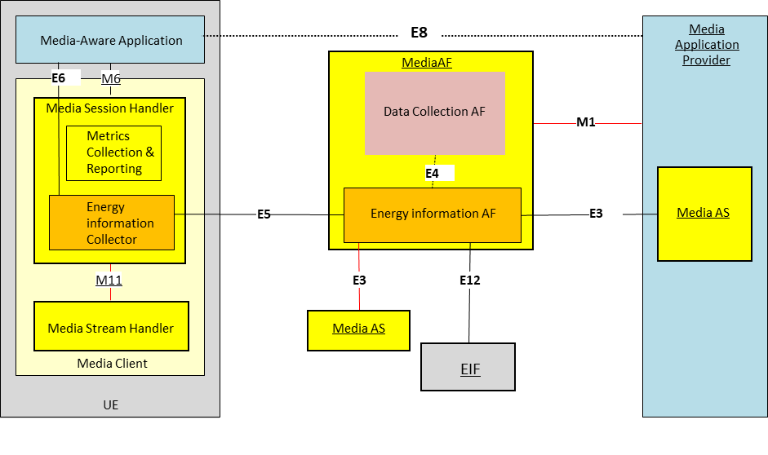
Figure 7.13.2.1-1: Metrics reporting feature with the overall generic reference architecture for collection and exposure of energy-related information (clause 7.6.2.2)
The following reference points are involved in the proposed EoS Metrics Reporting approach:
M1 Network API used by the Media Application Provider to provision the Media-Application-Service-Energy Metrics Reporting Configuration to the Media AF. This determines whether and which energy-related information submitted by the Energy information Collector for the UE, the Media AS and the EIF for the Core Network. The Energy Information AF instantiated in the Media AF collects the Energy-related information and creates Energy related information reports as it is in the Release 19 architecture.
NOTE: For backward compatibility of Metrics Reporting configuration provisioning, M1 is involved and the use of the reference point E1 is FFS.
E12 This reference point is used by the EIF to provide Energy-related information reports to the Energy Information AF instantiated in the Media AF. The Energy Information AF receives the information and creates the report aligned with the Media-Application-Service-Energy scheme of the configuration.
E3 After provisioning of Metrics Reporting in the Media AF and the configuration of Content Hosting in the Media AS, the Media-Application-Service-Energy Metrics Reporting configuration is obtained by the Media AS from the Energy information AF instantiated in the Media AF. Based on this configuration, the Media AS collects Media-Application-Service-Energy metrics, creates metrics reports aligned with the Media-Application-Service-Energy scheme of the configuration and uses this reference point to transmit the report to the Energy Information AF instantiated in the Media AF.
E5 Network API used by the UE Energy Information Collector instantiated in the Media Session Handler to obtain a Media-Application-Service-Energy Metrics Reporting configuration from the Energy Information AF. The Energy Information Collector fetches the collected Media-Application-Service-Energy metrics, creates the metrics report aligned with the Media-Application-Service-Energy scheme of the configuration. This API also allows the UE Energy Information Collector to receive the aggregated reports aligned with the Media-Application-Service-Energy scheme of the configuration from the Energy Information AF and propagate to the Media-aware application (via reference point E6) and optionally, to the Media Application Provider (via reference point E8).
E4 Network API used by the Data Collection in AF to subscribe to and receive Network Energy Information from the Energy Information AF. Network Energy Information exposed to the Data collection relates to a specific Application Service Provider. In particular, this API allows the Data Collection AF instantiated in the Media AF to receive the aggregated reports aligned with the Media-Application-Service-Energy scheme of the configuration from the Energy Information AF, and to expose them to event consumers via reference points R6 (not illustrated) (see TS 26.531 specification).
E6 Client API used by the Media-aware Application to subscribe to energy-related information notifications from the Energy Information Collector.
E8 Network API used by the Media Application Provider to receive Media-Application-Service-Energy reports from the Media-aware Application.

7.13.3 Procedures
Figure 7.13.3-1 below details the different steps for Media-Application-Service-Energy Metrics Reporting for the Approach in the system outlined in clause 7.13.2.1 (based on figure 5.5.3-1 of TS 26.501 [26501] but updated to generalise).
The step 1 of the sequence is based on the solution #10 in clause 7.11.

Figure 7.13.3-1: Procedures for Energy-of Service collection and reporting
The steps of the call flow are as follows:
1: The Media AF is provisioned with the Media-Application-Service-Energy Metrics Reporting configuration by the Media Application Provider, each pertaining to metrics collection by the Media Player and the EIF and the Media AS functions. The configuration is transmitted to the Energy Information AF to collect and generate the metrics reports regarding required post-processing functionality and deliver to the Media Application Provider. The Energy Information AF subscribe to the EIF network function to get the Energy-related information from the Core Network.

2: The Media-Aware Application triggers the Service Announcement and Content Discovery procedure. The Service Announcement includes the whole Service Access Information that contains metric configuration information for Media-Application-Service-Energy scheme
3: Time passes until the UE initiates session establishment and media playback.
4: The Media-Aware Application informs the Media Player of impending media playback.
5: The Media Session Handler requests the establishment of a streaming session with the Media AF which confirms the streaming session establishment.
6: Media playback pipeline is set up between the Media Player, the Media AS and the Application Provider.
7: The Service Access Information is retrieved by the Media AS to get the Media-Application-Service-Energy Metrics Reporting configuration.
8: The Media AS is notified of the Media-Application-Service-Energy Metrics Reporting configuration from the Energy Information AF via reference point E3.
9: The Service Access Information is retrieved by the Media Session Handler to get the Media-Application-Service-Energy Metrics Reporting configuration.
10: The Energy Information Collector is notified of the Media-Application-Service-Energy Metrics Reporting configuration from the Energy Information AF via reference point E5.
11: The Energy Information Collector queries the Media Player on its capability to perform metrics collection in accordance with Media-Application-Service-Energy scheme as defined by its Metrics Reporting configuration. At this step it is checked if the Media Player can support the reporting of Media-Application-Service-Energy metric.
12: The Media Player acknowledges its support for the collection of the required metric of the configured scheme.
13: The Media Player notifies the Media Session Handler of the start of media playback, causing the Media Session Handler to initialize and begin countdown of separate metrics reporting interval timers for the Media-Application-Service-Energy scheme.
During the course of media playback, steps 14–29 below may be repeated, depending on the duration of the playback and the frequency of metrics reporting as set by the metrics configuration for the Media-Application-Service-Energy scheme.
14: Causing the Media AS to initialize and begin countdown of Media-Application-Service-Energy metrics reporting interval timer for Media-Application-Service-Energy scheme.
15: Causing the Energy Information Collector to initialize and begin countdown of Media-Application-Service-Energy metrics reporting interval timer for Media-Application-Service-Energy scheme.
16: The Media Player fetches media content from the Media AS and begins media playback.
17: Upon expiration of the timer (associated with the Media-Application-Service-Energy scheme), the Media AS retrieves the logged metrics according to scheme.
18: The Media AS reports the logged metrics to the Energy Information AF.
19: The Energy Information AF processes the information according to the Media-Application-Service-Energy scheme.
20-21: Upon expiration of the timer (associated with the Media-Application-Service-Energy scheme), the UE Energy Information Collector retrieves the energy metrics from the Media Player according to Media-Application-Service-Energy scheme.
22: The Energy Information Collector processes the information according to the Media-Application-Service-Energy scheme
23: The EIF network function of the Core Network publishes the Energy related Information to the Energy Information AF sub-entity.
24: The Energy Information AF publishes the final Media-Application-Service-Energy Metric reports to the Media Application Provider.
25: Optionally, the Energy Information AF publishes the final Media-Application-Service-Energy Metric reports to the UE Energy Information Collector at reference point E5 reference point to allow the UE to report to the Application.
26: Optionally, the Energy Information Collector aggregates the Media-Application-Service-Energy Metric reports of the Media Client and the ones received from the Energy Information AF and publishes the final Media-Application-Service-Energy Metric reports to the Application at E6 reference point.
27: Optionally, the Application publishes the final Media-Application-Service-Energy Metric reports to the Media Application Provider at E8 reference point
28: Optionally, the Energy Information AF publishes the final Media-Application-Service-Energy Metric reports to the AF Data Collection AF at E4 reference point to allow the existing Data Collection function to expose the Media-Application-Service-Energy information as it is in the release 19.
29: Optionally, the Data Collection AF at R6 reference point exposes the Media-Application-Service-Energy Metrics reports to the Event Consumer AF as it is in the release 19.

Upon the termination of media playback (as notified by the Media-Aware Application to the Media Player) a final round of metrics collection and reporting is performed.

7.13.4 Impacts on existing services, entities and interfaces

7.13.4.1 Media AF
The Media AF would be required to support an Media-Application-Service-Energy Metrics Reporting Configuration as part of the Metrics Reporting Configuration.

7.13.4.2 Energy Information AF
The Energy Information AF is instantiated as a subfunction of the Media AF to collect energy-related information per application, per media session, and per media component, at multiple granularities and across CN and AS domains at reference points E3 and E12.
Collected information can be reported by the existing mechanisms of the Release 19 architecture.
Collected information can be reported to the UE Energy Information Collector instantiated within the Media Session Handler at reference point E5 to be propagated to the Media-aware Application at reference point E6 and, optionally, to the Media Application Provider at reference point E8.
Collected information can be reported to a Data Collection AF instantiated within the Media AF via the reference point E4 prior to exposure to authorized third parties at reference point R6, privacy-preserving post-processing being applied.

7.13.4.3 Reference point M1
At reference point M1, the Media Application Provider shall instantiate a Metrics Reporting Configuration resource associated with the target Provisioning Session to enable Media-Application-Service-Energy- collection and reporting.
End of changes

