3GPP TSG-SA WG4 Meeting #133-eS4-251289

Online, 18 – 25 July 2025

**Source: InterDigital, Samsung, Sony Group Corporation, Nokia, Philips, Deutsche Telekom, Fraunhofer HHI, KDDI, Huawei**

**Title: pCR on corrections and completion in clause 7 for scenario 2**

**Spec: 3GPP TR 26.956 1.0.0**

**Agenda item: 9.6**

**Document for: Agreement**

**1. Introduction**

This pCR provides missing information, corrections and update of references in clause 7 for scenario 2.

**2. Reason for Change**

Provided information and corrections are essential for the completion of the TR.

**3. Proposal**

It is proposed to agree the following changes to 3GPP TR 26.956.

* * * First Change * * * *

<Add the following text at the end of clause 7.3.2, remainder of 7.3.2 is unchanged.>

### 7.3.2 Motivation for the scenario

…

3GPP provides a study on 6G use cases and services requirements in TR 22.870 [Vol-36]. Clause 9.12 of this report describes a use case on personalized interactive immersive guided tour, where a dance performance represented as volumetric video is part of the scene. More details can be found in figure 9.12.1-1 and in the service flow description in the referenced technical report.

* * * Next Change * * * *

<Modify clause 7.3.3 as follows, text before B is unchanged.>

### 7.3.3 Description of the scenario

…

1. *Encoding*

Volumetric video can be represented in the representation format dense dynamic point clouds. MPEG has developed a specification named V-PCC for compressing and delivering the representation format dense dynamic point clouds at bitrates enabling consumer applications. V-PCC is standardized in ISO/IEC 23090-5 Visual Volumetric Video-based Coding (V3C) and Video-based Point Cloud Compression (V-PCC) [Vol-11].

During its experimentation with V-PCC KDDI implemented a real time V-PCC encoder [Vol-1].

The following figure shows the V-PCC encoder main steps.

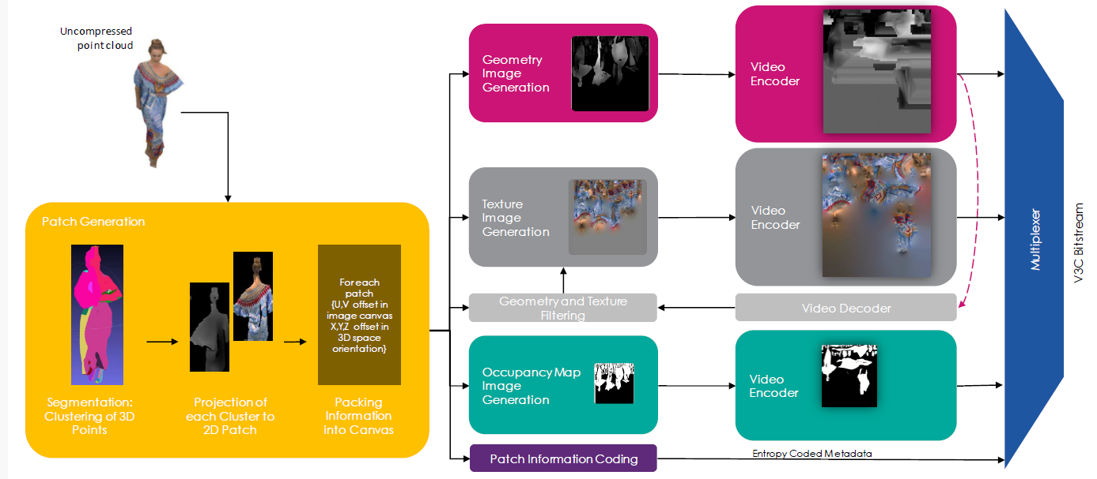

**Figure 7.3.3-5 V-PCC encoder main steps (Content courtesy 8i)**

For encoding of geometry, texture and occupancy map V-PCC relies on 2D video codecs. Due to its efficiency and market penetration HEVC aka H.265 is the choice of 2D video codec for the presented scenario.

Volumetric video can also be represented in the representation format dynamic mesh. MPEG has developed a specification named V-DMC for compressing and delivering the representation format dynamic at bitrates enabling consumer applications. V-DMC [DM-20] is standardized in ISO/IEC 23090-29 Video-based dynamic mesh coding (V-DMC). As V-PCC, V-DMC relies on (HW-accelerated) video codecs for the bulk of the data (attribute maps, etc.).

The following figure shows the V-DMC encoder main steps.

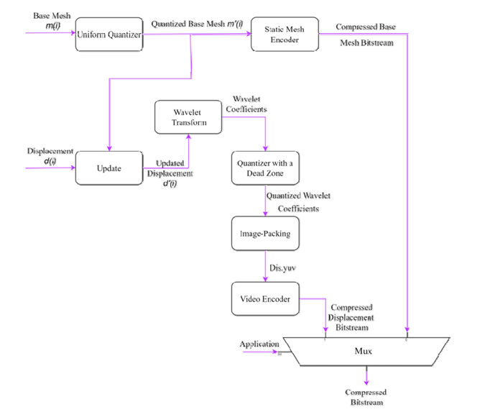

**Figure 7.3.3-6 V-DMC encoder main steps [Vol-35]**

* * * Next Change * * * *

1. *Packaging and delivery*

MPEG has developed a specification addressing storage and delivery V-PCC coded data published as ISO/IEC 23090-10 Carriage of visual volumetric video-based coding data [Vol-12].

As of July 2025, MPEG is working on the second edition of ISO/IEC 23090-10 that will cover V-DMC storage in ISOBMFF format and delivery utilizing DASH.

* * * Next Change * * * *

<Change in table 7.3.4-2 as follows, other text is unchanged.>

### 7.3.4 Source format properties

**Table 7.3.4-2 Signal properties for dynamic mesh format**

|  |  |
| --- | --- |
| Source format properties | Volumetric Video with single asset |
| Number of Polygons /Texture Map Resolution | 30k polygons with 4k texture per frame |
| Chroma format | RGB |
| Chroma subsampling | Not Applicable |
| Picture aspect ratio | Not Applicable |
| Frame rates | 25, 30 Hz |
| Bit depth | 8 and 10 |
| Colour space formats | RGB 444 nonlinear, BT.709 |
| Transfer characteristics | BT.709 |
| Viewpoints | All assets can be viewed from all directions and different distances |

* * * Next Change * * * *

<Change in table 7.3.4-2 as follows, remainder is unchanged.>

### 7.3.4 Source format properties

**Table 7.3.5 Encoding and decoding constraints**

|  |  |
| --- | --- |
| Encoding and Decoding Constraints | V-PCC with H.265/HEVC |
| Relevant Codec and Codec Profile/Levels | H.265/HEVC Main 10 Profile  Level 4.1, 5.1  Metadata stream parsing |
| Random access frequency | 1 seconds |
| Bit rates and quality configuration | Fixed QP Geometry see table D.3.4.1.1-1  Fixed QP Texture see table D.3.4.1.1-1  bitrates [1;50 Mbps] |
| Bit rate parameters (CBR, VBR, CAE, HRD parameters) | Covering a range of relevant bitrates and qualities |
| Latency requirements and specific encoding settings | No specific latency requirement |
| Encoding complexity context | Cloud-based encoding, offline encoding |
| Required decoding capabilities | 3 decoder instantiations of H.265/HEVC Main 10 Profile  Level 4.1, 5.1 for (occupancy, geometry and color)  One synchronized metadata bitstream (Atlas) |

* * * Next Change * * * *

### 7.3.7 Interoperability Considerations for the application

MPEG-DASH is used with ISO/IEC 23090-10 Carriage of visual volumetric video-based coding data [Vol-21]

As of April 2025, MPEG is working on the second edition of ISO/IEC 23090-10 that will cover V-DMC storage in ISOBMFF format and delivery utilizing DASH.

RTP is not proposed for this scenario.

* * * Next Change * * * *

<Change last sentence of the clause, remainder is unchanged.>

#### 7.3.8.3 Metadata for source dense point cloud sequences

…

A JSON scheme is defined in Annex B.2.3 for this matter. An example is provided in clause 7.3.8.3.3

* * * Next Change * * * *

<Keep all text and add the following text at the end. Remove the editor’s notes.>

#### 7.3.9.4 Bitstream Generation, output

Annex D.3 explains the installation of the scripts and the test sequences preparation and annex D.4 explains the bitstream and objective metric generation. In addition to the instructions provided in these annexes, there is documentation in the doc folder of the installed repository.

* * * Next Change * * * *

<Keep all text and add the following text at the end. Remove the editor’s notes.>

#### 7.3.9.5 Videos Generation for subjective tests

Annex D.5 explains the generation of videos and where to find these after successful execution of the scripts.

* * * Next Change * * * *

### 7.3.11 Additional information

Sequences can be decoded and visualized in real time using a 3D background or in Augmented Reality on a smartphone, tablet, head-mounted display using DASH streaming mode or local file system.

Nokia’s real-time V-PCC decoder implementation that was released as open source: <https://github.com/nokiatech/vpcc>

InterDigital recently made a public release of a platform for evaluation and demonstration of real time decoding and rendering of V-PCC. A streaming server provides pre-encoded volumetric video content with V-PCC in real time following a user request. The content has been previously segmented thanks to a V3C DASH Packager able to handle V3C bitstreams. The decoder platform is composed of a native decoder plugin in charge of decoding the content and a simple host application in charge of rendering. The platform has been released via 5G-MAG [Vol-8].

A simple scene description could be added to enable the placement of the asset in the scene (position, orientation, scale…) but is outside the scope of this document, which is focused on the format and codec evaluation.

# 2 References

[Vol-11] ISO/IEC 23090-5 Visual Volumetric Video-based Coding (V3C) and Video-based Point Cloud Compression (V-PCC) – 3rd edition

[Vol-36] 3GPP TR 22.870 V0.3.1, Study on 6G Use Cases and Service Requirements

* * * End of Changes * * * *