**3GPP TSG- Meeting #**

**, , -**

|  |  |  |  |  |  |  |  |  |
| --- | --- | --- | --- | --- | --- | --- | --- | --- |
| *CR-Form-v12.3* | | | | | | | | |
| **CHANGE REQUEST** | | | | | | | | |
|  | | | | | | | | |
|  |  | **CR** |  | **rev** |  | **Current version:** |  |  |
|  | | | | | | | | |
| *For* [***HE******LP***](http://www.3gpp.org/3G_Specs/CRs.htm#_blank)*on using this form: comprehensive instructions can be found at* [*http://www.3gpp.org/Change-Requests*](http://www.3gpp.org/Change-Requests)*.* | | | | | | | | |
|  | | | | | | | | |

|  |  |  |  |  |  |  |  |  |
| --- | --- | --- | --- | --- | --- | --- | --- | --- |
| ***Proposed change affects:*** | UICC apps |  | ME | **X** | Radio Access Network |  | Core Network | **X** |

|  |  |  |  |  |  |  |  |  |  |  |
| --- | --- | --- | --- | --- | --- | --- | --- | --- | --- | --- |
|  | | | | | | | | | | |
| ***Title:*** |  | | | | | | | | | |
|  |  | | | | | | | | | |
| ***Source to WG:*** |  | | | | | | | | | |
| ***Source to TSG:*** |  | | | | | | | | | |
|  |  | | | | | | | | | |
| ***Work item code:*** |  | | | | |  | ***Date:*** | | |  |
|  |  | | | |  | |  | | |  |
| ***Category:*** |  |  | | | | | ***Release:*** | | |  |
|  | *Use one of the following categories:* ***F*** *(correction)* ***A*** *(mirror corresponding to a change in an earlier release)* ***B*** *(addition of feature),* ***C*** *(functional modification of feature)* ***D*** *(editorial modification)*  Detailed explanations of the above categories can be found in 3GPP [TR 21.900](http://www.3gpp.org/ftp/Specs/html-info/21900.htm). | | | | | | | | *Use one of the following releases: Rel-8 (Release 8) Rel-9 (Release 9) Rel-10 (Release 10) Rel-11 (Release 11) … Rel-17 (Release 17) Rel-18 (Release 18) Rel-19 (Release 19)  Rel-20 (Release 20)* | |
|  |  | | | | | | | | | |
| ***Reason for change:*** | | *In-session unicast repair for MBS Object Distribution* as introduced in clause 5.9 of TR 26.802 is added to stage-2 and stage-3 specifications. In the course of producing stage-3 specifications, it was identified that stage-2 lacks certain details for a complete solution. | | | | | | | | |
|  | |  | | | | | | | | |
| ***Summary of change:*** | |  | | | | | | | | |
|  | |  | | | | | | | | |
| ***Consequences if not approved:*** | | Stage-2 specififcation and stage-3 specification not aligned | | | | | | | | |
|  | |  | | | | | | | | |
| ***Clauses affected:*** | | 4.5.6, 4.5.8, 5.6.2 | | | | | | | | |
|  | |  | | | | | | | | |
|  | | **Y** | **N** |  | | | |  | | |
| ***Other specs*** | | **X** |  | Other core specifications | | | | TS 26.517 CR 0031 | | |
| ***affected:*** | |  | **X** | Test specifications | | | | TS/TR ... CR ... | | |
| ***(show related CRs)*** | |  | **X** | O&M Specifications | | | | TS/TR ... CR ... | | |
|  | |  | | | | | | | | |
| ***Other comments:*** | |  | | | | | | | | |
|  | |  | | | | | | | | |
| ***This CR's revision history:*** | |  | | | | | | | | |

## ===== CHANGE =====

### 4.5.6 MBS Distribution Session parameters

This entity models an MBS Distribution Session, as provisioned by the MBS Application Provider and as managed by the MBSF. This MBSF subsequently uses this information to provision a corresponding MBS Distribution Session in the MBSTF.

The following parameters assigned by the MBS Application Provider may be updated by the MBS Application Provider at any time:

- Target service areas,

- MBS Frequency Selection Area (FSA) Identifier (applicable only to broadcast Service type),

- QoS information,

- Target UE classes as defined in clause 6.19 of TS 23.247 [5].

With the exception of the *MBS Session Identifier* (which is immutable after initial assignment) and the *Location-dependent service flag* (which is immutable after creation), all other parameters assigned by the MBS Application Provider may be updated by the MBS Application Provider when the MBS Distribution Session is in the INACTIVE state.

The baseline parameters for an MBS Distribution Session that are common to all distribution methods are listed in table 4.5.6‑1 below. All parameters are exposed to the MBS Application Provider except where noted otherwise.

Table 4.5.6‑1: Common baseline parameters of MBS Distribution Session entity

|  |  |  |  |
| --- | --- | --- | --- |
| Parameter | Cardinality | Assigner | Description |
| Distribution Session Identifier | 1..1 | MBSF | An identifier for this MBS Distribution Session that is unique within the scope of the MBS User Service (see clause 4.5.3). |
| State | 1..1 |  | The current state of the MBS Distribution Session: INACTIVE, ESTABLISHED, ACTIVE or DEACTIVATING (see clause 4.6.1). |
| MBS Session Context | 1..* |  | As defined in clause 6.9 of TS 23.247 [5] (see NOTE 1).  There shall be one MBS Session Context associated with the MBS Distribution Session unless multiple *Target service areas* are specified (see below). |
| MB‑UPF tunnel endpoint address | 0..1 |  | The tunnel endpoint address of the MB‑UPF that supports this MBS Distribution Session at reference point Nmb9 (see NOTE 1, NOTE 4). |
| MBMS GW tunnel endpoint address | 0..1 |  | The tunnel endpoint address of the MBMS GW that supports this MBS Distribution Session at reference point SGi‑mb (see NOTE 1, NOTE 4). |

|  |  |  |  |
| --- | --- | --- | --- |
| User Plane traffic flow information | 0..1 |  | Details of the MBS-4-MC User Plane traffic flow to be used by the MBSTF for this MBS Distribution Session, including the multicast group destination address and port number to be used inside the unicast tunnel at reference point Nmb9 (see NOTE 1).  This parameter is mandatory except in the case of Packet Distribution Method operating in Forward-only mode, in which case multicast-addressed packets ingested at reference point Nmb8 are relayed to Nmb9 without changing their address. |

|  |  |  |  |
| --- | --- | --- | --- |
| MBS Session Identifier | 0..1 | MBSF or MBS Application Provider | The Temporary Mobile Group Identity (TMGI) or Source-Specific Multicast (SSM) IP address of the MBS Session supporting this MBS Distribution Session (see NOTE 2).  Multiple MBS Distribution Sessions within the scope of the same MBS User Service may share the same value if they are location-dependent MBS Services, as defined in clause 6.2.3 of TS 23.247[5].  TMGI values are allocated by the MBSF in conjunction with the MB‑SMF unless supplied by the MBS Application Provider at the time of provisioning. |
| Target service areas | 0..* | MBS Application Provider | The set of regions comprising the MBS service area in which this MBS Distribution Session is to be made available (see NOTE 2).  The provided set of regions shall be disjoint with that of every other MBS Distribution Session sharing the same MBS Session Identifier.  A unique MBS Session Context shall be associated with the MBS Distribution Session for each declared service area, distinguishable by its Area Session Identifier. |
| MBS Frequency Selection Area (FSA) Identifier | 0..1 |  | (Applicable only to broadcast *Service type*.) Identifies a preconfigured area within which, and in proximity to, the cell(s) announce the MBS FSA ID and the associated frequency corresponding to this MBS Distribution Session (see NOTE 3). |
| Target UE classes | 0..* |  | Indicates whether this MBS Distribution Session is suitable for consumption by NR RedCap UEs and/or non-NR RedCap UEs as defined in clause 6.19 of TS 23.247 [5]. |

|  |  |  |  |
| --- | --- | --- | --- |
| Location-dependent service flag | 0..1 |  | An indication that this MBS Distribution Session corresponds to a location-dependent MBS Session.  If the flag is unset or omitted, the MBS Distribution Session is not location-dependent. |
| Multiplexed service flag | 0..1 |  | If set, all MBS Distribution Sessions in the scope of the same parent MBS User Data Ingest Session with identical or empty sets of *Target service areas* shall be multiplexed onto the same MBS Session.  All MBS Distribution Sessions in the multiplex shall be assigned the same MBS Session Identifier. |
| Restricted membership flag | 0..1 |  | (Applicable only to multicast *Service type*.) An indication that this MBS Distribution Session is restricted to a set of UEs according to their current subscription status in the MBS System.  If the flag is set, only UEs in the restricted set are permitted to join this MBS Distribution Session; otherwise, any UE is permitted to join. |
| QoS information | 0..1 |  | A 5G QoS Identifier (5QI) [2] to be applied to the traffic flow for this MBS Distribution Session (see NOTE 2).  The 5QI information is used by the MBSF to set the Quality of Service for the MBS Session by interacting with the PCF at reference point Nmb12. |

|  |  |  |  |
| --- | --- | --- | --- |
| Maximum content bit rate | 1..1 |  | The maximum bit rate for content in this MBS Distribution Session. |
| Maximum content delay | 0..1 |  | The maximum end-to-end content distribution delay that is tolerated for this MBS Distribution Session by the MBS Application Provider. |
| Distribution method | 1..1 |  | The distribution method for this MBS Distribution Session, as defined in clause 6. |
| Operating mode | 0..1 |  | The operating mode in the case where multiple modes are defined in clause 6 for the indicated distribution method. |

|  |  |  |  |
| --- | --- | --- | --- |
| FEC configuration | 0..1 |  | Configuration for Application Layer FEC (AL-FEC) information added by the MBSTF to protect this MBS Distribution Session.  The AL‑FEC scheme shall be identified using a term from the Reliable Multicast Transport (RMT) controlled vocabulary of FEC Encoding IDs [17] expressed as a fully-qualified URI, e.g. urn:ietf:rmt:fec:encoding:0.  The overhead of AL‑FEC protection shall be specified as a proportion of the (unprotected) MBS data, e.g. 1.1 for 10% overhead.  Additional scheme-specific parameters may be signalled in the form of uncontrolled name–value pairs. |

|  |  |  |  |
| --- | --- | --- | --- |
| Transport security protection | 1..1 |  | A flag indicating whether transport security protection is required by the MBS Application Provider for this MBS Distribution Session.  The MBSSF determines whether the control plane security procedure (see NOTE 5) or the user plane security procedure is selected. (See annex W of TS 33.501 [18] for details of these procedures.) |
| Traffic marking information | 0..1 | MBS Application Provider or MBSF | Information (e.g. a Differentiated Services Code Point) used by the MBSTF to mark the multicast packets that it conveys to the MB‑UPF at reference point Nmb9. |

|  |  |  |  |
| --- | --- | --- | --- |
| Time service endpoints | 0..N | MBS AS | A set of endpoints provided by the MBS AS and used by the MBS Client to synchronise its clock with the needed precision (see NOTE 1, NOTE 2). |

|  |
| --- |
| NOTE 1: Internal parameter not exposed to the MBS Application Provider.  NOTE 2: Parameter not relevant to the MBSTF.  NOTE 3: Used to guide frequency selection by the UE for a broadcast MBS Session.  NOTE 4: At least one of *MB‑UPF tunnel endpoint address* or *MBMS GW tunnel endpoint address* shall be present.  NOTE 5: The control plane security procedure (see clause W.4.1.2 of TS 33.501 [18]) is applicable only to Multicast MBS Session(s). |

An MBS Distribution Session Announcement (see clause 4.5.8 below) shall be associated with an MBS Distribution Session when the latter is in the ESTABLISHED or ACTIVE state.

The following MBS Distribution Session parameters are additionally relevant when the distribution method is the Object Distribution Method:

Table 4.5.6‑2: Additional MBS Distribution Session parameters for Object Distribution Method

|  |  |  |  |
| --- | --- | --- | --- |
| **Parameter** | **Cardinality** | **Assigner** | **Description** |
| Object acquisition method | 1..1 | MBS Application Provider | Indicates whether the objects(s) to be acquired and possibly distributed as part of the corresponding MBS User Data Ingest Session are to be pushed into the MBSTF by the MBS Application Provider or whether they are to be pulled from the MBS Application Provider by the MBSTF.  In the latter case, the *Object acquisition method* indicates whether the object(s) are to be retrieved once from the MBS Application Provider at the start of each active period of the corresponding MBS User Data Ingest Session, or whether the MBSTF is required to check their validity periodically, for example once per rotation of an object carousel.  When a reference to an object manifest is provided as the *Object acquisition identifiers*, it is the responsibility of the MBSTF to check for updates to the object manifest itself in an efficient manner. |
| Object acquisition identifiers | 0..* | MBS Application Provider | Directly or indirectly identifies the object(s) to be ingested and distributed by the MBSTF during this MBS Distribution Session.  This could be the ingest URL of the object, the ingest URL of a manifest describing a set of objects or the ingest URL of an Application Service Entry Point document.  For both pull- and push-based object acquisition, values are expressed as URL paths to be resolved relative to the *Object ingest base URL*.  Constraints on this parameter are specified in table 6.1-1. In particular, when referencing an object manifest, exactly one object acquisition identifier shall be present. |
| Object ingest base URL | 0..1 | MBS Application Provider or MBSF | In the case of push-based object acquisition, a URL indicating the host part and base path on the MBSTF to which objects are published. In this case, the value shall be nominated by the MBSF and shall be unique for all MBS Distribution Sessions within the MBS System.  In the case of pull-based object acquisition, a URL indicating a host part and base path on the MBS Application Provider's origin server (or, in the case of the User Service Announcement Channel, on the MBS AF) relative to which objects lacking an absolute URL are acquired. In this case, the value shall be nominated by the MBS Application Provider (or, in the case of the User Service Announcement Channel, by the MBSF) and need not be unique.  When present, this URL prefix is replaced by the MBSTF with the *Object distribution base URL* prior to distribution of ingested objects.  If omitted, nothing is substituted in the content ingest URL when forming the object distribution URL |
| Object distribution base URL | 0..1 | MBS Application Provider | A URL prefix substituted by the MBSTF in place of the *Object ingest base URL* prior to distribution of ingested objects.  If present, the optional *Object ingest base URL* shall also be present.  If omitted, the object distribution URL is the same as the object ingest URL. |
| Object repair base URL | 0..1 | MBSF | A URL prefix substituted by the MBSTF Client in place of the *Object distribution base URL* when repairing objects not received completely intact from this MBS Distribution Session (see NOTE 1). The value shall point to the MBS AS.  Present only when object repair is provisioned for this MBS Distribution Session. |
| Object repair exposure base URL | 0..1 | MBSTF | An endpoint on the MBSTF from which objects are additionally made available to the MBS AS at reference point MBS‑12 (NOTE 2).  Present only when object repair is provisioned for this MBS Distribution Session with pull-based ingest by the MBS AS. This parameter is therefore mutually exclusive with *Object repair ingest base URL*. |
| Object repair ingest base URL | 0..1 | MBS AS | An endpoint on the MBS AS to which objects ingested by the MBSTF are additionally pushed (NOTE 2).  Present only when object repair is provisioned for this MBS Distribution Session with push-based ingest by the MBS AS. This parameter is therefore mutually exclusive with *Object repair exposure base URL*.The |
| NOTE 1: Parameter not relevant to the MBSTF.  NOTE 2: Internal parameter not exposed to the MBS Application Provider. | | | |

The following MBS distribution session are additionally relevant when the distribution method is the Packet Distribution Method:

Table 4.5.6‑3: Additional MBS Distribution Session parameters for Packet Distribution Method

|  |  |  |  |
| --- | --- | --- | --- |
| Parameter | Cardinality | Assigner | Description |
| Packet ingest method | 1..1 | MBS Application Provider | Indicates whether packets are to be ingested using multicast ingest or unicast ingest.  Multicast ingest is valid for Proxy mode only. In this case, the MBSTF shall join a Source-Specific Multicast (SSM) group indicated in *MBSTF ingest endpoint addresses* parameter.  Unicast ingest is valid for Proxy mode and Forward-only mode. In this case, the MBSTF shall allocate a listening IP address and port number for packet ingest and shall return it to the MBSF in the *MBSTF ingest endpoint addresses* parameter below. |
| MBSTF ingest endpoint addresses | 1..1 | MBS Application Provider, MBSF, MBSTF | The endpoint addresses used by the MBS Application Provider and MBSTF to establish a connection at reference point Nmb8 prior to the commencement of this MBS User Data Ingest Session.  In the case of Proxy mode, this shall be the Source-Specific Multicast (SSM) endpoint addresses (including the source IP address, destination multicast group address and destination UDP port) nominated by the MBS Application Provider or else by the MBSF.  In the case of Forward-only mode, this shall be the IP addresses and UDP port numbers at the source and destination ends of the content ingest tunnel, nominated respectively by the MBS Application Provider and the MBSTF. |

## ===== CHANGE =====

### 4.5.8 MBS Distribution Session Announcement parameters

This entity models an MBS Distribution Session Announcement, which is compiled by the MBSF and used to advertise the current or imminent availability of an MBS Distribution Session in the MBS System. The baseline parameters for an MBS Distribution Session Announcement are listed in table 4.5.8‑1 below:

Table 4.5.8‑1: Baseline parameters of MBS Distribution Session Announcement entity

|  |  |  |  |
| --- | --- | --- | --- |
| Parameter | Cardinality | Assigner | Description |
| MBS Session Identifier | 1..1 | MB‑SMF | The Temporary Mobile Group Identity (TMGI) or Source-Specific Multicast (SSM) IP address of the MBS Distribution Session from which this announcement is derived. |

|  |  |  |  |
| --- | --- | --- | --- |
| MBS Frequency Selection Area (FSA) Identifier | 0..1 | MBS Application Provider or MB-SMF | (Broadcast MBS Session only.) Identifies a preconfigured area within which, and in proximity to, the cell(s) are announcing the MBS FSA ID and the associated frequency corresponding to this MBS Distribution Session Announcement (see NOTE). |
| Radio parameters | 0..* | MBSF | (Broadcast MBS Session only.) Radio transmission parameters of this MBS Distribution Session in its target service areas. The values are obtained by the MBSF from the OAM using the *MBS Frequency Selection Area (FSA) Identifier* (see above) as the lookup key. |
| Target UE classes | 0..* | MBS Application Provider | (Broadcast MBS Session only.) Indicates whether the MBS Distribution Session described by this announcement is suitable for consumption by NR RedCap UEs and/or non-NR RedCap UEs as defined in clause 6.19 of TS 23.247 [5]. |

|  |  |  |  |
| --- | --- | --- | --- |
| Distribution method | 1..1 | MBS Application Provider | The distribution method (as defined in clause 6) of the MBS Distribution Session from which this announcement is derived. |
| Session Description parameters | 1..* | MBSF | Additional parameters needed to receive the MBS Distribution Session from which this announcement is derived, including relevant User Plane traffic flow parameters. |
| Service protection description | 0..1 | MBSSF | The security parameters for the MBS Distribution Session (see clause W.4.2 of TS 33.501), including:  - Which form of transport security protection is in force, whether UICC key management (see TS 33.246 [19]) is selected and/or whether 2G GBA security (see TS 33.246 [19]) is selected.  - The MBS Session Key (MSK) identifier and key domain.  - The address of the key management server (FQDN of the MBSSF) when user plane security is in force. |

|  |  |  |  |
| --- | --- | --- | --- |
| Time service endpoints | 0..N | MBS AS | A set of endpoints provided by the MBS AS and used by the MBS Client to synchronise its clock with the needed precision. |

|  |
| --- |
| NOTE: Used to guide frequency selection by the UE for a broadcast MBS Session. |

The following session announcement parameters are additionally relevant when *Distribution method* above indicates the Object Distribution Method:

Table 4.5.8‑2: Additional MBS Distribution Session Announcement parameters for Object Distribution Method

|  |  |  |  |
| --- | --- | --- | --- |
| Parameter | Cardinality | Assigner | Description |
| Object distribution schedule | 0..1 | MBS Application Provider | A schedule indicating when individual objects are to be delivered on the corresponding MBS Distribution Session.  Present only when this information has been provided in the *Object acquisition identifiers* of the corresponding MBS Distribution Session (see table 4.5.6‑2). |
| Object distribution base URL | 0..1 |  | A URL prefix substituted by the MBSTF Client with the *Object repair base URL* when repairing objects not received completely intact from the corresponding MBS Distribution Session.  Present only when object repair is provisioned for the corresponding MBS Distribution Session. |
| Object repair base URL | 0..1 | MBSF | The base URL of the MBS AS to be used for object repair of the corresponding MBS Distribution Session.  Present only when object repair is provisioned for the corresponding MBS Distribution Session. |

## ===== CHANGE =====

### 5.6.2 In-session Object Repair

The procedures in clause 5.5 are extended as shown in figure 5.6.2-1 to support in-session object repair. In particular, after the steps described in clause 5.5.2 and figure 5.5-2, in case in-session object repair is configured for the MBS Client, the following steps are carried out.

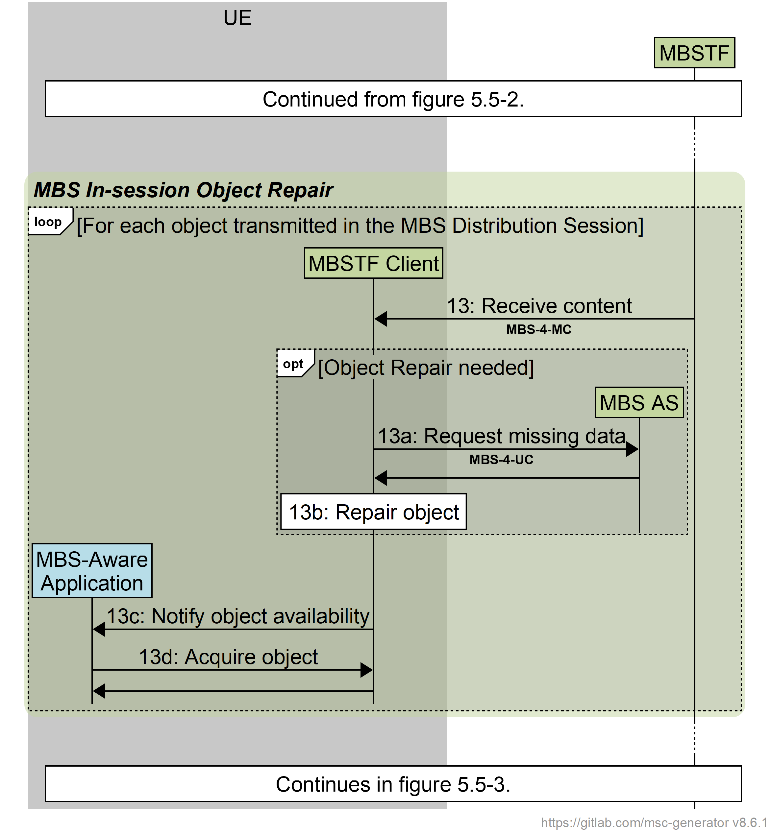

Figure 5.6.2‑1: Call flow for in-session Object Repair

Having received object data from the MBSTF (step 13 in clause 5.5.2):

If the MBSTF Client detects that the received object data is incomplete, and that Object Repair is therefore needed:

13a: The MBSTF Client requests from the MBS AS via reference point MBS‑4‑UC either (i) sufficient data in order to repair the object, or (ii) the entire object and ignores that data received from the MBSTF, and the requested data is returned by the MBS AS.

13b: The MBSTF Client repairs or recovers the object by applying the data provided in the previous step to the incomplete object data received in step 13.

Then, in all cases:

13c: The MBSTF Client informs the MBS-Aware Application that the object is available for retrieval.

13d: The MBS-Aware Application retrieves the object from the MBSTF Client.

In practice, multiple objects may be received in parallel, and the steps of the call flow are interleaved for each one.