3GPP TSG-SA4 Meeting #133-e S4-251281r01

Online, , 18th Jul 2025 - 25th Jul 2025
CR-Form-v12.3
CHANGE REQUEST
 | 26.501 | CR | 0111 | rev | 2 | Current version: | 19.1.0
For HELP on using this form: comprehensive instructions can be found at
http://www.3gpp.org/Change-Requests.

Proposed change affects: | UICC apps |  | ME | X | Radio Access Network |  | Core Network | X

Title: | [AMD_PRO-MED] WT2: Alignment with TS 26.512 CR 0091 - Multi-Source object coding architecture and procedures mapping
Source to WG: | Dolby Laboratories Inc.
Source to TSG: | S4
Work item code: | AMD_PRO-MED |  |  |  |  |  | Date: |  |  | 2025-07-14
Category: | B |  |  |  |  |  | Release: |  |  | Rel-19
 | Use one of the following categories:  F (correction)  A (mirror corresponding to a change in an earlier release)  B (addition of feature),  C (functional modification of feature)  D (editorial modification)  Detailed explanations of the above categories can  be found in 3GPP TR 21.900. |  |  |  |  |  |  |  | Use one of the following releases:  Rel-8 (Release 8)  Rel-9 (Release 9)  Rel-10 (Release 10)  Rel-11 (Release 11)  …  Rel-17 (Release 17)  Rel-18 (Release 18)  Rel-19 (Release 19)  Rel-20 (Release 20)
Reason for change: |  | Alignment with TS 26.512 CR 0091
Summary of change: |  | New annex that maps the use of multi-source object coding onto the 5GMS architecture and procedures.
Consequences if not approved: |  | Objectives of the Work Item not completely satisfied.
Clauses affected: |  | Annex I (new)
 |  | Y | N
Other specs |  | X |  | Other core specifications |  |  |  | TS 26.512 CR 0091
affected: |  |  | X | Test specifications
(show related CRs) |  |  | X | O&M Specifications
Other comments:
This CR's revision history: |  | S4aI250098: New CR. Noted.  S4-251281: Updated to address comments from BBC and Qualcomm.

===== CHANGE =====

Annex I (normative):
Multi-source media streaming using object coding

I.1 Introduction
Content delivery within the 5GMS System may be augmented using object coding to enable delivery of media resources (typically Media Segments) through the simultaneous use of multiple service locations exposed by the 5GMS AS at reference point M4 and/or the 5GMSd Application Provider at reference point M13. The use of object coding for content delivery is initiated by the 5GMS Application Provider establishing a Provisioning Session in which a Content Hosting Configuration or Content Publishing Configuration is defined to distribute coded objects at reference point M4 and/or M13, in addition to optionally referencing (or else providing subsequently via reference point M8) associated Media Entry Points containing object coding configuration information.
For downlink media streaming, media resources are encoded into objects by either the 5GMS Application Provider or the 5GMS AS (depending on the use case), and these are distributed to the 5GMS Client which decodes received objects to recover the original media resources.
For uplink media streaming, media resources are encoded into objects by 5GMS Client, and these are contributed to either the 5GMS AS or the 5GMS Application Provider (depending on the use case) which decodes received objects to recover the original media resources.
This annex maps the use of multi-source object coding onto the 5GMS System.

I.2 Downlink Media Streaming architecture with multi-source coded objects
The use of multi-source object coding mapped onto the downlink media streaming architecture defined in clause 4.2 is shown in figure I.2-1. Compared with figures 4.2.1-2 and 4.2.2-1, the 5GMSd AS is augmented with a Multi-source-coded Object Server subfunction and the Media Access Client, which is a subfunction of the Media Player, has the functionality to download and process multi-source coded objects.
Figure I.2-1: 5G unicast downlink media streaming architecture with multi-source coded objects
The descriptions for the following functions defined in clause 4.2 are expanded upon to describe the use of mutli-source object coding for downlink media streaming:
- Media Player: A function as defined in clause 4.2.1 that additionally supports multi-source object coded downlink media streaming. It sets up and configures a multi-source-enabled Media Access Client with the capability to access multi-source coded objects (e.g. DASH Media Segments) upon reception of a Media Player Entry containing necessary multi-source object coding configuration information and a description of a media presentation (e.g., MPD for DASH content, URL to a video clip file, etc.).
- (Multi-source-enabled) Media Access Client: A function as defined in clause 4.2.2 and which:
- May extend the functionalities of other defined Media Access Clients (e.g., a DASH Access Client) to enable the streaming of media using multi-source coded objects.
- Uses the Media Player Entry to locate and request multi-source coded objects containing encoded representations of the media resources required by the Media Player from one or more service locations exposed by the 5GMSd AS at reference point M4d and/or by the 5GMS Application Provider at reference point M13d. If indicated by the Media Player Entry, the multi-source-enabled Media Access Client may also translate media resource URLs described by a media presentation (e.g., MPD for DASH content, URL to a video clip file, etc.) into URLs pointing to the multi-source coded objects containing encoded representations of those media resources.
- For each media resource, downloads one or more multi-source coded objects (either partially or in full) from one or more service locations exposed by the 5GMSd AS at reference point M4d and/or by the 5GMSd Application Provider at reference point M13d.
- Recovers the media resource by decoding the received multi-source coded object(s).
- Makes decoded media resources available to the Media Playback and Content Decryption Platform (specified in TS 26.511 [26]) for immediate or delayed consumption.
- If retrieval of a media resource from multi-source coded objects fails, the multi-source-enabled Media Access Client should attempt to acquire the media resource using an alternate method (for example, by retrieving the original media resource directly from a single service location exposed by the 5GMSd AS at reference point M4d).
- 5GMSd AS: A function as defined in clause 4.2.1 that may additionally:
- Create or modify a Media Entry Point (or a document pointed to by a Media Entry Point) that contains necessary multi-source object coding configuration information and media presentation description(s) suitable for retrieval and consumption by a Media Access Client capable of decoding multi-source coded objects.
- Ingest multi-source coded objects, where each object is a different encoded representation of a media resource, from the 5GMSd Application Provider at reference point M2d.
- Ingest a media resource from the 5GMSd Application Provider at reference point M2d and encode it into one or more multi-source coded objects (where each is a different representation of the ingested media resource) using a provisioned Content Preparation Template.
- Cache ingested and/or prepared multi-source coded objects.
- Distribute multi-source coded objects to multi-source-enabled Media Access Clients from one or more service locations exposed at reference point M4d.
- 5GMSd Application Provider: A function as defined in clause 4.2.1 that may additionally:
- Create a Media Entry Point (or a document pointed to by a Media Entry Point) for ingest at reference point M2d or distribution via reference point M8d. The Media Entry Point (or a document pointed to by a Media Entry Point) contains multi-source object coding configuration information and/or a description of a media presentation (e.g., MPD for DASH content, URL to a video clip file, etc.), including any relevant service location information for service locations exposed at reference point M13d.
- Encode a media resource into one or more multi-source coded objects (where each is a different encoded representation of the media resource) prior to ingest at reference point M2d and/or distribution via reference point M13d.
- Host media resources and/or multi-source coded objects for ingest at reference point M2d and/or distribution via reference point M13d.

I.3 Procedures for downlink media streaming using multi-source object coding

I.3.1 General
The procedures for downlink media streaming using multi-source coded objects follow those described in clause 5. This clause provides additional details for provisioning the 5GMS System for downlink media streaming and delivery from multiple service locations of media encoded within multi-source coded objects.

I.3.2 Multi-source delivery procedure using multi-source object coding
Figure I.3.2-1 illustrates a variant of the high-level procedure defined in clause 5.2.6 in which downlink media streaming is from multiple service locations. Differences from the baseline procedure are highlighted in boldface.
The procedure makes the following assumptions:
- Multi-source-encoded content is hosted at two or more service locations. These service locations may be located inside the 5GMS System (i.e., hosted by the 5GMSd AS and exposed via reference point M4d) or outside it (i.e., hosted by the 5GMSd Application Provider and exposed via reference point M13d).
NOTE: It is the responsibility of the 5GMSd Application Provider to configure and provision service locations hosted outside the 5GMS System. In such cases, the 5GMSd Application Provider is also responsible for updating the Media Player Entry to include the necessary multiple service location configuration information to access content from these service locations.
- The multi-source-enabled Media Access Client in the Media Player has the necessary functionality to acquire multi-source encoded media from multiple service locations. This includes the functionality needed to acquire multi-source encoded objects from multiple service locations concurrently.
- Multi-source object coding configuration information required to access content across multiple service locations is available within the Media Player Entry (or available alongside the Media Player Entry, such as within a document referenced by the Media Player Entry). This configuration information may be:
- Embedded in a Media Player Entry document (e.g., MPD),
- Provided alongside the Media Player Entry document, such as in a separate document referenced by a Media Player Entry document (e.g., MPD), or
- Provided as the Media Player Entry document with a reference to a document containing the media streaming presentation information (e.g., MPD).
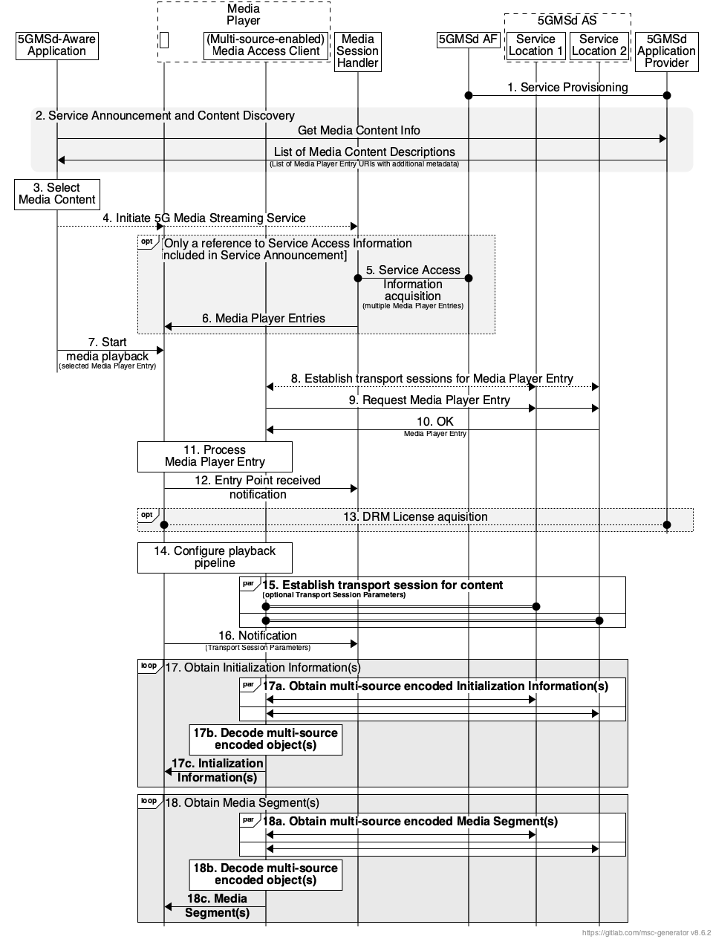
Figure I.3.2-1: High-level procedure for downlink streaming
from multiple service locations using multi-source object coding
Steps:
1. The 5GMSd Application Provider provisions the 5G Media Streaming System, including content hosting and ingest, such that multi-source-encoded content is available from two or more service locations (labelled Service Location 1, Service Location 2, etc.) where each service location hosts a unique encoded representation of the content to be streamed. Upon successful provisioning and content ingest (see clause 5.4.4), either the 5GMSd Application Provider or the 5GMSd AS may create or update Media Player Entry documents (or documents pointed to by each Media Player Entry document) to include any necessary multi-source object coding configuration information required by the 5GMSd Client to access media content from multiple service locations.
2. The 5GMSd-Aware Application triggers the Service Announcement and Service and Content Discovery procedure. The Service and Content Discovery procedure only involves the 5GMSd-Aware Application and the 5GMSd Application Provider. The Service Announcement includes either the whole Service Access Information (i.e. details for Media Session Handling at reference point M5d and for Media Streaming access at reference point M4d) or a reference to the whole Service Access Information.
3. A media content item is selected.
4. The 5GMSd-Aware Application triggers the 5GMSd Client to initiate the downlink 5G Media Streaming service.
When the 5GMSd-Aware Application has received only a reference to the Service Access Information (see step 1):
5. The Media Session Handler interacts with the 5GMSd AF to acquire the whole Service Access Information. The Service Access Information may include Media Player Entry URLs.
6. The Media Session Handler provides the Media Player Entries to the 5GMS-Aware Application. The information may indicate a precedence order for these Media Player Entries.
Then:
7. The Media Player is invoked with the selected Media Player Entry to start media access and playback.
8. The multi-source-enabled Media Access Client establishes the transport session for acquiring the Media Player Entry.
9. The multi-source-enabled Media Access Client requests the Media Player Entry.
10. The multi-source-enabled Media Access Client receives the Media Player Entry.
11. The Media Player processes the Media Player Entry. From the Media Player Entry, the Media Player determines the multi-source object coding configuration, including the set of available service locations where multi-source encoded content can be accessed and the multi-source object URL(s) for the media resources to be acquired. It further determines, for example, the number of transport sessions to each service location needed for media acquisition. The Media Player uses the Media Player Entry information to initialize the media pipelines for each media stream. The Media Player Entry also contains information to initialize the DRM client, when DRM is used.
12. The Media Player notifies the Media Session Handler about the Media Player Entry.
13. Optional: the Media Player acquires the necessary DRM information, for example a DRM License.
14. The Media Player configures the media playback pipeline.
15. The Media Player establishes the necessary transport sessions for the content according to multi-source object coding configuration information indicated by the Media Player Entry. These transport sessions may be established between the multi-source-enabled Media Access Client and any one or more of the available service locations. For example, the Media Player may establish one transport session for each media component (audio, video, etc) and possibly additional transport sessions for other media representations to each service location.
16. The Media Player notifies the Media Session Handler that it is ready to commence playback and optionally provides transport session parameters for those transport sessions terminating at the 5GMSd AS.
17. The Media Player requests and obtains the initialization information. The Media Player repeats this step for each required initialization segment.
17a. The multi-source-enabled Media Access Client requests and obtains, in parallel, unique multi-source-encoded representations of the required initialization information from two or more available service locations.
17b. Upon reception of enough information from the combination of partially or fully obtained multi-soruce-encoded objects, these objects are decoded by the multi-source-enabled Media Access Client, allowing it to recover the required initialization information.
17c. The multi-source-enabled Media Access Client provides the decoded initialization information to the Media Playback and Content Decryption Platform as specified in TS 26.511 [26] where it is inserted into the appropriate media rendering pipeline.
18. The Media Player requests and obtains the Media Segments. The Media Player repeats this step for each required Media Segment according to the Media Player Entry information.
18a. The multi-source-enabled Media Access Client requests and obtains, in parallel, unique multi-source-encoded representations of the Media Segment from two or more available service locations.
18b. Upon reception of enough information from the combination of partially or fully obtained multi-source-encoded objects, these objects are decoded by the multi-source-enabled Media Access Client, allowing it to recover the required Media Segment.
18c. The multi-source-enabled Media Access Client provides the decoded Media Segment to the Media Playback and Content Decryption Platform as specified in TS 26.511 [26] where it is inserted into the appropriate media rendering pipeline.

I.3.3 Provisioning Session for downlink media streaming using multi-source object coding
A simplified domain model suitable for downlink media streaming using multi-source object coding is depicted in figure I.3.3-1. It consists of a Provisioning Session containing, at a minimum, a Content Hosting Configuration where one or more Distribution Configurations are defined. Each Distribution Configuration is associated with a single service location exposed by the 5GMSd AS at reference point M4d.
Figure I.3.3-1: Multi-source object coding provisioning domain model
The 5GMSd Application Provider may provision one or more Content Preparation Templates that are referenced by the configured Distribution Configurations for the purposes of encoding media resources (e.g., Media Segments) ingested at reference point M2d into one or more multi-source encoded objects where each multi-source-encoded object is a different encoded representation of the ingested media resource.
Different encoded representations of the ingested media resource (each a different multi-source-encoded object) are distributed to a 5GMSd Client at reference point M4d via a different service location exposed by the 5GMSd AS. Each multi-source-encoded representation of a media resource (e.g., Media Segment) shall be exposed by exactly one 5GMSd AS service location at reference point M4d.
The procedure to provision the features of the 5GMS System for media streaming using multi-source object coding are described in clause 5.

