Source: Nokia
Title: On requirements for raw and compensated microphone signals
Document for: Discussion & Agreement
Agenda Item: 7.6 – DaCAS

1. Introduction
In the SA4-132 meeting further proposal on raw and compensated microphone signal requirements were presented [1]. Although no agreement was made, valuable feedback was received. In this contribution further proposal for the requirements of microphone signals is presented based on the received feedback.

2. Requirements for microphone signals
In the previous proposal [1], certain comments and concerns were raised towards the proposed requirements. To further progress the work, update on the proposed requirements is made. Namely, the resonance and SNR requirements are clarified, and additional requirement for the analog-to-digital conversion bit depth is added. Furthermore, clarifications on how the compensated microphone signal requirements should be understood are presented in the section 3.
The following requirements are proposed to be included to the DaCAS-2 [2]. The status whether such requirements would be normative or informative should be decided before integrating the requirements further to the technical specification. Change marks indicates the updates against the previous proposal in [1].
[
x.x Requirements for raw microphone signals
Editor’s note: Decision needed whether to have normative or informative requirements/recommendations.
Raw microphone input for DaCAS example solutions shall comply with the requirements specified in Table 1.
Table 1 Raw microphone signal requirements
Feature | Requirement | Recommendation
Raw frequency response (excluding resonances) | TBD | Minimum captured frequency (-3dB point) should be below 100 Hz  Frequency response above the minimum frequency and below the resonances should be as flat as possible.
Resonances | TBD | Should be above 8 kHz.
SNR | TBD | Should be at least 60 dB
Sensitivity | TBD | Level should be below -25 dBFS ($±$1 dB) with 1 kHz sine signal @ 94 dB SPL
Directivity | TBD | Recommended to have omnidirectional characteristics. Other directivity patterns are not generally excluded.  Microphone directivity characteristics shall be documented clearly.
ADC bit depth | TBD | The ADC bit depth should be 24 bits.
Note: It is expected that all the raw integrated microphones comply with the above requirements. In addition, it is favorable to have as similar characteristics as possible for all raw integrated microphones.

x.x Requirements for compensated microphone signals
Editor’s note: Decision needed whether to have normative or informative requirements/recommendations.
Compensated microphone input for DaCAS example solutions shall comply with the requirements specified in Table 2.
Table 2 Compensated microphone signal requirements
Feature | Requirement
Compensated frequency response | Compensated frequency response should be considered in the context of isotropic equalization target.  When compensation processing is applied to the same signal as used for designing the compensation filters:  - Compensated frequency response shall be within mask defined in Table 3  - Differences between compensated frequency responses shall be within mask defined in Table 4
Phase properties | Compensation processing should compensate sound source direction independent phase differences between integrated microphone responses.

Table 3: Compensated microphone sensitivity/frequency mask
 | Required |  | Recommended
Frequency (Hz) | Upper limit (dB) | Lower limit (dB)
100 | 4 |  | 2
200 | 4 | -4 | 2 | -2
5000 | 4 | -4 | 2 | -2
12500 | 4 | -6 | 2 | -3
16000 | 4 |  | 2
NOTE: All sensitivity values are expressed in dB on an arbitrary scale.

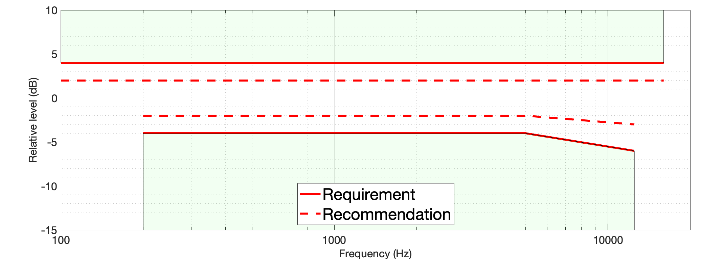
Figure 1 Compensated microphone response masks

Table 4: Compensated microphone sensitivity/frequency difference mask
 | Required |  | Recommended
Frequency (Hz) | Upper limit (dB) | Lower limit (dB) | Upper limit (dB) | Lower limit (dB)
100 | 2 |  | 1 | -1
200 | 2 | -2 | 1 | -1
5000 | 2 | -2 | 1 | -1
12500 | 2 | -4 | 1 | -2
16000 | 2 |  | 1
NOTE: All sensitivity values are expressed in dB on an arbitrary scale.

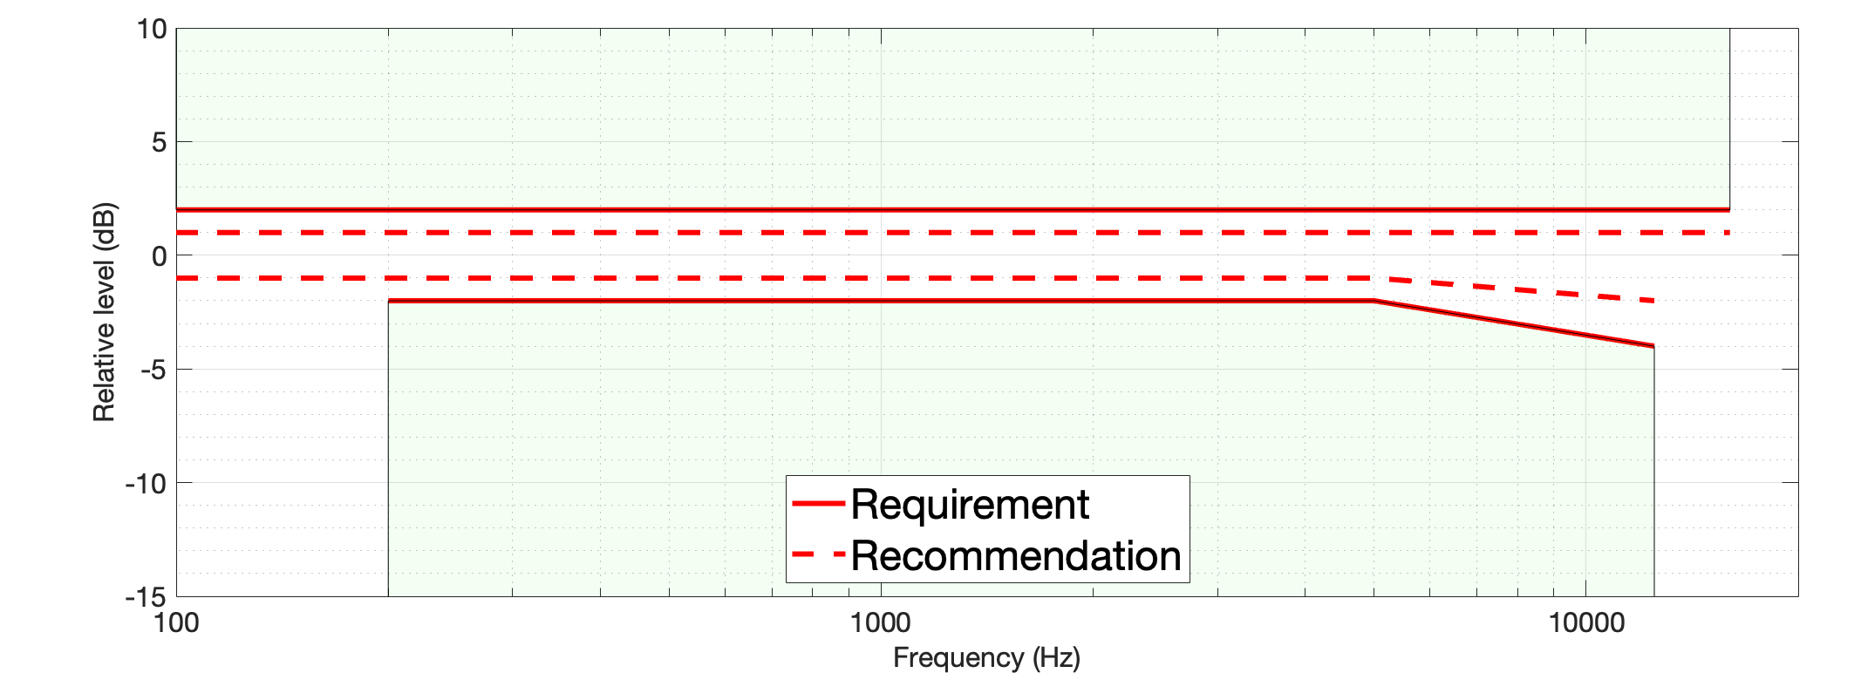
Figure 2 Compensated microphone response difference masks

]

3. Overview on the compensation and relation to the requirements
In the Figure 3 below, the compensation procedure and verification against the requirements is illustrated. Compensated frequency responses shall be verified against the requirements in Tables 3 and 4 using the same input signal as used for obtaining the compensation filter target response.
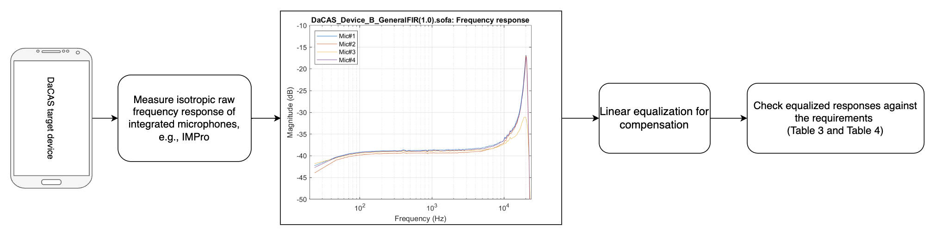
Figure 3 Overview on the processing and verification steps
To obtain the integrated raw microphone responses (for which the compensation filters are designed), IMPro measurement described in [3] and [4] can be used. First, the IMPro measurements are done according to the [3]. Based on the measurements, the isotropic microphone impulse responses are obtained for each integrated microphone. The frequency response of the integrated microphones can be estimated from the impulse responses, as visualized in the Figure 4.

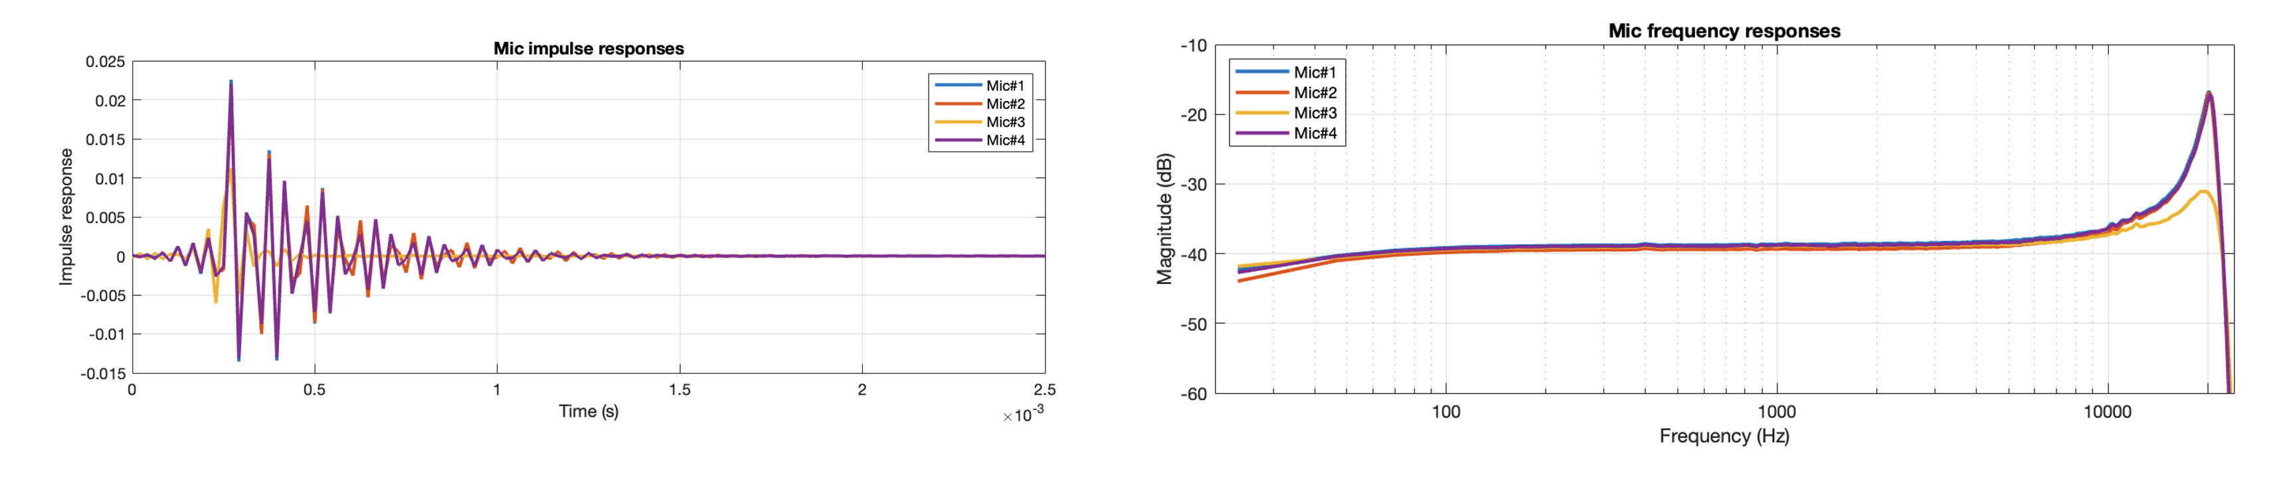
Figure 4 Impulse response and related frequency response of integrated microphones
Based on the obtained frequency response of each integrated microphone impulse response, the inverse responses are used as the compensation filter response target for target compensation filter of each microphone channel. Rough filter designs are presented in the Figure 5.

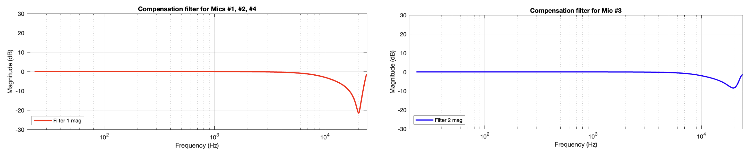
Figure 5 Example compensation filter designs
Compensation processing is applied to the original impulse responses, to verify that the compensated outputs fit to the required masks. The obtain compensated frequency responses and differences of the compensated frequency responses are illustrated in the Figure 6 and 7 below.
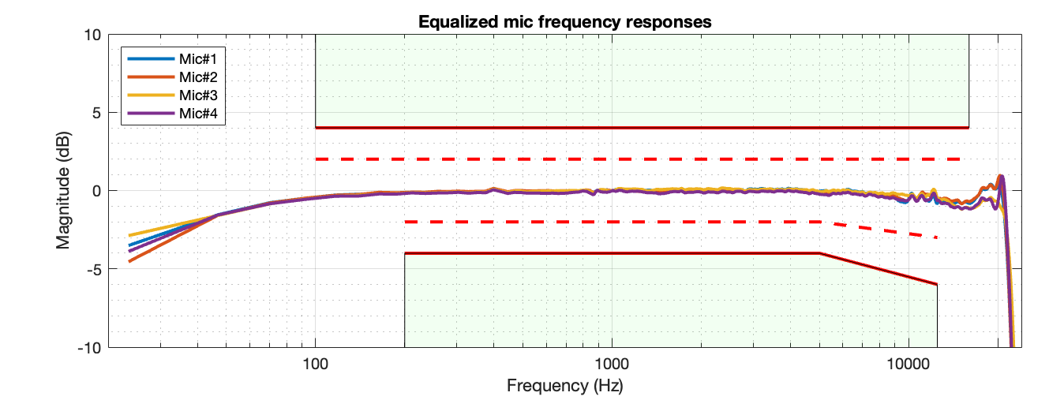
Figure 6 Compensated frequency response of the integrated microphones

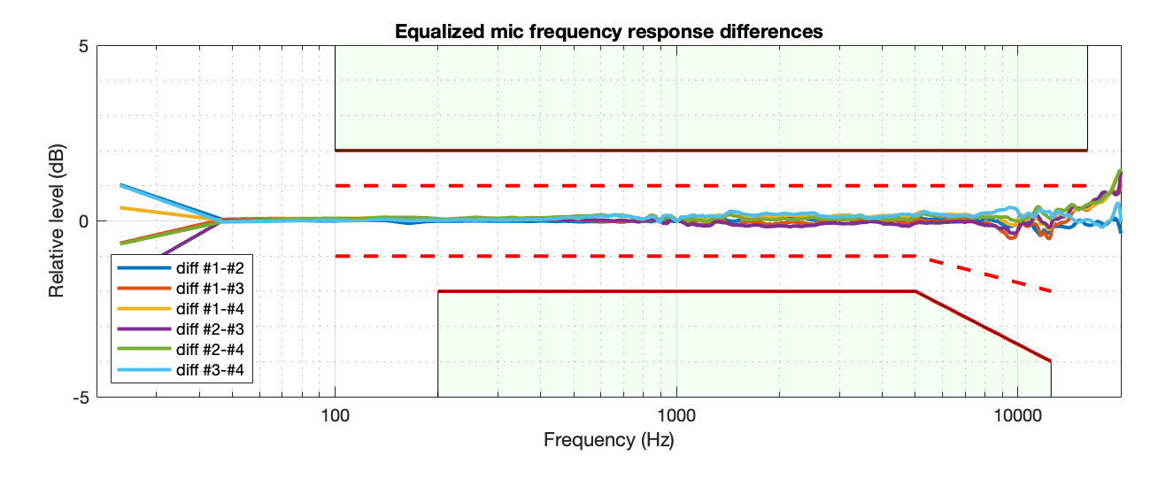
Figure 7 Compensated frequency response differences of the integrated microphones
It should be noted that the presented compensation is merely an example to further clarify source’s view on how the compensation and relevant requirements should be applied. For example, different approaches for applying the designed compensation filter EQs to the raw input signals may be considered.

4. Summary
In this contribution further proposals on the microphone response requirements in section 2 are presented. In addition, further clarification on applying the compensation and assessing the compensation against the requirements is described. Microphone signal requirements presented in the section 2 are proposed to be included to the DaCAS-2 permanent document [2] for further editing before potential integration to the technical specification.

5. References
[1] S4-250948: “On raw and compensated microphone signal requirements”, Nokia
[2] S4-251058: “DaCAS-2: Test methodologies and requirements v0.1”
[3] Cozens J., Hämäläinen M, Pekkarinen M, IMPro – Method for Integrated Microphone Pressure Frequency Response Measurement Using a Probe Microphone, AES 158th Convention, Warsaw, Poland 2025 May 22–24. https://aes2.org/publications/elibrary-page/?id=22907
[4] S4-250936: “On compensated microphone pressure frequency response measurement”, Nokia

