3GPP TSG-SA SA4#131-bis-e S4-250447

Online, 11 – 17 April 2025
CR-Form-v12.2
CHANGE REQUEST
 | 26.956 | CR |  | rev |  | Current version: | 0.3.0
For HELP on using this form: comprehensive instructions can be found at
http://www.3gpp.org/Change-Requests.

Proposed change affects: | UICC apps |  | ME |  | Radio Access Network |  | Core Network

Title: | pCR on inclusion of dynamic mesh and V-DMC in scenario 2
Source to WG: | InterDigital, Nokia, Samsung, Sony Group Corporation,China Mobile
Source to TSG:
Work item code: | FS_Beyond2D |  |  |  | Date: |  |  | 2025-04-04
Category: | B |  |  |  | Release: |  |  | Rel-19
 | Use one of the following categories:  F (correction)  A (mirror corresponding to a change in an earlier release)  B (addition of feature),  C (functional modification of feature)  D (editorial modification)  Detailed explanations of the above categories can  be found in 3GPP TR 21.900. |  |  |  |  |  | Use one of the following releases:  Rel-8 (Release 8)  Rel-9 (Release 9)  Rel-10 (Release 10)  Rel-11 (Release 11)  …  Rel-16 (Release 16)  Rel-17 (Release 17)  Rel-18 (Release 18)  Rel-19 (Release 19)
Reason for change: |  | Dynamic mesh have been included in the TR as representation format. This contribution includes dynamic mesh and V-DMC in scenario 2
Summary of change: |  | Includes dynamic mesh and V-DMC in scenario 2
Consequences if not approved: |  | Scenario for dynamic mesh would be unclear
Clauses affected:
 |  | Y | N
Other specs |  |  |  | Other core specifications |  | TS/TR ... CR ...
affected: |  |  |  | Test specifications |  | TS/TR ... CR ...
(show related CRs) |  |  |  | O&M Specifications |  | TS/TR ... CR ...
Other comments: |  | Changes are tracked starting from TR V0.3.0
This CR's revision history:

== CHANGE 1 (all new) ===

7.3 Scenario 2: Streaming of professionally produced Volumetric Video with single asset containing people

7.3.1 Scenario name
Streaming of professionally produced Volumetric Video with single asset containing people.

7.3.2 Motivation for the scenario
The scenario addresses on-demand streaming of post-produced volumetric video with single asset containing people, providing experiences beyond what is achievable with 2D content. Particularly in AR application, the user can watch the volumetric video asset from all directions as if the asset were naturally present. In both AR and VR applications, the user can move smoothly around the asset, change its size or make the asset rotate.
The content is in the form of volumetric video, which is a frame-based immersive experience whereby each frame represents a volumetric region in 3D space in which any point is either non-occupied or has a colour that may depend on the viewing direction. Volumetric video has the potential to provide a more immersive and interactive experience than 2D content.
Several use cases for on-demand volumetric video streaming can be envisioned related to various domains including but not limited to entertainment, education and industrial monitoring. For example, in the entertainment domain users can stream a performance from their favorite singer or band to their living room and experience greater immersion potentially combined with spatial audio. Another example is the education/training domain, where a produced volumetric video of a fitness instructor shows how to perform an exercise that helps a student to better understand how the exercise is done and thus replicate it in a correct way. Yet another example in the education domain would be a mechanic giving a tutorial on how to assemble a mountain bike. A trainee can watch the movements of the mechanic from different angles and get an improved understanding of the different steps due to depth perception and different viewpoints.
For first implementations of relevant use cases the content can be quite simple without hindering the purpose, consisting of a camera captured 6 DoF person as asset and a 3D graphics background or an AR camera background coming from the rendering device. As an alternative a person could be captured with an object (e.g. a ball) or two persons together. Important is that everything is in a single asset.

- Technology evaluation on the market
KDDI experimented transmission of produced volumetric video over mobile networks including real time encoding and decoding [Vol-1].
Volucap, based in Potsdam Germany, developed several showcases and tested these on the market. The number of showcases is growing and the current list can be consulted here: https://volucap.com/showcases/.
The following showcases illustrate particularly the proposed scenario:
- Sports training: Volucap and Deutsche Telekom produced a clip to learn cool dribbles and precise throws from the former basketball star Josh Mayo: https://volucap.com/portfolio-items/meeting-josh/
- Music Group: Volucap and the music group “Boss Hoss” prototyped the your favorite band in your living room: https://volucap.com/portfolio-items/the-bosshoss-augmented-reality/
- Tagesschau: Volucap and the German news broadcaster Tagesschau collaborated to capture a volumetric representation of a news: https://volucap.com/portfolio-items/tagesschau-2025/
- Book enhanced with AR: Volucap enhanced a children song book with AR content on a smartphone: https://volucap.com/portfolio-items/rolf-zuckowski/
- XR Fashion show: Volucap and Lana Mueller, a Berlin based designer, produced a fashion presentation in XR: https://volucap.com/portfolio-items/lana-mueller-fashion/
- Charité medical VR training: This immersive simulation uses advanced volumetric video technology to bring users into the heart of a realistic surgical environment, ideal for virtual reality (VR) training scenarios: https://volucap.com/portfolio-items/charite-medical-vr-training/
- Industry activities
Several industry activities regarding on-demand volumetric video streaming have been experimented between various mobile network operators, volumetric capture studios and technology providers. Some of these industry activities are listed here:
- Volograms, based in Dublin, Ireland
- Provides professional volumetric content creation services to feed AR use cases such as augmented museum, training or fashion experiences: https://www.volograms.com/made-with-volograms
- The company has also developed an AI based solution to enable AR volumetric content from 2D single photo or video: https://www.volograms.com/
- 8i, Mantis Vision, Metastage, Volograms, XD Productions, etc. present volumetric capturing projects on their websites, similar to Volucap
- XD Productions and Volograms content (both professional and AI-based) has been showcased in public trade shows and conferences by InterDigital as part of MPEG-I V3C platform demonstration with the V-PCC player
- Zerospace and Canon are collaborating to open a volumetric video capturing studio. With over 100 Canon Cinema EOS cameras, it claims to offer unmatched capabilities. The website illustrates capture of sports content (e.g. basketball, Karate): https://www.zerospace.co/studios/canon-volumetric-capture
- Brazilian SBTVD Forum has adopted volumetric video for inclusion in their TV 3.0 standards (support is not be mandatory in all receivers; focus is on content distribution over the Internet and consumption on smartphones and HMDs). TV 3.0 services are planned to be launched in 2025 [Vol-2]
- The Volumetric Format Association has been formed to ensure interoperability of volumetric video capturing, processing, compression and playback [Vol-3]
- Production tools/companies
The following is a non-exhaustive list of companies providing tools, equipment or services to produce volumetric video content:
- 4D People: Renderpeople is a company that provides large libraries of different kinds of scanned people in 3D and 4D, where 4D includes the dimension of time and corresponds to Volumetric Video: https://4dpeople.com/
- 4D Views: 4D Views is a company that provides a volumetric capturing system named Holosys including HW, SW, support and editing software. A volumetric player is provided to review volumetric demo sequences: https://www.4dviews.com/
- 8i: Provides a volumetric capturing system including HW, SW and a solution to stream content to devices, browsers and HR/VR headsets: https://8i.com/
- Arcturus: Provides volumetric capturing services and commercializes a volumetric capturing system named HoloCapture and a volumetric video post-production and streaming solution named HoloSuite. A number of volumetric production studios are installed around the world such as Dimension in London, Metastage in Los Angeles, ifland Studio in Seoul (SK Telecom), Nikon Creates Corporation in Tokyo and at ETH in Zurich. See more information: https://arcturus.studio/
- CIVIT: https://civit.fi/volumetric-capture-studio/
- Dimension Studio: https://dimensionstudio.co/
- Evercoast : https://evercoast.com/
- Mantis Vision : https://mantis-vision.com/
- Metastage : https://metastage.com/
- Volucap: Volucap claims to have the world’s highest resolution for capturing volumetric video with 700 megapixels for each shot and a unique lighting system: https://volucap.com/
- XD Prod : https://www.xdprod.com/
Capturing systems typically integrate with 3D editing tools such as Maya, Blender for post producing content.
- Delivery solutions
Arcturus provides an on-demand adaptive streaming solution for volumetric video [Vol-4]
8i provides a solution to stream volumetric video produced with their capturing system [Vol-5]
An end-to-end implementation of a MPEG V3C standardized platform for packaging and delivery of volumetric video over content delivery network (CDN) is available [Vol-6]
- Content decoding and rendering
Arcturus provides a play-back solution with broad delivery capabilities including support for Unreal, Unity, iOS and Android [Vol-7].
8i provides a solution to decode and render volumetric video on a browser running on CE devices and AR/VR headsets [Vol-5].
5G-MAG hosts a V3C Immersive Platform [Vol-8]. It provides a Unity package to decode, render and play V3C content in Unity using the V3C Immersive Platform – Decoder Plugin.

7.3.3 Description of the scenario
This scenario covers Streaming of professionally produced Volumetric Video with single asset containing people.
[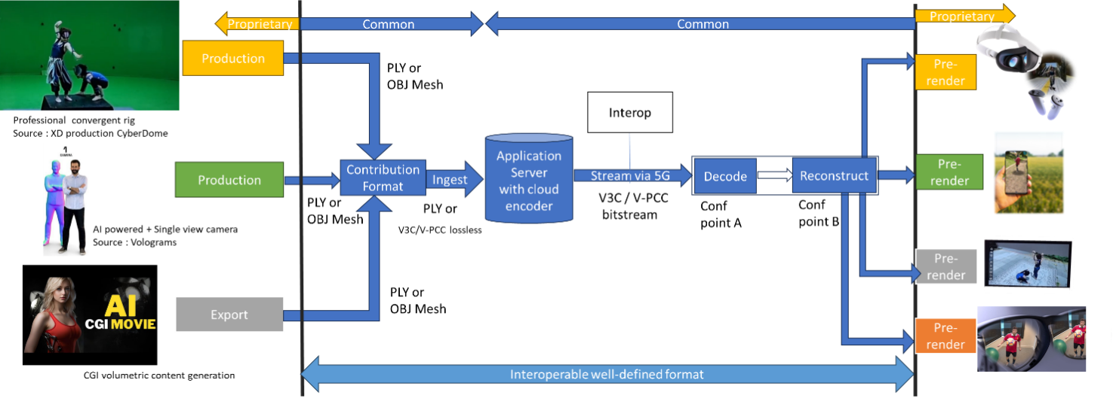]
Figure 7.3.3-1: Streaming of professionally produced Volumetric Video with single asset containing people (content courtesy XD Productions)
Editor’s Note: This Figure needs to be replaced to avoid copyright issues.
- Capturing and processing
Capturing of high-quality 6 DoF assets as a volumetric video is typically done with a rig of cameras aligned on a circle around the asset(s) to be captured. Depending on the rig, there can be one or more layers of cameras at different height positions. The number of cameras per layer depend again on the designer of the rig and in the year 2024 there are typically between 30 and 100 cameras per layer. Cameras can be equipped with depth sensors. Hardware such as cameras and depth sensors are mostly off the shelf equipment, but the assembly in the rig is vendor dependent and proprietary.
The various camera and depth sensor signals are fed into a production pipeline that produces the volumetric video. Production includes stitching the various signals, filling holes, correcting occlusions, etc. Persons or physical objects (e.g. a ball or an instrument) can be combined in an asset or separate assets can be used for each person or object. For simplification and not hindering the purpose, the use case described in this document is limited to a single asset. The representation format of a produced asset is typically a dense dynamic point cloud or a dynamic mesh.
As an example, in the following the production pipeline of the company XD Productions is illustrated.
The figures below show the XD Productions CYBERDOME capture rig and associated real time viewing to control acquisition.
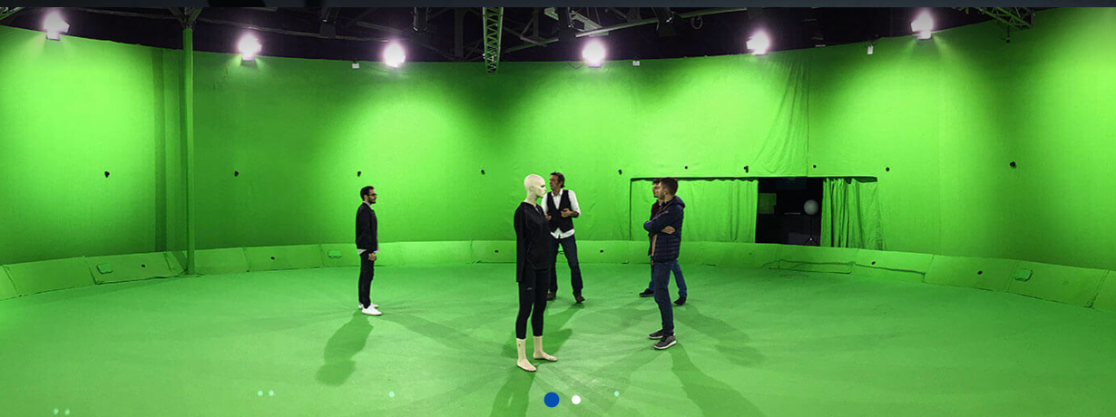
Figure 7.3.3-2: XD Productions capture rig (https://www.xdprod.com/services/studio/studio-virtuel/)
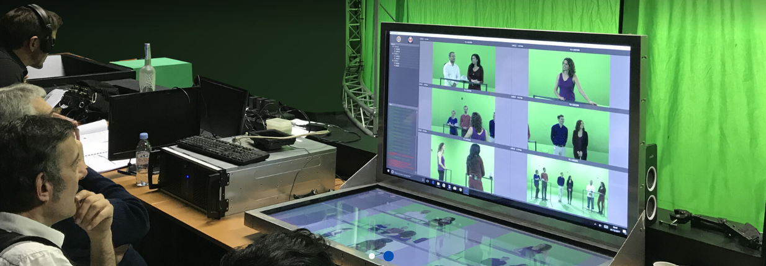
Figure 7.3.3-3: XD Production real time virtual production (https://www.xdprod.com/services/studio/studio-virtuel/)
The figures below show CYBERDOME acquisitions covering single or multiple characters in dynamic scenes.
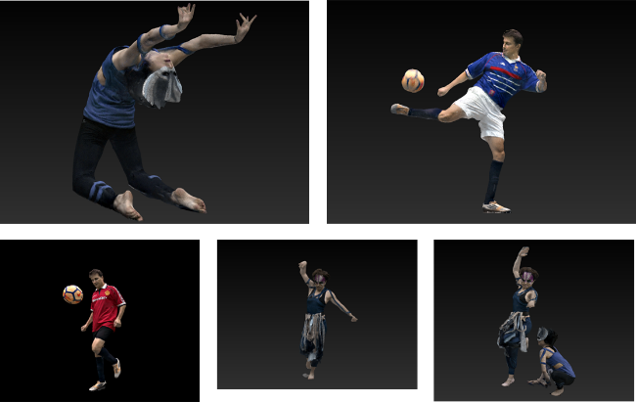
Figure 7.3.3-4: XD Productions contents screenshots, from top right to left: Acrobat01, Soccer Blue, Soccer Red, Dancer01 and Acrobat Duo
The acquisition processing pipeline includes a rig of about sixty 4K cameras, arranged in hemispheres around the scene to be captured. The set is 15-meter in diameter for a 7-meter diameter capture area. Two types of lenses are simultaneously used, with variable focal lengths, which allows to adapt the size of the capture area, and to mix wide shots and close-ups on the same captures to improve the quality of the textures. Each content item is then converted into point cloud frames. The processing output is provided in the PLY format.
Another example on how single asset volumetric video is produced is shown in a video (https://www.youtube.com/watch?v=xX4SJTE3hmQ) by Metastage.
There are several companies that provide volumetric video capturing technology or entire volumetric video capturing studios. More detailed information can be found in chapter 5.4.4 of the DVB Study Mission report S101 on Volumetric Video.[Vol-9]
The Volumetric Format Association [Vol-3] describes an end-to-end volumetric chain including capturing, processing, encoding, decoding and rendering. After capturing the processing generates a point cloud that can be encoded and delivered as dense dynamic point cloud and reconstructed either as a point cloud or as a mesh for rendering.
The Ultra Video Group of Tampere University describes the process of generating volumetric video content with the Mantis Vision system in their paper [Vol-10]. In a first step from the signals from multiple camera units on the rig a raw point cloud of the person or object is generated. In a second step a mesh is generated by using surface reconstruction algorithms. In a third step the mesh is sampled to generate a point cloud, which can then be voxelized on a regular 3D grid and normal can be calculated if needed.
It can be concluded that dense dynamic point clouds and dynamic meshes are used by industry to represent persons or objects as volumetric video.
In the following it is described how the scenario can be implemented with MPEG V-PCC [VOL-11] by using dense dynamic point clouds and with MPEG V-DMC [DM-20] by using dynamic meshes for representing the single asset.
The following figure shows the V-DMC workflow:
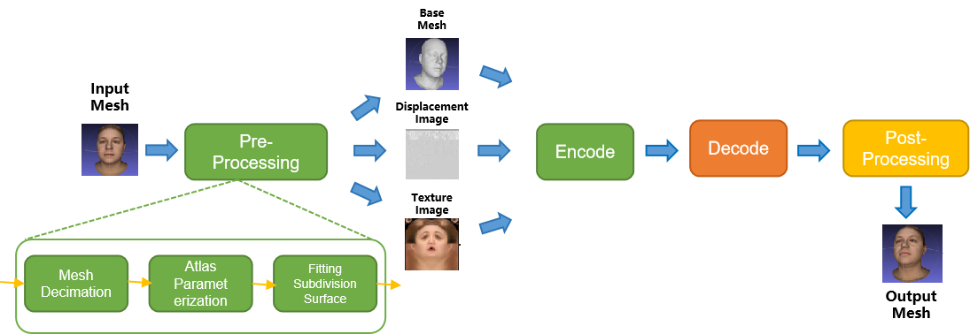
Figure 7.3.3-X V-DMC Workflow
The pre-processing stage consists of three main processes: a decimation step, an atlas parameterization step, and a subdivision step.

- Encoding
Volumetric video can be represented in the representation format dense dynamic point clouds. MPEG has developed a specification named V-PCC for compressing and delivering the representation format dense dynamic point clouds at bitrates enabling consumer applications. V-PCC is standardized in ISO/IEC 23090-5 Visual Volumetric Video-based Coding (V3C) and Video-based Point Cloud Compression (V-PCC) – 2nd edition [Vol-11].
During its experimentation with V-PCC KDDI implemented a real time V-PCC encoder [Vol-1].
The following figure shows the V-PCC encoder main steps.
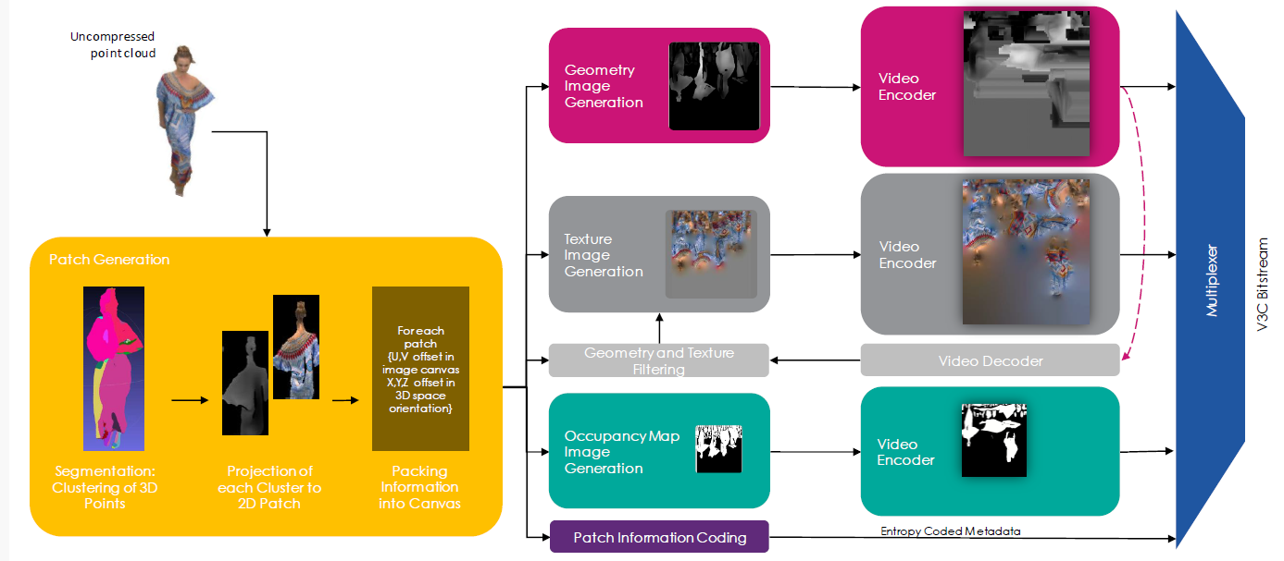
Figure 7.3.3-5 V-PCC encoder main steps (Content courtesy 8i)
For encoding of geometry, texture and occupancy map V-PCC relies on 2D video codecs. Due to its efficiency and market penetration HEVC aka H.265 is the choice of 2D video codec for the presented scenario.
Volumetric video can also be represented in the representation format dynamic mesh. MPEG has developed a specification named V-DMC for compressing and delivering the representation format dynamic at bitrates enabling consumer applications. V-DMC is standardized in ISO/IEC 23090-29 Video-based dynamic mesh coding (V-DMC). As V-PCC, V-DMC relies on (HW-accelerated) video codecs for the bulk of the data (attribute maps, …).
The following figure shows the V-DMC encoder main steps.
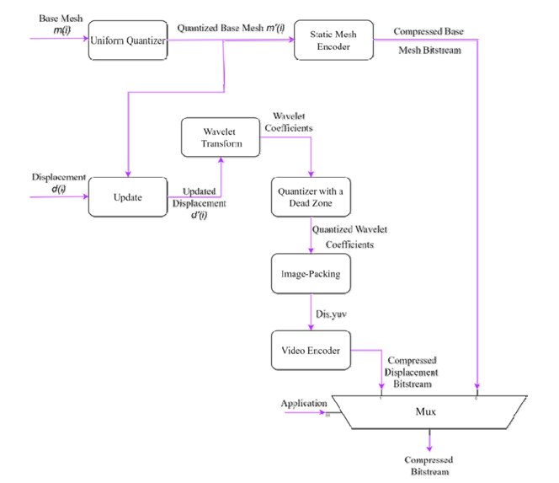
Figure 7.3.3-6 V-DMC encoder main steps (Vol-X1)

- Packaging and delivery
MPEG has developed a specification addressing storage and delivery of V-PCC coded data published as ISO/IEC 23090-10 Carriage of visual volumetric video-based coding data – 1st edition [Vol-12].
As of April 2025, MPEG is working on the second edition of ISO/IEC 23090-10 that will cover V-DMC storage in ISOBMFF format and delivery utilizing DASH.

An overview of MPEG standards for storage and transport of V3C can be found in [Vol-X].
- Decoding
For the dense dynamic point cloud representation format, decoding can rely on the V-PCC specification and for dynamic mesh it can rely on the V-DMC specification. In both cases no dedicated hardware is required for real-time decoding on consumer devices. If the encoder uses HEVC for the 2D video encodes, the decoder in the device can make use of integrated hardware HEVC video decoder capabilities for all pixel data, and a small number of data is decoded by a CPU.
As an example, the following figure shows the architecture of a V-PCC decoder.
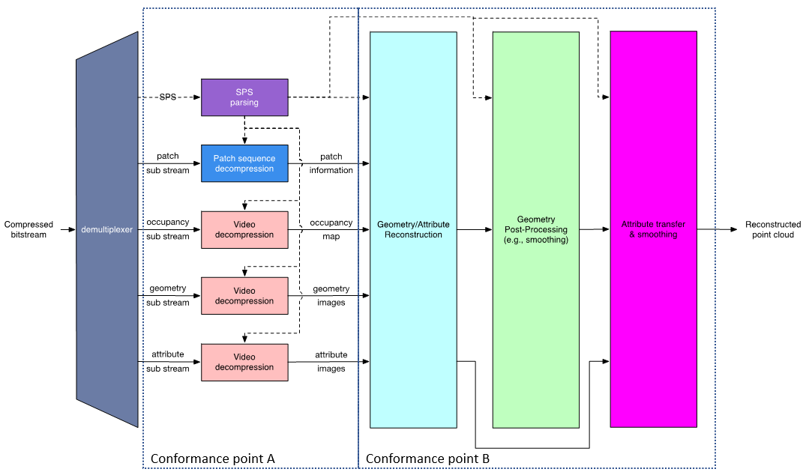
Figure 7.3.3-6 V-PCC decoder main steps
Decoding of the dense point cloud is terminated at the output of the video decoders, but these images are just intermediate results and do not represent a useable image for the human eye. Additional stages are needed to reconstruct the dense point cloud in 3D space and render it to the display of a consumer device. It can be rendered to 2D displays of e.g. smartphones and tablets, but also on head mounted devices or other 3D displays.
An example of point cloud data decoding processing has been described in [Vol-13].
During its experimentations with V-PCC and V-DMC, KDDI implemented a real time V-PCC encoder/decoder [Vol-1] and a V-DMC encoder/decoder [Vol-32].
Futuresource estimates that by the end of 2023 there are 4.1 billion Smartphones globally in the field with the capacity to decode HEVC video [Vol-14].
- *Post-processing
Post-processing is implementation dependent, but it is typically performed on a GPU without dedicated V-PCC/V-DMC hardware.
- Rendering
Rendering is implementation dependent, but it is typically performed on a GPU without dedicated V-PCC/V-DMC hardware. More information can be found in section 4.3.3.3 for dense dynamic point cloud and in section 4.3.5.3 for dynamic mesh.
- General constraints on latency, bandwidth, reliability and complexity
For delivery, the volumetric video frames are organized using a random-access reference frame structure.
All decoder and renderer processes are real-time and may have a latency in the order of a few frames.
== CHANGE 2 (all new) ===

7.3.4 Source format properties
As source format for the scenario the representation formats dense dynamic point clouds and dynamic mesh are considered. Section 4.3.3 describes the dense dynamic point cloud format and section 4.3.5 describes the dynamic mesh format. The present section provides more detail in direct relation with the scenario.
The following table includes signal properties that are typically used in the near/mid term to represent people or objects.
Table 7.3.4-1 Signal properties for dense point cloud format
Source format properties | Volumetric Video with single asset
Number of points /Spatial Resolution | Up to 2 million points per frame
Chroma format | RGB
Chroma subsampling | Not Applicable
Picture aspect ratio | Not Applicable
Frame rates | 25, 30 Hz
Bit depth | 8 and 10
Colour space formats | RGB 444 nonlinear, BT.709
Transfer characteristics | BT.709
Viewpoints | All assets can be viewed from all directions and different distances

Table 7.3.4-2 Signal properties for dynamic mesh format
Source format properties | Volumetric Video with single asset
Number of vertices /Spatial Resolution | TBD
Chroma format | RGB
Chroma subsampling | Not Applicable
Picture aspect ratio | Not Applicable
Frame rates | 25, 30 Hz
Bit depth | 8 and 10
Colour space formats | RGB 444 nonlinear, BT.709
Transfer characteristics | BT.709
Viewpoints | All assets can be viewed from all directions and different distances
The UHD World Association analyzed of over 110,000 samples on Sketchfab and provided the following typical parameters for different levels of experience for dynamic mesh：
Quality | Frame Rate | Texture Resolution | Texture Frame Sequence Bitrate | Mesh Polygon Count | Mesh Frame Sequence Bitrate
Acceptable | 30fps | 2048 × 2048 | 10 Mbps (H.265) | 10,000 | 70 Mbps
Good | 30fps | 4096 × 4096 | 25 Mbps (H.265) | 50,000 | 125 Mbps
Excellent | 60fps | 8192 × 8192 | 60 Mbps (H.265) | 1,000,000 | 260 Mbps

Editor’s note: Information TBD to be provided from CTC
For highly dynamic sports sequences higher frame rates such as 50 or 60 fps may be useful and this is left for the future.
In the following the quality of the dense point cloud representation format for representing people is further investigated.
Editor’s note: Depending on contributors, similar information could be provided in future for dynamic mesh

7.3.4.1 Conversion and quantization for dense dynamic point cloud format
If volumetric video source sequences are delivered in production quality, then bandwidth for consumer delivery may be too high and a conversion/quantization is necessary to reduce the number of points and use the fixed-point format. The result of that conversion is that the sequence is in a bounding box of 10, 11 or 12 bit which is named in the following as Vox10, Vox11 and Vox12.
- Vox 12 creates a quality that is close to the quality that comes out of the production system for most provided sequences. Emotional facial expressions are clearly visible and tissue structure of cloths is visible. See figures Y2 and Y5 below.
- Vox 11 creates a quality that allows viewing the sequence from a wider distance and it allows to zoom closer. Emotional facial expressions and patterns on cloths is visible. See figures Y3 and Y6 below.
- Vox 10 creates a quality allowing to view the sequence from a wider distance, but getting too close is less recommended. See figures Y4 and Y7 below.

7.3.4.2 Impact of rendering for dense dynamic point cloud format
It is referred to section 4.3.3.3 that covers rendering and display systems. Rendering is typically not covered by standards and allows manufacturers to differentiate. The referred section discusses hole filling, but also techniques such as local meshing could be applied.

7.3.4.3 Impact of the background
To avoid interference between the background and the test sequence, it is recommended to use a neutral background colour for codec evaluation. If a VR or AR background is used instead of a neutral background, potential artefacts in the sequence are less visible, as the human eye concentrates on the overall picture and not only on the sequence.
This means also that in a real service where a background is used, potential artefacts in a sequence are less visible.
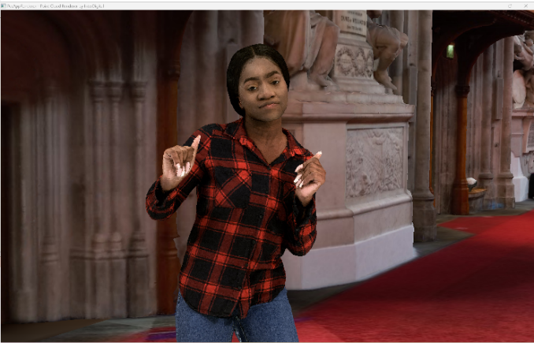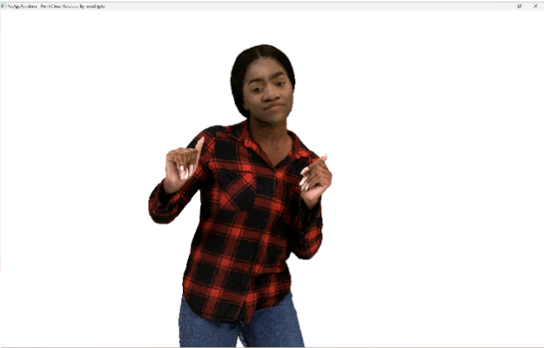
Figure 7.3.4.3-1 Impact of background on perceived quality (content courtesy RenderPeople [Vol-15])

7.3.4.5 Visual quality examples sequences in dense dynamic point cloud format
In the following the impact of number of points in a frame and type of renderer on the visual quality of the dense point cloud representation format is demonstrated. In this section still pictures are used to judge the preserved detail. In a volumetric video sequence some artefacts in the snapshots may not be visible.
It can be observed that sequences represented as dense point clouds of around 1M points/frame allow to watch a sequence with a person in AR from a wider distance (e.g. from 3m*) and point clouds of around 2M points/frame allow to get closer (e.g to around 1.5m distance) at good quality for the target scenario. In the latter emotional facial expressions and tissue structure of cloths is visible. More points per frame improve the details, but this may not be required for the target scenario. But if a scenario would require it, a high-end volumetric video production system is able to capture details from e.g. skin or finer details of tissue and it can be represented with the point cloud representation format.
*A typical demonstration scenario would be to use e.g. a smartphone or tablet running a volumetric video application showing a real person of e.g. 3m distance on the screen captured by the camera and rendering at the same time a second person rendered from a point cloud next to the first person.
In the following the sequence Volucap_T003_ThomasScenic-03 from Volucap [Vol-16] is used.

7.3.4.5.1 Thomas near with representative renderer (splat blend mode) and neutral background
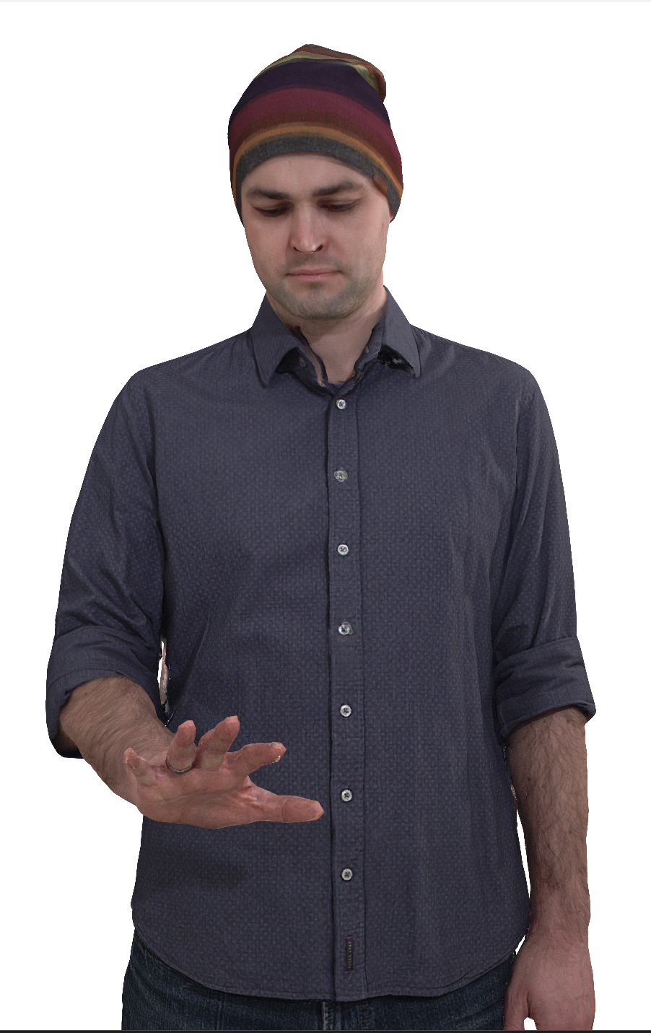
Figure 7.3.4.5.1-1 Vox 12 with 9.5M points per frame (content courtesy by Volucap [Vol-16])

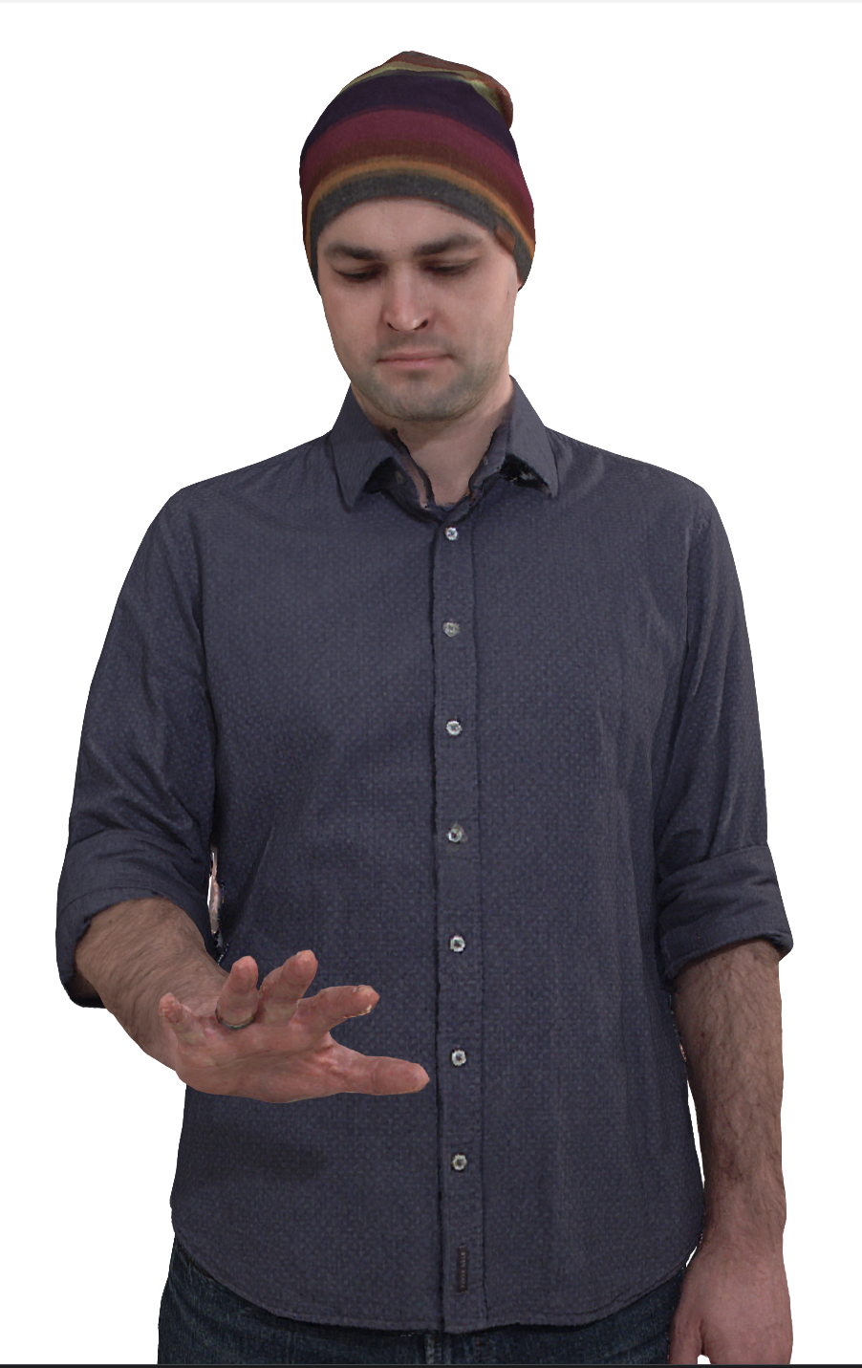
Figure 7.3.4.5.1-2 Vox 11 with 2.3M points per frame (content courtesy by Volucap [Vol-16])

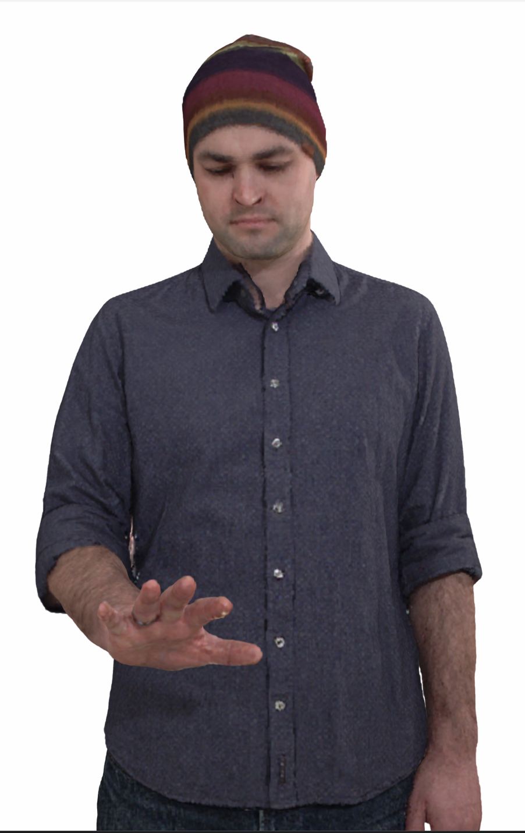
Figure 7.3.4.5.1-3 Vox 10 with 600K points per frame (content courtesy by Volucap [Vol-16])

7.3.4.5.2 Thomas near with representative renderer (cube mode) and neutral background
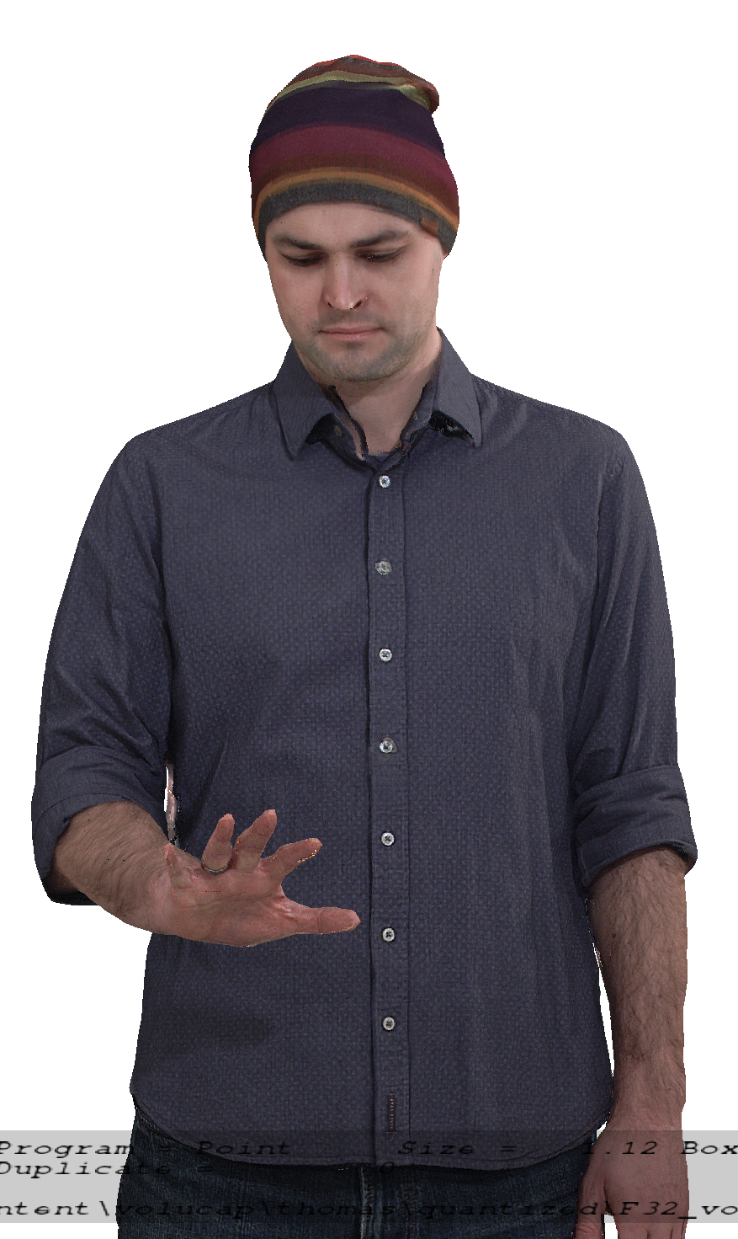
Figure 7.3.4.5.2-1 Vox 12 with 9.5M points per frame (content courtesy by Volucap [Vol-16])

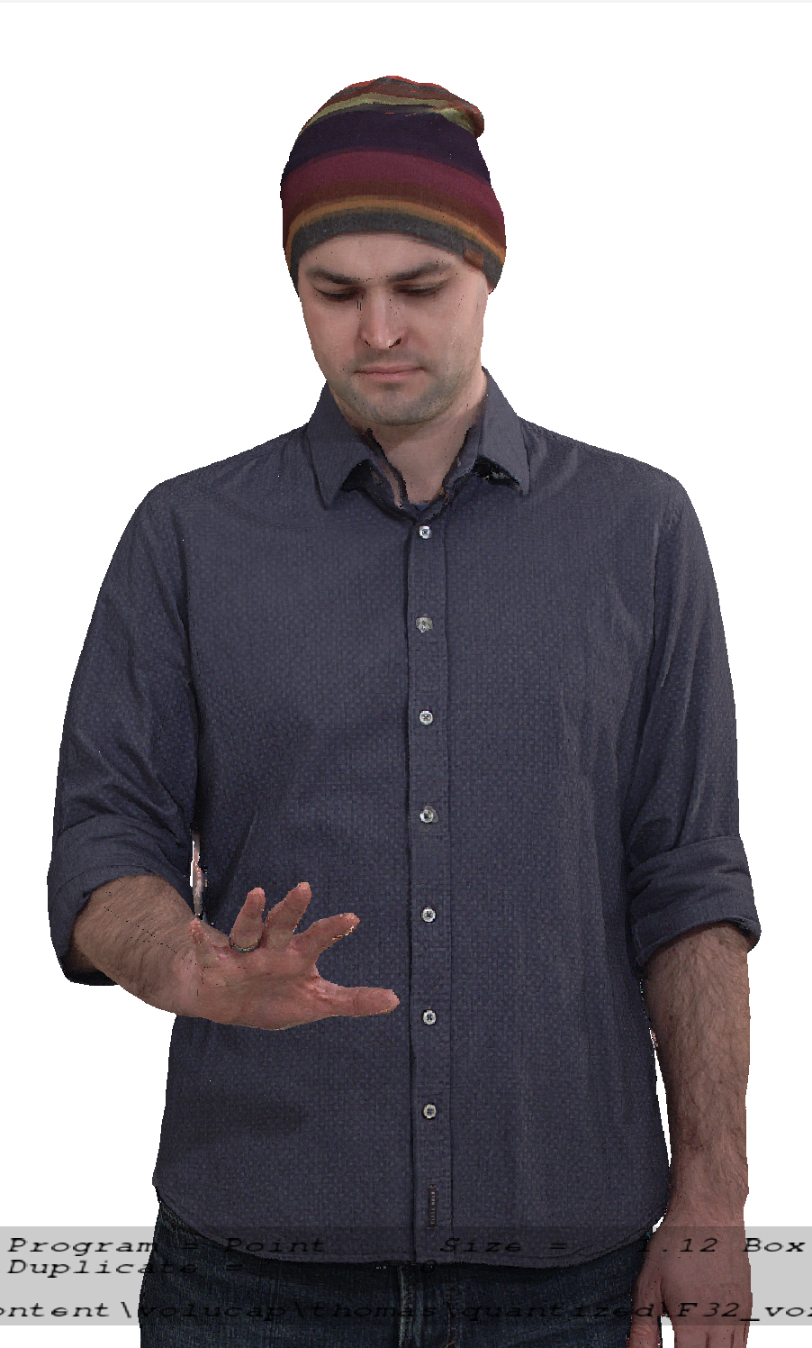
Figure 7.3.4.5.2-2 Vox 11 with 2.3M points per frame (content courtesy by Volucap [Vol-16])

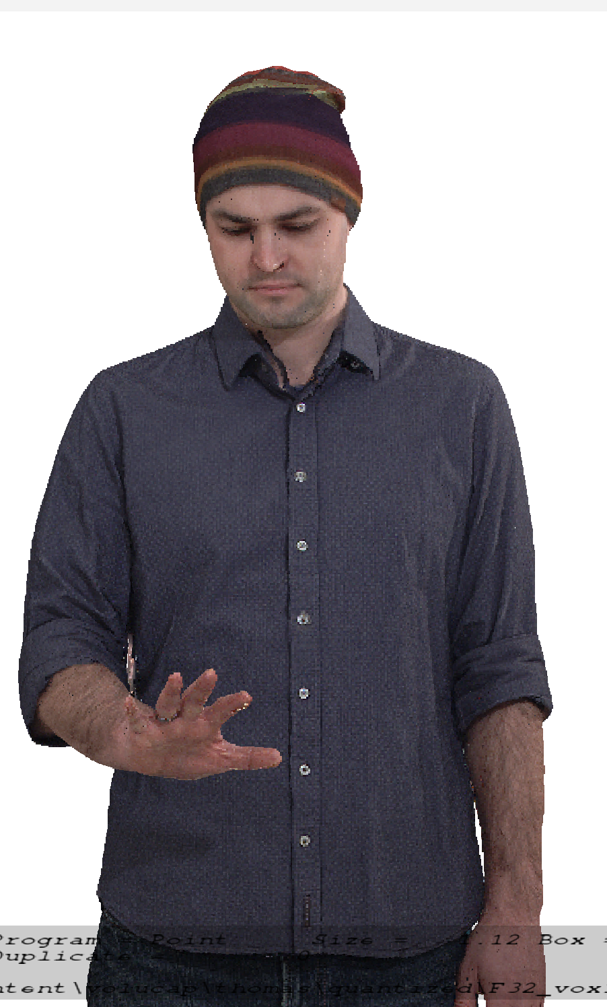
Figure 7.3.4.5.2-3 Vox 10 with 600K points per frame (content courtesy by Volucap [Vol-17])

== CHANGE 3 (all new) ===

7.3.5 Encoding and decoding constraints and settings
The following table provides an overview of encoding and decoding constraints for V-PCC with H.265/HEVC as codec for the Volumetric Video with single asset streaming scenario. Contribution aspects are not considered in this table.
Table 7.3.5 Encoding and decoding constraints
Encoding and Decoding Constraints | V-PCC with H.265/HEVC
Relevant Codec and Codec Profile/Levels | H.265/HEVC Main 10 Profile  Level 4.1, 5.1  Metadata stream parsing
Random access frequency | 1 seconds
Bit rates and quality configuration | Fixed QP Geometry: [32;28;24;20;16]  Fixed QP Texture: [42;37;32;27;22]  bitrates [1;50 Mbps]
Bit rate parameters (CBR, VBR, CAE, HRD parameters) | Covering a range of relevant bitrates and qualities
Latency requirements and specific encoding settings | No specific latency requirement
Encoding complexity context | Cloud-based encoding, offline encoding
Required decoding capabilities | 3 decoder instantiations of H.265/HEVC Main 10 Profile  Level 4.1, 5.1 for (occupancy, geometry and color)  One synchronized metadata bitstream (Atlas)

Table 7.3.6 Encoding and decoding constraints
Encoding and Decoding Constraints | V-DMC with H.265/HEVC
Relevant Codec and Codec Profile/Levels | Texture: H.265/HEVC Main 10 Profile Level 4.1, 5.1  Geometry: H.265/HEVC Main 10 Profile Level 3.0 (e.g. 256x768 at 30 fps)  Metadata stream parsing
Random access frequency | 1 seconds
Bit rates and quality configuration | TBD
Bit rate parameters (CBR, VBR, CAE, HRD parameters) | TBD
Latency requirements and specific encoding settings | No specific latency requirement
Encoding complexity context | Cloud-based encoding, offline encoding
Required decoding capabilities | - Two decoder instantiations of H.265/HEVC Main 10 Profile (Level 5.1 for texture, Level 3.0 for displacement)  - For packed video, one H.265/HEVC Main 10 Profile, Level 5.1  - Decoding of the base mesh (not video decoding) TBD

Editor’s note: Information TBD to be provided

== CHANGE 4 (all new) ===

7.3.6 Performance Metrics and Requirements

7.3.6.1 Anchors
There is no specification in 3GPP that references a volumetric video anchor codec suitable for the streaming single asset scenario. MPEG V-PCC [Vol-11] is the first codec supporting the dense dynamic point cloud representation format with inter coding and therefore no anchor codec for that format can be selected Similar to V-PCC, MPEG V-DMC [Vol-32] is the first codec supporting the dynamic mesh representation format and therefore no anchor codec for that format can be selected.

7.3.6.2 Objective tests
Objective tests for dense dynamic point cloud codecs and dynamic mesh codecs follow the principles as defined in TR 26.955, besides that there is no anchor:
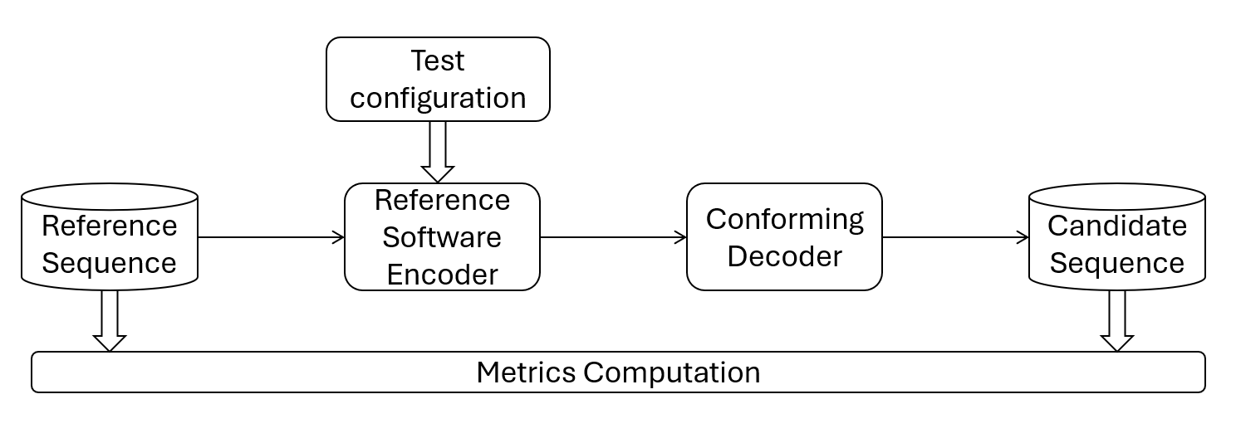
Figure 7.3.6.2-1 Test architecture for objective test
MPEG WG7 specified an objective metric that allows to characterize point cloud codecs. This objective metric is described in in annex B of the Call for Proposals for Point Cloud Compression [Vol-16]. MPEG WG7 used this “point-based” metric to develop codecs for point cloud compression. The “point-based” metric operates in 3D space and provides information on geometry and color distortion.
From 2D video objective testing it is known that a single objective metric is limiting, therefore “PCQM” [Vol-17] is added as a second objective metric in addition to the “point-based” metric.
Both objective metrics, the “point-based” metric and PCQM will be reported for all rate points and for all reference test sequences.
MPEG WG7 also specified objective metrics that allow to characterize dynamic mesh codecs. These objective metrics are described in in annex B of the Call for Proposals for Dynamic Mesh Coding [Vol-33]. It includes in annex B.1 the “point-based” metric as primary metric and in B.2 the “image-based metric” as informative metric.
To compute metrics, MPEG provides a public version of mpeg-pcc-mmetric [Vol-18]. The metric software implements the “point-based” metric, the “PCQM” metric and the “image-based” metric as referred in this section.
Five rate points that cover a range from low quality to high quality for codecs to be characterized will be selected.
A spreadsheet will be provided to 3GPP SA4 that can be used to visualize the objective results.
Note that objective results obtained with the selected metrics can only be used for comparison with codec for the same format. There is no known objective metric that allows to compare different volumetric video codecs (e.g. dense point cloud against mesh) in a fair manner.

7.3.6.3 Subjective tests
Persons or objects in the “Streaming of professionally produced Volumetric Video with single asset containing people” scenario can be viewed from any angle and distances. To cope with this free viewpoint, MPEG WG7 developed a special procedure how to subjectively evaluate such volumetric sequences: The selected reference sequences are rendered with a renderer by following a pre-defined camera path into a 2D video. The procedure is done with the source reference sequence and with the codec/decoded reference sequence. Both 2D videos can then be evaluated with well-known 2D video evaluation methods.
The software tool that implements rendering of 2D videos from dense dynamic point clouds and dynamic meshes by following a camera path is provided by MPEG [Vol-19] and is named in the following representative renderer.
Due to specifics related point cloud rendering described in 4.3.3., this representative renderer supports two methods how to render voxels, one method is like cubes of a fixed size, the second method is splat blend. The latter draws a camera facing semitransparent splat of radius PointSize centered on the point position. The transparency (or alpha) varies with the distance from the center from fully opaque at the center to nearly transparent at the edge, to provide blending between points and reduce aliasing. In order to correctly use alpha blending, the points are sorted relative to the camera plane. Two blending modes are available, gaussian and linear, and the alpha falloff speed is customizable using the "pointFocus" setting.
For objective compression performance tests against the source reference, the cube method is recommended. For tests of the dense dynamic point cloud format against other volumetric representation formats such as mesh, the splat blend rendering is recommended as it fills holes between voxels. The representative renderer allows to activate a 3D background model or a neutral background. It also allows to activate a floor so that the test sequences look grounded.
A characteristic camera path for each volumetric test sequence is pre-defined to get a length of the output video as close as possible to 10s. A camera path that includes a full person view and a closer view at typical distance to the face is a good example.
The representative renderer produces uncompressed RGB 2D videos that can then be compressed with high bitrate HEVC. Resolution of the videos is 1080p, the frame rate and color space are aligned with the input point cloud.
The produced compressed 2D videos are made available to SA4 members so that the qualityof a codec to be characterized can be judged.
There is no plan to engage an independent subjective test lab.

7.3.6.4 Correlation between the objective and subjective metrics
The objective metrics described in section 7.3.6.2 and the subjective comparison using the representative renderer in cube mode described in section 7.3.6.3 are used to evaluate coding distortions.
From MPEG there is no information available on the correlation between objective and subjective results and this may be investigated on a best effort basis.
A potential way of obtaining such correlation is described: the 4 licensed test sequences used in the MPEG subjective verification test report for V-PCC [Vol-20] can be obtained from the rights holders, the test sequences can be prepared as used in the verification test and objective metrics described in section 7.3.6.2 can be generated. The objective results can then be compared with the subjective results from the verification test and the correlation can be analyzed.
Note that for V-DMC the verification test is not available in the timeframe of this TR and no information will be provided.

7.3.6.5 Verification and crosscheck
All produced bitstreams, metric results and produced videos shall be crosschecked by at least one other 3GPP SA4 member to ensure that results are correct.

== CHANGE 5 (all new) ===

7.3.7 Interoperability Considerations for the application
MPEG-DASH is used with ISO/IEC 23090-10 Carriage of visual volumetric video-based coding data – 1st edition.[Vol-21]
As of April 2025, MPEG is working on the second edition of ISO/IEC 23090-10 that will cover V-DMC storage in ISOBMFF format and delivery utilizing DASH.
RTP is not proposed for this scenario.

== CHANGE 6 (all new) ===

7.3.8 Test Sequences
Editor’s Note: The content of this scenario relates to moving persons.

7.3.8.1 Candidate source sequences
Collected candidate raw dense point cloud sequences and dynamic mesh sequences that are available for testing are presented in Annex C.2

7.3.8.2 Selected source sequences for testing
This section lists 5 sequences that have been selected for objective and subjective testing.
Test sequences have been selected based on visual quality and that these have not been used during codec development in MPEG. The following table lists the selected test sequences:
Table 7.3.8.2 Selected source dense dynamic point cloud sequences
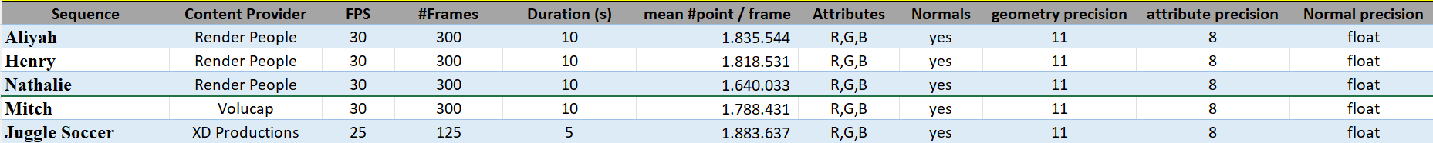

Table 7.3.8.3 Selected source dynamic mesh sequences
Editor’s note: To be done for dynamic mesh

The following thumbnails illustrate the selected test sequences:
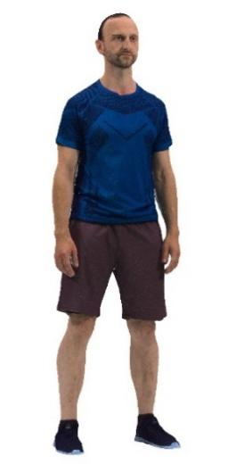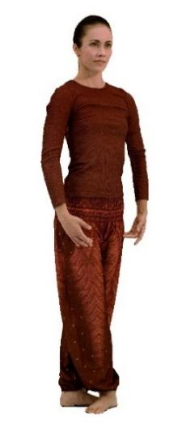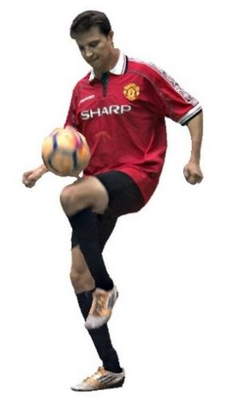
Figure 7.3.8.2-1 Aliya, Henry, Nathalie, Mitch and Joggle Soccer (content courtesy by Renderpeople, Volucap and XD Productions)
The selected licensed source sequences can be grouped as follows:
- Group 1 - Freely available to 3GPP members: Nathalie, Mitch and Joggle Soccer
- Group 2 - Publicly purchasable: Henry
- Group 3 - Publicly free available: Aliyah

Editor’s note: Test sequences for dynamic mesh to be added

Sequences of group 1 have already been converted to pointclouds of around 2 million points per frame and maximum 10s length and are provided on the server. Sequences of group 2 and group 3 need to be downloaded and converted by those wanting to reproduce completely the test.
Editor’s Note: Provide instructions and scripts on how to convert sequences of group 2 and group 3

7.3.8.3 Metadata for source dense dynamic point cloud sequences

7.3.8.3.1 Overview
For a raw dense point cloud sequence used in the context of this Technical Report, the following metadata is proposed:
- Name of the sequence
- Scenario
- Sequence key as provided in TR 26.956
- URI to zip file containing PLY files (URL to weblink where the original sequence is available)
- Name Format of files
- Frame count
- Start frame number
- Frame rate
- Geometry precision
- Color format
- Peak Value (bounding box resolution e.g. 1023, 2047)
- Copyright statement
- Contact Person
Optionally, the following metadata can be added:
- Background
- TR 26.956 reference
- Thumbnail preview
- Preview MP4
- Average point number per frame
- Duration
- MD5 of the zip file containing all point cloud frames
Size in bytes of the zip file containing all point cloud frames.
A JSON scheme is defined in clause 2.2 for this matter. An example is provided in clause 2.3

7.3.8.3.2 JSON Scheme
JSON schema for the raw format can be found in Annex B.2.3.

7.3.8.3.3 Example
An example is attached to the zip file:
{
"Sequence": {
"Name": "Exemple",
"Background": "This is a B2DV format example",
"Scenario": "Streaming of Beyond 2D Produced VoD Content",
"Key": "S01",
"TR26.956": "Annex X.Y.Z"
},
"Properties": {
"URI": "https://dash-large-files.akamaized.net/WAVE/3GPP/Beyond2D/ReferenceSequences/file.zip",
"thumbnail": "https://dash-large-files.akamaized.net/WAVE/3GPP/Beyond2D/ReferenceSequences/file.png",
"preview": "https://dash-large-files.akamaized.net/WAVE/3GPP/Beyond2D/ReferenceSequences/file.mp4",
"NameFormat": "exemple%04d.ply",
"frameCount": 320,
"startFrame": 0,
"frameRate": 30,
"pointsCountMean": 1000000,
"geometryPrecision": 10,
"colorformat": "rgb",
"peak": 2047,
"duration": 10.0,
"md5": "d055a94f35f7594776186fc5d09a9fa4",
"size": 11510343938
},
"CopyRight": "Conditions that are suitable for this study",
"Contact": {
"Name": "Celine Guede",
"Company": "InterDigital",
"e-mail": "celine.guede@interdigital.com",
"generation": "provided by contact"
}
}

7.3.8.3 Metadata for source dynamic mesh sequences
Editor’s note: To be done for dynamic mesh

== CHANGE 7 (all new) ===

7.3.9 Detailed test conditions

7.3.9.1 V-PCC
Editor’s note: Contribution S4-250446 on update V-PCC testing will replace that section if agreed

7.3.9.1.1 V-PCC test model and configuration files
The public version of the MPEG V-PCC test model named tmc2 in master branch is used to encode and decode dense dynamic point clouds [Vol-26].
Editor’s note: Configuration files to be validated
For using tmc2 in Random Access (RA) mode, MPEG provides a configuration file [Vol-27].
For each selected test sequence, a configuration file containing information needed for tmc2 configuration will be provided.

7.3.9.1.2 Rate points and test conditions
In line with the V-PCC verification test [Vol-28], 5 rate points R1 to R5 for Random Access (RA) will be used for each test sequence. Rates are obtained with the following V-PCC codec parameters:
 | R1 | R2 | R3 | R4 | R5
QP geometry | 32 | 28 | 24 | 20 | 16
QP Texture | 42 | 37 | 32 | 27 | 22
Occupancy Precision | 4 | 4 | 4 | 4 | 2

Editor’s note: Configuration files to be validated
For using this rate configuration, MPEG provides configuration files for each rate [Vol-29].

7.3.9.1.3 Profiles
In line with the V-PCC verification test [Vol-28], the following profiles are evaluated:
- Basic which corresponds to V-PCC profile HEVC Main10 V-PCC Basic Rec0. This profile uses the basic V-PCC toolset and a simple reconstruction of points in 3D space.
- Enhanced which corresponds to V-PCC profile HEVC Main10 V-PCC Basic Rec2. This profile uses the basic V-PCC toolset and a more sophisticated reconstruction of points in 3D space.
- High which corresponds to V-PCC profile HEVC Main10 V-PCC Extended Rec2. This profile uses the extended V-PCC toolset and a more sophisticated reconstruction of points in 3D space.

7.3.9.1.4 Bitstream Generation, output
The MPEG V-PCC test model is used to encode and decode test sequences as described previously [Vol-26].
To compute metrics, the tool mpeg-pcc-mmetric [Vol-18] is used.
Python scripts will be provided to be able to:
- Encode each sequence for each condition, rate and profile
- Decode the corresponding sequence
- Compute metrics
- Generate tables and graphs
Below are examples of command lines for the basic profile for a vox11 sequence:
- to encode a test sequence:
mpeg-pcc-tmc2/bin/PccAppEncoder \
--config=mpeg-pcc-tmc2/cfg/common/ctc-common.cfg \
--config=mpeg-pcc-tmc2/cfg/condition/ctc-random-access.cfg \
--config=mpeg-pcc-tmc2/cfg/sequence/${test_sequence}.cfg \
--config=mpeg-pcc-tmc2/cfg/rate/ctc-r1.cfg \
--configurationFolder=mpeg-pcc-tmc2/cfg/ \
--uncompressedDataFolder=${source_sequence}/ \
--compressedStreamPath=${test_sequence}.bin \
--normalDataPath=${source_sequence}/${source_sequence}_%04d.ply \
--frameCount=32 \
--resolution=2047 \
--mapCountMinus1=0 \
--profileToolsetIdc=0 \
--profileReconstructionIdc=0

- to decode a test sequence:
mpeg-pcc-tmc2/bin/PccAppDecoder \
--startFrameNumber=0 \
--compressedStreamPath=${test_sequence}.bin \
--reconstructedDataPath=${test_sequence}_dec_%04d.ply \
--inverseColorSpaceConversionConfig=mpeg-pcc-tmc2/cfg/hdrconvert/yuv420toyuv444_16bit.cfg

- to compute metrics of a test sequence:
mpeg-pcc-mmetric/build/Release/bin/mm sequence \
--firstFrame 0 \
--lastFrame 31 END \
compare --mode pcc \
--inputModelA source_sequence_%04d.ply \
--inputModelB test_sequence_dec_%04d.ply END \
compare --mode pcqm \
--inputModelA source_sequence_%04d.ply \
--inputModelB test_sequence_dec_%04d.ply

For each test, outputs are:
- Bitstream file
- Log files containing metrics information
- Encoder log output
- Decoder log output
- Metric log output
A CSV file containing concatenated metrics information for each condition and one profile is generated for all sequences and rates.
The following information will be stored:
- SeqId: identifier of the sequence
- CondId: tested condition (RA)
- RateId: tested rate number [R1..R5]
- nbFrame: number of tested frames
- NbInputPoints: number of points in the source sequence
- NbOutputPoints: number of points in the candidate test sequence
- MeanOutputPoints: mean number of points in the candidate test sequence
- MeanDuplicatePoints: mean number of duplicated points (with same geometry) in the candidate test sequence
- TotalBitstreamBits: size of the bistream in bits
- geometryBits: size of the geometry stream in bits
- metadataBits: size of the metadata stream in bits
- attributeBits: size of the attribute stream in bits
- D1Mean: mseF,PSNR (p2point)
- D2Mean: mseF,PSNR (p2plane)
- LumaMean: c[0],PSNRF
- CbMean: c[1],PSNRF
- CrMean: c[2],PSNRF
- PCQM: PCQM PSNR
- SelfEncoderRuntime: encoder time for current process
- ChildEncoderRuntime: encoder time for child processes
- SelfDecoderRuntime: decoder time for current process
- ChildDecoderRuntime: decoder time for child processes
From this CSV file, an excel spreadsheet is generated to get tables and graphs for interpretation of the results.

7.3.9.1.5 Videos Generation for subjective tests
The representative renderer [Vol-19] is used to generate the videos for the subjective test.
To avoid interference between the background and the test material, a neutral background with a color will be selected. A floor makes the rendered scene more realistic by preventing interference with the test material.
A script will be provided to generate videos with chosen camera path.
For each sequence, a video is generated. A camera path and blend parameter options adapted to each sequence is provided [Vol-30]. The output of this video generation with a camera path is stored as high-quality video sequence of a length as close as possible to 10s.
The generation is done into two steps: first the generation of the RBG raw file with the camera path and then the conversion into YUV or MP4 files.
Here is an example of the two command lines:
1-To generate a RGB raw file with a specific camera path
./PccAppRenderer.exe -d ${test_sequence}\
-i 1 \
-n 32 \
--play=1 \
--playBackward=1 \
--height=1080 --width=1920 \
--type=3 --alphaFalloff=6 --size=3.2 --blendMode=0 \
--floor=1 --overlay=0 \
--camera=${camera_path}.txt
--RgbFile=${test_sequence_rgb}

2-To convert the RGB file to x265 lossless mp4 file
./scripts/convert_video.sh \
-o ${test_sequence}_x265lossless.mp4 \
--videoType=2
--ffmpeg=ffmpeg.exe
-i ${test_sequence_rgb}.rgb

The video sequences are generated with the following video parameters:
- Video resolution: progressive uncompressed full-range HD format (1920x1080). Note that upsampling by the TV set should be avoided
- Frame rate: The frame rate will be aligned with the frame rate in the test data set
- Color space: ITU-R BT.709
- Sub-sampling: 4:2:0 YUV 10 bits or x265 fast preset lossless

7.3.9.2 V-DMC
Editor’s note: Testing of V-DMC will depend on availability of stable V-DMC specification (including profile to be tested), stable public test model and volunteers to contribute

7.3.9.2.1 V-DMC test model and configuration files

7.3.9.2.2 Rate points and test conditions

7.3.9.2.3 Profiles

7.3.9.2.4 Bitstream Generation, output

7.3.9.2.5 Videos Generation for subjective tests

7.3.9.3 Verification / crosschecks
All produced bitstreams, metric results and produced videos will be crosschecked by at least one other SA4 member to ensure that results are correct.

== CHANGE 8 (all new) ===

7.3.10 External Performance data
The subjective verification test report for V-PCC can be downloaded from the public MPEG website [Vol-20]
The Brazilian SBTVD Forum performed objective tests with V-PCC. Full results are available in chapter 6.10 (Candidate Technology I), 6.10.3.2 and 6.10.4 of the following document [Vol-31]

== CHANGE 9 (all new) ===

7.3.11 Additional information
Sequences can be decoded and visualized in real time using a 3D background or in Augmented Reality on a smartphone, tablet, head-mounted display using DASH streaming mode or local file system.
Nokia’s real-time V-PCC decoder implementation that was released as open source: https://github.com/nokiatech/vpcc
A simple scene description could be added to enable the placement of the asset in the scene (position, orientation, scale…) but is outside the scope of this document, which is focused on the format and codec evaluation.
Editor’s note: Add information for V-PCC on 5G-MAG

== CHANGE 10 (all new) ===

2 References
[DM-20] ISO/IEC 23090-29 Video-based dynamic mesh coding (V-DMC)
[VOL-32] https://www.kddi-research.jp/newsrelease/2025/020601.html
[VOL-33] CfP for Dynamic Mesh Coding, https://www.mpeg.org/wp-content/uploads/mpeg_meetings/136_OnLine/w21000.zip
[Vol-X] Ilola, L., Kondrad, L., Schwarz, S., & Hamza, A. (2022). An overview of the MPEG standard for storage and transport of visual volumetric video-based coding. Frontiers in Signal Processing, 2, 883943.
[Vol-X1] Jing, Liqi. “Research on Video-based Dynamic Mesh Compression Technology and Proposed Improvements.” Advances in engineering research/Advances in Engineering Research, 2024, pp. 47–57, doi:10.2991/978-94-6463-518-8_6.

