3GPP TSG-SA4 Meeting #127-bis-e S4-240591r01

Online, , 8th Apr 2024 - 12th Apr 2024
CR-Form-v12.3
CHANGE REQUEST
 | 26.804 | CR | 0006 | rev | - | Current version: | 18.1.0
For HELP on using this form: comprehensive instructions can be found at
http://www.3gpp.org/Change-Requests.

Proposed change affects: | UICC apps |  | ME | X | Radio Access Network |  | Core Network | X

Title: | [FS_AMD] Multi-CDN and Multi-Access Media Delivery
Source to WG: | Dolby France SAS
Source to TSG: | S4
Work item code: | FS_AMD |  |  |  |  |  | Date: |  |  | 2024-04-02
Category: | B |  |  |  |  |  | Release: |  |  | Rel-19
 | Use one of the following categories:  F (correction)  A (mirror corresponding to a change in an earlier release)  B (addition of feature),  C (functional modification of feature)  D (editorial modification)  Detailed explanations of the above categories can  be found in 3GPP TR 21.900. |  |  |  |  |  |  |  | Use one of the following releases:  Rel-8 (Release 8)  Rel-9 (Release 9)  Rel-10 (Release 10)  Rel-11 (Release 11)  …  Rel-17 (Release 17)  Rel-18 (Release 18)  Rel-19 (Release 19)  Rel-20 (Release 20)
Reason for change: |  | Document the FS_AMD key topic “c) Multi-Access and Multi-CDN Delivery” description and collaboration scenarios.
Summary of change: |  | Addition of new clause 5.x Multi-CDN and Multi-Access Media Delivery including sub-clause structure and headings. Addition of prose for Description and Collaboration Scenarios.
Consequences if not approved: |  | FS_AMD objectives not achieved.
Clauses affected: |  | 5.x (NEW)
 |  | Y | N
Other specs |  |  | X | Other core specifications |  |  |  | TS/TR ... CR ...
affected: |  |  | X | Test specifications |  |  |  | TS/TR ... CR ...
(show related CRs) |  |  | X | O&M Specifications |  |  |  | TS/TR ... CR ...
Other comments:
This CR's revision history: |  | Rev1: SA4#127-bis-e, description and collaboration scenarios

FIRST CHANGE

5.x Multi-CDN and Multi-Access Media Delivery

5.x.1 Description

5.x.1.1 General
Media streaming applications traditionally obtain their content from a single source over a single path within a network. The source and path may change during a media session by, for example, switching from one Content Delivery Network (CDN) or access network to another; but only one source/path is used at any given time. This imposes several limitations. First, performance is constrained to that of the source and path chosen. Whatever the limits on network bandwidth and latency between the client and that source are directly translated to the clients’ achievable Quality of Service (QoS) and Quality of Experience (QoE). Second, disruptions or degraded performance caused by the source in use or on any of the network links between the client and source can lead to poor user experience. Often in the form of lower playback quality, rebuffering, or complete playback failure. Multi-CDN switching techniques and Multi-Access technologies are common approaches to mitigate these challenges; but they are often too slow to react to disruptions or degraded performance and are only good enough to prevent major, long-term disruptions from impacting end-user quality. This study considers integration of different technologies into the 5G Media Streaming System to address these, and similar, issues.

5.x.1.2 Multi-CDN Media Delivery
Content Delivery Networks (CDNs) are often used by content distributors to globally scale delivery of their content to end-users. These networks consist of a number of Points of Presence (PoPs) located at various locations around the networks’ edge. These PoPs help load-balance delivery of content as well as improve Quality of Service (QoS) by reducing the distance/latency between every client and the content they are accessing. In many cases, content distributors employ multiple CDNs to leverage the strengths of one CDN over another in every location those CDNs have a PoP. For example, a client experiencing degraded performance while using one CDN may switch to another that is offering better performance at that time and location. As another example, a content distributor may prefer one CDN over another at a given time to reduce delivery costs and/or meet monthly contractual commitments. These Multi-CDN deployments aim to solve content delivery issues that exist when only one CDN is used; but the benefits they provide are often not fully realized because of the various challenges experienced and underlying methods used to stream content to every client.

An example of degraded QoS that commonly occurs is shown in Figure 5.x.1.2-1 where the time-to-first-byte (TTFB) for HTTP requests sent to three different CDNs are illustrated by the lines and complete HTTP request failures are illustrated as markers. In this example, the nominal TTFB for all three CDNs is in the range of 200 to 300 ms. However, one of the CDNs first experiences a significant increase in the TTFB to over 5500 ms followed by three request failures. Following this short duration of degraded performance, performance for that CDN returns to normal. The total duration of degraded performance for this specific example was only 30 seconds. Existing Multi-CDN switching techniques would have a difficult time either predicting that the degraded performance was going to occur and primitively switching to a different CDN, or switching quickly enough after observing degraded service to avoid impacting the end-user application.
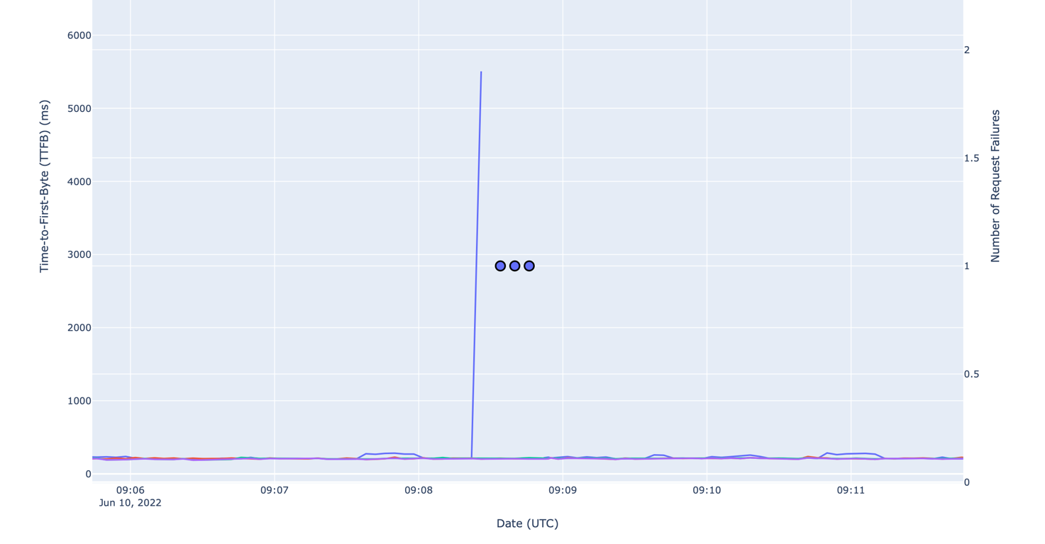
Figure 5.x.1.2-1: Example of an intermittent HTTP request failure.

5.x.1.3 Multi-Access Media Delivery
Multi-Access media delivery is also impacted by challenges similar to Multi-CDN delivery. Typically, media is streamed via one client network interface/access network (e.g., Wi-Fi, 5G, etc.). When performance on one access network is degraded, clients may switch to using another, more performant, one. The process of switching from one access network to another can be disruptive causing significant delays as transport layer connections are destroyed and re-established to successfully access the required content. Multi-path transport protocols such as MPTCP and MPQUIC may help mitigate these disruptions; however, their use does not ensure improved QoS and QoE per S4-240691 Section 2.2.

5.x.1.4 Topics for Study
The study investigates the use of techniques to efficiently access content across multiple CDNs or access networks. Different client implementations may then beneficially use the content on these multiple sources or networks concurrently, potentially guided by service or network provider. In addition, formats and techniques for generating content for multiple CDN or multiple access network delivery such as MPEG-DASH Part 9 (ReAP) may be taken into account. Further extensions include the ability for a client to use multiple access networks at the same time to support media delivery. Study of integration of different technologies into the 5G Media Streaming System is of relevance to address content provisioning, content hosting, impacts on user plane reference points M2 and M4, and on media session handling at reference point M5 as well as potential benefits in terms of quality and resource usage.

5.x.2 Gap Analysis
TBD

5.x.3 Use-cases

5.x.3.1 OTT VOD Streaming using a Multi-CDN Architecture

Description
TBD
Categorization
TBD
Preconditions
TBD
Nominal Cost Analysis
TBD

Potential Standardization Status and Needs
TBD

5.x.3.2 OTT VOD Streaming using a Multiple Access Networks
Description
TBD
Categorization
TBD
Preconditions
TBD
Nominal Cost Analysis
TBD

Potential Standardization Status and Needs
TBD

5.x.3.3 Unmanaged Wi-Fi to 5G Network Handover
Description
TBD
Categorization
TBD
Preconditions
TBD
Nominal Cost Analysis
TBD

Potential Standardization Status and Needs
TBD

5.x.4 Collaboration Scenarios

5.x.4.1 Multi-CDN Media Delivery
In this scenario, the 5GMSd Client requests adaptive media streaming content from 2 or more 5GMSd Application Servers (AS). The Client may choose one or use multiple simultaneously. This allows the client to distribute network load across ASes and M4 downlink transports, optimize costs, as well as improve QoS.
The client’s media session handler discovers the URLs of these application servers from the 5GMSd Application Function (AF), either through a media entry point or from a separate piece of metadata. QoE metrics from the client may be used by the AF to determine the best application server(s) for each client to use when streaming media.
Figure 5.x.4.1-1 shows the client communicating with multiple ASes. Each AS has no direct communication with its peers, rather it communicates (minimally) with the Application Provider and with the AF via M3d.
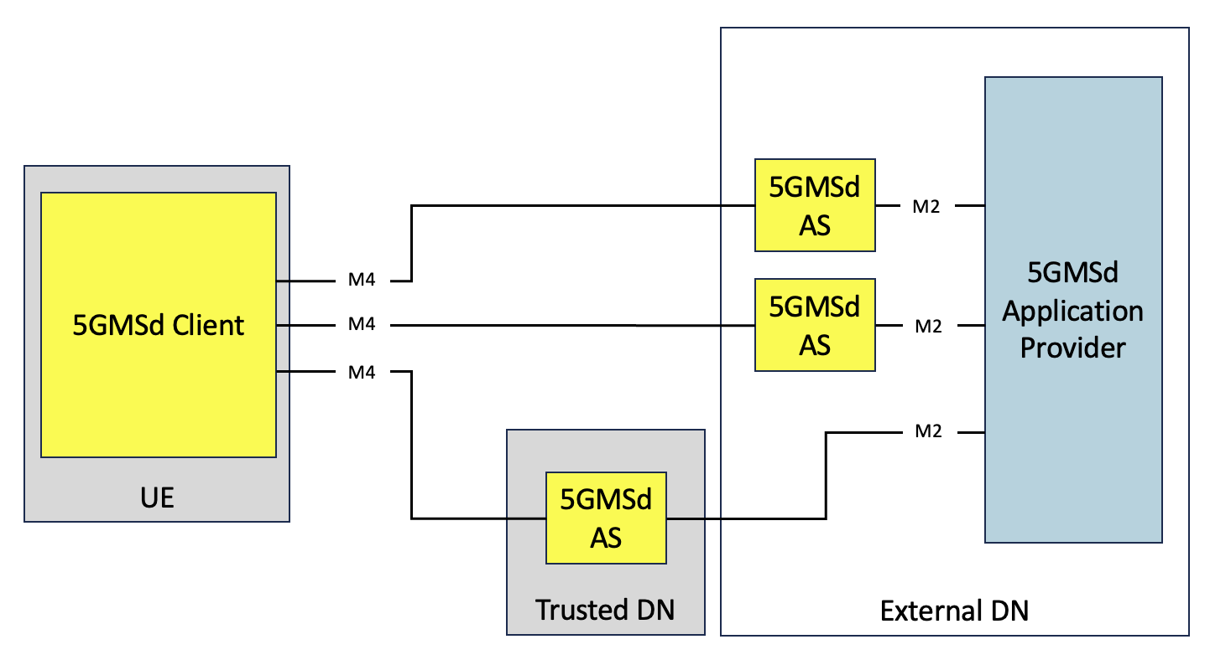
Figure 5.x.4.1-1: Multi-CDN media delivery within 5G system

5.x.4.2 Multi-Access Media Delivery
In this scenario, the 5GMSd Client is directly connected to multiple data, or access, networks (e.g., an unmanaged Wi-Fi network and the 5G network). The client requests adaptive media streaming content from 2 or more 5GMSd Application Servers (AS). The Client may choose one or use multiple simultaneously. This allows the client to distribute network load across access networks and ASes, optimize costs, as well as improve QoS.
The client’s media session handler discovers the URLs of these application servers from the 5GMSd Application Function (AF), either through a media entry point or from a separate piece of metadata. QoE metrics from the client may be used by the AF to determine the best application server(s) for each client to use when streaming media.
Figure 5.x.4.2-1 shows the client communicating with multiple ASes through different data networks. Neither data network nor AS has direct communication with its peers. Rather each AS communicates (minimally) with the Application Provider and with the AF via M3d.
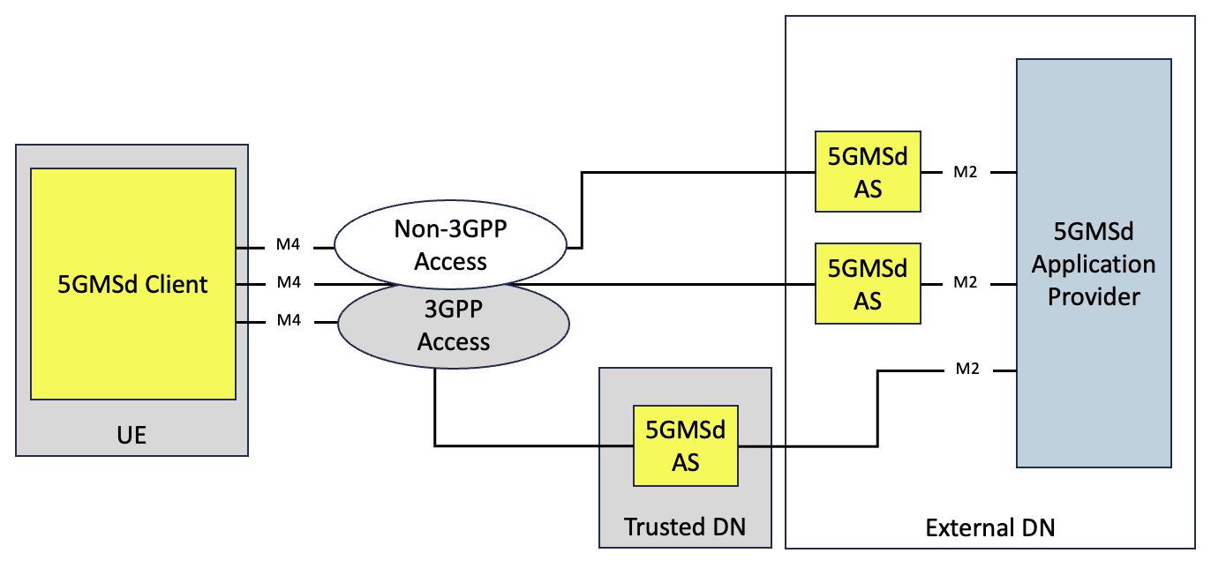
Figure 5.x.4.2-1: Multi-Access media delivery within 5G system

5.x.5 Deployment Architectures
TBD

5.x.6 Mapping to 5G Media Streaming and High-Level Call Flows

5.x.6.1 TBD
TBD

5.x.7 Potential open issues

5.x.7.1 TBD
TBD

5.x.8 Candidate Solutions

5.x.8.1 TBD
TBD

5.x.9 Conclusion and recommendations
TBD

END OF CHANGES

