Source: Samsung Electronics Co., Ltd. (Rapporteur)
Title: FS_5GSTAR Permanent Document
Version 0.4.0
Agenda Item: 10.9
Document for: Discussion and Agreement

Introduction
During SA4#109 the New Study Item on “5G Glass-type AR/MR Devices” in SA4-200897 was agreed and afterwards approved in by SA plenary#88 in SP-200399.
The objective of this study item are primarily to identify the AR glasses structures, media flow architecture, media exchange formats and profiles, and necessary content delivery protocols for glass-type AR/MR services. Key performance indicators, QoE factors for the AR use cases and device form-factor issues are also identified.
The concrete objectives are as follows:
- Provide formal definitions for the functional structures of AR glasses, classified as device types of XR5G-A4 (standalone) and XR5G-A2, A5 (wirelessly tethered) in TR 26.928, including their capabilities and constraints with respect to communication, computing and graphics processing, tracking, sensors, display, and power consumption
NOTE 1: Device type of XR5G-A3 (video see-through HMD) are not the primary scope of this study, but are not excluded per se.
- Describe key use cases for AR services over 5G based on those in Table 4.10 of TR 26.928, map each use case to suitable device types, and define relevant processing functions and reference architectures for the devices that are required to support the use cases, taking into account the constraints and capabilities identified under the first objective.
NOTE 2: The preferred cases will be those capable of delivering experiences previous or existing media services could not support, e.g., those requiring features for AR/MR 3D download, communication or conversational (related to use cases 1, 2, 7, 8, 11, 15, 16, 17, 19, 20, or 23). The study also allows new use cases not covered in TR 26.928.
- Describe the architecture for media flow relevant to the use cases identified in the second objective. Identify media (exchange) formats and profiles relevant to the use cases identified in the second objective that can be processed on AR platforms as defined under the first objective. Identify where media processing functions occur and which type of media formats are used for exchange between these elements to the described architecture.
NOTE 3: Exchange formats include both, formats and signals consumed on AR devices (e.g. overlays, scenes, animations) as well as those that are generated (and shared) on/by those (for example to support spatial localization, object recognition and tracking).
- Identify necessary content delivery transport protocols and capability exchange mechanisms, as well as suitable 5G system functionalities (e.g., device, edge, network) and QoS (including radio access and core network technologies) required for the use cases. If existing technologies and protocols cannot serve the cases sufficiently, describe the necessary functionalities and features.
- Identify key performance indicators and quality of experience factors (such as immersiveness, presence, localization, and world tracking accuracy) for the AR use cases based on the initial considerations in TR26.928, clause 4.2 with additional emphasis on the use cases, device platforms and exchanges formats for AR as identified in earlier objectives.
NOTE 4: As there can be several approaches for the optical implementation of displays, this study does not prefer any display types, nor will it define any detailed criteria or quality requirements.
- Identify relevant radio and system parameters (required bitrates, latencies, loss rates, range, etc.) to support the identified AR use cases and the required QoE, in particular when the AR device is connected via 5G sidelink interfaces.
NOTE 5: Depending on the use cases, other types of peripheral devices, such as external cameras and sensors, can also be connected to the UEs in a similar fashion.
- For each of the identified use cases and AR device platforms, provide a detailed overall power analysis for media AR related processing and communication building on the information in TR26.928, clause 4.8. Different design options should be considered, for example if media processing is carried out on the device, on a puck/smartphone or in the edge/cloud. It is recommended to contact relevant 3GPP WGs, in particular, and RAN4, on expected modem power consumption for certain use cases.
NOTE 6: Support other 3GPP WGs and other SDOs on relevant aspects related to their work and responsibilities for these new design options and form factors on a need basis, in particular when requested for processing functions in scope of SA4.
- Identify potential areas for normative work as the next phase and communicate with other 3GPP WGs on relevant aspects related to the study.
This permanent document collects additional agreed information that either needs more refinement or input before added to the technical report or document the status of issues that are of no immediate relevance for the TR26.998.

Use Cases under Consideration

2.1 Use Cases 1: Streaming volumetric video for glass-type MR devices

Use Case Description: Streaming volumetric video for glass-type MR devices
Bob and Patrick are gym instructors and run a gym ‘VolFit’. ‘VolFit’ provides their clients with a mixed-reality application to choose and select different workout routines on a 5G-enabled OHMD. The workout routines are available as high-quality photorealistic volumetric videos of the different gym instructors performing the routines. Bob and Patrick book a professional capture studio for a high-quality photorealistic volumetric capture of the different workout routines for their clients. Bob and Patrick perform the workout routines in the studio capture area. The studio captures Bob and Patrick volumetrically.
Alice is a member of ‘VolFit’ gym. Alice owns a 5G-enabled glass-type OHMD device. The ‘VolFit’ MR application is installed on her OHMD. The OHMD has an untethered connection to a 5G network.

Alice wears her OHMD device. The MR application collects and maps spatial information of Alice’s surrounding from the set of sensors available on the OHMD. The OHMD can further process the spatial mapping information to provide a semantic description of the Alice’s surrounding.
Alice wants to learn a workout routine from her instructors, Bob and Patrick. The photorealistic volumetric videos of Alice’s instructors are streamed to the MR application installed on her OHMD. The MR application allows Alice to position the volumetric representations of Bob and Patrick on real-world surfaces in her surroundings. Alice can move around with 6DoF, and view the volumetric videos from different angles. The volumetric representations are occluded by real-world objects in the XR view of Alice; when Alice move to a location where the volumetric objects are positioned behind real-world objects or vice-versa. During the workout session, Alice gets the illusion that Bob and Patrick are physically present in her surroundings, to teach her the workout routine effectively.

The MR application allows Alice to play, pause and rewind the volumetric videos. The functions can be triggered for example by hand-gestures, a dedicated controller connected to the OHMD, etc.
Categorization
Type: MR (XR5G-A1, XR5G-A2, XR5G-A4, XR5G-A5)
Degrees of Freedom: 6DoF
Delivery: Streaming, Split-rendering
Device: OHMD with/without a controller
Preconditions
- The application uses existing hardware capabilities on the device, including A/V decoders, rendering functionalities as well as sensors. Inside-out tracking is available.
- Spatial mapping to provide a detailed representation of real-world surfaces around the device
- Media is captured properly (refer to clause 4.6.7. TR 26.928). The quality of the capture depends on different factors:
  - Point-cloud based workflows
    - Studio setup i.e. camera lenses, distance of the captured object from the camera(s), stage lights
    - Filtering/Denoising algorithms
  - Mesh-based workflows
    - Mesh reconstruction algorithms (e.g. Poisson surface reconstruction)
    - Geometric resolution of the object i.e. poly counts
    - Texture resolution e.g. 4K, 8K, etc.
- Media is accessible on a server
- Connectivity to the network is provided
Requirements and QoS/QoE Considerations
- QoS:
- bitrates and latencies that are sufficient to stream a high-quality volumetric content within the immersive limits
- bitrate for a single compressed volumetric video (mesh compression using tools such as Google DracoTM (https://google.github.io/draco/) and texture compression using video encoding tools such as H.264), for example, “Boxing trainer” sequence [X.2] further processed to generate a 3D mesh sequence with 65,000 triangles; 25fps, Texture: 2048x2048 pixels; 25fps:
  - Data rate of 47.3Mbps, which constitutes of following:
    - Mesh sequence: 37 Mbps (using Google DracoTM )
    - Texture sequence: approximately 10 Mbps (encoding using H.264)
    - Audio: 133 kbps (AAC)
- access link bitrate estimates in case of split-rendering delivery methods (multiple objects):
- approximately 30% higher bitrate due to ultra-low delay coding structure (e.g. IPPP)
- left and right view (packed stereo frame)
- bitrates of a compressed stereo video depend on rendered objects resolution
- bitrates approximately 1Mbps (small objects)-35 Mbps (objects covering majority of the rendered viewport)
- Required QoE:
- volumetric video captured roughly in the range of ~1-10 million points per frame (this is dependent on capturing workflows as well as the level of details in captured object e.g. clothes’ textures)
- high geometric resolution of the volumetric object’s geometry to achieve accurate realistic simulations of rendering equations
- frame rate at least 30 FPS and above
- high-quality content rendering according to the user’s viewpoint
- real-time rendering of multiple high-quality volumetric objects
- fast reaction to user’s head and body movements
- fast reaction to hand-gestures, or a connected controller, etc
- real-time content decoding
- accurate spatial mapping
- accurate tracking
- accurate scene lighting
Feasibility
Volumetric content production:
- Volucap studios: https://volucap.de/
- Mixed Reality studio: https://www.microsoft.com/en-us/mixed-reality/capture-studios
- Metastage: https://metastage.com/

Device Features:
- Spatial mapping
- Tracking
- Scene understanding
- A/V decode resources

Selected Devices/XR Platforms supporting this:
- Microsoft Hololens: https://www.microsoft.com/en-us/hololens
- Nreal Light glasses: https://www.nreal.ai/
- MagicLeap 1: https://www.magicleap.com/en-us/magic-leap-1

Current solutions:
For a real-time mobile on-device mesh-based system, an acceptable-quality experience for 30 FPS can be achieved using at least 30,000-60,000 poly count for a volumetric object’s geometry with at least 4K texture resolution. On-device rendering of multiple complex 3D models is limited by graphics capabilities of the device.
In addition, advanced rendering techniques for lighting, reflection and etc, are subject to complex rendering equations which may result in inconsistent frame rate and increased power consumption. Therefore, it is challenging to achieve a real-time volumetric streaming for multiple high-quality 3D models with current networks and on-device hardware resources. Some existing solutions use remote rendering for streaming volumetric video:
- Azure remote rendering, https://azure.microsoft.com/en-us/services/remote-rendering/ , allows to render a huge and complex 3D model with millions of polygons remotely in cloud and stream in real-time to a MR device such as HoloLens. An intuitive demonstration of the Azure remote rendering of 3D model with approximately 18 million polygons on HoloLens is publicly available at: https://www.youtube.com/watch?v=XR1iaCcZPrU
- Mesh-based multiple high-quality volumetric video streaming using remote rendering [X.3]. More information is available at: https://www.hhi.fraunhofer.de/5GXR
Nvidia CloudXRTM: https://developer.nvidia.com/nvidia-cloudxr-sdk
Potential Standardization Status and Needs
The following aspects may require standardization work:
- Storage and access formats
- Network conditions that fulfill the QoS and QoE Requirements
- Relevant rendering APIs
- Scene composition and description
- Architecture design

2.2 Use Cases 2: AR Remote Cooperation

Use Case Name
AR remote cooperation
Description
In use case 8 in TR26.928, Annex A.9, remote experts provide AR actions (e.g. overlaying graphics and drawing of instructions) to the received local video content. This use case highlights that both parties can share their own video streams and overlay 2D/3D objects on top of these video streams compared with the scenario from TR 26.928.
For example, a car technician contacts the technical support department of the car components manufacture by phone when he has some difficulty in repairing a consumers' car. The technical support department can arrange an engineer to help him remotely via real-time communication supporting AR.
The car technician makes a video call with the remote engineer, captures the car parts as video contents and shares them with the remote engineer in-call. And he marks possible points of failure by drawing instructions on the top of these video contents in order that the remote engineer can see the marks and make a detailed discussion. Also, they have respectively FOVs on their sides to check the failure. The remote engineer can also overlay graphics and animated video models based on these shared video contents to adjust or correct the technician's operations. In addition, if the maintenance procedures are complex, the remote engineer can show the maintenance procedures step by step, and his camera captures the demonstrating video content in real-time to share it with the local technician. Therefore, the local technician can follow the operations. Finally, they find out the problems and fix it. It looks like that the remote engineer is beside the technician, discusses and solves the problems together.
In the extension to this use case, it can overlay another video stream captured by his front-facing camera based on the shared video stream to achieve more attentive experiences.
Categorization
Type: AR, MR
Degrees of Freedom: 3DoF+, 6DoF
Delivery: Interactive, Conversational
Device: XR5G-P1, XR5G-A2, XR5G-A3, XR5G-A4, XR5G-A5, others
Preconditions
<provides conditions that are necessary to run the use case, for example support for functionalities on the end device or network>

Requirements and QoS/QoE Considerations
<provides a summary on potential requirements as well as considerations on KPIs/QoE as well as QoS requirements>

Feasibility and Industry Practices
<How could the use case be implemented based on technologies available today or expected to be available in a foreseeable timeline, at most within 3 years?
- What are the technology challenges to make this use case happen?
- Do you have any implementation information?
- Demos
- Proof of concept
- Existing services
- References
- Could a reduced experience of the use case be implemented in an earlier timeframe or is it even available today?
>
Potential Standardization Status and Needs
<identifies potential standardization needs>

2.3 Use Cases 3: AR Remote Advertising

Use Case Name
AR remote advertising
Description
Conversational related use cases described in TR 26.928 including case 7, Annex A.8, a real-time 3D communication is constructed based on local user’s media stream (e.g. 3D capture capability camera, pre-captured 3D model and local AR effects) and case 11, Annex A.12, shop assistant help the buyer to choose furniture over AR scene captured by the buyer in a real time conversation. This use case emphasizes that the shared video streams between the two parties of a session are from a third party based on the above description. The shared video streams may be 360 degree and even free-viewpoint in order to help people have more interaction and immersive experiences.
For example, a real estate salesman introduces houses to a client. The real estate salesman can get some video content with 2D or 3D objects for houses from the third content provider and share them with his client. The client is able to see layout and furnishings of the virtual house which can be rendered following his viewpoint. The real estate salesman or the 3D model of the estate salesman can introduce what the client is seeing or is asking via audio and/or overlaying graphics based on the video content.
In an extension to the use case, the video content is free-viewpoint. It as if the client is just inside the advertised house, and is able to walk around rooms (e.g., dining room and living room and bedroom). Furthermore, the client can move a small couch in the living room couch, and touch the murals hanging on the dining room wall.
In another extension to the use case, the client can invite his friend to see the virtual house together. They can see it from their respectively viewpoint.
Categorization
Type: AR, MR
Degrees of Freedom: 6DoF
Delivery: Interactive, Conversational, Download, Streaming
Device: XR5G-P1, XR5G-A2, XR5G-A3, XR5G-A4, XR5G-A5, others
Preconditions
<provides conditions that are necessary to run the use case, for example support for functionalities on the end device or network>

Requirements and QoS/QoE Considerations
<provides a summary on potential requirements as well as considerations on KPIs/QoE as well as QoS requirements>

Feasibility and Industry Practices
<How could the use case be implemented based on technologies available today or expected to be available in a foreseeable timeline, at most within 3 years?
- What are the technology challenges to make this use case happen?
- Do you have any implementation information?
- Demos
- Proof of concept
- Existing services
- References
- Could a reduced experience of the use case be implemented in an earlier timeframe or is it even available today?
>
Potential Standardization Status and Needs
<identifies potential standardization needs>

2.4 Use Cases 4: AR Conferencing
Use Case Description: AR Conferencing
This clause describes an AR conferencing use-case that allows participants to be represented as 3D point clouds in order to provide an immersive conferencing experience.

3.2.1 AR Conferencing (1:1)
Bob and Alice want to make an AR conferencing call. Both are wearing AR headsets. Bob is located in Stockholm while Alice is located in Aachen. One or more cameras are placed in each location and are filming Bob and Alice, respectively. Bob can see a 3D point cloud representation of Alice on his AR headset and Alice can see a 3D point cloud representation of Bob on her AR headset. Bob and Alice can enjoy a truly immersive audio-visual experience.
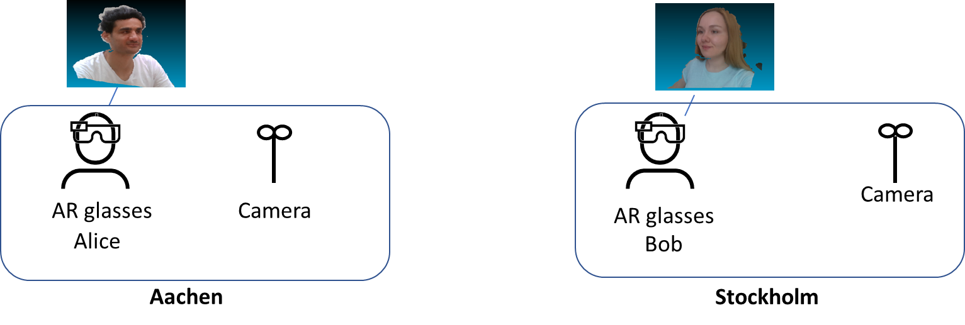
Figure 5.X-1: AR Conferencing (1:1)

3.2.1 AR Conferencing (1:many)
Bob and Alice are invited to an escalation meeting. Bob is able to physically attend the meeting, whereas Alice is virtually joining the meeting. Alice can be seen by Bob and other participants as a 3D point clouds on their AR glasses. Bob and other participants can interact with the 3D point cloud representations (e.g. rotate, zoom-in, resize). Alice can see and interact with Bob and other participants. Alice may use a laptop, phone, AR or VR device to visualize participants in the office. All participants can enjoy a truly immersive audio-visual experience.
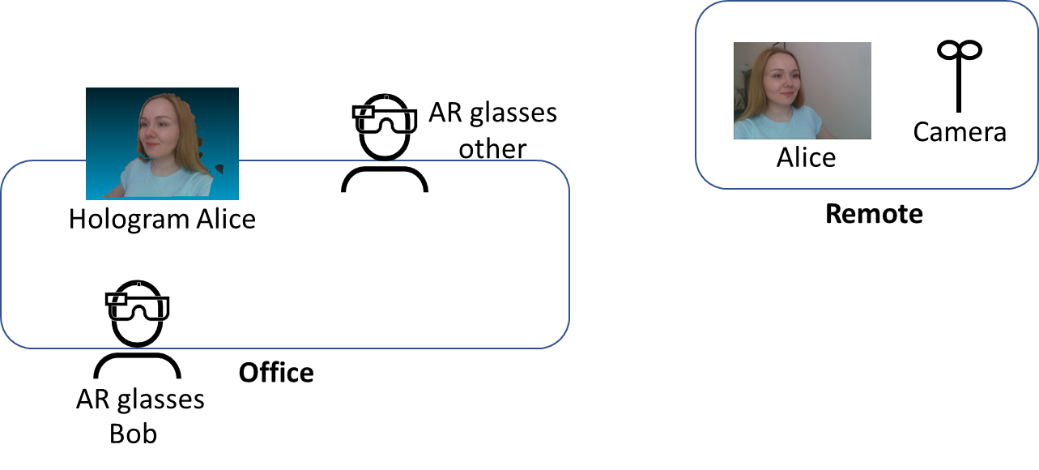
Figure 5.X-1: AR Conferencing (1:many)
Categorization
Type: AR
Degrees of Freedom: 3DoF+ or 6DoF
Delivery: Conversational
Device: AR glasses
Preconditions
- The participants are located in a room that is equipped with cameras that allow the capturing of participants including depth information. The movements can be captured by other means (e.g. AR glasses or phone camera).
- The participants are wearing AR glasses that allow the 3D point cloud representation of other participants.
Requirements and QoS/QoE Considerations
The network shall support the delivery of point cloud streams for real-time conversational services:
An audio stream has a bandwidth requirement of 128 kbps.
A point cloud stream has raw bandwidth requirement of up to 2 Gbps. The transmission bandwidth is expected to be lower after encoding and optimization. Preliminary data from MPEG V-PCC codec evaluation indicates 1:100 compression ratios can be achieved. For high-quality sequences of 1M points per frame and 30 fps this gives expected bitrates around 30Mbps.
Feasibility
The point cloud stream can be defined with mesh, texture and UV or similar representation. The bandwidth and latency requirements for AR conferencing using point cloud communications present a challenge to mobile networks. The complexity of the point cloud stream is challenging for the endpoints and introduces additional delay for processing and rendering functions. Intermediate edge or cloud components are needed.
Potential Standardization Status and Needs
The following aspects may require standardization work:
- Standardized formats for point cloud representation of participants on AR glasses.
- Cloud APIs for processing and rendering of point cloud streams.

2.5 Use Cases 5: AR Gaming

Use Case Name
AR gaming
Description
By using AR technology, AR gaming is to apply virtual models to the real world and then provides game entertainment experience in a world of virtual-reality combination, which is difficult to experience in reality. People can interact with virtual objects controlled by game operations in the foreground of the real world. For many consumers, immersion is a key factor in their enjoyment of games, and AR can help users achieve such experiences exactly.
For example, Alice wears AR glasses at home and opens an AR golf game application. The AR glasses display a virtual sand table of golf course and golf ball through the spatial location on the floor of her house. Alice needs to use a certain gesture to hit the golf ball and make it go into the hole. Finally, the AR golf game application can calculate Alice's score.
AR gaming can also support multi-player games. Alice invites Bob and Clare to play an online AR shooting game in her living room. They wear AR glasses, log in to the AR shooting game application, select the multi-player team mode, and then they can control the shooting action through a gesture or the tethering device. The virtual target set in the shot game will appear in the living room, and have corresponding response according to their operation and display in their AR glasses. Then they can complete the game task and upgrade.
Categorization
Media Type: Visual / Audio, 3D
Media Source Type: CGI (Computer-Generated Imagery)
Delivery: Uplink, Download, Interactive
Device Type: XR5G-A2, XR5G-A3, XR5G-A4, XR5G-A5
Preconditions
<provides conditions that are necessary to run the use case, for example support for functionalities on the end device or network>
-A game application on an AR device.
-Connectivity to the network
- Rendering according to user data
- Gesture acquisition or other control mode
- Spatial Computing Service
- Content synchronization

Requirements
<provides a summary on potential requirements for following aspects>
- Device functions
- Media processing functions
- KPIs/QoE and QoS>
-
- QoS:
- Sufficiently low latency for rendering.
- low packet loss rate
- QoE:
- Gaming time before vertigo
- Game jams
Feasibility and Industry Practices
<How could the use case be implemented based on technologies available today or expected to be available in a foreseeable timeline, at most within 3 years?
- What are the technology challenges to make this use case happen?
- Do you have any implementation information?
- Demos
- Proof of concept
- Existing services
- References
- Could a reduced experience of the use case be implemented in an earlier timeframe or is it even available today?
>
There are some AR game demonstration examples using AR glasses.
1. The Tech Behind Tilt Five's AR Gaming System
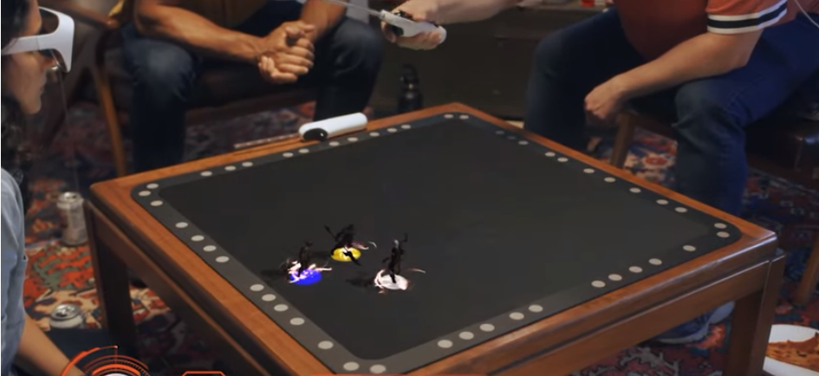
https://www.youtube.com/watch?v=Z3qAio315ak

2.Super Mario Bros Recreated as Life Size Augmented Reality Game
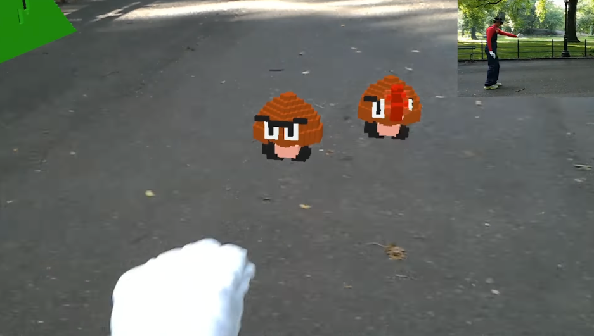
https://www.youtube.com/watch?v=QN95nNDtxjo
During the 2018 World Mobile conference, China Mobile, Tencent and Huawei jointly announced the completion of AR game experimental verification based on 5G enhanced bandwidth stable delay network slice.
Potential Standardization Status and Needs
<identifies potential standardization needs>

Device Functional Structure
[Editor’s note] The text in this clause were further improved and moved to clause 4.2.2 in TR26.998 (v0.3.0)

Device configurations
[Editor’s note] The text in this clause were further improved and moved to clause 4.2.2 in TR26.998 (v0.3.0)

Interfaces
Based on device configuration #1, we provide further details on the interfaces between the different functions of the device configuration:

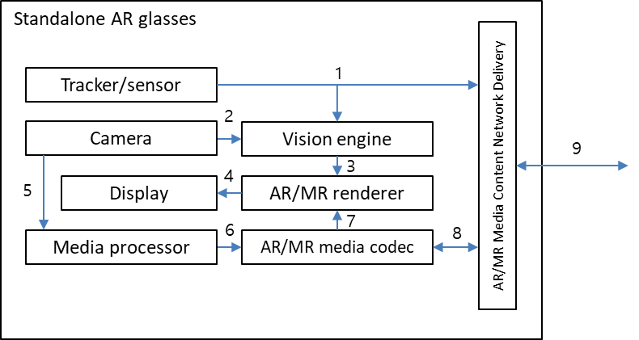
Figure 3.4: Interfaces for standalone AR glasses

- Tracker/sensor output interface
Raw outputs from various tracking and sensor device components, namely IMUs (inertial measurement unit). These outputs are typically sent as inputs to the vision engine, or to a cloud entity when cloud-based processing is utilised.
Current commercialised state of the art AR/MR devices might contain the following related components [X.4]:
- Accelerometer – used by the system to determine linear acceleration along the X, Y and Z axes and gravity
- Gyro – used by the system to determine rotations
- Magnetometer – used by the system to estimate absolute orientation

- Camera output to Vision engine interface
Depending on the device hardware, different types of camera outputs can be used as inputs into the vision engine, these may include [X.4]:
- Visible light environment tracking cameras – typically gray-scale cameras used by a system for head tracking and map building
- Depth cameras (ToF)– these may be short-throw (near-depth) or long-throw (far-depth), depending on the application desired (e.g. hand tracking, or spatial mapping)
- Infrared (IR cameras) – used for eye tracking
- World facing RGB camera – used for image processing tasks and locating the camera’s position in and perspective on the scene
Microsoft HoloLens 2 includes 4 visible light cameras for head tracking, 2 IR cameras for eye tracking, 1-MP ToF depth camera for capturing depth, and one world facing RGB camera capable of 8-MP stills and 1080p30 video [X.4].

- Vision engine to AR/MR renderer interface
The vision engine provides all the information required for the AR/MR renderer to adapt the rendering for a consistent combination of virtual content with the real world [X.5]. This information may be the output of vision engine processes such as spatial mapping, scene understanding, and room scan visualization [X.4]. Vision engine processes are typically SLAM related, differing depending on the specific device and/or platform implementation.
One typical output of the vision engine is the device/user pose information, which may include estimation properties depending on the service and application.

- AR/MR renderer to Display interface
The AR/MR rendering typically outputs a rendered 2D frame (per eye) for a given time instance according to the device/user’s current pose in his/her surrounding environment. This rendered 2D frame is sent as an input to the device display. In the future, it can be predicted that non-2D displays will require a different output from the AR/MR renderer in order to support 3D displays e.g., Light Field 3D display.

- Camera output to Media processor interface
RGB and depth cameras are be used to capture RGB/depth images and videos, which can be consumed as regular images and videos, or may be used as inputs to a media processor for further media processing.

- Media processor to AR/MR media codec interface
A media processor performs processes such as 3D modelling, in order to output uncompressed media data into the AR/MR media codec for encoding. One example of the media data at this interface is raw point cloud media data (in a format such as a ply file).

- AR/MR media codec to AR/MR renderer interface
Compressed AR/MR media content intended for rendering and display is decoded by the AR/MR media codec, and fed into the AR/MR renderer. This is typically a decoded video bitstream (for 2D AR/MR media), or a decoded 3D media bitstream (for 3D AR/MR media).

- AR/MR media codec to Network delivery interface
Media contents that are captured or generated by the device (from interface 5 and 6) are encoded by the AR/MR media codec before being passed onto the network delivery entity for packetization and delivery over the 5G network. For 2D AR/MR media contents, this is typically a compressed video bitstream that is conformant to the video codec used by the AR/MR media codec.
Network delivery to AR/MR media codec interface
Media contents that are received through the network delivery interface over the 5G network are depacketized by the network delivery entity and fed into the AR/MR media codec. The subsequent decoded bitstream is handled through interfaces 7 and 4.

- Network delivery interface
Network interface for AR/MR content delivery.

Case Study
Device types #1 and #2 were selected as the types for the case study since device type #3 is covered by the descriptions for device type #2. Generic reference device functional structures do not include any cloud-based entities, and as such are shown here as-is without the inclusion of cloud-based entity functions.
Note: The differences in specific requirements between the individual use cases (such as media formats, processing power, function latency, network latency etc) are not highlighted in this case study since the capabilities of each functional block in the entities specified in the device types are implementation dependent. Depending on the capabilities of the device type implemented, the service described by specific a use case may or may not be achievable by the device type alone.

3.3.1 Mapping to use cases 7, 8, 9, 12, 15, 16, 17, 18, 19, 2.2, 2.3, 2.4
7 | Real-time 3D Communication
8 | AR guided assistant at remote location (industrial services)
9 | Police Critical Mission with AR
12 | 360-degree conference meeting
15 | XR Meeting
16 | Convention / Poster Session
17 | AR animated avatar calls
18 | AR avatar multi-party calls
19 | Front-facing camera video multi-party calls
2.2 | AR remote cooperation
2.3 | AR remote advertising
2.4 | AR Conferencing

The use cases above have in common the following characteristics (this is not an exclusive list):
- The use of a camera(s) for the real time capture of either the user, or the real time capture of his/her surroundings (including objects), or both
- Bidirectional communication between 2 or more users for services similar to that of video telephony
- Media processing support, including in some services: video stitching, 3D media modelling, avatar modelling
Device type #1
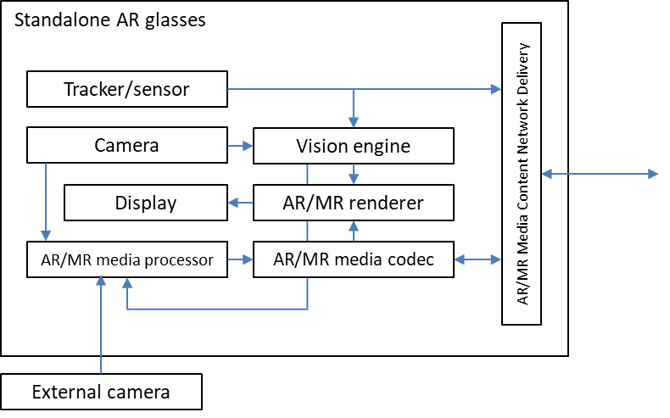
- Real time capture of the user or his/her surroundings) by either an external camera, or by the camera integrated into the standalone AR glasses, or both
- Video telephony similar service function flow realised by the combination of relevant functions within the standalone AR glasses, namely:
  - for capturing and uplink: camera/external camera, tracker/sensor, vision engine, AR/MR media processor, AR/MR media codec, content network delivery
  - for downlink and media presentation: content network delivery, AR/MR media codec, tracker/sensor, vision engine, AR/MR renderer, display
- Media processing support by the AR/MR media processor

Device type #2
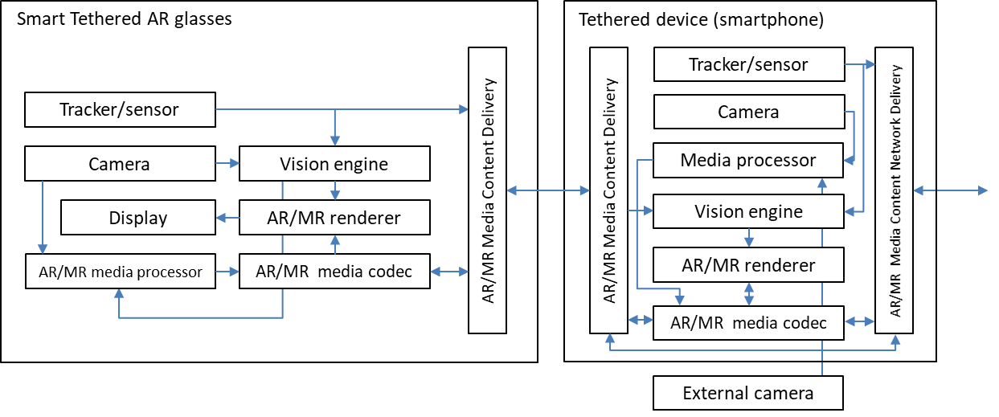
- Real time capture of the user or his/her surroundings by either an external camera, or by the camera integrated into the smart tethered AR glasses, or by the camera in the tethered device, or by a combination of these
- Video telephony similar service function flow realised by the combination of relevant functions within the smart tethered AR glasses and tethered device, namely:
  - for capturing and uplink: camera/external camera, tracker/sensor, vision engine, AR/MR media processor, AR/MR media codec, content delivery, content network delivery
  - for downlink and media presentation: content network delivery, content delivery, AR/MR media codec, tracker/sensor, vision engine, AR/MR renderer, display
- Media processing support by the AR/MR media processors in both the glasses and tethered device

3.3.2 Mapping to use cases 1, 11, 2.3
1 | 3D Image Messaging
11 | Real-time communication with the shop assistant
2.3 | AR remote advertising

The use cases above have in common the following characteristics (this is not an exclusive list):
- The use of a camera(s) for the capture of either the user, or of his/her surroundings (including objects), or both
- Bidirectional communication between 2 users for services similar to that of the traditional multimedia messaging service (MMS)
- Media processing support, including in some services: 3D media modelling

Device type #1
- Capture of the user or his/her surroundings) by either an external camera, or by the camera integrated into the standalone AR glasses, or both
- MMS similar service function flow realised by the combination of relevant functions within the standalone AR glasses, namely:
  - for capturing and uplink: camera/external camera, tracker/sensor, vision engine, AR/MR media processor, AR/MR media codec, content network delivery
  - for downlink and media presentation: content network delivery, AR/MR media codec, tracker/sensor, vision engine, AR/MR renderer, display
- Media processing support by the AR/MR media processor

Device type #2
- Capture of the user or his/her surroundings by either an external camera, or by the camera integrated into the smart tethered AR glasses, or by the camera in the tethered device, or by a combination of these
- MMS similar service function flow realised by the combination of relevant functions within the smart tethered AR glasses and tethered device, namely:
  - for capturing and uplink: camera/external camera, tracker/sensor, vision engine, AR/MR media processor, AR/MR media codec, content delivery, content network delivery
  - for downlink and media presentation: content network delivery, content delivery, AR/MR media codec, tracker/sensor, vision engine, AR/MR renderer, display
- Media processing support by the AR/MR media processors in both the glasses and tethered device

3.3.3 Mapping to use cases 2, 10, 23
2 | AR Sharing
10 | Online shopping from a catalogue – downloading
23 | Spatial Shared Data

The use cases above have in common the following characteristics (this is not an exclusive list):
- The download of AR/MR media by the AR/MR device, which has been created and made available for download prior to the service
- Presentation of the AR/MR media after download, in the manner of stored media consumption

Device type #1
- The download of AR/MR media by the AR/MR device through the content network delivery function
- Presentation of the AR/MR media after download and storage inside the device, by the function flow realised by the combination of relevant functions in the standalone AR glasses, namely:
  - AR/MR media codec, tracker/sensor, vision engine, AR/MR renderer, display

Device type #2
- The download of AR/MR media by the AR/MR device through the content network delivery function
- Presentation of the AR/MR media after download and storage inside the device (either the AR glasses or the tethered device), by the function flow realised by the combination of relevant functions in the smart tethered AR glasses and tethered device, namely:
  - AR/MR media codec, tracker/sensor, vision engine, AR/MR renderer, display

3.3.4 Mapping to use cases 20, 2.1
20 | AR Streaming with Localization Registry
2.1 | Streaming volumetric video for glass-type MR devices

The use cases above have in common the following characteristics (this is not an exclusive list):
- AR/MR media constantly received by the AR/MR device, where the AR/MR media is created and is being delivered by a provider, in a manner similar to that of current streaming services
- Presentation of the AR/MR media immediately after it is received, in a manner similar to that of current streaming services

Device type #1
- AR/MR media constantly received by the AR/MR device through the content network delivery function
- Presentation of the AR/MR media immediately after it is received, by the function flow realised by the combination of relevant functions in the standalone AR glasses, namely:
  - AR/MR media codec, tracker/sensor, vision engine, AR/MR renderer, display

Device type #2
- AR/MR media constantly received by the AR/MR device through the content network delivery function
- Presentation of the AR/MR media immediately after it is received, by the function flow realised by the combination of relevant functions in the AR glasses and the tethered device, namely:
AR/MR media codec, tracker/sensor, vision engine, AR/MR renderer, display

3.3.5 Case study implications
The case study above mapping the generic reference device functional structures with the 5GSTAR use cases (which were group for ease of mapping) has several implications that can be summarised as below:
- The generic reference device functional structures contain a set of functions that are sufficient in covering the broad set of use cases in 5GSTAR.
- Depending on the use case, certain functions in the device functional structures may not be required or instantiated for the function flow requested by the AR/MR service.
- Likewise, depending on the use case, certain function interfaces in the device functional structure may not be required.
The processing power and latency requirements for the functions required for each use case may be different, and are not considered in this case study. It can be expected that once these requirements are identified for each use case, the support for achieving those requirements will be further studied.

Service Architectures

4.1 Scenario 1: Extension to 5G Media Streaming Downlink for AR
Figure 4.1 identifies the downlink immersive media flow according to each of device type, described in Table 4.1 of clause 4.2 in TR26.998.

Figure 4.1: Downlink media flow to AR device
In the figure, each device type can be mapped into interfaces as follows;
- Interface 1 : Type 1 (when AR/MR functions are available in AR device)
- Interface 2 : Type 2 & Type 1/Type 3 (when AR/MR functions are split to cloud/edge)
- Interface 3 : Type 3 (when AR/MR functions are split to tethered device)
Each of media interface has its characteristics / properties in terms of QoS such as required data rate and latency. Below shows some of key observations
- Interface 1 requires higher bandwidth than Interface2 as it directly sends the immersive media (e.g., 3D), rather than pre-rendered 2D. However, it can be advantageous in terms of latency as it does not need additional 2D encoder/decoder process.
- Interface 2 additionally requires uplink traffic to deliver metadata for pre-processing (e.g., 6DoF pose information for pre-rendering)
- Media data and its relevant metadata for Interface 3 are almost identical to those of Interface1, but more latency caused by extra link between phone to AR glasses (e.g., 2D encoder/decoder, sidelink delay) should be taken into account.

4.1.1 Case Study – UC #18 Streaming of volumetric video for glass-type MR devices
This clause will document a case study how the immersive media flow looks like for a specific use case #18.
The use case #18 in Table 5.1 of technical report is about streaming volumetric media, captured by a gym instructor in advance. A user at home wearing an AR device receives the high-quality volumetric media in a streaming manner by enabling to play, pause, and rewind. While the user is walking around with 6DoF, he/she can see the different side of the virtual instructor and even can see the occlusion if it is blocked by real-world object.
Assuming the Type-2 device and pre-rendering at the cloud/edge, the basic procedure for this service is as follows;
1) A user selects the desired volumetric video. Information of device capability (e.g., display resolution, processing capability) is exchanged between cloud/edge and UE. Cloud/edge prepares the immersive media pipeline for pre-rendering
2) UE sends to the cloud/edge the metadata information for pre-rendering including 6DoF pose. Additionally, supplemental information for immersive renderer may also be sent to support the required processing for occlusion (e.g., Spatial mapping information to provide a detailed representation of real-world surfaces around the device)
3) Cloud/edge starts sending the pre-rendered 2D video from the received 6DoF pose. Additional metadata such as information for pose correction (e.g., depth), augmentation (e.g., object size, default orientation) may also be delivered as well as information used for pre-rendering (e.g., timestamp, pose info used)
4) Volumetric video is represented based on the extracted information from vision engine in UE.

In short, the following information may be required in this scenario; (example, but not limited to)
- Downlink
  - Pre-rendered 2D media, possibly enhanced with information for pose correction with associated pose information and depth information
  - Supplemental information of 3D model for augmentation: object size, default orientation, etc
- Uplink
  - Sensor and tracking information, including 6DoF pose information
  - Supplemental information for immersive renderer: Spatial mapping information to be rendered, light source information, etc.
Mapping to interface 1 and 3 is FFS.

[Editor’s Note] For next steps,
a. The basic procedures and call flows for the two architectures
b. identify the relevant content formats and rendering requirements
c. identify the relevant QoS and QoE Parameters
d. identify the potential standardization needs

4.2 Scenario 2: Extension to 5G Media Streaming Uplink for AR
Figure 4.2 identifies the uplink media flow according to each of device type, described in Table 4.1 of clause 4.2 in TR26.998.

Figure 4.2: Uplink media flow from AR device

Each of interface is mapped to the device types and the split processing, as follows;
- Interface 1 : Type 1 (when AR/MR functions are available in AR device)
- Interface 2 : Type 2 & Type 1/Type 3 (when AR/MR functions are split to cloud/edge)
- Interface 3 : Type 3 (when AR/MR functions are split to tethered device)
Each of media interface has its characteristics / properties in terms of QoS such as required data rate and latency. Below shows some of key observations
- Type 1 device may be able to choose either interface 1 and interface 2 depending on the processing capability and power limitation compared to the required immersive media quality
- Interface 2 requires to convey multiple of 2D image/video and/or depth information to reconstruct the immersive media in cloud/edge.
- Media data and its relevant metadata for interface 3 are almost identical to those of interface 1. The difference comes from the processing capability (AR device vs. smartphone) and the extra latency from 2D encoder/decoder.

[Editor’s Note] For next steps,
a. The basic procedures and call flows for the two architectures
b. identify the relevant content formats and rendering requirements
c. identify the relevant QoS and QoE Parameters
d. identify the potential standardization needs

4.3 Scenario 3: Extension to 5G System for Bi-directional AR Media
Using the most basic (in terms of scenario) AR conversational use cases as a reference (e.g. Real-time 3D Communication and AR Conferencing), figure 4.3 shows a media flow for bidirectional immersive media flows when utilising a cloud/edge for AR/MR media processing. Cloud/edge and AR/MR application provider entities are shown with respect to the media flows only, and are not specifically mapped or defined as any specific 3GPP entity (such as a 5G application server) as of yet. Other architectures for cases not utilising a cloud/edge for media processing may also be possible.

Figure 4.3: Bi-directional media flow between AR devices
Out of the AR/MR processing functions defined, the main media processing functions required to support such immersive media bidirectional conversational services include the generation of immersive media (reconstruction) for uplink, and the pre-rendering of immersive media for downlink. With both processing functions’ high computational requirements for immersive media, as well as the latency requirements for the conversational use case, leverage of a cloud/edge for remote-processing is possible as shown in figure 4.3, irrespective of the device type.
Figure 4.3 shows the different Basic AR functions and AR/MR functions as defined in clause 4.2, necessary for the reference AR conversational use case. Blue arrows show the specific flows of media and metadata between media functions, whilst red arrows show the flow of data between entities.

UE UL (from UE to cloud/edge)
The uplink of data from the UE (AR device) to the cloud/edge comprises of data which is captured by the UE for media generation in the cloud/edge, as well as data which is used as inputs for pre-rendering in the cloud/edge:
Metadata:
- UE pose information which may be used for immersive media generation, as well as pre-rendering
- UE vision information which may be required for immersive media generation or pre-rendering (UE processed vision data such as augmentation surface, light/reflection related data etc)
- UE 3D modelling parameters for immersive media generation (UE camera poses/orientation, camera intrinsic/extrinsic parameters etc)
- Any other metadata
Media data:
- Multiple coded RGB 2D video (captured from by UE)
- Multiple (coded) depth video (captured from by UE)

UE DL (from cloud/edge to UE)
The downlink of data from the cloud/edge to the UE (AR device) comprises of data from the result of pre-rendering on the cloud/edge. Additional media/metadata may also be necessary for media processing in the UE (AR device) before the rendered data is presented (such as pose correction):
Metadata:
- Rendered frame metadata (pose used for the render, timestamp of render etc)
- Metadata for pose correction
- Any other metadata
Media data:
- Coded RGB 2D video (pre-rendered by cloud/edge)
- Coded depth video (generated by cloud/edge, possibly used for pose correction)

Cloud UL (from cloud/edge to application provider)
The uplink of data from the cloud/edge to the AR/MR application provider comprises of data as a result of media generation in the cloud/edge (originally captured by the UE); such data may comprise of both media data (e.g. video or point clouds), as well as corresponding metadata:
Metadata:
- Immersive media (3D model) related information generated by cloud/edge during media reconstruction (such as object size, default orientation, default rendering size etc)
- Any other metadata
Media data:
- Coded 3D media data (point cloud, mesh etc)
- Other possible media data for pose correction at receiver UE consuming the coded 3D media data

Cloud DL (from application provider to cloud/edge)
The downlink of data from the AR/MR application provider to the cloud/edge comprises of data captured/generated from another UE which is also participating in the AR conversational service; such data is equivalent to that of the Cloud UL data generated by the UE shown in figure X:
Metadata:
- Another UE’s immersive media (3D model) related information generated by its respective cloud/edge during media reconstruction (such as object size, default orientation, default rendering size etc)
- Any other metadata
Media data:
- Another UE’s coded 3D media data (point cloud, mesh etc)
- Other possible media data for pose correction at the UE for consuming the coded 3D media data
Other media objects (2D/3D) from the AR/MR application provider related to the service

4.4 Scenario 4: XR view(s) split-rendering architecture for volumetric video streaming

4.4.1 Introduction
In TR26.928, Raster-based Split rendering (section 6.2.5) and Generalized XR rendering (section 6.2.6) relies on splitting the XR workload on a powerful XR Server (on the edge/cloud) and on the XR Device (with pose correction). The objective of the split architecture is facilitated by generating a rasterized-view which is encoded, delivered and decoded on the XR device. In the proposed architecture, the XR Server is capable of playing back a volumetric media sequence. The rasterized-view in sections 6.2.5 and 6.2.6 corresponds to the XR viewport. In the below extended architecture, the XR Server generates stereo XR view(s) for volumetric object(s) as shown in Figure 4.4 instead of the XR viewport. The rasterized XR view(s) for each volumetric object(s) are encoded and packed into a decodable 2D format. The 2D pre-rasterized encoded media along with associated XR metadata are delivered over a 5G network.

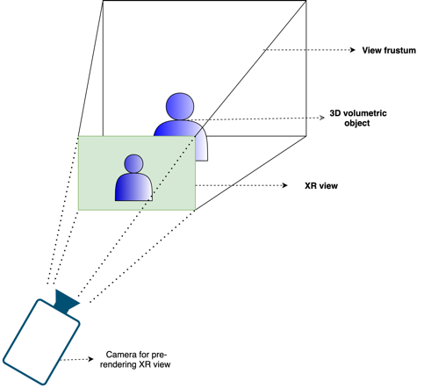
Figure 4.4: Pre-rendering a XR view for a volumetric video object on XR server

The XR device decodes the 2D pre-rasterized media. The 2D pre-rasterized media is integrated in the local XR scene which is generated by the XR device. The 2D pre-rasterized media(s) are anchored at positions specified by their respective XR metadata information in the XR scene. Upon a change in viewing position and/or orientation of the XR device, the pre-rendered 2D XR view is adjusted to align with the position and orientation of the XR viewer as shown in Figure 4.5. An position/orientation update (collected from different sensors) is sent in a regular period to the XR server to pre-render appropriate XR view(s) of the volumetric video objects.
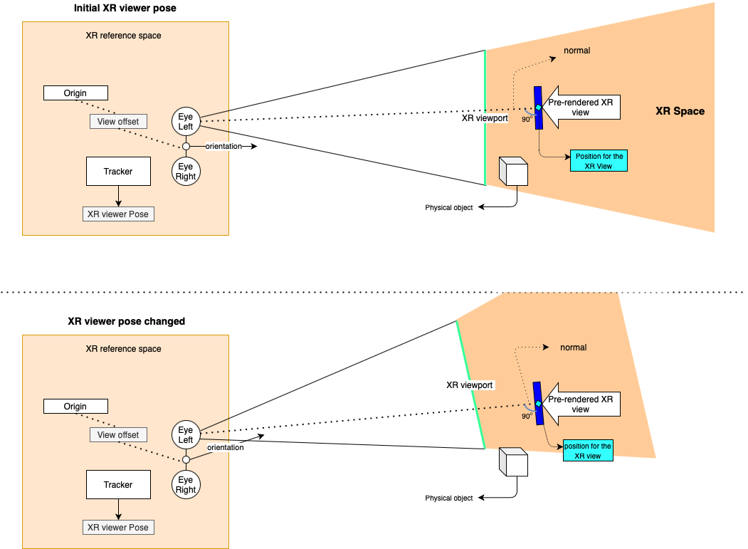
Figure 4.5: Positioning and adjustment to pre-rendered XR view in the XR space

4.4.2 Architecture
In Figure 4.6, an architecture is shown for which the XR server pre-renders an XR View for a volumetric video object. The pre-rendered XR view is encoded into a simpler format (i.e., 2D video) to be processed by the device (e.g., it may provide additional metadata that is delivered with the pre-rendered XR view). The device recovers the 2D media and does the compositing. At the final compositing stage, the pre-rendered XR View is positioned in the MR scene described by XR metadata. The device does a final render of the MR scene for glass-type devices and does adjustments based on local correction on the actual pose.
- XR graphics workload is split into rendering workload on a powerful XR server (on the Edge/cloud) and simpler XR processing on the XR device
- XR server is capable to play multiple volumetric video(s)
- The rasterised view of the volumetric video(s) are encoded in to a simple 2D format
- Associated spatial audio for the volumetric video(s) are also pre-rendered into a simple audio format
- The XR device is capable to generate a local semantic information of the surrounding using sensor data for spatial mapping and tracking
- The pre-rendered XR view(s) 2D media are decoded
- The decoded pre-rendered XR view(s) may be subjected to minimal pixel processing (e.g., background removal)
- The pre-rendered XR view(s) are positioned as described by the XR metadata during final compositing
- The pre-rendered XR view(s) may also be occluded by any real-world object physically present and overlapping the MR scene

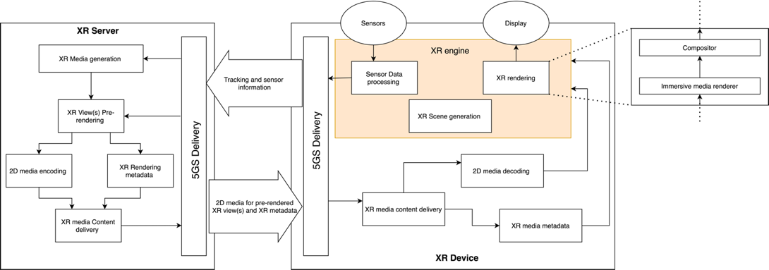
Figure 4.6: Split Rendering architecture for single/multiple pre-rendered XR view(s)
The architecture above applies to devices Type 1 and Type 3 defined section 4 in TR 26.998. As seen in Figure 4.6, the XR rendering consists of the functional blocks such as “Immersive media renderer” and “Compositor”. Note that the architecture does not apply to devices Type2 as Type 2 devices are based on pre-rendered viewports, while the architecture above is based on XR views that are mapped to some 2D planes at certain positions in the scene that are not necessarily the viewport.
Such an approach needs careful considerations on the formats of projected media and their compression with media decoders. Also important is distribution of latencies to different components of the system. More details and breakdown of the architectures is necessary. The interfaces in the device however are aligned with the general structure defined above.
<NOTE: Mapping to 5G System, e.g. 5G Media Streaming to be provided>

4.4.3 Basic Procedures
The following call flow highlights the key steps:
- An XR Device starts an XR application and initialises an XR scene
- The XR Device connects to the network and send information to the XR server such as following
  - Sends static device information (supported decoders, viewport size, supported formats)
  - Requests to stream desired volumetric video objects and their respective pose in the XR Scene
- Based on this information, XR server on the network sets up encoder and formats
- Loop
  - XR Device collects XR pose (or a predicted XR pose)
  - XR Pose is sent to XR Server
  - The XR Server uses the pose to pre-render XR Views for multiple volumetric video object resulting in one or multiple rendering buffers, possibly with different update frequencies
  - The rendering buffers are encoded with 2D encoder(s) (potentially as a single 2D video)
  - The compressed media is sent to XR device along with additional XR metadata that describes the media
  - The XR device decompresses the multiple buffers and sends these to the XR rendering engine
  - The XR rendering engine takes the buffers, the rendering pose assigned to the buffers
  - The XR rendering engine composites a XR scene whereby, the buffered XR views are accurately positioned as described by the XR metadata.
  - The latest XR pose is used (added with local pose correction) to create the finally rendered XR viewport of the XR scene for the XR device

4.4.4 Media Exchange format and profiles
A pre-rendered XR view for volumetric video object(s) is rasterized according to the XR pose received on the XR server. The pre-rendered XR view(s) are encoded into simple 2D format. The pre-rendered XR view(s) may be packed into a single 2D video in case of multiple objects. The encoded media constitutes of XR frames for stereo view.
The format of the 2D media, e.g., resolution, is limited by media profiles.
< NOTE: More clear information about format for perfect use experience needs to be provided. The object inserted into the scene does not cover the whole viewport. Maybe a way forward is defining a pixel density per degree>
The final compositing of the XR viewport happens on the XR device taking into account different decoded pre-rendered XR views.

4.4.5 Delivery protocol and Quality of Services
Low latency delivery protocols (i.e. RTP) are essential to achieve a fully immersive experience so that an update on any change in XR pose is made available as soon as possible. In this case, typically less than round trip latency of 50ms is a requirement for a fully immersive experience. This constitutes the end-to-end latency between the user motion and the XR device rendering. The XR views must be correctly positioned. Usually, the spatial mapping information is tracked locally and the scene semantic are constructed to identify different spatially located real-physical objects.
< NOTE: The value of 50ms needs more information to be provided>

4.4.6 Potential Normative works
In the context of the proposed architecture, the following potential standardisation needs are identified:
- Edge computing discovery and capability discovery for XR view(s) split rendering
- A XR split rendering application framework
- More flexible 5QIs and QoS support in 5G System for generalized split rendering addressing differentiated end-to-end latency requirements in the range of 10ms up to potentially 50ms and with bitrate guarantees
- XR metadata (e.g., defining XR views – position of planes for the 2D video)
- Media profiles
- Content delivery protocols

4.5 Scenario 5: Extension of conversational AR services

4.5.1 Extensions to functional architecture
To describe the functional architecture for AR conversational use-cases (e.g. clause A5 in TR 26.998) and identify the content delivery protocols and performance indicators an end-to-end architecture is proposed in Figure 4.7. The architecture extends device architectures for Types 1/2/3 by including the camera capturing part. A camera is capturing the participant in an AR conferencing scenario. The camera is connected to a UE (e.g. laptop) via a data network (wired/wireless). Live camera feed, sensors and audio signals are provided to a UE/Edge node (or split) which processes, encodes, and transmits immersive media content to the 5G system for distribution. The immersive media processing function can include pre-processing of the captured 3D video, format conversion, and any other processing needed before compression. The semantic input is considered for media processing functions (e.g., background removal) and an audio-video control is used for encoding configuration. Note: how semantic input is obtained is FFS.

Figure 4.7: Extensions to device architecture for conversational services

4.5.2 Architecture mapping to AR conferencing use-case
Figure 4.8 shows the end-to-end workflow for AR conferencing (one direction). The use-case is mapped to Type 3 device and similar mappings can be made for Type 1 and Type 2 devices.
A live feed from 3D camera captured in a 3D representation, e.g. point clouds, meshes or similar for, and is provided along audio to a sending UE. After processing and encoding, the compressed 3D video and audio streams are transmitted over a data network and 5G system. A 5G phone decodes, processes and renders the 3D video and audio stream and provides to the AR glasses for display. The use-case be extended to bi-directional by adding a 3D camera on the receiver side and AR glasses on the sender side and applying a similar workflow.
Note 1: Figure 4.8 sketches the basic end-to-end pipeline. Optimizations are possible such as pre-rendering by understanding latency loops and tradeoffs.
Note 2: Consider additional aspects as 5G System mapping, call flows, associated media, QoS/QoE requirements, etc..

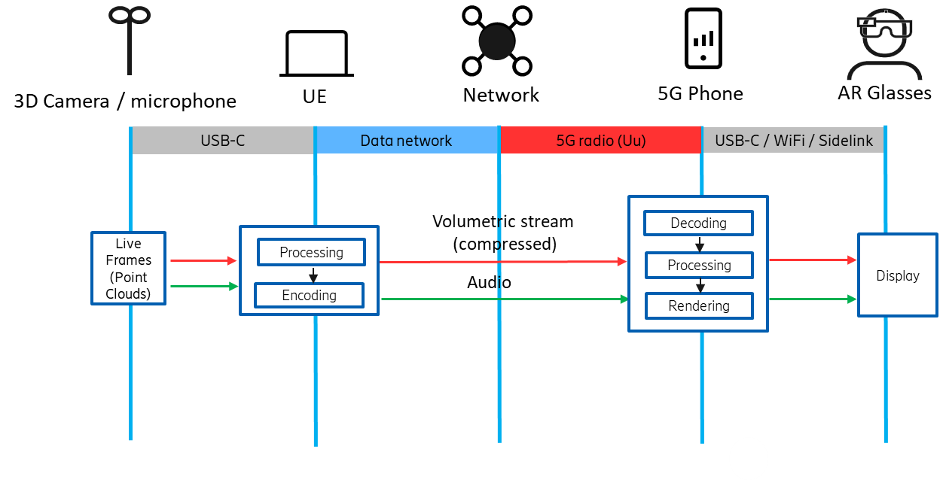
Figure 4.8: Workflow for AR Conferencing (one direction)

Media Exchange Formats
<Proposal of key technologies, including media exchange formats and profiles can be documented in this clause>

Delivery Protocol and Quality-of-Service

Device Form-factor related Issues

References
[1] 3GPP TS 26.928: "Extended Reality (XR) in 5G".
[X.2] T.Ebner, O.Schreer, I. Feldmann, P.Kauff, T.v.Unger, “m42921 HHI Point cloud dataset of boxing trainer”, MPEG 123rd meeting, Ljubljana, Slovenia
[X.3] Serhan Gül, Dimitri Podborski, Jangwoo Son, Gurdeep Singh Bhullar, Thomas Buchholz, Thomas Schierl, Cornelius Hellge, “Cloud Rendering-based Volumetric Video Streaming System for Mixed Reality Services”
Proceedings of the 11th ACM Multimedia Systems Conference (MMSys'20), June 2020
[X.4] https://docs.microsoft.com/en-us/windows/mixed-reality
[X.5] ETSI GS ARF 003 V1.1.1 “Augmented Reality Framework (ARF); AR framework architecture”

