3GPP TSG-SA4 Meeting #-e (AH) MBS post 134-2 S4aI260016r1

Online, , 29th Jan 2026 - 29th Jan 2026 is revision of S4aI260008
CR-Form-v12.5
CHANGE REQUEST
 | 26.942 | CR | 0024 | rev | 1 | Current version: | 19.0.0
For HELP on using this form: comprehensive instructions can be found at
https://www.3gpp.org/Change-Requests.

Proposed change affects: | UICC apps |  | ME |  | Radio Access Network |  | Core Network

Title: | [FS_Energy_Ph2_MED] Solution 5 update
Source to WG: | Orange, BBC
Source to TSG: | S4
Work item code: | FS_Energy_Ph2_MED |  |  |  |  |  | Date: |  |  | 2026-01-26
Category: | F |  |  |  |  |  | Release: |  |  | Rel-20
 | Use one of the following categories:  F (correction)  A (mirror corresponding to a change in an earlier release)  B (addition of feature),  C (functional modification of feature)  D (editorial modification)  Detailed explanations of the above categories can  be found in 3GPP TR 21.900. |  |  |  |  |  |  |  | Use one of the following releases:  Rel-8 (Release 8)  Rel-9 (Release 9)  Rel-10 (Release 10)  Rel-11 (Release 11)  …  Rel-18 (Release 18)  Rel-19 (Release 19)  Rel-20 (Release 20)  Rel-21 (Release 21)
Reason for change: |  | Correction in procedures in 7.6.3.1 and 7.6.3.2 to be compatible with TS 23.501 and 29.566.  Formating according to new principles for documenting Candidate Solutions
Summary of change: |  | References to 26.512 and 26.113 added.  Updates to follow principles for documenting Candidate Solutions (new clauses 7.6.1B and 7.6.5).  Updates of the procedures and related text in 7.6.3.1 and 7.6.3.2
Consequences if not approved: |  | Candidate solution not accurate and principles for documenting candidate solutions not followed.
Clauses affected: |  | 2, 7.6
 |  | Y | N
Other specs |  |  | X | Other core specifications |  |  |  | TS/TR ... CR ...
affected: |  |  | X | Test specifications |  |  |  | TS/TR ... CR ...
(show related CRs) |  |  | X | O&M Specifications |  |  |  | TS/TR ... CR ...
Other comments:
This CR's revision history: |  | r1: Steps 16 to 19 put outside the loop. Numbering in steps describing the procedures corrected.

==============First change==============

2 References
The following documents contain provisions which, through reference in this text, constitute provisions of the present document.
- References are either specific (identified by date of publication, edition number, version number, etc.) or non-specific.
- For a specific reference, subsequent revisions do not apply.
- For a non-specific reference, the latest version applies. In the case of a reference to a 3GPP document (including a GSM document), a non-specific reference implicitly refers to the latest version of that document in the same Release as the present document.
[1] 3GPP TR 21.905: "Vocabulary for 3GPP Specifications".
[…]
[87] Accubattery: https://play.google.com/store/apps/details?id=com.digibites.accubattery
[26510] 3GPP TS 26.510: "Media delivery; interactions and APIs for provisioning and media session handling".
[26512] 3GPP TS 26.512: "5G Media Streaming (5GMS); Protocols".
[26113] 3GPP TS 26.113: "Real-Time Media Communication; Protocols and APIs".

==============Next change==============

7.6.1A Functional description

Currently, it is possible to retrieve energy-related information from network functions within the 5G system using the EIF. However, it is not possible to access energy-related information from additional components of the 5G system under SA4 responsibility, such as a UE Media application or a Media Application Server (Media AS). Without this information, components involved in the media delivery chain, like the UE or the Media Application Function, find it challenging to act efficiently to optimize the environmental impact of media consumption.
This Candidate Solution proposes a generic approach to expose energy-related information from the device, the network, and Media AS to the UE or the Media AF. It also demonstrates how this approach can be integrated into the 5GMS architecture, enabling the UE or Media AF to take actions that effectively optimize environmental impact within this architecture.
It is not the aim of this solution to provide detailed optimization strategies. Instead, it offers a generic architecture and procedures that can be reused by other solutions to develop more specific optimizations.
The exposure of the energy-related information is enabled or disabled by the Application Service Provider over time and is expressed using an Energy Information Exposure Specification as envisaged by the Candidate Solution in clause 7.8.

7.6.1B Collaboration scenarios
This solution is applicable to all collaboration scenarios requiring access to energy-related information from a UE, an Application Server or the EIF.

7.6.2 Architecture mapping

7.6.2.1 Void

7.6.2.2 Generic reference architecture for collection and exposure of energy-related information

==============Next change==============

7.6.3 Procedures

7.6.3.1 Generic high-level procedures for collection and exposure of energy-related information
Figure 7.6.3.1-1 below details the different steps for energy-related information collection and reporting in the system outlined in clause 7.6.2.2.

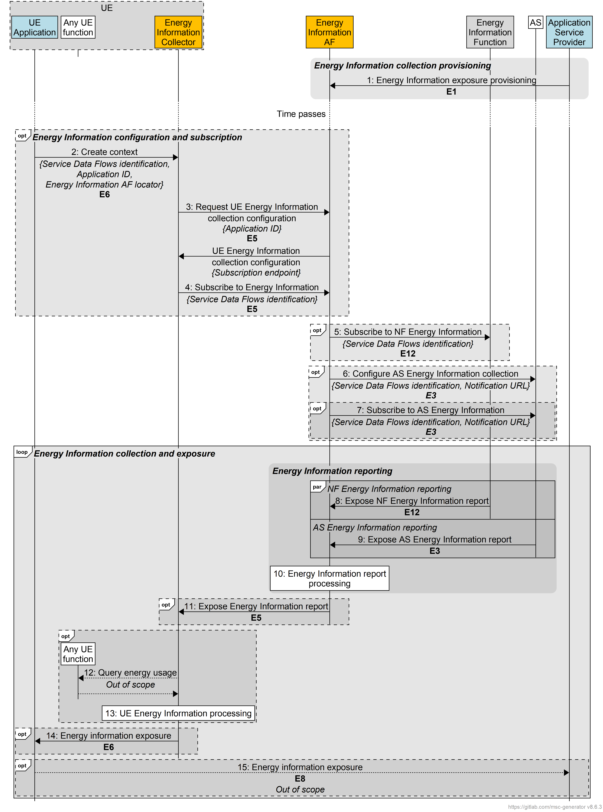
Figure 7.6.3.1-1: Procedures for energy-related information collection and reporting
A first step is required to provision Energy Information Collection:
1. The Application Service Provider provisions the Energy Information AF with an Energy Information Exposure Specification via reference point E1. The Energy Information exposure configuration may identify application(s) that fall within its scope.
At some later point, the Energy Information configuration and subscription may be initiated by the UE Application:
2. The UE Application may create an Energy information collection and reporting context with the Energy Information Collector via reference point E6. This includes parameters (e.g. Application Identifier or explicit Service Data Flow descriptions) identifying the set of Service Data Flows of interest.
3. The Energy Information Collector requests a UE Energy Information collection configuration from the Energy Information AF via reference point E5, if relevant. The request parameters identify the Provisioning Session provided in step 1 using an Application Identifier. The response is a UE Energy Information collection configuration in accordance with the set of parameters in the provisioned Energy Information Exposure Specifications that also includes details of a subscription endpoint to be used in the next step.
4. The Energy Information Collector subscribes to receive Network Energy Information reporting from the Energy Information AF via reference point E5. This subscription includes parameters (e.g. Application Identifier) identifying the set of Service Data Flows of interest to the UE Application.
According to the Service Data Flow identification parameters supplied in the previous step and/or the requirements of the Energy Information AF itself:
5. The Energy Information AF may subscribe to receive NF Energy Information reporting from the Energy Information Function via reference point E12, if relevant, in accordance with the set of parameters in the Energy Information Exposure Specification and/or the set of parameters (e.g. Application Identifier) supplied by the Energy Information Collector in step 4 above identifying the set of Service Data Flows of interest.
6. The AS may be configured by the Energy Information AF with an AS Energy Information collection configuration via reference point E3, if relevant, in accordance with the set of parameters in the Energy Information Exposure Specification and the set of parameters (e.g. Application Identifier) supplied by the Energy Information Collector in step 4 above identifying the set of Service Data Flows of interest. This may also include a callback endpoint on the Energy Information AF for submitting AS Energy Information reports in place of the next step.
7. If it has not already subscribed implicitly in the previous step

, the Energy Information
AF may subscribe to receive AS Energy Information reporting from the AS via reference point E3, if relevant, in accordance with the set of parameters in the Energy Information Exposure Specification. This includes a callback endpoint on the Energy Information AF for submitting AS Energy Information reports
NOTE: This separate subscription step is not required if the configuration in step 6 includes the optional callback endpoint.
After this initialisation phase, reporting can be done, processed and may be provided to the Energy Information Collector:
8. The Energy Information Function exposes an NF Energy Information report to the Energy Information AF via reference point E12. The Network Energy Information report may include energy consumption information of different granularities, e.g. UE, PDU Session and/or QoS Flow, as described in clause 5.51.2.3 of TS 23.501 [72].
9. The AS may expose an AS Energy Information report to the Energy Information AF via reference point E3 using the callback endpoint supplied in step 4. The AS Energy Information report may include energy consumption information of different granularities.
10. The Energy Information AF processes the energy-related information report(s) it has received.
11. The Energy Information AF may expose a processed Network Energy Information report about the UE to the Energy Information Collector subscriber via reference point E5. The Network Energy Information report may include energy consumption information of different granularities.
UE Energy information can optionally be requested, processed and added in the report received in step 11:
12. The Energy Information Collector may collect additional UE Energy Information from any UE function using methods beyond the scope of 3GPP standardisation, but in accordance with the set of parameters in the Energy Information Exposure Specification conveyed as part of the Energy Information collection configuration obtained in step 3.
13. The Energy Information Collector processes the UE-related Energy Information it has obtained in the previous step.
Then:
14. The Energy Information Collector may expose energy-related information to the subscribed UE Application via reference point E6. Based on the UE Energy Information collection configuration obtained in step 3, the energy-related information report may include energy consumption information of different granularities, e.g. for individual applications.
15. The UE Application may expose the received energy-related information to the Application Service Provider via reference point E8 using methods beyond the scope of 3GPP standardisation.

7.6.3.2 5GMS high-level procedures for collection and exposure of energy-related information
Figure 7.6.3.2-1 below details the different steps for energy-related information collection and reporting in the context of the 5GMS System defined in TS 26.501 [23] and as extended in clause 7.6.2.3 of the present document.

Figure 7.6.3.2-1: Procedures for energy-related information collection and reporting
in the 5GMS System
A first step is required to provision Energy Information Collection:
1. The 5GMS Application Provider provisions the 5GMS AF via reference point M1, including a Provisioning Session resource, any other required resources and an Energy Information exposure configuration intended for the Energy Information AF instantiated in the 5GMS AF. The Energy Information exposure configuration may identify application(s) that fall within its scope.
At some later point, a media delivery session is initiated and, as part of this, the collection of energy information collection is also initiated.
2. The 5GMS-Aware Application initiates a new media delivery session with the Media Session Handler via reference point M6, including a flag that enables energy-related information collection and reporting.
3. The Media Session Handler obtains Service Access Information from the 5GMS AF, including access details of the Energy Information AF and the relevant Application Identifier.
4. As a consequence of the flag set in step 2, the Media Session Handler creates a new energy-related information collection and reporting context in the Energy Information Collector instantiated in it, supplying the parameters obtained from Service Access Information mentioned in the previous step.
5. The Energy Information Collector requests a UE Energy Information collection configuration from the Energy Information AF via reference point E5, if relevant. The request parameters include the Application Identifier provided in the Service Access Information acquired in step 3. The response is a UE Energy Information collection configuration in accordance with the set of parameters in the provisioned Energy Information Exposure Specifications that also includes details of a subscription endpoint to be used in the next step, and which may include the static energy characteristics of currently provisioned AS service locations.
In certain cases, it is useful for the 5GMS Client to obtain an initial set of Network Energy Information to guide its selection of a Media Entry Point:
6. The Energy Information Collector subscribes to receive Network Energy Information reporting from the Energy Information AF, including the set of parameters corresponding to the implicit Service Data Flow description.
NOTE: At this point, the set of Service Data Flows used for media delivery at reference point M4 is not yet known: only implicit Service Data Flow description based on statically provisioned parameters in step 1 (e.g. Application Identifier) is included in the subscription request.
7. The Energy Information AF subscribes to receive NF Energy Information reporting from the Energy Information Function via reference point E12, including the Application Identifier of interest, and requests an immediate report.
The Energy Information Function responds with an NF Energy Information report.
8. The Energy Information AF configures the 5GMS AS via reference point E3, optionally including the callback notification location exposed by the Energy Information AF instantiated in the 5GMS AF and, in the subscription, the Application Identifier of interest.
9. If it has not already done so in the previous step, the Energy Information AF subscribes to receive AS Energy Information reporting from the 5GMS AS via reference point E3, including the Application Identifier of interest.
The 5GMS AS responds to the subscription with an AS Energy Information report containing the most recent information available.
10. The Energy Information AF processes the NF Energy Information report and AS Energy Information report.
11. The Energy Information AF exposes a processed Network Energy Information report about the UE to the Energy Information Collector subscriber via reference point E5. The Network Energy Information report may include energy consumption information of different granularities.
NOTE: The processed Network Energy Information report is not directly related to the UE itself because the prior subscriptions are based only on the Application Identifier. This information in the report describes the total energy consumed recently by all consumers. For example, if the Energy Information AF subscribes to receive generic energy information about a particular Application Identifier, the information describes the total energy consumed recently by all current application sessions. If the client subscribed to receive generic energy information about a particular AS service location, the information describes the total energy being consumed by all UEs using that service endpoint recently.

12. The Energy Information Collector may subscribe to UE Network Energy Information reporting from the Media Steam Handler via reference point M11.
The Media Stream Handler responds with a UE Network Energy Information report.
13. The Energy Information Collector processes the information in the Network Energy Information report and the UE Energy Information report.
14. The Energy Information Collector exposes the aggregated Energy Information report with the Media Session Handler and the Media Stream Handler.
In all cases:
15. The Media Session Handler provides the set of available Media Entry Points to the 5GMS-Aware Application, including Energy Information.
At the start of a new media streaming session, or at any subsequent point, a Media Entry Point is selected:
16. The 5GMS-Aware Application selects a Media Entry Point based on its configuration and possibly the initial Energy Information provided in the previous step.
17. The 5GMS-Aware Application invokes the Media Stream Handler with the Media Entry Point to start media access.
18. The Media Stream Handler establishes a transport session at reference point M4 for acquiring the Media Entry Point.
19. The Media Stream Handler requests the Media Entry Point from the 5GMS AS.
Then, media delivery occurs:
20. The Media Stream Handler selects a Service Operation Point from the Media Entry Point based on its configuration and recently received Energy Information.
21. The Media Stream Handler selects the Service Operation Point.
22. The Media Stream Handler may establish a new transport session with an appropriate service location on the 5GMS AS.
23. The Media Stream Handler notifies the Media Session Handler of the change in Service Operation Point via reference point M11, including any changed Service Data Flow identification information (e.g., Service Data Flow descriptions).
24. The Media Session Handler modifies the energy-related information collection and reporting context in the Energy Information Collector instantiated in it, including the modified Service Data Flow identification information provided in the previous step.

NOTE 2: Because the set of IP 5-tuples is known at this stage, the Service Data Flow description in the following steps is now explicit, based on those parameters.
25. Similar to step 6, with explicit Service Data Flow filter(s) based on IP 5-tuple to receive report specific to the UE.
26. Similar to step 7, with explicit Service Data Flow filter(s) based on IP 5-tuple to receive report specific to the UE.
27. Similar to step 9, with explicit Service Data Flow filter(s) based on IP 5-tuple to receive report specific to the UE.
28: Similar to step 10.
29: Media is streamed between the Media Stream Handler and the 5GMS AS service location (via reference point M4) and, as required by the media streaming session, between the 5GMS AS and the 5GMS Application Provider (via reference point M2).

During the course of the media streaming session, energy information is reported to the Energy Information Collector in parallel
30. The Energy Information Function may expose an NF Energy Information report to the Energy Information AF via reference point E12. The NF Energy Information report may include energy consumption information of different granularities, as described in clause 5.51.2.3 of TS 23.501 [72].
31. The 5GMS AS may expose an AS Energy Information report to the Energy Information AF via reference point E3 using the callback endpoint supplied in step 4. The AS Energy Information report may include energy consumption information of different granularities.
32. The Energy Information AF processes the energy information report(s) it has received.
32. The Energy Information AF exposes a processed Network Energy Information report about the UE to the Energy Information Collector subscriber established in step 8 via reference point E5. The Network Energy Information report may include energy consumption information of different granularities.
34. The Media Stream Handler may expose a UE Energy Information report to the Energy Information Collector via reference point M11.
35. The Energy Information collector processes the energy information report(s) it has received.
36. The Energy Information Collector shares the report processed in the previous step with the Media Session Handler.

37. The Media Session Handler may expose

energy-related information to the subscribed 5GMS-Aware Application via reference point M6. Based on the UE Energy Information collection configuration obtained in step 6, the energy-related information may include energy consumption information of different granularities.
38. The 5GMS-Aware Application may expose the received energy-related information to the Application Service Provider via reference point M8 using methods beyond the scope of 3GPP standardisation.

7.6.4 Gap analysis

This solution is based on Network Energy Information available from the Energy Information Function as well as the definition of two new entities, with their associated reference points, allowing the Network Energy Information to be complemented and delivered to the UE application:
- The Energy Information AF has some or all of the following responsibilities, depending on its current provisioning state:
- Subscribes to and consumes NF Energy Information from the Energy Information Function.
- Receives AS Energy Information reports from the Application Server.
- Collates and exposes the above Network Energy Information to the Energy Information Collector in the UE via the data plane.
- The Energy Information Collector, is a UE function with some or all of the following responsibilities, depending on its current configuration:
- Acquires an Energy Information collection configuration from the Energy Information AF.
- Subscribes to and consumes Network Energy Information from the Energy Information AF according to the Energy Information collection configuration.
- Collects UE Energy Information from other UE functions and about itself according to the Energy Information collection configuration.
- Collates and exposes collected Energy Information to the UE Application via a client API.

The interfaces between the abovementioned components and others will have to be defined and existing interfaces highlighted in the procedures will also have to be updated.

7.6.5 Proposed normative changes
To implement this solution, the following normative work is proposed:
1. A new stage 2 Technical Specification based on clause 7.6.2.2 that defines a generic architecture and generic procedures for the Energy Information AF and Energy Information Collector, including definitions and high-level parameters of operations for:
a. Provisioning the Energy Information AF via reference point E1.
b. Subscription and exposure of AS Energy Reports from Application Servers to the Energy Information AF via reference point E3, including baseline parameters for these reports.
c. Subscription and exposure of aggregated network energy information from the Energy Information AF to the Energy Information Collector in the UE via reference point E5, including baseline parameters for the information exposed.
d. Exposure of aggregated energy information from the Energy Information Collector to the UE Application via reference point E6, including baseline parameters for the information exposed.
2. A new stage 3 Technical Specification corresponding to point 1 above that specifies the network APIs used by the Energy Information AF and Energy Information Collector at reference points E1, E3 and E5, as well the client API exposed by the Energy Information Collector to the Application at reference point E6.
3. New clauses in TS 26.501 [23] defining:
a. The instantiation of the generic architecture defined in point 1 above in the 5G Media Streaming System, based on clause 7.6.2.3 of the present document.
b. Collaboration scenarios extending the generic procedures defined in point 1 above for particular Use Cases relevant to 5G Media Streaming.
4. New clauses in TS 26.506 [59] defining:
a. The instantiation of the generic architecture defined in (1) above in the RTC System.
b. Collaboration scenarios extending the generic procedures defined in point 1 above for particular Use Cases relevant to RTC.
5. New clauses in TS 26.510 [26510] specifying:
a. Extensions (as needed) to the procedures and service-based interfaces at reference point M5, in particular with regard to additional energy-related information provided in the Service Access Information response.
6. New clauses in TS 26.512 [26512] specifying:
a. Extensions (as needed) to the procedures and service-based interfaces at reference points E1, E3 and E5 that pertain to the 5G Media Streaming System, in particular with regard to additional energy-related information provided by the 5GMS AS in relation to media streaming sessions.
b. Extensions (as needed) to the client API exposed by the Energy Information Collector instantiated in the Media Session Handler to the 5GMS-Aware Application at reference point M6 that pertain to the 5GMS System.
7. New clauses in TS 26.113 [26113] specifying:
a. Extensions (as needed) to the procedures and service-based interfaces at reference points E1, E3 and E5 that pertain to the RTC System, in particular with regard to additional energy-related information provided by the RTC AS in relation to RTC sessions.
b. Extensions (as needed) to the client API exposed by the Energy Information Collector instantiated in the Media Session Handler to the RTC-Aware Application at reference point RTC-6 that pertain to the RTC System.

7.6.6 Summary
This Candidate Solution proposes a generic approach for exposing energy-related information from the device, the network, and Media Application Server to the UE or the Media Application Function. It also illustrates how this approach can be integrated into the 5GMS architecture by introducing two new components: the Energy Information Collector (located in the UE) and the Energy Information Application Function (located in the Media AF). These components enable the collection of energy-related data and allow the UE or the Media AF to take actions aimed at optimizing the environmental impact of media sessions.
The goal of this solution is not to define specific optimization strategies but to provide a generic architecture and procedures that can be reused by other solutions to develop more targeted and detailed optimizations.

==============End of change==============

