December 07, 2015

Invitation to the SA3 Meeting #84
July 25 – 29, 2016
Chennai, India

Dear Colleagues,

NEC has the pleasure to invite you to the 84th 3GPP SA3 meeting in Chennai, India.

The meeting will be held at The Leela Palace hotel, Chennai. A block of rooms has been reserved at The Leela Palace hotel. The room rate is INR 10,150 (incl. all taxes, WiFi, one-way airport transfer, breakfast and lunch). The cut-off date for hotel booking is Tuesday, May 31, 2016. Please read the reservations section of the invitation for more information regarding the room booking.

In addition to making your hotel reservation, it is very important to register for the meeting on the 3GPP website. This provides the MCC and meeting planners with important planning information. The registration form can be found on the 3GPP website. Please visit <http://www.3gpp.org/> to register on-line.

You may be required to obtain a visa for admittance into India. Please check <https://indianvisaonline.gov.in/> for more information. Please follow the procedure for Visa Processing as described in Appendix A. Request for Visa invitation letters should be sent to the points of contact as mentioned in Appendix A as soon as possible.

The meeting will start on Monday, 25th July at 09:00 hrs. and end on Friday 29^{h} July at 16:00 hrs. More information on the meeting itself will be found in the corresponding official documents. Meeting directions and general information are provided in the following pages.

We are looking forward to seeing you in Chennai.

Sincerely,

Anand R. Prasad
NEC Corporation
General Meeting Information

Meeting and Dates:
SA3#84
July 25 – 29, 2016

Location:
Chennai, India

Host:
NEC

Host Contacts:
Shelany Devaiah
Phone: +91 44 6685 5744
Fax: +91 44 66855601
Email: nmec_r_support_admin@ml.necindia.in

Shanthi Gowrishankar
Phone: +91 44 6685 5603
Fax: +91 44 66855601
Email: nmec_r_support_admin@ml.necindia.in

Meeting Venue:
The Leela Palace Chennai
Adyar Seaface, M.R.C Nagar
Chennai - 600 028, India
T. +91 (44) 3366 1234
F. +91 (44) 3366 1212
Email: nmec_r_support_admin@ml.necindia.in

Room Rate:
Single-Occupancy: Rs. 10,150 (incl. all taxes, WiFi, one-way airport transfer, breakfast and lunch)

Cut-off Date:
Tuesday, May 31, 2016
Please be sure to make your reservation before the cut-off date to ensure the lower group rate. Rates will be significantly higher after the cut-off date and we may not be able to add people to the block.

Check-in/Check-out Times:

Check in – 2:00 PM

Check out – 12:00 PM

Reservations:
Please fill out the reservation form in Appendix B and fax/email the completed form to the contact information provided in the form.

Cancellations:
Reservations must be cancelled 48 hours prior to arrival in order to avoid a penalty of one night’s room and tax.

Airport:
Chennai International Airport (MAA)

Wireless LAN:
This will be a paperless meeting. ETSI will provide and administer a WLAN for document distribution.

Time Zone:
Indian Standard Time (IST): GMT +5:30

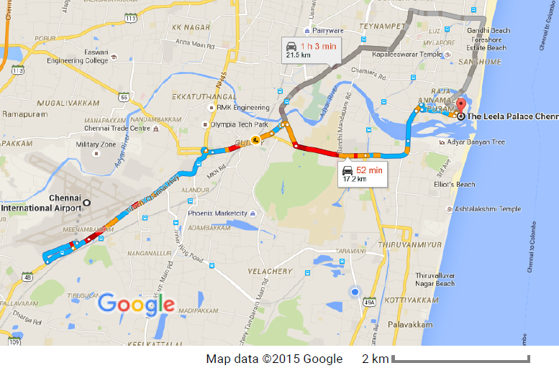
Directions:
From Airport To The Leela Palace, Chennai
Link: Google map direction
Distance from Hotel – 17 km. Drive Time – 50 min. Taxi – Approximately Rs.1,000 one way. Please note: Taxi fare and drive time from MAA can be significantly higher depending on traffic conditions.

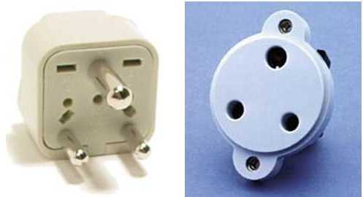
Voltage:
Please be sure you have the correct adapter. Voltage converters will not be provided at the meeting. India's A/C supply is 230V-50Hz. The plug is a "Type D." The image is a visual representation of the adapter you will need if your equipment does not have the correct plug.

Reserving Seats:
Please note: It is requested that delegates do not preselect seats prior to the first morning of the meeting. Any seat signs left the day before the meeting will be removed. There is no access to the meeting rooms prior to 7am on the first morning. Please come early on should you wish to choose a specific seat. Delegates should reserve seats for themselves only in an effort to be considerate to the other attendees. Your cooperation is appreciated by the host and your fellow delegates.
APPENDIX A

Visa Invitation Request Form

Please contact Ms. Shelany Devaiah via email at Shelany.d@necindia.in should you require a personal letter of invitation for a visa application. Your email must include a scanned copy of the passport along with the following information in order for it to be processed:

- Name of the applicant:
- Father/Husband name:
- Nationality:
- Date of Birth (month/date/year):
- Place of Birth:
- Passport Number:
- Date & Place of Issue:
- Date of Expiry:
- Company/mailing address:

Note: The name, date of birth, nationality, passport number, valid date of passport, etc. must be seen clearly in the scanned copy of the passport; to ensure readability, a scanned photograph page is preferred.)

PLEASE VERIFY THAT ALL INFORMATION IS ACCURATE AND WILL BE VALID AT THE TIME OF THE MEETING.

In addition, you may be asked for specific documentation showing strong social, economic, and other ties to your home country. Documents in a foreign language should have a notarized translation attached.

Please be sure to check your requirements for visa at the consulate where you will be applying and include any specific instructions in your request for a visa letter. The requirements can vary greatly from city to city, even within the same country, so delegates must request exactly what is needed to apply for a visa at that consulate.

It may take up to 12 weeks for visa approval, so please make your request for the invitation letter as soon as possible. Letters of invitation will be sent to you via email. A hard copy will only be sent upon special request.

Please do not contact ETSI/MCC or the meeting chairman for a visa letter. Letters will be processed within 14 working days of receiving an email request. If you have not received your letter within 14 working days or have any changes after receiving an email copy, please contact Ms. Shelany Devaiah via email at shelany.d@necindia.in

APPENDIX B

Hotel Reservation Form

The Leela Palace, Adyar Seaface, M.R.C Nagar
Chennai 600 028, India
Rates available from 24th – 29th July 2016

Please e-mail your booking details
to Shelany.d@necindia.in and nmec_r_support_admin@ml.necindia.in by May 31st 2016

NOTE: Reservation is not guaranteed without your credit card number.
Title: | Ms ( ) Mrs ( ) Mr ( )
Family name:
Forename:
Company:
Mailing address:
Telephone*:
Fax*:
E-mail:
Accompanied by:
* = including country code

The Leela Palace  Room rate per night:  (rates include all taxes, wireless Internet access, one-way airport transfer, breakfast and lunch) | Standard single INR 10,150 ( )  Standard double INR 11,500 ( )
Date and time of arrival:
Date and time of departure:
Any special arrangements:

Credit card: | AMEX ( ) MASTER CARD ( ) VISA ( ) other ( )
Credit card Number:
Expiry date (MM/YY):
Cardholder's name:

One way Airport Transfer:  Which is provided by Hotel vehicle on shared basis | Pickup from Airport to Hotel |  | Drop from Hotel to Airport
 | Yes | No | Yes | No
Flight Information (Arrival/Departure)

Cancellations:
Reservations must be cancelled 48 hours prior to arrival in order to avoid a penalty of one night’s room and tax.

