**3GPP TSG-SA3 Meeting #109Adhoc-e *draft_S3-230184-r1***

**Online, 16 - 20 January 2023**

**Source: Huawei, HiSilicon**

**Title: New solution to select the assistant ranging procedure based on privacy requirement**

**Document for: Approval**

**Agenda Item: 5.19**

# 1 Decision/action requested

***Approve the new solution proposal to TR 33.893***

# 2 References

N/A

# 3 Rationale

The contribution proposes to add a new solution to select the secured assistant ranging procedure based on security requirements. Two different assistant Ranging/SL Positioning procedures are concluded in Key Issue #2 of TR 23.700-86:

Procedure A: SL Reference UE and Target UE perform the Ranging/SL Positioning operation procedure with the selected Assistant UE(s) respectively. Then the measurement/result obtained by SL Reference UE and Target UE are used by the SL Reference UE or Target UE to calculate the final ranging result;

Procedure B: SL Reference UE triggers the selected Assistant UE(s) to perform Ranging/SL Positioning procedure with Target UE, and gets the ranging result between the selected Assistant UE(s) and Target UE from the selected Assistant UE(s). SL Reference UE calculates the final Ranging result based on the ranging result between the selected Assistant UE(s) and SL Reference UE and the received ranging result between the selected Assistant UE(s) and Target UE.

The major difference is whether or not the SL Reference UE/Target UE gets the ranging result from the selected Assistant UE. Considering the ranging result contains the location information of the SL Reference UE/Target UE which is privacy/security sensitive, the SL Reference UE/Target UE may not want to expose the ranging result to the Assistant UE. This solution proposes a mechanism to select between different assistant Ranging/SL Positioning procedures based on privacy requirements:

Option A: If privacy requirement is provided, then Procedure A is selected.

Option B: If privacy requirement is not provided, then Procedure B is selected.

# 4 Detailed proposal

pCR

***BEGINNING OF THE 1st CHANGE***

## 6.X Solution #X: Assistant ranging procedure selection based on privacy requirement.

### 6.X.1 Introduction

This solution addresses the privacy protection for Ranging/SL Positioning service as specified in Key Issue #1. In particular, the solution proposes a mechanism to select different Ranging/SL Positioning with assistant UE procedures based on privacy requirements.

### 6.X.2 Solution details

Two different assistant Ranging/SL Positioning procedures are concluded in Key Issue #2 of TR 23.700-86 [2] and the potential security aspect is highlighted in NOTE 4:

*‘NOTE 4: Coordination with SA WG3 is needed for security aspect.’*

The major difference is whether or not the SL Reference UE/Target UE gets the ranging result from the selected Assistant UE. Considering the ranging result contains the location information of the SL Reference UE/Target UE which is privacy/security sensitive, the SL Reference UE/Target UE may not want to expose the ranging result to the Assistant UE. This solution proposes a mechanism to select between different assistant Ranging/SL Positioning procedures based on privacy requirements. The high-level procedures are listed below:

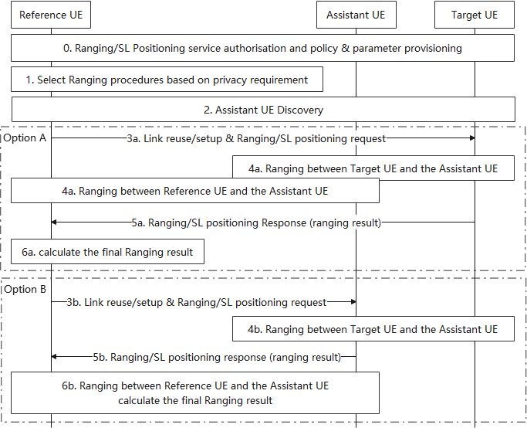

Figure 6.X.2-1: High-level procedures to select different Ranging procedures

0. SL Reference UE, Target UE and Assistant UE are authorised for Ranging/SL Positioning service and are provisioned with the policy/parameters related to the Ranging/SL Positioning service. The policy/parameters may include a privacy requirement. The privacy requirement indicates that the ranging results is sent over the direct link between the SL Referent UE and the Target UE (i.e. No ranging results are exposed to the Assistant UE).

1. The SL Reference UE selects the assistant Ranging/SL Positioning procedures based on the privacy requirement.

2. Assistant UE discovery procedures are performed by the SL Reference UE and/or Target UE.

[Option A] If the privacy requirement is provided:

3a. The SL Reference UE setups a new link or reuses existing link with the Target UE.

4a. After the link establishment, the SL Reference UE and the Target UE perform the Ranging/SL Positioning operation procedure with the selected Assistant UE(s) respectively.

5a. The measurement/result obtained by the Target UE are sent over the link between each other.

6a. The measurement/result receiving from the Target UE, and the measurement/result getting by the SL Reference UE are used by the SL Reference UE to calculate the final ranging result.

[Option B] If the privacy requirement is not provided:

3b-5b. The SL Reference UE triggers the selected Assistant UE(s) to perform Ranging/SL Positioning procedure with Target UE, and gets the ranging result between the selected Assistant UE(s) and Target UE from the selected Assistant UE(s).

6b. The SL Reference UE calculates the final Ranging result based on the ranging result between the selected Assistant UE(s) and SL Reference UE and the received ranging result between the selected Assistant UE(s) and Target UE.

### 6.X.3 Evaluation

This solution addresses the privacy protection for Ranging/SL Positioning service as specified in Key Issue #1. The ranging results are sent over the direct link between the SL Referent UE and the Target UE if a privacy requirement is provided. In this way, the ranging results are not sent via the Assistant UE and the privacy of the location information inside the results are protected.

Editor’s Note: The Assistant UE procedure and its presence in Rel-18 needs to align with the conclusion in RAN2 and SA2.

***END OF THE CHANGES***