3GPP TSG-SA3 Meeting #109AdHoc-e S3-230313-r1

Electronic meeting, 16 - 20 January 2023

Source: Ericsson

Title: New Solution to KI #11 based on Nnrf_AccesToken Service

Document for: Approval
Agenda Item: 5.24

1 Decision/action requested
Approve the pCR to TR 33.875 [1] below.

2 References
[1] 3GPP TR 33.875: "Study on enhanced security aspects of the 5G Service Based Architecture (SBA)"

3 Rationale
Key Issue #11 (NRF validation of NFc for access token requests) identifies various underspecifications in the mechanism used by the NRF to authorize an NF. One important missing detail is how an NF consumer (NFc) can securely register necessary profile at the NRF, i.e., Problem 1a (Clause 5.11.1.1) in the KI in TR 33.875 [1]. This document provides a direction towards detailing this underspecification. After receiving the necessary profile data, the NRF is ready to authorize the NF consumer’s request. Other underspecifications regarding Problem 1b and Problem 2 are not addressed in this solution. These other problems can be solved by other solution proposals in parallel.

4 Detailed proposal
*** 1st CHANGE ***

6.A Solution #A: NFc Registering using Nnrf_AccesToken Service

6.A.1 Introduction
This solution addresses KI #11. It proposes a mechanism for the NF consumers to register themselves to the NRF using new service operations defined under the Nnrf_AccessToken service, and mandate all the NF consumers to register to the NRF using at least one of the mechanisms available, e.g., using the existing Nnrf_NFManagement service or using the Nnrf_AccessToken service-based mechanism proposed in this solution.

6.A.2 Solution Details
Current Rel-17 specification 33.501 [3], clause 13.4.1.1.1, "OAuth 2.0 roles" states: "The NF Service registration procedure, as defined in clause 4.17.1 of TS 23.502 [8], may be used to register the OAuth 2.0 client (NF Service Consumer) with the OAuth 2.0 Authorization server (NRF), as described in clause 2.0 of RFC 6749 [43]."

This solution proposes to change the requirement to require that all NF service consumers shall register to NRF by using at least one of the mechanisms available, e.g., using the existing Nnrf_NFManagement service or using the Nnrf_AccessToken service-based mechanism proposed in this solution. The Nnrf_AcessToken service as described in the following.

The NFc uses the existing Nnrf_AccessToken service to serve the purpose of registering OAuth 2.0 client profile to NRF. This would require extending the functionalities of Nnrf_AccessToken service by defining new service operations such as ClientRegister, ClientUpdate, and ClientDeregister. The NFc uses the ClientRegister service operation to register itself to the NRF.

Before the NFc uses the new service operation ClientRegister, it is assumed that the NFc has generated an NF Instance ID and the O&M has provisioned the NFc withnecessary information. Since the NFc itself sends the registration request to the NRF, a security mechanism needs to be in place so that the NRF can verify that the NFc is not impersonating another NFc, i.e., the NFc is not using the profile of another NFc in the ClientRegister service operation. It is assumed that the NRF would identify an NFc by its NF Instance ID. To enable the NRF to verify the authenticity of the profile data sent by an NFc, the O&M also provisions the NFc with an instantiation token, which binds the NF Instance ID with the other necessary information about the NFc and is signed by the private key of the O&M. The instantiation token is forwarded by the NFc using the new service operation ClientRegister. Therefore, though the interface between O&M and NFc is proprietary, the instantiation token (e.g., its structure and content) needs to be standardized.

The integrity protection of OAuth 2.0 client profile data provisioned by the O&M to the NFc is out of 3GPP’s scope.

Figure 6.A.2-1 depicts a high-level view of the solution.

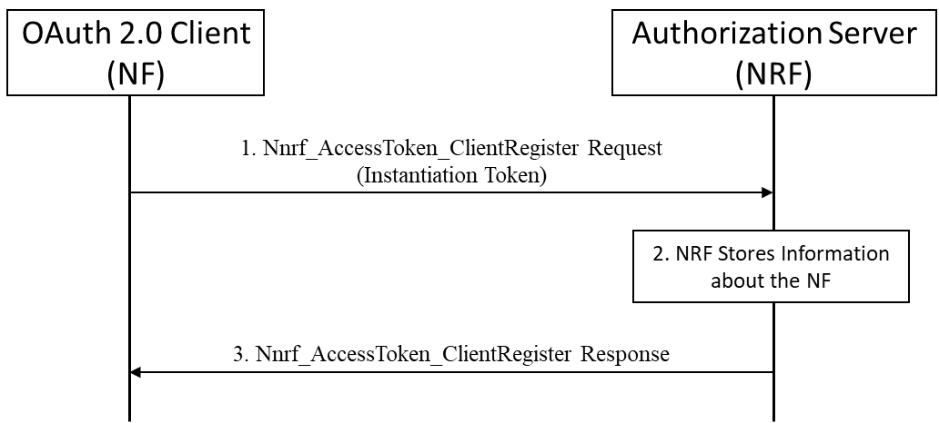

Figure 6.A.2-1: OAuth 2.0 client (NF Consumer) registering to the NRF
Editor' Note: This solution does not address all the problems mentioned in the KI. It addresses only problem 1a.
Editor’s Note: This solution does not yet address the case of using service mesh to register an NF cosumer to an NRF
Editor’s Note: This solution does not yet address the context of using hierarchial NRFs

6.A.3 Evaluation
This solution addresses one of the problems (1a) mentioned in the KI #11. It describes a secure way of registering an NFc to the NRF that protects against an NFc impersonating another NFc.
The solution requires modification in the existing implementations of NF consumers, NRF, and O&M.
Further evaluation is FFS.

*** END OF CHANGES ***

