3GPP TSG-SA3 Meeting #108Adhoc-e S3-222486

e-meeting, 10th – 14th October, 2022

Source: Huawei, HiSilicon

Title: E2E solution in L3 Relay

Document for: Approval
Agenda Item: 5.3

1 Decision/action requested
This contribution is accepted by the group.

2 References
NA

3 Rationale
This solution proposes to use application security to achieve E2E security for a L3 Relay. Whether to use application security is determined by the service itself which is out of scope of 3GPP.

4 Detailed proposal
********* Begin 1st change*********

6.Y Solution #Y: End-to-end security in L3 Relay

6.Y.1 Introduction
This solution addressed the requirement “The 3GPP system shall support a means to establish a secure connection between the source UE and the target UE in the UE-to-UE relay scenario” in KI#2 by using IPsec in application layer, when a L3 relay is used by a source UE and a target UE. The main goal of this solution is to introduce to application layer security to acehieve end to end security. The details of how and when to use application layer security is out of 3GPP scope. Meanwhile, the details of how the UEs discovery each other and the details of how the PC5 link establishment are not the goal of this solution, so they are simply mentioned, and they should comply with the agreement in TR 23.700-33[2], and the potential agreement of the present document.

6.Y.2 Solution details
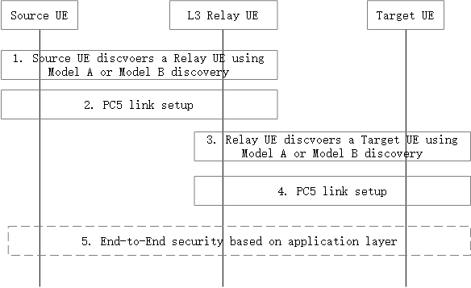
Figure 6.Y.2-1: Layer3 relay End-to-End security setup procedure
1. The source UE discovers a Relay UE using Model A or Model B discovery concluded in TR 23.700-33[2].
2. The Source UE and the Relay UE performs PC5 link setup procedure.
NOTE 1: The detail of this procedure is not in the scope of this solution.
3. The Relay UE discovers a target UE using Model A or Model B discovery concluded in TR 23.700-33[2].
4. The Relay UE and the target UE performs PC5 link setup procedure.
NOTE 2: The detail of this procedure is not in the scope of this solution.
5. If there is a need of End-to-end security, it should be setup in application layer which is out the scope of 3GPP.

6.Y.3 Evaluation
TBD
******** End of change*********

