3GPP TSG-SA3 Meeting #108Adhoc-e S3-222485

e-meeting, 10th – 14th October, 2022

Source: Huawei, HiSilicon

Title: New solution to KI#3

Document for: Approval
Agenda Item: 5.13

1 Decision/action requested
Approve the changes in clause 4 for inclusion in 33.887.

2 References
NA

3 Rationale
This contribution introduces a procedure to authenticate the AUN3 device by resuing the 7A.2.4 of TS 33.501. The different part comparing to 7A.2.4 is replacing the N5CW with AUN3, replacing the trusted non-3GPP access with 5G-RG, and replacing the TWIF with W-AGF. By this way, the 5GC will not be impacted.

4 Detailed proposal
********* Begin 1st change*********

6.Y Solution #Y: authentication for AUN3 devices

6.Y.1 Introduction
This solution addresses KI#1 by reusing existing mechanism.

6.Y.2 Solution details
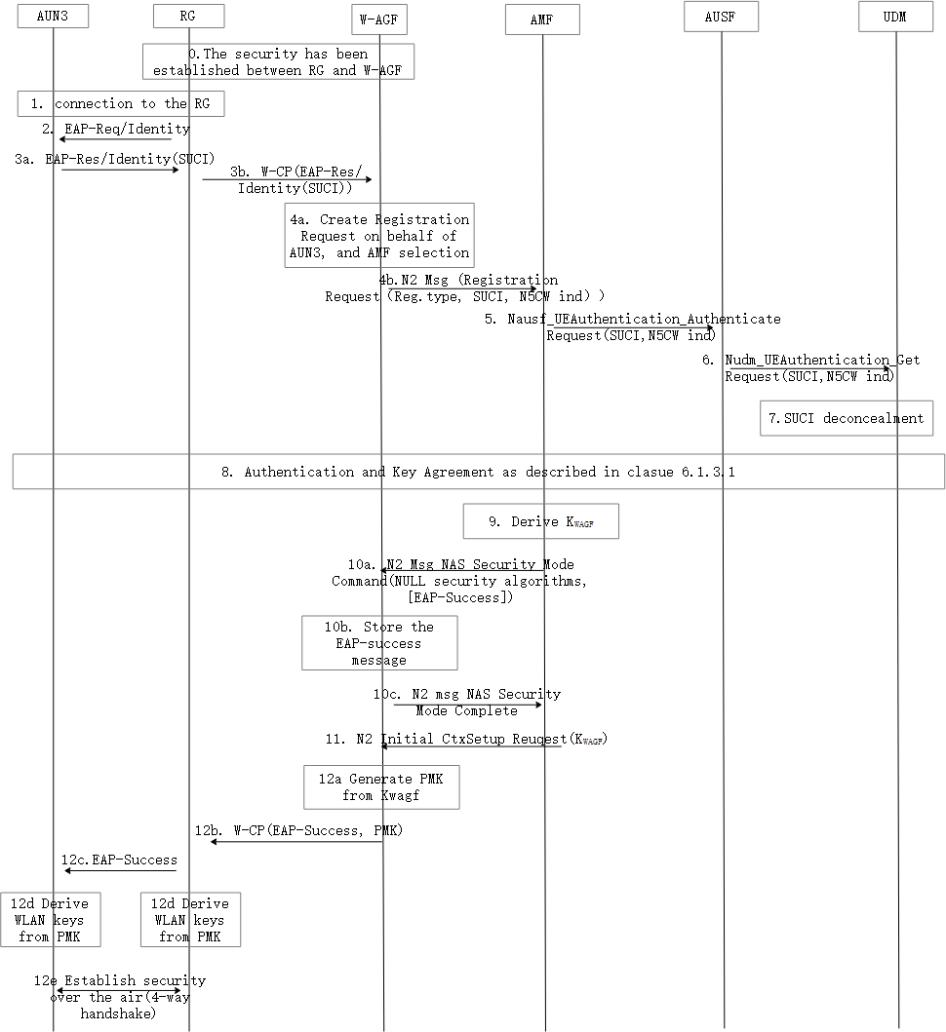
Figure 6.Y.2 AUN3 authentication procedure
0. The 5G-RG has established the security with W-AGF.
1. The AUN3 device connects to the 5G-RG
2. The 5G-RG sends an EAP-Req/Ideitity message to the AUN3 device.
3. The AUN3 device calculates the SUCI and sends EAP-Res/Identity message with SUCI to the 5G-RG, and the 5G-RG forwards the EAP-Res/Identity message to the W-AGF using W-CP protocol.
4-11. If the 5GC belongs to a PLMN only EAP-AKA’ authentication method can be used. If the 5GC belongs to a SNPN, different types of EAP authentication methods are allowed.
Editor’s Note: the step 8 in the figure needs to be updated.
12. the W-AGF generates the PMK from the K_{WAGF}, and sends the PMK to the 5G-RG for establishing the security over the air.

6.Y.3 Evaluation
No impact on 5GC.
******** End of change*********

