3GPP TSG-SA WG2 Meeting #172 S2-250bbbb
Dallas, US, November 17 - 21, 2025 (revision of S2-250xxxx)

Source: Sony
Title: [KI#1] Interim agreement update, UE capabilities
Document for: Approval
Agenda Item: 20.5.1
Work Item / Release: FS_AmbientIoT_Ph2_ARC / Rel-20
Abstract of the contribution: The contribution removes the Editor’s note and clarifies that the PLMN ID or NID is included when the AIOTF triggers the registration without filtering information the AF..

1. Introduction

There is an Editor’s note about UE capabilitiesng.
Editor's note: Whether UE reader capability is provided to AMF is FFS.
The discussion on SA#171 was around the AMF need to know specific radio capabilitoies before authorizing the UE to act as an UE Reader.
The current logic in the system is that the AMF get’s the UE radio capability information from the NG-RAN (who get’s it from the UE) and stores this in the UE context as long the UE is registered. The AMF provides the UE radio Capability information to the NG-RAN during the Initial UE context establishment in NG-RAN.
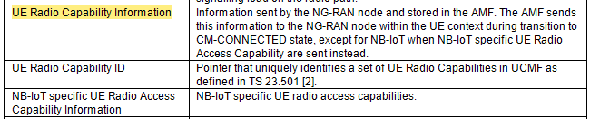
This IE is not used by the AMF, the AMF only stores the IE and provides it the NG-RAN when UE moves the RRC-Connected (UE context is established in NG-RAN).
Furthermore, for ProSe UE authorization the subscription information does not include any specific sidelink radio capabilities.
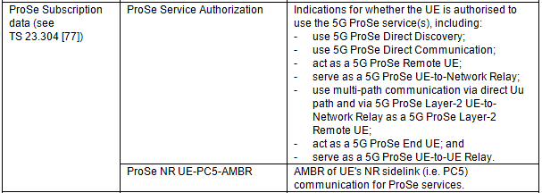

Based on the two observations, it would be fine at this stage to assume that the AMF would not need any specific UE radio capability to authorize the UE to act as UE Reader.
NG-RAN will, if needed, specify how to handle specific UE Ambient IoT radio capabilities when assigning Ambient IoT radio resources, whithout any involement with Core network.
Proposal: Remove the Editor’s note as it is assumed that Core network will not need to know any specific UE Ambient IoT Radio capabilities.

2. Proposal
It is proposed to agree the following changes to 3GPP TR 23.700-30:

* * * Start of Change * * * *

7.1.1 Agreed Principles for KI#1
'Figure 7.1.1-1 depicts the AIoT System Architecture for Topology 2.
Figure 7.1.1-1: AIoT System Architecture for Topology 2
Figure 7.1.1-2 depicts the AIoT system architecture, using the reference point representation.
Figure 7.1.1-2: AIoT System Architecture for Topology 2 in reference point representation
NOTE: Whether the interface between AIOTF and UDM is needed will be checked in later phase.
Message and protocol stack
- Messages between the UE Reader and the AIOTF are delivered using RRC between UE and NG-RAN and NGAP between NG-RAN and AMF and using an SBI interface between AMF and AIOTF. The related protocol stack is shown in Figure 7.1.1-3.
Figure 7.1.1-3: Protocol Stack for the RRC option
UE reader authorization and revocation part:
- Subscription aspects:
- The UE subscription in the UDM will be extended with UE Reader subscription information, which consists of the following:
- information indicating whether the UE is allowed to operate as a UE Reader.
Editor's note: Whether and what additional subscription information for the UE Reader is needed is FFS.
- UE Reader subscription information is available to AMF.
- If AMF receives, as part of the subscription information, the indication that the UE is authorized to operate as a UE Reader, AMF informs NG-RAN that the UE is authorized to operate as a UE Reader.
Editor's note: Whether to inform the UE about the authorization information is FFS.

- If the subscription information has been revoked, the indication that the UE is not authorized to operate as a UE Reader from the UDM, then the AMF informs NG-RAN that the UE is not authorized to operate as a UE Reader.
Editor's note: Whether and how UE Reader subscription information is provided to AIOTF is FFS.
- Radio resource management for UE Reader operation:
- If the gNB has received the indication that a UE is authorized to operate as a UE Reader, then the gNB may assign radio resources to the UE for UE Reader operation.
AIOTF Discovery and Selection for UE reader ID:
Editor's note: How to discover and select AIOTF when AF provides UE reader ID is FFS.
UE reader selection part:
Two scenarios will be supported for UE reader selection, AF providing UE reader ID case and AF providing Area case for all types of UE reader.
- For AF providing UE reader ID case:
- If UE Reader ID(s) is provided by the AF via the NEF for the operation, then that is used as the selected Reader(s) if authorized as UE reader. The AIOTF provides the selected UE Reader(s) to the NG-RAN.
Editor's note: How to select UE reader(s) based on the AF provided area information is FFS.
UE reader ID allocation:
Editor's note: Whether and how to allocate the UE reader ID is FFS..

* * * End of Change * * * *

