3GPP TSG-RAN WG4 Meeting # 98bis-e Revision of R4-2107130

Electronic Meeting, 12 – 20 April 2021

Agenda item: 9.1.2
Source: Keysight Technologies
Title: On CFFNF and CFFDNF test methodologies for high DL power and low UL power test cases
Document for: Approval

Introduction
This contribution outlines our view on topic #1 (Test methodology for high DL power and low UL power test cases) of the Enhanced Testability SI [1]. Simulations for the CFFDNF and the CFFNF methodologies were performed to determine the uncertainties for these methodologies.

CFFDNF and CFFNF Methodologies
The two methodologies considered for conformance testing with much reduced relaxations compared to the de-facto permitted IFF methodology are [3][4]:
- The Combined far-field/near-field (CFFNF) methodology
- The Combined far-field/direct-near-field (CFFNF) methodology
These methodologies are defined in TR38.884 as follows [4]:
- The Combined far-field/near-field (CFFNF) system utilizing a transform-based approach assumes that the UE beamlock function (UBF) activation is performed towards the FF beam peak direction based on the far-field method and then test case procedures are performed with measurement probe(s) in the NF of the DUT.
- Combined far-field/direct-near-field (CFFDNF) system assumes that the UE beamlock function (UBF) activation is performed towards the FF beam peak direction based on the far-field method and then test case procedures are performed based on the direct near-field method.
Both methodologies have in common that a FF probe, e.g., reflector&feed probe from IFF methodology, is used for the test cases and procedures that are not considered low UL power/high DL power. More importantly, this FF probe is used for the low UL/high DL power test cases to steer and lock the beam in the known FF direction before the NF measurements are performed with a NF probe that exhibits much lower free-space path losses. An example test setup of such hybrid system is shown in Figure 1.
The main differences between the two measurement approaches are outlined in Table 1. More information on the test procedures are outlined in Annex A.
Table 1: Main differences between CFFDNF and CFFNF measurement approaches
►Methodology ►  ▼Test Approach▼ | CFFDNF | CFFNF
Black Box | N/A | Wide local search at initial radius r₁, narrow local searches at radii r₂, r₃, i.e., multiple NF measurements at r₁, r₂, and r₃
Black&white-box | Single NF measurement or wide local search at r₁ (further investigated in Annex B) | Single NF measurements at r₁, and r₂

Figure 1: Hybrid NF/(I)FF test setup suitable for NF measurements utilizing black-box approach [Figure 16 of [3]].
The applicability of the two methodologies are outlined in detail in [4] and summarized in Table 2.
Table 2: Applicability of CFFDNF and CFFNF
►Test Case ► | BP Searches & Spherical Coverage |  | TRP |  | EIRP/EIS
►Methodology ►  ▼Test Approach▼ | CFFDNF | CFFNF | CFFDNF | CFFNF | CFFDNF | CFFNF
Black Box | Yes (FF) | Yes (FF) | Yes (Note 1) | No (Note 6) | No (Note 7) | Yes (Note 4)
Black & White Box | Yes (FF) | Yes (FF) | Yes (Note 2) | No (Note 6) | Yes (Note 3) | Yes (Note 5)
Note 1: At >32cm, no offset compensation is required. If offset is determined from CFFNF approach, range length ≤32cm are applicable with offset approach
Note 2: At range length ≤32cm, offset compensation is required while at >32cm, no offset compensation is required.
Note 3: Whether a local search to determine the NF test direction and/or optimize EIRP/EIS is FFS; min. range lengths are FFS
Note 4: Three radii approach with local searches can be used; EIRP/EIS can be approximated at very close distances (~22cm PC3; ~27cm PC1); unknown offset can be estimate accurately; other approaches no precluded
Note 5: Two radii approach without local searches can be used; EIRP/EIS can be approximated at very close distances (~21cm PC3; ~26cm PC1); other approaches no precluded
Note 6: not applicable since this approach is test time prohibitive
Note 7: This can be revised whenever empirical methods to determine the offset location are shown feasible

Simulation Assumptions for CFFDNF and CFFNF
The simulation assumptions for the CFFDNF and CFFNF methodologies are summarized in Table 3 for CFFNF and CFFDNF.
Table 3: Simulation assumptions for CFFDNF and CFFNF simulations
Parameter | Value(s)/Assumptions | Comment
Methodology | CFFDNF: with black&white-box approach  CFFNF: with black-box and black&white-box approach
Simulation Frequency [GHz] | 28 (others are not precluded)
UE Antenna Array Configuration | PC3: 8x2 and 4x1  PC1: 12x12
Beam Steering Assumptions | N/A | Not needed for CFFDNF as beam peak searches and spherical coverage measurements are based on FF probe
HPBW of Individual Array Element | 90º/90º | as suggested in [2]
Offsets of Active Array Panel | PC3 8x2&4x1:  0 ≤ x_{offset} ≤ 12.5cm  -12.5cm ≤ y_{offset} ≤ 12.5cm  -12.5cm ≤ z_{offset} ≤ 12.5cm  (The maximum radial offset cannot exceed 12.5cm)  PC1 12x12:  0 ≤ x_{offset} ≤ 10 cm  -10cm ≤ y_{offset} ≤ 10cm  -10cm ≤ z_{offset} ≤ 10cm  (The maximum radial offset cannot exceed 10cm) | Offsets should be picked randomly (for uniform distribution)  Min of 1k offsets selected randomly with uniform distribution
Path Loss Correction | Compensation of antenna array offset | Path loss applied to the EIRP measurements is not referenced to the centre of QZ but to the phase centre of the active antenna array
NF Measurement Direction | Determined theoretically from range length, FF BP direction, and array offsets | Local search is not precluded
Probe antenna pattern/gain compensation | - With compensation (uniform pattern assumed in simulations)  - Without compensation (typical horn pattern with ~50º HPBW pattern applied)
Tool Used for Simulations | Matlab or EM simulator
Range Lengths | CFFDNF: 20cm, 25cm, 30cm, 35cm, 40cm, 45cm, 20m

EIRP Simulation Results for CFFDNF
The EIRP simulations for the CFFDNF methodology were performed using Matlab and CST with the assumptions outlined in Table 3; additional details and simulation results are outlined in Annex B of this contribution which provide more detailed information of the assumptions and additional background on the simulation results. Some of the relevant observations from Annex B are listed below:
Observation 4: When performing measurements in the NF with CFFDNF methodology assuming the black&white-box approach, the path loss and probe antenna pattern must be compensated
Observation 5: CFFDNF simulations with 250 random offsets approximate the MUs (mean error and standard deviation) very well
Observation 6: CFFDNF simulations at 49GHz yield smaller MUs than at 28GHz.
Observation 7: A local search to determine the optimized NF beam peak direction/EIRP after pathloss and feed pattern compensation is not necessary.
Observation 8: The Matlab and CST antenna array patterns in the NF and FF are very similar.
Observation 9: The Matlab and CST MU analyses for CFFDNF with black&white-box approach yield very similar MU results.

As outlined in Annex B, reasonable MUs can be achieved only when not just the antenna panel offset is compensated but also the probe antenna pattern is compensated. The results for the mean error (from the FF reference EIRP) and the standard deviation of the 100k simulations for the three different antenna configurations is shown in Table 4. These results assume that the known array offset and the feed antenna patterns are compensated. Clearly, the 4x1 antenna configuration allows accurate NF measurements with insignificant MUs for 20cm range lengths, while the 8x2 antenna configurations allows accurate NF measurements with insignificant MUs down at 45cm range lengths; MUs in excess of ~0.5dB would apply for a range length of 20cm. The PC1 12x12 antenna configuration requires measurement uncertainties of ~0.5dB for range lengths exceeding 45cm.
Table 4: CFFDNF simulation results utilizing black&white-box with antenna array offset and feed antenna pattern compensated.
Antenna Configuration | Range Length [m] | |Mean EIRP Error| w.r.t. FF [dB] | Std. Dev of EIRP at NF BP [dB]
4x1 | 0.2 | 0.04 | 0.02
4x1 | 0.25 | 0.02 | 0.01
4x1 | 0.3 | 0.01 | 0.00
4x1 | 0.35 | 0.01 | 0.00
4x1 | 0.4 | 0.01 | 0.00
4x1 | 0.45 | 0.00 | 0.00
4x1 | 20 | 0.00 | 0.00
8x2 | 0.2 | 0.48 | 0.22
8x2 | 0.25 | 0.23 | 0.08
8x2 | 0.3 | 0.14 | 0.04
8x2 | 0.35 | 0.09 | 0.02
8x2 | 0.4 | 0.07 | 0.01
8x2 | 0.45 | 0.05 | 0.01
8x2 | 20 | 0.00 | 0.00
12x12 | 0.2 | 3.41 | 1.09
12x12 | 0.25 | 1.84 | 0.44
12x12 | 0.3 | 1.16 | 0.22
12x12 | 0.35 | 0.80 | 0.13
12x12 | 0.4 | 0.59 | 0.08
12x12 | 0.45 | 0.45 | 0.05
12x12 | 20 | 0.00 | 0.00

Based on these simulation results, the following observations were made in Annex B:
Observation 3: The CFFDNF methodology assuming the black&white-box approach with array offsets and the probe antenna pattern compensated is suitable for EIRP/EIS measurements with insignificant MU for PC3 devices with 8x2 antenna configuration when range length is greater or equal to 45cm. At smaller range lengths, small MUs (>0dB) must be applied to the measurements.
Observation 10: The CFFDNF methodology assuming the black&white-box approach with array offsets and the probe antenna pattern compensated is suitable for EIRP/EIS measurements with insignificant MU for PC3 devices with 4x1 antenna configuration when range length is greater or equal to 20cm.
Observation 11: The CFFDNF methodology assuming the black&white-box approach with array offsets and the probe antenna pattern compensated is suitable with small MUs (>0dB) for EIRP/EIS measurements for PC1 devices with 12x12 antenna configuration when range length is greater or equal to 45cm.

TRP Simulation Results for CFFDNF
The TRP simulations using Matlab for the CFFDNF methodology were performed based on the same assumptions outlined in Table 3 but with slightly different range lengths, i.e., the same used in a previous contribution [3]. The results are summarized in Table 5.
Table 5: CFFDNF TRP simulation results with and without path loss correction.
Antenna Configuration | Range Length [cm] | Constant Density Grid Step Size Δθ=Δφ [º] | With Path Loss Correction |  | Without Path Loss Correction
Antenna Configuration | Range Length [cm] | Constant Density Grid Step Size Δθ=Δφ [º] | |Mean TRP Error| [dB] | TRP Std. Dev. [dB] | |Mean TRP Error| [dB] | TRP Std. Dev. [dB]
8x2 | 20 | 5 | 0.01 | 0.04 | 0.39 | 0.24
8x2 | 20 | 7.5 | 0.02 | 0.13 | 0.39 | 0.25
8x2 | 20 | 10 | 0.03 | 0.17 | 0.39 | 0.29
8x2 | 32 | 5 | 0.02 | 0.01 | 0.14 | 0.08
8x2 | 32 | 10 | 0.04 | 0.03 | 0.14 | 0.09
8x2 | 43 | 5 | 0.02 | 0.01 | 0.08 | 0.04
8x2 | 43 | 10 | 0.04 | 0.03 | 0.08 | 0.04
12x12 | 20 | 5 | 0.02 | 0.07 | 0.29 | 0.17
12x12 | 20 | 7.5 | 0.01 | 0.24 | 0.29 | 0.21
12x12 | 20 | 10 | 0.01 | 0.36 | 0.27 | 0.39
12x12 | 32 | 5 | 0.04 | 0.13 | 0.11 | 0.06
12x12 | 32 | 10 | 0.09 | 0.63 | 0.07 | 0.64
12x12 | 43 | 5 | 0.06 | 0.13 | 0.06 | 0.03
12x12 | 43 | 10 | 0.12 | 0.65 | 0.01 | 0.66
The results show for PC3 that
- no additional MU is needed for range lengths exceeding 20cm if the path loss correction is applied for measurement grids with step size of at most 10º.
- no additional MU is needed for range lengths exceeding 43cm if the path loss correction is not applied for measurement grids with step size of at most 10º.
and for PC1 that
- no additional MU is needed for range lengths exceeding 20cm if the path loss correction is applied for measurement grids with step size of at most 5º.
- no additional MU is needed for range lengths exceeding 43cm if the path loss correction is not applied for measurement grids with step size exceeding 5º.
Observation 1: For PC3 TRP analyses based on the CFFDNF approach,
- no additional MU is needed for range lengths exceeding 20cm if the path loss correction is applied for measurement grids with step size of at most 10º
- no additional MU is needed for range lengths exceeding 43cm if the path loss correction is not applied for measurement grids with step size of at most 10º
Observation 2: For PC1 TRP analyses based on the CFFDNF approach,
- no additional MU is needed for range lengths exceeding 20cm if the path loss correction is applied for measurement grids with step size of at most 5º
- no additional MU is needed for range lengths exceeding 43cm if the path loss correction is not applied for measurement grids with step size exceeding 5º

EIRP Simulation Results for CFFNF
The EIRP simulations for the CFFNF methodology were performed using CST with the assumptions outlined in Table 3 with exceptions outlined in Annex C and D of this contribution.
Since simulations and the fine tuning of measurement algorithms are still in progress for the CFFNF methodology, especially based on the black-box approach, additional and missing results will hopefully be provided late, i.e., during the meeting. The preliminary observations clearly indicated that the CFFNF methodology supports significantly lower MUs and thus shorter range lengths than CFFDNF based on the black&white-box approach. No conclusions can be drawn yet for the CFFNF methodology based on the black-box approach.
Observation 12: The CFFNF methodology with the black&white-box approach yields smaller MUs than the CFFDNF methodology.
Observation 13: The CFFNF methodology assuming the black&white-box approach with array offsets and the probe antenna pattern compensated is suitable for EIRP/EIS measurements with insignificant MU for PC3 devices with 8x2 antenna configuration when range length is greater or equal to 21cm.
Observation 14: The CFFNF methodology assuming the black&white-box approach with array offsets and the probe antenna pattern compensated is suitable for EIRP/EIS measurements with small MU for PC1 devices with 12x12 antenna configuration when range length is greater or equal to 31cm.
Observation 15: Local Searches of the CFFNF methodology using black box approach can be accelerated using coarse&fine search grids and continuous scan measurements.
The preliminary results for CFFNF using the black&white-box approach are summarized in Table 6 and compared to the CFFDNF results using the black&white-box approach.
Table 6: Statistical results of 500 (52)EIRP CFFNF & CFFDNF CST simulations based on black&white-box approach with random 8x2 (12x12) antenna array offsets uniformly spaced within 12.5cm (10cm) in a single hemisphere. The antenna array offsets and probe pattern were compensated.
Antenna Configuration | Methodology | Number of Offsets | Range Length [m] | |Mean EIRP Error| w.r.t. FF [dB] | Std. Dev of EIRP at NF BP [dB]
8x2 | CFFNF with black box approach | 500 | 0.22
8x2 | CFFNF with black box approach | 500 | 0.27
8x2 | CFFNF with black box approach | 500 | 0.32
8x2 | CFFNF with black&white-box approach | 500 | 0.21 | 0.04 | 0.04
8x2 | CFFNF with black&white-box approach | 500 | 0.26 | 0.03 | 0.03
8x2 | CFFNF with black&white-box approach | 500 | 0.31 | 0.03 | 0.03
8x2 | CFFDNF with black&white-box approach | 500 | 0.2 | 0.42 | 0.19
8x2 | CFFDNF with black&white-box approach | 500 | 0.25 | 0.22 | 0.07
8x2 | CFFDNF with black&white-box approach | 500 | 0.3 | 0.14 | 0.04
12x12 | CFFNF with black&white-box approach | 52 | 0.21 | 0.97 | 0.41
12x12 | CFFNF with black&white-box approach | 52 | 0.26 | 0.37 | 0.12
12x12 | CFFNF with black&white-box approach | 52 | 0.31 | 0.18 | 0.06
12x12 | CFFDNF with black&white-box approach | 52 | 0.2 | 3.68 | 0.97
12x12 | CFFDNF with black&white-box approach | 52 | 0.25 | 2.01 | 0.40
12x12 | CFFDNF with black&white-box approach | 52 | 0.3 | 1.28 | 0.21
Note:
The range length for CFFNF with black&white-box approach is reported for radius r₂>r₁ and r₂=r₁+1cm.
The range length for CFFNF with black-box approach is reported for radius r₃>r₂>r₁ and r₃=r₂+1=r₁+2cm.

Proposal 1: Incorporate the presented MU results into TR 38.884
It was determined that CFFNF and CFFDNF methodologies require the compensation of path loss (w.r.t. to the active antenna array) and the compensation of the probe antenna pattern. It is therefore proposed to capture this accordingly in TR 38.884.
Proposal 2: Capture in TR 38.884 that CFFNF and CFFDNF methodologies require the compensation of the path loss (w.r.t. to the active antenna array) and the compensation of the probe antenna pattern

Conclusion
The following observations and proposals were made in this contribution
Observation 1: For PC3 TRP analyses based on the CFFDNF approach,
- no additional MU is needed for range lengths exceeding 20cm if the path loss correction is applied for measurement grids with step size of at most 10o
- no additional MU is needed for range lengths exceeding 43cm if the path loss correction is not applied for measurement grids with step size of at most 10o
Observation 2: For PC1 TRP analyses based on the CFFDNF approach,
- no additional MU is needed for range lengths exceeding 20cm if the path loss correction is applied for measurement grids with step size of at most 5o
- no additional MU is needed for range lengths exceeding 43cm if the path loss correction is not applied for measurement grids with step size exceeding 5o
Observation 3: The CFFDNF methodology assuming the black&white-box approach with array offsets and the probe antenna pattern compensated is suitable for EIRP/EIS measurements with insignificant MU for PC3 devices with 8x2 antenna configuration when range length is greater or equal to 45cm. At smaller range lengths, small MUs (>0dB) must be applied to the measurements.
Observation 10: The CFFDNF methodology assuming the black&white-box approach with array offsets and the probe antenna pattern compensated is suitable for EIRP/EIS measurements with insignificant MU for PC3 devices with 4x1 antenna configuration when range length is greater or equal to 20cm.
Observation 11: The CFFDNF methodology assuming the black&white-box approach with array offsets and the probe antenna pattern compensated is suitable with small MUs (>0dB) for EIRP/EIS measurements for PC1 devices with 12x12 antenna configuration when range length is greater or equal to 45cm.
Observation 4: When performing measurements in the NF with CFFDNF methodology assuming the black&white-box approach, the path loss and probe antenna pattern must be compensated
Observation 5: CFFDNF simulations with 250 random offsets approximate the MUs (mean error and standard deviation) very well
Observation 6: CFFDNF simulations at 49GHz yield smaller MUs than at 28GHz.
Observation 7: A local search to determine the optimized NF beam peak direction/EIRP after pathloss and feed pattern compensation is not necessary.
Observation 8: The Matlab and CST antenna array patterns in the NF and FF are very similar.
Observation 9: The Matlab and CST MU analyses for CFFDNF with black&white-box approach yield very similar MU results.
Observation 12: The CFFNF methodology with the black&white-box approach yields smaller MUs than the CFFDNF methodology.
Observation 13: The CFFNF methodology assuming the black&white-box approach with array offsets and the probe antenna pattern compensated is suitable for EIRP/EIS measurements with insignificant MU for PC3 devices with 8x2 antenna configuration when range length is greater or equal to 21cm.
Observation 14: The CFFNF methodology assuming the black&white-box approach with array offsets and the probe antenna pattern compensated is suitable for EIRP/EIS measurements with small MU for PC1 devices with 12x12 antenna configuration when range length is greater or equal to 31cm.
Observation 15: Local Searches of the CFFNF methodology using black box approach can be accelerated using coarse&fine search grids and continuous scan measurements.
Proposal 1: Incorporate the presented MU results into TR 38.884
Proposal 2: Capture in TR 38.884 that CFFNF and CFFDNF methodologies require the compensation of the path loss (w.r.t. to the active antenna array) and the compensation of the probe antenna pattern

References
- RP-192322, New SID: Study on enhanced test methods for FR2, Apple Inc., CAICT, 3GPP TSG-RAN Meeting #85, September 2019
- R5-206618, PC1 Assumptions for CDF Curve for MOP EIRP Spherical Coverage, Qualcomm, 3GPP TSG-RAN5 Meeting #89-e, November 2020
- R4-2102616, On Test methodology for high DL power and low UL power test cases, Keysight Technologies, 3GPP TSG-RAN WG4 Meeting # 98-e, February 2021
- R4-2103985, Draft TR38.884 Study on enhanced test methods for FR2 NR UEs v0.2.0, Apple, R4-2103985, February 2021
- 2012713, WF on the high DL power and low UL power test cases objective, Apple Inc., 3GPP TSG-RAN WG4 Meeting RAN4#96-e, August 2020
- R4-2102620, NF based solutions and Enhancement of permitted methods, Rohde & Schwarz, 3GPP TSG-RAN WG4 Meeting #98-e, February 2021
- TR38.810, Study on test methods, V16.4.0 (2019-09)
- TS 38.521-2, User Equipment (UE) conformance specification; Radio transmission and reception; Part 2: Range 2 Standalone, V16.6.0 (2020-12)

Annex A: Comparison of CFFDNF and CFFNF test procedures
In a NF system, the NF BP direction for an offset antenna is not necessarily the same as the FF BP direction; however, the knowledge of the antenna phase centre offset, i.e., black&white-box approach, can be leveraged to measure at the NF BP direction as illustrated in Figure 2. The knowledge of the offset together with the probe antenna pattern will allow the calculation of the optimized DUT orientation to optimize the NF measurement. The beam peak direction in the NF can either be calculated [3] or determined via a local search [6]. The results in this contribution are primarily based on calculating the NF BP direction based on the range length, the known phase centre offset of the active antenna array, and the FF BP direction. Additionally, simulations are performed to determine whether a local search is able to identify directions different from the calculated directions to further optimize EIRP/MUs.
Figure 2: Illustration of NF testing utilizing the black&white-box approach.
To guarantee that the correct beam is measured for when the black&white-box measurement approach is applied, the CFFDNF approach utilizes a FF probe that allows the UE to select the proper beam in the known beam peak direction. A beam lock activation via the UBF makes sure that the UE no longer changes its antenna pattern when the NF measurement probe is used to perform the measurements with significantly reduced free-space path losses than in existing IFF systems. The appropriate test steps required for NF testing based on the CFFDNF approach of DUTs with known phase-centre offsets (black&white-box) are illustrated in Figure 3.
Figure 3: Test Steps for CFFDNF testing of DUTs with known antenna phase centre offset (black&white-box approach).
For the CFFNF methodology that supports both the black-box and the black&white-box approach, the initial test steps are the same as steps 1-3 in Figure 3. The test steps for the NF measurement portion of the black-box approach are further outlined in Figure 4 while the NF test steps for the black&white-box approach are outlined in Figure 5. The diagrams on the right of Figure 4 illustrate the different local searches required for the measurements at each of the three radii. The measurements at the very first radius r₁ require a wide sector of grid points around the known FF beam peak direction big enough so that the local/NF beam peak is captured properly. For the initial local search at r₁=20cm, the width of the sector is about ±40º which can be covered using coarse and fine scans to further reduce the number of points. On the other hand, the sector of grid points for measurements at radius r₂ and r₃ can be significantly smaller as only a small region around the local NF beam peak found at r₁ is needed.

Figure 4: Illustration of the CFFNF test steps with asymptotic expansion transform utilizing the black-box approach.
Figure 5: Illustration of the CFFNF test steps with asymptotic expansion transform utilizing the black&white-box approach.

Annex B: Combined Far-Field Direct Near Field (CFFDNF) EIRP Simulations based on Black & White-Box Approach
In this section, we present results and detailed assumptions for near-field and far-field simulations of N_{y} x N_{z} antenna arrays for the CFFDNF methodology based on the black&white-box approach, i.e., the active antenna panel for the FF beam peak direction is known/declared. The assumptions are summarized in Table 3.
The test procedure for this methodology is further outlined in Annex A, specifically Figure 3.
The main intention of this section is to estimate the measurement uncertainties of EIRP measurements performed in the NF at various range lengths. Since the beam peak search and spherical coverage analyses are performed with the FF probe, the beam steering assumptions and CDF analyses previously agreed in [5] are not required here. The definitions of offsets (x_{offset}/y_{offset}/z_{offset}), maximum offsets (≤12.5cm for PC3 and ≤10cm for PC1), array configurations (PC3: 8x2 and 4x1, PC1: 12x12), range lengths (30cm, 20m, etc) have been adopted from [5].
The NF and FF patterns were determined using the superposition approach outlined in [3] for the Matlab based results.
As outlined in [3], the HPBW assumptions (Clause G1.1 of [7]) of the individual antenna elements were chosen to be 90º/90º as suggested in [2]. The FF 8x2 and 4x1 array patterns with the 90º/90º HPBW assumption are shown in Figure 6.
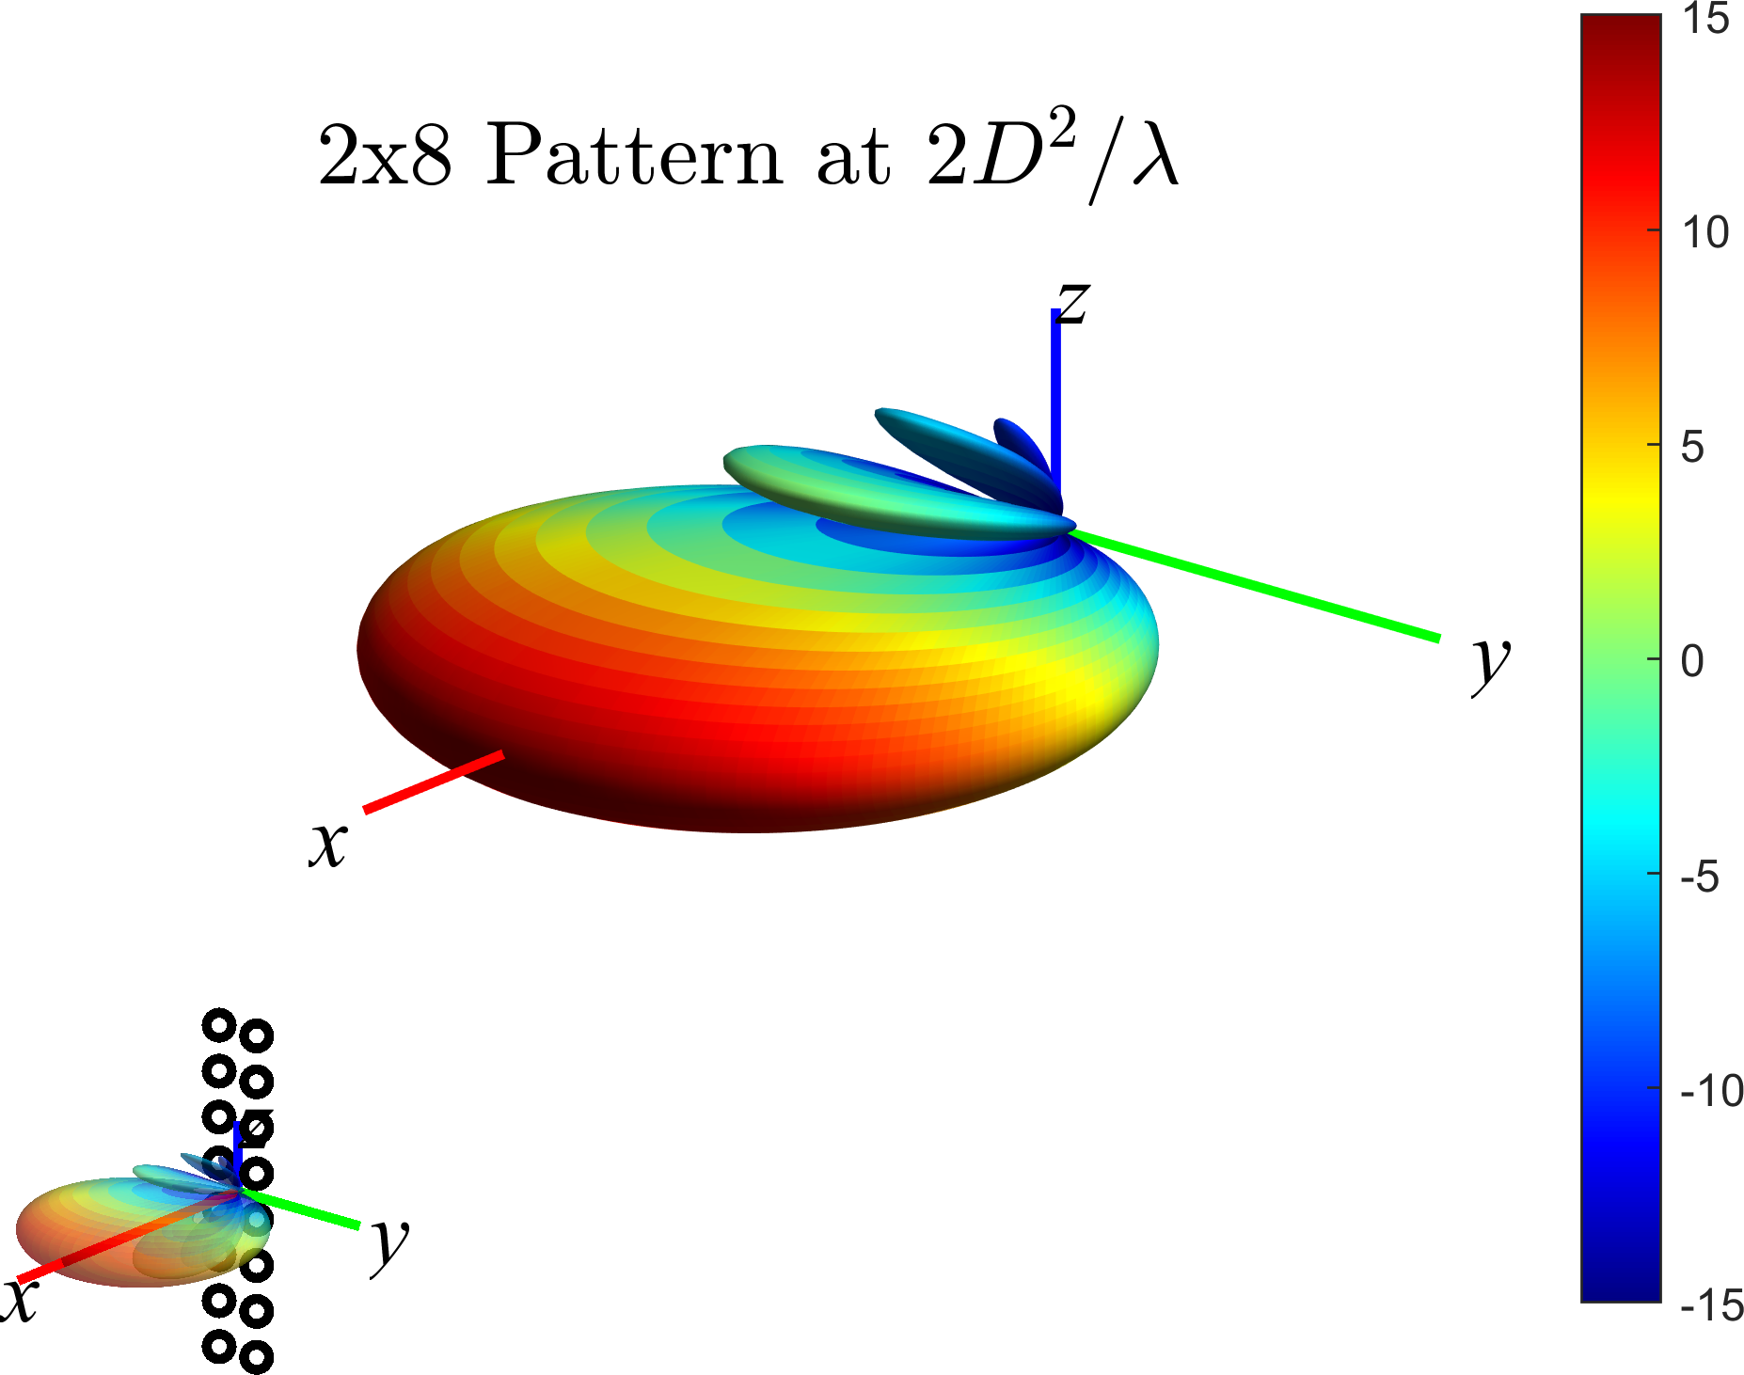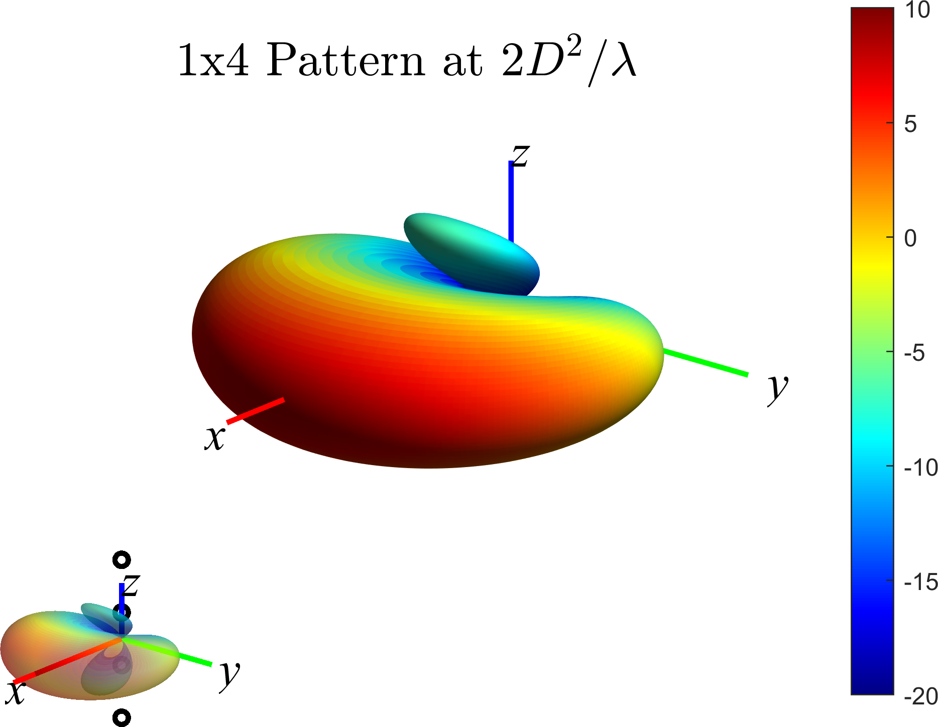
Figure 6: FF antenna pattern with 90º/90º HPBW for 8x2 antenna array configuration (left) and 4x1 antenna array configuration (right).

The pattern simulations assume superpositions of individual, single-element far-field antenna patterns; this approach requires that the NF of N_{y} x N_{z} antenna array is well in the FF of the single-element antenna as discussed in [3]. The EIRP simulations in this section were primarily performed using Matlab.
The simulations assume that the FF beam peak direction of the DUT is known, i.e., (θ, φ) = (90º, 0º) for the sample DUT considered.
Since these simulations do not require 3D scans but just single-directional measurements, the simulation time using Matlab is relatively reasonable. For the statistical analyses, a total of 100,000 simulations with random and uniformly spaced offsets were performed. These offsets were varied between 0 to 12.5cm (10cm) in x and from -12.5cm (-10cm) to 12.5cm (10cm) in y and z for PC3 (PC1) while making sure that the maximum radial offset cannot exceed 12.5cm (10cm). The offsets in x were limited to positive values since it is assumed that the front antenna of the DUT is always in the upper hemisphere since the geometric centre of the device is aligned with the centre of the QZ. A sample set of 100,000 random offsets is visualized in Figure 7. Histograms of the respective offset radii, and offsets in x, y, and z are shown in Figure 8.
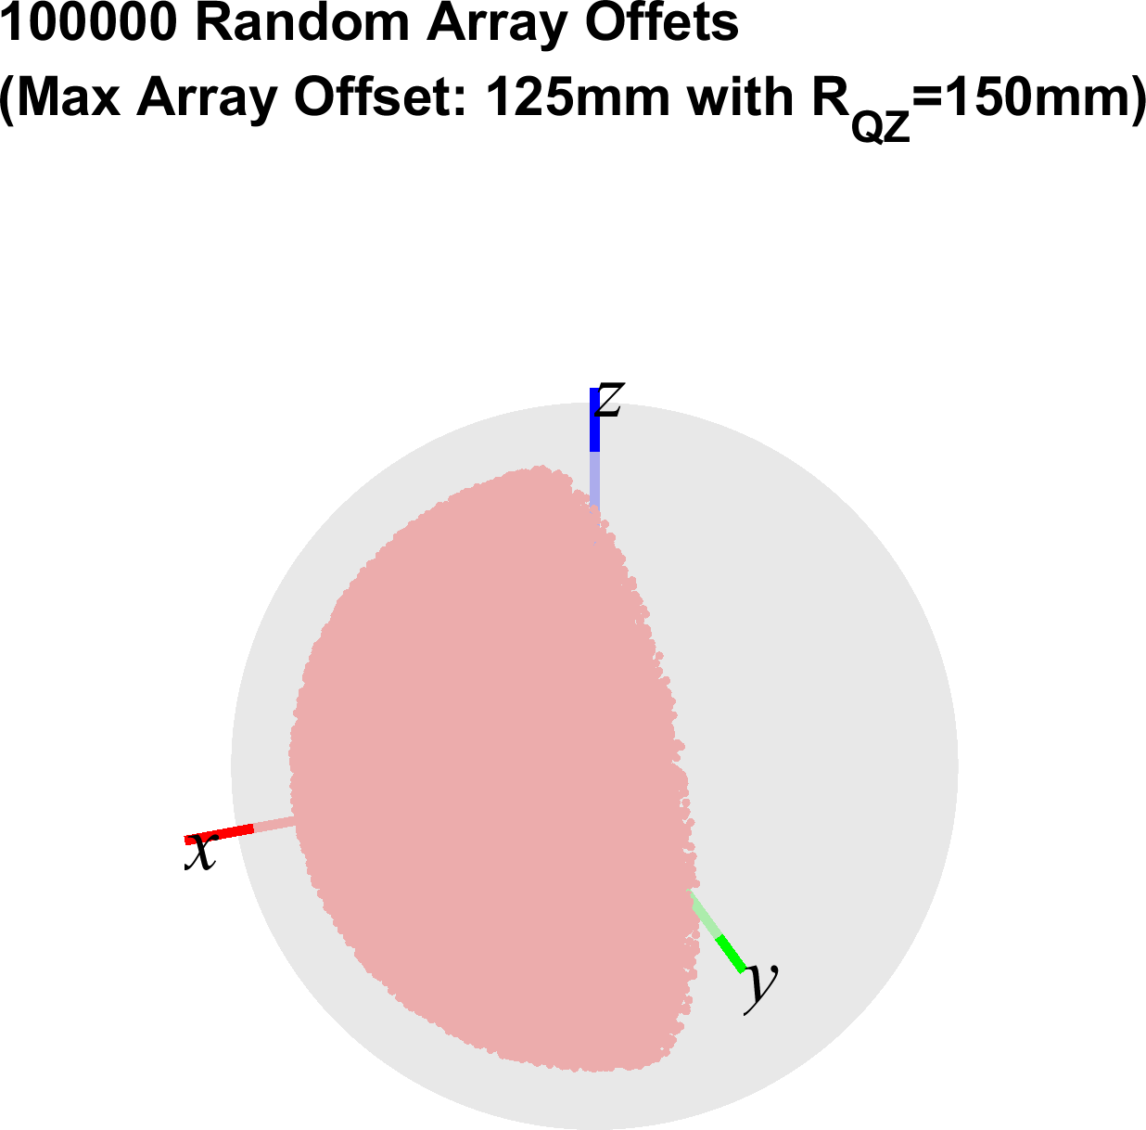
Figure 7: Illustration of 100,000 random offsets uniformly spaced within 12.5cm in a single hemisphere.
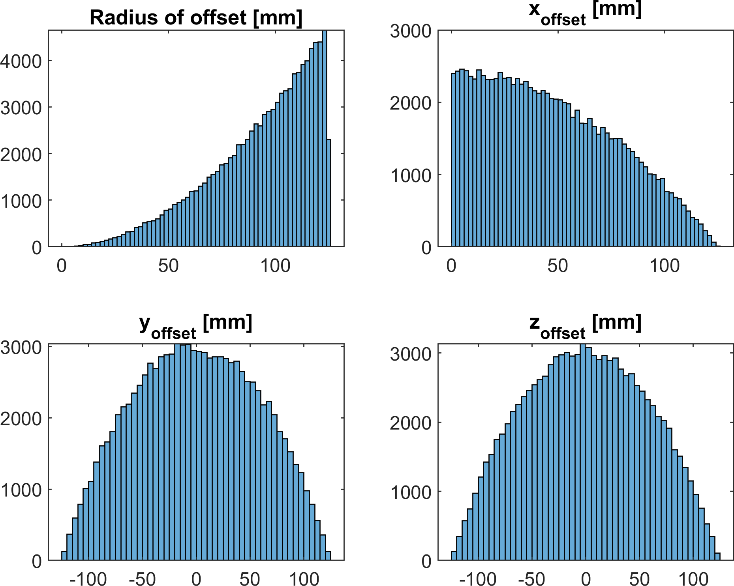
Figure 8: Histograms of 100,000 random offsets uniformly spaced within 12.5cm in a single hemisphere.
Since each of the offsets are known/declared, the offset can be properly compensated, i.e., the pathloss applied to the EIRP measurements is not referenced to the centre of QZ but to the phase centre of the active antenna array. The results in this section focus only on the EIRP results after the path loss with respect to the offset antenna array was compensated.

Additionally, for the best/optimized measurement uncertainties, the probe antenna pattern/gain must be compensated since the array offsets can result in the NF beam peak to be observed from directions with large deviations from the peak gain direction of the measurement probe/horn as illustrated in Figure 2. In the simulations, probe pattern/gain compensation can be modelled in the simplest approximation by assuming an omnidirectional pattern of the probe. To quantify the effect of not compensating the probe antenna pattern, this section will present measurement uncertainties for a typical horn antenna. For these simulations, a symmetric pattern of a horn antenna with ~50º HPBW pattern is assumed as plotted in Figure 9, which was obtained using the following Matlab commands:
ProbeTheta=-180:1:180;
HPBW=50;
ProbePattern_norm=-12*(ProbeTheta/HPBW);
Figure 9: Assumed measurement probe antenna pattern.

The NF beam peak direction, illustrated in Figure 2, was calculated using the known FF beam peak direction, the offset of the antenna array, and the range length.
A histogram of the 100k EIRP simulations for 4 different NF range lengths (20cm, 25cm, 30cm, 45cm) and the 20m FF range lengths is shown in Figure 10 and the statistical results of these simulations are tabulated in Table 7. These results assume that the antenna array offsets and the probe pattern/gain were compensated.
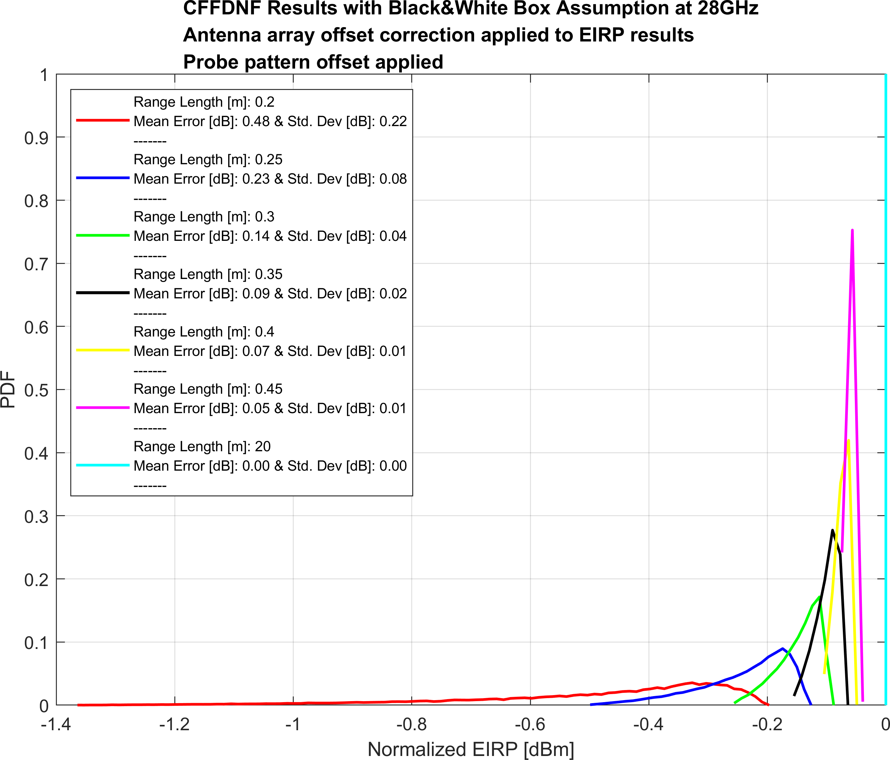
Figure 10: Histogram of 100,000 EIRP CFFDNF simulations based on black&white-box approach with random 8x2 antenna array offsets uniformly spaced within 12.5cm in a single hemisphere. The antenna array offsets and the probe pattern/gain were compensated

Table 7: Statistical results of 100,000 EIRP CFFDNF simulations based on black&white-box approach with random 8x2 antenna array offsets uniformly spaced within 12.5cm in a single hemisphere. The antenna array offsets and the probe pattern/gain were compensated
Range Length [m] | Max-Min EIRP [dB] | Max EIRP Error w.r.t. FF [dB] | |Mean EIRP Error| w.r.t. FF [dB] | Std. Dev of EIRP [dB]
0.2 | 1.17 | 1.36 | 0.48 | 0.22
0.25 | 0.37 | 0.50 | 0.23 | 0.08
0.3 | 0.17 | 0.26 | 0.14 | 0.04
0.35 | 0.09 | 0.16 | 0.09 | 0.02
0.4 | 0.06 | 0.10 | 0.07 | 0.01
0.45 | 0.04 | 0.07 | 0.05 | 0.01
20 | 0.00 | 0.00 | 0.00 | 0.00

Figure 11 illustrates which simulations for the 20cm range length result in the minimum and maximum EIRPs after antenna offset and probe pattern compensation.

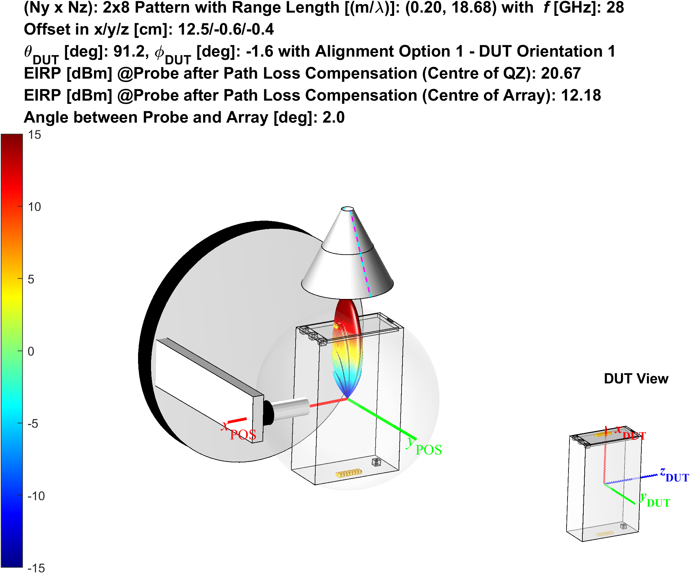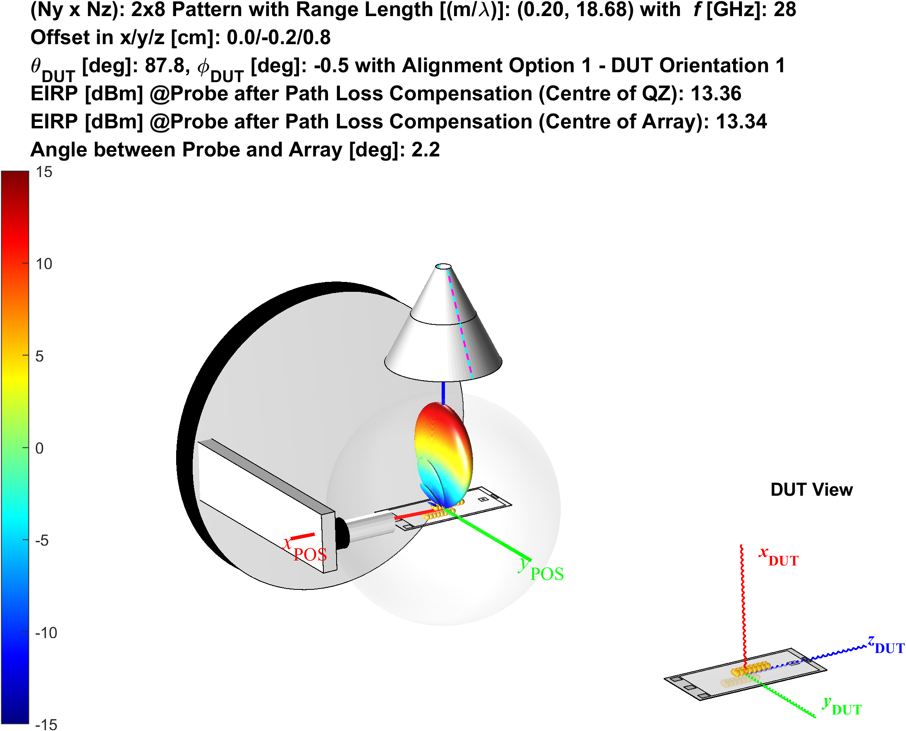
Figure 11: Illustration of simulations for the 20cm range length with 8x2 antenna configuration resulting in smallest (left) and largest (right) EIRPs after antenna offset and probe pattern compensation.

When the antenna array offset is towards the probe antenna, shown in the left plot of Figure 11, the EIRP without the offset compensation is very high (20.7dBm in this example); however, the offset compensation, i.e., applying the pathloss between the probe antenna and the active antenna array, helps to significantly improve the EIRP measurement uncertainty with respect to the EIRP measured in the FF.

Once the array offsets and the probe antenna pattern are compensated in the NF with CFFDNF methodology assuming the black&white-box approach, almost insignificant measurement uncertainties for PC3 devices can be observed at 45cm. At distances less than 45cm, measurement uncertainties must be taken into account.
Observation 3: The CFFDNF methodology assuming the black&white-box approach with array offsets and the probe antenna pattern compensated is suitable for EIRP/EIS measurements with insignificant MU for PC3 devices with 8x2 antenna configuration when range length is greater or equal to 45cm. At smaller range lengths, small MUs (>0dB) must be applied to the measurements.

When the probe pattern/gain is not compensated, a much larger variation of the measured EIRP results is expected due to the large off broadside directions of the antenna panels from the probe antenna, as illustrated schematically in Figure 2. This is further quantified in Figure 12 and in Table 8 for the same simulations. These results assume that the antenna array offsets are compensated while the probe pattern/gain were not compensated, i.e., the pattern in Figure 9 was applied to the simulations.

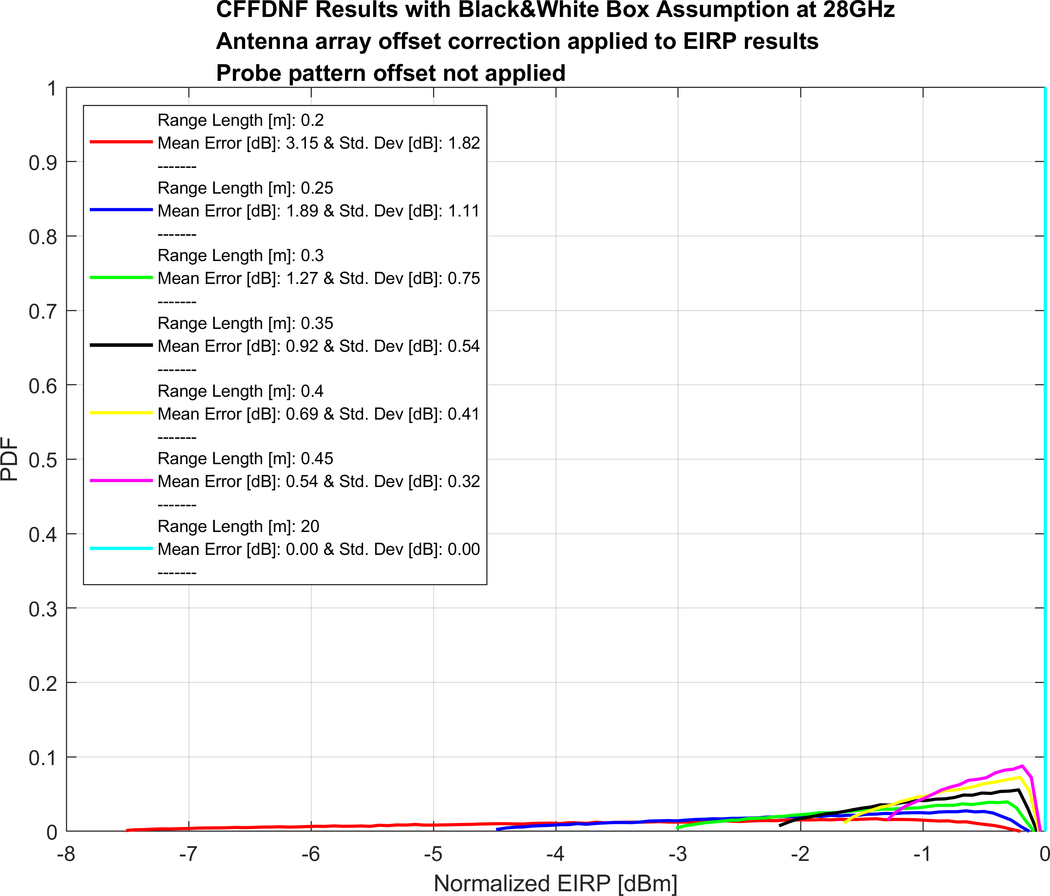
Figure 12: Histogram of 100,000 EIRP CFFDNF simulations based on black&white-box approach with random 8x2 antenna array offsets uniformly spaced within 12.5cm in a single hemisphere. The antenna array offsets were compensated while the probe pattern/gain was not compensated

Table 8: Statistical results of 100,000 EIRP CFFDNF simulations based on black&white-box approach with random 8x2 antenna array offsets uniformly spaced within 12.5cm in a single hemisphere. The antenna array offsets were compensated while the probe pattern/gain was not compensated.
Range Length [m] | Max-Min EIRP at (90,0) [dB] | Max EIRP Error w.r.t. FF [dB] | |Mean EIRP Error| w.r.t. FF [dB] | Std. Dev of EIRP at (90,0) [dB]
0.2 | 7.31 | 7.51 | 3.15 | 1.82
0.25 | 4.36 | 4.49 | 1.89 | 1.11
0.3 | 2.93 | 3.02 | 1.27 | 0.75
0.35 | 2.11 | 2.18 | 0.92 | 0.54
0.4 | 1.60 | 1.65 | 0.69 | 0.41
0.45 | 1.25 | 1.29 | 0.54 | 0.32
20 | 0.00 | 0.00 | 0.00 | 0.00
The latter results clearly demonstrate that when performing measurements in the NF with CFFDNF methodology assuming the black&white-box approach, the probe antenna pattern must be compensated.
Observation 4: When performing measurements in the NF with CFFDNF methodology assuming the black&white-box approach, the path loss and probe antenna pattern must be compensated
Figure 13 illustrates which simulations for the 20cm range length result in the minimum and maximum EIRPs after antenna offset compensation. These simulations do not take the probe pattern compensation into account.

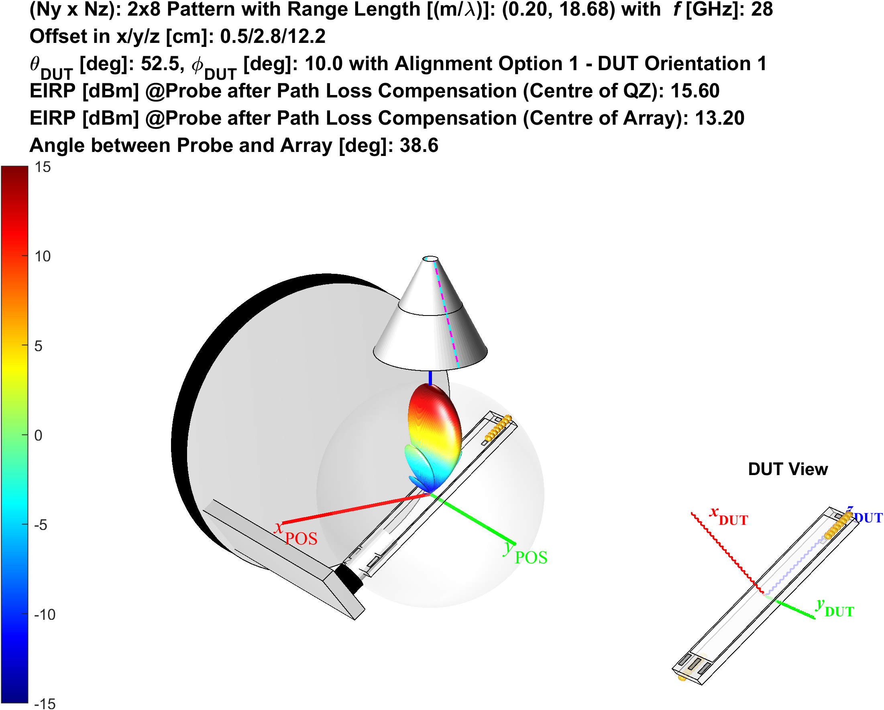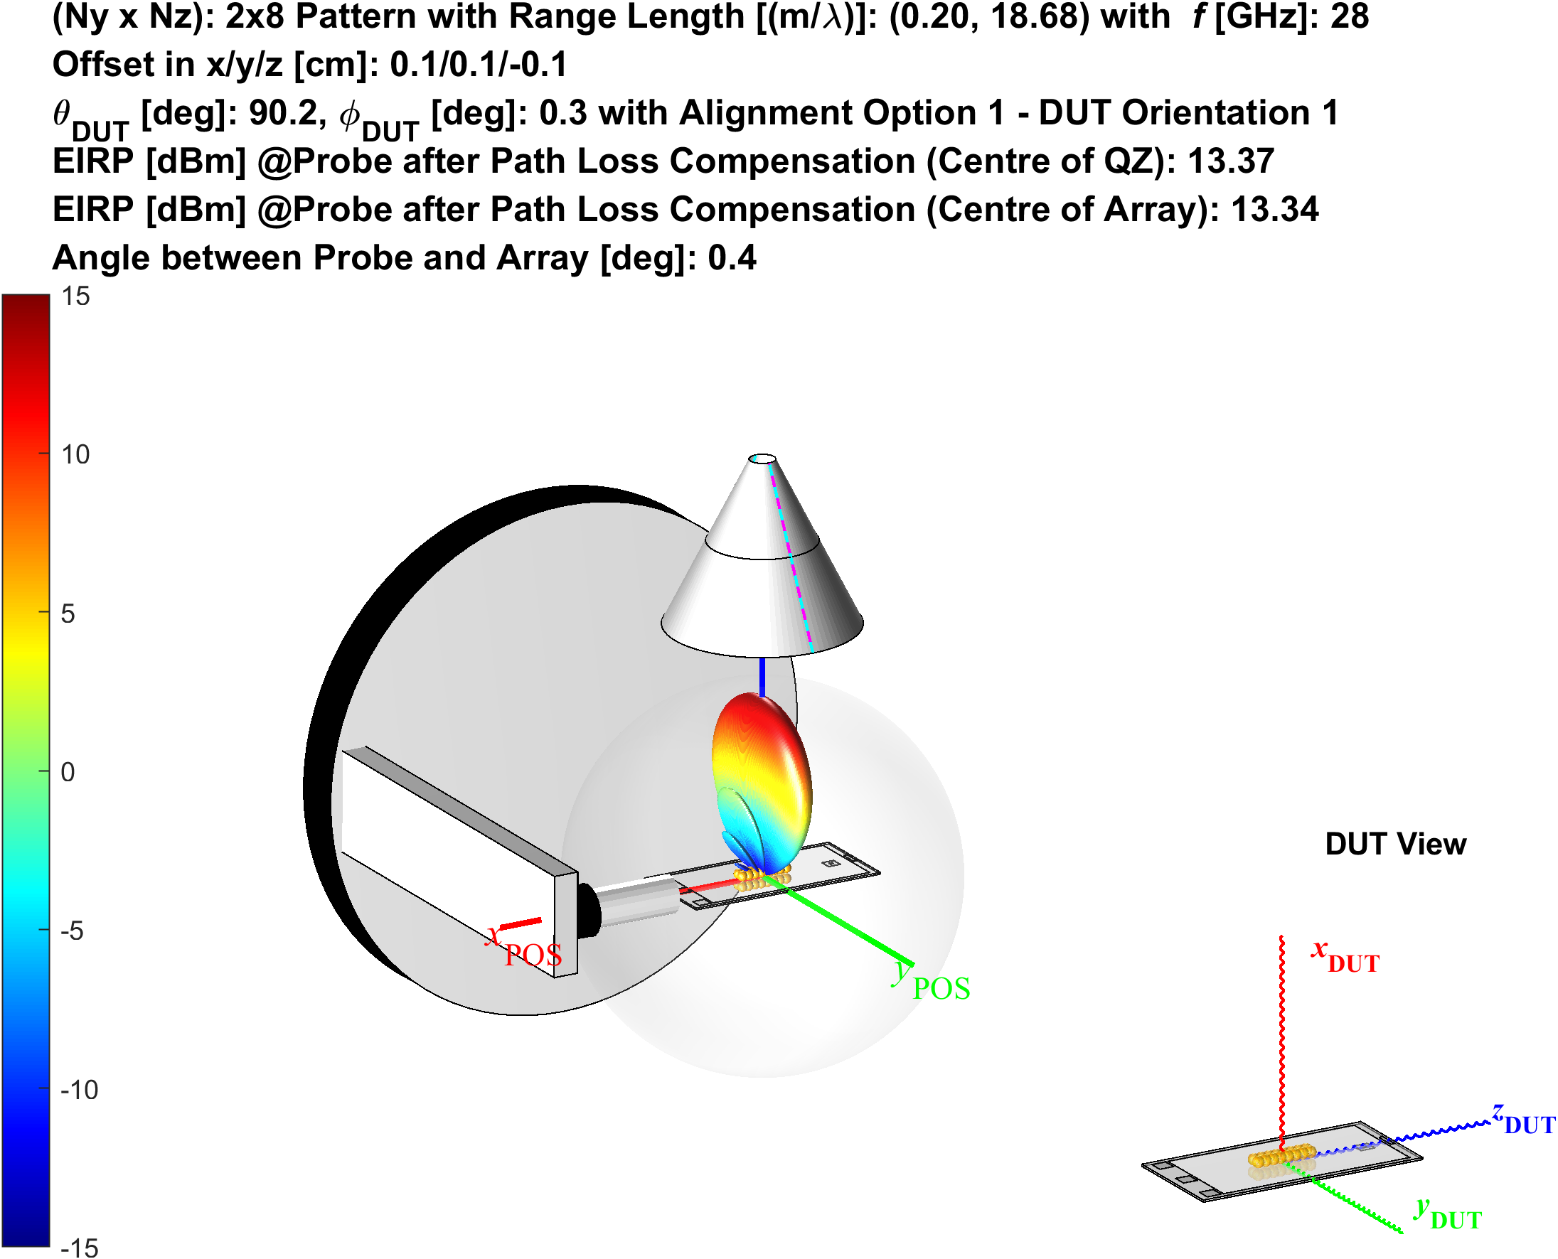
Figure 13: Illustration of simulations for the 20cm range length with 8x2 antenna configuration resulting in smallest (left) and largest (right) EIRPs. The antenna array offsets were compensated while the probe pattern/gain was not compensated.
When the antenna array offset is towards the top of the device (z direction), shown in the left plot of Figure 13, the the angle between the probe and the antenna array is maximized at ~39º and thus yields the lowest EIRP without probe pattern compensation; however, with an antenna placed near the centre of the QZ, the angle between the probe and antenna is minimized.

A study to determine whether 1k or even 250 offset simulations are sufficient for the MU results, a comparison of 100k vs 1k vs 250 offset simulations was made. The visualization of 100k vs 1k random offsets is illustrated in Figure 14. Clearly, the 100k offsets are uniformly distributed in the hemisphere while the random 250 and 1k offsets are distributed rather sparsely.

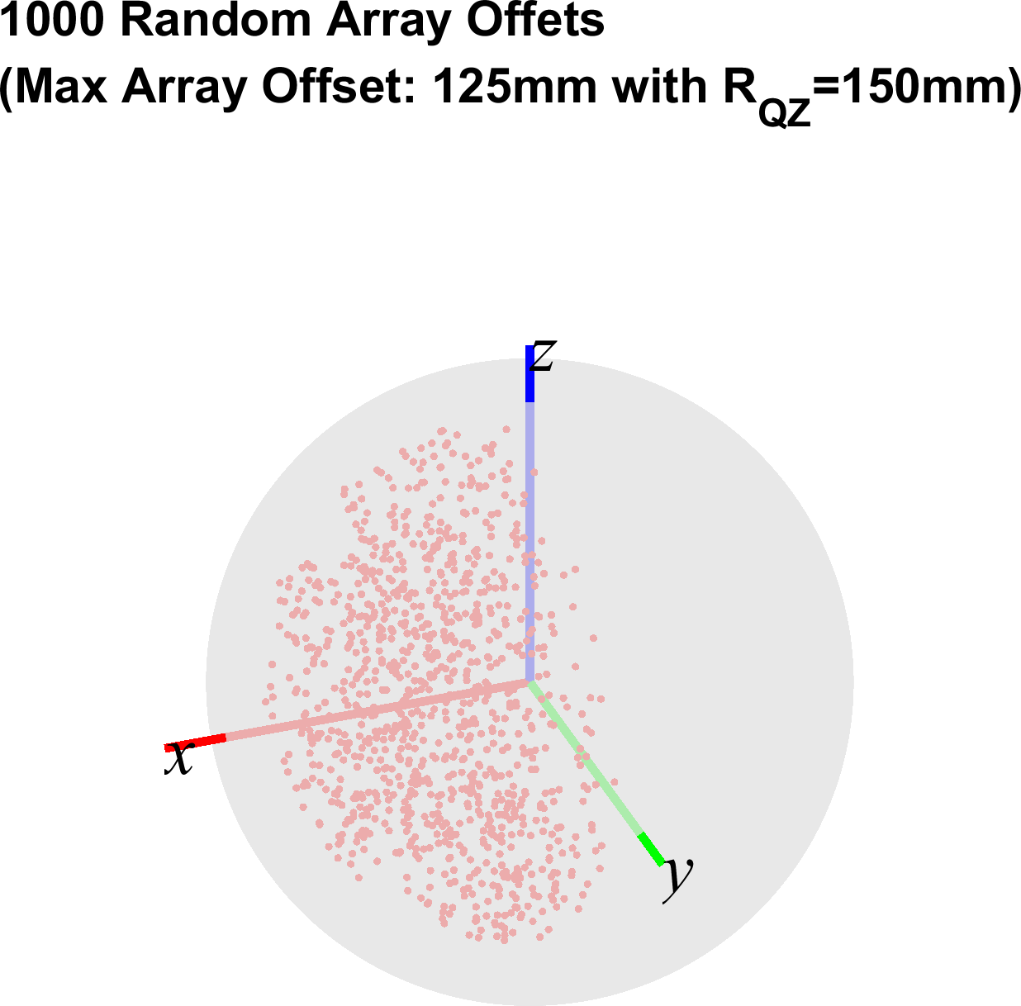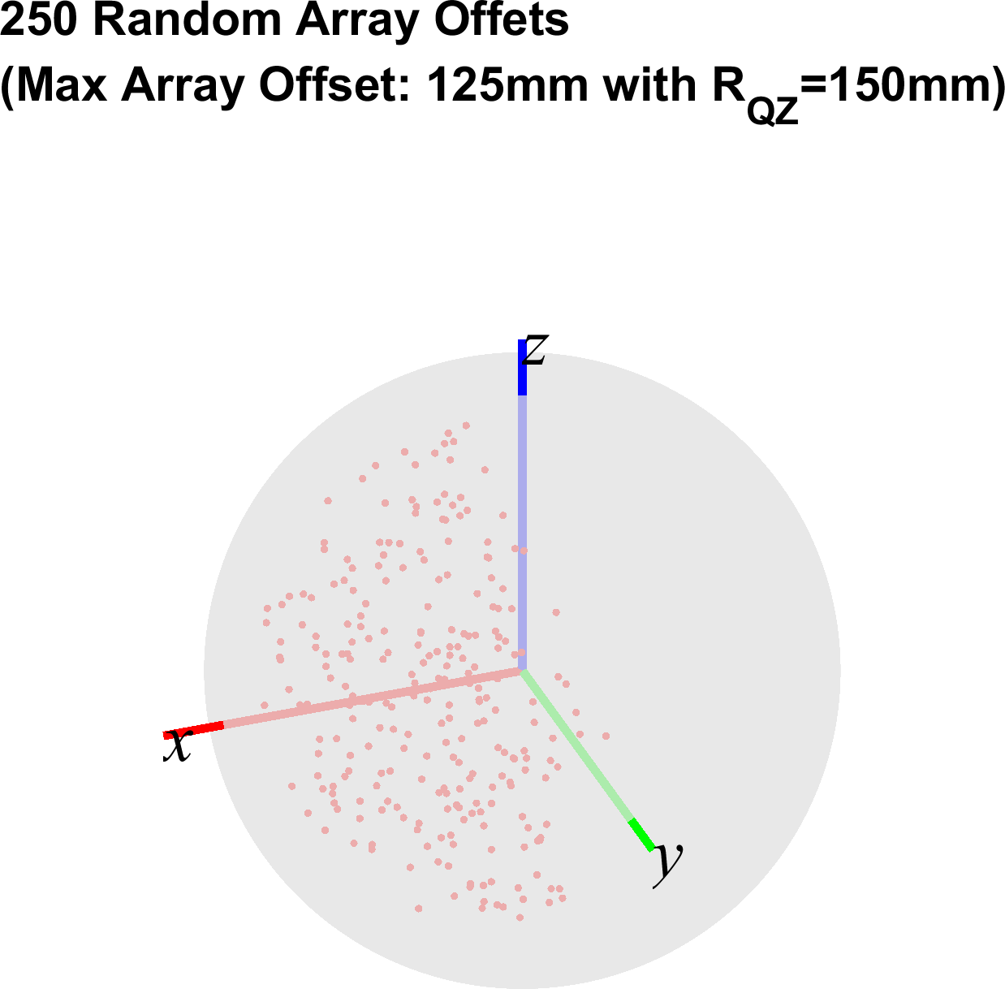
Figure 14: Illustration of 100k (left) vs 1k (middle) vs 250 (right) offsets.
The results summarizing the different simulations are tabulated in Table 9. The results show that regardless of range length and antenna configuration, the difference in mean error and standard deviation is almost insignificant.
Observation 5: CFFDNF simulations with 250 random offsets approximate the MUs (mean error and standard deviation) very well

Table 9: Statistical results of 100k vs 1k vs 250 EIRP CFFDNF offset simulations based on black&white-box approach with random antenna array offsets uniformly spaced within 12.5cm (PC3)/10cm (PC1) in a single hemisphere. The antenna array offsets were compensated.
Antenna Configuration | Number of Offsets | Range Length [m] | Mean EIRP Error w.r.t. FF [dB] | Std. Dev of EIRP at NF BP [dB]
8x2 | 100k | 0.2 | 0.48 | 0.22
8x2 | 100k | 0.25 | 0.23 | 0.08
8x2 | 100k | 0.3 | 0.14 | 0.04
8x2 | 100k | 0.35 | 0.09 | 0.02
8x2 | 100k | 0.4 | 0.07 | 0.01
8x2 | 100k | 0.45 | 0.05 | 0.01
8x2 | 100k | 20 | 0.00 | 0.00
8x2 | 1k | 0.2 | 0.48 | 0.21
8x2 | 1k | 0.25 | 0.23 | 0.07
8x2 | 1k | 0.3 | 0.14 | 0.03
8x2 | 1k | 0.35 | 0.09 | 0.02
8x2 | 1k | 0.4 | 0.07 | 0.01
8x2 | 1k | 0.45 | 0.05 | 0.01
8x2 | 1k | 20 | 0.00 | 0.00
8x2 | 250 | 0.2 | 0.49 | 0.23
8x2 | 250 | 0.25 | 0.23 | 0.08
8x2 | 250 | 0.3 | 0.14 | 0.04
8x2 | 250 | 0.35 | 0.09 | 0.02
8x2 | 250 | 0.4 | 0.07 | 0.01
8x2 | 250 | 0.45 | 0.05 | 0.01
8x2 | 250 | 20 | 0.00 | 0.00
12x12 | 100k | 0.2 | 3.41 | 1.09
12x12 | 100k | 0.25 | 1.84 | 0.44
12x12 | 100k | 0.3 | 1.16 | 0.22
12x12 | 100k | 0.35 | 0.80 | 0.13
12x12 | 100k | 0.4 | 0.59 | 0.08
12x12 | 100k | 0.45 | 0.45 | 0.05
12x12 | 100k | 20 | 0.00 | 0.00
12x12 | 1k | 0.2 | 3.43 | 1.10
12x12 | 1k | 0.25 | 1.85 | 0.44
12x12 | 1k | 0.3 | 1.17 | 0.22
12x12 | 1k | 0.35 | 0.81 | 0.13
12x12 | 1k | 0.4 | 0.59 | 0.08
12x12 | 1k | 0.45 | 0.45 | 0.05
12x12 | 1k | 20 | 0.00 | 0.00
12x12 | 250 | 0.2 | 3.47 | 1.13
12x12 | 250 | 0.25 | 1.87 | 0.45
12x12 | 250 | 0.3 | 1.18 | 0.23
12x12 | 250 | 0.35 | 0.81 | 0.13
12x12 | 250 | 0.4 | 0.60 | 0.08
12x12 | 250 | 0.45 | 0.46 | 0.06
12x12 | 250 | 20 | 0.00 | 0.00

Another investigation focused on the MUs at two different frequencies at opposite ends of FR2, i.e., 28GHz and 49GHz using the same fixed range lengths. The simulation results are tabulated in Table 10 which show that the MUs at 28GHz are larger than at 49GHz.

As outlined in the table below, the range lengths as a function of wavelength are different between those two frequencies. The MUs are smaller for 49GHz when compared to 28GHz since the distances in wavelength are larger for the 40GHz case.
Range Length [m] | Frequency [GHz]
Range Length [m] | 28 | 49
Range Length [m] | Distance [λ] | Distance [λ]
0.2 | 19 | 33
0.3 | 28 | 49
0.45 | 42 | 74
20 | 1868 | 3269

Table 10: Statistical results of 28GHz vs 49GHz EIRP CFFDNF offset simulations based on black&white-box approach with random antenna array offsets uniformly spaced within 12.5cm (PC3)/10cm (PC1) in a single hemisphere. The antenna array offsets were compensated.
Antenna Configuration | Simulation Frequency [GHz] | Range Length [m] | |Mean EIRP Error| w.r.t. FF [dB] | Std. Dev of EIRP at NF BP [dB]
8x2 | 28 | 0.2 | 0.48 | 0.22
8x2 | 28 | 0.25 | 0.23 | 0.08
8x2 | 28 | 0.3 | 0.14 | 0.04
8x2 | 28 | 0.35 | 0.09 | 0.02
8x2 | 28 | 0.4 | 0.07 | 0.01
8x2 | 28 | 0.45 | 0.05 | 0.01
8x2 | 28 | 20 | 0.00 | 0.00
8x2 | 49 | 0.2 | 0.16 | 0.07
8x2 | 49 | 0.25 | 0.08 | 0.02
8x2 | 49 | 0.3 | 0.05 | 0.01
8x2 | 49 | 0.35 | 0.03 | 0.01
8x2 | 49 | 0.4 | 0.02 | 0.00
8x2 | 49 | 0.45 | 0.02 | 0.00
8x2 | 49 | 20 | 0.00 | 0.00
Observation 6: CFFDNF simulations at 49GHz yield smaller MUs than at 28GHz.

A separate investigation was performed to determine whether a local search in θ and φ around the calculated NF BP direction, as illustrated in Figure 15, is able to identify an even further optimized EIRP.
Figure 15: Illustration of Near-Field and Far-field direction.
Here, a separate local search was performed around a ±15º cone centred around the calculated NF BP direction with 1º increments in θ and φ. A total of 10k offsets with a local search performed for each simulation were investigated and the results are summarized in Figure 16 which is showing the difference of the EIRPs before and after the local search as a function of the 10k offsets. Clearly, these results show that no local search is necessary to determine the appropriate NF EIRP/EIS and that the NF beam peak direction can be calculated.
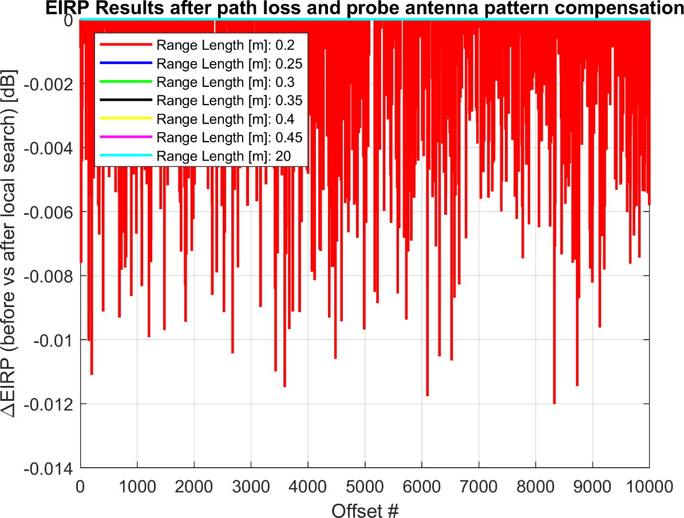
Figure 16: Difference in EIRP after pathloss and feed pattern compensation before and after local searches around the calculated NF beam peak direction.

Observation 7: A local search to determine the optimized NF beam peak direction/EIRP after pathloss and feed pattern compensation is not necessary.

Another investigation focused on whether Matlab which is using a theoretical approximation of the radiation pattern of the antenna arrays in the NF and FF based on the superposition approach [3] yields similar uncertainties as a full EM simulation tool, i.e., CST, which is calculating the NF and FF patterns based on a numerical approach. Figure 17 illustrates the differences of the simulated 8x2 antenna patterns between Matlab (solid lines) and CST (dashed lines) both for the FF interface distance of 2D²/λ, i.e., 47cm at 28GHz with D=5cm, (red lines) and the NF interface distance of , i.e., 7cm at 28GHz with D=5cm, (blue lines) in two principal cuts. Clearly, the agreement between Matlab and CST simulations of a dipole-based antenna element array placed over a ground plane is very good in both NF and FF. CFFDNF analyses were performed with the data used for the CFFNF simulations (see Annex B and C) based on the EM simulation tool CST. These analyses which used a grid size of 1º in Δθ and Δφ were used to compare them with the analyses performed with Matlab. Only a limited number of offsets were performed with CST; however, as shown earlier, even 250 offset simulations were shown to yield very accurate MU results. Those results are summarized in Table 11 and assume that array offsets and the feed probe have been compensated. The simulations with the limited number of offsets assumed the same offsets were used in Matlab and CST. Overall, these results show that were good agreement between 100k and the limited number of offsets can be achieved and that the Matlab and CST simulations yield excellent agreement.

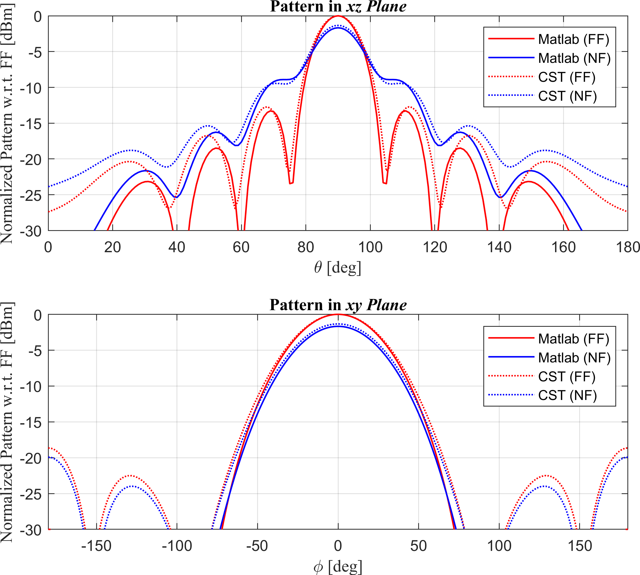
Figure 17: Comparison of CST and Matlab 8x2 antenna pattern.

Table 11: Statistical results of EIRP CFFDNF simulations performed with Matlab and CST.
Antenna Configuration | Simulation Tool | Number of Offsets | Range Length [m] | Max-Min EIRP at NF BP [dB] | Max EIRP Error w.r.t. FF [dB] | |Mean EIRP Error| w.r.t. FF [dB] | Std. Dev of EIRP at NF BP [dB]
8x2 | Matlab | 100k | 0.2 | 1.17 | 1.36 | 0.48 | 0.22
8x2 | Matlab | 100k | 0.25 | 0.37 | 0.50 | 0.23 | 0.08
8x2 | Matlab | 100k | 0.3 | 0.17 | 0.26 | 0.14 | 0.04
8x2 | Matlab | 500 | 0.2 | 1.05 | 1.25 | 0.48 | 0.22
8x2 | Matlab | 500 | 0.25 | 0.34 | 0.47 | 0.23 | 0.07
8x2 | Matlab | 500 | 0.3 | 0.16 | 0.25 | 0.14 | 0.03
8x2 | CST | 500 | 0.2 | 0.93 | 1.10 | 0.42 | 0.19
8x2 | CST | 500 | 0.25 | 0.34 | 0.45 | 0.22 | 0.07
8x2 | CST | 500 | 0.3 | 0.18 | 0.26 | 0.14 | 0.04
12x12 | Matlab | 100k | 0.2 | 5.38 | 7.24 | 3.41 | 1.09
12x12 | Matlab | 100k | 0.25 | 2.07 | 3.26 | 1.84 | 0.44
12x12 | Matlab | 100k | 0.3 | 1.02 | 1.85 | 1.16 | 0.22
12x12 | Matlab | 52 | 0.2 | 3.70 | 5.69 | 3.39 | 0.91
12x12 | Matlab | 52 | 0.25 | 1.47 | 2.72 | 1.84 | 0.36
12x12 | Matlab | 52 | 0.3 | 0.73 | 1.59 | 1.16 | 0.18
12x12 | CST | 52 | 0.2 | 4.01 | 6.18 | 3.68 | 0.97
12x12 | CST | 52 | 0.25 | 1.61 | 2.98 | 2.01 | 0.40
12x12 | CST | 52 | 0.3 | 0.82 | 1.77 | 1.28 | 0.21

Observation 8: The Matlab and CST antenna array patterns in the NF and FF are very similar.
Observation 9: The Matlab and CST MU analyses for CFFDNF with black&white-box approach yield very similar MU results.
The results for the other antenna configurations are tabulated in Table 12.

Table 12: Statistical results of 100,000 EIRP CFFDNF simulations based on black&white-box approach with random antenna array offsets uniformly spaced within 12.5cm (PC3)/10cm (PC1) in a single hemisphere. The antenna array offsets were compensated.
Antenna Configuration | Probe Pattern Compensation | Range Length [m] | Max-Min EIRP at NF BP [dB] | Max EIRP Error w.r.t. FF [dB] | |Mean EIRP Error| w.r.t. FF [dB] | Std. Dev of EIRP at NF BP [dB]
4x1 | yes | 0.2 | 0.10 | 0.11 | 0.04 | 0.02
4x1 | yes | 0.25 | 0.03 | 0.04 | 0.02 | 0.01
4x1 | yes | 0.3 | 0.01 | 0.02 | 0.01 | 0.00
4x1 | yes | 0.35 | 0.01 | 0.01 | 0.01 | 0.00
4x1 | yes | 0.4 | 0.01 | 0.01 | 0.01 | 0.00
4x1 | yes | 0.45 | 0.00 | 0.01 | 0.00 | 0.00
4x1 | yes | 20 | 0.00 | 0.00 | 0.00 | 0.00
4x1 | no | 0.2 | 7.19 | 7.21 | 2.73 | 1.84
4x1 | no | 0.25 | 4.32 | 4.33 | 1.68 | 1.12
4x1 | no | 0.3 | 2.91 | 2.92 | 1.15 | 0.76
4x1 | no | 0.35 | 2.10 | 2.11 | 0.84 | 0.55
4x1 | no | 0.4 | 1.59 | 1.60 | 0.64 | 0.42
4x1 | no | 0.45 | 1.25 | 1.25 | 0.50 | 0.33
4x1 | no | 20 | 0.00 | 0.00 | 0.00 | 0.00
12x12 | yes | 0.2 | 5.38 | 7.24 | 3.41 | 1.09
12x12 | yes | 0.25 | 2.07 | 3.26 | 1.84 | 0.44
12x12 | yes | 0.3 | 1.02 | 1.85 | 1.16 | 0.22
12x12 | yes | 0.35 | 0.58 | 1.19 | 0.80 | 0.13
12x12 | yes | 0.4 | 0.36 | 0.82 | 0.59 | 0.08
12x12 | yes | 0.45 | 0.24 | 0.61 | 0.45 | 0.05
12x12 | yes | 20 | 0.00 | 0.00 | 0.00 | 0.00
12x12 | no | 0.2 | 5.63 | 7.49 | 5.07 | 1.41
12x12 | no | 0.25 | 3.05 | 4.25 | 2.89 | 0.73
12x12 | no | 0.3 | 1.98 | 2.81 | 1.88 | 0.47
12x12 | no | 0.35 | 1.40 | 2.02 | 1.33 | 0.33
12x12 | no | 0.4 | 1.05 | 1.52 | 0.99 | 0.25
12x12 | no | 0.45 | 0.82 | 1.19 | 0.77 | 0.20
12x12 | no | 20 | 0.00 | 0.00 | 0.00 | 0.00
Observation 10: The CFFDNF methodology assuming the black&white-box approach with array offsets and the probe antenna pattern compensated is suitable for EIRP/EIS measurements with insignificant MU for PC3 devices with 4x1 antenna configuration when range length is greater or equal to 20cm.
Observation 11: The CFFDNF methodology assuming the black&white-box approach with array offsets and the probe antenna pattern compensated is suitable with small MUs (>0dB) for EIRP/EIS measurements for PC1 devices with 12x12 antenna configuration when range length is greater or equal to 45cm.

Annex C: Combined Far-Field Near Field (CFFNF) EIRP Simulations based on Black & White-Box Approach
In this section, we present results for near-field and far-field simulations of N_{y} x N_{z} antenna arrays for the CFFNF methodology based on the black&white-box approach, i.e., the active antenna panel for the FF beam peak direction is known/declared. The simulation assumptions are, for the most part, the same as those in Table 3.
The test procedure for this methodology is further outlined in Annex A, specifically Figure 4, for the black&white-box approach.
All simulations are performed with an EM simulator, CST, using the same antenna array model introduced in Annex B. The grid size used for the CST simulations had step sizes of 1º in Δθ and Δφ. Given the longer simulation times, only a limited number of offset simulations were performed by the submission deadline and only a subset of the number of range lengths, and antenna array configurations in Table 3 were considered; additional data with more antenna offsets will likely be provided in a revised contribution. Given the previous observation regarding the need to offset the probe pattern, i.e., Observation 4, the simulations for CFFNF using black&white approach only focused on the feed probe pattern compensated.
Since the CFFNF approach using the black&white-box approach relies on measurements in the NF BP direction at two different radii r₁ and r₂, the same r₁ simulations taken into account for the CFFDNF results using CST, Table 11, were used here. Those CFFNF results are tabulated in Table 13 for 8x2 (PC3) and in Table 14 for 12x12 (PC1) and compared with the CFFDNF results (same as those in Table 11). Clearly, the measurement at the additional radius r₂ significantly reduces the measurement uncertainties and allows EIRP/EIS measurements of PC3 (PC1) devices at 21cm (31cm) range length without additional (with very small) MU. Simulations with larger range lengths are currently in progress.
Table 13: Statistical results of 500 EIRP CFFNF & CFFDNF CST simulations based on black&white-box approach with random 8x2 antenna array offsets uniformly spaced within 12.5cm in a single hemisphere. The antenna array offsets and probe pattern were compensated.
Antenna Configuration | Methodology | Number of Offsets | Range Length [m] | Max-Min EIRP at NF BP [dB] | Max EIRP Error w.r.t. FF [dB] | |Mean EIRP Error| w.r.t. FF [dB] | Std. Dev of EIRP at NF BP [dB]
8x2 | CFFNF | 500 | 0.21 | 0.24 | 0.16 | 0.04 | 0.04
8x2 | CFFNF | 500 | 0.26 | 0.22 | 0.13 | 0.03 | 0.03
8x2 | CFFNF | 500 | 0.31 | 0.25 | 0.15 | 0.03 | 0.03
8x2 | CFFDNF | 500 | 0.2 | 0.93 | 1.10 | 0.42 | 0.19
8x2 | CFFDNF | 500 | 0.25 | 0.34 | 0.45 | 0.22 | 0.07
8x2 | CFFDNF | 500 | 0.3 | 0.18 | 0.26 | 0.14 | 0.04
Note: The range length for CFFNF is reported for radius r₂>r₁ and r₂=r₁+1cm.
Table 14: Statistical results of 52 EIRP CFFNF & CFFDNF CST simulations based on black&white-box approach with random 12x12 antenna array offsets uniformly spaced within 10cm in a single hemisphere. The antenna array offsets and probe pattern were compensated.
Antenna Configuration | Methodology | Number of Offsets | Range Length [m] | Max-Min EIRP at NF BP [dB] | Max EIRP Error w.r.t. FF [dB] | |Mean EIRP Error| w.r.t. FF [dB] | Std. Dev of EIRP at NF BP [dB]
12x12 | CFFNF | 52 | 0.21 | 1.70 | 2.10 | 0.97 | 0.41
12x12 | CFFNF | 52 | 0.26 | 0.52 | 0.70 | 0.37 | 0.12
12x12 | CFFNF | 52 | 0.31 | 0.22 | 0.30 | 0.18 | 0.06
12x12 | CFFDNF | 52 | 0.2 | 4.01 | 6.18 | 3.68 | 0.97
12x12 | CFFDNF | 52 | 0.25 | 1.61 | 2.98 | 2.01 | 0.40
12x12 | CFFDNF | 52 | 0.3 | 0.82 | 1.77 | 1.28 | 0.21
Note: The range length for CFFNF is reported for radius r₂>r₁ and r₂=r₁+1cm.
Observation 12: The CFFNF methodology with the black&white-box approach yields smaller MUs than the CFFDNF methodology.
Observation 13: The CFFNF methodology assuming the black&white-box approach with array offsets and the probe antenna pattern compensated is suitable for EIRP/EIS measurements with insignificant MU for PC3 devices with 8x2 antenna configuration when range length is greater or equal to 21cm.
Observation 14: The CFFNF methodology assuming the black&white-box approach with array offsets and the probe antenna pattern compensated is suitable for EIRP/EIS measurements with small MU for PC1 devices with 12x12 antenna configuration when range length is greater or equal to 31cm.

Annex D: Combined Far-Field Near Field (CFFNF) EIRP Simulations based on Black-Box Approach
In this section, we present results for near-field and far-field simulations of N_{y} x N_{z} antenna arrays for the CFFNF methodology based on the black-box approach, i.e., the active antenna panel for the FF beam peak direction is known/declared. The simulation assumptions are, for the most part, the same as those in Table 3.
The test procedure for this methodology is further outlined in Annex A, specifically Figure 5 for the black-box approach.
All simulations are performed with an EM simulator, CST, using the same antenna array model introduced in Annex B. Given the longer simulation times, only a limited number of offset simulations were performed and only a subset of the number of range lengths, and antenna array configurations in Table 3 were considered. Given the previous observation regarding the need to offset the probe pattern, i.e., Observation 4, the simulations for CFFNF using black&white approach only focused on the feed probe pattern compensated.
--------------------
While the previous simulations in [3] focused on offsets in just a single direction z, this contribution aimed at arbitrary offsets in x, y, and z. Unfortunately, the algorithm was not finalized on time by the submission deadline for 3D offsets; 2D offsets in y and z showed very promising results, similar to those presented in [3]. It is the intention to provide updated CFFNF with black-box approach in a revision during the meeting or by RAN4#99-e the latest.
--------------------
Since this approach utilizes/requires relatively wide area local searches at r = r₁, e.g., the width of the sector is about ±40º for r₁=20cm, with limited local searches at r₂ and r₃ as illustrated in Figure 5, the test time for the black-box approach is inherently longer than the black&white-box approach due to the 3 vs 2 radii and local searches vs no local search requirements. On the other hand, this approach does not require the declaration of the active antenna array location.
Suitable approaches to reduce the test time of these local searches include coarse and fine search approaches, e.g., Figures M.2.2-3 and M.2.2-4 of [8]. Alternatively, continuous non-modulated EIRP measurements on sectors with fixed angular distance could be utilized to speed up the local searches, as illustrated in Figure 18.

Figure 18: Stepped (left) vs continuous (right) search approach for EIRP.
Observation 15: Local Searches of the CFFNF methodology using black box approach can be accelerated using coarse&fine search grids and continuous scan measurements.

