3GPP TSG-RAN WG4 Meeting # 98-e R4-200XXXX
Electronic Meeting, 25th Jan. – 5th Feb., 2021

Agenda item: 11.8.3
Source: Moderator (Samsung)
Title: Email discussion summary for [98e][311] NTN_Solutions_Part2
Document for: Information

Introduction
Briefly introduce background, the scope of this email discussion and provide some guidelines for email discussion if necessary.
This lead summary document captures issues related to NR NTN coexistence aspects. It contains a summary of the contributions under sections 11.8.3 at TSG-RAN WG4 #98e, together with identified key open issues and recommends topics/questions to be handled via email discussions. The goal of this document is also to provide recommendation on prioritization of discussion and whether any issues should be postponed.
A total of 14 TDOCs have been received for this agenda (see Annex) and 5 topics are listed as below to cover proposals and contents in these documents as appropriate.
- Topic #1: Scope of coexistence study
- Topic #2: Coexistence simulation scenarios
- Topic #3: Network layout model
- Topic #4: Simulation assumptions
- Topic #5: HAPS
To progress the discussion, it is proposed that the meeting could:
- 1st round: Focus on Topic #1 and Topic #2 and target on narrow down the scope and scenarios in GTW session if arranged.
- 2nd round: Focus on the other Topics based on the outcome of topic #1/#2 and also GTW sessions. Target to agree on WF for simulation assumption for providing results in RAN4 #99e

Topic #1: Scope of coexistence study

Companies’ contributions summary
T-doc number | Company | Proposals / Observations
R4-2102174 | Ericsson | Proposal 1: Co-channel coexistence and coexistence with adjacent services are out of NTN WI’s scope.

Open issues summary

Sub-topic 1-1
Sub-topic description:
Open issues and candidate options before e-meeting:
Issue 1-1: Scope of coexistence study
- Proposals
  - Option 1: Co-channel coexistence and coexistence with adjacent services are out of NTN WI’s scope.
  - Option 2: TBA
- Recommended WF
  - TBA

Companies views’ collection for 1st round

Open issues
Company | Comments
XXX | Sub topic 1-1:  Sub topic 1-2:  ….  Others:

Summary for 1st round

Open issues
Moderator tries to summarize discussion status for 1st round, list all the identified open issues and tentative agreements or candidate options and suggestion for 2nd round i.e. WF assignment.
 | Status summary
Sub-topic#1 | Tentative agreements:  Candidate options:  Recommendations for 2nd round:

Recommendations on WF/LS assignment
 | WF/LS t-doc Title | Assigned Company,  WF or LS lead
#1

Discussion on 2nd round (if applicable)

Summary on 2nd round (if applicable)
Moderator tries to summarize discussion status for 2nd round and provided recommendation on CRs/TPs/WFs/LSs Status update suggestion
CR/TP/LS/WF number | T-doc Status update recommendation
XXX | Based on 2nd round of comments collection, moderator can recommend the next steps such as “agreeable”, “to be revised”

Topic #2: Co-existence simulation scenarios
Main technical topic overview. The structure can be done based on sub-agenda basis.

Companies’ contributions summary
T-doc number | Company | Proposals / Observations
R4-2100399 | CATT | Proposal 4: It is proposed to focus on fixed beam scenario for satellite.  Proposal 5: It is proposed to consider the NTN scenarios in Table 2.2-1 for co-existence study.  Proposal 6: It is proposed to consider Rural and Dense urban scenario with priority for terrestrial network.  Based on the above proposal, the scenarios for co-existence study can be further down selected as the following table.  Table 3-1. Proposed scenarios for co-existence study
   |  |  | Set 1 |  |  | Set 2
   |  |  | GEO | LEO 1200km | HAPS | GEO | LEO 1200km | HAPS
  NR / NB-IoT | Rural |  | X | X | X | X | X | X
  NR / NB-IoT | Dense Urban |  | X | X | X | X | X | X
  NTN | GEO | Set 1 | X | X | X | N/A | N/A | N/A
  NTN | LEO 1200km | Set 1 | X | X | X | N/A | N/A | N/A
  NTN | HAPS | Set 1 | X | X | X | N/A | N/A | N/A
  NTN | GEO | Set 2 | N/A | N/A | N/A | X | X | X
  NTN | LEO 1200km | Set 2 | N/A | N/A | N/A | X | X | X
  NTN | HAPS | Set 2 | N/A | N/A | N/A | X | X | X
R4-2100486 | CATT | It is proposed that only earth fixed beams is used and only FDD is used for co-existence study. So the aggressor and victim combination is list in Table 2.1-2.  Table 2.1-2 Aggressor and victim  The proposed frequency and bandwidth are listed as table 2.1-3.  Table 2.1-3. Proposed frequency and bandwidth for co-existence study
  No. | Combination | Aggressor | Victim | Notes
  1 | TN with NTN | TN DL | NTN DL | Assuming TN BS ACLR is not impacted.
  2 | TN with NTN | TN UL | NTN UL | Assuming TN UE ACLR is not impacted
  3 | TN with NTN | NTN DL | TN DL | Assuming TN UE ACS is not impacted.
  4 | TN with NTN | NTN UL | TN UL | Assuming TN BS ACS is not impacted
  5 | TN with NTN | NTN UL | TN DL | Co-existence between NTN and adjacent TDD bands. E.g. TDD in 2010-2025MHz.
  6 | TN with NTN | TN UL | NTN DL | Co-existence between NTN and adjacent TDD bands. E.g. TDD in 2010-2025MHz.
  7 | TN with NTN | NTN DL | TN UL | Co-existence between NTN and adjacent TDD bands. E.g. TDD in 2010-2025MHz.
  8 | TN with NTN | TN DL | NTN UL | Co-existence between NTN and adjacent TDD bands. E.g. TDD in 2010-2025MHz.
  9 | NTN with NTN | NTN DL | NTN DL
  9 | NTN with NTN | NTN UL | NTN UL
   | Frequency | Bandwidth | Note
  Rural | 2 GHz | 30 MHz | Include both FDD and TDD
  Dense Urban | 2 GHz | 30 MHz | Include both FDD and TDD
  GEO | 2 GHz | 30 MHz | FDD
  LEO 1200km | 20 GHz | 200 MHz | FDD
  LEO 1200km | 2 GHz | 30 MHz | low priority, FDD
  HAPS | 2 GHz | 30 MHz | FDD
R4-2100904 | Samsung | Proposal 1: For coexistence study of FR1, 2GHz can be assumed as the simulation frequency no matter L-band or S-band to be chosen as the exemplary band.  Proposal 2: Coexistence scenarios for FR1 in the table below are suggested to be captured at least.  Table 1 Scenarios for FR1 coexistence study  Proposal 3: For initial coexistence study of FR1, scenarios of LEO@600km and GEO@35,786km are taken into account with higher priority.  With the deployment related parameters in Table 6.1.1.1-5 as baseline, for details assumption such as deployment scenarios (such as rural etc.), BW per beam, frequency re-use factor etc., the typical deployment requirements of satellite based NTN system should be well take into account.
  No. | Usage scenario | Aggressor | Victim | Direction | Simulation frequency
  1 | eMBB | NTN | TN | DL to DL | 2 GHz
  2 | eMBB | NTN | TN | UL to UL | 2 GHz
  3 | eMBB | NTN | NTN | DL to DL | 2 GHz
  4 | eMBB | NTN | NTN | UL to UL | 2 GHz
R4-2101105 | Xiaomi | Proposal 1: It is proposed that rural scenario shall be as priority coexistence cases between NTN and TN for FR1.  Proposal 2: Rural scenario shall be removed when do the coexistence between NTN and TN in FR2.
R4-2101812 | Huawei, HiSilicon | Proposal 1: It’s proposed to down-select the NTN co-existence scenarios as table 2.  Table 2 The items and candidate options
  Items | Proposal
  Frequency range | L-band
  NTN scenarios | LEO-600, HIBS (priority)  GEO, LEO-1200
  Parameter Set | Merge both set1 and set2 as one parameter set
  Beam configurations | Earth Fixed Beam
  NR scenarios | Rural, Urban macro (priority)  Dense Urban, Micro/small cell outdoor, Indoor hotspot
  UE type for NTN | Handheld UE
R4-2101859 | Thales | Proposal 1: NTN-TN and NTN-NTN coexistence scenarios should consider realistic deployments with different number of users and cell densities.  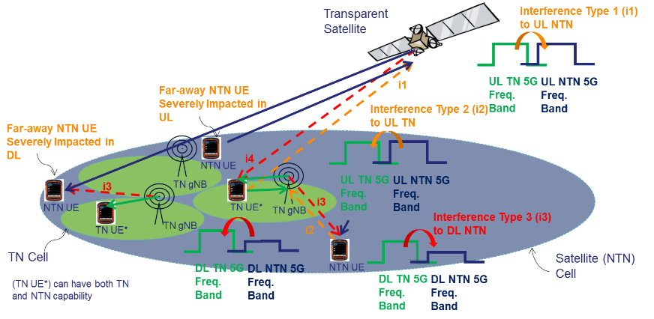  Proposal 2: RAN4 should consider and evaluate the following interference types in adjacent channels for NTN-TN coexistence:  1) Interference Type 1 (i1) in adjacent bands from UL TN to UL NTN;  2) Interference Type 2 (i2) in adjacent bands from UL NTN to UL TN;  3) Interference Type 3 (i3) in adjacent bands from DL TN to DL NTN;  4) Interference Type 4 (i4) in adjacent bands from DL NTN to DL TN.  Proposal 3: NTN-TN coexistence impact in adjacent bands has to be considered at different levels:  1) At satellite level for Interference Type 1;  2) At gNB level for Interference Type 2;  3) At NTN UE level for Interference Type 3;  4) At TN UE level for Interference Type 4.  Proposal 4: Based on simulation and evaluation results for described NTN-TN coexistence scenarios in adjacent bands, work may further focus on reducing:  1) Interference Type 1;  2) Interference Type 3;  as the NTN system may be severely impacted.  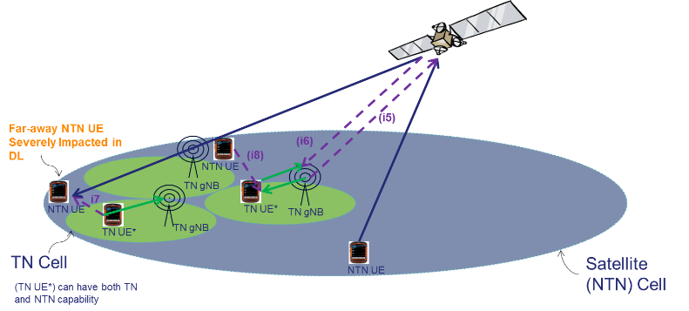  Proposal 7: RAN4 should evaluate potential impact of special type of UL-DL interference in adjacent bands such as:  1) Interference Type 5 (i5) in adjacent bands from DL TN to UL NTN;  2) Interference Type 6 (i6) in adjacent bands from DL NTN to UL TN;  3) Interference Type 7 (i7) in adjacent bands from UL TN to DL NTN;  4) Interference Type 8 (i8) in adjacent bands from UL NTN to DL TN.  Proposal 8: Based on simulation and evaluation results for described NTN-TN coexistence scenarios in adjacent bands, work may further focus on reducing:  1) Interference Type 5;  2) Interference Type 7.
R4-2101880 | Thales | Proposal 1: Consider only NTN extreme cases e.g. 1 worst case and 1 best case (in terms of Doppler, received power) for 2 types of configurations (Earth Fixed Beam, Earth Moving Beam) with 3-4 BW configurations.  Proposal 2: RAN4 should focus the work on satellite scenarios C1.1, C2.1 (LEO Earth Fixed Beams and Earth Moving Beams) and A1 (GEO):  • C1.1: LEO @ 600 km altitude, FR1, Earth fixed beams;  • C2.1: LEO @ 600 km altitude, FR1, Earth moving beams;  • A1: GEO @ 35,786 km altitude, FR1, Earth fixed beams;  and only if sufficient RAN4 resources, consider also LEO @ 1200 km altitude.
R4-2101964 | ZTE Corporation | Proposal 1: to prioritize the rural and sub-urban macro scenario for NR or NB-IoT coexisting with satellite.  Proposal 2: whether GEO and LEO could operate at the same frequency should be clarified at the beginning.
R4-2102174 | Ericsson | A down-selection of the scenarios would be needed to optimize the simulations effort. Following aspects might be a starting point to agree on a down-selection:  - Rural scenario is usually not considered in FR2.  - Most likely, indoor scenario would be less impacted especially in FR2 due to path loss and building isolation.  - In the agreed WF ([6]), LEO @1200km was already down-prioritized for FR1, it should be discussed if it could then be considered as out of scope for the simulations and so, from the scope of RF requirements that will be worked on.  - A deeper analysis of set 1 and set 2 would be needed to identify if one set would be more stringent and so, if all simulations would be needed for both sets.  Observation: Relevant ITU studies should be a good starting point to discuss the simulation assumptions in RAN4.
R4-2102508 | Qualcomm | Proposal 1: For NTN deployment scenarios, GEO satellite, LEO satellite and HAPS with FDD carrier at 2GHz (UL&DL), and 20GHz (UL) and 30GHz (DL) should be considered for co-existence simulation in RAN4 as the starting point.  Proposal 2: Fixed earth beams shall be assumed in the NTN co-existence study.  Proposal 3: For TN deployment scenarios, Rural and Urban Marco scenario with the carrier frequency adjacent to TN network should be prioritized for NTN-TN co-existence study. The simulation results for other scenarios can be provided. For TN networks, NR could be selected as the reference.  Proposal 4: RAN4 to agree co-existence scenarios listed in Table 1.  Table 1: co-existence scenarios
   |  | NTN
   |  | GEO | LEO 600km | LEO 1200km | HAPS
  NTN | GEO | Yes | Yes | Yes | Yes
  NTN | LEO 600km | Yes | Yes | Yes | Yes
  NTN | LEO 1200km | Yes | Yes | Yes | Yes
  NTN | HAPS | Yes | Yes | Yes | Yes
  TN | Rural | Yes | Yes | Yes | Yes
  TN | Urban Marco | Yes | Yes | Yes | Yes
  Note 1: For FR1, FDD carrier frequency at 2GHz is considered. For FR2, FDD carrier frequency at 20GHz and 30GHz is considered.
  Note 2: Rural and Urban Marco with 100% outdoor UE distribution is prioritized for TN scenario. The simulation results for other scenarios can be provided.
  Note 3: For TN networks, NR is considered as the reference.

Open issues summary

Sub-topic 2-1
Sub-topic description
Open issues and candidate options before e-meeting:
Issue 2-1: Frequency for coexistence study
- Proposals
  - Option1 (Huawei): L-band
  - Option2 (CATT, Samsung, ZTE, Qualcomm): 2GHz (for both UL&DL)
  - Option3 (CATT): 20GHz (for both UL&DL)
  - Option4 (Qualcomm, ZTE): 20GHz (UL), 30GHz (DL)
- Recommended WF
  - TBA

Sub-topic 2-2
Sub-topic description: To down-select TN deployment scenarios
Open issues and candidate options before e-meeting:
Issue 2-2: TN deployment scenario
- Proposals
  - Option 1:
 | FR1 | FR2
TN | Rural,  Urban Macro,  Dense Urban | Remove Rural
Note： The simulation results for other scenarios can be provided.
  - Option 2: TBA
- Recommended WF

Sub-topic 2-3
Sub-topic description: To confirm TN types
Open issues and candidate options before e-meeting:
Issue 2-3: TN Type
- Proposals
  - Option 1 (Qualcomm): NR
  - Option 2 (Ericsson, ZTE): NR/NB-IoT
- Recommended WF
  - TBA

Sub-topic 2-4
Sub-topic description: To down-select NTN deployment scenarios.
Open issues and candidate options before e-meeting:
Issue 2-4: Satellite based NTN deployment
- Proposals
  - Option 1(Qualcomm): GEO, LEO@600km, LEO@1200km
  - Option 2 (CATT): GEO, LEO@1200km
  - Option 3 (Thales): GEO and LEO@600km
  - Option 4 (Huawei): LEO@600km
  - Option 5: in addition to Options above, whether GEO and LEO could operate at the same frequency should be clarified.
- Recommended WF
  - TBA

Companies views’ collection for 1st round

Open issues
Company | Comments
XXX | Sub topic 2-1:  Sub topic 2-2:  ….  Others:

Summary for 1st round

Open issues
Moderator tries to summarize discussion status for 1st round, list all the identified open issues and tentative agreements or candidate options and suggestion for 2nd round i.e. WF assignment.
 | Status summary
Sub-topic#1 | Tentative agreements:  Candidate options:  Recommendations for 2nd round:

Suggestion on WF/LS assignment
 | WF/LS t-doc Title | Assigned Company,  WF or LS lead
#1

Discussion on 2nd round (if applicable)

Summary on 2nd round (if applicable)
Moderator tries to summarize discussion status for 2nd round and provided recommendation on CRs/TPs/WFs/LSs Status update suggestion
CR/TP/LS/WF number | T-doc Status update recommendation
XXX | Based on 2nd round of comments collection, moderator can recommend the next steps such as “agreeable”, “to be revised”

Topic #3: Network layout model
Note: RAN4 has decided that “Use TR 38.821 as a baseline/starting point”.

Companies’ contributions summary
T-doc number | Company | Proposals / Observations
R4-2100486 | CATT | The network layout between NTN and TN is depicted in the Figure 2.2-1. Since the satellite beam coverage is quite large, it is proposed only one satellite is considered in the co-existence study between NTN and TN.  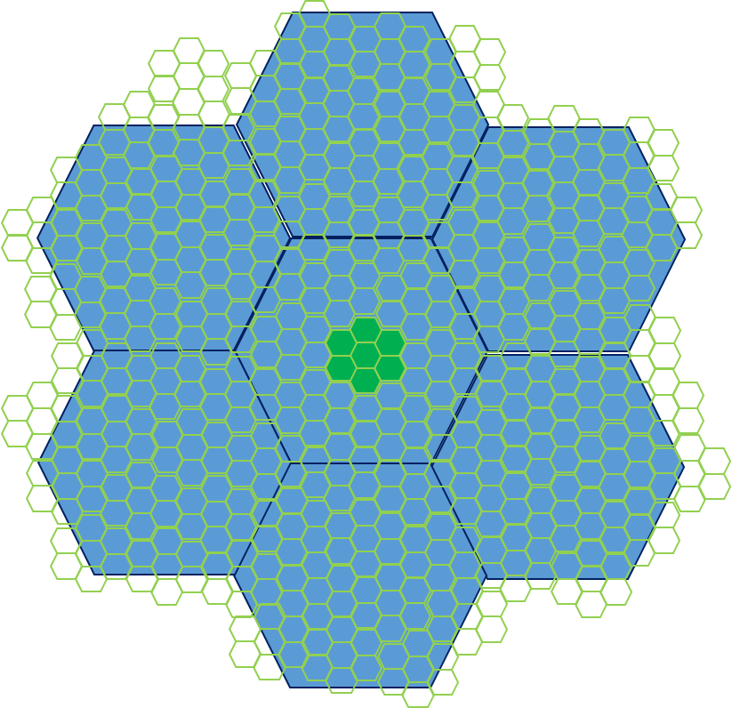  Figure 2.2-1 layout for coexistence between NTN and TN system  The network layout between NTN and NTN is depicted in the Figure 2.2-2 and figure 2.2-3.  In Figure 2.2-2, only one satellite carry two neighbour carriers is assumed and the footprints of the 2 carriers are the same.  Figure 2.2-2 layout for coexistence between NTN systems  In Figure 2.2-3, two satellites operating on two neighbour carriers but at different height are assumed, where the GEO have larger cell coverage and LEO has smaller coverage.  Figure 2.2-3 layout for coexistence between NTN systems (different height satellites)  For NTN UE distribution, at least X = [10] UEs per beam with uniform distribution in all the cell coverage area associated to each beam.  The TN UE distribution could refer to TR38.803, which also considered uniform UE distribution.  For both TN and NTN network, it is proposed frequency reuse factor 1 is considered in the coexistence study.  The wrap around mechanism should be considered in system level simulations.
R4-2100904 | Samsung | Proposal 4: Use Satellite and UE parameters as well as network deployment assumptions in TR 38.821 as the baseline/starting point for FR1 coexistence study.  Beam layout definition is suggested to be aligned with TR38.821 in Table 6.1.1.1-4.
R4-2101105 | Xiaomi | Proposal 3: For the coexistence study between NTN and NTN, the layout in TR38.821 for system level simulation could be as baseline.  Proposal 4: For the coexistence study between NTN and TN, only one satellite is considered but how many beam cells for the satellite needs to be studied with the following three options as the starting point.  - Option 1: 19 beam cell  - Option 2: 19 beam cell with a new wrap around mechanism as mentioned in TR38.821 based on different frequency reuse factor  - Option 3: only one beam cell
R4-2101812 | Huawei, HiSilicon | Observation 1: The figure 1 can be used as heterogeneous network layout between NR legacy network and NTN network for one beam cell.  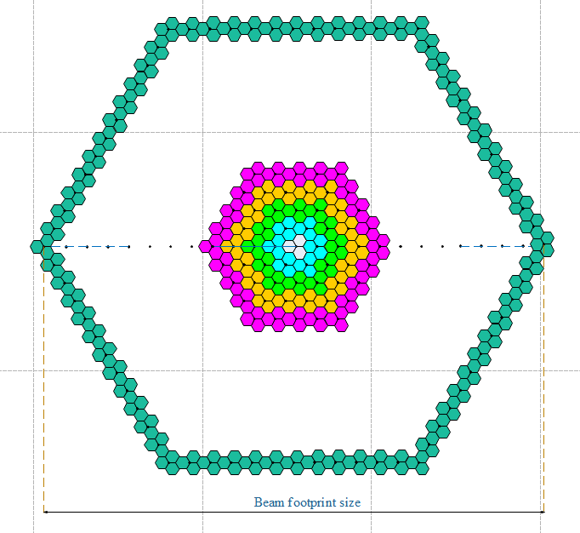  Figure 1 The heterogeneous network layout  Observation 2: The equation (1) and (3) can be used to calculate the number of layers and sites for NR legacy network.  Layer = D-beam/ISD/2 + 1 (1)  Site_total = 3*n*(n-1) + 1 (3)  Observation 3: Even if the minimum beam diameter was chosen in table 6.1.1.1-1 from TR 38.821, thousands of sectors will be used. Thus, RAN4 need to further check whether there is a method to further decrease the complexity of simulations.
R4-2101859 | Thales | Proposal 9: NTN deployments should consider FFR techniques with frequency reuse factor>1.  Proposal 10: NTN-NTN coexistence scenarios should consider interference reduction techniques for both UL and DL.
R4-2101964 | ZTE Corporation | Proposal 2: whether GEO and LEO could operate at the same frequency should be clarified at the beginning.  Proposal 3: only one satellite is assumed for coexistence study at the beginning.  Proposal 4: consider the frequency reuse factor 1 as worst case for coexistence study.  Table 2.2.7-3: Beam layout definition for single satellite simulation  Table 2.2.7-4: System Level Simulation assumptions for calibration  The beam layout parameters captured in the following table are adopted as a starting point for single satellite simulations.  Table 2.2.7-3-6: Beam layout parameters for single satellite simulation
  Scenario | Scenario A, C2 and D2
  Beam layout definition | Baseline: Hexagonal mapping of the beam bore sight directions on UV plane defined in the satellite reference frame.  Only the 3dB beam width parameters should be used. The beam diameter and beam spacing values can be computed directly from the 3 dB beam width assumptions and should be considered as informative.
  Number of beams | Baseline: 19-beam layout considering wrap-around mechanism (i.e. 18 beams surrounding the central beam and allocated on 2 distinct "tiers")
  UV plane illustration (extracted from [19]) | 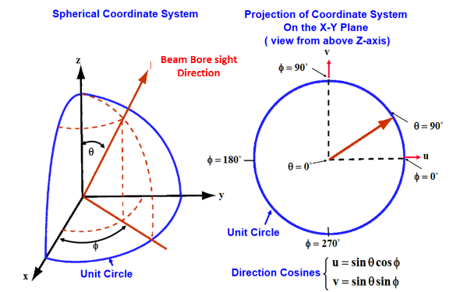
  UV plane convention | U axis is defined as the perpendicular line to the satellite-earth line on the orbital plane as illustrated here after:  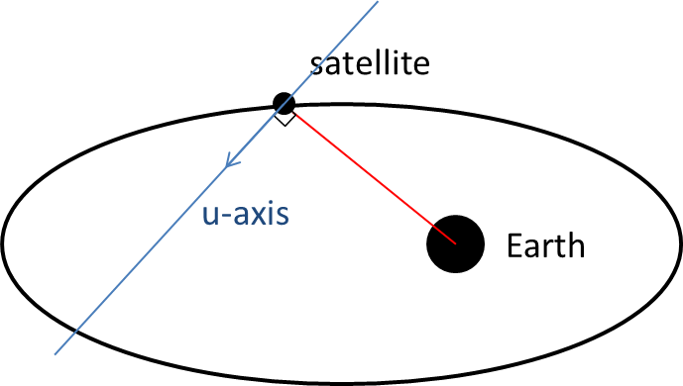  The straight line being orthogonal to UV plane is pointing towards the Earth centre.  UV coordinates of the nadir of the reference satellite is (0,0)
  Adjacent beam spacing on UV plane | Baseline: Adjacent beam spacing computation based on 3dB beam width of the satellite antenna pattern:  ABS = sqrt(3) x sin(HPBW/2 [rad])
  Central beam bore sight direction definition | Baseline:  Case 1: Central beam center is considered at nadir point  Case 2: Central beam boresight direction computed based on elevation angle target
  Configuration scenario | A, C2 and D2
  Frequency band | S-band (i.e. 2 GHz) / Ka-band (i.e. 20 GHz DL, 30 GHz UL)
  Maximum Bandwidth per beam (DL + UL) | S-band: DL 30 MHz and UL 30 MHz  Ka-band: DL 400 MHz and UL 400 MHz  The bandwidth per beam must be adapted based on the frequency factor and the polarization re-use option considered.
  Satellite characteristics (G/T, EIRP density, antenna diameter) | See Table 6.1.1.1-1 and Table 6.1.1.1-2  Note: Same satellite characteristics should be considered for both single and multi-satellite simulations
  Satellite antenna pattern | See section 6.4.1 in [2]: Bessel function
  Satellite polarization configuration | Circular
  Beam layout definition | For singles satellite simulation: See Table 6.1.1.1-4  For multi satellites simulation: FFS
  Frequency re-use factor | Option1: 1[worst case preferred for co-existence study]  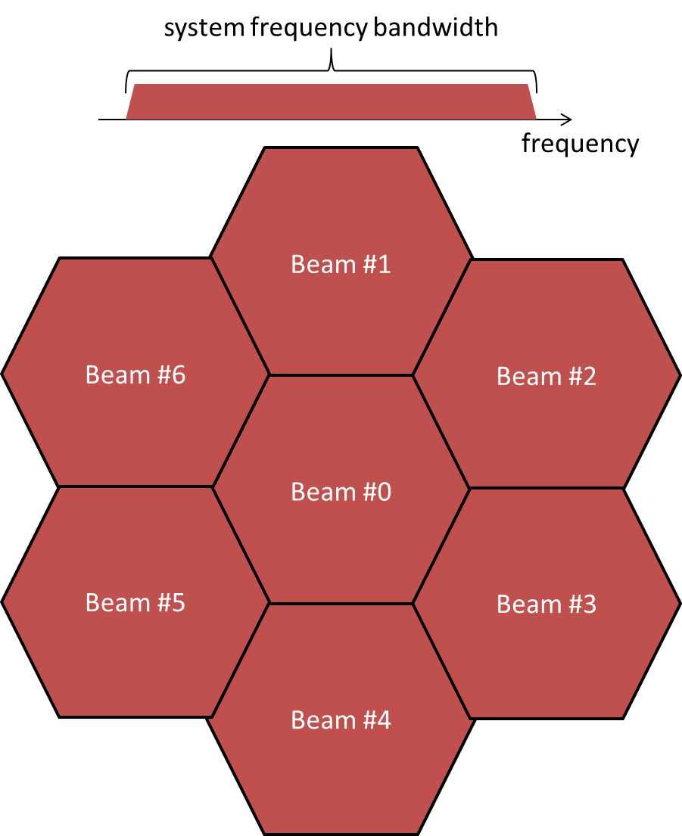
  Polarization re-use | Option 1: Disable  Option 2: Enable  Note: Polarization re-use should apply only if circular polarization for terminal antenna is considered
  Channel model | Large scale model of [2] (Note 2)
  Deployment scenarios | Base-line: Rural  Additional deployment scenario results can be provided
  Propagation conditions | Base-line:  Clear Sky  Line of sight
  UEs outdoor/indoor distribution | 100% outdoor distribution for UEs
  UE distribution | Base-line for calibration: at least X=10 UEs per beam with uniform distribution in all the Voronoi cell area associated to each beam.  The cell area associated to a given beam is defined as the Voronoi cell associated with the corresponding beam centers.
  UE configuration | S-band:  Handheld (optional for scenario A)  Ka-band:  VSAT  Others (optional for scenario A)  See Table 6.1.1.1-3
  UE orientation | VSAT and Others: Ideal Tracking serving beam;  Handheld: Random
  Handover Margin | 0 dB
  UE attachment | RSRP
  Metrics for calibration | Base-line: Coupling loss, Geometry  Note: Coupling loss is defined as the signal loss from the antenna port to the antenna port
  NOTE 1: Typical impairment values (additional frequency error, SNR loss) due to the feeder link except for delay can be considered to be negligible. When available, specific values can be considered in the evaluation and should be reported.
  NOTE 2: For the calibration purpose, the ionospheric scintillation loss shall be considered equal to zero (i.e., the UEs are located between 20 and 60 degrees of latitude). The atmospheric absorptions loss shall be considered.
  Scenario | Scenario A | Scenario C2/D2
  Carrier frequency | S-band: 2 GHz  Ka-band: 20 GHz for DL | S-band: 2 GHz  Ka-band: 20 GHz for DL
  Adjacent beam spacing (ABS) on UV plane | S-band:  Set 1: ABS = 0.0061  Set 2:ABS = 0.0111  Ka-band:  Set 1: ABS = 0.0027  Set 2: ABS = 0.0067 | S-band:  Set 1: ABS = 0.0668  Set 2: ABS = 0.1334  Ka-band:  Set 1: ABS = 0.0267  Set 2: ABS = 0.0667
  Satellite location | Any position on the geostationary orbit | Any position on the LEO orbit
  Central beam center elevation angle target | Baseline: 45 deg | Baseline: 90 deg
  Central beam bore sight direction coordinates in UV plane | Baseline: (0.107,0) | Baseline: (0,0)
  Gateway direction coordinates in UV plane | Baseline: Same as central beam bore sight direction coordinates in UV plane  Note: Not needed for calibration
R4-2102174 | Ericsson | Observation: Relevant ITU studies should be a good starting point to discuss the simulation assumptions in RAN4.
R4-2102508 | Qualcomm | Proposal 5: Single satellite with 19 inner beams and FRF of 3 shall be used for NTN co-existence simulation.  Proposal 6: RAN4 to consider both coordinated and uncoordinated NTN-NTN deployment. For uncoordinated deployment, the cell layout listed in Table 2 shall be evaluated.  Table 2: Cell layout for uncoordinated deployment
   | Attitude and footprint size | Uncoordinated deployment
  GEO-GEO  LEO 600km-LEO 600km  LEO 1200km-LEO 1200km  HAPS-HAPS | Same attitude and footprint size
  GEO-LEO 600km/LEO 1200km/HAPS  LEO 600km- GEO/LEO 1200km/HAPS  LEO 1200km- GEO/LEO 600km/HAPS  HAPS - GEO/ LEO 600km/LEO 1200km | Different attitude and footprint size | Option 1: The locations of beams centre are the identical.  Option 2: The locations of beams centre are not identical.

Open issues summary

Sub-topic 3-1
Sub-topic description:
Open issues and candidate options before e-meeting:
Issue 3-1: Baseline/Starting point
- Proposals
  - Option 1 (Samsung): Use Satellite and UE parameters as well as network deployment assumptions in TR 38.821 as the baseline/starting point for FR1 coexistence study.
  - Option 2 (Ericsson): Relevant ITU studies should be a good starting point to discuss the simulation assumptions in RAN4.
  - Option 3: TBA
- Recommended WF
  - TBA

Sub-topic 3-2
Sub-topic description:
Open issues and candidate options before e-meeting:
Issue 3-2: Number of satellite
- Proposals
  - Option 1: only 1 satellite at the beginning
  - Option 2: multiple satellites
- Recommended WF
  - TBA

Sub-topic 3-3
Sub-topic description:
Open issues and candidate options before e-meeting:
Issue 3-3: Number of beams for each satellite
- Proposals
  - Option 1: 19 beams
  - Option 2: 19 beam cell with a new wrap around mechanism as mentioned in TR38.821 based on different frequency reuse factor
  - Option 3: only one beam cell
- Recommended WF
  - TBA

Sub-topic 3-4
Sub-topic description:
Open issues and candidate options before e-meeting:
Issue 3-4: Frequency reuse factor (FRF)
- Proposals
  - Option 1: FRF=1
  - Option 2: FRF>1
  - Option 3: FRF=3
- Recommended WF
  - TBA

Sub-topic 3-5
Sub-topic description:
Open issues and candidate options before e-meeting:
Issue 3-5: Network Layout between NTN & TN
- Proposals
  - Option 1 (CATT): The network layout between NTN and TN is depicted in the Figure 3.2.5-1. Since the satellite beam coverage is quite large, it is proposed only one satellite is considered in the co-existence study between NTN and TN.
Figure 3.2.5-1 Network layout for coexistence between NTN and TN system
  - Option 2 (Huawei): The Figure 3.2.5-2 can be used as heterogeneous network layout between NR legacy network and NTN network for one beam cell.
Figure 3.2.5-2 The heterogeneous network layout
The equation (1) and (3) can be used to calculate the number of layers and sites for NR legacy network.
Layer = D-beam/ISD/2 + 1 (1)
Site_total = 3*n*(n-1) + 1 (3)
- Recommended WF
  - TBA

Sub-topic 3-6
Sub-topic description:
Open issues and candidate options before e-meeting:
Issue 3-6: Network Layout between NTN & NTN
- Proposals
  - Option 1 (Xiaomi): For the coexistence study between NTN and NTN, the layout of NTN in TR38.821 for system level simulation could be as baseline.
  - Option 2 (CATT): The network layout between NTN and NTN is depicted in the Figure 3.2.6-1 and figure 3.2.6-2.
In Figure 3.2.6-1, only one satellite carry two neighbour carriers is assumed and the footprints of the 2 carriers are the same.
Figure 3.2.6-1 Network layout for coexistence between NTN systems
In Figure 3.2.6-2, two satellites operating on two neighbour carriers but at different height are assumed, where the GEO have larger cell coverage and LEO has smaller coverage.
Figure 3.2.6-2 Network layout for coexistence between NTN systems (different height satellites)
  - Option 3: TBA
- Recommended WF
  - TBA

Sub-topic 3-7
Sub-topic description:
Open issues and candidate options before e-meeting:
Issue 3-7: Cell layout for uncoordinated NTN-NTN deployment
- Proposals
  - Option 1 (Qualcomm): RAN4 to consider both coordinated and uncoordinated NTN-NTN deployment. For uncoordinated deployment, the cell layout listed in Table below shall be evaluated.
 | Attitude and footprint size | Uncoordinated deployment
GEO-GEO  LEO 600km-LEO 600km  LEO 1200km-LEO 1200km  HAPS-HAPS | Same attitude and footprint size
GEO-LEO 600km/LEO 1200km/HAPS  LEO 600km- GEO/LEO 1200km/HAPS  LEO 1200km- GEO/LEO 600km/HAPS  HAPS - GEO/ LEO 600km/LEO 1200km | Different attitude and footprint size | Option 1: The locations of beams centre are the identical.  Option 2: The locations of beams centre are not identical.
  - Option 2:TBA
- Recommended WF
  - TBA

Companies views’ collection for 1st round

Open issues
Company | Comments
XXX | Sub topic 1-1:  Sub topic 1-2:  ….  Others:

Summary for 1st round

Open issues
Moderator tries to summarize discussion status for 1st round, list all the identified open issues and tentative agreements or candidate options and suggestion for 2nd round i.e. WF assignment.
 | Status summary
Sub-topic#1 | Tentative agreements:  Candidate options:  Recommendations for 2nd round:

Recommendations on WF/LS assignment
 | WF/LS t-doc Title | Assigned Company,  WF or LS lead
#1

Discussion on 2nd round (if applicable)

Summary on 2nd round (if applicable)
Moderator tries to summarize discussion status for 2nd round and provided recommendation on CRs/TPs/WFs/LSs Status update suggestion
CR/TP/LS/WF number | T-doc Status update recommendation
XXX | Based on 2nd round of comments collection, moderator can recommend the next steps such as “agreeable”, “to be revised”

Topic #4: Simulation assumptions

Companies’ contributions summary

Open issues summary
Note: RAN4 has decided that “Use TR 38.821 as a baseline/starting point”.
T-doc number | Company | Proposals / Observations
R4-2100486 | CATT | 2.3. Simulation parameters assumptions  The simulation assumptions defined in section 6.1.1 in TR38.821 can be as baseline.  Table 2.3-1 Set-1 satellite parameters for co-existence study  Table 2.3-2 Set-2 satellite parameters for co-existence study  UE characteristics are considered as in Table 2.3-3.  Table 2.3-3 UE characteristics for co-existence study  2.4 Antenna and beam forming pattern modelling  Satellite and UE Antenna and beam forming pattern modelling of satellite could be referred to section 6.4.1 in TS 38.811 [5].  Antenna and beam forming pattern modelling of TN BS and UE could be referred to TR38.803 [6].  2.3. Propagation model  Propagation model between NTN and UE could be referred to section 6.6 in TR 38.811 [5].  Propagation model between TN BS and UE could be referred to section 5.2.2 in TR 38.803 [6].  2.4. Transmission power control model  For downlink scenario, no power control scheme is applied.  For uplink scenario, TPC model specified in Section 9.1 TR 36.942 could be applied with following parameters.  Where, Pmax = 24dBm, Rmin = -54dB if UE minimum power is -30dBm (or Rmin = -64dB if UE minimum power is -40dBm), CLx-ile and γ are set as following:  - CLx-ile = 88 + 10*log10 (200/X) + 11 – Y,  where X is UL transmission BW (MHz) and Y is the BS noise figure  - γ = 1  2.5. Received power model  The received power in downlink and uplink scenarios is defined as below:  RX_PWR = TX_PWR – Path loss + G_TX + G_RX  Where,  RX_PWR is the received power  TX_PWR is the transmitted power  G_TX is the transmitter antenna gain (directional array gain)  G_RX is the receiver antenna gain (directional array gain).  2.6. Performance metric  Same criteria as previous study, e.g. the throughput loss of victim system should be below 5%.
  Satellite orbit |  | GEO | LEO-1200
  Satellite altitude |  | 35786 km | 1200 km
  Payload characteristics for DL transmissions
  Satellite EIRP density | 2GHz | 59 dBW/MHz | 40 dBW/MHz
  Satellite Tx max Gain | 2GHz | 51 dBi | 30 dBi
  3dB beamwidth | 2GHz | 0.4011 deg | 4.4127 deg
  Satellite beam diameter | 2GHz | 250 km | 90 km
  Satellite EIRP density | 20GHz | 40 dBW/MHz | 10 dBW/MHz
  Satellite Tx max Gain | 20GHz | 58.5 dBi | 38.5 dBi
  3dB beamwidth | 20GHz | 0.1765 deg | 1.7647 deg
  Satellite beam diameter | 20GHz | 110 km | 40 km
  Payload characteristics for UL transmissions
  G/T | 2 GHz | 19 dB K⁻¹ | 1.1 dB K⁻¹
  Satellite Rx max Gain | 2 GHz | 51 dBi | 30 dBi
  G/T | [20] GHz | 28 dB K⁻¹ | 13 dB K⁻¹
  Satellite RX max Gain | [20] GHz | 58.5 dBi | 38.5 dBi
  Satellite orbit |  | GEO | LEO-1200
  Satellite altitude |  | 35786 km | 1200 km
  Payload characteristics for DL transmissions
  Satellite EIRP density | 2GHz |  | 53.5 dBW/MHz | 34 dBW/MHz
  Satellite Tx max Gain |  | 45.5 dBi | 24 dBi
  3dB beamwidth |  | 0.7353 deg | 8.8320 deg
  Satellite beam diameter |  | 450 km | 190 km
  Satellite EIRP density | 20GHz | 32 dBW/MHz | 2 dBW/MHz
  Satellite Tx max Gain | 20GHz | 50.5 dBi | 30.5 dBi
  3dB beamwidth | 20GHz | 0.4412 deg | 4.4127 deg
  Satellite beam diameter | 20GHz | 280 km | 90 km
  Payload characteristics for UL transmissions
  G/T | 2 GHz | 14 dB K⁻¹ | -4.9 dB K⁻¹
  Satellite Rx max Gain | 2 GHz | 45.5 dBi | 24 dBi
  G/T | [20] GHz | 20 dB K⁻¹ | 5 dB K⁻¹
  Satellite RX max Gain | [20] GHz | 50.5 dBi | 30.5 dBi
  Characteristics | VSAT | Handheld
  Frequency band | [30 GHz UL and 20 GHz DL] | 2 GHz
  Polarisation | circular | Linear: +/-45°X-pol
  Rx Antenna gain | 39.7 dBi | 0 dBi per element
  Antenna temperature | 150 K | 290 K
  Noise figure | 1.2 dB | 7 dB
  Tx transmit power | 2 W (33 dBm) | 200 mW (23 dBm)
  Tx antenna gain | 43.2 dBi | 0 dBi per element
R4-2100904 | Samsung | Proposal 4: Use Satellite and UE parameters as well as network deployment assumptions in TR 38.821 as the baseline/starting point for FR1 coexistence study.  Table 2 Set-1 satellite parameters for FR1 coexistence study  Table 3 Set-2 satellite parameters for FR1 coexistence study  Table 4 Handheld UE characteristics for FR1
  Satellite orbit | GEO | LEO-600
  Satellite altitude | 35786 km | 600 km
  Satellite antenna pattern | TR 38.811  Section 6.4.1 | TR 38.811  Section 6.4.1
  Payload characteristics for DL transmissions
  Equivalent satellite antenna aperture (Note 1) | 22 m | 2 m
  Satellite EIRP density | 59 dBW/MHz | 34 dBW/MHz
  Satellite Tx max Gain | 51 dBi | 30 dBi
  3dB beamwidth | 0.4011 deg | 4.4127 deg
  Satellite beam diameter (Note 2) | 250 km | 50 km
  Payload characteristics for UL transmissions
  Equivalent satellite antenna aperture (Note1) | 22 m | 2 m
  G/T | 19 dB K⁻¹ | 1.1 dB K⁻¹
  Satellite Rx max Gain | 51 dBi | 30 dBi
  NOTE 1: This value is equivalent to the antenna diameter in TR 38.811 Sec. 6.4.1.
  NOTE 2: This beam size refers to the Nadir pointing of the satellite
  NOTE 3: All these satellite parameters are applied per beam.
  NOTE 4: The EIRP density values are considered identical for all frequency re-use factor options.
  NOTE 5: The EIRP density values are provided assuming the satellite HPA is operated with a back-off of [5] dB.
  Satellite orbit | GEO | LEO-600
  Satellite altitude | 35786 km | 600 km
  Satellite antenna pattern | TR 38.811  Section 6.4.1 | TR 38.811  Section 6.4.1
  Payload characteristics for DL transmissions
  Equivalent satellite antenna aperture (Note 1) | 12 m | 1 m
  Satellite EIRP density | 53.5 dBW/MHz | 28 dBW/MHz
  Satellite Tx max Gain | 45.5 dBi | 24 dBi
  3dB beamwidth | 0.7353 deg | 8.8320 deg
  Satellite beam diameter (Note 2) | 450 km | 90 km
  Payload characteristics for UL transmissions
  Equivalent satellite antenna aperture (Note1) | 12 m | 1 m
  G/T | 14 dB K⁻¹ | -4.9 dB K⁻¹
  Satellite Rx max Gain | 45.5 dBi | 24 dBi
  NOTE 1: This value is equivalent to the antenna diameter in TR 38.811 Sec. 6.4.1.
  NOTE 2: This beam size refers to the Nadir pointing of the satellite
  NOTE 3: All these satellite parameters are applied per beam.
  NOTE 4: The EIRP density values are considered identical for all frequency re-use factor options.
  Characteristics | Handheld
  Frequency band | 2 GHz
  Antenna type and configuration | omni-directional antenna
  Polarisation | Linear: +/-45°X-pol
  Rx Antenna gain | 0 dBi
  Antenna temperature | 290 K
  Noise figure | 7 dB
  Tx transmit power | 200 mW (23 dBm)
  Tx antenna gain | 0 dBi
R4-2101105 | Xiaomi | Proposal 5: the existing RF requirements (i.e. ACS and ACLR for both BS and UE) of TN in the spec should be reused when doing the coexistence study between NTN and TN.
R4-2101812 | Huawei, HiSilicon | Proposal 1: It’s proposed to down-select the NTN co-existence scenarios as table 2.  Table 2 The items and candidate options
  Items | Proposal
  Frequency range | L-band
  NTN scenarios | LEO-600, HIBS (priority)  GEO, LEO-1200
  Parameter Set | Merge both set1 and set2 as one parameter set
  Beam configurations | Earth Fixed Beam
  NR scenarios | Rural, Urban macro (priority)  Dense Urban, Micro/small cell outdoor, Indoor hotspot
  UE type for NTN | Handheld UE
R4-2101964 | ZTE Corporation | 2.2.2 Propagation model  For propagation model between NTN and UE or gateway, this could be referred to section 6.6 in TR 38.811.  For propagation model between TN BS and UE, this could be referred to TR 38.901 or section 5.2.2 in TR 38.803.  2.2.3 Antenna and beam forming pattern modelling  For antenna and beam forming pattern for NTN BS and UE, it could be referred in section 6.4 of TR 38.811.  For antenna and beam forming pattern of TN FR2 NR BS and UE, it could be referred in section 5.2.3 of TR 38.803.  For antenna and beam forming pattern for TN FR1 NR BS and UE, it could be referred in section 8 of TR 38.912 [6] and in reply LS to ITU WP5D [7].  2.2.4 Transmission power control model  For downlink scenario, no power control scheme is applied.  For uplink scenario, TPC model specified in Section 9.1 TR 36.942 is applied with following parameters.  - CLx-ile = 88 + 10*log10(200/X) + 11 – Y, where X is UL transmission BW (MHz) and Y is the BS noise figure  - γ = 1  2.2.5 Received power model  The received power in downlink and uplink scenarios is defined as below:  RX_PWR = TX_PWR – Path loss + G_TX + G_RX  where:  RX_PWR is the received power  TX_PWR is the transmitted power  G_TX is the transmitter antenna gain (directional array gain)  G_RX is the receiver antenna gain (directional array gain).  2.2.6 Link level performance for 5G NR coexistence  For the throughput of a modem for NTN and TN, it could be referred in section 5.2.7 of TR 38.803.  2.2.7 Other simulation parameters  Table 2.2.7-1: Other simulation parameters  The following table is agreed for UE characteristics for System Level Simulations  Table 2.2.7-2: UE characteristics for system level simulations
  Satellite orbit |  | GEO | LEO-1200 | LEO-600
  Satellite altitude |  | 35786 km | 1200 km | 600 km
  Satellite antenna pattern |  | Section 6.4.1 in [2] | Section 6.4.1 in [2] | Section 6.4.1 in [2]
  Payload characteristics for DL transmissions
  Equivalent satellite antenna aperture (Note 1) | S-band  (i.e. 2 GHz) | 22 m | 2 m | 2 m
  Satellite EIRP density | S-band  (i.e. 2 GHz) | 59 dBW/MHz | 40 dBW/MHz | 34 dBW/MHz
  Satellite Tx max Gain | S-band  (i.e. 2 GHz) | 51 dBi | 30 dBi | 30 dBi
  3dB beamwidth | S-band  (i.e. 2 GHz) | 0.4011 deg | 4.4127 deg | 4.4127 deg
  Satellite beam diameter (Note 2) | S-band  (i.e. 2 GHz) | 250 km | 90 km | 50 km
  Equivalent satellite antenna aperture (Note 1) | Ka-band  (i.e. 20 GHz for DL) | 5 m | 0.5 m | 0.5 m
  Satellite EIRP density | Ka-band  (i.e. 20 GHz for DL) | 40 dBW/MHz | 10 dBW/MHz | 4 dBW/MHz
  Satellite Tx max Gain | Ka-band  (i.e. 20 GHz for DL) | 58.5 dBi | 38.5 dBi | 38.5 dBi
  3dB beamwidth | Ka-band  (i.e. 20 GHz for DL) | 0.1765 deg | 1.7647 deg | 1.7647 deg
  Satellite beam diameter (Note 2) | Ka-band  (i.e. 20 GHz for DL) | 110 km | 40 km | 20 km
  Payload characteristics for UL transmissions
  Equivalent satellite antenna aperture (Note1) | S-band  (i.e. 2 GHz) | 22 m | 2 m | 2 m
  G/T | S-band  (i.e. 2 GHz) | 19 dB K⁻¹ | 1.1 dB K⁻¹ | 1.1 dB K⁻¹
  Satellite Rx max Gain | S-band  (i.e. 2 GHz) | 51 dBi | 30 dBi | 30 dBi
  Equivalent satellite antenna aperture (Note1) | Ka-band (i.e. 30 GHz for UL) | 3.33 m | 0.33 m | 0.33 m
  G/T | Ka-band (i.e. 30 GHz for UL) | 28 dB K⁻¹ | 13 dB K⁻¹ | 13 dB K⁻¹
  Satellite RX max Gain | Ka-band (i.e. 30 GHz for UL) | 58.5 dBi | 38.5 dBi | 38.5 dBi
  NOTE 1: This value is equivalent to the antenna diameter in Sec. 6.4.1 of [2].
  NOTE 2: This beam size refers to the Nadir pointing of the satellite
  NOTE 3: All these satellite parameters are applied per beam.
  NOTE 4: The EIRP density values are considered identical for all frequency re-use factor options.
  NOTE 5: The EIRP density values are provided assuming the satellite HPA is operated with a back-off of [5] dB.
  Characteristics | VSAT (Note 2) | Handheld | Other (Note 1)
  Frequency band | Ka band(i.e. 30 GHz UL and 20 GHz DL) | S band (i.e. 2 GHz) | Ka band(i.e. 30 GHz UL and 20 GHz DL)
  Antenna type and configuration | Directional  Section 6.4.1 of [2] with 60 cm equivalent aperture diameter | (1, 1, 2) with omni-directional antenna element | Directional  (M,N,P,Mg,Ng) = (TBD,TBD,2,1,1); (dV,dH) = (TBD, TBD)λ with directional antenna element (HPBW=65 deg)
  Polarisation | circular | Linear: +/-45°X-pol | Linear: +/-45°X-pol
  Rx Antenna gain | 39.7 dBi | 0 dBi per element | TBD dBi per element
  Antenna temperature | 150 K | 290 K | TBD K
  Noise figure | 1.2 dB | 7 dB | TBD dB
  Tx transmit power | 2 W (33 dBm) | 200 mW (23 dBm) | [TBD W (TBD dBm)]
  Tx antenna gain | 43.2 dBi | 0 dBi per element | TBD dBi per element
  NOTE 1: Moving platforms (e.g., aircrafts, vessels), building mounted devices. These values are provided for information.
  NOTE 2: VSAT terminal characteristics could be implemented with phased array antenna
R4-2102174 | Ericsson | A down-selection of the scenarios would be needed to optimize the simulations effort. Following aspects might be a starting point to agree on a down-selection:  - A deeper analysis of set 1 and set 2 would be needed to identify if one set would be more stringent and so, if all simulations would be needed for both sets.  Observation: Relevant ITU studies should be a good starting point to discuss the simulation assumptions in RAN4.  Proposal 2: For NR and NB-IoT, ACLR and ACS specified in TS 38.104 and 38.101 shall be assumed for NR BS and NR UE when running coexistence simulations.
R4-2102508 | Qualcomm | 2.2.1 Propagation model  For NTN, the propagation model from section 6.6 of TR 38.811 can be referred. For TN, the propagation model mode from TR 36.942 can be referred for 2GHz and propagation model mode from TR 38.803 for 20GHz&30GHz carrier frequency.  2.2.2 Power Control Modelling  For downlink, there is no power control for both NTN and TN networks.  For uplink, the UE output power formula in TR 36.942 shown as equation (1) is applied for both NTN and TN networks.  (1)  Where P_{max} is the maximum transmit power, R_{min} is the minimum power reduction ratio to prevent UEs with good channels to transmit at very low power level, CL is the path coupling loss defined as max{path loss-G_Tx-G_Rx, MCL}, where path loss is propagation loss plus shadow fading, G_TX is the transmitter antenna gain in the direction of the receiver, G_RX is the receiver antenna gain in the direction of the transmitter and CLx-ile is the x-percentile CL value. With this power control equation, the x percent of UEs that have the highest coupling loss will transmit at Pmax. Finally, 0<γ<=1 is the balancing factor for UEs with bad channel and UEs with good channel.  The CLx-ile parameters defined in Table 5.3 of TR36.942 (FR1) and section 5.2.4 of TR38.803 (FR2) could be reference for TN and NTN uplink power control setting.  2.2.4 Other simulation assumptions  For NTN, other simulation assumptions could refer to section 6.1.1.1 of TR38.821.  For TN, other simulation assumptions for 2GHz could refer to TR36.942. And TR 38.803 could be the reference for the other simulation assumptions in 20GHz and 30GHz carrier frequencies.

Sub-topic 4-1
Sub-topic description:
Open issues and candidate options before e-meeting:
Issue 4-1: Satellite parameters
- Proposals
  - Option 1 (ZTE): Set 1
  - Option 2 (Huawei): Merge both Set1 and Set2 as one parameter set. (Delete?)
  - Option 3 (Ericsson) : A deeper analysis of Set 1 and Set 2 would be needed to identify if one set would be more stringent and so, if all simulations would be needed for both sets.
  - Option 4 (CATT, Samsung): Set 1 & Set 2
  - Option 4: TBA
Note:
- Set 1 satellite parameters refer to Table 6.1.1.1-1 in TR 38.821 and Set 2 satellite parameters refer to Table 6.1.1.1-2 in TR 38.821.
- Selection of NTN deployment and frequency bands depend on the result of section 2.
- Recommended WF
  - TBA

Sub-topic 4-2
Sub-topic description
Open issues and candidate options before e-meeting:
Issue 4-2: Satellite antenna beam configurations
- Proposals
  - Option 1 (CATT, Huawei, Qualcomm): Earth fixed beam only
  - Option 2 (THALES): Earth Fixed Beams and Earth Moving Beams
- Recommended WF
  - TBA

Sub-topic 4-3
Sub-topic description:
Open issues and candidate options before e-meeting:
Issue 4-3: NTN UE parameters
- Proposals
  - Option 1 (ZTE, CATT, Samsung, Huawei): Table 6.1.1.1-3 in TR 38.821
  - Option 2: TBA
Note: Selection of UE type depends on the result of section 2.
- Recommended WF
  - TBA

Sub-topic 4-4
Sub-topic description:
Open issues and candidate options before e-meeting:
Issue 4-4: TN UE & BS parameters
- Proposals
  - Option 1: the existing RF requirements (i.e. ACS and ACLR for both BS and UE) of TN in the spec (i.e. TS 38.104 and 38.101) should be reused when doing the coexistence study between NTN and TN.
  - Option 2: TBA
- Recommended WF
  - TBA

Sub-topic 4-5
Sub-topic description:
Open issues and candidate options before e-meeting:
Issue 4-5: Antenna & beam forming pattern modelling
- Proposals
  - Option 1(CATT, ZTE):
For antenna and beam forming pattern for NTN BS and UE, it could be referred in section 6.4.1 of TR 38.811.
For antenna and beam forming pattern of TN FR2 NR BS and UE, it could be referred in section 5.2.3 of TR 38.803.
For antenna and beam forming pattern for TN FR1 NR BS and UE, it could be referred in section 8 of TR 38.912 and in reply LS to ITU WP5D (R4-2008924)
  - Option 2: TBA
- Recommended WF
  - TBA

Sub-topic 4-6
Sub-topic description
Open issues and candidate options before e-meeting:
Issue 4-6: Bandwidth configuration for coexistence study
- Proposals
  - Option 1 (CATT): FR1-30MHz
  - Option 2 (CATT): FR2-200MHz
  - Option 3 (ZTE): FR2-400MHz
  - Option 4 (Thales): 3-4 BW configurations to be considered
- Recommended WF
  - TBA

Sub-topic 4-7
Sub-topic description:
Open issues and candidate options before e-meeting:
Issue 4-7: Propagation model
- Proposals
  - Option 1 (CATT, ZTE):
- Propagation model between NTN and UE could be referred to section 6.6 in TR 38.811.
- Propagation model between TN BS and UE for 20GHz & 30GHz could be referred to section 5.2.2 in TR 38.803.
- Propagation model between TN BS and UE for 2Hz could be referred to TR 36.942
  - Option 2: TBA
- Recommended WF
  - TBA

Sub-topic 4-8
Sub-topic description:
Open issues and candidate options before e-meeting:
Issue 4-8: Transmission power control model
- Proposals
  - Option 1 (CATT, ZTE, Qualcomm):
Downlink scenario | No power control scheme is applied
Uplink scenario | TPC model specified in Section 9.1 TR 36.942 could be applied with following parameters.  Where, P_{max} = 24dBm, R_{min} = -54dB if UE minimum power is -30dBm (or R_{min} = -64dB if UE minimum power is -40dBm), CL_{x-ile} and γ are set as following:  - CL_{x-ile} = 88 + 10*log₁₀ (200/X) + 11 – Y,  where X is UL transmission BW (MHz) and Y is the BS noise figure  - γ = 1

  - Option 2: TBA
- Recommended WF
  - TBA

Sub-topic 4-9
Sub-topic description:
Open issues and candidate options before e-meeting:
Issue 4-9: Received power model
- Proposals
  - Option 1 (CATT, ZTE):
The received power in downlink and uplink scenarios is defined as below:
RX_PWR = TX_PWR – Path loss + G_TX + G_RX
Where,
RX_PWR is the received power
TX_PWR is the transmitted power
G_TX is the transmitter antenna gain (directional array gain)
G_RX is the receiver antenna gain (directional array gain).
- Recommended WF
  - TBA

Sub-topic 4-10
Sub-topic description:
Open issues and candidate options before e-meeting:
Issue 4-10: Performance metric
- Proposals
  - Option 1 (CATT, ZTE): Same criteria as previous study, e.g. the throughput loss of victim system should be below 5%. Note that for the throughput of a modem for NTN and TN, it could be referred in section 5.2.7 of TR 38.803.
- Recommended WF
  - TBA

Sub-topic 4-11
Sub-topic description:
Open issues and candidate options before e-meeting:
Issue 4-11: Other simulation assumptions
- Proposals
  - Option 1 (Qualcomm):
- For NTN, other simulation assumptions could refer to section 6.1.1.1 of TR38.821.
- For TN, other simulation assumptions for 2GHz could refer to TR36.942. And TR 38.803 could be the reference for the other simulation assumptions in 20GHz and 30GHz carrier frequencies.
- Recommended WF
  - TBA

Companies views’ collection for 1st round

Open issues
Company | Comments
XXX | Sub topic 1-1:  Sub topic 1-2:  ….  Others:

Summary for 1st round

Open issues
Moderator tries to summarize discussion status for 1st round, list all the identified open issues and tentative agreements or candidate options and suggestion for 2nd round i.e. WF assignment.
 | Status summary
Sub-topic#1 | Tentative agreements:  Candidate options:  Recommendations for 2nd round:

Recommendations on WF/LS assignment
 | WF/LS t-doc Title | Assigned Company,  WF or LS lead
#1

Discussion on 2nd round (if applicable)

Summary on 2nd round (if applicable)
Moderator tries to summarize discussion status for 2nd round and provided recommendation on CRs/TPs/WFs/LSs Status update suggestion
CR/TP/LS/WF number | T-doc Status update recommendation
XXX | Based on 2nd round of comments collection, moderator can recommend the next steps such as “agreeable”, “to be revised”

Topic #5: HAPS

Companies’ contributions summary
T-doc number | Company | Proposals / Observations
R4-2101934 | Nokia, Nokia Shanghai Bell | Proposal 1: Existing UE adjacent channel requirements apply to HAPS and TN co-existence scenarios.  Proposal 2: Determine the adjacent channel requirements for HAPS based on a 5% throughput degradation in the victim network in HAPS and TN co-existence scenarios.  Proposal 3: RAN4 to use frequency reuse factor 1 for co-existence studies.  Proposal 4: Consider both densely deployed TN and sparsely deployed TN in HAPS-TN co-existence scenarios.  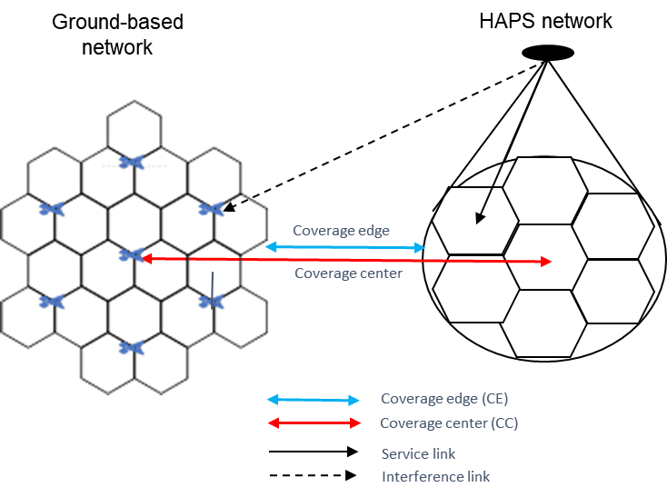  Figure 1. HAPS and TN co-existence scenario 1  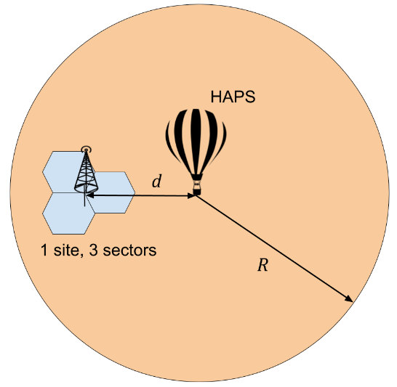  Figure 2. HAPS and TN co-existence scenario 2  Proposal 5: Adjacent channel interference in co-existence scenarios should be studied for both FDD and TDD.  Proposal 6: Adopt a reference HAPS antenna array for adjacent channel co-existence simulations.  Figure 3. Example of HAPS antenna array and cell layout  Table 1. Example HAPS antenna parameters for IMT bands below 2.7 GHz  Proposal 7: Determine simulation assumptions based on the HAPS co-existence scenarios and the terrestrial bands for HAPS deployment.  Table 2. Example system level simulation parameters for rural scenario
  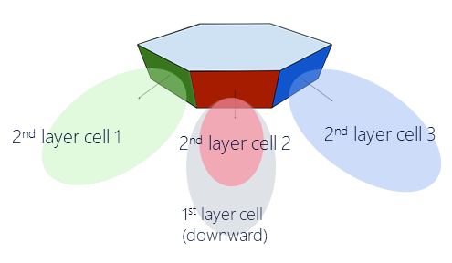 | 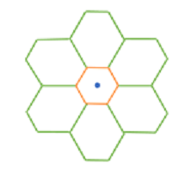
  (a) | (b)
  Number of cells | 7
  Antenna array configuration (row x column) | 2 x 2 for 1st layer cell  4 x 2 for 2nd layer cell
  Antenna polarization | Linear $±45°$
  Element gain | 8 dBi
  Element HPBW horizontal/vertical | $65°$ for both H/V
  Element front-to-back ratio horizontal/vertical | 30 dB for both H/V
  Element spacing horizontal/vertical | 0.5 wavelength for both H/V
  Antenna panel tilt | $90°$ for 1st layer cell  $23°$ for 2nd layer cell
  Tx power per antenna panel | 46 dBm
  Frequency band | Band n1 (UL: 1920-1980 MHz, DL: 2110-2170 MHz)
  Terrestrial environment | Urban Macro | Rural Macro
  Channel bandwidth | 20 MHz | 20 MHz
  HAPS altitude | 20 Km | 20 Km
  HAPS coverage radius | 100 Km | 100 Km
  HAPS and TN coverage center distance | 0, 20, 40 Km | 0, 20, 40 Km
  HAPS channel model | NTN urban [7] | NTN rural [7]
  HAPS indoor UE percentage | 0% | 0%
  TN inter-site distance | 1 Km | 2 Km
  TN BS antenna height | 25 m | 35 m
  TN BS transmit power | 46 dBm | 46 dBm
  TN BS antenna array configuration | 8 x 8 x 2 (M=8, N=8, P=2)  0.5 wavelength spacing | 8 x 1 x 2 (M=8, N=1, P=2)  0.5 wavelength spacing
  TN BS antenna downtilt | 10⁰ | 6⁰
  TN channel model | UMa model [8] | RMa model [8]
  TN BS element gain | 8 dBi | 8 dBi
  TN BS element HPBW horizontal/vertical | 65⁰ for H/V | 65⁰ for H/V
  TN BS element radiation pattern | As in Table 7.3-1 of [8] | As in Table 7.3-1 of [8]
  TN indoor UE percentage | 70% | 50%
  Body loss | 4 dB | 4 dB
  UE antenna gain | -3 dBi | -3 dBi
  UE antenna array | 1 x 1 x 2 (M=1, N=1, P=2) | 1 x 1 x 2 (M=1, N=1, P=2)
  UE transmit power | 23 dBm | 23 dBm
R4-2101935 | Nokia, Nokia Shanghai Bell | Observation 1: HAPS are already deployed in the LTE spectrum.  Observation 2: No additional UE requirements are needed for the terminal when applying already defined terrestrial bands for HAPS support.  Proposal 1: Adjacent channel coexistence studies to prioritize FDD bands.  Proposal 2: RAN4 to study (FDD) band n1 for HAPS and TN coexistence studies.  Proposal 3: RAN4 to study (TDD) band n41 for HAPS and TN coexistence studies.  Proposal 4: RAN4 to study ACLR requirements on HAPS BS for adjacent channel coexistence with terrestrial IMT systems.  Proposal 5: RAN4 to study ACS requirements on HAPS BS for adjacent channel coexistence with terrestrial IMT systems.  Proposal 6: RAN4 to study HAPS to HAPS adjacent channel interference.

Open issues summary

Sub-topic 5-1
Sub-topic description:
Open issues and candidate options before e-meeting:
Issue 5-1: Coexistence study scenarios
- Proposals
  - Option 1:
- Consider both densely deployed TN and sparsely deployed TN in HAPS-TN co-existence scenarios.
- RAN4 to study HAPS to HAPS adjacent channel interference.
HAPS – TN ACI | 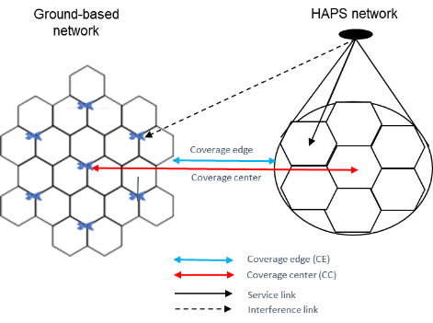  HAPS may cover a large area with multiple cells.  A cellular layout of 7 sites, 21 cells with a certain ISD may be used to model TN | 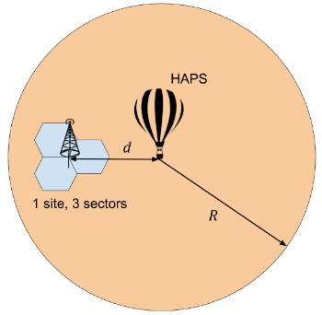  HAPS coverage overlaps spotty TN cells
HAPS – TN ACI | Duplex mode: FDD(prioritized), TDD
HAPS-HAPS ACI | FFS
  - Option 2: TBA
- Recommended WF
  - TBA

Sub-topic 5-2
Sub-topic description:
Open issues and candidate options before e-meeting:
Issue 5-2: Frequency band
- Proposals
  - Option 1: RAN4 to study and prioritize (FDD) band n1 for HAPS and TN coexistence studies.
  - Option 2: RAN4 to study (TDD) band n41 for HAPS and TN coexistence studies.
  - Option 3: TBA
- Recommended WF
  - TBA

Sub-topic 5-3
Sub-topic description:
Open issues and candidate options before e-meeting:
Issue 5-3: Antenna Model of HAPS
- Proposals
  - Option 1: Adopt a reference HAPS antenna array for adjacent channel co-existence simulations.
(a) | (b)
Figure 5.2.3.1 Example of HAPS antenna array and cell layout

Table 5.2.3.1. Example HAPS antenna parameters for IMT bands below 2.7 GHz
Number of cells | 7
Antenna array configuration (row x column) | 2 x 2 for 1st layer cell  4 x 2 for 2nd layer cell
Antenna polarization | Linear $±45°$
Element gain | 8 dBi
Element HPBW horizontal/vertical | $65°$ for both H/V
Element front-to-back ratio horizontal/vertical | 30 dB for both H/V
Element spacing horizontal/vertical | 0.5 wavelength for both H/V
Antenna panel tilt | $90°$ for 1st layer cell  $23°$ for 2nd layer cell
Tx power per antenna panel | 46 dBm
  - Option 2: TBA
- Recommended WF
  - TBA

Sub-topic 5-4
Sub-topic description:
Open issues and candidate options before e-meeting:
Issue 5-4: Simulation assumptions for HAPS-TN coexistence study
- Proposals
  - Option 1: Determine simulation assumptions based on the HAPS co-existence scenarios and the terrestrial bands for HAPS deployment.
Table 5.2.4.1 Example system level simulation parameters for rural scenario
Frequency band | Band n1 (UL: 1920-1980 MHz, DL: 2110-2170 MHz)
Terrestrial environment | Urban Macro | Rural Macro
Channel bandwidth | 20 MHz | 20 MHz
HAPS altitude | 20 Km | 20 Km
HAPS coverage radius | 100 Km | 100 Km
HAPS and TN coverage center distance | 0, 20, 40 Km | 0, 20, 40 Km
HAPS channel model | NTN urban [7] | NTN rural [7]
HAPS indoor UE percentage | 0% | 0%
TN inter-site distance | 1 Km | 2 Km
TN BS antenna height | 25 m | 35 m
TN BS transmit power | 46 dBm | 46 dBm
TN BS antenna array configuration | 8 x 8 x 2 (M=8, N=8, P=2)  0.5 wavelength spacing | 8 x 1 x 2 (M=8, N=1, P=2)  0.5 wavelength spacing
TN BS antenna downtilt | 10⁰ | 6⁰
TN channel model | UMa model [8] | RMa model [8]
TN BS element gain | 8 dBi | 8 dBi
TN BS element HPBW horizontal/vertical | 65⁰ for H/V | 65⁰ for H/V
TN BS element radiation pattern | As in Table 7.3-1 of [8] | As in Table 7.3-1 of [8]
TN indoor UE percentage | 70% | 50%
Body loss | 4 dB | 4 dB
UE antenna gain | -3 dBi | -3 dBi
UE antenna array | 1 x 1 x 2 (M=1, N=1, P=2) | 1 x 1 x 2 (M=1, N=1, P=2)
UE transmit power | 23 dBm | 23 dBm
FRF | 1
Note: Existing UE adjacent channel requirements apply to HAPS and TN co-existence scenarios.
  - Option 2: TBA
- Recommended WF
  - TBA

Sub-topic 5-5
Sub-topic description:
Open issues and candidate options before e-meeting:
Issue 5-5: Performance metric
- Proposals
  - Option 1: Determine the adjacent channel requirements for HAPS based on a 5% throughput degradation in the victim network in HAPS and TN co-existence scenarios.
  - Option 2: TBA
- Recommended WF
  - TBA

Sub-topic 5-6
Sub-topic description:
Open issues and candidate options before e-meeting:
Issue 5-6: BS & UE requirements
- Proposals
  - Option 1:
- RAN4 to study ACLR & ACS requirements on HAPS BS for adjacent channel coexistence with terrestrial IMT systems.
- No additional UE requirements are needed for the terminal when applying already defined terrestrial bands for HAPS support.
  - Option 2: TBA
- Recommended WF
  - TBA

Companies views’ collection for 1st round

Open issues
Company | Comments
XXX | Sub topic 1-1:  Sub topic 1-2:  ….  Others:

Summary for 1st round

Open issues
Moderator tries to summarize discussion status for 1st round, list all the identified open issues and tentative agreements or candidate options and suggestion for 2nd round i.e. WF assignment.
 | Status summary
Sub-topic#1 | Tentative agreements:  Candidate options:  Recommendations for 2nd round:

Recommendations on WF/LS assignment
 | WF/LS t-doc Title | Assigned Company,  WF or LS lead
#1

Discussion on 2nd round (if applicable)

Summary on 2nd round (if applicable)
Moderator tries to summarize discussion status for 2nd round and provided recommendation on CRs/TPs/WFs/LSs Status update suggestion
CR/TP/LS/WF number | T-doc Status update recommendation
XXX | Based on 2nd round of comments collection, moderator can recommend the next steps such as “agreeable”, “to be revised”

Annex TDOC list for this agenda
A total of 14 TDOCs have been provided for this agenda listed as below. Note that R4-2100487, R4-2102176 and part of R4-2101859 will be handled in [310] NTN_Solutions_Part1 this time.
TDoc Number | TDoc Type | Title | Company | Status | General Purpose | Agenda Item
R4-2100399 | discussion | Discussion on frequency band and scenarios for NTN | CATT | available | Discussion | 11.8.3.1
R4-2100486 | discussion | Simulaiton assumptions for NTN co-existence | CATT | available | Discussion | 11.8.3.1
R4-2100487 | discussion | Consideration on BS requirement impact for NTN | CATT | available | Discussion | 11.8.3.3
R4-2100904 | discussion | Simulation assumption for FR1 coexistence study | Samsung | available | Agreement | 11.8.3.1
R4-2101105 | other | Coexistence study on NR to support non-terrestrial networks | Xiaomi | available | Approval | 11.8.3.1
R4-2101812 | other | General discussion on NTN simulation assumptions | Huawei, HiSilicon | available | Approval | 11.8.3.1
R4-2101859 | discussion | NTN FR1 Coexistence Scenarios and Related Core Requirements | THALES | available | Decision | 11.8.3
R4-2101880 | discussion | Simulations for NTN FR1 Coexistence Cases | THALES | available | Decision | 11.8.3
R4-2101934 | discussion | NTN - HAPS simulation assumptions for co-existence study | Nokia, Nokia Shanghai Bell | available | Approval | 11.8.3.1
R4-2101935 | discussion | NTN - HAPS adjacent channel coexistence | Nokia, Nokia Shanghai Bell | available | Approval | 11.8.3.3
R4-2101964 | other | Discussion on simulation assumptions for NTN coexistence study | ZTE Corporation | available | Approval | 11.8.3.1
R4-2102174 | other | NTN Simulations assumptions discussion | Ericsson | available | Approval | 11.8.3.1
R4-2102176 | discussion | NTN - BS requirements overview | Ericsson | available | Discussion | 11.8.3.3
R4-2102508 | discussion | Simulation assumptions for NR NTN co-existence study | Qualcomm Incorporated | available | Decision | 11.8.3.1

