3GPP TSG-RAN WG4 Meeting #95-e Revised R4-2006903

Electronic meeting, 25th May – 5th Jun., 2020
CR-Form-v12.0
CHANGE REQUEST
 | 38.101-2 | CR | 0176 | rev | 1 | Current version: | 15.9.1
For HELP on using this form: comprehensive instructions can be found at
http://www.3gpp.org/Change-Requests.

Proposed change affects: | UICC apps |  | ME | X | Radio Access Network |  | Core Network

Title: | CR on minor corrections to TS 38.101-2 (Rel-15)
Source to WG: | ZTE Corporation
Source to TSG: | R4
Work item code: | NR_newRAT-Core |  |  |  |  |  | Date: |  |  | 2020-05-11
Category: | F |  |  |  |  |  | Release: |  |  | Rel-15
 | Use one of the following categories:  F (correction)  A (mirror corresponding to a change in an earlier release)  B (addition of feature),  C (functional modification of feature)  D (editorial modification)  Detailed explanations of the above categories can  be found in 3GPP TR 21.900. |  |  |  |  |  |  |  | Use one of the following releases:  Rel-8 (Release 8)  Rel-9 (Release 9)  Rel-10 (Release 10)  Rel-11 (Release 11)  Rel-12 (Release 12)  Rel-13 (Release 13)  Rel-14 (Release 14)  Rel-15 (Release 15)  Rel-16 (Release 16)
Reason for change: |  | Some minor errors in section 5 need to be modified.
Summary of change: |  | - Typo corrections in subclause 5.3.3.  - Correct the format in the header of Table 5.3.5-1 and 5.4.2.1-1.  - Remove empty row in the table of synchronization raster to SS block resource element mapping. Synchronization raster to SS block resource element mapping
Consequences if not approved: |  | The above mentioned problems will be remain.
Clauses affected: |  | 5.3.3, 5.3.5, 5.4.2.1, 5.4.3.2
 |  | Y | N
Other specs |  |  | X | Other core specifications |  |  |  | TS/TR ... CR ...
affected: |  | X |  | Test specifications |  |  |  | TS/TR ... CR ... 38.521-2
(show related CRs) |  |  | X | O&M Specifications |  |  |  | TS/TR ... CR ...
Other comments:
This CR's revision history:

<< start of changes >>

<< Unchanged sections omitted >>

5.3 UE Channel bandwidth

5.3.1 General
The UE channel bandwidth supports a single NR RF carrier in the uplink or downlink at the UE. From a BS perspective, different UE channel bandwidths may be supported within the same spectrum for transmitting to and receiving from UEs connected to the BS. Transmission of multiple carriers to the same UE (CA) or multiple carriers to different UEs within the BS channel bandwidth can be supported.
From a UE perspective, the UE is configured with one or more BWP / carriers, each with its own UE channel bandwidth. The UE does not need to be aware of the BS channel bandwidth or how the BS allocates bandwidth to different UEs.
The placement of the UE channel bandwidth for each UE carrier is flexible but can only be completely within the BS channel bandwidth.
The relationship between the channel bandwidth, the guardband and the transmission bandwidth configuration is shown in Figure 5.3.1-1.
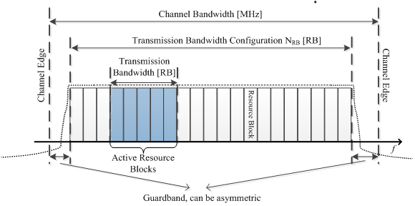
Figure 5.3.1-1: Definition of channel bandwidth and transmission bandwidth configuration for one NR channel

5.3.2 Maximum transmission bandwidth configuration
The maximum transmission bandwidth configuration N_{RB} for each UE channel bandwidth and subcarrier spacing is specified in Table 5.3.2-1
Table 5.3.2-1: Maximum transmission bandwidth configuration N_{RB}
SCS (kHz) | 50 MHz | 100 MHz | 200 MHz | 400 MHz
SCS (kHz) | N_{RB} | N_{RB} | N_{RB} | N_{RB}
60 | 66 | 132 | 264 | N.A
120 | 32 | 66 | 132 | 264

5.3.3 Minimum guardband and transmission bandwidth configuration
The minimum guardband for each UE channel bandwidth and SCS is specified in Table 5.3.3-1
Table 5.3.3-1: Minimum guardband for each UE channel bandwidth and SCS (kHz)
SCS (kHz) | 50 MHz | 100 MHz | 200 MHz | 400 MHz
60 | 1210 | 2450 | 4930 | N. A
120 | 1900 | 2420 | 4900 | 9860

NOTE: The minimum guardbands have been calculated using the following equation: (BW_{Channel} x 1000 (kHz) - N_{RB} x SCS x 12) / 2 - SCS/2, where N_{RB} are from Table 5.3.2-1.
The minimum guardband of receiving BS SCS 240 kHz SS/PBCH block for each UE channel bandwidth is specified in table 5.3.3-2 for FR2.
Table: 5.3.3-2: Minimum guardband (kHz) of SCS 240 kHz SS/PBCH block
SCS (kHz) | 100 MHz | 200 MHz | 400 MHz
240 | 3800 | 7720 | 15560

NOTE: The minimum guardband in Table 5.3.3-2 is applicable only when the SCS 240 kHz SS/PBCH block is received adjacent to the edge of the UE channel bandwidth within which the SS/PBCH block is located.

Figure 5.3.3-1: Void
The number of RBs configured in any channel bandwidth shall ensure that the minimum guardband specified in this clause is met.
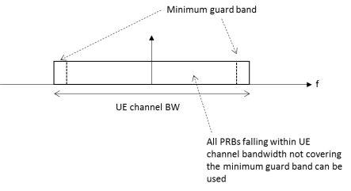
Figure 5.3.3-2 UE PRB utilization
In the case that multiple numerologies are multiplexed in the same symbol due to BS transmission of SSB, the minimum guardband on each side of the carrier is the guardband applied at the configured channel bandwidth for the numerology that is transmitted immediately adjacent to the guardband.
If multiple numerologies are multiplexed in the same symbol and the UE channel bandwidth is > 200 MHz, the minimum guardband applied adjacent to 60 kHz SCS shall be the same as the minimum guardband defined for 120 kHz SCS for the same UE channel bandwidth.
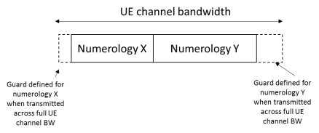
Figure 5.3.3-3 Guardband definition when transmitting multiple numerologies
Note: Figure 5.3.3-3 is not intended to imply the size of any guard between the two numerologies. Inter-numerology guardband within the carrier is implementation dependent.

5.3.4 RB alignment
For each numerology, its common resource blocks are specified in Clause 4.4.4.3 in [9], and the starting point of its transmission bandwidth configuration on the common resource block grid for a given channel bandwidth is indicated by an offset to "Reference point A" in the unit of the numerology. The UE transmission bandwidth configuration is indicated by the higher layer parameter carrierBandwidth [13] and will fulfil the minimum UE guardband requirement specified in Clause 5.3.3.

5.3.5 Channel bandwidth per operating band
The requirements in this specification apply to the combination of channel bandwidths, SCS and operating bands shown in Table 5.3.5-1. The transmission bandwidth configuration in Table 5.3.2-1 shall be supported for each of the specified channel bandwidths. The channel bandwidths are specified for both the Tx and Rx path.
Table 5.3.5-1: Channel bandwidths for each NR band
Operating band / SCS / UE channel bandwidth
Operating band | SCS  (kHz) | 50 MHz | 100 MHz | 200  MHz | 400¹ MHz
n257 | 60 | Yes | Yes | Yes
n257 | 120 | Yes | Yes | Yes | Yes
n258 | 60 | Yes | Yes | Yes
n258 | 120 | Yes | Yes | Yes | Yes
n260 | 60 | Yes | Yes | Yes
n260 | 120 | Yes | Yes | Yes | Yes
n261 | 60 | Yes | Yes | Yes
n261 | 120 | Yes | Yes | Yes | Yes
NOTE 1: This UE channel bandwidth is optional in this release of the specification.

5.3A UE channel bandwidth for CA

5.3A.1 General

5.3A.2 Minimum guardband and transmission bandwidth configuration for CA
For intra-band contiguous carrier aggregation, Aggregated Channel Bandwidth and Guard Bands are defined as follows, see Figure 5.3A.2-1.
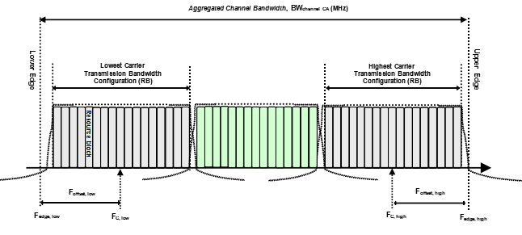
Figure 5.3A.2-1: Definition of Aggregated Channel Bandwidth for intra-band carrier aggregation
The aggregated channel bandwidth, BW_{Channel_CA}, is defined as
BW_{Channel_CA} = F_{edge,high} - F_{edge,low} (MHz).
The lower bandwidth edge F_{edge, low} and the upper bandwidth edge F_{edge,high} of the aggregated channel bandwidth are used as frequency reference points for transmitter and receiver requirements and are defined by
F_{edge,low} = F_{C,low} - F_{offset,low}
F_{edge,high} = F_{C,high} + F_{offset,high}
The lower and upper frequency offsets depend on the transmission bandwidth configurations of the lowest and highest assigned edge component carrier and are defined as
F_{offset,low} = (N_{RB,low}*12 + 1)*SCS_{low}/2 + BW_{GB} (MHz)
F_{offset,high} = (N_{RB,high}*12 - 1)*SCS_{high}/2 + BW_{GB} (MHz)
BW_{GB} = max(BW_{GB,Channel(k)})
BW_{GB,Channel(k)} is the minimum guard band defined in sub-clause 5.3.3 of carrier k, while N_{RB,low} and N_{RB,high} are the transmission bandwidth configurations according to Table 5.3.2-1 for the lowest and highest assigned component carrier, SCS_{low} and SCS_{high} are the sub-carrier spacing for the lowest and highest assigned component carrier respectively.
For intra-band non-contiguous carrier aggregation Sub-block Bandwidth and Sub-block edges are defined as follows, see Figure 5.3A.2-2.
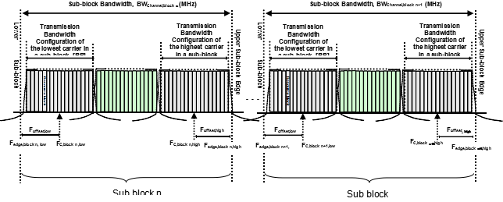
Figure 5.3A.2-2: Definition of sub-block bandwidth for intra-band non-contiguous spectrum
The lower sub-block edge of the Sub-block Bandwidth (BW_{Channel,block}) is defined as
F_{edge,block, low} = F_{C,block,low} - F_{offset, low.}
The upper sub-block edge of the Sub-block Bandwidth is defined as
F_{edge,block,high} = F_{C,block,high} + F_{offset, high.}
The Sub-block Bandwidth, BW_{Channel,block}, is defined as follows:
BW_{Channel,block} = F_{edge,block,high -} F_{edge,block,low} (MHz)
The lower and upper frequency offsets F_{offset,block,low} and F_{offset,block,high} depend on the transmission bandwidth configurations of the lowest and highest assigned edge component carriers within a sub-block and are defined as
F_{offset,block,low} = (N_{RB,low}*12 + 1)*SCS_{low}/2 + BW_{GB} (MHz)
F_{offset,block,high} = (N_{RB,high}*12 - 1)*SCS_{high}/2 + BW_{GB} (MHz)
BW_{GB} = max(BW_{GB,Channel(k)})
where N_{RB,low} and N_{RB,high} are the transmission bandwidth configurations according to Table 5.3.2-1 for the lowest and highest assigned component carrier within a sub-block, respectively. SCS_{low} and SCS_{high} are the sub-carrier spacing for the lowest and highest assigned component carrier within a sub-block, respectively. BW_{GB,Channel(k)} is the minimum guard band defined in sub-clause 5.3.3 of carrier k within a sub-block.
The sub-block gap size between two consecutive sub-blocks W_{gap} is defined as
W_{gap} = F_{edge,block n+1,low -} F_{edge,block n,high} (MHz)

5.3A.3 RB alignment with different numerologies for CA

5.3A.4 UE channel bandwidth per operating band for CA
For intra-band contiguous carrier aggregation, a carrier aggregation configuration is a single operating band supporting a carrier aggregation bandwidth class with associated bandwidth combination sets specified in clause 5.5A.1. For each carrier aggregation configuration, requirements are specified for all aggregated channel bandwidths contained in a bandwidth combination set, UE can indicate support of several bandwidth combination sets per carrier aggregation configuration. The requirements are applicable only when Uplink CCs are configured within the frequency range between lower edge of lowest downlink component carrier and upper edge of highest downlink component carrier.
For intra-band non-contiguous downlink carrier aggregation, a carrier aggregation configuration is a single operating band supporting two or more sub-blocks, each supporting a carrier aggregation bandwidth class. The requirements are applicable only when Uplink CCs are configured within the frequency range between lower edge of lowest downlink component carrier and upper edge of highest downlink component carrier.
Frequency separation class specified in Table 5.3A.4-2 indicates the maximum frequency span between lower edge of lowest component carrier and upper edge of highest component carrier that UE can support per band in downlink or uplink respectively in non-contiguous intra-band operation.
For inter-band carrier aggregation, a carrier aggregation configuration is a combination of operating bands, each supporting a carrier aggregation bandwidth class.
Table 5.3A.4-1: CA bandwidth classes
NR CA bandwidth class | Aggregated channel bandwidth | Number of contiguous CC | Fallback group
A | BW_{Channel} ≤ 400 MHz | 1 | 1,2,3,4
B | 400 MHz < BW_{Channel_CA} ≤ 800 MHz | 2 | 1
C | 800 MHz < BW_{Channel_CA} ≤ 1200 MHz | 3 | 1
D | 200 MHz < BW_{Channel_CA} ≤ 400 MHz | 2 | 2
E | 400 MHz < BW_{Channel_CA} ≤ 600 MHz | 3 | 2
F | 600 MHz < BW_{Channel_CA} ≤ 800 MHz | 4 | 2
G | 100 MHz < BW_{Channel_CA} ≤ 200 MHz | 2 | 3
H | 200 MHz < BW_{Channel_CA} ≤ 300 MHz | 3 | 3
I | 300 MHz < BW_{Channel_CA} ≤ 400 MHz | 4 | 3
J | 400 MHz < BW_{Channel_CA} ≤ 500 MHz | 5 | 3
K | 500 MHz < BW_{Channel_CA} ≤ 600 MHz | 6 | 3
L | 600 MHz < BW_{Channel_CA} ≤ 700 MHz | 7 | 3
M | 700 MHz < BW_{Channel_CA} ≤ 800 MHz | 8 | 3
O | 100 MHz ≤ BW_{Channel_CA} ≤ 200 MHz | 2 | 4
P | 150 MHz ≤ BW_{Channel_CA} ≤ 300 MHz | 3 | 4
Q | 200 MHz ≤ BW_{Channel_CA} ≤ 400 MHz | 4 | 4
NOTE 1: Maximum supported component carrier bandwidths for fallback groups 1, 2, 3 and 4 are 400 MHz, 200 MHz, 100 MHz and 100 MHz respectively except for CA bandwidth class A.
NOTE 2: It is mandatory for a UE to be able to fallback to lower order CA bandwidth class configuration within a fallback group. It is not mandatory for a UE to be able to fallback to lower order CA bandwidth class configuration that belong to a different fallback group.

Table 5.3A.4-2: Frequency separation classes for non-contiguous intra-band operation
Frequency separation class | Frequency separation (Fs)
I | Fs ≤ 800 MHz
II | Fs ≤ 1200 MHz
III | Fs ≤ 1400 MHz

5.3D Channel bandwidth for UL MIMO
The requirements specified in clause 5.3 are applicable to UE supporting UL MIMO.

5.4 Channel arrangement

5.4.1 Channel spacing

5.4.1.1 Channel spacing for adjacent NR carriers
The spacing between carriers will depend on the deployment scenario, the size of the frequency block available and the channel bandwidths. The nominal channel spacing between two adjacent NR carriers is defined as following:
For NR operating bands with 60 kHz channel raster,
Nominal Channel spacing = (BW_{Channel(1)} + BW_{Channel(2)})/2 + {-20 kHz, 0 kHz, 20 kHz} for ∆F_{Raster} equals to 60 kHz
Nominal Channel spacing = (BW_{Channel(1)} + BW_{Channel(2)})/2 + {-40 kHz, 0 kHz, 40 kHz} for ∆F_{Raster} equals to 120 kHz
where BW_{Channel(1)} and BW_{Channel(2)} are the channel bandwidths of the two respective NR carriers. The channel spacing can be adjusted depending on the channel raster to optimize performance in a particular deployment scenario.

5.4.2 Channel raster

5.4.2.1 NR-ARFCN and channel raster
The global frequency raster defines a set of RF reference frequencies F_{REF}. The RF reference frequency is used in signalling to identify the position of RF channels, SS blocks and other elements.
The global frequency raster is defined for all frequencies from 0 to 100 GHz. The granularity of the global frequency raster is ΔF_{Global}.
RF reference frequency is designated by an NR Absolute Radio Frequency Channel Number (NR-ARFCN) in the range [2016667...3279165] on the global frequency raster. The relation between the NR-ARFCN and the RF reference frequency F_{REF} in MHz is given by the following equation, where F_{REF-Offs} and N_{Ref-Offs} are given in table 5.4.2.1-1 and N_{REF} is the NR-ARFCN
F_{REF} = F_{REF-Offs} + ΔF_{Global} (N_{REF} – N_{REF-Offs})
Table 5.4.2.1-1: NR-ARFCN parameters for the global frequency raster
Frequency range (MHz) | ΔF_{Global} (kHz) | F_{REF-Offs} (MHz) | N_{REF-Offs} | Range of N_{REF}
24250 – 100000 | 60 | 24250.08 | 2016667 | 2016667 – 3279165

The channel raster defines a subset of RF reference frequencies that can be used to identify the RF channel position in the uplink and downlink. The RF reference frequency for an RF channel maps to a resource element on the carrier. For each operating band, a subset of frequencies from the global frequency raster are applicable for that band and forms a channel raster with a granularity ΔF_{Raster}, which may be equal to or larger than ΔF_{Global}.
The mapping between the channel raster and corresponding resource element is given in Clause 5.4.2.2. The applicable entries for each operating band are defined in clause 5.4.2.3

5.4.2.2 Channel raster to resource element mapping
The mapping between the RF reference frequency on channel raster and the corresponding resource element is given in Table 5.4.2.2-1 and can be used to identify the RF channel position. The mapping depends on the total number of RBs that are allocated in the channel and applies to both UL and DL. The mapping must apply to at least one numerology supported by the UE.
Table 5.4.2.2-1: Channel raster to resource element mapping
 | N_{RB} mod 2 = 0 | N_{RB} mod 2 = 1
Resource element index k | 0 | 6
Physical resource block number n_{PRB} | 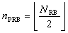

k, n_{RB} , N_{RB} are as defined in TS 38.211 [9].

5.4.2.3 Channel raster entries for each operating band
The RF channel positions on the channel raster in each NR operating band are given through the applicable NR-ARFCN in Table 5.4.2.3-1, using the channel raster to resource element mapping in clause 5.4.2.2.
- For NR operating bands with 60 kHz channel raster above 24 GHz, ΔF_{Raster} = I ×ΔF_{Global} , where I ϵ {1,2}. Every Ith NR-ARFCN within the operating band are applicable for the channel raster within the operating band and the step size for the channel raster in table 5.4.2.3-1 is given as <I>.
- In frequency bands with two ΔF_{Raster}, the higher ΔF_{Raster} applies to channels using only the SCS that is equal to the higher ΔF_{Raster} and the SSB SCS that is equal to or larger than the higher ΔF_{Raster}.
Table 5.4.2.3-1: Applicable NR-ARFCN per operating band
Operating Band | ΔF_{Raster}  (kHz) | Uplink and Downlink  Range of N_{REF}  (First – <Step size> – Last)
n257 | 60 | 2054166 – <1> – 2104165
n257 | 120 | 2054167 – <2> – 2104165
n258 | 60 | 2016667 – <1> – 2070832
n258 | 120 | 2016667 – <2> – 2070831
n260 | 60 | 2229166 – <1> – 2279165
n260 | 120 | 2229167 – <2> – 2279165
n261 | 60 | 2070833 – <1> – 2084999
n261 | 120 | 2070833 – <2> – 2084999

5.4.3 Synchronization raster

5.4.3.1 Synchronization raster and numbering
The synchronization raster indicates the frequency positions of the synchronization block that can be used by the UE for system acquisition when explicit signalling of the synchronization block position is not present.
A global synchronization raster is defined for all frequencies. The frequency position of the SS block is defined as SS_{REF} with corresponding number GSCN. The parameters defining the SS_{REF} and GSCN for all the frequency ranges are in Table 5.4.3.1-1.
The resource element corresponding to the SS block reference frequency SS_{REF} is given in clause 5.4.3.2. The synchronization raster and the subcarrier spacing of the synchronization block is defined separately for each band.
Table 5.4.3.1-1: GSCN parameters for the global frequency raster
Frequency range | SS block frequency position SS_{REF} | GSCN | Range of GSCN
24250 – 100000 MHz | 24250.08 MHz + N * 17.28 MHz,  N = 0:4383 | 22256 + N | 22256 – 26639

5.4.3.2 Synchronization raster to synchronization block resource element mapping
The mapping between the synchronization raster and the corresponding resource element of the SS block is given in Table 5.4.3.2-1.
Table 5.4.3.2-1: Synchronization raster to SS block resource element mapping
Resource element index k | 120

k is the subcarrier number of SS/PBCH block defined in TS 38.211 clause 7.4.3.1 [9].

5.4.3.3 Synchronization raster entries for each operating band
The synchronization raster for each band is give in Table 5.4.3.3-1. The distance between applicable GSCN entries is given by the <Step size> indicated in Table 5.4.3.3-1.
Table 5.4.3.3-1: Applicable SS raster entries per operating band
NR Operating Band | SS Block SCS | SS Block pattern¹ | Range of GSCN  (First – <Step size> – Last)
n257 | 120 kHz | Case D | 22388 - <1> - 22558
n257 | 240 kHz | Case E | 22390 - <2> - 22556
n258 | 120 kHz | Case D | 22257 - <1> - 22443
n258 | 240 kHz | Case E | 22258 - <2> - 22442
n260 | 120 kHz | Case D | 22995 - <1> - 23166
n260 | 240 kHz | Case E | 22996 - <2> - 23164
n261 | 120 kHz | Case D | 22446 - <1> - 22492
n261 | 240 kHz | Case E | 22446 - <2> - 22490
NOTE 1: SS Block pattern is defined in clause 4.1 in TS 38.213 [10].

==============================================================

<< End of changes >>

