3GPP TR 38.753 V0.1.0 (2025-05)
Technical Report

3rd Generation Partnership Project;
Technical Specification Group Radio Access Network;
Study on spatial channel model for demodulation performance requirements for NR;
(Release 19)
The present document has been developed within the 3rd Generation Partnership Project (3GPP TM) and may be further elaborated for the purposes of 3GPP.
The present document has not been subject to any approval process by the 3GPP Organizational Partners and shall not be implemented.
This Specification is provided for future development work within 3GPP only. The Organizational Partners accept no liability for any use of this Specification.
Specifications and Reports for implementation of the 3GPP TM system should be obtained via the 3GPP Organizational Partners' Publications Offices.

3GPP
Postal address

3GPP support office address
650 Route des Lucioles - Sophia Antipolis
Valbonne - FRANCE
Tel.: +33 4 92 94 42 00 Fax: +33 4 93 65 47 16
Internet
http://www.3gpp.org

Copyright Notification
No part may be reproduced except as authorized by written permission.
The copyright and the foregoing restriction extend to reproduction in all media.

© 2025, 3GPP Organizational Partners (ARIB, ATIS, CCSA, ETSI, TSDSI, TTA, TTC).
All rights reserved.

UMTS™ is a Trade Mark of ETSI registered for the benefit of its members
3GPP™ is a Trade Mark of ETSI registered for the benefit of its Members and of the 3GPP Organizational Partners
LTE™ is a Trade Mark of ETSI registered for the benefit of its Members and of the 3GPP Organizational Partners
GSM® and the GSM logo are registered and owned by the GSM Association

Contents
Foreword 5
1 Scope 7
2 References 7
3 Definitions of terms, symbols and abbreviations 8
3.1 Terms 8
4 Background 9
4.1 General 9
5 Deployment Scenarios 10
5.1 CDL Approach 10
5.1.1 Antenna Panel Configuration 11
5.1.2 Antenna Array Virtualization 11
5.1.3 Antenna Element Configuration 12
5.1.4 Channel Models 12
5.1.4.1 Parameters for Angle Scaling 13
5.1.4.2 Parameters for Randomness Reduction 13
5.1.4.2 CDL Truncation 14
5.1.4.3 Channel Models 14
5.2 TDL Approaches 15
5.2.1 MIMO correlation and angular spread 15
5.2.2 Multi-cluster TDL channel via TX-RX beam steering 16
5.2.2.1 Steering matrices for cross-polarized antenna arrays 17
5.2.2.2 Cluster model example 18
6 Spatial Channel Modelling Approaches 19
6.1 SU PMI performance 19
6.2 PDSCH performance under SU-MIMO scenario 27
7 Alignment of Spatial Channel Models 28
7.1 CDL option 1 results alignment 29
7.2 CDL option 2 results alignment 29
7.3 Enhanced TDL option 1 results alignment 30
7.4 Enhanced TDL option 2 results alignment 30
8 Evaluation 31
9 Summary 31
Annex A: Channel Measurements 32
A.1 Measurement Configurations 32
A.1.1 Measurement campaign A: a 4-port transmitter and a 4-port receiver system 32
A.1.2 Measurement campaign B: a 4-port transmitter and a 32-port receiver 33
A.2 Measurement Results 34
A.2.1 Channel Eigenmodes 34
A.2.3 Power Angular Distribution 35
Annex B: Modelling execution for CDL Channel Models 36
B.1 Introduction 36
B.2 [Common Execution steps to all CDL models] 36
B.3 Derivation of CDL Models for RAN4 Demod 38
Annex C: Modelling execution for TDL Channel Models 39
C.1 TDL Approaches 39
C.1.1 Multi-cluster TDL channel for 2-CW fixed-MCS testing 39
C.1.1.1 Example 1 40
C.1.1.2 Example 2 42
Annex D: MU-MIMO (Informative) 43
Annex <E> (informative): Change history 46

Foreword
This Technical Report has been produced by the 3rd Generation Partnership Project (3GPP).
The contents of the present document are subject to continuing work within the TSG and may change following formal TSG approval. Should the TSG modify the contents of the present document, it will be re-released by the TSG with an identifying change of release date and an increase in version number as follows:
Version x.y.z
where:
x the first digit:
1 presented to TSG for information;
2 presented to TSG for approval;
3 or greater indicates TSG approved document under change control.
y the second digit is incremented for all changes of substance, i.e. technical enhancements, corrections, updates, etc.
z the third digit is incremented when editorial only changes have been incorporated in the document.
In the present document, modal verbs have the following meanings:
shall indicates a mandatory requirement to do something
shall not indicates an interdiction (prohibition) to do something
The constructions "shall" and "shall not" are confined to the context of normative provisions, and do not appear in Technical Reports.
The constructions "must" and "must not" are not used as substitutes for "shall" and "shall not". Their use is avoided insofar as possible, and they are not used in a normative context except in a direct citation from an external, referenced, non-3GPP document, or so as to maintain continuity of style when extending or modifying the provisions of such a referenced document.
should indicates a recommendation to do something
should not indicates a recommendation not to do something
may indicates permission to do something
need not indicates permission not to do something
The construction "may not" is ambiguous and is not used in normative elements. The unambiguous constructions "might not" or "shall not" are used instead, depending upon the meaning intended.
can indicates that something is possible
cannot indicates that something is impossible
The constructions "can" and "cannot" are not substitutes for "may" and "need not".
will indicates that something is certain or expected to happen as a result of action taken by an agency the behaviour of which is outside the scope of the present document
will not indicates that something is certain or expected not to happen as a result of action taken by an agency the behaviour of which is outside the scope of the present document
might indicates a likelihood that something will happen as a result of action taken by some agency the behaviour of which is outside the scope of the present document
might not indicates a likelihood that something will not happen as a result of action taken by some agency the behaviour of which is outside the scope of the present document
In addition:
is (or any other verb in the indicative mood) indicates a statement of fact
is not (or any other negative verb in the indicative mood) indicates a statement of fact
The constructions "is" and "is not" do not indicate requirements.

1 Scope
The present document contains the findings of the Study on spatial channel model for demodulation performance requirements for NR, with the detailed objectives as follows:

- Study practical spatial channel modelling methodology for both SU- and MU-MIMO demodulation requirements and CSI reporting requirements:
  - Identify the limitations of the current (i.e. up to and including Release 18) channel models and corresponding scenarios and how they relate to UE MIMO performance
  - Consider both Clustered Delay Line (CDL)-based and TDL-based channel modelling approaches
    - For CDL-based channel modelling, use the tuned repeatable spatial channel model of TR38.827 as the starting point and identify any necessary changes.
  - Study and verify test methodology feasibility including test complexity and achievable results uncertainty. The test complexity shall not be significantly increased.
  - The methodology shall include both FR1 (conducted) and FR2 (wireless cable), with first priority for FR1.

2 References
The following documents contain provisions which, through reference in this text, constitute provisions of the present document.
- References are either specific (identified by date of publication, edition number, version number, etc.) or non-specific.
- For a specific reference, subsequent revisions do not apply.
- For a non-specific reference, the latest version applies. In the case of a reference to a 3GPP document (including a GSM document), a non-specific reference implicitly refers to the latest version of that document in the same Release as the present document.
[1] 3GPP TR 21.905: "Vocabulary for 3GPP Specifications".
[2] RP-241610, Study on spatial channel model for demodulation performance requirements for NR, RAN#104
[3] RP-250577, Revised SID: Study on spatial channel model for demodulation performance requirements, RAN#107 meeting, Nokia, BT Plc
[4] RP-160210, SID: Study on channel model for frequency spectrum above 6 GHz, RAN#71, Samsung, Nokia, March 2016
[5] 3GPP TR 38.900, Study on channel model for frequency spectrum above 6 GHz
[6] RP-170379, SID: Study on New Radio Access Technology, NTT DOCOMO INC., RAN#75, March 2017
[7] 3GPP TR 38.901, Study on channel model for frequencies from 0.5 to 100 GHz
[8] 3GPP TS 38.101-4, User Equipment (UE) radio transmission and reception; Part 4: Performance requirements
[9] R4-1808400, NR Test Methods SI ad-hoc meeting notes, RAN4#87, Intel Corporation
[10] R4-1812001, RAN4#88 Meeting report, RAN4#88
[11] RP-181325, New SID on Study on radiated metrics and test methodology for the verification of multi-antenna reception performance of NR UEs, RAN#80, CATR, OPPO, Samsung
[12] 3GPP TR 38.827, Study on radiated metrics and test methodology for the verification of multi-antenna reception performance of NR User Equipment (UE)
[13] 3GPP TS 38.104, Base Station (BS) radio transmission and reception
[14] R4-2017678, “Way Forward on PMI Reporting Requirement for NR eMIMO”, RAN4#97-e
[15] R4-2214397, “WF on UE demodulation and CSI requirements for feMIMO”, RAN4#104b-e
[16] R4-2210669, “WF on CSI requirement for Rel-17 feMIMO”, RAN4#103-e
[17] R4-2402277, Discussion on 8Rx general demodulation aspects and spatial channel models, RAN4#110, Nokia, Nokia Shanghai Bell, BT

3 Definitions of terms, symbols and abbreviations
This clause and its three (sub) clauses are mandatory. The contents shall be shown as "void" if the TS/TR does not define any terms, symbols, or abbreviations.

3.1 Terms
For the purposes of the present document, the terms given in TR 21.905 [1] and the following apply. A term defined in the present document takes precedence over the definition of the same term, if any, in TR 21.905 [1].
Definition format (Normal)
<defined term>: <definition>.
example: text used to clarify abstract rules by applying them literally.

3.2 Symbols
For the purposes of the present document, the following symbols apply:
α bearing angle
β downtilt angle
γ slant angle
azimuth angle
zenith angle

3.3 Abbreviations
For the purposes of the present document, the abbreviations given in TR 21.905 [1] and the following apply. An abbreviation defined in the present document takes precedence over the definition of the same abbreviation, if any, in TR 21.905 [1].
AAV Antenna Array Virtualization
AOA Azimuth angle Of Arrival
AOD Azimuth angle Of Departure
AS Angular Spread
ASA Azimuth angle Spread of Arrival
ASD Azimuth angle Spread of Departure
BS Base Station
CDL Clustered Delay Line
DS Delay Spread
FR1 Frequency Range 1
FR2 Frequency Range 2
GCS Global Coordinate System
LOS Line Of Sight
LCS Local Coordinate System
MIMO Multiple Input Multiple Output
NLOS Non-LOS
PAD Power Angular Distribution
PDP Power Delay Profile
TDL Tapped Delay Line
UE User Equipment
XPR Cross-Polarization Ratio
ZOA Zenith angle Of Arrival
ZOD Zenith angle Of Departure
ZSA Zenith angle Spread of Arrival
ZSD Zenith angle Spread of Departure

4 Background

4.1 General
In the RAN#104 meeting, the SID [2] for “New SID: Study on spatial channel model for demodulation performance requirements” has been approved, which starts from RAN4#112 in Aug 2024 and targeting to complete by RAN#109 in Sep 2025 [3]. The present document is a technical report based upon the study for a practical spatial channel modelling methodology for both SU- and MU-MIMO demodulation requirements and CSI reporting requirements for both FR1 (conducted) and FR2 (wireless cable) for RAN4 in 3GPP Rel-19, which provides evaluations on both CDL-based and TDL-based channel modelling approaches.
Generally, the channel model with spatial property has been discussed at the beginning of NR. In Rel-14, two study items were progressed carried out: the first one analyzing how to define a channel model representing the channel for frequencies up to 100 GHz [4], whose outcome was documented in 3GPP TR 38.900 [5], and the second one aiming to develop an NR access technology to meet a broad range of use cases including enhanced mobile broadband, massive MTC, critical MTC [6], including the channel model definition that was finally documented in TR 38.901 [7]. RAN1 are using geometric based SCM(E) defined in 38.901 for system level simulation since this channel model is more realistic. 38.901 CDL channel model are derived from SCM(E) with randomness reduction on some parameters, and 38.901 TDL are further derived from 38.901 CDL without spatial property [6]. In Rel-15, RAN4 decided to use simplified TDL model [8] for NR FR1 demodulation test in May 2018 [9] and simplified TDL model for NR FR2 demodulation test in Aug 2018 [10] since majority companies acknowledge TDL is enough for demodulation performance requirements and it is hard to align simulation results using 38.901 CDL at that stage. A New SID [11] on the radiated metrics and test methodology for the verification of multi-antenna reception performance of NR UEs was approved in June 2018, which targeting for TR 38.827 [12] approval in Dec 2019 and actually approved in June 2020.
Until now, the demodulation performance requirements in RAN4 [8][13] are all based on TDL channel modelling. There are two types of correlation matrices defined for TDL channel modelling, i.e., Uniform Linear Array (ULA), Cross Polarized Antennas (X-pol). Different correlation factors and beam steering approach are also defined to control the correlation levels and steering directions during the tests. Even with applying correlation matrices on these TDL models, all taps would use the same correlation matric which also could not reflect the spatial fading on different clusters. Therefore, it is hard for RAN4 to show the performance gains verified by RAN1 for features need separate directions, such as Rel-16 NR_eMIMO [14], Rel-17 NR_feMIMO [15][16], and even unexpected performance for 8Rx [17]. In order to achieve perfect matching with realistic propagation conditions, separate spatial components for different clusters/taps should be introduced for RAN4 SCM.

5 Deployment Scenarios

5.1 CDL Approach
The Clustered Delay Line (CDL) channel model is a widely used framework for simulating realistic wireless propagation environments. CDL models capture the spatial, temporal, and frequency-dependent characteristics of radio channels by representing multipath propagation through discrete clusters of scatterers, each contributing multiple delay paths. The details of the CDL based approach employed in the study are provided in this section with the relevant parameter configurations. The model employed in the study is applicable for 3.5 GHz frequency in urban macro scenario.

5.1.1 Antenna Panel Configuration
The antenna panel is one of the primary components for CDL modeling methodology. The antenna panel configuration employed in this study for BS and UE are presented in Table 5.1.1.-1.
Table 5.1.1-1: BS and UE Panel parameters
Parameter | Value
LCS UE | α = 180°, β=0°, γ = 0°
LCS gNodeB | α = 0°, β=10°, γ = 0°
GCS UE | Height = 1.5 m; Azimuth = 0; X Coordinate = 100 m
GCS gNodeB | Height = 25 m; Azimuth = 0; X Coordinate = 0 m
Antenna Panel Placement | YZ Plane

5.1.2 Antenna Array Virtualization
The antenna panel is composed by antenna elements arranged in columns and rows, single or dual polarized, and can be split in subarrays. One subarray is a unique set of co-polarized antenna elements mapped exclusively to one antenna port through a virtualizer (set of complex values).
The antenna panel configuration is defined as (M,N,P,Ms,Ns), according to the description below:
M is the number of antenna elements per panel with the same polarization in each column (vertical size)
N is the number of antenna elements per panel with the same polarization in each row (horizontal size)
P is the number of polarizations
Ms is the number of antenna elements per subarray with the same polarization in each column (vertical size)
Ns is the number of antenna elements per subarray with the same polarization in each row (horizontal size)
Different AAV configurations for base station are employed in this study.
BS AAV Configurations:
- Sub-array Antenna Array Virtualization (AAV) configuration
(M,N,P,M_{s},N_{s}) = (8,2,2,8,1) for 4Tx CSI-RS Ports
(M,N,P,M_{s},N_{s}) = (8,4,2,8,1) for 8Tx CSI-RS Ports
- Pass though AAV configuration:
(M,N,P,M_{s},N_{s}) = (1,2,2,1,1) for 4Tx CSI-RS Ports
(M,N,P,M_{s},N_{s}) = (1,4,2,1,1) for 8Tx CSI-RS Ports

UE AAV is a pass-through AAVc configuration
(M,N,P,M_{s},N_{s}) = (1,2,2,1,1) for 4 RX

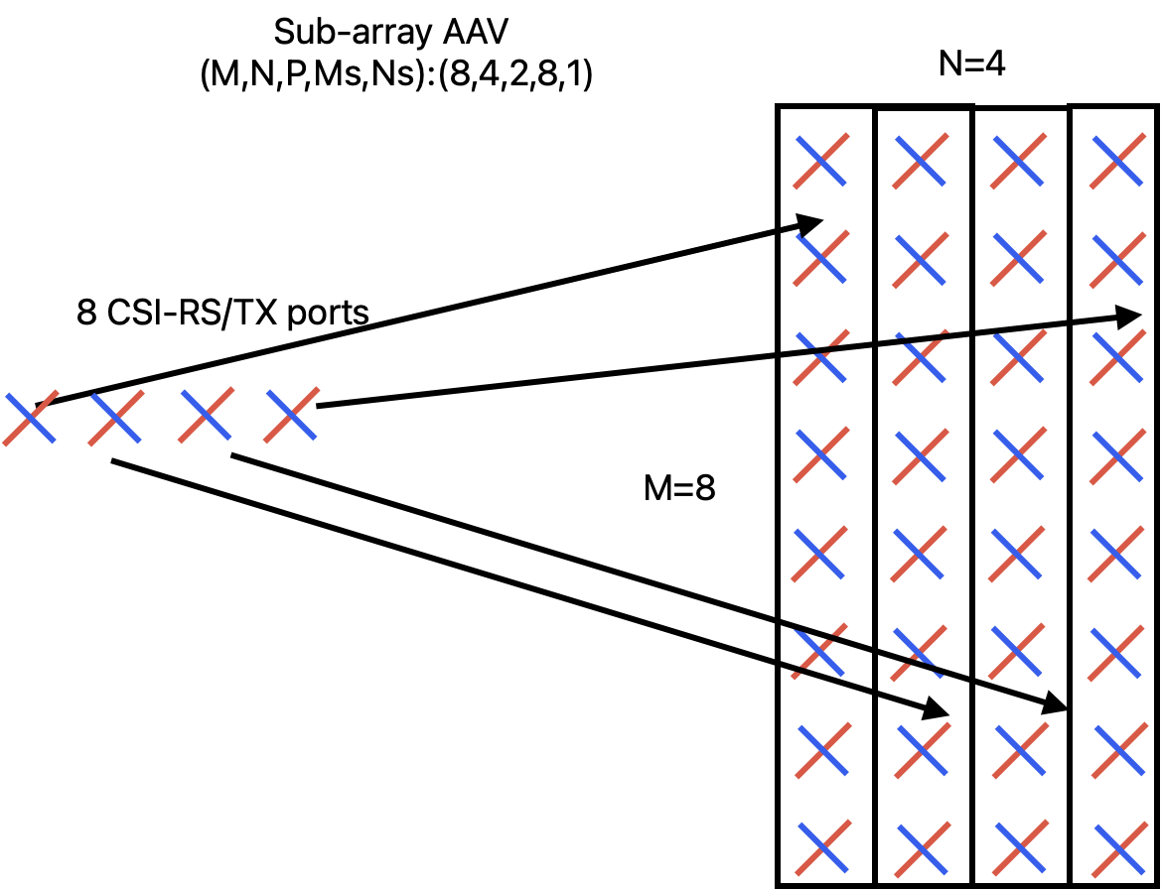 | 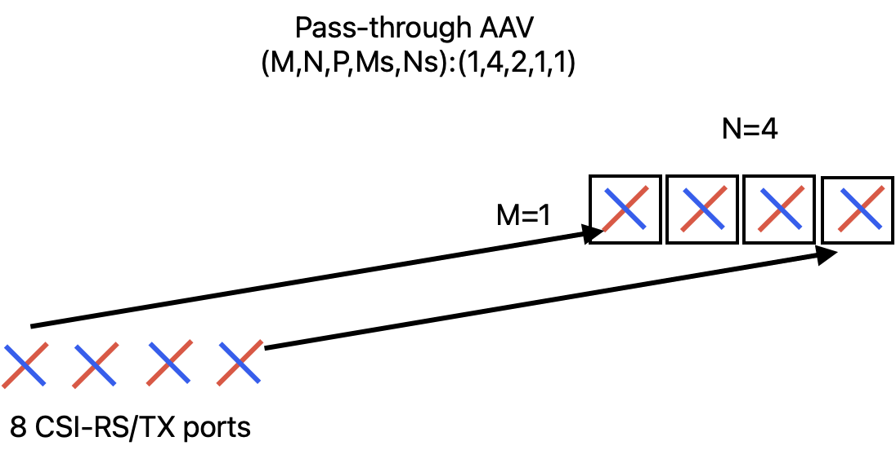

5.1.3 Antenna Element Configuration
<This section provides parameters for antenna element configuration>
Table 5.1.3-1: BS and UE Antenna element parameters
Parameter | Value
BS Antenna Polarization | (+45, -45)
BS Radiation Pattern | defined in TR38.901 Table 7.3-1.
UE Antenna Polarization | (0, 90)
UE Antenna Radiation Pattern | Omnidirectional

5.1.4 Channel Models
The CDL-C model from 38.901 in Table 7.7.1-3 is taken as a starting point. The parameters for angle scaling, delay spread are derived based on urban macro (UMa) scenario for 3.5 GHz carrier. The randomness introduced by the channel generation based on 38.901 is alleviated by randomness reduction framework adopted from 38.827.

5.1.4.1 Parameters for Angle Scaling
The angles need to be scaled for the scenario to achieve the desired angular spread and direction. The parameters for scaling the angles of arrival and departure are provided here. The CDL tables provided in 5.1.4.3 include the delay scaling for RMS delay of 365ns and desired angle scaling.
φn,scaled=wrap(ASdesiredASmodel.wrap(φn,model-μφ,model)+μφ,model)
φn,model is the tabulated CDL ray angle from 38.901
ASmodel is the rms angular spread of the tabulated CDL from 38.901 including the offset ray angles provided below
μφ,model is the mean angle of the tabulated CDL from 38.901, calculated using the definition in Annex A.2 of 38.901
ASdesired is the desired rms angular spread provided below
φn,scaled is the resulting scaled ray angle.
y = wrap(x) makes y to fall between -180 and +180 degrees so that y = (x+180) mod 360 - 180
The power weighted mean angle is given by
μφ=arg{n=1Nm=1Mexp(jφn,m)Pn,m}
where Pn,m is the power for the mth ray of the nth cluster and φn,m is the ray angle (either AOA, AOD, ZOA, ZOD) given in radians.

Table 5.1.4.1-1: Angle scaling parameters
AS | AS_{model} / AS_{desired} [deg]
AS | ASD | ASA | ZSD | ZSA
Model (827) | 39.0949 | 71.1175 | 4.0666 | 10.4245
Model (901) | 37.4036 | 71.4535 | 4.0665 | 10.4182
Desired | 25.7620 | 74.1138 | 4.8978 | 18.2050

5.1.4.2 Parameters for Randomness Reduction
The randomness reduction framework employs fixed coupling pattern for ray angles and fixed initial phases for polarization matrices in the channel coefficient generation.
Within a cluster the AOD angles are coupled to AOD angles using the fixed coupling pattern specified in Table 5.1.4.2-1. The same fixed coupling pattern is applied for all clusters n.
Table 5.1.4.2-1: Fixed coupling pattern of ray angles to be applied for each cluster
 | m
 | 6 | 12 | 5 | 10 | 8 | 11 | 16 | 14 | 18 | 9 | 20 | 4 | 2 | 15 | 7 | 13 | 19 | 17 | 3 | 1
 | 20 | 9 | 12 | 1 | 13 | 18 | 10 | 4 | 8 | 2 | 6 | 14 | 11 | 19 | 7 | 3 | 17 | 5 | 15 | 16
 | 2 | 16 | 3 | 11 | 18 | 9 | 5 | 17 | 4 | 19 | 15 | 20 | 13 | 7 | 10 | 1 | 8 | 12 | 6 | 14
 | 15 | 18 | 13 | 1 | 12 | 9 | 6 | 7 | 5 | 3 | 2 | 8 | 14 | 17 | 19 | 16 | 11 | 20 | 10 | 4

The initial phase {Φn,mθθ,Φn,mθφ,Φn,mφθ,Φn,mφφ} for each ray m of each cluster n and for four different polarization combinations (θθ, θϕ, ϕθ, ϕϕ) are fixed as in the Table 5.1.4.2-2
Table 5.1.4.2-2: Fixed initial phases for 2x2 polarization matrices
m | Φmθθ [rad] | Φmϕθ [rad] | Φmθϕ [rad] | Φmϕϕ [rad]
1 | 1.7609 | -0.6928 | -1.6230 | -0.6037
2 | -2.5356 | -2.3124 | 2.7775 | 2.8660
3 | 0.4725 | -2.7660 | -1.6664 | -0.9226
4 | 2.0181 | -3.0448 | -2.8713 | -2.0798
5 | 0.9369 | 1.4560 | 0.9283 | -0.3084
6 | 0.2954 | -1.2798 | 1.5375 | -1.9544
7 | 1.1735 | -1.9886 | -0.8263 | 0.7893
8 | 1.7607 | -2.6319 | 2.6979 | 1.7324
9 | -0.0830 | -0.4030 | -0.3344 | -1.2167
10 | 0.0535 | 0.0677 | 1.9957 | 1.8525
11 | 0.9068 | -0.7627 | 1.9577 | 0.2062
12 | -0.9379 | 2.7583 | 2.3621 | 0.3151
13 | 0.7695 | 0.5469 | -1.8363 | -1.2488
14 | -0.1827 | -1.6934 | 2.1634 | -1.9179
15 | -1.7221 | -2.0690 | -1.7111 | -0.4040
16 | -1.1869 | 2.6602 | -0.4385 | -1.9804
17 | 2.5439 | 3.0143 | -0.3841 | -2.4434
18 | -1.5201 | -0.5735 | 0.5962 | -1.4941
19 | 0.6462 | 1.3271 | -1.7483 | -2.4038
20 | -1.2775 | -1.1386 | -0.4765 | 0.0494

5.1.4.2 CDL Truncation
The CDL model is truncated to 12 taps based on the procedure provided in Annex.

5.1.4.3 Channel Models
UMa-CDLC1: Derived based on CDL-C from 38.901 with the desired delay and angle spread applied, and truncated to 12 significant clusters.
Table 5.1.4.3-1: Channel model parameters for UMa-CDL-C1
Cluster # | Cluster delay (ns) | Power in [dB] | AOD in [°] | AOA in [°] | ZOD in [°] | ZOA in [°]
1 | 0 | -7.4 | -38.2 | -96.9 | 96.8 | 98.1
2 | 132 | -1.2 | -21.8 | 118.9 | 98.5 | 71.1
3 | 138 | -5.5 | -34.2 | -124.4 | 100.9 | 67.6
4 | 402 | 0.0 | -5.9 | 171.2 | 99.2 | 76.6
5 | 416 | -10.4 | 44.2 | 51.9 | 106.4 | 62.8
6 | 502 | -10.1 | -50.6 | 63.4 | 94.5 | 56.6
7 | 518 | -13.7 | 49.1 | -42.1 | 107.5 | 69.8
8 | 776 | -8.1 | -44.2 | 65.1 | 104.6 | 103.4
9 | 826 | -9.8 | -50.4 | -63.4 | 105.2 | 50.1
10 | 1372 | -11.7 | -60.2 | 79.0 | 91.7 | 51.7
11 | 1712 | -16.2 | 64.6 | 26.3 | 105.2 | 121.0
12 | 2906 | -16.9 | 55.0 | -1.6 | 91.8 | 61.6
Per-Cluster Parameters
Parameter |  | c_{ASD} in [°] | c_{ASA} in [°] | c_{ZSD} in [°] | c_{ZSA} in [°] | XPR in [dB]
Value |  | 1.4 | 15.6 | 3.6 | 12.2 | 7

5.2 TDL Approaches
The novel multi-cluster TDL approach builds on top of the widely used and well tested legacy RAN4 TDL channel models. In the legacy models, spatial selectivity is introduced by applying MIMO correlation matrices on top of uncorrelated fading MIMO channel. However, the legacy correlation models (TS 38.101-4: Annex B.2.3) amplify the signal only in the broadside direction (AOD/AOA) of the TX and RX antenna arrays. As a result, the spatial degrees of freedom remain limited, and only a relatively low number of spatial layers can be supported. In order to support a higher number of layers, multiple separate spatial signal directions should exist. This can be achieved by introducing spatial clusters, where each cluster has its own separable mean AOD/AOA.

The multi-cluster TDL models aim to be an easier-to-use and easier-to-configure alternative to CDL models. There is just a handful of high-level parameters that can be chosen to achieve desired channel properties, and to match the scope of different performance tests. To further improve the test coverage, the spatial properties of the clusters (in terms of AOA/AOD) could be defined to be time-varying.

5.2.1 MIMO correlation and angular spread
For both LTE and NR, RAN4 demodulation and CSI reporting tests until 3GPP Release 18 employ TDL fading channel models. In many of those tests, spatial selectivity is introduced by applying MIMO correlation matrices on top of an uncorrelated fading MIMO channel. Correlation models are defined for two different antenna array assumptions: Uniform Linear Array (ULA) and Cross-polarized Antennas (X-pol).
MIMO correlation (TDL) and angular spread (CDL) approaches are alternative ways to generate spatial selectivity. High angular spread corresponds to low MIMO correlation and vice versa. As can be seen in Figure 5-1, a typical 3GPP correlation model generates spatial selectivity that resembles that of a single-cluster CDL channel model. As a result of the real-valued spatial correlation matrix, the strongest beam direction is always at 0⁰ AOD/AOA angle (broadside) of each linear array dimension.
The spatial selectivity of a MIMO channel can be depicted as power angular distribution (PAD) that represents the average channel power response as function of TX or RX direction. Figure 5-1(a) illustrates the power angular distribution (PAD) measured from an 8TX-8RX X-pol medium correlated TDL channel model (α₁=0.3, β=0.6). As can be seen, this channel favors the AODs and AOAs close to zero degrees. The PAD at the TX side is slightly wider than at the RX side because the TX-correlation is lower than the RX-correlation (α < β). Similarly, Figure 5-1(b) shows the PAD measured from a single-cluster 8TX-8RX CDL channel model with mean AOA = 0 degrees. Here, the angular spread is at the TX side CASD = 1.3710 and at the RX side CASA = 15.632 degrees, and the assumed antenna element radiation patterns is flat.
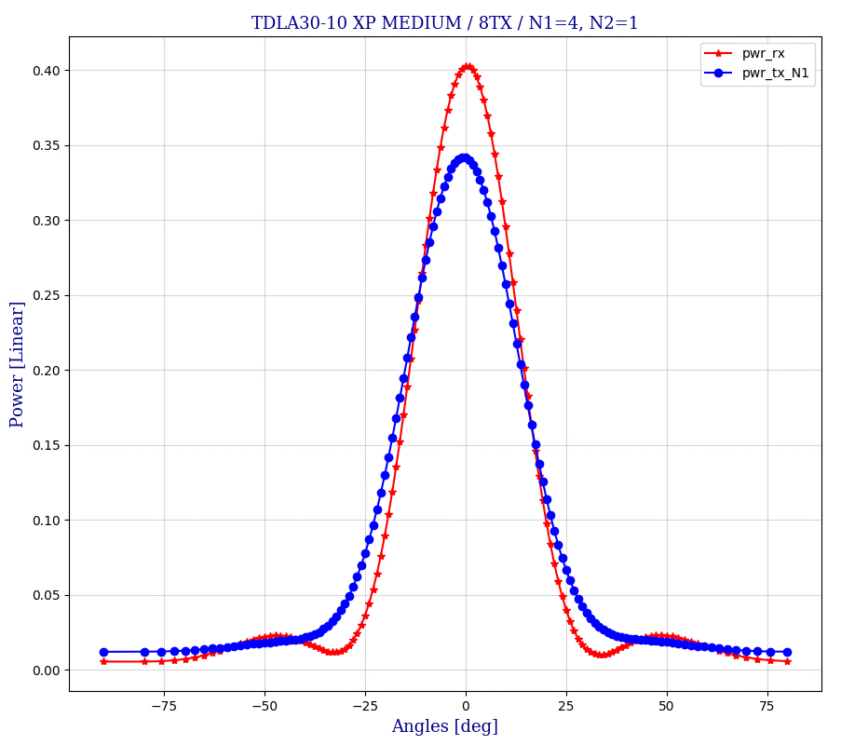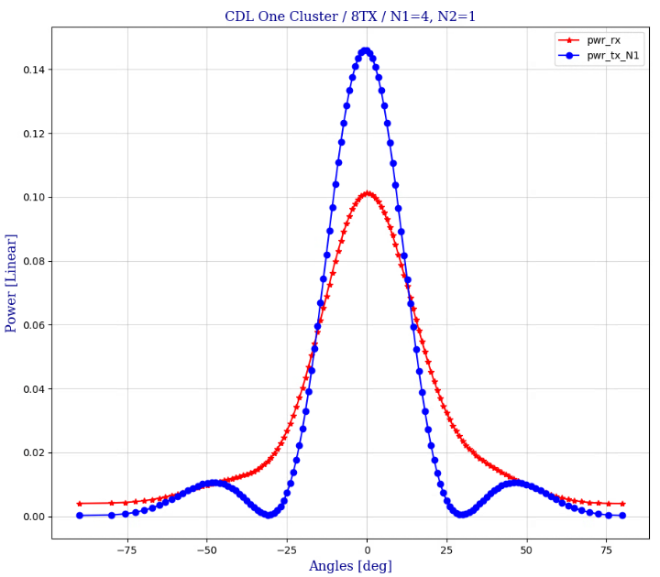
- (b)
Figure 5-1: Spatial selectivity of X-pol correlated TDL channel (a) and single-cluster CDL channel (b).

5.2.2 Multi-cluster TDL channel via TX-RX beam steering
The multi-cluster TDL channel model re-uses and extends the concept of beam steering that has earlier been specified for RAN4 PMI reporting tests ([X] TS 38.101-4: B.2.3.2.3 and B.2.3.2.3A). In TX-RX beam steering, the average AOA and AOD present in a correlated TDL MIMO channel are shifted to desired directions by post-processing. Note that beam steering is a part of the channel model, it is not an action taken by the transmitter or the receiver.
An example of multi-cluster channel is illustrated in Figure 5-2.
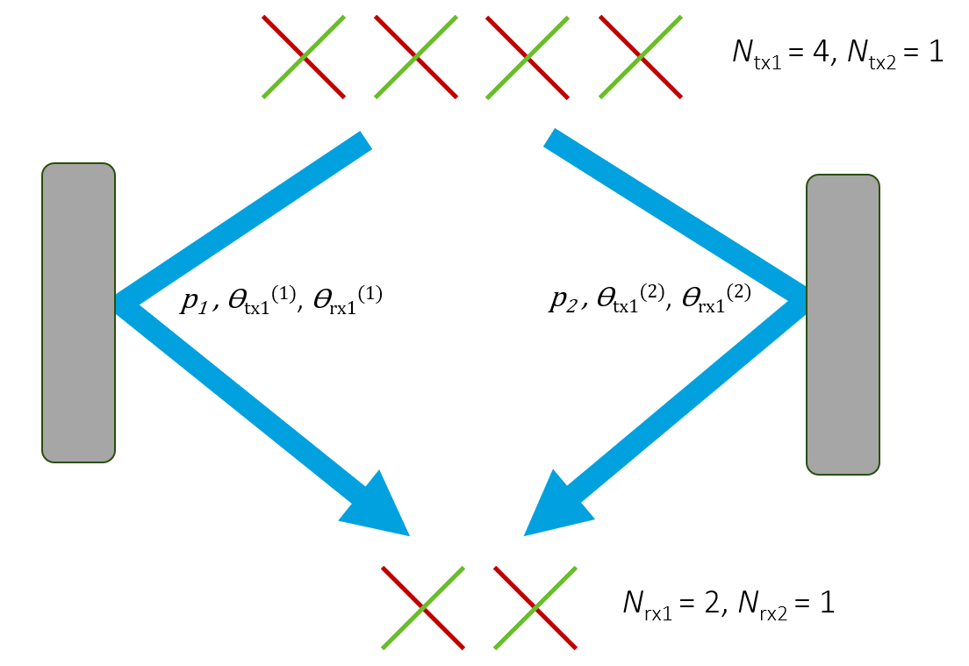
Figure 5-2: TX-RX beam steering channel with two spatial clusters.

The general channel model employs one or more statistically independent time-varying legacy TDL channel instances using some existing spatial correlation model. For the purpose of TX and RX beam steering, the delay taps of each TDL channel instance are split into spatial clusters. The delay taps in a spatial cluster are steered corresponding to common cluster-specific AOD/AOA angles. For mathematical notation, let n(k,m) denote the cluster index corresponding to delay tap m of TDL channel instance k.
The MIMO channel impulse response matrix with dimensions Nrx× Ntx at some time instant is
Hτ=k=1Km=1MPk∙pm∙Dn(k,m)(rx)Hk,mDn(k,m)(tx)∙δτ-τm
where
- k is the TDL channel instance index, m is the delay tap index, and τ is the delay variable
- K is the number of legacy TDL channel instances, and M is the number of delay taps in the TDL model
- pm is the power of delay tap m from the TDL power-delay profile, and Pk the power weight of TDL model instance k so that kmPk∙pm=1
- τm is the propagation delay of tap m
- Hk,m is the spatially correlated fading MIMO channel matrix of delay tap m of TDL channel instance k with unit average power response and dimensions Nrx× Ntx
- Dn(k,m)(rx) is the diagonal RX steering matrix of cluster n(k,m) with dimensions Nrx× Nrx
- Dn(k,m)(tx) is the diagonal TX steering matrix of cluster n(k,m) with dimensions Ntx× Ntx
- δτ is the Dirac delta function.
The implementation complexity of the channel model grows with the number of underlying TDL channel instances K. It is anticipated that one or two TDL channels is adequate for most testing purposes.

5.2.2.1 Steering matrices for cross-polarized antenna arrays
Steering parameters with cross-polarized (X-pol) antenna array assumption:
- gNB TX-array dimensions:
  - Ntx1 and Ntx2 are the number of antenna elements with the same polarization in the first and the second array dimension.
  - Ntx=2∙Ntx1∙Ntx2
- UE RX-array dimensions:
  - Nrx1 and Nrx2 are the number of antenna elements with the same polarization in the first and the second array dimension. Note that 3GPP X-pol model for TDL channels (TS 38.101-4 Annex B.2.3.2) supports only 1D RX-arrays: Nrx2=1.
  - Nrx=2∙Nrx1∙Nrx2
- TX phases: θtx1(n) and θtx2(n) per cluster n
- RX phases: θrx1(n) and θrx2(n) per cluster n
Steering matrix definitions:
- Dn(tx)=1001⊗Dθtx1(n),Ntx1⊗Dθtx2(n),Ntx2
- Dn(rx)=1001⊗Dθrx1(n),Nrx1⊗Dθrx2(n),Nrx2
- The steering matrix of size N× N as function of phase θ is defined as
  - Dθ,N=diag1ejθ⋯ejθ(N-1)
  - Assuming the antenna arrays employ uniform distance between elements in each linear dimension, the phase shift θ corresponds to AOA or AOD angle φ so that θφ,dλ=2π∙dλ∙sinφ, where d is the distance between adjacent antenna elements and λ is the carrier wavelength.
  - The steering phases θtx1(n), θtx2(n), θrx1(n), θrx2(n) may be specified either directly or by specifying the corresponding directional angles φtx1(n), φtx2(n), φrx1(n), φrx2(n).
The beam steering phases can be either constant or (slowly) time-varying. In general, the model parameters can be chosen to match the scope of each test case. For example, the number of clusters can be selected so that the desired number of layers (rank) is supported. Optionally, cluster-specific Doppler shifts can also be specified.

5.2.2.2 Cluster model example
An example parameterization of a four-cluster channel employing two TDLC channel instances is shown in Table 5-1. Here, the second TDLC channel instance is 9dB weaker than the first. Furthermore, delay taps 1-4 are grouped into one spatial cluster, and taps 5-12 into another cluster.
Assuming 8TX-8RX array setup with (Ntx1, Ntx2, Nrx1, Nrx2)= (4, 1, 4, 1), the steering phases both at TX and RX side are chosen so that the TX and RX beams become mutually orthogonal between clusters. Orthogonality between the beams maximizes the spatial multi-layer capacity of the channel for a given set of power weights.
The cluster power distribution also affects the spatial properties of the channel. For a set of orthogonal beams, assigning equal power for all clusters results in the highest channel capacity. The total power of a cluster depends on the power weight of the corresponding TDL channel instance, and on the sum power of the delay taps included in the cluster. Thus, the cluster power distribution can be adjusted by two different methods: by setting set the power weights and by splitting the delay taps into clusters so that a desired distribution is achieved.

Table 5-3: Cluster model with 2 TDL-C channel instances and 4 clusters
TDLC 300 / XP-high correlation |  |  | TX-RX beam steering
Tap | Delay (ns) | Tap power  (dB) | TDL channel 1  Power: 0 dB |  |  | TDL channel 2  Power: -9 dB
Tap | Delay (ns) | Tap power  (dB) | Cluster index | θtx1 | θrx1 | Cluster index | θtx1 | θrx1
1 | 0 | -6.9 | 1 | 0 | 0 | 3 | π | π
2 | 65 | 0
3 | 70 | -7.7
4 | 190 | -2.5
5 | 195 | -2.4 | 2 | -π/2 | -π/2 | 4 | π/2 | π/2
6 | 200 | -9.9
7 | 240 | -8.0
8 | 325 | -6.6
9 | 520 | -7.1
10 | 1045 | -13.0
11 | 1510 | -14.2
12 | 2595 | -16.0

6 Spatial Channel Modelling Approaches

6.1 SU PMI performance
This section provides comparison for different spatial channel modes with simulation assumptions captured in Table 6.1-2.
Table 6.1-2: Common simulation assumptions for PMI
Parameter |  |  | Unit | 8Tx
Bandwidth |  |  | MHz | 40
Subcarrier spacing |  |  | kHz | 30
Duplex Mode |  |  |  | TDD
TDD DL-UL configurations |  |  |  | 7D1S2U S=6D+4G+4U
Antenna configuration |  |  |  | 8 x 4  (N1,N2) = (4,1)
NZP CSI-RS for CSI acquisition | CSI-RS resource Type |  |  | Periodic
NZP CSI-RS for CSI acquisition | Number of CSI-RS ports (X) |  |  | 8
NZP CSI-RS for CSI acquisition | CDM Type |  |  | CDM4 (FD2, TD2)
NZP CSI-RS for CSI acquisition | Density (ρ) |  |  | 1
NZP CSI-RS for CSI acquisition | First subcarrier index in the PRB used for CSI-RS (k₀, k_{1,} k₂, k₃) |  |  | Row 8, (4,6)
NZP CSI-RS for CSI acquisition | First OFDM symbol in the PRB used for CSI-RS (l₀) |  |  | Row 8, (5)
NZP CSI-RS for CSI acquisition | CSI-RS  interval and offset |  | slot | 10, 1
cqi-FormatIndicator |  |  |  | Wideband
pmi-FormatIndicator |  |  |  | Not configured for eType II  Wideband for Type I
Sub-band Size |  |  | RB | 8
csi-ReportingBand |  |  |  | 11111111111111
Codebook configuration | Codebook Type |  |  | - typeII-r16  - typeI-SP
Codebook configuration | eType II CB config | paramCombination-r16 |  | 6  (L =4, p_{ν} =1/2, β=1/2 )
Codebook configuration | eType II CB config | R(numberOfPMISubbandsPerCQISubband-r16) |  | 1
Codebook configuration | (CodebookConfig-N1,CodebookConfig-N2) |  |  | (4,1)
Codebook configuration | (CodebookConfig-O1,CodebookConfig-O2) |  |  | (4,1)
Codebook configuration | CodebookSubsetRestriction |  |  | 0x FFFF
Codebook configuration | RI Restriction (typeII-RI-Restriction-r16) |  |  | Rank 2: 0010  Rank 4: 1000
Physical channel for CSI report |  |  |  | PUSCH
CQI/RI/PMI delay |  |  | ms | 7
Maximum number of HARQ transmission |  |  |  | 4
PDSCH & PDSCH DMRS Precoding configuration for random Precoding |  |  |  | Type I: Random and Follow PMI.  eType II: Folow PMI
Note: Use DM-RS based FOE and compensation.

Table 6.1-3: Simulation assumptions for CDL channel
Parameter |  | Value
 |  | Rank4 | Rank8
FR / Carrier frequency |  | FR1,3.5GHz
UE speed and movement direction |  | 3km/h, (65°,90°)
AAV assumptions |  | (M,N,P,Ms,Ns) = (1,2,2,1,1) | (M,N,P,Ms,Ns) = (1,4,2,1,1)
Channel Geometry | LCS UE | α = 180°, β=0°, γ = 0°
Channel Geometry | LCS gNodeB | α = 0°, β=10°, γ = 0°
Channel Geometry | GCS UE | Height = 1.5 m; Azimuth = 0; X Coordinate = 100 m
Channel Geometry | GCS gNodeB | Height = 25 m; Azimuth = 0; X Coordinate = 0 m
Channel Geometry | BS Antenna Polarisation | Cross Polarized antenna elements with +/-45 degrees polarization slant angles
Channel Geometry | BS Radiation Pattern | Defined Table 7.3-1 in TS 38.901
Channel Geometry | UE Antenna Polarisation | cross-polarized antenna elements with +90/0 degrees polarization slant angles
Channel Geometry | UE Antenna Radiation Pattern | Omnidirectional
Channel Geometry | Antenna Panel Placement | YZ Plane

For the CDL channel model, RAN4 models A2 channel model, CDL (TR 38.753) based on Table 7.7.1-3 in TR 38.901 without truncation and quantization. And A4 channel model, CDL (TR 38.753) based on Table 7.7.1-3 in TR 38.901 with truncation and quantization. B1 and B2 enhanced TDL channel model, the specific description can be found in the Annex B.
Table 6.1-3: AAV configurations
Options | Description
AAV 1Y | (16,8,2,8,1) for SU-MIMO eTypeII, for 32 Tx
AAV 1Y | (M,N,P,Ms,Ns) = (8,4,2,8,1) for 8Tx
AAV 3 | (M,N,P,Ms,Ns) = (1,4,2,1,1) for 8Tx

Full throughput curves as shown in the following Figure 6-1 to Figure 6-10.

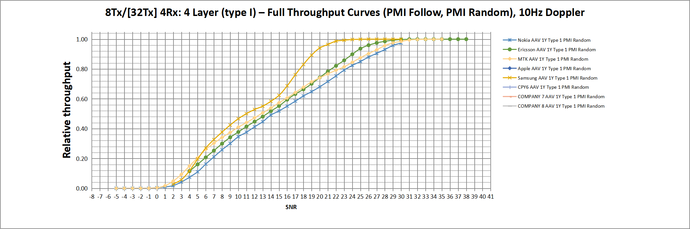
Figure 6-1. Full throughput curves for A2 channel model with AAV 1Y for 4 layer.

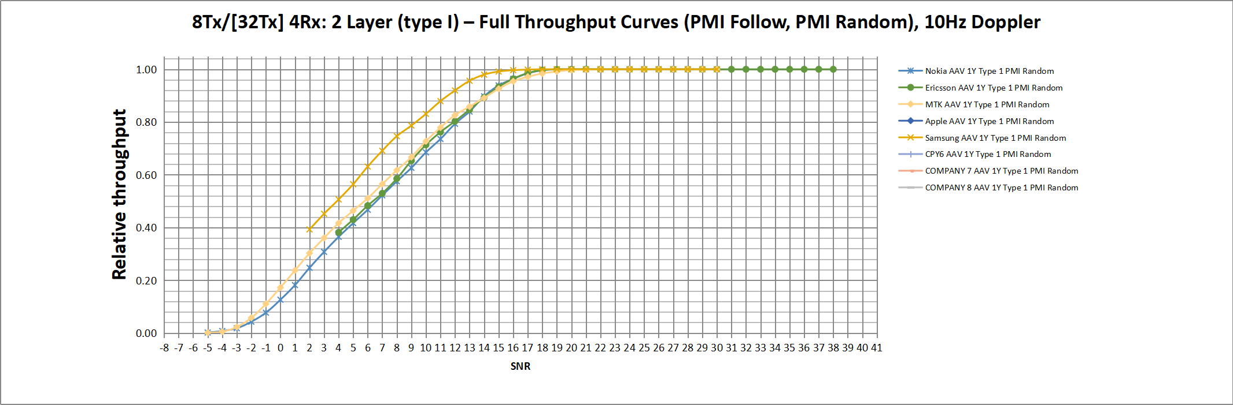
Figure 6-2. Full throughput curves for A2 channel model with AAV 1Y for 2 layer.

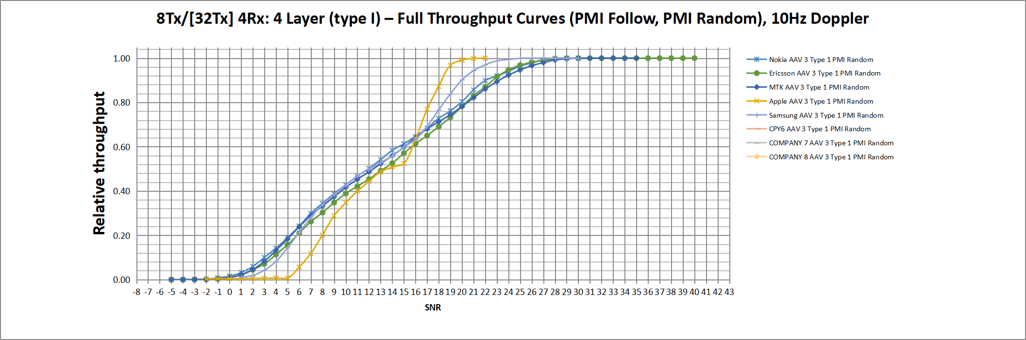
Figure 6-3. Full throughput curves for A2 channel model with AAV 3 for 4 layer.

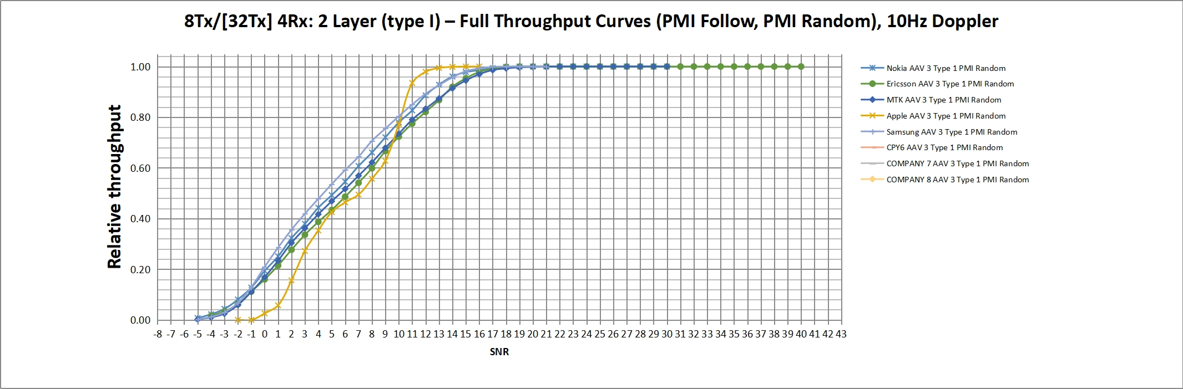
Figure 6-4. Full throughput curves for A2 channel model with AAV 3 for 2 layer.

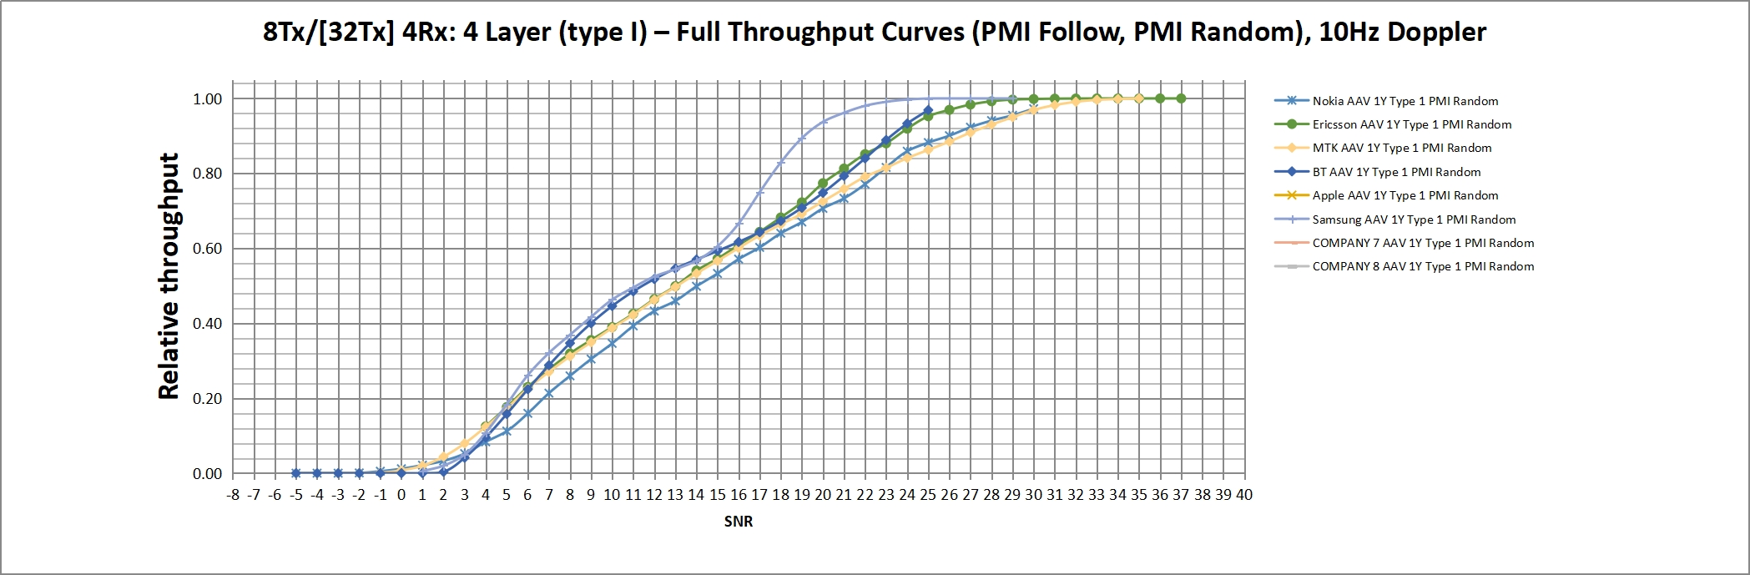
Figure 6-5. Full throughput curves for A4 channel model with AAV 1Y for 4 layer.
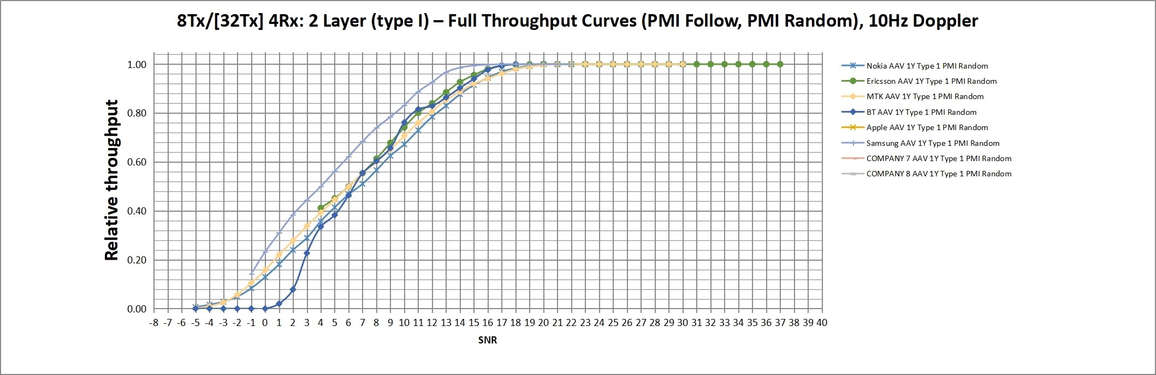
Figure 6-6. Full throughput curves for A4 channel model with AAV 1Y for 2 layer.

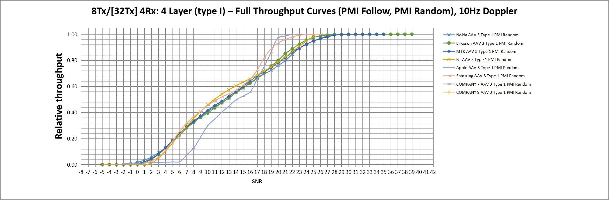
Figure 6-7. Full throughput curves for A4 channel model with AAV 3 for 4 layer.

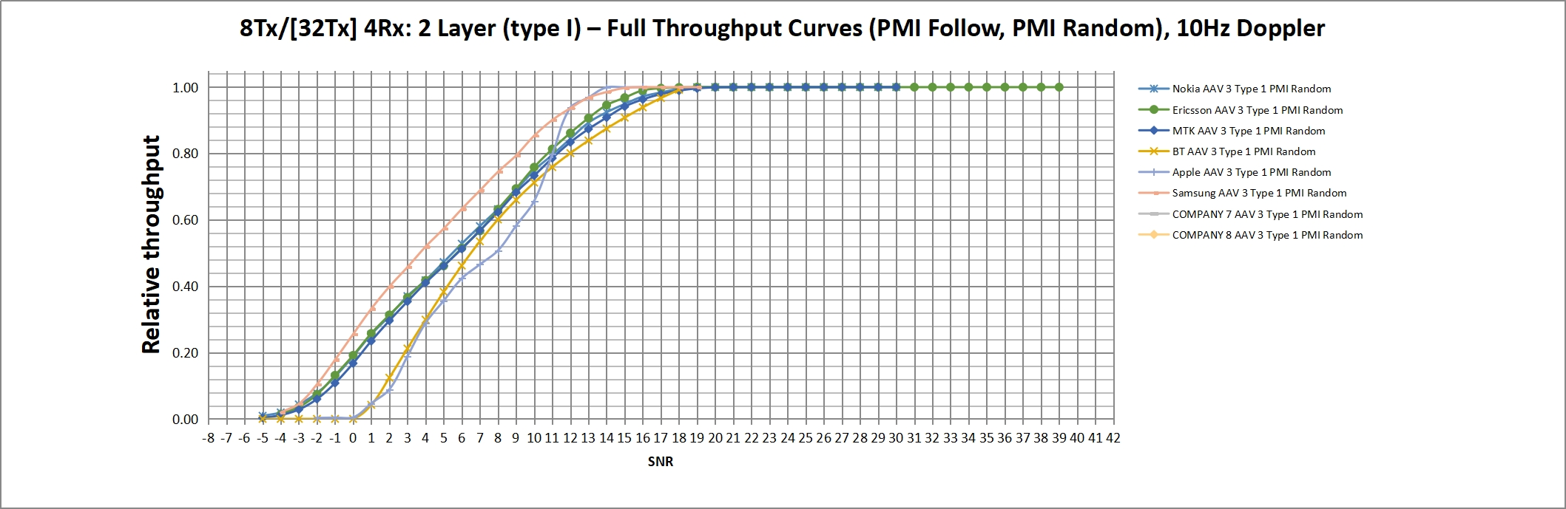
Figure 6-8. Full throughput curves for A4 channel model with AAV 3 for 2 layer.
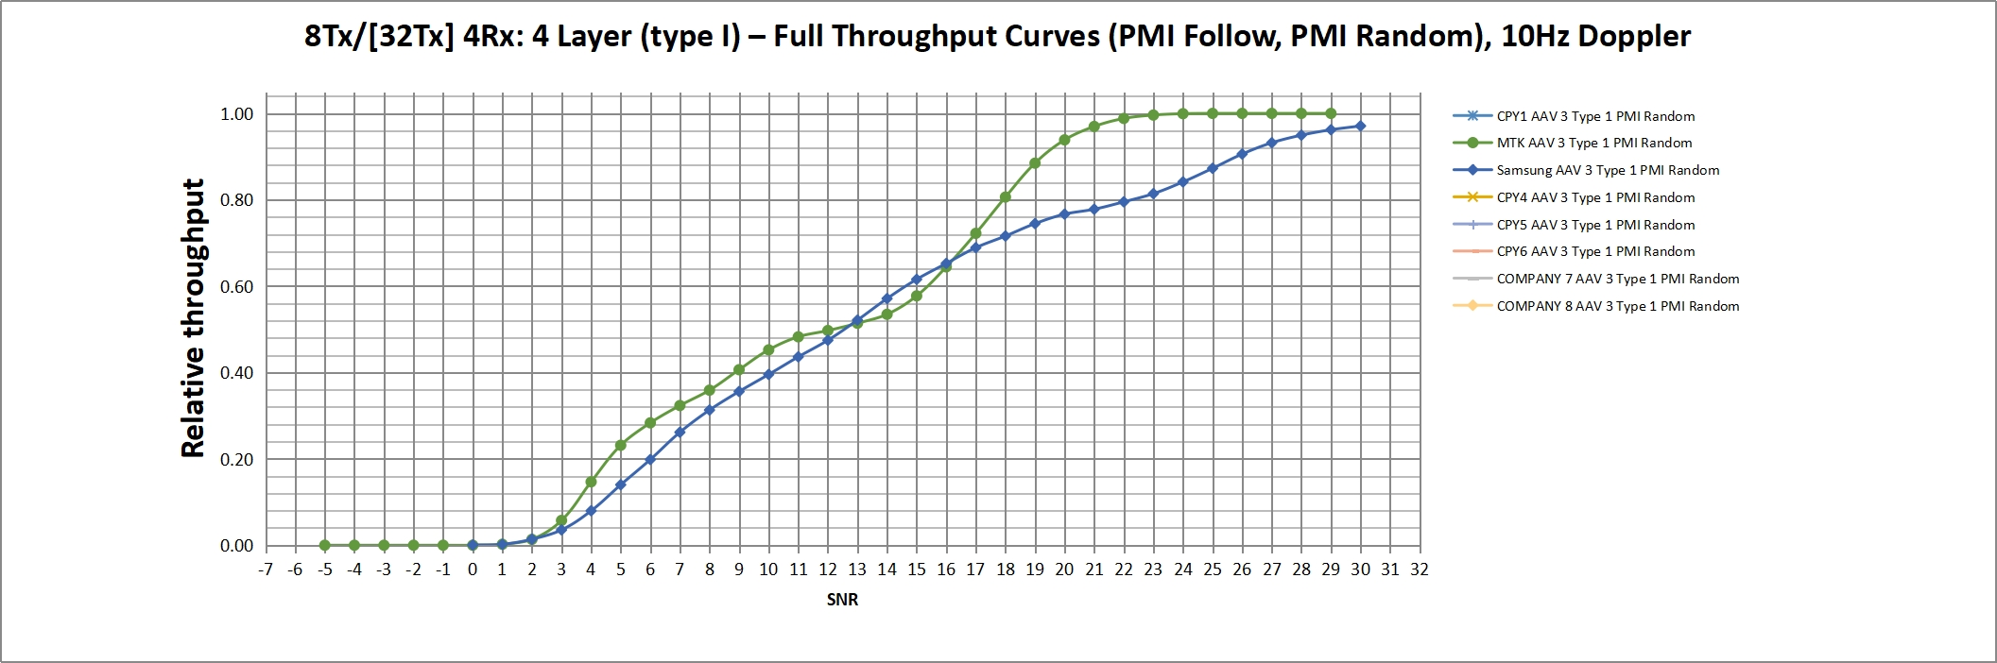
Figure 6-9. Full throughput curves for B1 channel model with AAV 3 for 4 layer.

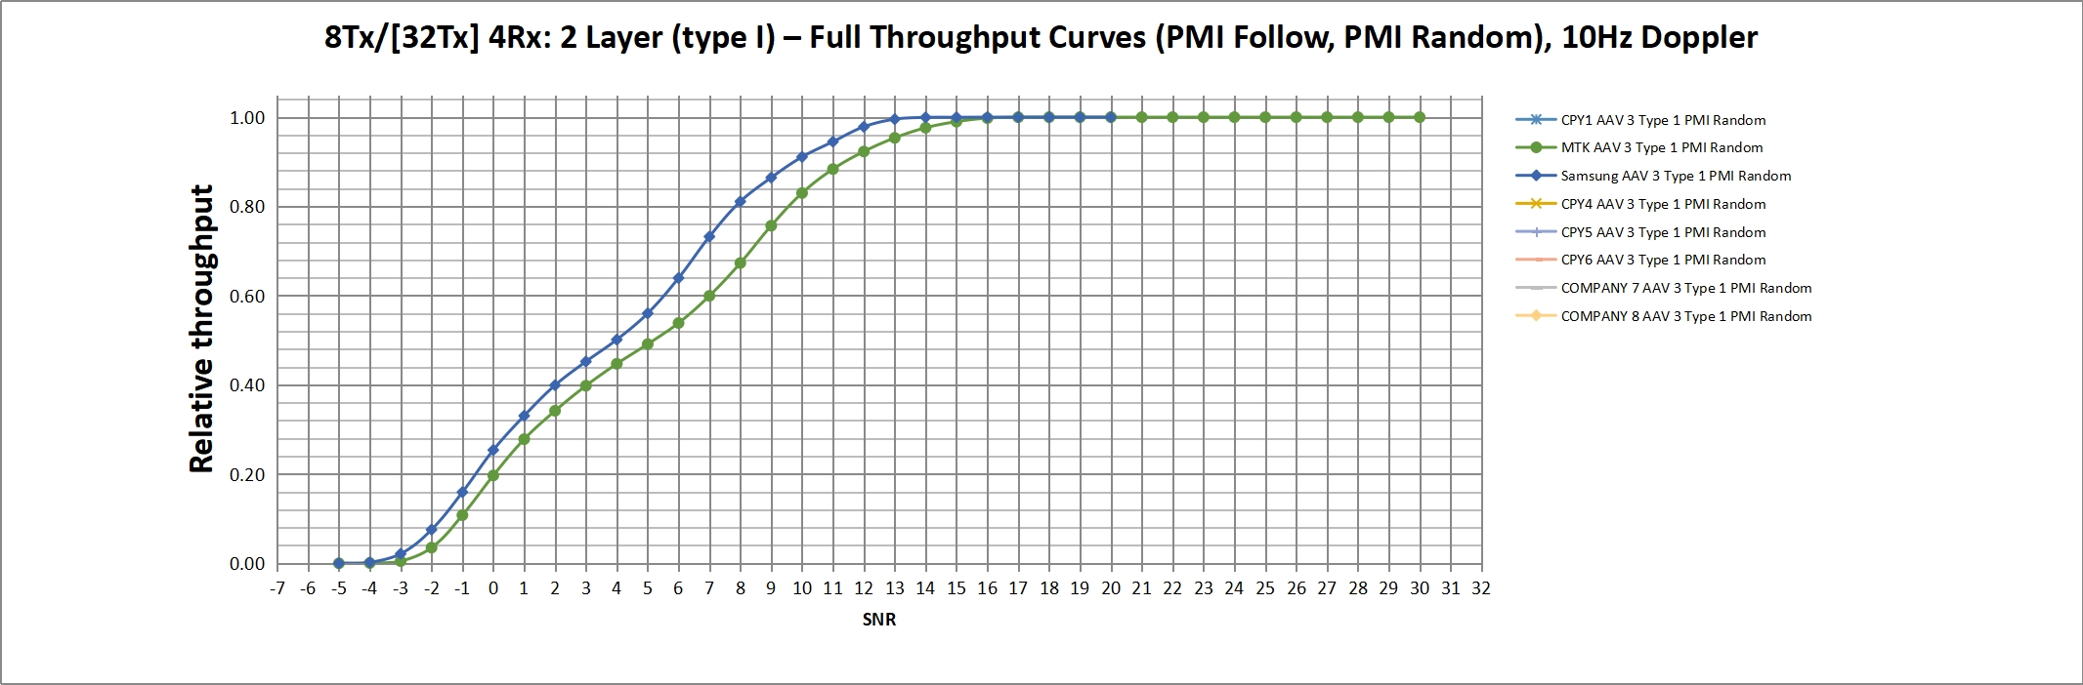
Figure 6-10. Full throughput curves for B1 channel model with AAV 3 for 2 layer.

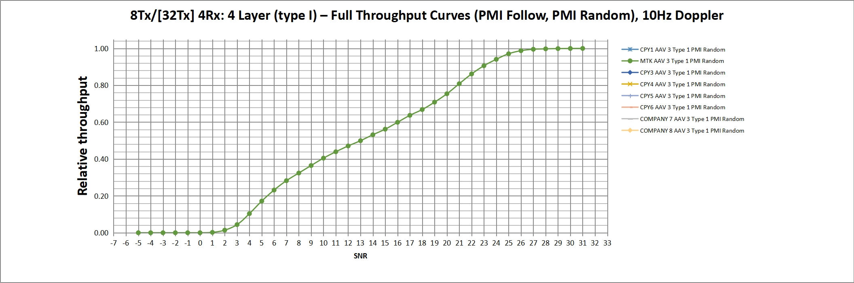
Figure 6-10. Full throughput curves for B2 channel model with AAV 3 for 4 layer.

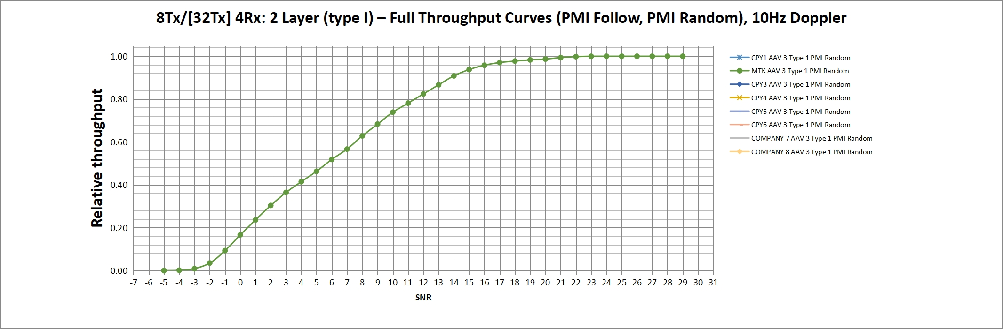
Figure 6-10. Full throughput curves for B2 channel model with AAV 3 for 2 layer.

Observation(TBA).

6.2 PDSCH performance under SU-MIMO scenario
This section provides comparison for different spatial channel models with common simulation assumptions captured in Table 6.2-1.
Table 6.2-1: Common Simulation Assumptions
Parameter |  |  | Value
Duplex mode |  |  | TDD
TDD Slot Configuration Pattern |  |  | 7D1S2U (PDSCH is not scheduled in S slot for Rank8)
Channel Bandwidth/SCS |  |  | 40MHz/30kHz
Rank |  |  | 8
Antenna configuration |  |  | 8T8R
MCS |  |  | 13 (64 QAM table)
Channel model |  |  | 4 TDL-C channel instances and 4 clusters (Table B-2)  1 TDL-C channel instance and 4 clusters (Table B-3)  2 TDL-C channel instances and 4 clusters (Table 5-3)  TDLC300-10 Low  TDLC300-10 Medium,XP  CDL channel model
Codebook configuration for PDSCH and DMRS |  | CodebookType | For CDL channel: Single Panel Type I;(i_{1,1}=i_{1,2}=i₂)=(4,0,0)  For TDL channel: Single Panel Type I; (i_{1,1}=i_{1,2}=i₂)=(0,0,0)
 |  | Codebook configuration | (N₁,N₂,O₁,O₂) = (4,1,4,1)
PDSCH configuration | Mapping type |  | Type A
PDSCH configuration | k0 |  | 0
PDSCH configuration | Starting symbol (S) |  | 2
PDSCH configuration | Length (L) |  | 12
PDSCH configuration | PDSCH aggregation factor |  | 1
PDSCH configuration | Resource allocation type |  | Type 0
PDSCH configuration | VRB-to-PRB mapping type |  | Non-interleaved
PDSCH configuration | VRB-to-PRB mapping interleaver bundle size |  | N/A
PDSCH DMRS configuration | DMRS Type |  | Type 1
PDSCH DMRS configuration | Number of additional DMRS |  | 1
PDSCH DMRS configuration | Maximum number of OFDM symbols for DL front loaded DMRS |  | 2
Number of HARQ Processes |  |  | 8
Maximum HARQ transmissions |  |  | 4
UE receiver type |  |  | MMSE-IRC
Test metric |  |  | Rank 4: SNR@70% of maximum throughput  Rank8: SNR(dB) @ 30% and 70% of max throughput for each codeword

Simulation assumptions for CDL channel specifically are captured in Table 6.2-2:
Table 6.2-2: Simulation assumptions for CDL channel
Parameter |  | Value
 |  | Rank8
FR / Carrier frequency |  | FR1,3.5GHz
UE speed and movement direction |  | 3km/h, (65°,90°)
AAV assumptions |  | - (M,N,P,Ms,Ns) = (1,2,2,1,1) | (M,N,P,Ms,Ns) = (1,4,2,1,1)
Channel Geometry | LCS UE | α = 180°, β=0°, γ = 0°
Channel Geometry | LCS gNodeB | α = 0°, β=10°, γ = 0°
Channel Geometry | GCS UE | Height = 1.5 m; Azimuth = 0; X Coordinate = 100 m
Channel Geometry | GCS gNodeB | Height = 25 m; Azimuth = 0; X Coordinate = 0 m
Channel Geometry | BS Antenna Polarisation | Cross Polarized antenna elements with +/-45 degrees polarization slant angles
Channel Geometry | BS Radiation Pattern | Defined Table 7.3-1 in TS 38.901
Channel Geometry | UE Antenna Polarisation | cross-polarized antenna elements with +90/0 degrees polarization slant angles
Channel Geometry | UE Antenna Radiation Pattern | Omnidirectional
Channel Geometry | Antenna Panel Placement | YZ Plane

Simulation results are captured in [R4-2507823]
Observations: TBD

7 Alignment of Spatial Channel Models
Simulation results and analysis of different test cases with different channel model are captured in chapter 6 for model comparison. The chapter 7 for alignment is to capture companies’ simulation results on agreed performance metric per channel model and also the span and average value of companies results.
The following alignment test cases are included in this chapter:
- FR1 SU-MIMO PDSCH 4Tx4Rx with 4 layers. The SNR of [30% and] 70% maximum throughput are captured. The detailed parameter assumptions can be found in Table 6.x.x.
- FR1 SU-MIMO PDSCH 8Tx8Rx with 8 layers. The SNR of [30% and] 70% maximum throughput per codeword are captured. The detailed parameter assumptions can be found in Table 6.x.x.
- FR1 SU-MIMO PMI 8Tx4Rx with 4 layers and Type-I codebook. The SNR of 70% and 90% maximum throughput are captured. The detailed parameter assumptions can be found in Table 6.x.x.
- FR1 SU-MIMO PMI 8Tx4Rx with 4 layers and eType-II codebook. The SNR of 70% and 90% maximum throughput are captured. The detailed parameter assumptions can be found in Table 6.x.x.

There are two CDL based models and two TDL based models are captured for alignment simulation.
- CDL option 1: The model has 20 clusters which is derived based on Table 7.7.1-3 in TR 38.901 without cluster truncation. The model profile is in Table [X-Y1].
- CDL option 2: The model has 12 clusters which is derived based on CDL option 1 with further cluster truncation. The model profile is in Table [X-Y2].
- Enhanced TDL option 1: The model description is in Table [X-Y3].
- Enhanced TDL option 2: The model description is in Table [X-Y4].

The BS antenna configuration for CDL alignment is one antenna element per subarray.
- 4Tx case: (M, N, P, Ms, Ns) = (1, 2, 2, 1, 1).
- 8Tx case: (M, N, P, Ms, Ns) = (1, 4, 2, 1, 1).

The Doppler shift configurations are 3km/h for CDL based models and 10Hz for TDL based models.

7.1 CDL option 1 results alignment

Table 7.1-1 Simulation result summary for FR1 SU-MIMO PDSCH 4Tx4Rx with 4 layers
SNR at Norm. Throughput [dB] | Source #1 | Source #2 | Source #3 | Source #4 | Source #5 | Source #6 | Average | Span
30%
70%

Table 7.1-2 Simulation result summary for FR1 SU-MIMO PDSCH 8Tx8Rx with 8 layers
SNR at Norm. Throughput [dB] |  | Source #1 | Source #2 | Source #3 | Source #4 | Source #5 | Source #6 | Average | Span
CW1 | 30%
CW1 | 70%
CW2 | 30%
CW2 | 70%

Table 7.1-3 Simulation result summary for FR1 SU-MIMO PMI 8Tx4Rx with 4 layers
SNR at Norm. Throughput [dB] |  | Source #1 | Source #2 | Source #3 | Source #4 | Source #5 | Source #6 | Average | Span
Type-I | 70%
Type-I | 90%
eType-II | 70%
eType-II | 90%

[Observations TBA]

7.2 CDL option 2 results alignment

Table 7.2-1 Simulation result summary for FR1 SU-MIMO PDSCH 4Tx4Rx with 4 layers
SNR at Norm. Throughput [dB] | Source #1 | Source #2 | Source #3 | Source #4 | Source #5 | Source #6 | Average | Span
30%
70%

Table 7.2-2 Simulation result summary for FR1 SU-MIMO PDSCH 8Tx8Rx with 8 layers
SNR at Norm. Throughput [dB] |  | Source #1 | Source #2 | Source #3 | Source #4 | Source #5 | Source #6 | Average | Span
CW1 | 30%
CW1 | 70%
CW2 | 30%
CW2 | 70%

Table 7.2-3 Simulation result summary for FR1 SU-MIMO PMI 8Tx4Rx with 4 layers
SNR at Norm. Throughput [dB] |  | Source #1 | Source #2 | Source #3 | Source #4 | Source #5 | Source #6 | Average | Span
Type-I | 70%
Type-I | 90%
eType-II | 70%
eType-II | 90%

[Observations TBA]

7.3 Enhanced TDL option 1 results alignment

Table 7.3-1 Simulation result summary for FR1 SU-MIMO PDSCH 4Tx4Rx with 4 layers
SNR at Norm. Throughput [dB] | Source #1 | Source #2 | Source #3 | Source #4 | Source #5 | Source #6 | Average | Span
30%
70%

Table 7.3-2 Simulation result summary for FR1 SU-MIMO PDSCH 8Tx8Rx with 8 layers
SNR at Norm. Throughput [dB] |  | Source #1 | Source #2 | Source #3 | Source #4 | Source #5 | Source #6 | Average | Span
CW1 | 30%
CW1 | 70%
CW2 | 30%
CW2 | 70%

Table 7.3-3 Simulation result summary for FR1 SU-MIMO PMI 8Tx4Rx with 4 layers
SNR at Norm. Throughput [dB] |  | Source #1 | Source #2 | Source #3 | Source #4 | Source #5 | Source #6 | Average | Span
Type-I | 70%
Type-I | 90%
eType-II | 70%
eType-II | 90%

[Observations TBA]

7.4 Enhanced TDL option 2 results alignment

Table 7.4-1 Simulation result summary for FR1 SU-MIMO PDSCH 4Tx4Rx with 4 layers
SNR at Norm. Throughput [dB] | Source #1 | Source #2 | Source #3 | Source #4 | Source #5 | Source #6 | Average | Span
30%
70%

Table 7.4-2 Simulation result summary for FR1 SU-MIMO PDSCH 8Tx8Rx with 8 layers
SNR at Norm. Throughput [dB] |  | Source #1 | Source #2 | Source #3 | Source #4 | Source #5 | Source #6 | Average | Span
CW1 | 30%
CW1 | 70%
CW2 | 30%
CW2 | 70%

Table 7.4-3 Simulation result summary for FR1 SU-MIMO PMI 8Tx4Rx with 4 layers
SNR at Norm. Throughput [dB] |  | Source #1 | Source #2 | Source #3 | Source #4 | Source #5 | Source #6 | Average | Span
Type-I | 70%
Type-I | 90%
eType-II | 70%
eType-II | 90%

[Observations TBA]

8 Conclusions

8.1 General
This TR has developed spatial channel models for RAN4 demodulation performance requirements, that may be used in future 3GPP work items for defining performance requirements [and have been able to produce repeatable and consistent spatial effects].
<further sub-clauses will collect unanimous conclusions on both the alignment and comparison outcomes for the SCM candidates and legacy channel model, and capture any agreements of channel models to be used in future requirements derivation>

Annex A: Channel Measurements
During SCM channel measurements have been provided to demonstrate properties of sample MIMO channels from operational networks. This section summarises contributed material, observations and conclusions.
For ease of reference, Table 1 below lists and summarizes some contributions to the study to date, and relevant channel properties reported.
Tdoc number | Channel properties reported | Observations
R4-2402277, Sec. 2.5 | Singular value distributions of measured 4x4 MIMO channels | Variability in the quality of spatial layers observed.
R4-2411557 | Long-term stability of singular values, cross-polarisation discrimination | Variations in channel eigenmodes characterised, long-term stability consistent with expected behaviour in a measurement scenario is observed.
R4-2415673 | Power delay profile | The power delay profiles from reflections of the transmitted reference signals exhibit stability across time (~250ms in this specific measurement sample) for static scenarios
R4-2419338 | Angle of Arrival | MIMO radio channels for stationary UE in typical deployments exhibit multiple long-term stable spatial directions of arrivals
R4-2501745 | Eigenmodes for 32x4 channels from commercial deployments; Angular spread | In typical MIMO deployments, dominant eigenmodes remain within a narrow high-gain range, while weaker eigenmodes are more spread out, leading to performance disparities among codewords
R4-2504431 | PMI statistics for sample measured 32x4 channels | The UE's preference for a specific PMI subset is observed in measured MIMO channels from typical deployments

A.1 Measurement Configurations
Results were provided based on two sets of measurement campaigns for:
- a 4-port transmitter and a 4-port receiver system, and
- a 4-port transmitter and a 32-port receiver.

A.1.1 Measurement campaign A: a 4-port transmitter and a 4-port receiver system
The MIMO channel measurements were conducted using a typical commercial MIMO deployment using a base station with 4 transceiver ports and receiving equipment with 4 ports. Measurements were conducted in a 15MHz channel at 2162.2MHz centre frequency, over several locations in a campus-type environment shown in Figure 1. Reported samples were collected in static positions during office hours, with some movement of people and vehicles in the coverage sector, yet not in the immediate vicinity of the measurement setup. More detailed information on the measurement setup, similar to the one utilized in results presented here, can be found in [4].
The output of the measurements were complex channel gains per transmitter and receiver port pair (the H matrices), including all system gains and losses. Noise power was estimated at the receiving equipment, while the transmitter power setting was 15 dBm per resource element (15 kHz subcarrier spacing).

A.1.2 Measurement campaign B: a 4-port transmitter and a 32-port receiver
Uplink sounding reference signals (SRS) were used for evaluation of respective MIMO channel between a typical commercial MIMO base station and a UE. Measurements were conducted using a 40MHz channel in n78 band (3680 – 3720 MHz) in four locations A to D shown in [Figure 1B]. The output of the measurements were complex channel gains per transmitter and receiver port pair (the H matrices), including all system gains and losses. Noise power was estimated at the receiving equipment, while the transmitter power setting was 15 dBm per resource element (15 kHz subcarrier spacing).

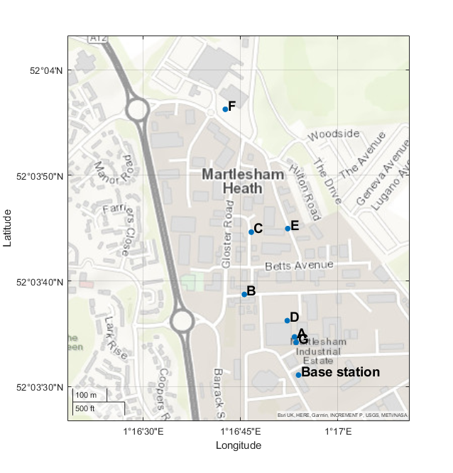
[Figure 1A]. Measurement point locations for the sample MIMO channels from a typical 4T4R base station for measurement campaign A.
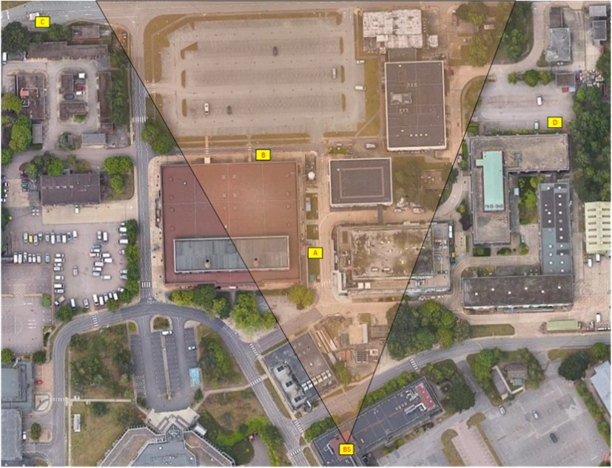
[Figure 1B]. Measurement point locations for the sample MIMO channels measurement campaign B.

A.2 Measurement Results
Analysis of sample MIMO channel measurements was provided covering following channel properties:
- Channel Eigenmodes
- Power Angular Distribution
- Time Coherence
- Frequency Coherence
- PMI Preference

A.2.1 Channel Eigenmodes
Histograms in [Figure 2] illustrate the distribution of singular values of measured MIMO channels in locations B and D, in conditions outlined above.

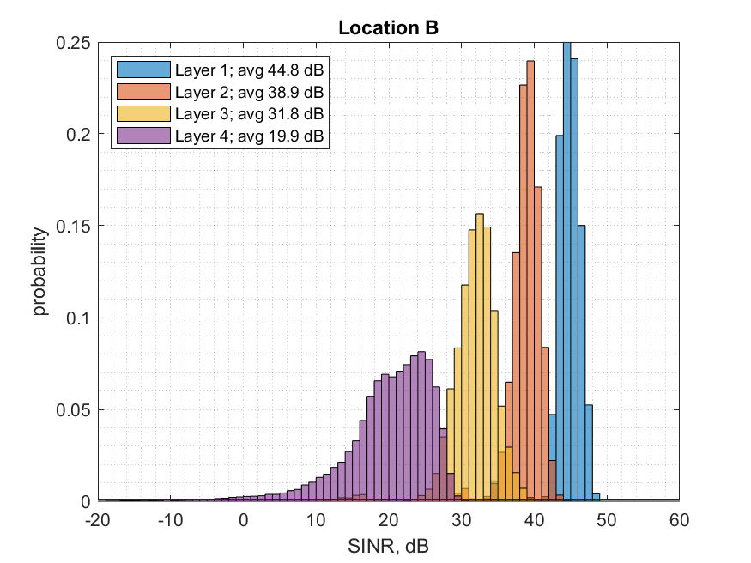 | 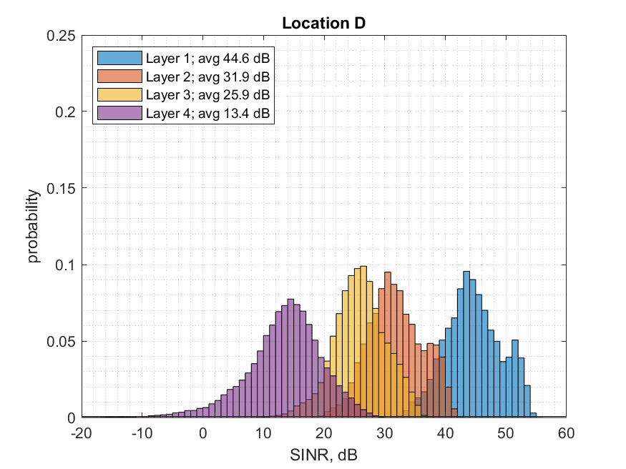
[Figure 2.] Measurement campaign A. Histograms of the SINR assuming SVD precoding and combining for measurement locations with a strong line of sight (B), and for non-line of sight position (D)
[Table 2] below summarises the relative channel “eigenmode” gains for the set of sample measurements.
[Table 2.] Average eigenmode gains relative to the strongest spatial preference per measurement location
Location | Average gain relative strongest eigenmode, dB
Location | Eigenmode 2 | Eigenmode 3 | Eigenmode 4
A | -4.85 | -20.70 | -33.18
B | -5.84 | -12.94 | -24.38
C | -7.48 | -15.71 | -27.86
D | -12.74 | -18.65 | -30.67
E | -7.92 | -14.89 | -24.89
F | -7.84 | -15.17 | -27.00
G | -7.91 | -18.58 | -31.92
Average | -7.80 | -16.66 | -28.56

Empirical CDFs of eigenmodes for Measurement campaign B are provided in [Figure 3].

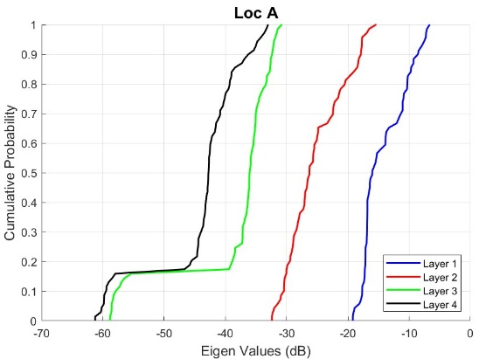 | 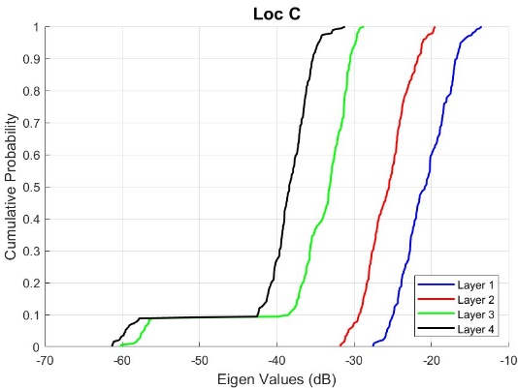
[Figure 3]. Empirical CDF of Eigen Modes for Locations A and C.
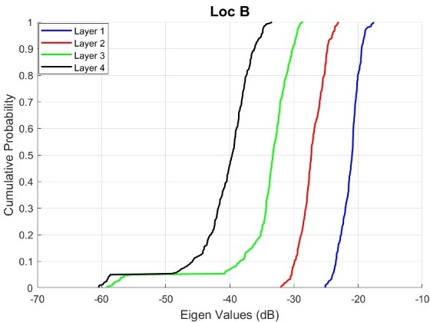 | 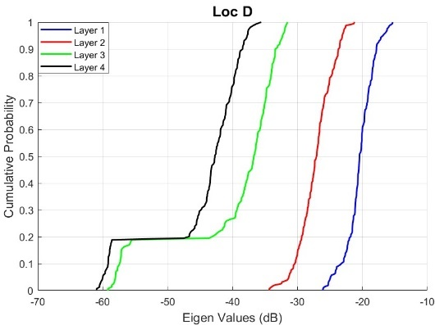
[Figure 3]. Empirical CDF of Eigen Modes for Locations B and D.

A.2.3 Power Angular Distribution
Spatial properties were analysed based on measurement campaign B
Angle of Arrival stability
[Figures 4 and 5] illustrate the estimated AoAs over time. In this analysis, the focus was on exploring whether MIMO channels in typical field deployments have long-term stable spatial preferences. Presence of three dominant arrivals was assumed and a simple implementation of MUSIC algorithm was applied to measured MIMO channel matrices.
<<<Editor Note: The remainder of R4-2507826 causes errors in the overall TR – request to be revised for RAN4#116>>>

Annex B: Modelling execution for CDL Channel Models

B.1 Introduction
[Unless otherwise specified, the procedure below is applied to all CDL models studied in this TR.
Parameters including for example as:
- CDL Tables
- Antenna Panel Configuration
- Antenna Array Virtualizer
are left up to the CDL model configuration.]

Step 0: Definition of all indices, coordinate system, etc etc
[TBD]

B.2 [Common Execution steps to all CDL models]
Step 1: Set environment, network layout, antenna array parameters
[a) Give number of BS and UT
c) Give 3D locations of BS and UT, and determine LOS AOD (ϕ_{LOS,AOD}), LOS ZOD (θ_{LOS,ZOD}), LOS AOA (ϕ_{LOS,AOA}), and LOS ZOA (θ_{LOS,ZOA}) of each BS and UT in the global coordinate system
f) Give speed and direction of motion of UT in the global coordinate system
g) Specify system centre frequency and bandwidth
h) Specify CDL Table (includes already Angular spread and scaling)
Step 2: Spatial Filtering: use Antenna Array Virtualization procedure to obtain the BS and UT antenna field patterns F_{rx} and F_{tx} in the global coordinate system and array geometries
The antenna panel is composed by antenna elements arranged in columns and rows, single or dual polarized, and can be split in subarrays. One subarray is a unique set of co-polarized antenna elements mapped exclusively to one antenna port through a virtualizer (set of complex values).
The antenna panel configuration is defined as (M,N,P,Ms,Ns), according to the description below:
- M is the number of antenna elements per panel with the same polarization in each column (vertical size)
- N is the number of antenna elements per panel with the same polarization in each row (horizontal size)
- P is the number of polarizations
- Ms is the number of antenna elements per subarray with the same polarization in each column (vertical size)
- Ns is the number of antenna elements per subarray with the same polarization in each row (horizontal size)

[Include here cluster power equations for spatial filtering based on AAV, and expression of Alpha (for AAV response)]
Step 3: Couple rays within the cluster for both azimuth and elevation according to fixed coupling
[add an explanation here]
Step 4: Compute cross polarization power ratio
The linear cross polarization power ratios (XPR)   are calculated for each ray m of each cluster n as
,
where X is the per-cluster XPR in dB from Tables 7.7.1-1 – 7.7.1-5 of TR38.901.
Step 5: Set the fixed initial phases for each ray in the cluster
[ TBD whether we include here the table or an explanation ]
Step 6: Generate channel coefficients for each cluster n and each receiver and transmitter element pair u, s.
Hu,s,nNLOSt=PnMm=1Mne=1Neme=1MeFrx,u,θθn,m,ZOA,φn,m,AOAFrx,u,φθn,m,ZOA,φn,m,AOATexpjΦmθθκn,m-1expjΦmθϕκn,m-1expjΦmϕθexpjΦmϕϕFtx,s,me,ne,θθn,m,ZOD,φn,m,AODFtx,s,me,ne,φθn,m,ZOD,φn,m,AOD
αs,me,neexpjΦn,mexpj2πrrx,n,mT.drx,uλ0expj2πrtx,n,mT.dtx,s,me,neλ0expj2πrrx,n,mT.vλ0t
Note that the patterns are given in the GCS and therefore include transformations with respect to antenna orientation. is the spherical unit vector with azimuth arrival angle ϕ_{n,m,AOA} and elevation arrival angle θ_{n,m,ZOA}, given by
,
where n denotes a cluster and m denotes a ray within cluster n. is the spherical unit vector with azimuth departure angle ϕ_{n,m,AOD} and elevation departure angle θ_{n,m,ZOD}, given by
,
where n denotes a cluster and m denotes a ray within cluster n. Also, is the location vector of receive antenna element u and is the location vector of transmit antenna element s, _{n,m} is the cross polarisation power ratio in linear scale, and ₀ is the wavelength of the carrier frequency. If polarisation is not considered, the 2x2 polarisation matrix can be replaced by the scalar and only vertically polarised field patterns are applied.
The Doppler frequency component depends on the arrival angles (AOA, ZOA), and the UT velocity vector with speed v, travel azimuth angle ϕ_{v}, elevation angle θ_{v} and is given by

B.3 Derivation of CDL Models for RAN4 Demod
[This section will contain a step by step procedure on how to generate the R4 CDL tables according to agreed RAN4 procedure for cluster combining and reduction, starting from the RAN1 CDL tables in 38.901.
Intermediate result tables per each step will also be included]

Annex C: Modelling execution for TDL Channel Models

C.1 TDL Approaches

C.1.1 Multi-cluster TDL channel for 2-CW fixed-MCS testing
As one example, testing of two-codeword (up to 8 layers) MIMO demodulation – so that consistently different channel quality per CW is maintained – has turned out to be challenging with current RAN4 correlation models. This section presents examples how to construct PDSCH demodulation tests with fixed rank, fixed Type I PMI, and different fixed MCS per CW.

C.1.1.1 Example 1
For fixed PMI testing, the per-cluster phase shifts: θtx1(n) and θtx2(n) can be chosen to be fixed and to match the beams of the transmit PMI. In Type I codebook, each CW often maps to a subset of the orthogonal PMI-beams. This is illustrated below for the 5-layer precoder (TS 38.214: 5.2.2.2.1). Consequently, per-CW channel quality levels can be adjusted by adjusting the cluster-specific channel powers.
To minimize cross-layer/CW interference at the UE, the RX-phases θrx1(n) can be chosen so that the corresponding steering vectors are orthogonal. Alternatively, by choosing non-orthogonal RX steering vectors, cross-layer/CW interference can be increased if so desired. Finally, the selection of the X-pol spatial correlation model parameters (α₁, α₂, β) determines how strictly the mean spatial directions are maintained. Higher correlation is analogous to narrower angular spread per cluster.
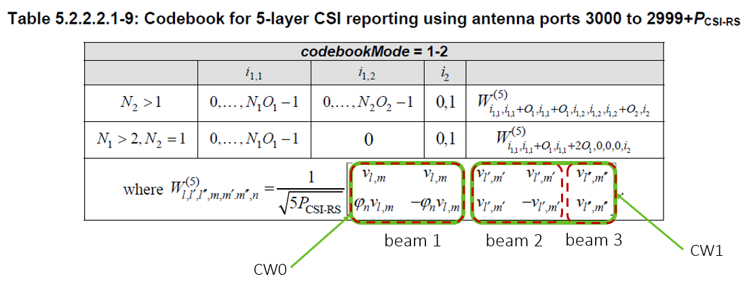
To demonstrate the concept, a rank 5 PDSCH setup as detailed in Table B-1 was simulated in the channel model defined in Table B-2. The results are depicted in Figure C-1. Here, CW0 employs 16QAM while CW1 has QPSK, but as clusters corresponding to CW0 are 6dB stronger, the BLER performances of the two CWs are almost on par. Thus, it can be concluded that CW-specific TX-RX beam steering clusters can effectively be used to scale CW-specific demodulation and decoding performance.
Table C-: Simulation setup
Antenna setup: N_{tx1}, N_{tx2}, N_{rx1}, N_{rx2} | 2, 2, 4, 1
Rank 5 Type1 TX-PMI: i_{1,1}, i_{1,2}, i₂  1st dim PMI beam indexes: l, l’, l”  2nd dim PMI beam indexes: m, m’, m” | 0, 0, 0  0, O₁, O₁ => phase 2πl/O₁N₁ = 0, π, π  0, 0, O₂ => phase 2πm/O₂N₂ = 0, 0, π
MCS / CW0  MCS / CW1 | MCS13, 16-QAM, code rate 0.48  MCS7, QPSK, code rate 0.51

Table C-2: Cluster model with 3 TDL-A channel instances and 3 clusters
TDLA-30  delay profile  10Hz Doppler  XP-high correlation | TX-RX beam steering
TDLA-30  delay profile  10Hz Doppler  XP-high correlation | TDL channel 1 / cluster 1  Power: 0 dB |  |  | TDL channel 2 / cluster 2  Power: -6 dB |  |  | TDL channel 3 / cluster 3  Power: -6 dB
TDLA-30  delay profile  10Hz Doppler  XP-high correlation | θtx1 | θtx2 | θrx1 | θtx1 | θtx2 | θrx1 | θtx1 | θtx2 | θrx1
TDLA-30  delay profile  10Hz Doppler  XP-high correlation | 0 | 0 | 0 | -π | 0 | π/2 | -π | -π | π

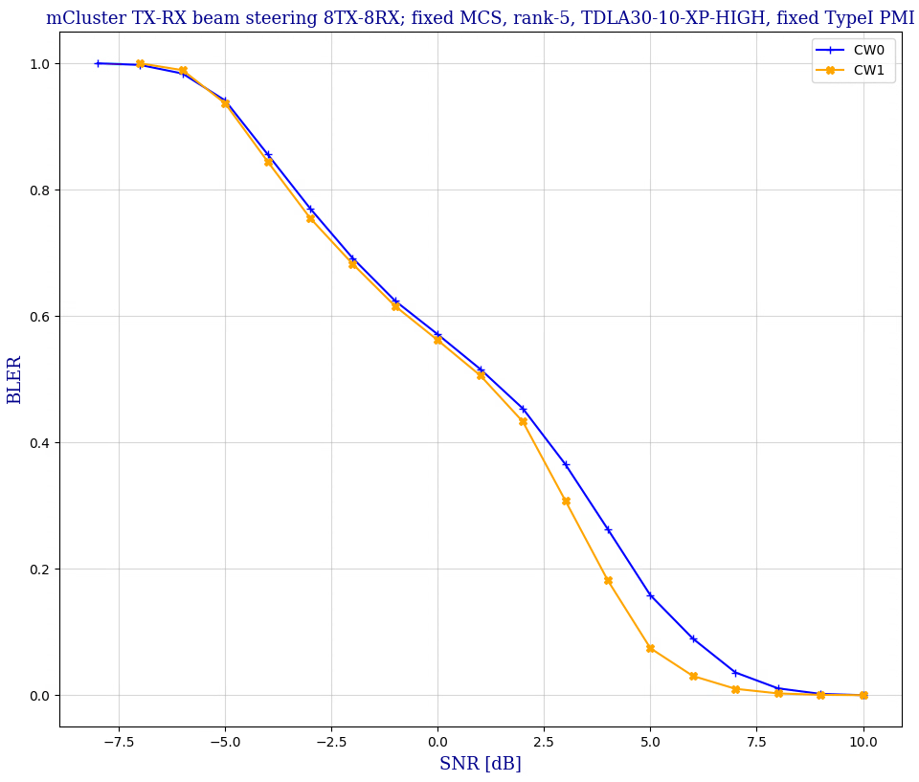
Figure C-1: 2-CW fixed MCS case in three-cluster TDL-A channel.

C.1.1.2 Example 2
A model with just one TDL channel instance can also satisfy the 2-CW fixed MCS testing requirements by setting mapping relation between clusters and taps to control the 2CWs power and delay difference in the reasonable level. Take channel model in Table C-3 as an example, where cluster 3 and cluster 4 correspond to last four taps, leading to large power and delay difference with cluster 1 and 2. Specific precoder mapping the 1st CW to first two clusters and 2nd CW to second two clusters leads to large SINR difference between two CWs. In the case, different MCSs could be configured to match performance difference.
Table C-3: Cluster model one TDL channel instance and 4 clusters
TDLC-300 / XP-high / 100Hz Doppler |  |  | TX-RX beam steering
Tap | Delay (ns) | Tap power  (dB) | Cluster index | θtx1 | θrx1
1 | 0 | -6.9 | 1 | 0 | 0
2 | 65 | 0 | 1 | 0 | 0
3 | 70 | -7.7 | 2 | -π/2 | -π/2
4 | 190 | -2.5 | 2 | -π/2 | -π/2
5 | 195 | -2.4 | 2 | -π/2 | -π/2
6 | 200 | -9.9 | 2 | -π/2 | -π/2
7 | 240 | -8.0 | 2 | -π/2 | -π/2
8 | 325 | -6.6 | 2 | -π/2 | -π/2
9 | 520 | -7.1 | 3 | -π | -π
10 | 1045 | -13.0 | 3 | -π | -π
11 | 1510 | -14.2 | 4 | π/2 | π/2
12 | 2595 | -16.0 | 4 | π/2 | π/2

A simulation is performed to verify the characteristic with simulation assumptions captured in table C-4. Rank 8 is assumed it can be seen that with fixed precoder i_{1,1}=i_{1,2}=i₂=0, Single panel I, 2nd cluster and 3rd cluster are mapped to last four taps with low power and large delay, leading to big performance difference between two codewords.
Table C-4: Simulation setup
Parameters | Values
Antenna setup: N_{tx1}, N_{tx2}, N_{rx1}, N_{rx2} | (4,1,4,1) for 8TX-8RX (1-dimensional antenna arrays)
Precoder | Type I Single panel, Fixed precoder i_{1,1}=i_{1,2}=i₂=0
Rank | 8
MCS | 13

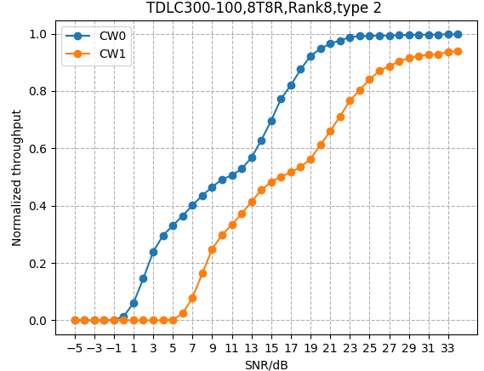
Figure C-2: 2-CW fixed MCS case in four-cluster TDL-C channel

Annex D: MU-MIMO (Informative)
The study of SCM for MU MIMO scenarios was part of the initial WID and interest in this aspect was voiced by a number of contributors, including operators. MU MIMO has not been part of the alignment or comparison discussions, however comments and proposals have been made, and discussions have been observed throughout the study.
The discussions highlighted two types of MU scenarios. Firstly, the legacy version with a single transmitter and a single receiver, hence necessitating creation of a single SU CDL channel and addition of MU interference via simultaneous transmission of two transport blocks using two precoders. Secondly, a version with a single transmitter and two receivers, hence necessitating creation of two single SU CDL channels (potentially with spatial consistency constraints on the both).
It was not concluded whether the "two receiver" version is useful and/or necessary for MU performance requirement derivation.
No agreement on SCM, implementation, alignment, usage in MU MIMO has been reached in this phase of SCM study.
Spatial channel models for MU-MIMO cases were evaluated based on the table Section 3 in [1].

Parameter |  | MU-MIMO PDSCH (FR1)
Duplex mode |  | TDD
TDD Slot Configuration Pattern |  | 7DS2U
FR / Carrier frequency |  | FR1 / 3.5 GHz
UE receiver type |  | IRC, E-IRC
Number of Tx Ports |  | 4
Number of Rx Ports/Antennas |  | 4
Number of layers |  | 2+2
PMI |  | UE1: Random  UE2: Random and not equal to UE1,  Orthogonal
Waveform |  | CP-OFDM with normal CP
Channel Bandwidth/SCS |  | 40MHz/30kHz
MCS |  | 13 (64 QAM table)
PDSCH configuration | Mapping type | Type A
PDSCH configuration | k0 | 0
PDSCH configuration | Starting symbol (S) | 2
PDSCH configuration | Length (L) | 12
PDSCH configuration | PDSCH aggregation factor | 1
PDSCH configuration | Resource allocation type | Type 0
PDSCH configuration | VRB-to-PRB mapping type | Non-interleaved
PDSCH configuration | VRB-to-PRB mapping interleaver bundle size | N/A
PDSCH DMRS configuration | DMRS Type | Type 1
PDSCH DMRS configuration | Number of additional DMRS | 1
PDSCH DMRS configuration | Maximum number of OFDM symbols for DL front loaded DMRS | 2 (for rank > 4)  1 (for rank <= 4)
Codebook configuration | CodebookType | type-I-SP
Codebook configuration | Codebook configuration | (N₁,N₂,O₁,O₂) = (2,1,4,1)
PDSCH DMRS Precoding Configuration |  | For Random precoding: for every PRB Bundle (size=2)
NZP CSI-RS for CSI acquisition | CSI-RS resource Type | Aperiodic
NZP CSI-RS for CSI acquisition | Number of CSI-RS ports (X) | TBD
NZP CSI-RS for CSI acquisition | Density (ρ) | 1
NZP CSI-RS for CSI acquisition | First OFDM symbol in the PRB used for CSI-RS (l0) | (13)
CQI/RI/PMI delay |  | N/A
Number of HARQ Processes |  | 8
Maximum HARQ transmissions |  | 4
Channel Models |  | The purpose of the study item.
Testing Metric |  | Full Throughput Curves
Channel Geometry (CDL) | LCS UE | α = 180°, β=0°, γ = 0°
Channel Geometry (CDL) | LCS gNodeB | α = 0°, β=10°, γ = 0°
Channel Geometry (CDL) | GCS UE | Height = 1.5 m; Azimuth = 0; X Coordinate = 100 m
Channel Geometry (CDL) | GCS gNodeB | Height = 25 m; Azimuth = 0; X Coordinate = 0 m
Channel Geometry (CDL) | BS Antenna Polarisation | (+45, -45)
Channel Geometry (CDL) | BS Radiation Pattern | defined in TR38.901 Table 7.3-1.
Channel Geometry (CDL) | UE Antenna Polarisation | (0, 90)
Channel Geometry (CDL) | UE Antenna Radiation Pattern | Omnidirectional
Channel Geometry (CDL) | Antenna Panel Placement | YZ Plane

Annex <E> (informative):
Change history

Change history
Date | Meeting | TDoc | CR | Rev | Cat | Subject/Comment | New version
2024-10 | 3GPP RAN4#112-bis | R4-2415297 |  |  |  | Initial TR skeleton | 0.0.1
2025-05 | 3GPP RAN4#115 | R4-2506178 |  |  |  | Update | 0.1.0

