|  |  |
| --- | --- |
| 3GPP TR 38.768 V0.0.4 (2025-05) | |
| Technical Report | |
| 3rd Generation Partnership Project;  Technical Specification Group Radio Access Network;  NR;  Low NR Band Carrier Aggregation via Switching  (Release 19) | |
|  | |
|  |  |
|  | |
| The present document has been developed within the 3rd Generation Partnership Project (3GPP TM) and may be further elaborated for the purposes of 3GPP. The present document has not been subject to any approval process by the 3GPPOrganizational Partners and shall not be implemented. This Specification is provided for future development work within 3GPPonly. The Organizational Partners accept no liability for any use of this Specification. Specifications and Reports for implementation of the 3GPP TM system should be obtained via the 3GPP Organizational Partners' Publications Offices. | |

|  |
| --- |
|  |
| ***3GPP***  Postal address  3GPP support office address  650 Route des Lucioles - Sophia Antipolis  Valbonne - FRANCE  Tel.: +33 4 92 94 42 00 Fax: +33 4 93 65 47 16  Internet  https://www.3gpp.org |
| ***Copyright Notification***  No part may be reproduced except as authorized by written permission. The copyright and the foregoing restriction extend to reproduction in all media.  © 2025, 3GPP Organizational Partners (ARIB, ATIS, CCSA, ETSI, TSDSI, TTA, TTC).  All rights reserved.  UMTS™ is a Trade Mark of ETSI registered for the benefit of its members  3GPP™ is a Trade Mark of ETSI registered for the benefit of its Members and of the 3GPP Organizational Partners LTE™ is a Trade Mark of ETSI registered for the benefit of its Members and of the 3GPP Organizational Partners  GSM® and the GSM logo are registered and owned by the GSM Association |

Contents

Foreword 4

1 Scope 6

2 References 6

3 Definitions of terms, symbols and abbreviations 7

3.1 Terms 7

3.2 Symbols 7

3.3 Abbreviations 7

4 Low NR band aggregation scenarios 7

5 Switching time mask 8

5.1 Switching periods 8

5.2 Switching period location 8

5.2.1 General 8

5.2.2 FDD to SDL switch 9

5.2.3 SDL to FDD switch 9

5.3 Time mask for switching 10

5.3.1 General 10

5.3.2 UL time mask 10

6 RRM aspects 11

6.1 General 11

6.2 Discussion of switching delay or interruption requirement 12

6.3 Discussion of SDL SCell related requirement 12

6.3.1 Activated SDL SCell L3 measurement requirement 12

6.3.2 Deactivated SDL SCell L3 measurement requirement 12

6.3.3 SDL SCell activation/deactivation requirement 12

6.3.4 SDL SCell L1 requirement 12

6.4 Discussion of impact on FDD PCell RRM 13

# Foreword

This Technical Report has been produced by the 3rd Generation Partnership Project (3GPP).

The contents of the present document are subject to continuing work within the TSG and may change following formal TSG approval. Should the TSG modify the contents of the present document, it will be re-released by the TSG with an identifying change of release date and an increase in version number as follows:

Version x.y.z

where:

x the first digit:

1 presented to TSG for information;

2 presented to TSG for approval;

3 or greater indicates TSG approved document under change control.

y the second digit is incremented for all changes of substance, i.e. technical enhancements, corrections, updates, etc.

z the third digit is incremented when editorial only changes have been incorporated in the document.

In the present document, modal verbs have the following meanings:

**shall** indicates a mandatory requirement to do something

**shall not** indicates an interdiction (prohibition) to do something

The constructions "shall" and "shall not" are confined to the context of normative provisions, and do not appear in Technical Reports.

The constructions "must" and "must not" are not used as substitutes for "shall" and "shall not". Their use is avoided insofar as possible, and they are not used in a normative context except in a direct citation from an external, referenced, non-3GPP document, or so as to maintain continuity of style when extending or modifying the provisions of such a referenced document.

**should** indicates a recommendation to do something

**should not** indicates a recommendation not to do something

**may** indicates permission to do something

**need not** indicates permission not to do something

The construction "may not" is ambiguous and is not used in normative elements. The unambiguous constructions "might not" or "shall not" are used instead, depending upon the meaning intended.

**can** indicates that something is possible

**cannot** indicates that something is impossible

The constructions "can" and "cannot" are not substitutes for "may" and "need not".

**will** indicates that something is certain or expected to happen as a result of action taken by an agency the behaviour of which is outside the scope of the present document

**will not** indicates that something is certain or expected not to happen as a result of action taken by an agency the behaviour of which is outside the scope of the present document

**might** indicates a likelihood that something will happen as a result of action taken by some agency the behaviour of which is outside the scope of the present document

**might not** indicates a likelihood that something will not happen as a result of action taken by some agency the behaviour of which is outside the scope of the present document

In addition:

**is** (or any other verb in the indicative mood) indicates a statement of fact

**is not** (or any other negative verb in the indicative mood) indicates a statement of fact

The constructions "is" and "is not" do not indicate requirements.

# 1 Scope

This Technical Report captures the outcomes from the Work Item on NR low band carrier aggregation via switching. The scope of the Work Item is to introduce physical layer procedures and requirements to enable low band carrier aggregation via switching according to the following objectives:

- Specify UE requirements, including at least switching gap (if needed), and corresponding physical layer procedures to allow switching between {case 1, case 2} [RAN4, RAN1]

- Case 1: Tx/Rx on FDD carrier 1 and no Rx on SDL carrier 2

- Case 2: Rx on SDL carrier 2 and no Tx/Rx on FDD carrier 1

- RAN1 to specify only a semi-static switching pattern based on RRC configuration, liaising with RAN2 and RAN4 as necessary

- Specify the switching delay and time mask for carrier switching [RAN4]

- Specify necessary RRM requirements [RAN4]

- Define the corresponding UE capabilities [RAN4, RAN2, RAN1]

- Consider the following deployment constraints:

- The carrier frequency for all cases is <1 GHz

- Co-located and synchronized network deployment for both carriers

- Both carriers are in a single TAG

- SCS 15KHz on both carriers

Note 1: Specify requirements for the feature with the following example band combination: CA_n5A-n29A in this WI, with additional band combinations to be handled via the basket work item approach

Note 2: Strive to minimize the RAN1 impact

# 2 References

The following documents contain provisions which, through reference in this text, constitute provisions of the present document.

- References are either specific (identified by date of publication, edition number, version number, etc.) or non‑specific.

- For a specific reference, subsequent revisions do not apply.

- For a non-specific reference, the latest version applies. In the case of a reference to a 3GPP document (including a GSM document), a non-specific reference implicitly refers to the latest version of that document *in the same Release as the present document*.

[1] 3GPP TR 21.905: "Vocabulary for 3GPP Specifications".

[2] 3GPP TS 38.101-1: "NR; User Equipment (UE) radio transmission and reception; Part 1: Range 1 Standalone".

# 3 Definitions of terms, symbols and abbreviations

## 3.1 Terms

For the purposes of the present document, the terms given in TR 21.905 [1] and the following apply. A term defined in the present document takes precedence over the definition of the same term, if any, in TR 21.905 [1].

Definition format (Normal)

**<defined term>:** <definition>.

**example:** text used to clarify abstract rules by applying them literally.

## 3.2 Symbols

For the purposes of the present document, the following symbols apply:

Symbol format (EW)

<symbol> <Explanation>

## 3.3 Abbreviations

For the purposes of the present document, the abbreviations given in TR 21.905 [1] and the following apply. An abbreviation defined in the present document takes precedence over the definition of the same abbreviation, if any, in TR 21.905 [1].

Abbreviation format (EW)

<ABBREVIATION> <Expansion>

# 4 Low NR band aggregation scenarios

<Editor’s note: capture operator-requested scenarios in this clause>

Operator interest for aggregating low band spectrum has always been high during the entire history of the carrier aggregation feature, spanning LTE and NR specifications. Considering the practicalities of handset RF front end architectures available in the market today, the operators have requested 3GPP to consider specifying a solution based on a switching scheme which can potentially accommodate the related limitations.

The following observations motivate the effort undertaken by this Work Item:

- The amount of mid-band spectrum an operator holds is typically 10-20 times greater than their low-band spectrum holdings.

- Mid-band spectrum is more effective closer to cell sites, while low-band spectrum propagates farther, making it more useful at greater distances from sites.

- Low-band spectrum carries significant traffic volumes in urban (indoor) and rural areas, leading to congestion that severely degrades customer experience.

- This issue is exacerbated by the fact that low-band SDL bands, which reach most poor coverage areas, cannot be paired with an UL, rendering them useless.

- Utilization of SDL bands via Low-Low band CA, where one low band serves as an SDL, could potentially solve this problem. However, this solution doesn't exist due to OEM challenges in supporting it.

In the context of the scope of this Work Item, where only CA_5A-n29A is handled as the example band combination, Table 4-1 below also illustrates other applicable operator-provided scenarios which can be specified in a separate basket work item once the feature is completed.

Table 4-1: Operator-provided scenarios for NR low band aggregation via switching

|  |  |  |
| --- | --- | --- |
| Configuration | Illustration | Notes |
| CA_n5A-n29A |  | (1), (2) |
| CA_n12A-n29A |  | (3) |
| CA_n14A-n29A |  |  |
| CA_n28A-n67A |  | (4), (5) |
| CA_n29A-n71A |  | (6), (7) |
| NOTE 1: CA_n5A-n29A is already specified in TS38.101-1 [1] based on Rel-15 NR CA framework  NOTE 2: Fractional bandwidth of a single antenna to support this combination is 22% and represents a practical implementation challenge  NOTE 3: There is no incumbent narrowband service in the band gap between n29 and n12 DL (728~729 MHz) in Canada  NOTE 4: In Europe band n28 spectrum is restricted to 703-733 MHz UL and 758-788 MHz DL  NOTE 5: 3GPP will introduce requirements for band n28 assuming full band duplexer architecture in Rel-19  NOTE 6: CA_n29A-n71A is already specified in TS38.101-1 [1] based on Rel-15 NR CA framework  NOTE 7: Fractional bandwidth of a single antenna to support this combination is 16.5% and represents a practical implementation challenge | | |

# 5 Switching time mask

<Editor’s note: capture outcome of the discussion on the switching time mask in this clause>

## 5.1 Switching periods

To accommodate different UE implementations, RAN4 has reached the agreement in RAN4#114 on the applicable switching periods of 35μs and 140μs for switching between Case 1 and Case 2 as an optional UE capability.

## 5.2 Switching period location

### 5.2.1 General

For what follows we consider switching between an FDD and SDL band for the CA-n5A-29A configuration in Table 4-1 but without loss of generality: one UL is configured in a paired band with the DL Scell configured in either a DL band of another paired band or in an SDL band.

The switching period, defined in units of 𝜇s according to UE capability, is located within a switching gap located within the switched-from carrier. Switching gaps, expressed in units of symbols, are accommodated by the network according to the physical layer design of the feature.

The timing reference for the switching pattern and switching gap at the UE is the DL timing of the Pcell (in the FDD band). The uplink radio frame transmission on the Pcell takes placeTTA = (NTA + TAoffset)*T*c before the reception of the first detected path (as defined in TS 38.133) in time on the corresponding DL radio frame. This means that the timing advance must be considered at switching events.

The duration of the switching gap is RRC configured. The network ensures that the switching gap is large enough to cover the switching period (35 or 140 𝜇s according to the UE capability), transient periods and the TA, if needed, in both switch directions.

### 5.2.2 FDD to SDL switch

For the FDD to SDL switch the gNB configures a gap long enough to accommodate timing advance such that no collisions should occur. Figure 5.2.2-1 shows the case with TTA > 0 µs. The figure illustrates the applicable transient periods, switching period (35 or 140 𝜇s according to UE capability), and the applicability of ON and OFF power requirements.

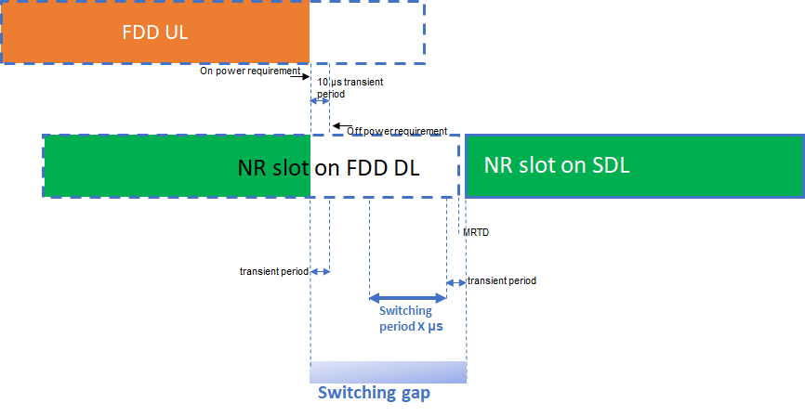

Figure 5.2.2-1: FDD to SDL switch with the switching gap on the switched-from carrier.

The UL slot will always end before the DL slot, neglecting any timing errors in case TA = 0 µs. The worst case in terms of switching is that in which TTA = 0 µs, the DL and UL timing are the same (again neglecting the errors that are of the order of 1 µs) and the SDL starts RTD µs before the Pcell DL slot timing. The switching gap with respect to the end of the last FDD DL symbol must therefore be at least

actual switching gap length > Tswitch + MRTD + FDD UL trailing end transient period + SDL leading transient period.

where the MRTD = [CP length/TAE] assuming that the FDD and SDL carriers are colocated.

### 5.2.3 SDL to FDD switch

For the SDL to FDD switch, the switching gap *ends* at end of slot on “switch from” carrier (SDL). The timing advance must also be accounted for; Figure 5.2.3-1 shows the case where the switch is assumed to occur before the start of the time advanced UL. The figure illustrates the applicable transient periods, switching period (35 or 140 𝜇s according to UE capability), and the applicability of ON and OFF power requirements.

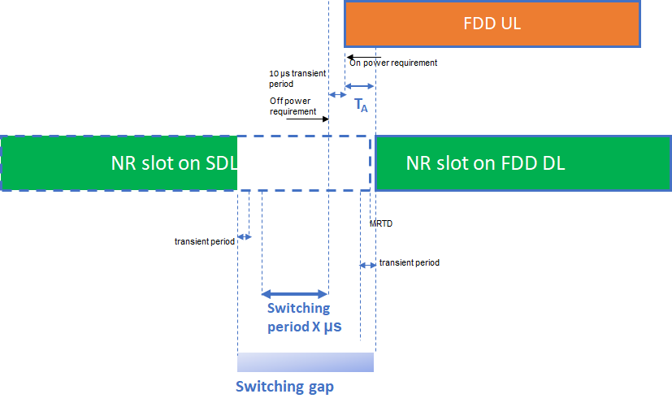Figure 5.2.3-1: SDL to FDD switch with the switch occurring before the start of the UL slot.

The time mask could be devised such that the switching period occurs before the first symbol of the UL slot of the switched-to FDD carrier, this to avoid dropping symbols on the UL that starts TTA before the first symbol of the FDD DL slot. Notwithstanding, the switching gap on the SDL carrier must be at least

Actual switching gap length > Tswitch + TTA + MRTD + SDL trailing transient period + FDD UL leading transient period

with account of the SDL received at maximum RTD of a [CPlength/TAE]. The worst case is when the SDL is traling the Pcell DL as shown in the figure.

## 5.3 Time mask for switching

### 5.3.1 General

The switching gap is configured by RRC in terms of number of symbols blanked by the network, while the actual location of the switch is specified by time masks similarly to UL Tx switching.

### 5.3.2 UL time mask

Figure 5.3.2-1 below illustrates the ON/OFF time mask for low NR band carrier aggregation via switching.

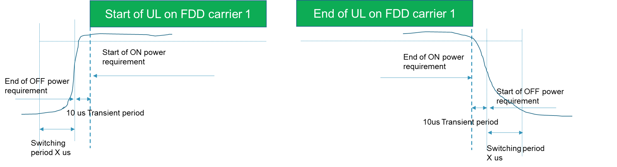

Figure 5.3.2-1: ON/OFF time mask for NR UL transmission for DL CA via switching with non-CA in the UL

<Editor’s note: RAN4 to further discuss whether the time mask should show the switching period/gap location and whether the diagram similar to Figure 5.2.2-1 and 5.2.3-1 should be considered.>

# 6 RRM aspects

<Editor’s note: capture RRM aspects in this clause>

## 6.1 General

RAN4 has reached the following agreements on the switching pattern applicability for RRM requirement in R19 LB CA via switching in RAN4#114bis meeting:

For the SCell which has been activated(i.e., after UE reporting valid CQI for SCell activation in section 8.3.2 TS38.133),

- The switching pattern for SDL SCell is applied.

For the SCell which is in activation procedure,

- The switching pattern for SDL SCell is not applied.

- RAN4 defines SCell activation requirement assuming UE utilizes the RS occasions to perform SDL SCell activation, where the RS occasions are FFS

For the SCell which is deactivated,

- The switching pattern for SDL SCell is not applied.

- If the deactivated SDL SCell measurement requirement is needed, FFS whether UE follows legacy deactivated SCell measurement requirements to perform deactivated SDL SCell measurement or follow a new measurement requirement for deactivated SDL SCell measurement.

Note: the above FFS parts will be discussed and decided in RAN4.

The necessity of requirement for SDL SCC was agreed in RAN4 #115 meeting, as summarized in Table 6.1-1.

Table 6.1-1. Necessity of requirement on SDL CC

|  |  |
| --- | --- |
| Requirement | Whether or not RAN4 will have requirement |
| interruption requirement for CC switching | No (can be revisited if not aligned with RAN1 further agreement.) |
| Activated SDL SCell L3 measurement | Yes |
| Deactivated SDL SCell measurement [and corresponding interruption] | Yes |
| SDL SCell activation/deactivation and corresponding interruption | Yes |
| [BFD/CBD] | Yes |
| TCI state switch delay | Yes |
| PL-RS switch delay | No |
| L1-RSRP/SINR | Yes |

Following SSB assumptions for R19 LB CA via switching are agreed in RAN4 #115:

The baseline assumption is:

- SDL SCell is transmitting SSB

- RAN4 to use SSB based requirement as baseline for Rel-19 low band CA via switching

- requirement of PCell will still use the existing principle as baseline but the impact of carrier switching in LB CA will be considered

Following MRTD assumptions for R19 LB CA via switching is agreed in RAN4 #115:

- The maximum receive timing difference for collocated FDD PCell and SDL SCell CA via switching is 3us.

- Whether or not above RTD can be used as side condition for SCell activation will be further discussed.

## 6.2 Discussion of switching delay or interruption requirement

It was agreed in RAN4 #115 meeting that, for SDL to FDD switching and FDD to SDL switching, RAN4 will not define interruption or scheduling restriction requirement on SDL carrier and FDD carrier.

Note: the above agreement can be revisited if not aligned with RAN1 further agreement.

## 6.3 Discussion of SDL SCell related requirement

### 6.3.1 Activated SDL SCell L3 measurement requirement

RAN4 #115 agreed to define the requirement for activated SDL SCell L3 measurement. For activated SDL SCell measurement, UE performs the SDL SCell measurement on the overlapped occasions of SMTC window and SDL SCell reception duration indicated by switching pattern.

### 6.3.2 Deactivated SDL SCell L3 measurement requirement

RAN4 #115 agreed to define the requirement for deactivated SDL SCell L3 measurement. The legacy deactivated SCell measurement delay requirements are applied for UE to perform deactivated SDL SCell measurement.

### 6.3.3 SDL SCell activation/deactivation requirement

RAN4 #115 agreed that PUCCH SCell activation, Rel-19 fast SCell activation through EMR, and activation of multiple SCells is not in the scope of the WI. The side condition for SDL SCell activation/deactivation requirement follows the legacy case and side conditions for SSB based inter-band FR1 SCell activation in existing spec.

The following principle design for SDL SCell activation/deactivation delay requirement was agreed in RAN4#115:

- The R18 SSB based FR1 inter-band SCell activation delay requirement can be reused to SDL SCell activation in LB CA via switching if UE supports corresponding feature.

- R16 Direct SCell activation with HO is not considered for R19 LB CA.

- R17 PUCCH SCell activation is not considered for R19 LB CA.

- R18 SSB-less SCell activation for NES is not considered for R19 LB CA.

- R17 Fast SCell activation is not considered for R19 LB CA.

- Reuse the existing SCell deactivation delay requirement for SDL SCell deactivation.

- Known/unknown conditions are reused from existing SCell activation requirements

### 6.3.4 SDL SCell L1 requirement

If RAN4 to define requirement for BFD/CBD for SDL SCell in LB CA via switching, the BFD/CBD on SDL carrier is performed on the overlapped occasions between SSB/CSI-RS and SDL duration in switch pattern.

The L1-RSRP measurement and T/F tracking for TCI switching on SDL carrier is performed on the overlapped occasions between SSB/CSI-RS and SDL duration in switch pattern.

RAN4 will not define requirement for PL-RS switch delay for SDL SCell in LB CA via switching

For L1-RSRP/SINR measurement requirement for SDL SCell, UE can only perform such measurement on the overlapped occasions of L1 RS and SDL SCell reception duration indicated by switching pattern.

## 6.4 Discussion of impact on FDD PCell RRM

RAN4#115 meeting agreed that the existing Tx timing requirement for PCell with the same applicability condition (SSB is available in last 160ms) can apply for R19 LB CA via switching.

Annex <F> (informative):  
Change history

Use style "Heading 8" in TSs and "Heading 9" in TRs. Do not use "informative" in the title in TRs.

This is the last annex for TS/TSs which details the change history using the following table.  
This table is to be used for recording progress during the WG drafting process till TSG approval of this TS/TR.  
For TRs under change control, use one line per approved Change Request  
Date: use format YYYY-MM  
CR: four digits, leading zeros as necessary  
Rev: blank, or number (max two digits)  
Cat: use one of the letters A, B, C, D, F  
Subject/Comment: for TSs under change control, include full text of the subject field of the Change Request cover  
New vers: use format [n]n.[n]n.[n]n

|  |  |  |  |  |  |  |  |
| --- | --- | --- | --- | --- | --- | --- | --- |
| Change history | | | | | | | |
| Date | Meeting | TDoc | CR | Rev | Cat | Subject/Comment | New version |
| 2025-02 | RAN4#114 | R4-2502875 |  |  |  | Initial skeleton | 0.0.2 |
| 2025-04 | RAN4#114bis | R4-2505146 |  |  |  | Implemented text proposals from the following:  R4-2503477 TP to TR 38.768 on switching periods  R4-2505147 TP to TR38.768 on operator provided scenarios for low band aggregation via switching | 0.0.3 |
| 2025-05 | RAN4#115 | R4-2508119 |  |  |  | Implemented text proposals from the following:  R4-2506072 TP to TR 38.768 on clause 4 (Scenarios)  R4-2507932 TP for 38.768: time masks for DL-only CA via switching  R4-2508434 TP to TR38.768 on RRM requirements for low band aggregation via switching | 0.0.4 |