**3GPP TSG-RAN WG4 Meeting # 114bis draft R4-2504688**

**Wuhan, China,** **7th -11th April, 2025**

**Agenda item:** 7.24.5

**Source:** Moderator (Huawei)

**Title:** Topic summary for [114bis][130] A-IoT_BSCW

**Document for:** Information

# Introduction

The thread [114bis][130] A-IoT_BSCW is on Rel-19 WI on solutions for Ambient IoT in NR (RP-243326 in RAN#106, revised to RP-250796 in RAN#107).

The topic summary is R4-2500687 (RAN4 #114) in previous meetings.

The following WF was agreed: R4-2502859 (RAN4 #114).

The summary covers contributions submitted under the agenda items including:

7.24.2.1 RF requirements for Type 1-C Ambient-IoT BS

7.24.2.3 RF requirements for CW

Companies’ contributions are as follows:

|  |  |  |  |  |
| --- | --- | --- | --- | --- |
| **Index No.** | **TDoc** | **Title** | **Source** | **Agenda item** |
| 1 | [**R4-2503217**](https://www.3gpp.org/ftp/tsg_ran/WG4_Radio/TSGR4_114bis/Docs/R4-2503217.zip) | RF requirements for A-IoT BS | Huawei, HiSilicon | 7.24.2.1 |
| 2 | [**R4-2503315**](https://www.3gpp.org/ftp/tsg_ran/WG4_Radio/TSGR4_114bis/Docs/R4-2503315.zip) | Initial D2R LLS simulation result | Xiaomi | 7.24.2.1 |
| 3 | [**R4-2503317**](https://www.3gpp.org/ftp/tsg_ran/WG4_Radio/TSGR4_114bis/Docs/R4-2503317.zip) | Discussion on AIoT CW requirements | Xiaomi | 7.24.2.3 |
| 4 | [**R4-2503389**](https://www.3gpp.org/ftp/tsg_ran/WG4_Radio/TSGR4_114bis/Docs/R4-2503389.zip) | Discussion on A-IoT CW RF requirements | CMCC | 7.24.2.3 |
| 5 | [**R4-2503390**](https://www.3gpp.org/ftp/tsg_ran/WG4_Radio/TSGR4_114bis/Docs/R4-2503390.zip) | Discussion on A-IoT BS RF requirements | CMCC | 7.24.2.1 |
| 6 | [**R4-2503470**](https://www.3gpp.org/ftp/tsg_ran/WG4_Radio/TSGR4_114bis/Docs/R4-2503470.zip) | Discussion on A-IoT BS requirements | CATT | 7.24.2.1 |
| 7 | [**R4-2503471**](https://www.3gpp.org/ftp/tsg_ran/WG4_Radio/TSGR4_114bis/Docs/R4-2503471.zip) | Discussion on RF requirements for CW for D1T1 | CATT | 7.24.2.3 |
| 8 | [**R4-2503560**](https://www.3gpp.org/ftp/tsg_ran/WG4_Radio/TSGR4_114bis/Docs/R4-2503560.zip) | Relevance of phase noise and LLS for SNR for REFSENS | Qualcomm Incorporated | 7.24.2.1 |
| 9 | [**R4-2503672**](https://www.3gpp.org/ftp/tsg_ran/WG4_Radio/TSGR4_114bis/Docs/R4-2503672.zip) | Discussion on RF requirements for CW | Spreadtrum,UNISOC | 7.24.2.3 |
| 10 | [**R4-2503814**](https://www.3gpp.org/ftp/tsg_ran/WG4_Radio/TSGR4_114bis/Docs/R4-2503814.zip) | Discussion on the RF requirement for AIoT BS | vivo | 7.24.2.1 |
| 11 | [**R4-2503816**](https://www.3gpp.org/ftp/tsg_ran/WG4_Radio/TSGR4_114bis/Docs/R4-2503816.zip) | Discussion on the RF requirement for CW | vivo | 7.24.2.3 |
| 12 | [**R4-2504205**](https://www.3gpp.org/ftp/tsg_ran/WG4_Radio/TSGR4_114bis/Docs/R4-2504205.zip) | on RF requirements for CW | OPPO | 7.24.2.3 |
| 13 | [**R4-2504303**](https://www.3gpp.org/ftp/tsg_ran/WG4_Radio/TSGR4_114bis/Docs/R4-2504303.zip) | RF requirements for CW | Huawei, HiSilicon | 7.24.2.3 |
| 14 | [**R4-2504353**](https://www.3gpp.org/ftp/tsg_ran/WG4_Radio/TSGR4_114bis/Docs/R4-2504353.zip) | Discussions on RF requirements for A-IoT BS | ZTE Corporation, Sanechips | 7.24.2.1 |
| 15 | [**R4-2504355**](https://www.3gpp.org/ftp/tsg_ran/WG4_Radio/TSGR4_114bis/Docs/R4-2504355.zip) | Discussion on RF requirement for CW node | ZTE Corporation, Sanechips | 7.24.2.3 |
| 16 | [**R4-2504398**](https://www.3gpp.org/ftp/tsg_ran/WG4_Radio/TSGR4_114bis/Docs/R4-2504398.zip) | A-IoT BS RF impact overview | Ericsson | 7.24.2.1 |
| 17 | [**R4-2504401**](https://www.3gpp.org/ftp/tsg_ran/WG4_Radio/TSGR4_114bis/Docs/R4-2504401.zip) | CW node RF impact overview | Ericsson | 7.24.2.3 |
| 18 | [**R4-2504517**](https://www.3gpp.org/ftp/tsg_ran/WG4_Radio/TSGR4_114bis/Docs/R4-2504517.zip) | Discussion on RF requirement for CW | LG Electronics UK | 7.24.2.3 |

# Topic #1: A-IoT BS TX

### Issue 1-1: Base station output power

* Proposals:
  + **Proposal 1**: A-IoT BS output power, Prated,c,AC≤ 38 dBm (CMCC, R4-2503390; HW, R4-2503217; ）
  + **Proposal 2**: The number of RBs of R2D signal and the number of RBs corresponding to the BS output power need to be clarified. (CATT, R4-2503470)
  + **Proposal 3**: RAN4 to decide if the maximum distance of 15 m for device 1 should be used to specify the min RF requirements for A-IoT BS and device. (Ericsson, R4-2504398)
* Recommended WF
  + Clarify that A-IoT BS transmit full RBs is a common understanding in RAN4. If confirmed，Discuss whether Proposal 1 can be agreed. Since proposal 1 aligns with the Micro BS output power and there is no coexistence issue with Pout up to 38dBm.

### Issue 1-2-1: RE power control dynamic range

* Proposals:
  + Option 1: NO (HW, R4-2503217; CMCC, R4-2503390; ZTE, R4-2504353; CATT, R4-2503470)
  + Option 2: Total power dynamic range and RE dynamic range may not be needed if A-IoT BS always transmit the full RB.（Ericsson, R4-2504398）
* Recommended WF
  + No need.

### Issue 1-2-2: Total power dynamic range

* Proposals:
  + Option 1: NO (HW, R4-2503217;)
  + Option 2: YES (CATT, R4-2503470; ZTE, R4-2504353)
  + Option 3: It depends:
    - Needed if wider bandwidth is defined besides minimum transmission bandwidth and the requirements are M value relevant. Otherwise, no need.（CMCC, R4-2503390）
    - May not be needed if A-IoT BS always transmit the full RB. ( Ericsson, R4-2504398)
* Recommended WF
  + No need.

### Issue 1-3-1: Transmitter OFF power

* Proposals:
  + **Proposal 1**: Transmitter OFF power spectral density shall be less than -85 dBm/MHz per antenna connector.（HW, R4-2503217; CMCC, R4-2503390; CATT, R4-2503470; ZTE, R4-2504353;）
  + **Proposal 2**: Reuse same OFF power as NR TDD BS for AIoT BS as starting point.（Vivo, R4-2503814）
* Recommended WF
  + TDD NR BS requirements can be reused.

### Issue 1-3-2: Transmitter transient period

* Proposals:
  + - Proposal 1:Reuse the NR BS type 1-C NR requirements for Transmitter transient period,10µs（HW, R4-2503217; CMCC, R4-2503390; CATT, R4-2503470; ZTE, R4-2504353; Ericsson, R4-2504398）
    - Proposal 2: Reuse same transient period as NR TDD BS for AIoT BS as starting point.（Vivo, R4-2503814）
* Recommended WF
  + Reuse 1-C NR TDD BS requirements,10µs

### Issue 1-4-2: Modulation quality

*Copied from R4-2502859[3]*

Issue 1-4-2: Modulation quality

* Agreement:
  + FFS whether to define requirements such as modulation Depth, RF Envelope Ripple, RF Envelope Rise Time, RF Envelope Fall Time and RF Pulse width for A-IoT BS.
* Proposals:
  + **Option 1**:Define RF envelop requirements, including modulation Depth, RF Envelope Ripple, RF Envelope Rise Time, RF Envelope Fall Time and RF Pulse width for A-IoT BS. Values are as the following table (HW, R4-2503217)
* Table 1: A-IoT BS RF envelope parameters

|  |  |  |  |  |  |
| --- | --- | --- | --- | --- | --- |
| **Parameter** | **Symbol** | **Mimimum** | **Nominal** | **Maximum** | **Units** |
| Modulation Depth | (A–B)/A | 80 | 90 | 100 | % |
| RF Envelope Ripple | Mh = Ml | 0 |  | 0.15(A–B) | V/m orA/m |
| RF Envelop Rise Time | Tr,10-90 |  |  | 0.33Tari | µs |
| RF Envelop Fall Time | Tf,10-90 |  |  | 0.33Tari | µs |
| RF Pulsewidth | PW |  | 0.5Tari | 0.65Tari | µs |

* + **Option 2:** Define RF envelop requirements for A-IoT BS as follows. (ZTE, R4-2504353)
* Table 2: A-IoT BS RF envelope parameters

|  |  |  |  |  |  |  |
| --- | --- | --- | --- | --- | --- | --- |
| Tari | Parameter | Symbol | Mimimum | Nominal | Maximum | Units |
| 1. 1/(M*15KHz)*10^6   Where M could be 1, 2, 4, 6, 8, 12, 16, 24 | Modulation Depth | (A–B)/A | 80 | 90 | 100 | % |
| RF Envelope Ripple | Mh = Ml | 0 |  | 0.1(A–B) | V/m orA/m |
| RF Pulsewidth | PW |  | 0.5Tari |  | µs |

* + **Option 3**: Define the modulation depth, RF envelope ripple, RF envelope rise time, RF envelope fall time, RF pulse width as modulation quality requirement, but the requirement need to be differentiated for different R2D data rate.（Vivo, R4-2503814）
  + **Option 4:** RAN4 define modulation depth, RF envelop ripple, RF plusewidth requirements and further check whether to reuse the same value as RFID or not based on RAN1 conclusion of CP discussion. (CMCC, R4-2503390)
  + **Option 5**: Not to define the modulation depth and ripple performance. (Ericsson, R4-2504398)
  + **Option 6:** Specify the OOK-M signal quality requirement with equivalent EVM requirement better than 64QAM. (E, R4-2504398)
  + **Option 7:** Either RF envelope or EVM requirements can be defined for R2D signal. (CATT, R4-2503470).If EVM is introduced, it can be defined as 17.5% at on chip only. (CATT, R4-2503470)
* Recommended WF
  + Discuss whether RF envelop parameters or EVM requirements to be defined.
  + If defining RF envelope parameters is agreed, may need align definition first，for a single high level, or take the average value in a certain period of time(for example, a symbol ,or 1ms); use the table below as a start point.

|  |  |  |  |  |  |  |
| --- | --- | --- | --- | --- | --- | --- |
| **Tari** | **Parameter** | **Symbol** | **Mimimum** | **Nominal** | **Maximum** | **Units** |
| 1/(M*15KHz)*10^6  Where M could be 1, 2, 4, 6, 8, 12, 16, 24 | Modulation Depth | (A–B)/A | 80 | 90 | 100 | % |
| RF Envelope Ripple | Mh = Ml | 0 |  | **Option 1**:0.15(A–B)  **Option 2**:0.1(A–B) | V/m orA/m |
| RF Envelop Rise Time | Tr,10-90 |  |  | 0.33Tari | µs |
| RF Envelop Fall Time | Tf,10-90 |  |  | 0.33Tari | µs |
| RF Pulsewidth | PW |  | 0.5Tari | 0.65Tari | µs |

### Issue 1-5-1: Occupied bandwidth

* Proposals:
  + **Proposal 1:** Reuse the legacy OBW requirement for A-IoT BS R2D transmission. (ZTE, R4-2504353)
  + **Proposal 2:** The occupied bandwidth for each A-IoT carrier shall be less than the A-IoT BS channel bandwidth.( HW, R4-2503217; CATT, R4-2503470)
* Recommended WF
  + Discuss the issue together with channel BW in thread [114bis][129]

### Issue 1-5-2: ACLR

* Proposals:
  + **Option 1**: ACLR1 is 40dB and ACLR2 is 50dB without 100kHz offset (CATT, R4-2503470; Vivo, R4-2503814)
  + **Option 2**: ACLR 1 (40 dB) and ACLR2 (50 dB) for one RB transmission bandwidth（Ericsson, R4-2504398）
  + **Option 3**: ACLR1 is 40dB and ACLR2 is 50dB with 100kHz offset (CMCC, R4-2503390)
  + **Option 4:** ACLR 1 is 30dB and ACLR2 is 40dB for A-IoT BS 1 to 4 PRB transmission BW with Foffset=100kHz. (HW, R4-2503217)
  + **Option 5**: ACLR as 20dB or 30dBc for 1st adjacent channel and further discuss the potential freq offset to meet the ACLR requirement. (ZTE, R4-2504353)
* Recommended WF
  + Discuss whether offset is needed.
  + ACLR value is TBD.

### Issue 1-5-3: OBUE

* Proposals:
  + **Proposal 1:** OBUE requirement for standalone NB-IoT MR BS can be reused for A-IoT BS. (CATT, CATT, R4-2503470; CMCC, R4-2503390)
  + **Proposal 2:** Define OBUE requirement up to the ACLR requirement and carrier bandwidth requirement. (ZTE, R4-2504353)
* Recommended WF
  + TBA

### Issue 1-5-4: Transmitter spurious emissions

* Proposals:
  + **Proposal 1:** Reuse the FR1 NR BS transmitter spurious emission requirement for A-IoT BS (HW, R4-2503217; CMCC, R4-2503390)
  + **Proposal 2:** Reuse the co-existence and co-location requirements of NR Micro BS.( HW, R4-2503217; ZTE, R4-2504353; Ericsson, R4-2504398)
  + **Proposal 3:** In D1T1-B scenario, the possibility of A-IoT BS co-located with BS operating in other frequency bands is relatively small. (CATT, R4-2503470)
* Recommended WF
  + Reuse the FR1 NR BS transmitter spurious emission requirement for A-IoT BS
  + Reuse the co-existence and co-location requirements of NR Micro BS

### Issue 1-6: Transmitter intermodulation

* Proposals:
  + **Option 1:** No need, because the A-IoT BS and NR BS are not co-located. (HW, R4-2503217; CATT, R4-2503470)
  + **Option 2:** Need to define. (Ericsson, R4-2504398; ZTE, R4-2504353)
    - Reuse the FR1 MR Tx intermodulation requirement for A-IoT BS. (ZTE, R4-2504353)
    - Tx intermodulation should be defined if the NR BS is deployed within the same A-IoT band.( Ericsson, R4-2504398)
* Recommended WF
  + TBA

# Topic #2: A-IoT BS RX

### Issue 2-1-1: Reference sensitivity level

*Background:*

*Following conclusion* *of reference sensitivity level for A-IoT BS was captured in TR38.769*

Copied from TR38.769:

Regarding the reference sensitivity level for A-IoT BS, RAN4 reached the following consensus:

* For BS type 1-C,

$$P_{REFSENS}\left(dBm\right)=-174dBm+10×{log10}(BW)+N_{F}+I_{M}+SNR+[ desens target]$$

Copied from WF R4-2502859:

* Agreement:
  + Define the reference sensitivity level specifically for 15 kHz D2R channel BW at least,
  + Consider the follow aspects
    - Noise figure=10dB
    - IM=2dB
    - SNR
    - Coverage

FFS on the definition of channel bandwidth depending on RAN1 conclusions.

* Proposals:
  + **Proposal 1**: Adding X dB relaxation on the REFSENS accounting the desensitization due to linearity, reciprocity mixing and power leakage from digital filter.(Ericsson, R4-2504398)
  + **Proposal 2**: Specify Y dBm CW received power for REFSENS, FFS on value of Y. (Ericsson, R4-2504398)
  + **Proposal 3**: Discuss further factors to specify the CW power received at BS antenna: (Ericsson, R4-2504398)
    - a, CW cancellation
    - b, Increasing the CW node to BS distance
    - c, Reconfiguring CW Tx power and CW Tx should be less than a maximum Tx power
  + **Proposal 4**: further discuss the maximum input power (e.g. -66dBm) for CW signal in D1T1-B scenario and potential maximum desens due to the CW reception. (ZTE, R4-2504353)
  + **Proposal 5**: The impact of CW (e.g., phase noise) is related to the minimum small frequency shift which need to be pending on RAN1 progress. （Vivo, R4-2503814）
  + **Proposal 6:** Use 6dB as the desensitivity target for reference sensitivity. (HW, R4-2503217)
  + **Proposal 7**:Postpone the REFSENS requirement discussion until RAN1 reach the consensus.( ZTE, R4-2504353)
* Recommended WF
  + For proposal 1, suggest to follow SI conclusion, it can be merged into the ‘desens target’, no need to add a new item;
  + TBD whether the received CW power at the BS antenna can be standardized. Given the numerous variables influencing this value, Proposal 6 serves as the alternative option if consensus cannot be reached.

Issue 2-1-2: LLS assumptions and parameters for SNR

* Proposals:
  + **Proposal 1:** Add preamble/midamble configuration parameter to simulation assumptions. Detail can be decided after RAN1 draw conclusions.( Xiaomi, R4-2503315)
  + **Proposal 2:** No need to restrict the repetition and FEC in D2R SNR evaluation.（Vivo, R4-2503814）
  + **Proposal 3:** list the simulation assumption which could be used as baseline for final SNR definition. (CMCC, R4-2503390)
* Recommended WF
  + Discuss whether to modify the assumptions as follows:
  + Red highlights show changes to that in WF R4-2502859

|  |  |
| --- | --- |
| **Parameters** | **Assumptions** |
| Carrier frequency | 900 MHz |
| SCS | 15 kHz as baseline |
| Block structure | Depend on RAN1 |
| Channel model | AWGN |
| Number of Tx/Rx chains for Ambient IoT device | 1 |
| Number of BS antenna elements | 1 |
| Reference data rate | 1 kbps (M)  5 - 7 kbps (M) |
| Message size | **Option 1**：  {20 bits, 96 bits, 400 bits} are considered for message size.  Note 1: companies to report the M value and chip length used for each message size  Note 2: CRC is not included for the message size  **Option 2**：  96 bits |
| BLER target | 10% |
| Sampling frequency（SFO） | Option 1: Randomly select a value from the range of [104 ppm~105 ppm] for device 1  Option 2: No need. |
| Residual SFO | Max 500ppm |
| Transmission bandwidth（DSB） | **Option 1**：  X kHz is considered for D2R transmission bandwidth.  The value is for two sidebands, i.e., the total transmission bandwidth for DSB is X kHz  X = {[15 (M)], [180 (O)]}  **Option 2:**  15kHz  **Option 3:**  2SB=round up (4*data rate) in the units of 15kHz |
| [OOK/BPSK chip rate] | **Option 1**: Companies to report  **Option 2:** Data rate *2 |
| Receiver bandwidth | It’s suggested the same as transmission bandwidth. |
| Waveform (CW) | unmodulated single tone |
| Modulation | OOK |
| Line code | Manchester encoding |
| FEC | **Option 1**：No FEC  **Option 2**：1/3 Convolutional Code  **Option 3:** No need to restrict FEC |
| ADC bit width | Ideal |
| D2R receiver | coherent receiver |
| Repetition | **Option 1**: None  **Option 2**: No need to restrict the repetition |
| Preamble configuration | after RAN1 draw conclusions |
| Midamble configuration | after RAN1 draw conclusions |

### Issue 2-1-3: SNR value

* Proposals:
  + **Proposal 1**: The AWGN D2R modulation SNR is -6dB @ 10% BLER. (HW, R4-2503217)
  + **Proposal 2:** Consider the 0 dB SNR as the starting point for 15kHz D2R REFSENS.（Vivo, R4-2503814）
  + **Proposal 3:** RAN4 can wait RAN1 progress or make reasonable residue SFO.(Ericsson, R4-2504398)
  + **Proposal 4:** RAN4 to wait for confirmation of the D2R bandwidth before agreeing final SNR values（QC, R4-2503560）
  + **Observation 1:** The simulation results of SNR are shown in Table 4. It can be seen that the SNR of BPSK is obviously better than that of OOK. (CATT, R4-2503470)
* **Table 4: SNR simulation results**

|  |  |  |
| --- | --- | --- |
| **Parameters** | **SFO** | **SNR (10% BLER)** |
| OOK, CC(R=1/3)+Manchester | no SFO | -0.6 |
| 1000 ppm | 2.5 |
| OOK, CC(R=1/3)+repetition | no SFO | -0.6 |
| 1000 ppm | 1.5 |
| BPSK, CC(R=1/3)+Manchester | no SFO | -6.7 |
| 1000 ppm | -3.5 |
| BPSK, CC(R=1/3)+repetition | no SFO | -6.7 |
| 1000 ppm | -4.6 |

* Recommended WF
  + Companies are encouraged to provide simulation results after aligning the assumptions in Issue 2-1-2

### Issue 2-2: Dynamic range

* Proposals:
  + **Proposal 1:** Further discuss the co-channel interference coming from co-channel device transmission and CW interference for dynamic range requirement in D1T1-B scenario (ZTE, R4-2504353)
* Recommended WF
  + TBA

### Issue 2-3: ACS

* Proposals:
  + **Proposal 1:** For ACS requirements, reuse legacy NB-IOT requirements.（CMCC, R4-2503390）

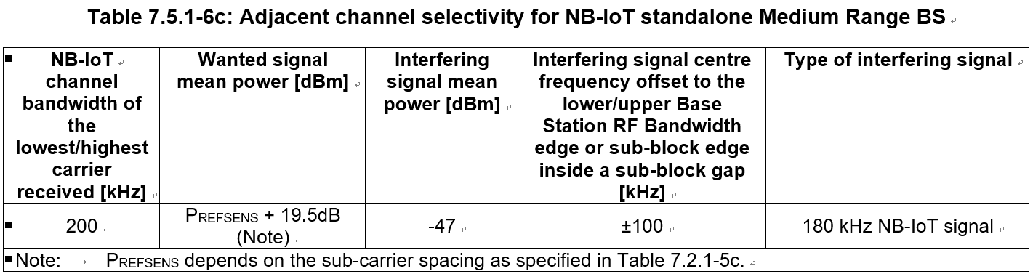

* + **Proposal 2:** The ACS for NR BS can be reused for A-IoT BS. (Ericsson, R4-2504398; CATT, R4-2503470)

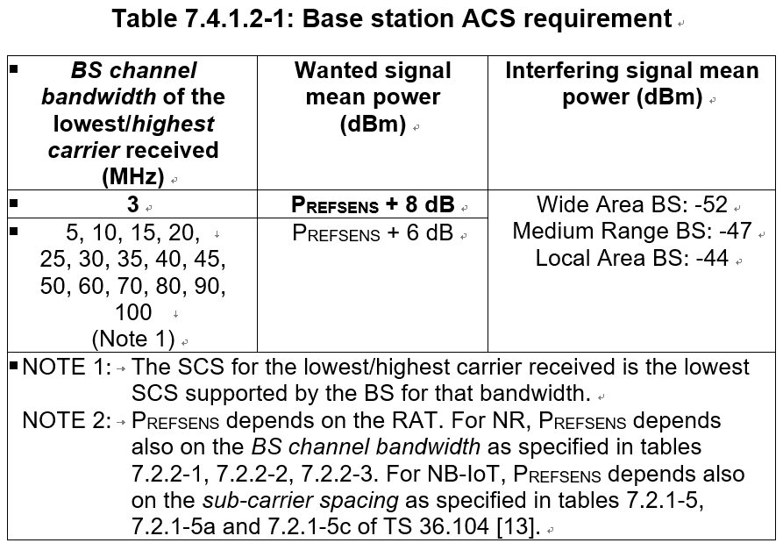

* + **Proposal 3:** define A-IoT BS ACS requirement between 20-30dBc(ZTE, R4-2504353)
  + **Proposal 4:** No ACS requirement for A-IoT BS. (HW, R4-2503217)
* Recommended WF
  + TBA

### Issue 2-4-1: general blocking

* Proposals:
  + **Proposal 1:** Reuse the in-band blocking requirement from NB-IoT standalone Medium Range BS for A-IoT BS. (HW, R4-2503217) (-38dBm interference,
  + **Proposal 2:** Reuse the IBB requirement in legacy NR BS. (Ericsson, R4-2504398; ZTE, R4-2504353)
* Recommended WF
  + Reuse the in-band blocking requirement from either NR or NB-IoT standalone Micro BS, as they are the same.

### Issue 2-4-2: narrowband blocking

* Proposal:
  + **Proposal 1:** No need.( CATT, R4-2503470)
  + **Proposal 2:** Define narrow-band blocking requirements for reader. (CMCC, R4-2503390)
* Recommended WF
  + TBA

### Issue 2-7-1: General intermodulation

* Proposals:
  + **Option 1:** No need. (HW, R4-2503217; CATT, R4-2503470)
  + **Option 2:** Reuse FR1 MR BS Rx IMD requirement in the licensed band for A-IoT BS Rx IMD requirement. (ZTE, R4-2504353; Ericsson, R4-2504398)
* Recommended WF
  + TBA

### Issue 2-7-2: Narrowband intermodulation

* Proposals:
  + **Proposal 1:** No need (HW, R4-2503217; CATT, R4-2503470)
  + **Proposal 2:** Need to define. (CMCC, R4-2503390)
* Recommended WF
  + TBA

### Issue 2-8: ICS

* Proposals:
  + **Proposal 1:** No need. (HW, R4-2503217; ZTE, R4-2504353)
  + **Proposal 2:** needed with assuming wanted signal coming from the nearest device and interference signal coming from the farthest device. (CMCC, R4-2503390)
  + **Proposal 3:** Further discuss on ICS of multiple devices receiving. Ericsson, R4-2504398)
* Recommended WF
  + TBA

### Issue 2-9: A-IoT BS others

* Proposals:
  + **Proposal 1**: Take care of the definition of MCL for micro cell scenario and taken the device allowed max input power level and deployment scenario into consideration.( CMCC, R4-2503390)
  + **Proposal 2**: CW nodes communicating with active devices can’t be co-located with any active readers. (CATT, R4-2503470)
  + **Proposal 3**:consider the above test setup for A-IoT BS refersens conformance testing. (ZTE, R4-2504353)

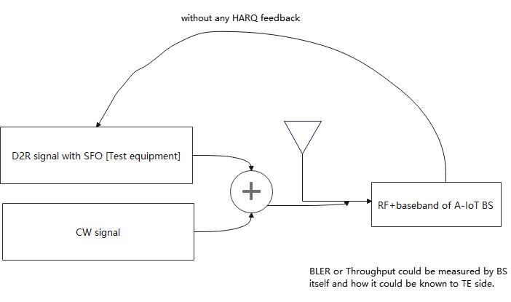

* Recommended WF
  + Proposal 2 seems common sense in RAN4.
  + Postpone discussion of Proposal 3 at this stage.

# Topic #3: CW

### Issue 3-1: CW Output power

Copied from WF R4-2502859:

* Agreement:
  + CW output power [33] dBm.
* Proposals:
  + **Proposal 1**: 33dBm (HW, R4-2504303; CMCC, R4-2503389; Spreadtrum, R4-2503672; LGE, R4-2504517）
  + **Proposal 2:** 33dBm output power is conducted power and only apply for band n8.( OPPO, R4-2504205)
  + **Proposal 3**: less than 27dBm. (CATT, R4-2503471)
  + **Proposal 4-1**: Specify also CW Tx power of 23 dBm if only fixed power level to be specified. (Ericsson, R4-2504401)
  + **Proposal 4-2**: Alternatively, the CW Tx power can be specified with a maximum output power the same as BS and manufacture declare the related CW power. (Ericsson, R4-2504401)
* Recommended WF
  + CW output power <=33dBm , and can be declared by manufacture

### Issue 3-2-1: OFF power

* Proposals:
  + **Option 1**: Need to be specified (E, R4-2504401; LGE, R4-2504517; Xiaomi, R4-2503317; OPPO, R4-2504205; Vivo, R4-2503816; Spreadtrum, R4-2503672; ZTE, R4-2504355)
    - **Proposal 1**: Define CW off power requirement following reader off power value.(Xiaomi, R4-2503317; OPPO, R4-2504205; Vivo, R4-2503816)
    - **Proposal 2**: Reuse NR off power (i.e., -50dBm).(Spreadtrum, R4-2503672)
    - **Proposal 3**: Define the OFF power for CW node transmission as -50dBm/0.18MHz (ZTE, R4-2504355)
  + **Option 2**: No needed（CMCC, R4-2503389; CATT, R4-2503471;）
* Recommended WF
  + Define CW OFF power
  + Value TBD

### Issue 3-2-2: transient period

* Proposals:
  + **Proposal** **1**: It’s not necessary to define CW transient period requirement. (Xiaomi, R4-2503317; OPPO, R4-2504205)
  + **Proposal** **2**: Same transient period of AIoT BS can be applied to CW node. (Vivo, R4-2503816)
* Recommended WF
  + TBA

### Issue 3-4: Phase noise

* Proposals:
  + **Option 1**: No need（HW, R4-2504303; Vivo, R4-2500746; Spreadtrum, R4-2503672; Xiaomi, R4-2503317; CATT, R4-2503471）
  + **Option 2**: Define phase noise
    - Proposal 1: A -110 to -160 dBc/Hz at 10kHz offset can be a requirement together consider the phase noise as well as the unwanted emission. (OPPO, R4-2504205)
    - Proposal 2: Specify CW node phase to be better than -90 dBc/15 kHz. （QC, R4-2503560）
    - Proposal 3: Define the integrated phase noise requirement between CW and minimum small frequency shift ± D2R transmission bandwidth/2, and the principle is to make sure the D2R SNR degradation aligns with the dense target in REFSENS formula.(Vivo, R4-2503816)

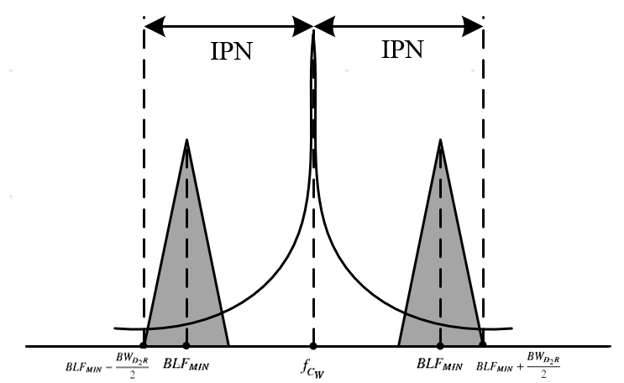

* + **Option 3:** further check whether the phase noise of CW could be implicitly reflected into sensitivity degradation part of reader sensitivity requirements definition. (CMCC, R4-2503389)
* Recommended WF
  + Phase noise can be discussed together with the Issue 3-5

### Issue 3-5: Unwanted emission

* Proposals:
  + **Proposal 1**: The unwanted emission of CW is defined from minimum small frequency shift ± D2R transmission bandwidth/2 to the boundary of D2R channel bandwidth, and principle could be different allowed D2R performance degradation for each dash line of the mask. (Vivo, R4-2503816)

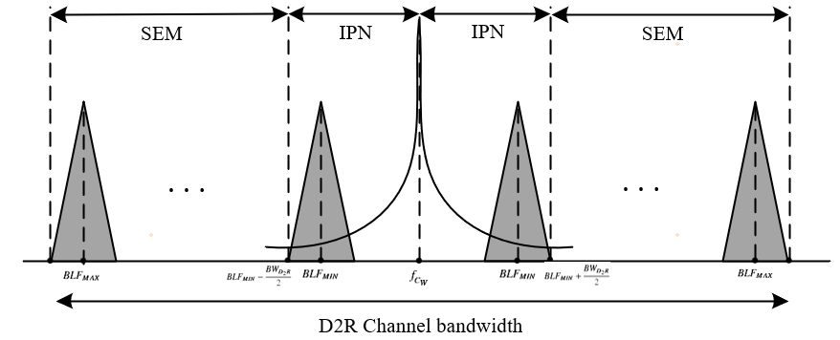

* + **Proposal 2:** The spectrum emission mask of the CW node applies to frequencies (Δf) starting from the assigned transmission frequency. The spectrum emission mask for CW node is defined as in Table 2.2-4. (Huawei, R4-2504303)

**Table 2.2-4: CW node spectrum emission mask**

|  |  |  |
| --- | --- | --- |
| **Δf (kHz)** | **Emission limit (dBm)** | **Measurement bandwidth** |
| ± 0-90 | N/A |  |
| ± 90-270 | -15 | 30 kHz |
| ± 270-450 | -20 | 30 kHz |
| ± 450- Δfmax | -27 | 30 kHz |

* + **Proposal 3**: Propose to further the guard band (e.g 1PRB or 2 PRBs) if GSM UE spectral mask is reused for CW node transmission. (ZTE, R4-2504355)
  + **Proposal 4**: Use NB-IoT BS unwanted emission requirements as baseline for CW. (CMCC, R4-2503389; Spreadtrum, R4-2503672; CATT, R4-2501030)
  + **Proposal 5**: The value of unwanted emission requirement can be analysed based on the output power of CW signal and frequency offset of CW signal and D2R signal. (CATT, R4-2503471)
  + **Proposal 6**: CW unwanted emission can be modeled with 40 dBc for ACLR1 and 50 dBc for ACLR2. (Ericsson, R4-2504401)
  + **Proposal 7**: Unwanted emission requirement is not defined. (Xiaomi, R4-2503317)
* Recommended WF
  + TBA

### Issue 3-6: Spurious emissions

* Proposals:
  + **Proposal 1**: The spurious emission of CW starts from the boundary of D2R channel bandwidth. (Vivo, R4-2503816; Xiaomi, R4-2503317)

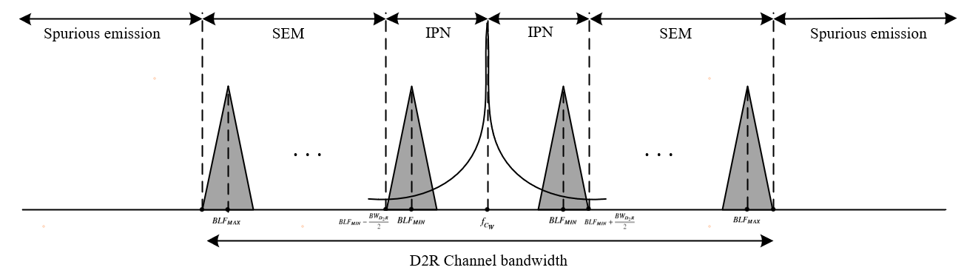

* + **Proposal 2**: The boundary between spectrum emission mask domain and spurious emission domain for CW node is specified as ΔF = 10 MHz (Huawei, R4-2504303)
  + **Proposal 3**: Spurious emissions limits is defined as in Table 2.2-5. (Huawei, R4-2504303)
* **Table 2.2-5: Spurious emissions limits**

|  |  |  |
| --- | --- | --- |
| **Frequency Range** | **Maximum Level** | **Measurement bandwidth** |
| 9 kHz ≤ f < 150 kHz | -36 dBm | 1 kHz |
| 150 kHz ≤ f < 30 MHz | -36 dBm | 10 kHz |
| 30 MHz ≤ f < 1000 MHz | -36 dBm | 100 kHz |
| 1 GHz ≤ f < 12.75 GHz | -30 dBm | 1 MHz |
| 12.75 GHz ≤ f < 5th harmonic of the upper frequency edge of the UL operating band in GHz | -30 dBm | 1 MHz |

* Recommended WF
  + TBA

### Issue 3-7: Intermodulation

* Proposals:
  + **Option 1:** No（Huawei, R4-2504303; CATT，R4-2503471; Xiaomi, R4-2503317）
    - Observation 3: the CW node will not be co-located with other BS or reader according to current scope. (CMCC, R4-2503389)
    - Scenario in which A-IoT BS receiver and the co-located CW node operate simultaneously is not recommended.(CATT, R4-2503471)
  + **Option 2:** if CW node will transmit the multiple tone CW signal in addition to single tone CW signal, then Tx IMD requirement are still need as intra-system TxD requirement.( ZTE, R4-2504355)
  + **Option 3**: Discuss if the co-location with other BS is a valid scenario before discussing the inter-modulation requirement. (Ericsson, R4-2504401)
* Recommended WF
  + It is described that “Carrier wave transmission for waveform 1 only, without hopping” in the WID RP-250796. So no need to define intermodulation in this release.

### Issue 3-8: CW others

* Proposals:
  + **Proposal 1**: Introduce the synchronization requirement of 3 us between CW node and A-IoT BS. (Ericsson, R4-2504401)
  + **Proposal 2**: A bandwidth should be defined together with CW output power so that the power can be measured with OCC bandwidth. (Ericsson, R4-2504401)
  + **Proposal 3**: A minimum channel bandwidth can be defined for CW node. (Ericsson, R4-2504401)
  + **Proposal 4**: Further discuss whether an inband emission mask should be needed for a certain CW Tx power and ISD distance. (Ericsson, R4-2504401)
* Recommended WF
  + TBA