Hello all,

This is an invitation to RAN4#113 Webinar sessions on 18 – 22 November 2024. This invitation covers two sessions in two separate rooms: Main and RRM.

GoToWebinar (GTW) conference calls will be set in each session. And one-way remote participants can be supported.

Please remember that consistent registration format is important for session chairing and hence use the following format when you register: BriefCompanyName - Firstname, Lastname. An example is shown below

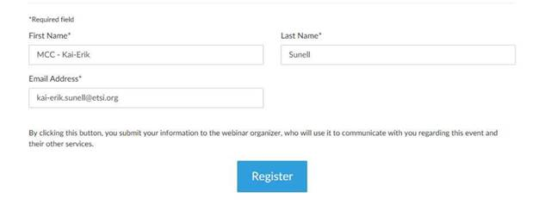
where BriefCompanyName is ‘MCC’, Firstname is ‘Kai-Erik’ and Lastname is ‘Sunell’.

Your email address for Webinar registration needs to be the same as for your 3GPP meeting registration.

Registration links are found below and they are session-specific. You may register to all sessions, e.g. if you plan to switch between sessions or if you are able to listen to all sessions at the same time. Once you have registered for a session your registration is valid for the whole week.

The starting time for Main Webinar and RRM Webinar sessions (18 October is 14:00 UTC (15:00 CET) (09:00 local time) – 24:30 UTC (01:30 CET) (19:30 local time) but you can joiny already 15 minutes earlier, i.e. 13:45 UTC, to check that the equipment work fine. (Observe, registration links below show time in Paris time zone CET). Webinars are scheduled to stop at 24:30 UTC (01:30 CET) (19:30 local time).

The starting time for Main Webinar and RRM Webinar sessions (19 – 21 October) is 13:30 UTC (14:30 CET) (08:30 local time) – 24:30 UTC (01:30 CET) (19:30 local time) but you can join already 15 minutes earlier, i.e. 13:15 UTC, to check that the equipment work fine. (Observe, registration links below show time in Paris time zone CET). Webinars are scheduled to stop at 24:30 UTC (01:30 CET) (19:30 local time).

The starting time for Main Webinar and RRM Webinar sessions (22 October) is 13:00 UTC (14:00 CET) (08:00 local time) – 21:00 UTC (22:00 CET) (16:00 local time) but you can join already 15 minutes earlier, i.e.12:45 UTC, to check that the equipment work fine. (Observe, registration links below show time in Paris time zone CET). Webinars are scheduled to stop at 21:00 UTC (22:00 CET) (16:00 local time).

Note 1: One-way remote participants is default and entail listen only mode.
Note 2:In this meeting the host, Chairs, MCC and IT should be warned two weeks in advance if measures need to be taken (e.g. two-way audio). In this case, it will be the Chairs’ decision if they want to have two-way audio for their meetings.
Instructions on how to join the Webinars will be sent automatically every day.

RAN4#113 RRM Webinar Sessions (18 - 22 Nov)
Mon, Nov 18, 2024 3:00 PM - Tue, Nov 19, 2024 1:30 AM CET

RAN4#113 RRM Webinar Sessions (18 - 22 Nov)
Join us for a webinar beginning on Nov 18, 2024 at 3:00 PM CET.
Register now!

After registering, you will receive a confirmation email containing information about joining the webinar.
View System Requirements

RAN4#113 Main Webinar Sessions (18 - 22 Nov)
Mon, Nov 18, 2024 3:00 PM - Tue, Nov 19, 2024 1:30 AM CET

RAN4#113 Main Webinar Sessions (18 - 22 Nov)
Join us for a webinar beginning on Nov 18, 2024 at 3:00 PM CET.
Register now!

After registering, you will receive a confirmation email containing information about joining the webinar.
View System Requirements

Regards,
Carolyn

