3GPP TSG-RAN WG4 Meeting #113 R4-2418151

Orlando, USA, 18th – 22nd November, 2024

Agenda item: 7.17.6
Source: Moderator (Qualcomm)
Title: Topic summary for [113][129] NR_AIML_air
Document for: Information

Introduction
This is the summary thread for issues related to NR AI/ML study in RAN4. A WF summarizing many topics/issues to be further studied and discussed was agreed in the previous meeting in R4-23xxxxx. This summary is organized in 3 high level topics and contains several sub-topics for discussion.

Topic #1: Testability and interoperability issues for CSI Compression
This section contains the sub-topics regarding general issues and proposed TR updates

Companies’ contributions summary
T-doc number | Company | Proposals / Observations
R4-2417615 | CAICT | Proposal 1: The specified dataset for option 4a shall at least contain {encoder input, encoder output w/ quantization}.  Proposal 2: The encoder output in the dataset could be obtained through a reference encoder.  Proposal 3: A performance requirement shall be set for option 4a.  Observation 1: To investigate the feasibility of option 4a, the evaluation assumptions for option 3 could be reused and the output reference encoder of option 3 could be used to construct the dataset.  Proposal 4: RAN4 to discuss following steps for the feasibility study of option 4a:  - Step 0: Finalized the feasibility study of option 3.  - Step 1: Generate the dataset of encoder input base on evaluation assumption and generate the data set of encoder output using the reference encoder from option 3.  - Sub-step 1: validate the consistency of data distribution if aggregating dataset is performed.  - Step 2: Interested companies develop test decoders based on dataset set {encoder input, encoder output}.  - Step 3: Interested companies submit own encoders.  - Step 4: Cross check the performance between all test decoders and all encoders.  - Step 5: Summarize all testing results and determine the performance requirements for option 4a.
R4-2417618 | OPPO | Proposal 1: Principles to define test decoder(s)  - to meet the minimum performance requirement in RAN4 tests  - to be a simple design  Observation 1: FLOPs, Number of parameters, model size for CNN based CSI encoder and CNN based CSI decoder are evaluated as below:  Observation 2: Based on the CNN based CSI encoder and CNN based CSI decoder proposed by RAN4#111, performance evaluation results are shown as below (train by UMa channel data, test by different channel model)  Note：Baseline etype2 SGCS is 0.71  Proposal 2: For RAN4 test model alignment, the motivation should be further clarified  - Option1: It is expected that the alignment of minimum performance understanding can be achieved through results from different companies  - Option2: It is expected to strictly align the output results of each company's AI/ML models through simulation  Observation 3: According to the refined simulation parameters in R4-2414447, corresponded second-round alignment results could be found as below:  Observation 4: Simulation results on “CDF of SGCS per subband” are shown as follows:  Observation 5: In comparison to the CNN-based CSI encoder, there's a substantial decrease in FLOPs in the MLP-based CSI encoder, dropping from 94M to a mere 0.22M  Observation 6: For the reference encoder, a simplified MLP-based CSI encoder could lower the challenges of aligning and implementing standardized CSI encoders across different companies, without compromising the CSI compression feedback performance.
  CSI feedback bits | FLOPs |  | Num. of Trainable Parameters |  | Model Size
  CSI feedback bits | Encoder | Decoder | Encoder | Decoder | Encoder | Decoder
  64 bits | 94.1M | 1481.6M | 0.13M | 1.80M | 638KB | 7.03MB
  112 bits | 94.2M | 1481.7M | 0.14M | 1.82M | 677KB | 7.11MB
  CSI feedback bits | Training dataset | Test dataset (SGCS)
  CSI feedback bits | Training dataset | TDL-A30 | CDL-A30 | CDL-C30 | UMa
  64 bits | UMa | 0.759 | 0.705 | 0.603 | 0.725
  112 bits | UMa | 0.784 | 0.768 | 0.645 | 0.782
  CSI feedback bits | Quantization of encoder output | SGCS (UMa channel)
  64 bits | 2 bits quantization for CSI report | 0.717
  32 floats | without quantization of the FC layer outputs for validation purposes only, i.e., float32 is sent in CSI report | 0.771
  Subband index | SGCS
  Subband index | Average | 10% | 20% | 30% | 40% | 50% | 60% | 70% | 80% | 90%
  0 | 0.689 | 0.319 | 0.481 | 0.588 | 0.671 | 0.742 | 0.804 | 0.861 | 0.918 | 0.967
  1 | 0.718 | 0.389 | 0.540 | 0.635 | 0.708 | 0.769 | 0.823 | 0.873 | 0.922 | 0.968
  2 | 0.731 | 0.415 | 0.564 | 0.659 | 0.727 | 0.783 | 0.833 | 0.879 | 0.924 | 0.969
  3 | 0.732 | 0.411 | 0.566 | 0.658 | 0.728 | 0.785 | 0.834 | 0.881 | 0.926 | 0.969
  4 | 0.723 | 0.385 | 0.547 | 0.645 | 0.718 | 0.779 | 0.832 | 0.880 | 0.927 | 0.969
  5 | 0.713 | 0.359 | 0.525 | 0.630 | 0.708 | 0.772 | 0.829 | 0.878 | 0.926 | 0.970
  6 | 0.711 | 0.351 | 0.520 | 0.627 | 0.704 | 0.770 | 0.828 | 0.878 | 0.927 | 0.970
  7 | 0.716 | 0.362 | 0.529 | 0.634 | 0.709 | 0.774 | 0.830 | 0.881 | 0.926 | 0.969
  8 | 0.724 | 0.390 | 0.545 | 0.646 | 0.719 | 0.781 | 0.834 | 0.881 | 0.926 | 0.969
  9 | 0.732 | 0.411 | 0.565 | 0.658 | 0.728 | 0.785 | 0.836 | 0.881 | 0.926 | 0.969
  10 | 0.732 | 0.418 | 0.565 | 0.657 | 0.725 | 0.783 | 0.833 | 0.879 | 0.924 | 0.968
  11 | 0.717 | 0.385 | 0.536 | 0.634 | 0.708 | 0.769 | 0.822 | 0.871 | 0.921 | 0.968
  12 | 0.687 | 0.312 | 0.475 | 0.585 | 0.669 | 0.741 | 0.805 | 0.861 | 0.917 | 0.967
R4-2417701 | CATT | Proposal 1: RAN4 randomly selects a decoder(s) from the submitted decoders.  Observation 1: Any meaningful outcomes in SI phase can be documented in TR and how they will be used depends on readers.  Proposal 2: RAN4 decides whether to document reference encoder/training dataset or not after the study on Option 3 is completed.  Proposal 3: RAN4 not to verify the TE verification/validation.
R4-2417803 | MediaTek inc. | Observation #1: For the case of 2GHz and 1 layer, the SGCS of quantized ResCNN model is 0.697 with 64 bits feedback. Also, the SGCS of eTypeII PC1 with 62 bits feedback is 0.719.  Observation #2: For the case of 4GHz and 1 layer, the SGCS of quantized ResCNN model is 0.695 with 64 bits feedback. Also, the SGCS of eTypeII PC1 with 62 bits feedback is 0.716.  Observation #3: For the case of 2GHz and 4GHz with 1 layer, the comparison of ResCNN and eTypeII CDFs of SGCS indicate that the performance losses surpass the performance gains, leading to an average decrease in overall performance.  Observation #4: For the case of 2GHz and 4GHz with 1 layer, the comparison of SGCS between sub-bands indicate that the performance is slightly reduced on band edge sub-bands.  Observation #5: FLOPs of ResCNN encoder is 93M and FLOPs of ResCNN decoder is 1480M.  Observation #6: Parameters of ResCNN encoder is 0.127M and parameters of ResCNN decoder is 1.808M.
R4-2417950 | Xiaomi | Proposal 1: RAN4 should discuss and establish the criteria for simulation alignment.  Proposal 2: Multiple decoders can be chosen as candidates first and then the final decoder can be selected from these candidates with good generalization.  Proposal 3: If alignment can be achieved, company can train own encoder with multiple candidate reference decoders by company-specific data.  Proposal 4: If alignment cannot be achieved using company-specific data, RAN4 should discuss how to combine data from different companies to create a common data set for training models.
R4-2418095 | Samsung | Standardization for Test decoder Option 3  Proposal 1: For this round of performance alignment, at least the following issues shall be studied and concluded:  - Issue-1: Whether the performance alignment can be achieved, with the aligned CNN-structure and training procedure (both of which are aligned as much as possible), by leaving the following difference:  - the company-wise SLS-generated dataset, with particular SLS implementation, randomness and the size of dataset.  - Issue-2: How performance results can be regarded as being “aligned”?  Proposal 2: On the issue of “How performance results can be regarded as being ‘aligned’”, the following criteria is adopted:  - If the standard variance of collected SGCS values with AI/ML-based encoder/decoder is no larger than the counterpart with eType-II based codebook, the performance results can be regarded as “aligned”.  Proposal 3: The metric of FLOPs shall be adopted used to evaluate neural network complexity, and original CNN complexity values (47M and 740M for encoder/decoder respectively) are actually for MACs, which shall be corrected by FLOPs (9.39*10⁷ and 1.48*10⁹ for encoder/decoder respectively).  Observation 1: SGCS performance and complexity for CNN-based model trained and evaluated over Samsung-SLS generated dataset is provided as:  Observation 2: Per requested for our proposed CNN-based encoder/decoder with scalar quantization, the details of quantization and normalization are provided as:  - The quantization has been bypassed in the back propagation, i.e., straight-through estimator;  - The scalar quantization is used: fixed uniform scalar quantization with equal ranges;  - Sigmoid function and inverse sigmoid function are used for normalization and denormalization.  Observation 3: The CDF curves of SGCS values for each subbands are provided in the following figures, for CNN-based encoder/decoder without and with scalar quantization respectively.  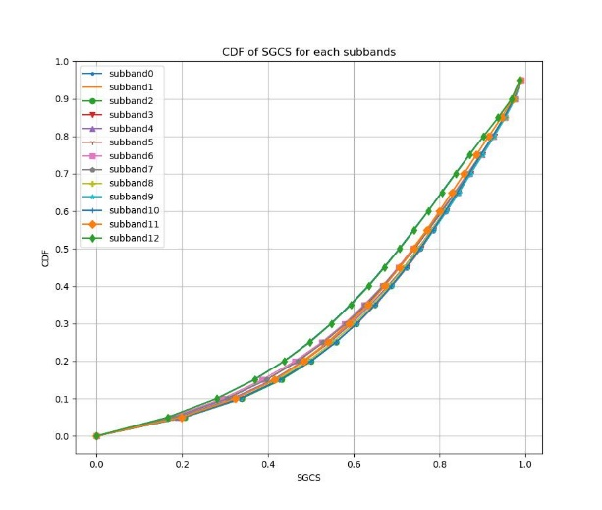  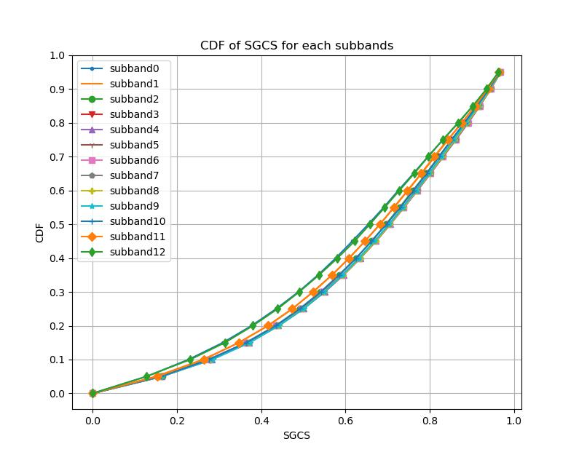  Figure 1. The CDF curves of SGCS values for each subbands for CNN-based encoder/decoder without quantization (left) and with scalar quantization (right).  Observation 4: The CDF curves of the largest eigen value of the channel matrix of training data for each subbands are provided in the following figure.  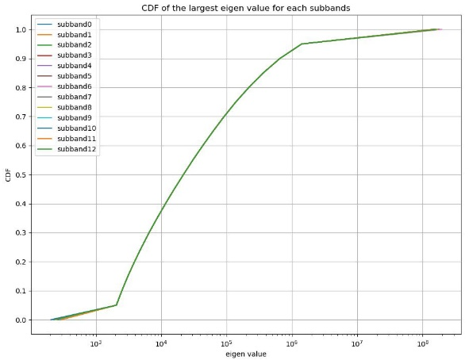  Figure 2. The CDF curves of the largest eigen value of the channel matrix of training data for each subbands.  Discussion on Test decoder Option 4  Observation 5: The feasibility of Option 4b depends upon the confirmed feasibility of Option 3.  Observation 6: For Option 4a, if the training data set (including enough amount of data for raw CSI and compressed bit strings) is specified in 3GPP standard, Option 4a can be regarded as the standardized training dataset.  Proposal 4: If Option 4 is selected, among three sub-options, Option 4a is preferred by assuming:  - TE vendor will not share decoder directly to other vendors (DUT and/or infra vendors);  - Parameters that need to be specified for defining test decoder shall include:  Training data set for TE decoder training, including enough amount of data for raw CSI and compressed bit string.
   | Corresponding model file name | Overall SGCS performance
  CNN-based encoder/decoder without quantization | samsR4_113mlec_NQ.onnx  samsR4_113mldc_NQ.onnx | 0.6872
  CNN-based encoder/decoder with scalar quantization | samsR4_113mlec_SQ.onnx  samsR4_113mldc_SQ.onnx | 0.6459
R4-2418455 | CMCC | Proposal 1: for option 3 feasibility strudy, the decoders can be selected randomly.  Proposal 2: it is proposed to discuss if option 3 is feasible, whether option 4 is still needed.
R4-2418523 | Apple | Observation 1: Simulation results comparing SGCS between AI/ML and e-typeII are captured below:  Observation 2: We observe a tendency for overfitting when we train the AI/ML model. This can be observed by the continuous improvement of the training error and the saturation of the testing error.  Observation 3: Edge sub-bands seem to have the worst performance in terms of SGSS for the AI/ML model  Observation 4: Significant performance differences are observed (in SGCS) across different simulation assumptions for Option 3 test decoder  Proposal 1: Each company to report training/testing results across training epochs. If overfitting is consistently observed, investigate the sources of overfitting  Proposal 2: Each company to report cdf plots of the testing data per SGCS. Based on these results investigate if there is a tendency for the edge sub-bands to perform worse.  Proposal 3: To better understand the relative gains of AI/ML compared to type-II SGCS in adapting optimized simulation parameters for feasibility analysis, we propose conducting a related study. This will help pave the way for simulation alignment and for the definition of performance requirements. We have identified two parameters for optimization:  - Learning rate (it could be adaptive)  - Phase normalization of the eigenvectors  - Increasing the data size remedies tendency to overfit  Proposal 5: RAN4 to employ the procedures shown in the flowchart for studying the feasibility analysis of test decoder Option 3. (It captures both Option 1 and Option 2)  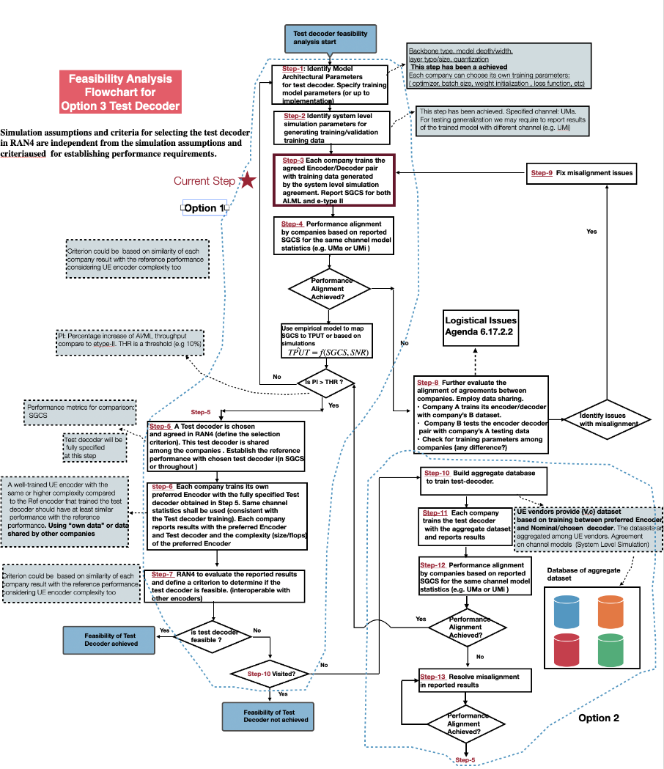  Proposal 6: The following criteria should establish the feasibility of the test decoder:  - The test decoder (along with the encoder) should deliver reasonable throughput performance gain compared to e-type II in ideal conditions. RAN4 to extend the feasibility analysis to higher ranks and different payload sizes to determine consistency of performance improvement. FFS on how to quantify the acceptable performance gain. (performance-complexity tradeoff)  - All UE preferred encoders should be aligned (work well) with the chosen test decoder  Proposal 7: The following principles should guide the establishment of the alignment aspect of the feasibility analysis (steps 6-7):  - A well-trained UE encoder with the same or higher complexity compared to the Ref encoder that the test decoder was trained with, should have at least similar performance with the reference performance. (in throughput)  FFS on how to define a criterion for the similarity/dissimilarity of all companies' performance results with respect to the reference performance, considering UE encoder complexity as well  Proposal 8: RAN4 to define a criterion to select a test decoder among all the test decoders reported after performance alignment is achieved (step 5). The criterion could be based upon:  - Each company tests its trained pair of {Encoder, test decoder) with other companies testing data set. Chose the pair (and therefore test decoder) that has the best performance averaged across other’s companies datasets.  Proposal 9: According to the flowchart, RAN4 should first evaluate feasibility analysis with Option 1 and proceed to Option 2 (aggregated dataset) if Option 1 does not produce a feasible test decoder  Proposal 10: RAN4 to employ the procedures shown in the flowchart for studying the feasibility analysis of test decoder Option4 based on the aggregate dataset and database of test decoder models. (Proposed Option 5 for partially specified test decoder)  - The architecture of the test decoder is partially specified through some high-level parameters (to be agreed) while leaving room for vendor specific implementations  - Interested companies implement a test decoder according to the partially specified agreement  - The partially specified test decoder is trained from an aggregate data set of UE encoder latent space distributions (dataset is stored in a server). Multiple test decoders are trained from participating companies. The test decoders are stored in a database.  - Each UE vendor tests its own preferred Encoder with the test decoders stored in the database  - Analysis of results to determine feasibility of test decoder  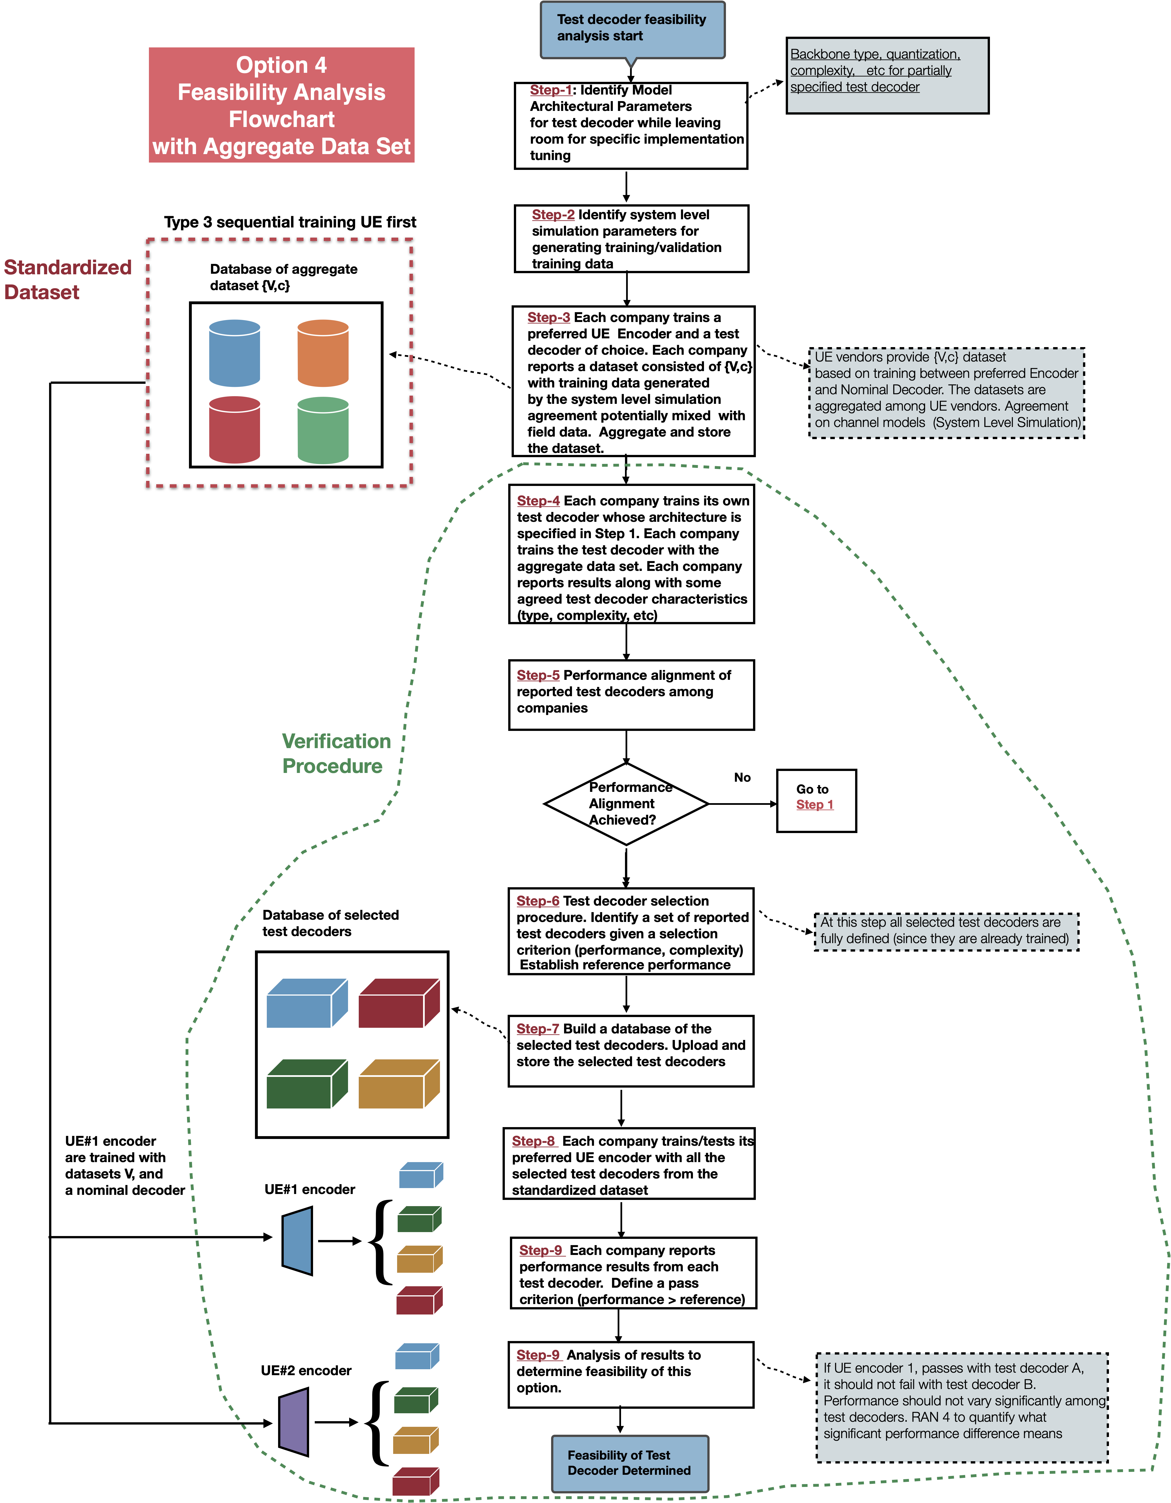  Proposal 11:  Consider the following aspects regarding the different conditions for testing generalization for CSI AI/ML use:  - Various antenna port layouts, e.g., (N1/N2/P) and/or antenna port numbers (e.g., 32 ports, 16 ports)  - Various antenna spacings (e.g., 0.5 lambda, 0.8 lambda, etc)  - Various antenna virtualization (TxRU mapping)  - Various carrier frequencies and bands (e.g., 2GHz, 4.0GHz)  - Various outdoor/indoor UE distributions for UMa/Umi  - Various UE speeds.  Consider the following aspects regarding the scalability aspect for generalization testing for CSI AI/ML use:  - Various bandwidths (e.g., 20MHz, 50MHz) and/or frequency granularities, (e.g., size of subband), different layers  - Various sizes of CSI feedback payloads
  SGCS | Encoder/Decoder
  0.698 (Relative improvement 1.9%) | AI/ML (64 bits)
  0.685 | e-type II (configuration 1, 62 bits)
R4-2418748 | vivo | Observation 1: From initial results for field test, the generalization performance of AI/ML model trained by UMa simulation data on field data seems acceptable, which has similar performance as eType II codebook. The generalization performance of AI/ML model trained by CDL simulation data on field data is worse than AI/ML model trained by UMa simulation data.  Observation 2: From initial results of field test, it is observed that  - Directly use reference model in field (Case 2): similar performance on field data as eType II for one cell and performance loss compared to eType II is observed for another cell.  - Finetuned encoder or decoder using field data against reference decoder/encoder (Case 2A-1, Case 2A-2): performance improved compared to directly use reference model (Case 2), but still has performance loss compared to fully trained by field data (Case1). Finetuned decoder (Case 2A-2) is better than finetuned encoder (Case 2A-1).  - Pairing of finetuned encoder and finetuned decoder (Case 2A-3, Case 2A-4): performance loss in some cases considering mismatch on training data between UE and NW.  Proposal 1: To achieve better field performance, the reference model should at least include the encoder part.  Proposal 2: Reference encoder needs to be specified, due to the following aspects:  - To be used as verification encoder in the TE test decoder verification.  - No extra training procedure to train the verification encoder will be needed.  - No performance degradation from imperfectly matched verification encoder will be caused.  - To achieve better field performance.  - To facilitate Rel-19 AI/ML study for reference model in RAN1 and RAN4.  Proposal 3: In Option 4a-1 (the specified dataset is generated by the aligned reference encoder and reference decoder), the model structure needs to be specified, to guarantee the performance of test decoder.  Proposal 4: In Option 4a-1 (the specified dataset is generated by the aligned reference encoder and reference decoder), dataset of raw channel or encoder input needs to be aligned, by aggregating the dataset of raw channel or encoder input from all companies, or choosing one dataset of raw channel or encoder input from all companies.  Proposal 5: The feasibility of Option 4a-2 (the specified dataset is aggregated by the datasets provided by all companies) could not be concluded, since at least the encoder from aggregated dataset could not work.  Proposal 6: In Option 4b (reference encoder based), channel generation method and reference decoder structure need to be in the spec.  Proposal 7: There is no essential difference between reference model and reference dataset. Reference dataset may have some disadvantages compared to reference model, and the benefit of reference dataset over reference model is unclear.  - Reference dataset would cause some performance loss compared to reference model.  - The spec impact of writing model and dataset in the spec would be similar.  - Reference dataset needs extra step compared to reference model, which is dataset generating from the aligned reference encoder and reference decoder.  - The storage size of reference dataset is larger than reference model.  - Reference model is more flexible than referend dataset for future release.  Proposal 8: Reference encoder and reference decoder are needed for requirement derivation, and could largely be used for test decoder derivation for both Option 3 and Option 4 (Option 4a-1 and Option 4b). RAN4 to work on reference encoder and reference decoder firstly. Later to discuss what will be put in the spec.  Proposal 9: Similar feasibility conclusion through the simulation campaign of test options can be draw for both Option 3 and Option 4 (Option 4a-1 and Option 4b).  Proposal 10: One test decoder could be used for one test case or multiple test case.  Proposal 11: Different reference encoder may be defined for different requirement or test case.  Proposal 12: Option 3 next steps for RAN4#113:  - Select one or more decoder for further analysis  - selection criteria: select the decoder from the encoder and decoder pair, which has the best SGCS performance on the aggregated dataset with only encoder input.  - If there are multiple encoder and decoder pair has similar SGCS performance, one pair could be chosen randomly.  - Company brings results for training of “own encoder” with selected decoder(s)  - performance alignment to be checked/discussed  - using “own” data or data shared by other companies  - Conclude on overall feasibility of Option 3  - consider the conditions under which Option 3 is feasible if found feasible  - feasibility criteria: nearly all companies can obtain acceptable performance using their “own encoder” paired with selected decoder(s).  Proposal 13: Option 4a-1 next steps for RAN4#113:  - Select one or more dataset(s) for further analysis  - selection criteria: select the dataset generated from the encoder and decoder pair, which has the best SGCS performance on the aggregated dataset with only encoder input.  - If there are multiple encoder and decoder pair has similar SGCS performance, one pair could be chosen randomly.  - Company brings results for training of “own encoder and decoder” with selected dataset(s)  - performance alignment to be checked/discussed  - using “own” training method or training method shared by other companies  - Conclude on overall feasibility of Option 4a-1  - consider the conditions under which Option 4a-1 is feasible if found feasible  - feasibility criteria: nearly all companies can obtain acceptable performance using their “own encoder and decoder” paired with selected dataset(s).  Proposal 14: Option 4b next steps for RAN4#113:  - Select one or more encoder for further analysis  - selection criteria: select the encoder from the encoder and decoder pair, which has the best SGCS performance on the aggregated dataset with only encoder input.  - If there are multiple encoder and decoder pair has similar SGCS performance, one pair could be chosen randomly.  - Company brings results for training of “own decoder” with selected encoder(s)  - performance alignment to be checked/discussed  - using “own” data or data shared by other companies  - Conclude on overall feasibility of Option 4b  - consider the conditions under which Option 4b is feasible if found feasible  - feasibility criteria: nearly all companies can obtain acceptable performance using their “own decoder” paired with selected encoder(s).  Proposal 15: The feasibility study of Option 3, Option 4a-1 and Option 4b could work in parallel.  Observation 3: Based on the aligned model structure and simulation assumptions, the SGCS of AI/ML model for 64 bits payload is 0.732, AI/ML model for 64 float value is 0.784, and the SGCS of eType II is 0.720. The CDF curve of SGCS is shown in Figure 2.4-1. The CDF of SGCS per sub-band is shown in Figure 2.4-2.  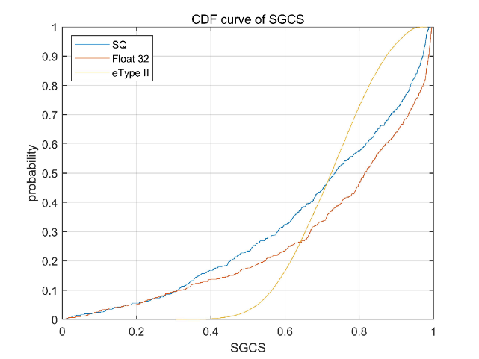  Figure 2.4-1. CDF curve of SGCS for aligned model structure and simulation assumptions  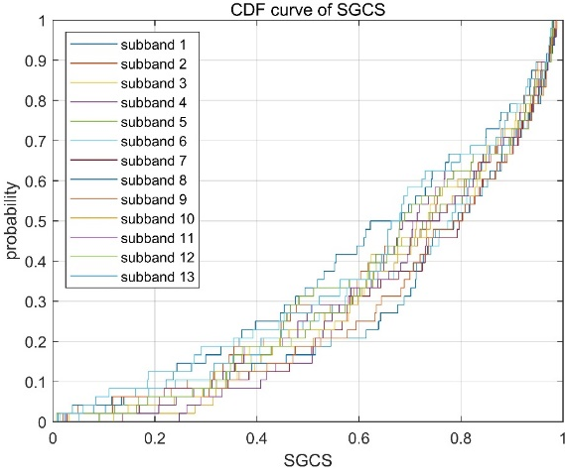  Figure 2.4-2. CDF curves of SGCS per sub-band for aligned model structure and simulation assumptions  Observation 4: It is seen that AI/ML model has better mean performance but worse variance performance, compared to eType II. The loss function for training may be further studied in the future.  Proposal 16: In future actual reference encoder and reference decoder design, RAN4 may consider smaller model, for the convenience of implementation.  Proposal 17: Using the mixed dataset for model training, including the mixing of TDL, CDL and UMa, while using the TDL dataset for RAN4 tests. Other mixing rules are not precluded.
   | eType II | AI/ML model  for 64 bits | AI/ML model  for 64 float value
  SGCS | 0.720 | 0.732 | 0.784
R4-2418898 | Intel Corporation | Proposal #1: Further align the AI/ML test methodology with RAN1's conclusions on inter-vendor training collaboration for AI/ML-based CSI compression.  Proposal #2: Randomly select 2-3 candidate decoder implementations for further feasibility analysis.  Proposal #3: Further study Option 4a under assumption that the following information is specified  - Channel dataset (encoder input / decoder output)  - Latent space dataset (encoder output / decoder input)  - Reference encoder/decoder  Deprioritize Option 4b.  Proposal #4: Consider the following steps for Option 4a feasibility analysis:  - Agree on simulation assumptions for Channel dataset generation  - Agree on reference AI-ML models (encoder/decoder) for Latent dataset generation  - Jointly train encoder/decoder models and generate Latent space dataset  - Share companies’ datasets (channel and latent)  - Select one or more datasets (channel and latent) for further analysis  - Each company brings results for training of own decoder / encoder  - Conclude on overall feasibility of Option 4  Proposal #5: Further discuss and define the upper bound complexity including the number of computations and number of parameters for test/reference encoders/decoders for the purpose of performance requirements definition.
R4-2418969 | Huawei,HiSilicon | Proposal 1: Use throughput as test metric for AIML-enabled CSI compression.  Observation 1: MLP is superior to CNN in terms of SGCS.  Observation 2: The complexity of MLP is lower than that of CNN.  Proposal 2: Principle of reference model design – complexity of reference model is one of the metrics for selecting reference model structure.  Proposal 3: Different model structures of encoder and decoder can be considered for reference model design, e.g., MLP for encoder while Transformer for decoder.  Proposal 4: Two options are identified for defining the alignment in step 1.  - Option 1: The SGCS margin is within x  - FFS: the value of x  - Option 2: The throughput margin is within y  - FFS: the value of y  Proposal 5: Take throughput performance gain into account for defining the criteria of overall feasibility for potential testing options.  Observation 3: The feasibility of option 4 is the same as that of option 3.  Proposal 6: If the overall feasibility of potential testing options can be verified, RAN4 will further discuss which part of the model would be specified if AI CSI compression turns to WI.  Observation 4: Simulation results on “CDF of SGCS per subband” are shown as follows:
   | Subband Index
  SGCS | 0 | 1 | 2 | 3 | 4 | 5 | 6 | 7 | 8 | 9 | 10 | 11 | 12
  10% | 0.30845 | 0.27375 | 0.34038 | 0.37372 | 0.36475 | 0.38757 | 0.36931 | 0.35864 | 0.36766 | 0.36948 | 0.31009 | 0.32433 | 0.2931
  20% | 0.47815 | 0.43784 | 0.5098 | 0.52712 | 0.53501 | 0.53393 | 0.52884 | 0.53134 | 0.53677 | 0.53963 | 0.49504 | 0.47263 | 0.43349
  30% | 0.59196 | 0.54526 | 0.61633 | 0.63551 | 0.62946 | 0.62649 | 0.63196 | 0.6452 | 0.63036 | 0.62901 | 0.60907 | 0.60082 | 0.55779
  40% | 0.66892 | 0.64265 | 0.68787 | 0.70451 | 0.69893 | 0.70278 | 0.70495 | 0.70379 | 0.70631 | 0.69691 | 0.68059 | 0.66754 | 0.65079
  50% | 0.73194 | 0.71328 | 0.75881 | 0.7641 | 0.76578 | 0.76497 | 0.766 | 0.76319 | 0.76345 | 0.75044 | 0.74466 | 0.74077 | 0.72246
  60% | 0.79371 | 0.78245 | 0.80597 | 0.81644 | 0.81316 | 0.81271 | 0.82132 | 0.81035 | 0.81731 | 0.81349 | 0.80159 | 0.79994 | 0.78306
  70% | 0.85553 | 0.84996 | 0.85984 | 0.86307 | 0.85668 | 0.85379 | 0.86335 | 0.85949 | 0.85785 | 0.86255 | 0.85127 | 0.85176 | 0.84311
  80% | 0.89908 | 0.89688 | 0.90545 | 0.90405 | 0.90852 | 0.90839 | 0.90672 | 0.9056 | 0.90698 | 0.90134 | 0.89995 | 0.89421 | 0.89026
  90% | 0.94292 | 0.94225 | 0.94426 | 0.94446 | 0.942 | 0.94314 | 0.94678 | 0.94813 | 0.94627 | 0.94601 | 0.94627 | 0.94144 | 0.94057
  Ave. | 0.65994 | 0.67945 | 0.69424 | 0.70712 | 0.70706 | 0.70599 | 0.70600 | 0.70302 | 0.70772 | 0.70641 | 0.70641 | 0.68208 | 0.66259
R4-2419093 | NTU | Proposal 1: Next steps for option 4a and 4b feasibility study:  Reuse the decoder/encoder pair derived in option 3 as the reference pair  Use the reference pair to generate dataset, or reuse any agreed dataset in option 3 discussion for option 4a, and use the encoder in the reference pair as the reference encoder for option 4b  Define the decoder verification criterion from one of the following options (for 4a and 4b, respectively):  (Option 4a: specify dataset)  - 4a-1: RAN4 derive the threshold $δ$ via simulation study (setup following option 3 discussion), and check whether it’s feasible to derive a test decoder satisfying  $\sum_{z∈Z}{f\left(g_{ref}(z),g_{test}(z)\right)}<δ,$  where $Z$ is the set of decoder inputs (latent messages) in the specified dataset (from step 2), and f is the chosen loss/similarity function $g_{ref}(z)$ is the test decoder output and $g_{test}(z)$ is from the dataset.  - 4a-2: RAN4 studies whether it is feasible to derive a test decoder satisfying  $$\left\|g_{ref}(z)-g_{test}(z)\right\|=\min_{y∈Y_{test}}\left\|g_{ref}(z)-y\right\| for all z∈Z$$  where the notations are the same as 4a-1, and $Y_{test}$ is the test decoder output space.  (Option 4b: specify reference encoder)  - 4b-1: RAN4 derive the threshold $δ$ and the encoder input X generation procedure via simulation study (setup following option 3 discussion), and check whether it’s feasible to derive a test decoder satisfying  $\sum_{x∈X}{f\left(g_{ref}(z(x)),g_{test}(z(x))\right)}<δ,$  where $z(x)$ is the reference encoder output (latent message) of encoder input x, and $X$ is the sampled encoder input in the test decoder verification procedures. Note that RAN4 needs to specified the generation procedures of X and specifying  - 4b-2: RAN4 studies whether it is feasible to derive a test decoder satisfying  $$\left\|g_{ref}(z)-g_{test}(z)\right\|=\min_{y∈Y_{test}}\left\|g_{ref}(z)-\hat{y}\right\| for all z∈Z$$  where $Y_{test}$ is the test decoder output space and Z is the reference encoder output space.  RAN4 check if the decoders derived from the above procedure can satisfy test repeatability requirement, i.e., the loss function delta between two different decoders when connecting to the same encoder, is within a RAN4 agreed margin. If yes, we can conclude that option 4 (at least one sub-option) is feasible.  Proposal 2: Next steps for feasibility study of option 4c  - Use the encoder input part of the dataset from option 3 feasibility study, derive the sample covariance matrix, and use principle component analysis to derive eigenvectors and eigenvalues.  - RAN4 decides how many dominant eigenvectors, and the number of quantization bits for the coefficients of eigenvectors (sum to the number of bits in the latent message) to include in indexing procedure in proposal 3.  - Companies propose any encoder-decoder pair, with the latent message reordering based on the procedures in proposal 3 and the dominant eigenvectors decided in step 1  - RAN4 check if the decoders derived from the above procedure can satisfy test repeatability requirement, i.e., the loss function delta between two different decoders when connecting to the same encoder (also following the latent message reordering procedure), is within a RAN4 agreed margin. If yes, we can conclude that option 4c is feasible.  Proposal 3: The latent message reordering procedure is in the following:  Step 1: Perform principle component analysis (PCA) on encoder input dataset, i.e., derive the SVD of the covariance matrix of the encoder input dataset.  Step 2: Select the eigenvectors corresponding to the M largest eigenvalues as dominant eigenvectors.  Step 3: Derive the coefficients of each of the decoder output on the (incomplete) basis composed of the selected M eigenvectors.  Step 4: Suppose the latent message length is N. Distribute the N bits to represent the coefficients of the M eigenvalues proportional to the magnitude of the corresponding eigenvalues.  Step 5: Quantize the coefficients to form the latent message corresponding to each decoder output. The mapping from the new latent message from these steps to the original latent message before reordering is added before decoder input. The mapping from the original encoder output to the new latent message from these latent messages is added to the encoder output.  Proposal 4: Additional margin to account for the mismatch $\left\|{\hat{x}}_{ref}(z)-{\hat{x}}_{test}(z)\right\|=\min_{\hat{x}∈{\overline{X}}_{test}}\left\|{\hat{x}}_{ref}(z)-\hat{x}\right\|$ need to be considered when determining requirement.  Proposal 5: Consider the test decoder selection criterion based on the agreed step, i.e., check whether performance alignment across contributing companies’ “own encoder”, which may have different structures, can be achieved.  Therefore, companies can bring the test decoder proposal together with performance metrics achieved when connecting to different encoders with different structures, e.g., the structure options for test decoder discussion, but trained with the decoder input and output dataset from the proposed decoder.
R4-2419171 | ZTE Corporation, Sanechips | Observation 1. Based on the CDF curves of each subband, it can be found that the performance of the edge is relatively poor.  Observation 2. RAN4 needs to build a strict guidelines to govern process for Release 19 for AI compression test metric.  Observation 3. If RAN4 would like to study feasibility for CSI compression, new regulations should be considered for AI/ML-based KPI.  Proposal 1. RAN4 may need to investigate how large of a span can be considered aligned results.  Proposal 2. RAN4 could check the throughput to prove whether the SGCS is aligned.  Proposal 3. Random selection, as long as performance is similar it does not matter which decoder is selected.  Proposal 4. To consider reference encoder based method, and training datasets need to be specified.  Proposal 5. Option 4a next steps:  - Discuss the system level simulation parameters for generating training dataset, discuss the framework of the test decoder, e.g. backbone, quantization, and leaving some flexibility for test decoder. Companies report the own training dataset and store them as aggregated datasets.  - Companies train their own encoder based on the aggregated datasets and test decoder. Check on performance alignment see simulation results from contributing companies.  - repeat simulations until good alignment is achieved  - move to next step after alignment  - Share models (encoder and /or decoder ) or datasets (training/testing/inference)  - Select one or more datasets for further analysis  - selection criteria is TBD  - Companies bring results for “own encoder and decoder” with selected dataset  - performance alignment to be checked  - Conclude Option 4a feasibility  - feasibility criteria to be discussed  Proposal 6. Option 4b next steps:  - Discuss the system level simulation parameters for generating training dataset, discuss the framework of the test decoder, e.g. backbone, quantization, and leaving some flexibility for test decoder.  - Companies train test decoder based on the own datasets and reference encoder. Check on performance alignment see simulation results from contributing companies.  - repeat simulations until good alignment is achieved  - move to next step after alignment  - Share models (encoder and /or decoder ) or datasets (training/testing/inference)  - Select one or more encoders for further analysis  - selection criteria is TBD  - Companies bring results for “own encoder and decoder” with selected encoder  - performance alignment to be checked  - Conclude Option 4b feasibility  - feasibility criteria to be discussed
R4-2419178 | Nokia | The following Observations and Proposals were made:  - As shown in Tables 2-4 above, the trained reference encoder-decoder pairs exhibited dataset dependency, indicating that a model trained on a single dataset may not perform well on other datasets, even under identical scenario settings. Training on a mixed dataset significantly enhances the model’s generalization ability, with larger mixed datasets yielding better performance.  On Option 3:  - RAN4 to use an aggregated dataset of eigenvectors {V} for training and comparison of the performance of encoders/decoders provided by the companies.  - Aggregated dataset should be created by taking A first sample from each of the contributing datasets, where A = 600 000 / n, and n is the number of contributing datasets.  - A single decoder demonstrating SGCS performance closest to be average across companies on aggregated dataset can be selected for the further study as a test decoder.  - “Own encoders” should be trained on the company-specific dataset.  - “Own encoders” trained for the selected test decoder should not follow the agreed CNN architecture internally. The output size and quantization should be kept the same.  - It should be confirmed that the performance of “own” encoder is not worse than the performance of the CNN-based encoder.  The encoder trained based on known test decoder and company own dataset can demonstrate difference performance on different datasets/channel implementations coming from different test equipment vendors.  - To conclude about the feasibility of Option 3, RAN4 needs to ensure that there is no significant performance (SGCS) variation in between “own” encoder – test decoder(s) in datasets from different companies.  - RAN4 would need to check the span of the throughput-based test metric in between the companies to conclude about the success of Option3 feasibility study.  - Create a fixed aggregated dataset based on companies’ contributions and train the decoder based on this dataset  - Compare the performances and select single decoder, e.g., demonstrating average performance.  - Each company brings results for training of “own encoder” with selected decoder  - Training is done using “own” dataset  - It is verified that the performance of “own encoder” is not worse than for the agreed CNN-based encoder  - Conclude on overall feasibility of Option 3  - The performance variation across the companies and datasets are within certain limits  - The throughput-based performance metric variations are within certain limits  - RAN4 to consider the steps 3-5 above to continue the feasibility check of Option 3.  On Option 4:  The first two steps of the feasibility study procedures for Options 3, 4a, and 4b can be shared, utilizing the same reference encoder and decoder.  The reference encoder and decoder obtained in the first two steps of the feasibility study procedures for Options 3, 4a, and 4b are utilized for different purposes in each of the procedures.  There are common processes used in the development and evaluation of the UE encoders across the feasibility study procedures for Options 3, 4a, and 4b.  - Share the agreed reference encoder and decoder across the feasibility study procedures for Options 3, 4a, and 4b, utilizing those in a manner appropriate for each option.  - In Option 4a, CNN-based encoder and test decoder pair from Option 3 can be used to generate the common dataset (that includes latent messages) based on aggregated dataset  - In Option 4b, CNN-based encoder matching the selected test decoder from Option 3 can be used.
R4-2419179 | Nokia
R4-2419345 | Ericsson | Observation 1 One or more example test decoder(s) need to be selected.  Observation 2 The number of selected test decoder(s) should not be so many that an excessively large amount of simulation effort is needed to compare all of them.  Observation 3 If other companies cannot train an encoder to interoperate with one example test decoder, this may not entirely disprove option 3. It may be that for some reason the test decoder is a “bad” decoder.  Based on the discussion in the previous sections we propose the following:  Proposal 1 List [4] example test decoders in priority order. Evaluation of option 3 can take place according to the flowchart below.  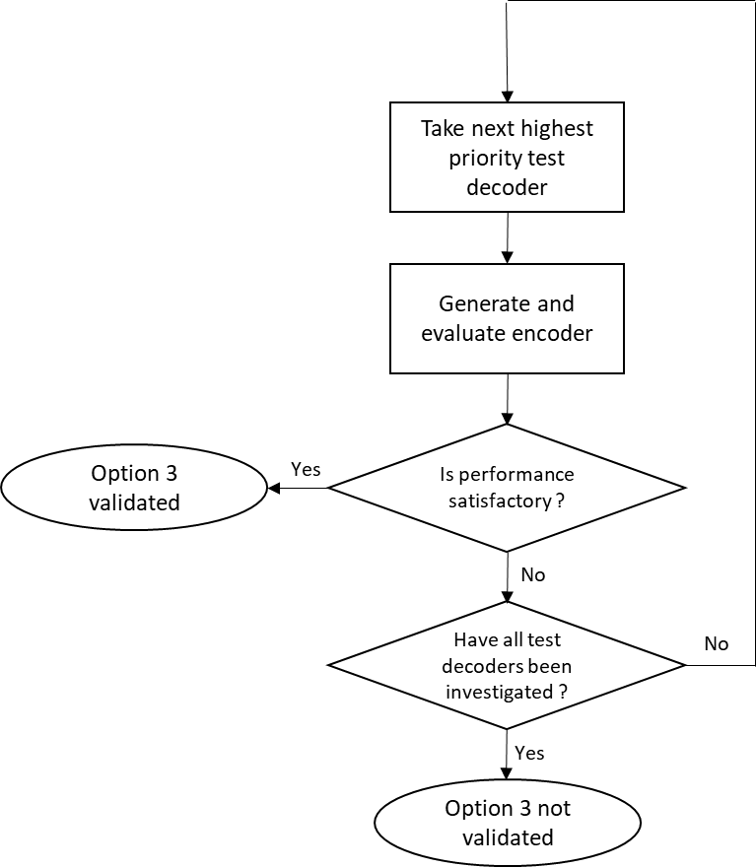  Proposal 2 Companies are encouraged to consider several test decoders in order to increase knowledge on whether there is variation in performance depending on the selected test decoder.  Proposal 3 Based on largest Eigenvalue CDFs, identify if there are “training set outliers”. Aim to select test decoders based on training datasets that are not outliers.  Proposal 4 Based on SCGS CDFs, identify if there are unusual or “outlier” CDFs. Aim to select test decoders from SCGS CDFs that are not outliers.  Proposal 5 After excluding outliers, prioritize decoders based on highest absolute [mean] SCGS.  Proposal 6 RAN4 to discuss whether the “test decoders” generated for option 4 should assume the same structure and training as already agreed, or could have a different structure.
R4-2419365 | NTU | Proposal 1: Next steps for option 4a and 4b feasibility study:  Reuse the decoder/encoder pair derived in option 3 as the reference pair  Use the reference pair to generate dataset, or reuse any agreed dataset in option 3 discussion for option 4a, and use the encoder in the reference pair as the reference encoder for option 4b  Define the decoder verification criterion from one of the following options (for 4a and 4b, respectively):  (Option 4a: specify dataset)  - 4a-1: RAN4 derive the threshold $δ$ via simulation study (setup following option 3 discussion), and check whether it’s feasible to derive a test decoder satisfying  $\sum_{z∈Z}{f\left(g_{ref}(z),g_{test}(z)\right)}<δ,$  where $Z$ is the set of decoder inputs (latent messages) in the specified dataset (from step 2), and f is the chosen loss/similarity function $g_{ref}(z)$ is the test decoder output and $g_{test}(z)$ is from the dataset.  - 4a-2: RAN4 studies whether it is feasible to derive a test decoder satisfying  $$\left\|g_{ref}(z)-g_{test}(z)\right\|=\min_{y∈Y_{test}}\left\|g_{ref}(z)-y\right\| for all z∈Z$$  where the notations are the same as 4a-1, and $Y_{test}$ is the test decoder output space.  (Option 4b: specify reference encoder)  - 4b-1: RAN4 derive the threshold $δ$ and the encoder input X generation procedure via simulation study (setup following option 3 discussion), and check whether it’s feasible to derive a test decoder satisfying  $\sum_{x∈X}{f\left(g_{ref}(z(x)),g_{test}(z(x))\right)}<δ,$  where $z(x)$ is the reference encoder output (latent message) of encoder input x, and $X$ is the sampled encoder input in the test decoder verification procedures. Note that RAN4 needs to specified the generation procedures of X and specifying  - 4b-2: RAN4 studies whether it is feasible to derive a test decoder satisfying  $$\left\|g_{ref}(z)-g_{test}(z)\right\|=\min_{y∈Y_{test}}\left\|g_{ref}(z)-\hat{y}\right\| for all z∈Z$$  where $Y_{test}$ is the test decoder output space and Z is the reference encoder output space.  RAN4 check if the decoders derived from the above procedure can satisfy test repeatability requirement, i.e., the loss function delta between two different decoders when connecting to the same encoder, is within a RAN4 agreed margin. If yes, we can conclude that option 4 (at least one sub-option) is feasible.  Proposal 2: Next steps for feasibility study of option 4c  - Use the encoder input part of the dataset from option 3 feasibility study, use principle component analysis to derive eigenvectors and eigenvalues of the encoder input dataset.  - RAN4 decides how many dominant eigenvectors, and the number of quantization bits for the coefficients of eigenvectors (sum to the number of bits in the latent message) to include in indexing procedure in proposal 3.  - Companies propose any encoder-decoder pair, with the latent message reordering based on the procedures in proposal 3 and the dominant eigenvectors decided in step 1  - RAN4 check if the decoders derived from the above procedure can satisfy test repeatability requirement, i.e., the loss function delta between two different decoders when connecting to the same encoder (also following the latent message reordering procedure), is within a RAN4 agreed margin. If yes, we can conclude that option 4c is feasible.  Proposal 3: The latent message reordering procedure is in the following:  Step 1: Perform principle component analysis (PCA) on encoder input dataset, i.e., derive the SVD of the covariance matrix of the encoder input dataset.  Step 2: Select the eigenvectors corresponding to the M largest eigenvalues as dominant eigenvectors.  Step 3: Derive the coefficients of each of the decoder output on the (incomplete) basis composed of the selected M eigenvectors.  Step 4: Suppose the latent message length is N. Distribute the N bits to represent the coefficients of the M eigenvalues proportional to the magnitude of the corresponding eigenvalues.  Step 5: Quantize the coefficients to form the latent message corresponding to each decoder output. The mapping from the new latent message from these steps to the original latent message before reordering is added before decoder input. The mapping from the original encoder output to the new latent message from these latent messages is added to the encoder output.  Proposal 4: Additional margin to account for the mismatch $\left\|{\hat{x}}_{ref}(z)-{\hat{x}}_{test}(z)\right\|=\min_{\hat{x}∈{\overline{X}}_{test}}\left\|{\hat{x}}_{ref}(z)-\hat{x}\right\|$ need to be considered when determining requirement.  Proposal 5: Consider the test decoder selection criterion based on the agreed step, i.e., check whether performance alignment across contributing companies’ “own encoder”, which may have different structures, can be achieved.  Therefore, companies can bring the test decoder proposal together with performance metrics achieved when connecting to different encoders with different structures, e.g., the structure options for test decoder discussion, but trained with the decoder input and output dataset from the proposed decoder.
R4-2419749 | Qualcomm Incorporated | Observation 1: The mean SGCS of CNN based model and eTypeII based on latest simulation assumptions are shown below (same as our contribution in RAN4 112bis)  Observation 2: The next step to study the feasibility of option 3 would be to select one or more decoders for further analysis.  Observation 3: It is more reliable to select multiple decoders for analysis.  Proposal 1: Select three decoders for feasibility study of option 3.  - The three decoders can be selected based on best, worst and median performance among the ones that got submitted to RAN4 #112bis.  - RAN4 down-selects the benchmark for performance to select decoders from the following two options:  - Absolute SGCS with quantization  - Relative improvement of SGCS with respect to eTypeII performance.  Proposal 2: Option 4b is suggested to be modified in the following way (modifications are shown in blue):  - 4b: Reference encoder and reference decoder based: encoder is documented in the specifications, used to derive a decoder to be implemented by TE vendors. Reference decoder is documented in the specifications, used by UE to train its encoder.  - FFS whether training dataset (channel information) needs to be specified
  Method | Mean SGCS  (across samples and subbands) | Median SGCS  (across samples and subbands)
  CNN encoder – CNN decoder without quantization | 0.74 | 0.8
  CNN encoder – CNN decoder with quantization | 0.683 | 0.73
  eTypeII | 0.67 | --

Open issues summary
The open issues were grouped in the following sub-topics for further discussion:
- Option 3 simulation results for 2nd round
- Option 3 next step for 2-sided model
- Option 4a next steps
- Option 4b next steps
- Option 4c next steps
- Reference encoder and/or dataset for Option 3, test decoder verification

Sub-topic 1-1
Option 3 simulation results for 2nd round
Issue 1-1: Simulation results discussion
- Proposals
  - Option 1: See simulation results in the table below.
- Recommended WF
Further discuss simulation results including the new data submitted to check alignment

Sub-topic 1-2
Option 3 next step for 2-sided model
The next step for option 3 is to select one or more decoders from the ones submitted by companies such that other companies can try to train an encoder to work with it.
Issue 1-2: Option 3 next step - decoder(s) selection
- Proposals
  - Option 1: Select 3 decoders: with highest, lowest and closest to mean relative performance gain in SGCS over eTypeII decoder.
  - Option 2: Select 3 decoders ranodmly
  - Option 3: Select more than 3 decoders
    - Evenly distributed in performance?
  - Option 4: Select decoders after excluding any models for which the training dataset or SGCS CDFs appear to be outliers compared to others
  - Option 5: Select the decoder(s) from the encoder and decoder pair(s) which has the best SGCS performance on the aggregated dataset with only encoder input.
- Recommended WF
  - To be discussed

Sub-topic 1-3
Option 4a for 2-sided model
Option 4 was further split into 4 sub-options in the previous meeting in R4-2414323. The next steps on feasibility study for these options should be discussed
Issue 1-3: Option 4a(Dataset based) for 2-sided model
- Proposals
  - Option 1: Next steps:
      - Discuss/decide how to generate the training dataset and other assumptions
- need to align the ML model, what should the dataset contain (channel/eigenvector realization, etc), how to generate the dataset (aggregate dataset based on inputs from multiple companies, etc)
      - {encoder input, encoder output w/quantization}
      - {channel data, latent message}
      - Others?
- reuse the same assumptions/dataset from Option 3 study?
      - Check on performance alignment see simulation results from contributing companies
- repeat simulations until good alignment is achieved
- move to next step after alignment
- reuse Option 3?
      - Share models (encoder and/or decoder)/datasets (training/testing/inference) (sharing framework is currently under discussion)
        - Reuse Option 3?
      - Select one or more datasets for further analysis
- Selection criteria is TBD
      - Companies bring results for “own encoder and decoder” with selected dataset
- performance alignment to be checked (
      - Conclude Option 4a feasibility
    - feasibility criteria to be discussed (e.g. Perform testing of all the UE encoders using all test decoders (replicating the process of testing UE’s against RAN4 requirements with different TE vendor decoders, others given in R4-2415376, etc ).
  - Option 2:
    - Step 1-3: Reuse results of Option 3
    - Step 4: Select one or more dataset(s) for further analysis
      - Selection criteria: select the dataset(s) generated from the selected encoder and decoder pair(s) from Option 3.
    - Step 5: Company brings results for training of “own encoder(s) and decoder(s)” with selected dataset(s)
      - Performance alignment to be checked/discussed
    - Step 6: Conclude on overall feasibility of Option 4a
      - Feasibility criteria to be discussed

- Recommended WF
  - To be discussed
The steps should be discussed and if any changes and/or additions are needed
To be clarified: whether “own decoder” in step 5 is expected to have the agreed structure or could be different (in order to investigate whether the specification needs to capture a decoder structure for option 4a or not). This would apply to any 4b also.
Include also: Selected test decoder and matching encoder pair from Option 3 can be used to generate the common dataset (that includes latent messages) based on aggregated/mixed dataset

Sub-topic 1-4
Option 4b for 2-sided model
The next steps on feasibility study for option4b should be discussed, these are likely very similar to option 4a
Issue 1-4: Option 4b(Reference encoder based) for 2-sided model
- Proposals
  - Option 1: Next steps:
      - Discuss/decide how to generate the training dataset and other assumptions, including the encoder model
- need to align the decoder assumptions, dataset derivation assumptions, reference encoder/decoder as needed, etc
- reuse Option 3 assumptions/data?
      - Check on performance alignment see simulation results from contributing companies
- repeat simulations until good alignment is achieved
- move to next step after alignment
- reuse Option 3 ?
      - Share models (encoder and/or decoder)/datasets (training/testing/inference) (sharing framework is currently under discussion)
        - Reuse Option 3?
      - Select one or more encoder for further analysis
- Selection criteria is TBD
      - Companies bring results for “own encoder and decoder” with selected encoder
- performance alignment to be checked
      - Conclude Option 4b feasibility
- feasibility criteria to be discussed
      - e.g Perform testing of all the UE encoders using all test decoders (replicating the process of testing UE’s against RAN4 requirements with different TE vendor decoders).
      - others
  - Option 3:
  - Step 1-3: Reuse results of Option 3
  - Step 4: Select one or more encoder(s) for further analysis
    - Selection criteria: select the encoder(s) from the selected encoder and decoder pair(s) of Option 3.
  - Step 5: Company brings results for training of “own decoder(s)” with selected encoder(s)
    - Performance alignment to be checked/discussed
  - Step 6: Conclude on overall feasibility of Option 4b
    - Feasibility criteria to be discussed
  - Others
- Recommended WF
  - To be discussed
The steps should be discussed and if any changes and/or additions are needed
Next step: Re-use CNN-based encoder matching the selected test decoder from Option 3 to train possible test decoders.

Sub-topic 1-5
Option 4c for 2-sided model
The next steps on feasibility study for option4c should be discussed
Issue 1-5: Option 4c(decoder output ordering) for 2-sided model
- Proposals
  - Option 1: Next steps for Option 4c:
1. Use the encoder input part of the dataset from option 3 feasibility study, derive the sample covariance matrix, and use principle component analysis to derive eigenvectors and eigenvalues.
2. RAN4 decides how many dominant eigenvectors, and the number of quantization bits for the coefficients of eigenvectors (sum to the number of bits in the latent message) to include in indexing procedure in proposal 3.
3. Companies propose any encoder-decoder pair, with the latent message reordering based on the procedures in proposal 3 and the dominant eigenvectors decided in step 1
4. RAN4 check if the decoders derived from the above procedure can satisfy test repeatability requirement, i.e., the loss function delta between two different decoders when connecting to the same encoder (also following the latent message reordering procedure), is within a RAN4 agreed margin. If yes, we can conclude that option 4c is feasible.
Latent message reordering procedure as proposed in R4-24019093 (Steps 1-5 in Proposal 3
  - Option 2: Others
- Recommended WF
  - To be discussed
The steps should be discussed and if any changes and/or additions are needed

Sub-topic 1-6
Reference encoder documentation
Several companies brought up the need to document a reference encoder for several of the options. This could be needed for different purposes (performance evaluation, TE verification procedure, decoder derivation, etc)
Issue 4-3: Reference encoder and/or training dataset
- Proposals for parameters that should be agreed upon:
  - Option 1: A reference encoder will need to be documented(e.g. in a TR) irrespective of the Option chosen, in case one of the options will every be specified
  - Option 2: Postpone the discussion until the feasibility is concluded
  - Option 3: Postpone the discussion until the need becomes clear
  - Option 4: others
- Recommended WF
  - Option 2

Topic #2: Testability and interoperability issues for CSI Prediction
This section contains the sub-topics regarding specific issues for CSI prediction.

Companies’ contributions summary
T-doc number | Company | Proposals / Observations
R4-2417616 | CAICT | Proposal 1: Suggest to consider TDL channel as starting point for CSI prediction tests.  Proposal 2: For performance test of CSI prediction, suggest to take static condition as default assumption.  Observation 1: Two possible alternations for introducing non-static conditions in generalization test:  - Alt 1: the conditions are randomly changed  - Alt 2: the conditions are sequentially changed in predefined order.  Proposal 3: Further discuss whether and how to introduce non-static conditions in generalization test.  Proposal 4: Check the applicability of the agreements for ground truth drawn under BM case to CSI prediction.  Proposal 5: If taking random precoding as baseline for relative throughput, discuss following two options  - Option 1: use TypeI single panel codebook for random precoding  - Option 2: use the same codebook as prediction for random precoding  Proposal 6: Suggest to discuss taking UE reported precoder generated from measurement as baseline for relative throughput. FFS the specific test procedure (e.g., as illustrated in figure 1 and 2).
R4-2417702 | CATT | Proposal 1: Performance of AI/ML based CSI prediction should be better than legacy performance requirement.  - The legacy performance requirement is the requirement for R18 CSI prediction.  Proposal 2: RAN4 to use TDL model for testing and static condition (similar to legacy test).
R4-2417805 | MediaTek inc. | Observation #1: Existing PMI reporting tests use random PMI of Type I codebook as reference throughput.  Proposal #1: Use random PMI of Type I codebook as reference throughput in test metric for CSI prediction.  Observation #2: When defining Release 18 PMI prediction test requirements it was challenging to find test configuration that enables measurable PMI prediction gains over legacy baseline.  Proposal #2: We propose to use eType II non-predicting reporting as reference in test case definition to ensure test feasibility.  Observation #3: There are four existing PMI requirements for PMI prediction that can be used as starting point for Rel-19 work.  Observation #4: There is still room to improve existing test configuration to enable even better prediction gain.  Proposal #3: We propose to use existing eType II doppler codebook test configurations as a starting point for Rel-19 work.  Proposal #4: We propose to further study if existing eType II doppler codebook test configurations can be enhanced for better prediction opportunities.
R4-2418454 | CMCC | Proposal 1: for CSI prediction accuracy metrics for inference, the relative throughput is the throughput gain achieved with predicted PMI compared to random PMI.  Proposal 2: for CSI prediction, it is proposed to use intermediate KPI, e.g. SGCS, as requirements/tests metrics for LCM.
R4-2418524 | Apple | Observation 1: In the context of CSI prediction performance monitoring, RAN1 is already exploring a network-side mechanism that relies on UE-reported ground truth. This same approach can be utilized to evaluate the accuracy of CSI prediction as a performance KPI within RAN4  Proposal 1: The γ value comparing predicted PMI to random PMI can be used in the test for CSI prediction. To infer the gains of AI/ML-based CSI prediction, the γ values can be compared between AI/ML and non-AI/ML cases.  Proposal 2: Same mechanism used for NW-side performance monitoring can be employed for testing where the UE provides both the current channel information and the predicted channel information. Subsequently, the TE can calculate the SGCS by comparing the current channel from the latest report with the predicted channel from the previous report.
R4-2418750 | vivo | Observation 1: In non-AI CSI prediction, random precoding based on Type I Single Panel codebook has been agreed as the baseline throughput  Proposal 1: The baseline of AI CSI prediction could be the throughput from random precoding, which means that AI prediction and non-AI prediction could follow the similar test procedure. AI-prediction would have similar or higher gamma value compared to non-AI prediction.  Proposal 2: RAN4 to discuss simulation assumptions and reference model for AI CSI prediction.
R4-2418971 | Huawei,HiSilicon | Proposal 1: The baseline of the requirement in CSI prediction is the throughput that TE uses a random PMI.  Observation 1: How to ensure that the testing dataset aligns well with training dataset is still an open issue.  Proposal 2: RAN4 will start to discuss the test configuration after other WGs achieve sufficient progress.
R4-2418987 | Ericsson | Observation 1 The goal with the RAN4 requirement is not to demonstrate AI performance relative to performance with non-AI (“show a gain”), but it is to establish a minimum performance level for the AI/ML-based CSI (PMI) prediction.  Observation 2 It is important that monitoring can observe and quantify partial reduction in performance (not just a large or catastrophic loss).  Observation 3 It is non-trivial to ensure that a monitoring function can determine the performance of an AI model in isolation, since in the real world a very large number of interacting factors influence performance.  Observation 4 Monitoring requirements should define the constancy/accuracy of monitoring reports from the UE if they are defined.  Observation 5 Testability of monitoring report accuracy needs discussion, since the reliability of underlying models will differ between UEs and a test of accuracy needs to force UEs into known reliability levels.  Observation 6 For network sided monitoring, if the UE reports both predicted and measured CSI, there may be some need to consider setting conformance requirements on the performance of both measured and predicted when operating in this monitoring mode.  Based on the discussion in the previous sections we propose the following:  Proposal 1 For the performance metric, use throughput with AI predicted CSI (PMI) relative to random PMI with Rel-15 Type I Single-Panel Codebook.  Proposal 2 Study the variation of performance of CSI prediction with different channel model, SNR level, changes in SNR and Doppler.  Proposal 3 Depending on the results of the study, define sufficient requirement variations that proper model training is achieved, i.e., verify a model/functionality can perform well across variations in cell conditions.  Proposal 4 Consider whether to make conformance to CSI prediction with lower/higher Doppler scenario, according to RAN1 study.
R4-2419172 | ZTE Corporation, Sanechips | Observation 1. There is no difference in testing framework between legacy and AI/ML prediction.  Proposal 1. To consider the legacy predicted PMI as baseline throughput for AI based CSI prediction accuracy metric.  Proposal 2. For AI/ML based CSI prediction, the testing framework can reuse legacy testing procedures.
R4-2419181 | Nokia | - The RAN4 Demod requirements on Multiple PMI with 16Tx Enhanced Type II codebook for predicted PMI are defined for typeII-doppler-r18 codebook type, N4=1 and for TDLA30-20 channel conditions. The requirements are specified on (γ) - the throughput relative to the random precoding from typeI-SinglePanel codebook.  - RAN1 considered UE-side model only and assumed R18 eType II doppler codebook for CSI report for both AI/ML and Non AI/ML predictions.  - RAN4 to assume R18 eType II Doppler codebook for reporting AI/ML based CSI predictions. Correspondingly, R16 eType II codebook needs to be supported by the UE as well.  - RAN4 can start the discussion with a single AIML-based CSI prediction (N4=1).  RAN1 baseline scenario and model training uses UMa channel model according to TR 38.901.  - RAN4 to assume that the training of AI/ML CSI prediction model is done based on system-level scenario (e.g., based on UMa channel model according to TR 38.901).  Due to unrealistic spatial behavior of TDL models, CSI prediction would have only trivial outcomes: spatial characteristics of the channel either demonstrate always the same behavior for medium or high correlation, or random for - low correlation.  - RAN4 to consider Spatially Correlated Channel models (SCM) for the requirements/tests on AIML CSI prediction.  RAN1 has discussed two metrics (SGCS and user TPut) and two benchmarks (the nearest historical CSI and non-AI/ML based CSI prediction) for the evaluation of the gain of AIML -based CSI prediction. Additionally, performance monitoring, including a possibility of ground-truth reporting (Type 2), is under discussion but still lacking the details.  RAN4 does not need to use the metric from RAN1 that is based on closest historical CSI for the definition of the reference user throughput because just latest reported CSI can be used.  - RAN4 can consider further two possible baselines for AIML-enabled predicted CSI:  - Use throughput based on randomized typeI-SinglePanel codebook like in legacy tests  - Use throughput based on eTypeII codebook measured and reported by the UE (without prediction)  - RAN4 to verify the performance of AI/ML CSI feedback in the same test configuration/conditions as for eTypeII and/or eTypeII Doppler-r18.  - Since there is no reduction in measurements the AI/ML based CSI prediction performance should be better than the legacy (non-AI/ML based).  Non-static scenarios in RAN4 need to be considered to verify that there is no performance degradation while UE is autonomously switching in between different AI/ML models due to the change of radio conditions.  - RAN4 needs to define a test when some of conditions (e.g., channel type, SINR, speed/Doppler, etc.) change during the test without the change of the functionality.  - RAN4 should discuss the parameters in Table 4 to define the generalization scenarios for CSI prediction use case.  Less generalized functionalities across a set of scenarios can result in frequent switching of model/functionality resulting in performance degradation.  - RAN4 needs to design a new metric, indicative of generalization capabilities of AI/ML functionality, to verify it’s the generalization performance in different scenarios.  For UE-assisted or NW-based performance monitoring, if required LCM action is not taken in a timely manner, the performance of AI/ML-based CSI feedback may be degraded to undesirable levels.  - Use-case specific core requirements should be considered to limit latency of LCM actions (e.g. activation, deactivation, fallback, switching etc.) for AI/ML-enabled CSI prediction functionality.  - If localized models are considered for CSI prediction, RAN4 will need to study model ID-based LCM requirements for a given functionality.
R4-2419750 | Qualcomm Incorporated | Observation 1: PMI prediction related test cases of Rel-18, e.g., “Multiple PMI with 16Tx Enhanced Type II codebook for predicted PMI” (6.3.2.1.8 of [2]) use relative throughput as requirement metric. Random precoding-based throughput is used as the baseline in those test cases.  Proposal 1: RAN4 selects random precoding-based throughput as the baseline in the test cases for AI-ML based CSI prediction where relative throughput is used as requirement metric.  Proposal 2: The test case for AI-ML based CSI prediction can follow the flow of PMI prediction related test cases of Rel-18.

Open issues summary
The open issues were grouped in the following sub-topics for further discussion:
- Chanel model
- Reference throughput (Baseline performance) for comparison random PMI
- Testing condition static vs. non-static

Sub-topic 2-1
Channel model
Issue 2-1: Channel model for CSI prediction tests
Proposals
  - Option 1: TDL channel models
  - Option 2: Spatial channel models currently under study in RAN4
  - Option 3: others
- Recommended WF
  - Option 1
Vivo: OK to use TDL for test. For the requirement, we suggest to use mixed data set with CDL and TDL.
Ericsson: Not quite sure how we can differentiate CDL and TDL. We need define the model.
Samsung: for testing we support option 1. For model training, it depends on UE implementation. We do not care how UE can achieve that. Similar story for AI. How to do training is out of scope of discussions here. Finally we align the requirement does not depend on the aligned for data set for training.
OPPO: We also think option 1 can be used
Apple: Agree with Samsung. Vivo concern is that in case UE base the AI model on the TDL then the UE performance is too good. We should avoid that.
Qualcomm: We support the agreement. Similar view as Samsung. This is one set. The training is transparent. We can consider the generic requirement later.
Ericsson: We have concern on the sanity test issue.
Nokia: We also have the concern on the TDL model. When the prediction for Rel-18 is introduced, then AI testing is not meaningful. We think we should consider other alternative. We should consider CDL.
Samsung: For CDL model, we have other concern, which is related to Rel-19 SI. How can we handle it?
Mediatek: We should not consider CDL model in Rel-19 SI. For CSI Rel-19, TDL is the only solution.
ZTE: we have the same concern as Samsung.

Agreement:
- For channel model for CSI prediction tests, TDL channel models will be used.
  - FFS on whether CDL channel model is needed for generalization test.

Sub-topic 2-2
Reference throughput
RAN4 will have to agree on the reference throughput (baseline performance) to be compared with the throughput obtained based on the predicted CSI
Issue 2-2: Reference throughput
- Proposals
  - Option 1: reference throughput is obtained based on random PMI with Rel-15 Type I single panel codebook
  - Option 2: reference throughput is obtained based on eType II codebook measured and reported by the UE
  - Option 3: others
- Recommended WF
  - To be discussed

Qualcomm: Support option 1. We have similar case in Rel-18 for legacy. We can compare the performance.
Ericsson: Support option 1.
Vivo: Option 1.
Nokia: Option 2 is basically to provide the benefit verification. Both two can be supported. No too strong view.
OPPO: Option 1. For Option 2, if we choose eType II, the performance would be degraded.

Agreement:
- reference throughput is obtained based on random PMI with Rel-15 Type I single panel codebook

Sub-topic 2-3
Testing conditions
There are several proposal on what kind of testing conditions should be used in the tests
Issue 2-3: Testing conditions
- Proposals
  - Option 1: use static conditions
  - Option 2: non-static conditions
    - Which conditions change (e.g., SNR, speed/Doppler, channel type) and how (randomly, sequentially, etc.) is FFS
  - Option 3: use static conditions as baseline, use of non-static conditions for some generalization tests is FFS
  - Option 4: others
- Recommended WF
  - To be discussed

Apple: Take option 1 as the baseline.
Nokia: Option 2 is useful because the test is for functionality, i.e., switching the model… We want to ensure UE performance.
Ericsson: Option 2 could be one case. It does not think it is feasible due to difficulty to define the throughput.

Agreement:
- use static conditions as baseline.
  - FFS on whether to have non-static condition

Topic #3: Testability and interoperability issues for beam management
This section contains the sub-topics regarding specific issues for positioning

Companies’ contributions summary
T-doc number | Company | Proposals / Observations
R4-2417613 | CAICT | Proposal 1: The principle to define the measurement period T_{L1-RSRP_Measurement_Period_SSB} for FR2 in current specification TS 38.133 could be reused. The detailed values of {M, N, P} needs further study.  Proposal 2: RAN4 to identify the impact of reduced resource configuration (only for beams in Set B) on existing RAN4 requirements with L1-RSRP related measurements. Table 1 could be considered as starting point.  Table 1  Proposal 3: Postpone discussion on reporting related requirements until other WGs define detailed reporting mechanism.  Proposal 4: RAN4 to discuss the delay components of LCM procedures, which may include such as,  - UE processing time of the signaling with model switching command  - UE processing time of switching model  - UE processing time of transmitting UL acknowledgement, if any  - Signaling of RRC-reconfiguration for the target model, if any  - Whether UE has the associated ID and/or other additional conditions for the target model.
  RRM Req. Category | RRM procedure
  Signaling characteristics | SSB /CSI-RS based Radio Link Monitoring
  Signaling characteristics | Link recovery procedures (SSB/CSI-RS based beam failure indication, L1 indication, Candidate beam detection)
  Signaling characteristics | Active TCI state switching delay
  Signaling characteristics | Uplink spatial relation switch delay
  Signaling characteristics | Pathloss reference signal switching delay
  Signaling characteristics | Active downlink TCI switching delay for unified TCI
  Signaling characteristics | Active uplink TCI switching delay for unified TCI
  Measurement procedure | NR intra-frequency measurements (Number of cells and number of SSB, measurement reporting requirements, etc)
  Measurement procedure | L1-RSRP measurements for reporting
  Measurement performance requirements – NR measurements | Intra-frequency RSRP accuracy requirements for FR1/FR2
  Measurement performance requirements – NR measurements | RSRP measurement report mapping
  Measurement performance requirements – NR measurements | L1-RSRP accuracy requirements for FR1/FR2
R4-2417619 | OPPO | Observation 1: Absolute RSRP accuracy may not truly reflect the effectiveness of beam prediction in some cases. For example, if beam i is not the best choice, yet an AI/ML model designates it as the optimal beam. Despite achieving a seemingly perfect absolute RSRP accuracy score by accurately predicting the RSRP of beam i, this could lead to sub-optimal outcomes that deviate from expectations.  Proposal 1: To define the relative RSRP accuracy as：The relative RSRP accuracy for AI/ML-based beam prediction = the ground truth of L1-RSRP of the predicted beam index i - the ground truth of the L1-RSRP of the Top-1 ideal beam index j  Proposal 2: Regarding the model output tests, the selection of metrics depends on the progress in RAN1,  - if Beam information on predicted Top K beam(s) among a set of beams is the only reported content, beam prediction accuracy may be the only available KPI accordingly (also depends on the refined definition of RSRP accuracy in RAN4),  - if both Beam information on predicted Top K beam(s) among a set of beams and RSRP of predicted Top K beam(s) among a set of beams are reported by the UE, both beam prediction accuracy and RSRP accuracy could be utilized as RAN4 test KPIs.  Proposal 3: UE can monitor the performance of AI/ML based CSI model/functionality through RSRP accuracy or Beam prediction accuracy, depending on the progress in RAN1.  Proposal 4: Stability of performance monitoring and decision-making mechanism should be considered to mitigate the impact of random effects on monitoring outcomes.  Observation 2: Regarding the impact of measurement error on BM performance evaluation, the following aspects should be further considered  - whether the impact of measurement error obtained from the SLS UMA channel (measuring error added from a CDL channel evaluation) can be directly applied to the OTA testing environment  - differences in implementation (e.g., BS antenna configurations, BS antenna element radiation pattern, Beamforming characteristic of the BS pattern) among companies may result in inconsistent evaluation results
R4-2417703 | CATT | Proposal 1: UE Rx beam is known.  Proposal 2: Known conditions for TCI state for AI/ML BM can reuse the legacy conditions and modifications are adopted in red:  Proposal 3: RAN4 defines unified inference delay requirements for both BM-Case1 and Case2 and discussion is based on BM-Case2.  Proposal 4: Inference delay requirements are defined by considering at least the follow parameters:  - Periodicity of measurement resources.  - Periodicity of SMTC/MG.  - Duration of DRX cycles.  - F and K (For BM-Case 2).  Details are FFS and RAN4 can wait for more RAN1/2 inputs.  Proposal 5: For BM cases with NW-side AI/ML model, no AI/ML-specific RRM requirements are needed.  Proposal 6: For Type1 network-based performance monitoring, the time duration between the reception of the configuration/signalling for performance monitoring and UE reporting can be defined as performance monitoring delay.  Proposal 7: For Type2 UE-based performance monitoring, RAN4 to further discuss the necessity of performance monitoring delay requirements.
  The TCI state is known if the following conditions are met:
  - During the period from the last transmission of the RS resource used for the L1-RSRP measurement reporting for the target TCI state or AI/ML based inference to the completion of active TCI state switch, where the RS resource for L1-RSRP measurement is the RS in target TCI state or QCLed to the target TCI state, or the RS resources for AI/ML based inference is the RS in SetB or in target TCI state or QCLed to the target TCI state.
  - TCI state switch command is received within 1280 ms upon the last transmission of the RS resource for beam reporting or measurement or inference
  - The UE has sent at least 1 L1-RSRP report for the target TCI state or completes AI/ML based inference before the TCI state switch command
  - The TCI state remains detectable during the TCI state switching period
  - The SSB associated with the TCI state remain detectable during the TCI switching period
  - SNR of the TCI state ≥ -3dB
  Otherwise, the TCI state is unknown.
R4-2417780 | Tejas Network Limited | Observation 1: The legacy measurement period should be considered for reuse, with adaptations for factors like sharing elements and DRX, to maintain prediction efficiency.  Observation 2: Accurate L1-RSRP and Top-K/1 metrics ensure reliable identification of the strongest beams.  Observation 3: Consistency and rank accuracy in beam predictions ensure reliable connectivity by accurately prioritizing the strongest beams.  Observation 4: Option 5’s two-step method verifies that predicted beams are both present in the Top-K and correctly ranked, supporting optimal network performance.  Proposal 1: The number of required SSB samples should be standardized to prevent non-uniformity, even though UE implementation complexity influences sample requirements.  Proposal 2: Performance monitoring delay must be minimized to maintain the effectiveness of AI/ML in beam management and ensure timely and accurate beam predictions  Proposal 3: Option 5 should be considered alongside other metrics, such as Option 1 and Option 2, to provide a comprehensive evaluation of beam prediction accuracy and rank consistency for beam management requirements.
R4-2417893 | MediaTek Inc. | Observation 1: Both DL Tx beam prediction and beam prediction are studied in R18 AI/ML SI, but only DL Tx beam prediction is in the scope of R19 AI/ML WI.  Observation 2: According to the submitted input from different companies in R18 SI, for DL Tx beam prediction, the model inputs are L1-RSRP of Tx beams in Set B with Tx beam ID information as input or implicitly indicated. The outputs are probability of each beam in set A to be the Top-1 beam or predicted L1-RSRP of beams in Set A.  Observation 3: AoA information is not used at least in all the submitted simulations in R18 SI (R18 AI/ML BM evaluation in RAN1). Rx beam information is not used in DL Tx beam prediction.  Proposal 1: RAN4 to confirm Rx beam info is not part of the AI/ML model inputs or outputs in R19 AI/ML BM.  Proposal 2: The TCI state QCL to an RS that is not in Set B is unknown even if this RS was included in the L1-RSRP report by UE within 1280ms before TCI state activation.  Proposal 3: The TCI state which is QCL to an RS in Set B is known:  - if the corresponding predicted beam is reported in 1280ms before the TCI state switch command and SNR of the RS is above -3dB for spatial-domain beam prediction.  - if the last observation occasion is within 1280ms before the TCI state switch command and SNR of the RS is above -3dB for temporal beam prediction.  Observation 4: In terms of Top K/1 prediction accuracy, the performance of AI/ML BM case 1 models for different scenarios may have much difference.  Proposal 4: Further study and discuss whether it is possible to define scenario-agnostic performance requirements for AI/ML BM. If not, maybe we can seek for similar solutions as TDCP, i.e., define the test cases for limited scenarios instead of defining scenario-agnostic accuracy requirements.  Observation 5: Beam prediction accuracy Top-K/1 degrades significantly after considering measurement error in set B, especially when the Tx beams are measured in very low SNR conditions.  Observation 6: It is beneficial to improve AI/ML BM model performance by setting a threshold to exclude the dirty beams when measurement error is considered.  Observation 7: AI/ML BM model performance degrades after considering measurement error due to two aspects: degradation of model itself and “ground truth” not accurate enough.  Proposal 5: To practical AI/ML BM model performance in the real field, further study the performance of models trained with measurement error too.  Proposal 6: If some key parameter changes in HO will trigger BM model activation/switch, RAN4 should discuss whether and how to extend HO delay.
R4-2417949 | Xiaomi | Observation 1: Ideal L1-RSRP for 1st best beam and 2nd best beam are quite close in some cases, e.g. only 0.16dB for 10% case, that means the measurement accuracy has to be within 0.16dB in order to successfully distinguish between the 1st and 2nd beams in 90% case. 20 percentile of CDF is 0.3dB, it means that UE can successfully distinguish between the 1st and 2nd beams in 80% case if measurement accuracy can be within 0.3dB.  Observation 2: The beam resolution is dependent on the total Tx beam numbers, the more Tx beams, the more difficult to identify the best beam.  Observation 3: For derive ground truth for best Top-1 beam, UE needs to measure for all beams in set A under high SNR. However, there is still some measurement uncertainty due to RF and BB. It’s challenging for UE to detect the best 1st beam even at high SNR due to the small gap between best 1st and 2nd beam.  Proposal 1: For beam prediction accuracy, add new metric:  - Top-K/N (%): the percentage of "the Top-N genie-aided beam is one of the Top-K predicted beams". FFS how N is derived.  Proposal 2: For both BM case-1 and BM case-2, RAN4 to discuss whether there is impact on measurement period due to specific RX beam assumption.  Proposal 3: For BM-case 2, RAN4 to discuss impact on measurement requirement, e.g. measurement time, prediction time, measurement restriction and scheduling restriction, etc.  Observation 4: When best predicted TX beam is in set B, UE knows the best RX beam. When best predicted TX beam is in set A but not in set B, it’s still possible for UE to know the RX beam corresponding to the best TX beam.  Proposal 4: RAN4 may know RX beam based on UE capability.  Observation 5: For UE-assisted performance monitoring, RAN1 will study how to design evaluation time, evaluation criteria and L1 reporting.  Proposal 5: RAN4 to define requirement for UE assistant performance monitoring. The detail needs more input from RAN1.
R4-2418093 | Samsung | RAN4 Core Requirements for Supporting NW-sided Model  Observation 1: For NW-sided model, for inference report, enhancement on beam reporting in L1 signaling is agreed to be introduce to accommodate Top-M (where M can be larger than 4) beams with corresponding beam information.  Proposal 1: RAN4 shall introduce the necessary L1-RSRP reporting requirement on supporting data collection for NW-side AI/ML model inference/training (for both BM-Case1 & 2), by considering:  - L1 measurement/reporting for inference: e.g., Top-M (where M can be larger than 4) beams with corresponding beam information;  Proposal 2: For L1-RSRP accuracy requirement of data collection for inference of AI-BM NW-sided model:  - RAN4 shall reuse the accuracy requirement from Rel-15 L1-RSRP for both absolute and relative RSRP reporting.  Proposal 3: No RAN4 impact is expected for NW-side data collection for training.  Proposal 4: No RAN4 impact is expected for NW-side AI/ML model inference for BM-Case1 & 2.  Proposal 5: FFS RAN4 impact from NW-side AI/ML model performance monitoring for BM-Case1 & 2 (if RAN1/2 introduce any mechanism for UE side additional conditions).  Proposal 6: No RAN4 impact is expected for NW-side AI/ML model LCM for BM-Case1 & 2.  Based on corresponding proposals, the expected RAN4 requirement impacts from AI-BM NW-sided model are summarized as:  RAN4 Core Requirements for Supporting UE-sided Model  Proposal 7: No RAN4 impact is expected from data collection for UE-sided model training.  Proposal 8: RRM requirement shall be introduced to guarantee UE-side AI/ML model inference to guarantee (1) the accuracy of inference results accordingly to the agreed KPI and (2) the delay of reporting inference results (containing the inference latency).  Proposal 9: The following compromised option is adopted by merging Option 2 (Top-1/K) and Option 3:  - Option-New: The successful rate for the correct prediction which is considered as "the Top-1 predicted beam is one of the Top-K strongest beams, and the Top-1 predicted beam’s ground truth RSRP value is larger than the RSRP of the strongest beam – x dB”  - FFS: K = 2 and x = 3 as baseline  Observation 2: For UE-sided model, DL Tx beam prediction are considered with the measurements from (1) the best Rx beam or (2) Tx-Rx beam pair, as the input to AI/ML network.  Proposal 10: RAN4 core requirement shall be general enough to cover both alternatives of UE-side model inputs:  - Alt-1: L1-measurements from the best RX beam taken as model input  - Alt-2: L1-measurements from Tx-Rx beam pair taken as model input  Proposal 11: For the testing of UE-sided model inference and monitoring (if any), the consistency of NW-side additional condition across training and inference shall be guaranteed by applying the same associated ID as side condition.  Proposal 12: For different types of performance monitoring for UE-sided model, the necessity of RAN4 requirement is provided as:  - Type 1, Option 1 (NW-side performance monitoring): No RAN4 requirement is required on data collection for monitoring, because it is similar to data collection for other purposes.  - Type 1, Option 2 (UE-assisted performance monitoring): At least for Alt 1 (Top 1 or Top K beam prediction accuracy), RAN4 prediction accuracy requirement shall be used to guarantee monitoring performance.  - Type 2 (UE-side performance monitoring): No RAN4 requirement is required because no UE feedback will be performed and the performance monitoring can be guarantee by model generalization test implicitly.  Proposal 13: For UE-sided model LCM, the necessity of RAN4 requirement:  - “Network decision, network-initiated” LCM: RAN4 requirement is needed.  - FFS the detailed RAN4 requirement (depending on RAN1/2 input).  Based on corresponding proposals, the expected RAN4 requirement impacts from AI-BM UE-sided model are summarized as:
   | New Sub-Feature introduced in RAN1/2 | Whether RAN4 requirement impact is expected? | Clause in TS 38.133 impacted, if any | Related Proposal(s)
  NW-sided model | Data collection (for inference) | Yes: for L1-RSRP measurement delay requirement | • Clause 9.5 L1-RSRP measurements for reporting (or similar new requirement for L1-RSRP measurement for reporting for AI-BM) | Proposal 1-2
  NW-sided model | Data collection (for training) | No | N/A | Proposal 3
  NW-sided model | Inference | No | N/A | Proposal 4
  NW-sided model | Perf. monitoring | FFS RAN4 impact | FFS | Proposal 5
  NW-sided model | LCM | No | N/A | Proposal 6
   | New Sub-Feature introduced in RAN1/2 | Whether RAN4 requirement impact is expected? | Clause in TS 38.133 impacted, if any | Related Proposal(s)
  UE-sided model | Data collection for training | No | N/A | Proposal 7
  UE-sided model | Inference (including additional assistance information) | Yes | New clause for UE-side AI/ML model inference (to guarantee (1) prediction accuracy; (2) the delay of reporting inference results) | Proposal 8-11
  UE-sided model | Perf. monitoring | No: For Type 1 (Option 1) and Type 2;  Yes: Type 1 (Option 2) | FFS additional requirement is needed considering existing model inference requirement will be specified. | Proposal 12
  UE-sided model | LCM | Yes | FFS detailed RAN4 requirement | Proposal 13
R4-2418453 | CMCC | Proposal 1: it is proposed that the RSRP absolute accuracy requirements apply to all predicted beams.  Proposal 2: it is proposed that both the RSRP accuracy and beam prediction accuracy are the metrics/KPIs for beam prediction.
R4-2418475 | ZTECorporation,Sanechips | Observation 1: Whatever the cost time for UE to report the measurement to gNB, the gNB shall decide when to start to perform the model inference since the model inference will be up to gNB implementation.  Observation 2: It is observed that there is no RAN2’s specification impact associated to gNB-side model inference.  Proposal 1: From RAN4 perspective, there is no RRM impact for model inference on NW-side and no need to define RRM requirements.  Observation 3: After performing the inference, UE shall report the model output (predicted results) to gNB.  Observation 4: Two delays shall be considered: (1) model inference delay; (2) UE report delay.  Proposal 2: The RRM requirements for model inference of UE-side model shall be considered especially the delay requirements in order to guarantee the accuracy of inference results.  Observation 5: RAN2 is still discussing specifications enhancements associated to gNB-side model monitoring.  Observation 6: RAN2 deems that the gNB is responsible for monitoring its own performance, which means the gNB-implementation.  Proposal 3: RAN4 can wait for the progress of RAN1 and RAN2, then we can decide whether the RRM requirements shall be defined or not.  Observation 7: For Type 2 performance monitoring, RAN1 deems that the indication/request/report from UE to gNB for performance monitoring is not needed.  Observation 8: For Type 1 performance monitoring, there are two options: (1) NW-side performance monitoring, UE sends the report to gNB; (2) UE-assisted performance monitoring, UE calculates the performance metrics and reports it to gNB.  Observation 9: For Type 1 performance monitoring, option 1 and option 2 are similar to the inference on UE-side model.  Proposal 4: The performance monitoring will be up to UE implementation and there is no RRM impact on Type 2 performance monitoring.  Proposal 5: RAN4 shall consider to define the RRM requirements for Type 1 performance monitoring like inference on UE-side if it has.
R4-2418521 | Apple | Observation 1: From the network operator's perspective, a number of optimal beams need to be known in order to optimize load balancing and make trade-offs in performance and complexity  Observation 2: Ensuring that RSRP accuracy implies beam prediction accuracy is challenging and depends on absolute RSRP accuracy and the RSRP difference between the best beams  Observation 3: When using neural networks for regression, we rely on the Normalized Mean Squared Error (NMSE) criterion for training. It's crucial to ensure that the accuracy of weaker beams is not compromised by the accuracy of the strongest beams  Observation 4: The measurement period for Set-B would depend on the accuracy needed for prediction.  Observation 5: The legacy definition for known TCI state cannot be used when target TCI state is based on predicted beam and not transmitted to and measured & reported by UE.  Observation 6: RAN4 needs to discuss known TCI for UE side and NW side prediction.  Observation 7: RAN4's goal of aligning test conditions with real-world deployment scenarios is closely related to ensuring generalization performance. Since field deployment conditions can vary significantly across different environments, the test conditions should account for this variability  Observation 8: The source of training data for beam management will play a crucial role in AI/ML BM performance and in the generalization performance in real deployment  Observation 9: For training data based on real measurements, the quality of training data depends on RF impairments, and other noise sources. There is tradeoff between training data quality and generalization performance. With training data collection from the field (across varying SNR conditions), both set-B and set-A beams will be affected by impairments  Proposal 1: RAN4 should investigate the specification of reference AI/ML models for BM, the associated training procedures, and the training datasets to ensure alignment of simulation results. This will help pave the way for defining performance requirements for the BM use case, with careful consideration of constraints on model complexity. To initiate the discussion, we have provided a reference table as a starting point.  Proposal 2: We propose that RSRP accuracy be defined as the difference between the predicted RSRP and the measured (genie) RSRP associated with the same Tx beam. Accuracy requirements should apply to all predicted beams that satisfy the predefined side conditions, including SNR.  Proposal 3: When considering the necessity of additionally testing for beam prediction accuracy, we propose to study the additional information and significance that this test will provide, especially in light of our definition of RSRP accuracy.  Proposal 4: Use legacy measurement period as a starting point for Set-B for evaluation if sufficient to achieve good prediction accuracy.  Proposal 5: For UE side model known TCI state is determined based on Set B transmission and UE report of top-K.  Proposal 6: For NW side model -  (1) TCI state is unknown if RS of target beam is not transmitted to UE prior to TCI state switch  (2) If RS of target beam is transmitted to the UE and reported, legacy definition of known TCI state is applicable  Proposal 7: RAN4 should agree that the training dataset used in testing is strictly for testing purposes. In real-world applications, it will be the responsibility of UE implementations to determine the appropriate training dataset. This could involve using a vendor-specific dataset or creating a mixed dataset sourced from multiple vendors for training their models.  Proposal 8: To define the testing data for BM and provide sufficient test environments/conditions for vendors to generate the necessary training data, RAN4 should select a set of standardized test conditions. UEs will be tested across these identified conditions, and it will be up to the UE implementation to either switch between models or employ a supermodel capable of accommodating all these conditions during. Example of test conditions/configurations are:  - Details of the channel fading characteristics (CDL, LOS/NLOS, etc)  - Different paterns of set B/ set A  - Tx codebooks,Tx antenna architecture layout, antenna spacing  - SNR conditions  - Carrier Frequency  - Doppler conditions, measurement window configurations and window of predicted time instances (BM case 2)  Proposal 9: For all potential non-tested conditions that are part of possible deployment scenarios, including additional conditions not explicitly addressed during RAN4 testing, we propose to employ Post-Deployment Procedures. These procedures will augment RAN4 conformance testing to effectively manage and assess performance across all possible deployment conditions  Proposal 10: If the outcome of simulating the performance with the impairment model results in degraded performance, then we can consider the following options:  - Adjusting RSRP Requirements and Enhance Measurement Accuracy: Reevaluate and potentially modify the current RSRP accuracy requirements to better align with the observed performance under the impairment model.  - Adopting Compensation Mechanisms: Make the AI/ML adaptable to changing SNR conditions,  - To maintain performance the number of setp B beams can increase  - The number of K in top-K could increase to compensate for degraded performance. (change model, address scalability of AI/ML model).  - Switch from RSRP prediction to beam prediction with an increased number of beams (K). UE signals the predicted beams to the network (NW) and relies on measurements, rather than predictions, of the NW-transmitted beams identified by the UE.  - Apply AI/ML denoising learning techniques to reject noise and impairments and make the model robust to a range of SNR values  - Change the side conditions, (like SNR, etc) under which the AI/ML operation can be supported. Below a threshold SNR point, legacy procedures should be employed.
R4-2418751 | vivo | Proposal 1: RAN4 to define the latency requirements on entire prediction process for BM, the following can be the baseline:  - The latency starts from the reception of radio signals by UE and ends at the reporting of prediction results.  - The delay components at least include:  - Measurement delay for prediction: the time required to collect input data (measurements of set B) for inference  - Inference delay: the time for using a trained AI/ML model to produce BM prediction results  - Delay uncertainty for reporting: the delay uncertainty in acquiring the first available reporting occasion  Proposal 2: For whether Rx beam is assumed as known in case of DL Tx beam prediction, RAN4 to introduce UE capability of supporting DL Tx beam prediction with knowledge of paired Rx beam  Proposal 3: For performance monitoring for BM, RAN4 to first determine the testing goal. The following alternatives can be considered:  - Option 1: The testing goal is to verify whether the performance metrics can be correctly calculated by UE;  - Option 2: The testing goal is to verify whether UE can perform monitoring and report the performance metrics within a certain latency upon performance monitoring is required;  - Option 3: The combination of Option 1 and Option 2.  Observation 1: There is a certain probability that the Top-K predicted beam is not any of the Top-K beams based on ground-truth RSRP.  Observation 2: For RSRP Absolute accuracy, if the index i can be any beam index in top-K beams based on ground-truth L1-RSRP, the RSRP accuracy for those beams which belong to Top-K predicted beam but not any of the Top-K beams based on ground-truth RSRP cannot be guaranteed.  Proposal 4: The absolute RSRP accuracy for AI/ML based beam prediction = predicted L1-RSRP of beam index i – ground-truth of L1-RSRP of beam index i. The index i can be any beam index in top-K beams based on predicted L1-RSRP.  Proposal 5: RAN4 to confirm to use beam prediction accuracy as one of metrics/KPIs for defining requirements on BM.  Observation 3: There is a non-negligible performance degradation in beam prediction accuracy when considering measurement error modeling for inference.  Observation 4: With the decrease of SNR, the beam prediction accuracy will also decrease. However, when the SNR reaches a certain level (e.g., 0dB), this performance decline will stabilize.  Observation 5: Compared with Truncated Gaussian distribution, the error derived from LLS-based modeling has a greater impact on the decline of beam prediction accuracy performance under similar SNR levels.  Proposal 6: RAN4 to define beam prediction accuracy requirements with consideration of the impact on measurement error.  Observation 6: In addition to the rate of correct beam prediction, when additional 1dB RSRP margin is considered (e.g., For the success rate of the difference between the ideal RSRP of ideal Top-1 beam and the predicted RSRP of predicted Top-K beam are within the X=1dB range), it will bring a noticeable improvement in the rate of prediction accuracy.  Observation 7: The probability of predicted RSRP of predicted Top-K beam falling into the range of [the RSRP of Top-1 beam± XdB] has significant improvement with the increase of X value.  Observation 8: When using predicted RSRP of predicted Top-1 beam and Ideal RSRP of ideal Top-1 beam as the benchmark, the probability that the difference between the RSRP of Top-1 beam and the predicted RSRP of Top-K beam is within the [X]dB range are similar.  Proposal 7: RAN4 to use Top-K/1 as the metric of beam prediction accuracy for further performance evaluation.  Proposal 8: For core requirements for beam management, RAN4 to define 1-sample based delay requirements for beam prediction of Spatial-domain in BM case-1. For Temporal beam prediction in BM case-2, the definition of delay requirements may take into account specific methods (e.g., caseA and caseB) and characteristics of time-domain.  Observation 9: There is some impact on beam prediction and predicted RSRP value due to RF error.  Proposal 9: For the study on the impact of measurement error, the method of RF error modeling needs to be involved in RAN4 discussion, e.g.,  - An offset value in the original dataset;  - Truncated Uniform distribution;  - Truncated Gaussian distribution.
R4-2418899 | Ericsson | Observation 1: In inference, UE may not know the Rx beam associated with a Tx beam in Set A, if a Tx beam falls into one of the two situations listed below:  - UE isn’t capable to store the Rx beam for Tx beam which has been detected/measured in training.  - UE has not been able to detect/measure the beam in training.  Observation 2: Switching to a TCI state, which is ‘known’ by the prediction without any measurement, is a valid use case.  Proposal 1: UE may signal through an indication, such as UE capability or UAI, indicating whether it is able to know the Rx beam paired with the predicted Tx beam or not.  Proposal 2: For the prediction-based TCI state switch, RAN4 to study the known conditions based on prediction status instead of the measurement and corresponding delay.  Note: The known conditions may be regarded as the ‘predicted known’ conditions, if need to be distinguished from the ‘measured known’ conditions.  Proposal 3: The ‘predicted known’ conditions of the prediction-based TCI state shall take below conditions into account:  - The TCI state switch command is received during valid inference phase of AI/ML mode.  - The predicted beam in Set A is the RS in target TCI state.  - The predicted beam in Set A is detectable during training and inference phase, which implies the beam has been trained successfully and available in inference phase.  - The UE knows the Rx beam for the predicted beam.  Proposal 4: Below cases don’t need to be considered for the beam prediction-based TCI state switch.  - During training phase, measurement reporting on Set A and Set B also may enable the NW to configure a TCI state associated with a RS out of the measured Set A or Set B. However, it is not relevant to AI/ML model, instead the legacy known conditions can be applied. Hence, the known conditions for Set A or Set B during training phase are not in scope.  - During inference phase, it may occur that the TCI state is QCLed with a RS belonging to Set B. The legacy known conditions are applied for it. Hence, the known conditions for Set B during inference phase are not in scope.  Proposal 5: For the absolute RSRP, the index i may be any beam index in top-K beams based on predicted L1-RSRP as per UE reporting.  Proposal 6: Relative RSRP accuracy= predicted L1-RSRP of beam index i – predicted L1-RSRP of beam index n, where the beam index n owns the largest RSRP among the predicted beams.  Proposal 7: Regarding measurement period for prediction (how long will set B be measured before making a prediction),  - For BM-case1, one shot L1-RSRP measurement result on Set B is enough for the UE to predict Set A.  - For BM-case 2, the UE may measure Set B for multiple L1-RSRP measurement periods/occasions before prediction. The exact number of the periods/occasions may be configurable which is to be studied and defined in RAN1.  Proposal 8: Metrics/KPIs for beam management requirements/tests are outlined by the below options:  - In the case of the AI/ML model with label (beam ID) output type  - Beam prediction accuracy, i.e., Option 2, is adopted.  - In the case of the AI/ML model with label (beam ID) + RSRP output type  - Beam prediction accuracy and RSRP accuracy, i.e., Option1, 2 an 3, are adopted simultaneously.
R4-2418901 | Ericsson | Observation 1: The L1-RSRP differences of SSB in the SNR range [-3,0,3] is only a few tenths of dBs so its impact would be minor.  Observation 2: The measurement error impact is mainly from the RF errors.  Proposal 1: The negative impact of measurement error is mainly from the RF errors and cannot be ignored at least on Top 1 and 2 beam prediction.  Proposal 2: Whether tightening the current RF errors needs further discussison.
R4-2418972 | Huawei,HiSilicon | Proposal 1: For data collection in NW-sided model, use the existing core requirement for beam related information reporting as the starting point.  Proposal 2: If measurement reporting is used for the calculation of performance metric at NW during model monitoring, reuse RAN4 legacy requirement for measurement reporting.  Proposal 3: If metric reporting is introduced by RAN1 for model monitoring, RAN4 will study the related requirement.
R4-2419115 | NTU | Observation 1: Option 1a and 1b in the previous meeting simulation assumption WF are with uniform beam-width, and expected to have worse performance, can’t show prediction model’s best capability, and deviated from reality.  Proposal 1: Use the following hierarchical codebook:  Wide beams: (M, N)=(4,2) for BS antenna configuration, 8 beams with grid of 2 elevation angles from [-30° to 30°] and 4 azimuth angles from [-60° to 60°].  Narrow beams: (M, N)=(8,4) for BS antenna configuration, 32 beams with grid of 4 elevation angles from [-30° to 30°] and 8 azimuth angles from [-60° to 60°].
R4-2419184 | Nokia | In this paper we share our views on potential RAN4 impacts from issues related to RRM core requirements for AI/ML enabled BM-Case1 and BM-Case2. Specifically, we cover following aspects:  - Measurement error impact and the approximated ground truth  - Indicated/activated TCI states requirements  - Impacts on requirements related to candidate beam detection  - KPIs for beam prediction  - LCM related requirements  In the paper, the following Observations and Proposals were made:  Observation 1: In Table below, we can see that the BB error margin of the Gaussian distribution is larger than the BB error margins provided by LLS distributions.  Table. AI/ML model performance with BB error models without considering RF error.  Note: 90%-tile L1-RSRP difference = max(abs(95%-tile L1-RSRP), abs(5%-tile L1-RSRP))  Observation 2: Given the lower BB error margin with LLS distributions, both prediction accuracy and L1-RSRP difference KPIs are not significantly impacted by the BB errors with distributions derived from LLS. On the other hand, there is a degradation of ~3 dB for the BB error with Gaussian distribution where the error margin is considering current measurement error margin ±2.5 dB for BB errors (considering error margin ±6.5 for both BB and RF errors).  Observation 3: The performance degradation of AI/ML model in presence of Gaussian RF error is lower than that of Uniform distribution as most of the RF errors are concentrated near the mean value zero, and few RF errors appear further away from the mean.  Observation 4: The performance degradation of AI/ML model is high when RF error is added independently. Contrarily, performance degradation is minimal when RF error is same for all TX beams. Hence, the performance degradation difference between two cases is significant.  Proposal 1: RAN4 to consider realistic approach to model RF error as the prediction accuracy difference of AI/ML model with worst case scenario of independent RF error and best-case scenario of same RF error for all TX beams is very high.  Proposal 2: Given the significant degradation in prediction performance observed with independent RF error, RAN4 shall discuss:  - Whether such degradation (Top-1 decreases by 13% and 90%-tile L1-RSRP difference decreases by 7 dB) with respect to the case without errors is acceptable or not.  Proposal 3: It is reasonable to assume that UE may know the Rx beam to be used for receiving the predicted Tx beam, therefore Option 2 should be selected.  Proposal 4: RAN4 should consider relaxing known conditions for TCI states (Clause 8.10.2 of TS 38.133) for BM-Case1 and BM-Case2. TCI state switch command can be received within a delay of X+1280 ms. Further analysis is required to define the exact value of X.  Proposal 5: RAN4 should consider the impact in RAN4 requirements for the Evaluation period $T_{Evaluate_CBD_CSI-RS}$ due to the presence of predicted beams.  Observation 5: Top-1(%) metric of Option2 is the strictest requirement and RAN4 should not consider it as a performance metric.  Observation 6: Top-K/1(%) metric of Option2 only verifies if actual strongest beam is among Top-K predicted beams and it doesn’t verify the accuracy of prediction for other beams.  Proposal 6: Top-K/1(%) metric of Option 2 should be considered in the combination of Top-1/K(%).  Observation 7: Top-1/K(%) metric of Option2 only verifies if Top-1 predicted beam is among Top-K actual strongest beams and it doesn’t verify the accuracy of other predictions.  Observation 8: Option 3 only compares the measured L1-RSRP of the strongest predicted beam with the measured L1-RSRP of the actual strongest beam. It does not verify the quality of prediction for other predicted beams.  Proposal 7: RAN4 should consider Option 3 but in combination of other Options (such as Option 1 and Option 2).  Observation 9: The behaviour of beam prediction functionalities can be tested without explicit definition of the ground truth by comparing the predictions to each other.  Proposal 8: RAN4 to introduce additional requirements based on relative difference in between the predictions due to change in the conditions/inputs, i.e., without dependency on the measurement accuracy errors and uncertainties.  Proposal 9: Option 5 should be considered in the combination of other approximated ground truth-based options (such as Option 1).  Proposal 10: RAN4 should consider, based on the study on the measurement error impacts on RSRP prediction, if worse than legacy performance for RSRP prediction can be acceptable if there is significant reduction in the measurements.  Proposal 11: The delay components of LCM operations should be considered for different CSI-report configurations (i) periodic CSI report (ii) semi-persistent CSI report and (iii) aperiodic CSI report for both BM-Case1 and BM-Case2.  Proposal 12: RAN4 should consider Table below as a baseline to start discussions for LCM operations related RRM core requirements.  Table: Delay components related LCM operations for different CSI-report configurations
  BB error model | Top-1 (%) | $\text{T}\text{op-3}$ (%) | $\text{Top-5}$ (%) | 90%-tile L1-RSRP difference (dB)
  No error | 83.59 | 96.22 | 98.34 | 5.98
  1st LLS conditions (# samples = 3, SINR = -4 dB) | 81.99 | 95.98 | 98.21 | 6.83 (Δ = 0.85)
  2nd LLS conditions (# samples = 5, SINR = 0 dB) | 82.98 | 96.22 | 98.34 | 6.44 (Δ = 0.46)
  Gaussian (95% of errors within ±2.5 dB error margin) | 78.68 | 95.14 | 97.94 | 8.94 (Δ = 2.96)
  CSI-Report Configuration | Activation | Switching | Fall-back  (From AI/ML BM to legacy)
  Periodic CSI-reporting | Delay from RRC Reconfiguration  Delay from UE processing related to capability report  Delay related to associated ID  Delay due to CSI-RS measurement period | Delay from RRC Reconfiguration  Delay from UE processing related to capability report  Delay related to associated ID  Delay due to CSI-RS measurement period | Delay from RRC Reconfiguration  Delay from UE processing related to capability report  Delay due to CSI-RS measurement period
  Semi-persistent CSI-reporting | Delay for activating semi-persistent CSI resource set  Delay for selecting of semi-persistent CSI resource set  Delay from UE processing related to capability report  Delay related to associated ID  Delay due to CSI-RS measurement period | Delay for selecting of semi-persistent CSI resource set  Delay from UE processing related to capability report  Delay related to associated ID  Delay due to CSI-RS measurement period | Delay for activating semi-persistent CSI resource set  Delay for selecting of semi-persistent CSI resource set  Delay from UE processing related to capability report  Delay due to CSI-RS measurement period
  Aperiodic CSI reporting | Delay from UE processing related to capability report  Delay related to associated ID  Delay due to CSI-RS measurement period | Delay from UE processing related to capability report  Delay related to associated ID  Delay due to CSI-RS measurement period | Delay from UE processing related to capability report  Delay due to CSI-RS measurement period
R4-2419753 | Qualcomm Incorporated | Observation 1: RAN1’s agreed beam prediction metric without or with margin simply translates to option 2 and option 3 of RAN4’s beam prediction metric.  Observation 2: Support for option 1 of beam prediction metric is still TBD in RAN1.  Observation 3: Option 2’s drawback lies in the fact that its pass/fail criteria don’t depend on whether the top predicted beams are adjacent to the strongest beams or not.  - If TE configures the setB and setA beams to be too close to each other and the actual measured RSRP of more than topK beams of setA lies within the range of UE’s measurement error, UE will not be able to pass option 2 focused test.  - Note: The maximum value of K depends the maximum number of beams that UE can report for measurement and inference. The max value of K is decided by RAN1/RAN2 and RAN4 cannot control it.  Observation 4: Option 3 does not suffer from the constraints of option 2 that got mentioned in observation 4. Even if more than topK beams of setA lies within the range of UE’s measurement error, UE will be able to pass option 3 tests as long as the measured RSRP of its predicted beam lies within X dB of the strongest beam.  - RAN4 can control the value of X dB and ensure that UE does not fail a test due to RAN4 allowed measurement error.  Observation 5: 3GPP is considering L1-RSRP accuracy as a potential prediction metric for AI-ML based beam management. UE has to know its RX beam to predict L1-RSRP accuracy of a particular gNB TX beam.  Observation 6: To compare between gNB beams of setA, UE needs to have some idea of the Rx gain associated with them. UE has to know the Rx beam of the predicted gNB beam even if it only has to predict top-1 (%) or top-K (%) beams.  Observation 7: Some companies mentioned that the AI-ML model considered in RAN1 uses (gNB Tx beam, measured RSRP) as inputs and the model does not explicitly indicate UE’s Rx beam. RAN1 assumed that UE knows its corresponding RX beam for the output of the AI-ML model, including predicted gNB Tx beam.  Observation 8: RAN1 has not yet fully clarified if UE can assume two sets of beams to be QCLed if they have the same association ID. RAN4 should enforce UE to “know” RX beam of predicted TX beam from setA only if it has measured the same setA beams during training.  Observation 9: The evaluation results for 8 beam based setB and 64 beam based setA without any measurement error are shown in Table 2.  Table 2 Evaluation results for BM-Case1 (Use case 1) without model generalization for DL Tx beam prediction at UE side (Results for Set B, Set B subset of Set A)  Observation 10: At -3 dB SNR, the distribution of measurement error can be fitted with following Gaussian distributions:  - AWGN: Gaussian with zero mean and sigma = 0.6 dB  - TDL-CD: Gaussian with mean = -0.4 dB and sigma = 0.6 dB  Observation 11: RF error of a UE is expected to be same within a module, but it varies across modules. A UE can have multiple modules.  Proposal 1: Regarding down-selection of prediction metrics, RAN4 takes following steps:  - Option 3: RAN4 defines requirement for this option now.  - Option 2: RAN4 waits to investigate simulation results of different companies in RAN4 before defining requirements.  - Option 1: RAN4 waits until RAN1 agrees to support option 1.  Proposal 2: UE knows the RX beam paired with the predicted Tx beam from setA under following conditions:  - UE has measured setB and setA beams during training.  - UE has measured setB, but not setA, beams during inference.  - FFS: Whether TCI state should be considered known.  - FFS: Whether side conditions for known TCI state should be modified (relaxed) for this case.  Proposal 3: RAN4 should discuss the scenarios where UE can assume same RF error between time instances of setB measurement and those of setA prediction.
  Qualcomm
  Assumptions |  | Number of beams [beams/beam pairs] in Set A | 192 | 192
   |  | Number of beams [beams/beam pairs] in Set B | 24 | 24
   |  | Baseline scheme | Empirical PMF-based approach | linear interpolation-based approach
  AI/ML model input/output |  | Model input | RSRPs of Set B beams | RSRPs of Set B beams
   |  | Model output | Best Tx beam ID | Best Tx beam ID
  Data size |  | Training | 4000 | 4000
   |  | Testing | 600 | 600
  AI/ML model |  | Model description | FC layer based NN | FC layer based NN
   |  | Model complexity | 4.6K parameters | 4.6K parameters
   |  | Computational complexity | 9.8K FLOPs | 9.8K FLOPs
  Evaluation results [with AI/ML/baseline  (Baseline-2)] | Beam prediction accuracy (%) | Top-1 (%) | 63.5 / 28.3 | 63.5 / 10.7
  Evaluation results [with AI/ML/baseline  (Baseline-2)] | Beam prediction accuracy (%) | Top-2/1 (%) | 80.0 / 46.1 | 80.0 / 16.3
  Evaluation results [with AI/ML/baseline  (Baseline-2)] | Beam prediction accuracy (%) | Top-5/1 (%) | 92.5 / 79.2 | 92.5 / 31.8
  Evaluation results [with AI/ML/baseline  (Baseline-2)] | Beam prediction accuracy (%) | 1-dB marginal accuracy (%) | 90.4 / 59.0 | 90.4 / 32.8
  Evaluation results [with AI/ML/baseline  (Baseline-2)] | L1-RSRP diff (otion 3 with K = 1) | Avg. L1-RSRP difference in dB | 0.36 / 1.27 | 0.36 / 4.22
  Evaluation results [with AI/ML/baseline  (Baseline-2)] | System performance | RS overhead Reduction (%) | 87.5 | 87.5
R4-2417614 | CAICT | Proposal 1: RAN4 to discuss the Rx beam assumption in AI-based beam prediction tests.  Proposal 2: RAN4 to consider define a more stringent requirements for measurement used to generate ground truth and discuss how to verify the measurement performance.  Proposal 3: Consider to take option 4 as the definition of relative RSRP accuracy for BM-case 2:  - Option 4: Relative RSRP accuracy= predicted L1-RSRP of beam index i – predicted L1-RSRP of beam index n, where the beam index n owns the largest predicted value  Proposal 4: Suspend the discussion for BM-case 1 until RAN1 makes decision on the content of inference report for BM-case 1.
R4-2417620 | OPPO | Proposal 1: For BM testability, RAN4 need to:  - Clarify the limitations regarding the FR2 beams or probes that TE vendors could support  - To determine the test setup for BM, a potential approach could be:  - Assuming that TE supports X probes in a chamber  - By utilizing X probes, X different angles of arrival (AOA) can be achieved and can be mapped to a TX beam transmission with X paths(clusters)  - Different TX beams in BM set A or set B can be represented by setting different pathloss for the different AOA paths, to mimic the beam sweeping procedure  - FFS the number of probes that could be supported by TE vendors  - FFS the number of AoAs that RAN4 needs to represent a beam  - FFS how to map the X AoAs and corresponding X pathloss to different beams in BM set A/B  Proposal 2:  - Maximum number of set B Tx beams that test system should be able to emulate: 8  - Maximum number of set A Tx beams that test system should be able to emulate: 64  Proposal 3: Further consider how to ensure that the BM model constructed on the DUT side can match(or approximate match) and be utilized in the testing environment on the TE side.  Proposal 4: The simplified CDL should be used as the channel assumption.
R4-2417673 | Anritsu Corporation | Observation 1: If we simply extend the existing MPAC system and create a test system for the AI/ML beam management evaluation, we will have another different OTA chamber.  Observation 2: We should note that we don’t have other usages with the AI/ML beam management test system.  Proposal 1: Agree to avoid creating independent FR2 OTA chamber for the conformance test of AI/ML beam management.  Observation 3: The new test system needs to equip an ability to emulate a lot of Tx (BS) beams, [64 to 128] beams for Set A to obtain the ground truth.  Observation 4: If we try to apply the CDL channel model with a straightforward way for the FR2 Beam management test, where multiple DL signals are provided simultaneously and physically from multiple directions to emulate multiple clusters, many corresponding test probes along with the test equipment become inevitable.  Observation 5: Multiple CDL channel models will increase a variation of cluster patterns (AoDs and AoAs) to be emulated.  Observation 6: We need to consider hundreds of patterns of probe placement in the chamber if we try to simulate CDL models following the MIMO OTA methodology, which is not practical.  Observation 7: A simplified CDL model may cause an issue with insufficient test conditions.  Observation 8: Following conditions should be fulfilled to achieve the FR2 beam management test setup.  - Reuse the existing OTA chamber.  - Achievable number of Tx (BS) beams are same with set A.  - Clusters can be emulated based on the number of agreed set A beams.  Observation 9: The AI needs to be able to predict the optimum BS beam and RSRP from a limited number of measurements, independent of the UE orientations and UE Rx beam patterns.  Observation 10: Given the above, even if the AI/ML estimation results were tested in such a way that the UE Rx beam is locked and the UE Rx beam characteristics are incorporated into a fading simulator, the test results in such a test environment are justified, as far as tested with various enough UE orientations and UE Rx beam patterns in the channel-model simulations.  Observation 11: FFS on a verdict of measurement results and corresponding inferences.  Proposal 2: As for the AI/ML beam management test, we evaluate the performance of the feature with the following test setup: BTS simulator + Fading simulator + 1AoA OTA chamber.  Proposal 3: Following aspects need further studies.  Specification of the report and the interface between the UE and the test system.  CDL models to be supported (LOS and/or NLOS)  Definitions of UE antenna beam steering patterns to be contained in the simulated channel model  UE orientations to be contained in the simulated channel model  2-layer test is the starting point. FFS for a need of 4-layer support.  Verdict of the measurement results and/or inferences.  Total test time.  Observation 12: Feedback to the issue 2-9 in the previous way forward [1] in a case we use the test system described at clause 2.3 is as follows.  CDL model: Same as existing CDL models. No need to simplify the legacy CDL models.  AoD range: Same as Set A.  Number of beams: Same as Set A.  Number of probes: One with cross polarized antenna (2 layers), FFS for 4-layer case.
R4-2417704 | CATT | Proposal 1: Remove the bracket in the definition of absolute RSRP accuracy.  Proposal 2: If absolute RSRP accuracy and relative RSRP accuracy are verified in one test case, relative RSRP accuracy can be defined as the RSRP difference between the predicted L1-RSRP of different beams.  Proposal 3: For beam prediction accuracy, RAN4 waits for RAN1 progress in monitoring metric which could be reused for beam prediction test.
R4-2417781 | Tejas Network Limited | Observation 1: Current FR2 MIMO OTA test system is not capable to simulate the large number beams (8-16 for set B and 64-128 for set A) for AIML enabled beam management testing  Observation 2: To achieve an accurate L1-RSRP prediction for Set A, sufficient randomness and variation in the time and spatial domains of Set B beams is required.  Observation 3: Enabling UE rotation could help reduce the number of probes required for AI/ML-enabled beam management testing  Observation 4: CDL models provide the multi-directional AoA and spatial characteristics needed for accurate conformance testing, which are absent in TDL models, limiting TDL’s applicability in real-world assessments.  Observation 5: The CDL model more closely aligns with the multi-beam gNodeB deployment scenarios expected in FR2, providing a relevant testing environment for AI/ML-based beam management algorithms.  Observation 6: The standard CDL model requires a complex setup with multiple probes, increasing test system cost and complexity.  Proposal 1: A multi-probe test setup with diverse beam patterns and AoAs, along with sufficient randomness and spatial variation in Set B beams, is required to enable reliable prediction of Set A beams  Proposal 2: RAN4 should limit the discussion to single TRP cases for Rel-19 AI-BM to establish a foundational assumption for testability studies.  Proposal 3: To ensure both testing feasibility and conformance accuracy, it is recommended to adopt the Simplified CDL model as the baseline for AI/ML BM testing in FR2, as it retains essential spatial features and requires fewer resources than the full CDL model.  Proposal 4: Safeguards should be implemented to prevent UEs from manipulating prediction results to align with ground truth reports, ensuring reliable test outcomes.
R4-2417894 | MediaTek Inc. | Observation 1: Both DL Tx beam prediction and beam prediction are studied in R18 AI/ML SI, but only DL Tx beam prediction is in the scope of R19 AI/ML WI.  Observation 2: According to the submitted input from different companies in R18 SI, for DL Tx beam prediction, the model inputs are L1-RSRP of Tx beams in Set B with Tx beam ID information as input or implicitly indicated. The outputs are Probability of each beam in set A to be the Top-1 beam or predicted L1-RSRP of beams in Set A.  Observation 3: AoA information is not used at least in all the submitted simulations in R18 SI (R18 AI/ML BM evaluation in RAN1). Rx beam information is not used in DL Tx beam prediction.  Observation 4: In terms of Top K/1 prediction accuracy, the performance of AI/ML BM case 1 models for different scenarios may have much difference.  Proposal 1: For AI/ML BM, further discuss whether the performance under synthetic channels can reflect the performance of AI/ML models in the real field.  Proposal 2: For AI/ML BM, discuss what the testing goal is, to verify the model can work well in real field or just to test UE can train a model that works well under a specific scenario.  Proposal 3: If the testing goal is to verify the model can work well in real field, and the performance under a specific channel/scenario cannot reflect the performance in the real field, it is necessary to design a test system that is possible to use field data in the test.  Observation 5: Using single AoA test system in AI/ML BM test, it can be like virtue conductive test. From the point of TE implementation, there is no much different on using CDL channel or TDL channel.  Observation 6: Using multiple AoA test system in AI/ML BM test, emulating CDL channel and TDL channel are on different difficulty levels according to TE vendors’ past analysis.  Since it is also possible to use single AoA test system to emulate CDL channel and TDL channel, some discussion shall be also focus on the comparison of single AoA and multiple AoA test systems.  Proposal 4: Discussion shall be focused on comparison of Single AoA or multiple AoA test systems, but not only CDL or TDL channels.  Proposal 5: If to use multiple AoAs test system for AI/ML BM test, test system should be able to emulate as many Tx beams as in set A, that is at least 64.  Observation 7: It is difficult to ensure reference RSRP is measured under similar channel conditions as in prediction phase.  Proposal 6: How to avoid UE cheating in the test, such as reports fake values according to the previous predicted results, shall be further discussed to use the reported RSRP measurement as ground truth.  Proposal 7: If to use multiple AoAs test system for AI/ML BM test, UE rotation should be supported. Otherwise, Rx beamforming gain for each AoA will be basically fixed during the test.  Proposal 8: RAN4 should further discuss how to handle potential performance loss if simplified CDL channel is used in AI/ML BM test.  Proposal 9: It is not necessary to emulate AoAs and AoDs of each Tx beam as the information is not used in all the submitted simulations in R18 SI.  Proposal 10: In AI/ML BM test, emulate the spatial-selective and time-varying in propagation conditions through adjusting Tx power at TE on each beam at different time.  Observation 8: Single AoA test system can be applicable to all kinds of synthetic channels as well as using real field data. It can be easily extended to different scenarios and settings.  Observation 9: With single AoA, TE can know the expected RSRP of Tx beams at UE baseband.  Proposal 11: Use existing IFF or enhance IFF test systems with single AoA for R19 AI/ML BM test.  Observation 10: The upper bound of SNR with rough beam are much lower than that with fine beam.  Proposal 12: Fine beam should be used in AI/ML test.  Observation 11: Among all the test methods, only using peak fine beam can make sure the lowest SNR above -6dB with 30dB dynamic power range.  Observation 12: Multiple AoA test systems cannot use peak fine beam only.  Proposal 13: Use peak fine beam in AI/ML BM test with single AoA test system.  Observation 13: SNR dynamic range of multiple AoA test system would be at least 12dB smaller than single AoA test system.
R4-2417948 | Xiaomi | Proposal 1: For TDL channel model, RAN4 needs to discuss how to generate different TX power for beams in set B or set A.  Observation 1: There will be big TX power difference for TX beams in set A.  Proposal 2: For simplified CDL model, cluster number can be reduced from spatial angle offset and power aspect:  - Combine clusters if AOA offset between these clusters is smaller than a threshold  - Remove cluster with low power.  Observation 2: For simplified CDL-C model, L1-RSRP of weaker TX beams will decrease more than strong TX beams when compared with CDL-C model. The impact on AI prediction needs further study.  Observation 3: For simplified CDL-C model, L1-RSRP delta between different TX beams will increase if cluser number and AOA number is further reduced. It’s more easiler for AI to distingwish the best Top-K TX beam. The AI prediction requirement will be relaxed.  Proposal 3: If simplified CDL model will be chosen, RAN4 to discuss how to select cluster and AOA number to balance test complexity and prediction performance requirement.  Observation 4: There will be performance degradation due to measurement error.  Observation 5: For set B, L1-RSRP difference between best 1st beam and 8th beam is large.  Proposal 4: For simplicity, L1-RSRP delta for different TX beams in set B can be equal to SNR difference for beams in set B.  Observation 6: Under low SNR conditions, measurement error can be large.  Proposal 5: If the test metric is beam index prediction accuracy, UE may need to report ground truth of N best beam index for set A. RAN4 to discuss how to decide number N.  Observation 7: For deriving ground truth of set A, SNR level should satisfy that for at least best M beams, the measurement error is small. SNR didn’t need to guarantee that all beams in set A can be measured accurately.  Proposal 6: For deriving ground truth of set A, SNR level should satisfy that for at least Top-M beams, the measurement error is small. RAN4 to discuss how to decide M and how to set SNR.  Proposal 7: For BM case-1, channel doppler can set to 0 or a small value to guarantee that there is neglectable L1-RSRP variation.  Proposal 8: for BM case-2, channel doppler will depend on UE speed and UE trajectory. RSRP variation impact can be considered in RSRP accuracy requirement.  Proposal 9: It’s more challenging to obtain accurate RSRP measurement in multiple-AOA test setup. it’s FFS whether extra margin needs to considered in RSRP accuracy requirement.  Observation 8: UE will report best predicted L1-RSRP/beam index at T1 and measured RSRP/beam index of best beam at T2 to TE, it’s easy for UE to pass the test by cheating.  Proposal 10: RAN4 to discuss how to solve the UE cheating issue if UE report both predicted result and ground truth.
R4-2418094 | Samsung | Observation 1: For UE-sided model, DL Tx beam prediction, testability discussion could be different for AI/ML model input by using the measurements from (1) the best Rx beam or (2) Tx-Rx beam pair.  Proposal 1: For UE-sided model inference testing, RAN4 shall study the testability by considering L1-measurements from the best RX beam taken as model input.  Proposal 2: The conformance testing procedure for AI-BM UE-side model (using AI-BM Case1 as a example), is provided as:  - Preparation Phase:  - Step-1: TE configures resource sets for both Set A and Set B beams in CSI-ReportConfig, and associated ID as side condition  - Model Inference Phase:  - Step-2: TE configures the test environment to transmit Set B beams  - Step-3: DUT (a.k.a, UE) predicts Set A beams based on the measurement from Set B beams, and reports the prediction results back to TE  - Ideal Measurement Phase:  - Step-4: TE adjusts the test environment to transmit Set A beams, ensuring a certain level of SNR for the ideal measurement of RSRP  - Step-5: DUT measures the Set A beams, and report measurement results to TE  - TE Evaluation Phase:  - Step-6: TE evaluates the success of the prediction by comparing the predicted results from Step 3 with the actual measurement results from Step 5.  Proposal 3: For metrics for UE-sided AI-BM requirements/tests, RAN4 adopt the combined Option 2 and Option 3 for compromise:  - Option-New: The successful rate for the correct prediction which is considered as "the Top-1 predicted beam is one of the Top-K strongest beams, and the Top-1 predicted beam’s ground truth RSRP value is larger than the RSRP of the strongest beam – x dB”  - K = 2 and x = 3 as baseline  Observation 2: The necessity of introducing spatial differentiated AoAs in AI-BM testing could depends on different AI/ML model inputs:  - For AI/ML model with TX-RX beam pair measurement as model input, CDL model with the spatial differentiated AoAs is required.  - For AI/ML models by TX beam measurement from the best RX beam as model input, to test this AI/ML models, the spatial AoA characteristics could be not that important.  Proposal 4: At least for Rel-19 AI-BM, RAN4 discussion shall focus on single TRP case, which is considered as baseline assumption for testability study.  Proposal 5: AI-BM OTA test setup shall generate the not only Set B of beams, but also Set A of beams for the ideal measurement of RSRP on the predicted Tx beam.  Proposal 6: The feasibility of enhanced 3D MPAC chamber shall consider the following factors:  - FFS how many beams out of Set A (e.g., 128 beams containing Set B beams) are relevant for AI-BM inference testing;  - All Tx beams from a single TRP;  - Acceptable PAS similarity percentage based on a certain configuration of probes
R4-2418452 | CMCC | Proposal 1: for beam prediction testing, simplified CDL is prefered.  Proposal 2: If the absolute RSRP is agreed to be metric for the beam management prediction, it is proposed that tests for BM at least include two parts: the part to get ground truth, and the part for prediction verification.
R4-2418474 | ZTECorporation,Sanechips | Observation 1: The relative accuracy is the measured L1-RSRP difference between two RSs.  Proposal 1: The predicted L1-RSRP difference is similar to the legacy, the relative RSRP accuracy can be:  Relative RSRP accuracy= predicted L1-RSRP of beam index i – predicted L1-RSRP of beam index n, where the beam index n owns the largest predicted value.  Observation 2: TE will verify whether the predicted strongest beam ID is the same as strongest ideal beam ID. If the strongest beam ID is same as legacy, that means the AI/ML method is better. Otherwise, the test fails.  Proposal 2: Option 2 shall be considered as the performance metrics for beam prediction.  Observation 3: For option 3, there are two different understandings and the different understanding will cause the different outcomes.  Observation 4: Alt.1 does not emphasize whether the strongest RSRP of predicted beam ID is the same with the reference beam ID or not.  Observation 5: Alt.1 may have worse average RSRP prediction accuracy level even if the UE passes the test.  Proposal 3: The possible worse average RSRP prediction accuracy shall be considered if option 3 Alt.1 is chosen to be one of the performance metrics.  Proposal 4: RAN4 shall discuss which alternative shall be considered for option 3 and the understanding for option 3 shall be aligned.  Proposal 5: The description of option 3 shall be refined if Alt.2 is considered and it can be refined as:  The reference RSRP value of the beam ID corresponding to the maximum predicted RSRP value shall larger than the strongest reference RSRP value minus x dB.  Observation 6: CDL can reflect the characteristic of spatial domain. In order to reflect the real-word environment, CDL shall be considered instead of TDL models since TDL models cannot reflect critical beamforming effects at all.  Observation 7: However, based on TR38.901 and TR 38.827, there are a lot of clusters for CDL, 24 clusters which are to many for AI/ML beam prediction testing. It is not practical to use all of the clusters without change since it will have the heavy complexity and cost of the test system.  Proposal 6: RAN4 shall support the simplified CDL models.  Proposal 7: For BM case 1, two CDL channels are enough. For BM case 2, the tracking change shall be considered if RAN4 would like to reduce the CDL clusters.
R4-2418522 | Apple | Observation 1: The testing environment for Beam Management (BM) case 1 and BM case 2 should replicate conditions that sufficiently capture the correlations of the transmit (Tx) and receive (Rx) beam patterns across the entire spectrum of propagation conditions in both spatial (angles of arrival and departure - AoAs and AoDs) and temporal domains.  Observation 2: The following conditions will introduce randomness and variations in propagation conditions across both time and spatial domains for the computation of L1-RSRP  - Different AoDs with respect to the Tx antenna array  - Different AoAs with respect to the Rx antenna array  - Different superpositions of {AoA,AoD} pairs  - Fading/Variation in time domain ( different {AoA,AoD} pairs per resolvable delay bin path)  - UE movement (including rotation)  Observation 3: During real-world deployment, UE will encounter random radio propagations characterized by variations in both spatial and temporal domains (fading). Testing UE under similar conditions is important to reflect the realities of deployment accurately.  Observation 4: The following questions need to be answered to evaluate the feasibility of the FR2 OTA-based test procedure:  - How can we generate multiple beams from the Set-B and Set-A Tx beams given the limitation of two AoAs?  - What assumption is made regarding Rx beam sweeping? Does the UE utilize a fixed Rx beam, or does it sweep to find the optimal Rx beam?  - How can we simultaneously emulate different AoAs (Rx beam) and AoD (Tx beams)?  - How can we achieve dynamic variation in the AoD domain (Tx beam sweeping) for BM case 2 prediction?  Observation 5: For RAN 4 testing we should have the following goals: (1) Provide confidence that if a DUT passes the test it will also perform well in the field (2) Ensure reliability of using synthetic channels for test data in evaluating models trained on real data.  Observation 6: (BM testing set up):  Advantages (Option 5): The channel model captures simultaneous reception across multiple AoAs/AoDs, providing a more accurate representation of CDL channels and real-world field data.  Disadvantages (Option 5): It may lead to a more complex testing setup. There could be challenges in selecting the appropriate simplified CDL channel.  Advantages (Option 6): The testing setup is simplified, and existing OTA set up can be reused. For beam prediction only (not RSRP prediction) it may be possible to avoid transmission of set A beams since TE could know the best beam before hand.  Disadvantages (Option 6): It may not accurately represent real field conditions. The reliability of using a simplified channel model for testing data may be questionable when evaluating models trained on real-world data.  Observation 7: To guarantee that the UE operates within acceptable margins, it's essential to subject it to various radio conditions and additional conditions for testing and generalization validation in RAN4  Observation 8: For BM use case the identified scenarios and configurations can be initially understood as those reported by UE through capability signaling as part of functionality identification.  Observation 9: The additional conditions for the AI/ML model training (which do not constitute part of UE capability) for the AI/ML-enabled feature/FG can serve as the different scenarios/configuration for defining generalization  Observation 10: Achieving consistency between training and inference by model monitoring could result in delays and increased complexity in model management for BM use case  Observation 11: If multiple models with varying generalization capabilities and requirements for network-side additional conditions are trained by different UE vendors, it would necessitate substantial standardization efforts for BM use case  Observation 12: Current proposals on assistance information for additional conditions and Model Identification only serve the purpose of selecting the appropriate AI/ML model. However, this approach may not be scalable due to considerations of UE implementation complexities and granualtity of conditions/additional conditions. Complexity can increase substantially, especially if condition granularity is fine.  Beam Prediction Testability Discussion (Testing set-up)  Proposal 1: Multipath based Testing Setup for BM: Evaluate the testability requirements for simulating time-varying input power to a sparse probe layout based on a simplified channel CDL model. The key aspects to be considered are:  - How to determine the minimum number of clusters to be emulated without introducing bias in the results. Investigate a quantitative “goodness” criterion to selecting the number of probes/clusters.  - Consider incorporating UE rotation for the test  - How many different CDL channels we need to support (considering generalization purposes as well)  Proposal 2: To establish a criterion for assessing the feasibility of a simplified sparse probe layout (Option 5 simplified CDL) for beam management (BM) testing, the following procedure can be considered:  - Train a model using the reference CDL channel and test it with the simplified sparse layout-based CDL channel.  - Train a model using the simplified CDL channel and test it with the reference CDL channel model.  - Train and test a model using the reference CDL channel.  A similarity metric should be defined to compare the RSRP accuracies across these test cases. This metric would indicate the effectiveness of testing with the simplified CDL model. The similarity metric can be derived through simulations. Below figure: CDL_ref is the reference channel to be approximated by the simplified CDL_TE channel during test.  Observation 1: The testing environment for Beam Management (BM) case 1 and BM case 2 should replicate conditions that sufficiently capture the correlations of the transmit (Tx) and receive (Rx) beam patterns across the entire spectrum of propagation conditions in both spatial (angles of arrival and departure - AoAs and AoDs) and temporal domains.  Observation 2: The following conditions will introduce randomness and variations in propagation conditions across both time and spatial domains for the computation of L1-RSRP  - Different AoDs with respect to the Tx antenna array  - Different AoAs with respect to the Rx antenna array  - Different superpositions of {AoA,AoD} pairs  - Fading/Variation in time domain ( different {AoA,AoD} pairs per resolvable delay bin path)  - UE movement (including rotation)  Observation 3: During real-world deployment, UE will encounter random radio propagations characterized by variations in both spatial and temporal domains (fading). Testing UE under similar conditions is important to reflect the realities of deployment accurately.  Observation 4: The following questions need to be answered to evaluate the feasibility of the FR2 OTA-based test procedure:  - How can we generate multiple beams from the Set-B and Set-A Tx beams given the limitation of two AoAs?  - What assumption is made regarding Rx beam sweeping? Does the UE utilize a fixed Rx beam, or does it sweep to find the optimal Rx beam?  - How can we simultaneously emulate different AoAs (Rx beam) and AoD (Tx beams)?  - How can we achieve dynamic variation in the AoD domain (Tx beam sweeping) for BM case 2 prediction?  Observation 5: For RAN 4 testing we should have the following goals: (1) Provide confidence that if a DUT passes the test it will also perform well in the field (2) Ensure reliability of using synthetic channels for test data in evaluating models trained on real data.  Observation 6: (BM testing set up):  Advantages (Option 5): The channel model captures simultaneous reception across multiple AoAs/AoDs, providing a more accurate representation of CDL channels and real-world field data.  Disadvantages (Option 5): It may lead to a more complex testing setup. There could be challenges in selecting the appropriate simplified CDL channel.  Advantages (Option 6): The testing setup is simplified, and existing OTA set up can be reused. For beam prediction only (not RSRP prediction) it may be possible to avoid transmission of set A beams since TE could know the best beam before hand.  Disadvantages (Option 6): It may not accurately represent real field conditions. The reliability of using a simplified channel model for testing data may be questionable when evaluating models trained on real-world data.  Observation 7: To guarantee that the UE operates within acceptable margins, it's essential to subject it to various radio conditions and additional conditions for testing and generalization validation in RAN4  Observation 8: For BM use case the identified scenarios and configurations can be initially understood as those reported by UE through capability signaling as part of functionality identification.  Observation 9: The additional conditions for the AI/ML model training (which do not constitute part of UE capability) for the AI/ML-enabled feature/FG can serve as the different scenarios/configuration for defining generalization  Observation 10: Achieving consistency between training and inference by model monitoring could result in delays and increased complexity in model management for BM use case  Observation 11: If multiple models with varying generalization capabilities and requirements for network-side additional conditions are trained by different UE vendors, it would necessitate substantial standardization efforts for BM use case  Observation 12: Current proposals on assistance information for additional conditions and Model Identification only serve the purpose of selecting the appropriate AI/ML model. However, this approach may not be scalable due to considerations of UE implementation complexities and granualtity of conditions/additional conditions. Complexity can increase substantially, especially if condition granularity is fine.  Beam Prediction Testability Discussion (Testing set-up)  Proposal 1: Multipath based Testing Setup for BM: Evaluate the testability requirements for simulating time-varying input power to a sparse probe layout based on a simplified channel CDL model. The key aspects to be considered are:  - How to determine the minimum number of clusters to be emulated without introducing bias in the results. Investigate a quantitative “goodness” criterion to selecting the number of probes/clusters.  - Consider incorporating UE rotation for the test  - How many different CDL channels we need to support (considering generalization purposes as well)  Proposal 2: To establish a criterion for assessing the feasibility of a simplified sparse probe layout (Option 5 simplified CDL) for beam management (BM) testing, the following procedure can be considered:  - Train a model using the reference CDL channel and test it with the simplified sparse layout-based CDL channel.  - Train a model using the simplified CDL channel and test it with the reference CDL channel model.  - Train and test a model using the reference CDL channel.  A similarity metric should be defined to compare the RSRP accuracies across these test cases. This metric would indicate the effectiveness of testing with the simplified CDL model. The similarity metric can be derived through simulations. Below figure: CDL_ref is the reference channel to be approximated by the simplified CDL_TE channel during test.  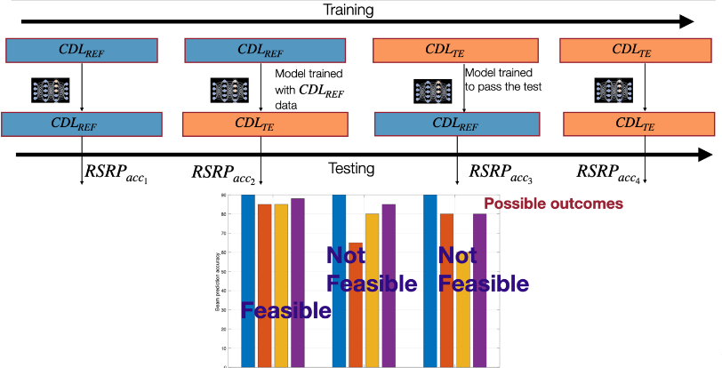  Proposal 3: For BM-Case 1 spatial prediction and for verifying RSRP accuracy we propose to use the testing setup and channel emulator functionality as described in Figure below. (multiple static configurations) (Option 5)  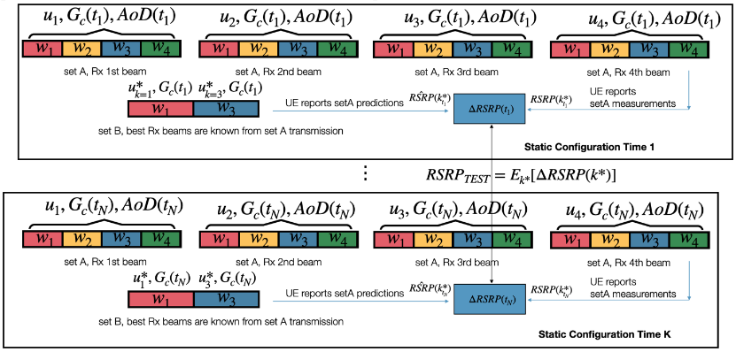  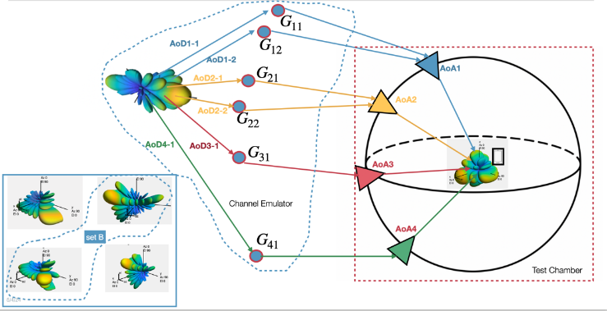  Proposal 4: For testing the beam prediction/RSRP accuracy for BM-Case 2 temporal prediction we propose the framework described in this section and visualized in Figure below, through a non static configuration of the channel emulator. (dynamic channel)  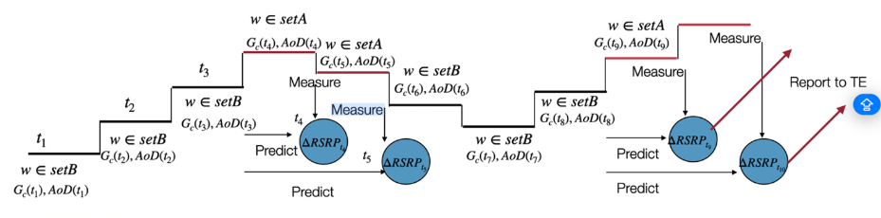  Proposal 5: For BM spatial prediction RAN4 to consider the following options option 5 and option 6  Option 5 Multipath based Testing Setup with a simplified CDL channel and probe layout. Criterion of evaluating the feasibility of a particular simplified CDL model has been proposed.  Option 6 Single path/cluster (LOS condition) based Testing Setup  Option 6 for BM testing set-up is shown below:  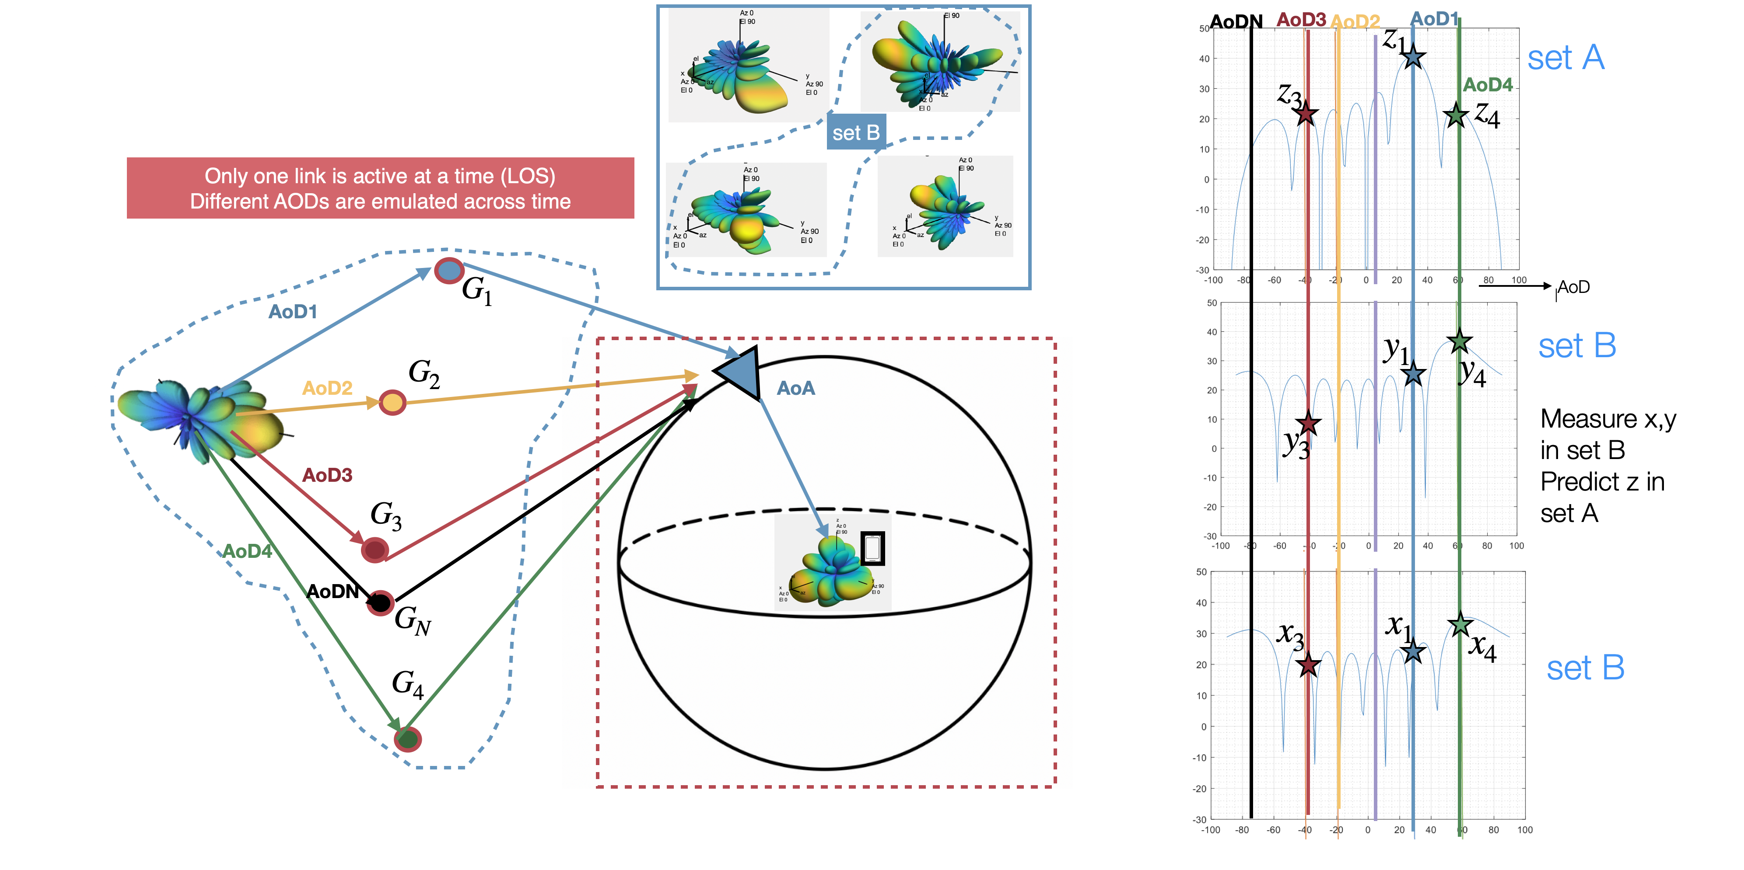  Generalization issues for BM  Proposal 6: In the RAN4 core requirement, it is mandated that the consistency or association between Set B beams and Set A beams during both training and inference must be guaranteed. This serves as additional assistance information from the network side for testing UE-sided models during inference and monitoring  Proposal 7: RAN4 should define identified scenarios/configurations associated with the UE capability report of an AI/ML-enabled Feature FG. For defining generalization tests, the additional conditions can serve as the other identified scenarios/configurations for the BM use case  Proposal 8: RAN4 should investigate the feasibility of providing assistance information for the additional conditions to aid generalization and consistency across training and testing when defining requirements. Other additional conditions that are not part of UE capability can be used to define generalization tests  Proposal 9: For additional conditions that cannot be shared due to proprietary concerns, RAN4 can explore the feasibility of using a virtual ID to indicate the specific conditions under which a model was trained. This approach would assist in the proper selection of UE models to support generalization. Additionally, RAN4 should identify which additional conditions should be exclusively reserved for generalization tests.  Consistency between Training and Inference  Proposal 10: RAN4 to consider option 1 as a baseline for achieving consistency between training and inference for both set A and set B for beam spatial and temporal prediction  Proposal 11: RAN4 to consider option 1 for achieving consistency between training and inference for only static conditions.  Proposal 12: In order to ease the burden for testing models with different NW additional conditions, it would beneficial to train the UE-side model with mixed dataset from various gNB settings, thus reducing the number of AI/ML models (selected by NW-side additional conditions) required to guarantee generalization and maintain the system performance for BM use case  Proposal 13: For achieving consistency between training and inference, if the model drifts due to misalignment of network-side additional conditions, the alignment could be achieved through an ID assigned by the network during training data collection. This ID indicates the association of the training data with the additional conditions implied to generate those data  Proposal 14: For achieving consistency between training and inference, if the UE lacks the ID but the network possesses the model ID, then the network can transfer the model to the UE, and the UE can update its list of models  Proposal 15: For achieving consistency between training and inference, if the UE has a model that partially supports the network-sided additional conditions, then the network can trigger data collection for fine-tuning the UE-sided model. Subsequently UE updates its list of model IDs.  Proposal 16: The UE updates its model list with a new model derived from either fine-tuning, model transfer from the NW, or monitoring to ensure the consistency of additional conditions. Then, the UE assigns an ID to the new model that supports the NW's additional conditions and shares this information with the NW. If some of the new conditions/configurations are standardized, the UE updates its capability report accordingly.  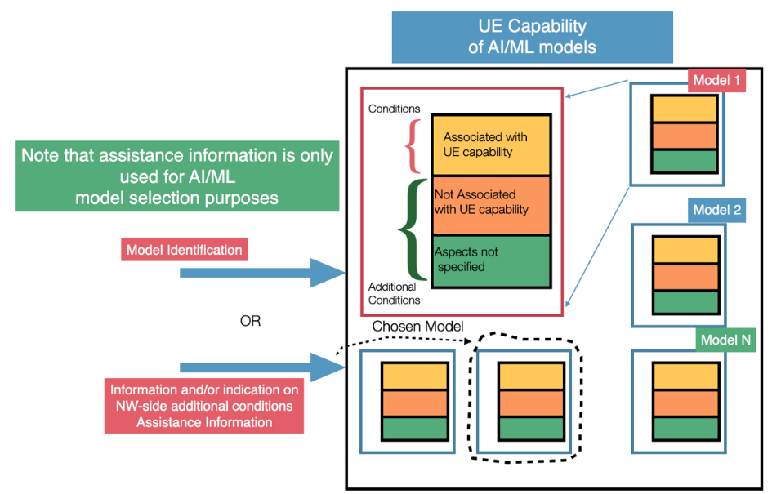  Proposal 17: If there is no ID available to associate training data with additional conditions, and monitoring procedure fails to guarantee the consistency of the model with the additional conditions then UE should fallback to legacy mode.  Proposal 18: Investigate the feasibility of enhancing the generalizability of the AI/ML model and reducing the number of AI/ML models and the testing burden for the beam management case by supplementing the core AI/ML input signals with both network (NW) and UE auxiliary information signals integral to its inference engine  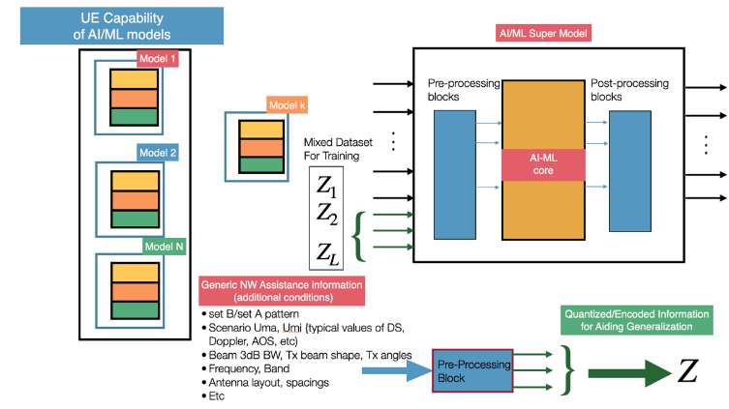  Proposal 19: Investigate the feasibility of training the models with a mixed dataset associated with both network (NW) and UE auxiliary information signals to further enhance the generalizability of the AI/ML model for the beam management case and reduce the number of generalization tests.
R4-2418752 | vivo | Observation 1: The simplified CDL channel with small number clusters will degrade the test dependability.  Observation 2: The number of probes can be greatly reduced by grouping different Tx beams together. Only one probe or one set of probes can emulate different Tx beams in one group.  Observation 3: Different test system with reduced cost and complexity can be introduced by using the Tx beam grouping method.  Proposal 1: RAN4 to consider methods to group Tx beams together to reduce the number of probes in the test system.  Proposal 2: RAN4 to consider the following procedures to simplify the test system:  - Step 1. Generate the BS beamforming power pattern of every Tx beam  - Step 2. Add the BS beamforming power pattern into the power of different clusters in specific ZoD and AoD, and derive the new power of every cluster  - Step 3. Use the new power of clusters to generate the power angular spectrum (PAS) of ZoA and AoA  - Step 4. Some Tx beams with the corresponding ZoA/AoA are to be grouped together based on a certain rule (e.g., the ZoA/AoA of the strongest power derived from the PAS in step 3 are the same angle or in a pre-defined range)  - Step 5. Using one or small number of probes to emulate one beam group.  - Step 6. Delete the unnecessary probes and merge some adjacent probes.  Proposal 3: RAN4 to consider the following two approaches for design the test system  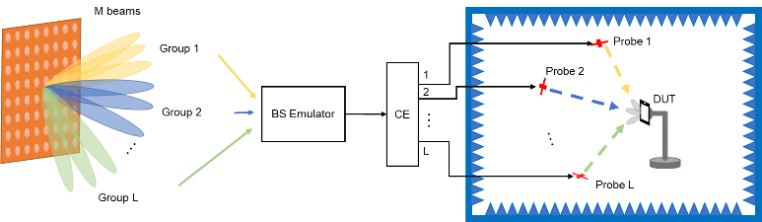  approach a  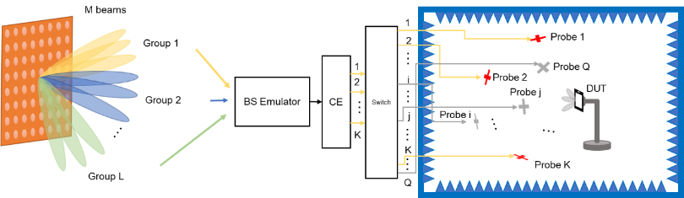  approach b  Proposal 4: Companies to provide candidate probe locations for CDL-A/B/C for merging and rotating. E.g.,  Proposal 5: RAN4 to consider the UE Rx beamforming resolution in angular domain to perform OTA probe allocations.
  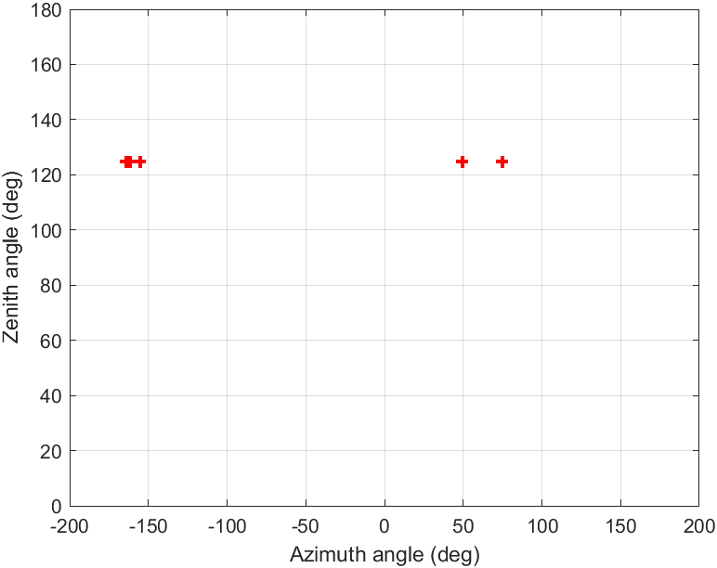  (a) CDL-A | 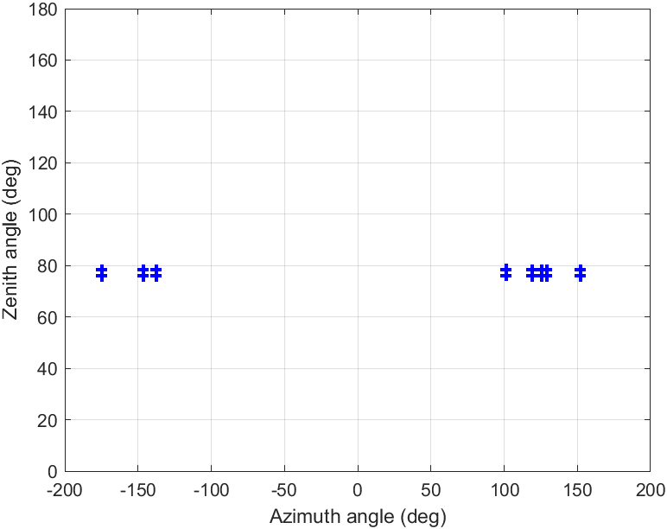  (b) CDL-B | 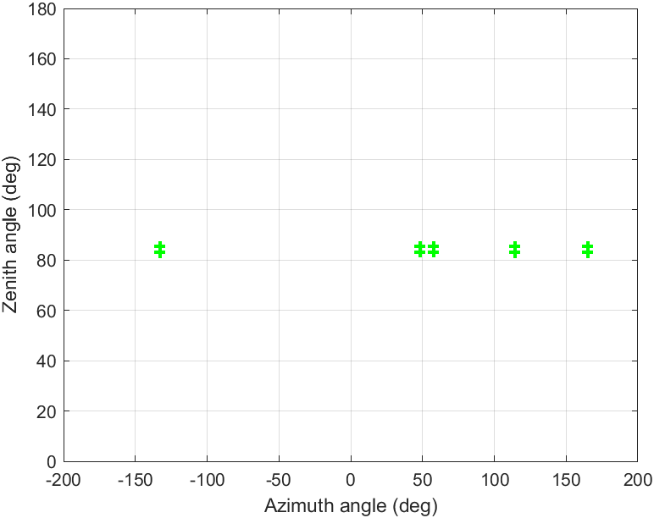  (c) CDL-C
R4-2418848 | Qualcomm Incorporated | Observation 1: An effective test case for beam prediction use case BM-Case1 requires the following:  - Sufficient randomness and variation in time and spatial domain of L1-RSRP  - DL Tx beam sweeping with enough number of Tx beams in Set B and Set A  Observation 2: Verifying the AI/ML beam management performance (e.g., prediction of top K beams) in a TDL channel with single AoA without spatial characteristics makes the test too simple and inconsistent with the actual field environment. Thus it is not feasible to general proper Set A and Set B with single AoA setup.  Observation 3: Some companies suggested to emulate multiple beams with single AoA by using different power. The power levels will have to be defined in test configuration to enable this method. That will allow UE to predict the strongest beam through simple interpolation.  Observation 4: CDL with spatial properties is a more realistic and proper channel model for AI/ML beam management testing. To support CDL, multiple probes test setup is needed.  Observation 5: With TDL channel, to generate Set A and Set B, multiple AoAs/probes test setup is necessary.  Observation 6: The key requirements for AI/ML BM test setup are listed following:  - Requirement#1: Channel model in the test  - CDL or simplified CDL or TDL with multiple AoAs to properly verify beam management performance.  - Requirement#2: Avoid the cheating  - Progress A: Data training for Set A’s is generated with channel parameters #1. Set B in UE measurement should have enough randomness compared to Set A’.  - Progress B: Set A is generated to make sure to use the same parameters (initial phase, angular spread, delay spread) as the Set B in the Progress A measurement step. NW antenna/beam configurations for Set A and Set B should be deterministic. For some prediction metrics (e.g., option 2 and 3), UE can pass the test without actual measurement if TE does not randomize the transmission of its beams during measurement step of progress of Figure 4.  - Requirement#3: Support the beam number of Set A  - TE needs to support Set A for ground truth verification, i.e., upto 128.  Observation 7: There will be plenty of additional probes if BS Tx beams point to other clusters even though some of the probes could be reused.  Observation 8: The UE’s antenna gain gap between peak and 50%-tile spherical coverage is over 10dB for PC3. The very weak clusters would not influence the UE beam management even if they reach the UE within the UE’s spherical coverage.  Observation 9: The AoDs/ZoDs of very weak clusters are unlikely to influence the selection of the strongest beam in any reasonably designed codebook of Set A and Set B.  Observation10: The weak clusters that have a limited impact on the beam management could be removed to reduce the number of clusters in the CDL channel model.  Observation 11: The clusters that have the same/similar AoAs could be merged. And the intra-cluster angle spread, e.g., CASD, CASA, CZSD, CZSA can be reduced to simplify the test setup.  Observation 12. TE vendors need to check UE positioning time to mimic simplified CDL or TDLchannel model by sequentially rotating the positioner to reduce the number of probes. Order of ~1s dwell time will lead to an unrealistic test environment for AI/ML beam management testing.  Proposal 1: RAN4 do NOT consider single AoA/probe test setup (with TDL or Los condition) for AI/ML beam management testing.  Proposal 2: RAN4 take multiple AoAs/probes test setup as the basline for AI/ML BM testing and downselet the channel model from Simplified CDL and TDL considering the following aspects:  - Number of Tx Beams: Upto 128 for Set A  - Randomization:  - Channel parameters for data training and generation should have enough randomness  - During measurement step of progress B, TE randomizes the transmission of setA beams, e.g., during time t1, TE does not transmit with beam shape A1 and TE transmits using the shape of a beam whose ID is randomly selected from set A).  Proposal 3: RAN4 considers reducing the cluster number with weak power level, merging the cluster with the same/similar AoA, and decreasing intra-cluster angle spread in CDL channel model to simplify the test setup based on the evaluation of the impact on beam management performance considering the UE beam width.  Proposal 4: RAN4 to further discuss the nuumbers of Tx beams, probes and testablities considering the follwoing two options  - Option 1: Simplified CDL with mutliple AoAs/probes  - Option 2: TDL channel model with mutliple AoAs/probes  - TDL based test setup should be compareble with simplifed CDL, e.g., generating same Tx beam number of Set A as CDL, similar number of AoAs
R4-2418900 | Ericsson | Observation 1: the measurement error in Datasets for training/testing may be covered by the overall measurement error.  Observation 2: Different ratios between the number of Set A and Set B may demonstrate various AI/ML model characteristics.  Proposal 1: RAN4 to clarify the following parameters which simplifies the CDL channel:  - Number of AOA  - Number of AOD  Proposal 2: The simplified CDL channel only is considered to be applied in inference, no need to be applied in training.  Proposal 3: The metric to estimate the “goodness” of a simplified CDL channel model may be represented by the below steps:  Step 1: Test (inference) with the reference CDL channel.  Step 2: Test (inference) with the simplified CDL channel.  Step 3: The prediction difference between the results of the two tests in the above steps is less than a threshold with [95] percentile.  Proposal 4: For BM-case1, the ratio between the numbers of Set A and Set B shall be a metric, at least two sets of numbers of Set A and Set B are provided as test configurations. Below are two examples:  - For verifying the prediction model computational power/complexity of AI/ML model, the number of set A = X and the number of set B = X/4.  - For verifying the prediction scaling capability of AI/ML model, the number of set A = X and the number of set B = X/16  Note: Different accuracy requirements may be applied for different sets of number of set A and set B.  Where X may be the maximum number of Set A that a UE supports mandatorily.  Proposal 5: RAN4 to evaluate the SNR condition for the ground truth by simulation.  Proposal 6: Test procedure shall at least comprise the below three steps:  - Acquire the predicted RSRP under the required corresponding SNR condition  - Acquire the ideal measurement of RSRP under high SNR condition  - Compare the two RSRPs acquired in the above steps  Note 1: Test configurations are kept same in the steps except for different SNR conditions.  Note 2: Arranging the details on the sequence and test configuration may need further investigation in performance part.  Proposal 7: RAN4 to study the correlation between error (offset) between the predicted RSRP and ideal measurement RSRP, and the correlation impact to the prediction metrics/KPIs.  Proposal 8: How to avoid cheating in the reports on RSRP measurement and prediction is a valid issue to be studied. A simple way for the test environment is adding a procedure to manually switch the beam indexes between the prediction duration and the measurement duration.  Proposal 9: Regarding channel generation in tests (for each test configuration, a test case may contain more than one test configuration):  - For BM-case1, generating 2 channel instants including channel #1 for training and generating channel #2 with same parameters for inference.  - For BM-case2, plural channel instants with a series of changes of the channel parameters are necessary to reflect temporal correlation between channels. At least, it includes:  - Generating a set of channel instants, from channel #1 to channel #m, for training, and  - Generating a set of channel instants, from channel #m+1 to channel #n for inference  Wherein,  - The channels instants comprise sequent and grade updates of a set of parameters.  - The numbers of m and n depend on the measurement window and prediction window of BM-case2.  - The channel parameters may comprise one or more than one of  - Departure angles (AOD, ZOD)  - Arrival angles (AOA, ZOA)  - UE position and/or rotation  - Channel coefficient  Proposal 10: In order to avoid overfitting of UE models to the test environment only, the test (including data sets) shall be able to demonstrate the robustness of the AI/ML model and match the practical field deployment conditions.
R4-2418941 | Rohde & Schwarz | Observation 1: Following the MIMO-OTA / 3D MPAC methodology, to emulate 8 BS Tx Beams with a CDL-C UMi channel requires a test system with ≥100 probes and ≥200 RF channels which is unfeasible.  Observation 2: For a feasible spatial (multi-AoA) emulation of the CDL channel, simplifications in terms of number of Tx beams, their spatial distribution and channel model need to be investigated.  Observation 3: AI/ML Beam prediction performance (e.g. Top 3, Top 1 Set AI beams) improves as the ratio Set B / Set A increases. For a given Set A, we need to emulate more Set B beams for better performance, especially for the prediction of the best (Top 1) beam.  Observation 4: The spatial distribution of Set B beams affects the prediction performance. For a better prediction of multiple beams (e.g. Top 3) a wider spatial distribution of Set B beams is required.  Observation 5: Emulating power-offset Set B beams, does probably not bring much value for prediction performance and might have unexpected impact on a CDL trained AI/ML model, since such beams are co-located and introduce inappropriate spatial information.  Observation 6: Set A beams (up to 128) needs to be generated in the chamber for ground truth extraction.  Observation 7: The overall number of beams and their spatial distribution needs to remain high for a good AI/ML prediction performance and ground truth extraction.  Observation 8: Since for a meaningful AI/ML performance the number of beams and their spatial distribution is required to be high (>8, ≤128), even significant simplification of the channel model (currently 8 beams requires 100 probes), would rather not downscale the number of probes to a feasible spatial (multi-AoA) emulation of CDL in TE.  Observation 9: Main reason for spatial (multi-AoA) emulation of CDL channel model is probably the inclusion of UE Rx Beam/Antenna pattern and UE Rx Beam sweeping performance in the AI/ML BM requirements.  Observation 10: With the knowledge of the UE Rx Beam/Antenna pattern, the CDL channel can be emulated in a practical and feasible single-AoA test setup, keeping the L1-RSRP and the CDL characteristics of the signal unchanged.  Observation 11: The UE Rx Beam/Antenna pattern for single-AoA CDL, can be defined as a reference for requirement definition and testing, or can be provided or measured before the testing.  Observation 12: The supported power dynamic range for FR2 testing is circa 30dB. This applies the same to all AoAs in terms of absolute powers. Thus, moving from a multi-AoA to a single-AoA CDL emulation, does not impact the number of Tx Beams supported.  Observation 13: The single-AoA emulation of the CDL channel with the knowledge of the UE Rx Beam/Antenna pattern, does not consider the time aspect of the UE Rx Beam sweeping.  Observation 14: The time aspect of the UE Rx Beam sweeping can be tested in a separate multi-AoA test, optimized only for this purpose and with less complexity in terms of number of beams and channel model (e.g. TDL).  Observation 15: TDL channels are currently supported by TE and used for testing, including multi-AoA scenarios. Further extensions in terms of taps and dynamic should probably not introduce feasibility issues for TE.  Observation 16: The emulation of a TDL channel is in general done from a single AoA as the signal taps do not contain explicit spatial information.  Observation 17: Currently, in multi-AoA tests with TDL, signals from different AoAs, go through separate TDL channels and have different content i.e. AoA(n) contains Beam(n) or Cell(n), which represent a multi-TRP scenario.  Observation 18: Multi-AoA scenarios, with same signal content per AoA i.e. single TRP (still with separate TDL per AoA), should be feasible from TE perspective and could be investigated for relevance for UE AI/ML BM requirements and testing.  Observation 19: Number of in baseband generated BS Tx beams (SSB, CSI-RS) is in general not limited, but might be restricted by the overall resources required in the test case (combination of numbed of beams, TDL channels, AoAs, BWs). This can be assessed during the test case parameters’ definition phase.  Observation 20: Number of BS Tx beams (SSB, CSI-RS) from the same AoA, is restricted by the power dynamic range of 30dB, only if the beams are differentiated by power-offsets, and depends on the granularity of the power offsets.  Observation 21: Current eIFF system with 2AoA covers all RF / Demod / RRM tests up to Rel-17.  Observation 22: Current eIFF commercial implementations cover all RF / Demod / RRM tests including Rel-18 and have probably capacity for up to 4AoAs, under certain AoA layout restrictions.  Observation 23: The definition and availability of a single FR2 system with full coverage across RF / Demod / RRM features is essential when considering the complexity and commercial feasibility of the system. Also, it is the only way to fully ensure the inter-dependencies and cross-references between requirements in RF / Demod / RRM (side conditions).  Observation 24: eIFF systems are the only system type supporting multi AoA black box testing with best MU within a quiet zone of at least 30 cm for all AoAs. This is crucial for L1-RSRP measurement accuracy and UE Rx beam sweeping (precise UE antenna configuration for sweeping is unknown).  Observation 25: eIFF systems, including potential upgrades, support single-AoA CDL testing with measurement of UE Rx Beam/Antenna pattern, as well as multi-AoA TDL for UE Rx Beam sweeping testing, as described above. Thus, they are suitable to be baseline system for AI/ML BM testing.  Proposal 1: Segregate CDL testing for AI/ML BM in a first single-AoA test with CDL emulation with known UE Rx Beam/Antenna pattern (referenced / provided / measured) and necessary number of beams, and in a second multi-AoA test for UE Rx Beam sweeping (channel TBD).  Proposal 2: Consider TDL testing for AI/ML BM, at least for multi-AoA UE Rx Beam sweeping.  Proposal 3: Define eIFF system, including potential upgrades, as the baseline system for AI/ML BM testing, since it is feasible and supports single-AoA CDL and multi-AoA TDL, as well as all RF / Demod / RRM legacy tests (one system fits all, side condition fulfilled), allows black box testing for beam sweeping (big quiet zone) and precise UE measurements (low MUs).
R4-2418973 | Huawei,HiSilicon | Observation 1: AoA and AoD are not used as model input in AI BM Case 1 and Case 2.  Proposal 1: Use TDL as the channel model for AI BM testing.  Observation 2: Only the measured RSRP rather than the ideal RSRP can be obtained by UE both for model training and model inference.  Proposal 2: Take the measurement error into consideration for generating the labels for model training.  Proposal 3: For the impact of measurement error on BM performance evaluation, RAN4 to study how to use the evaluation results with system-level simulation assumptions for requirement definition study under link-level channel models.  Proposal 3: Before investigating how to set up the test environment, the following questions have to be answered:  - How to ensure the consistency between model training and model testing  - Whether and how to define a common training/testing dataset.  - If define, how to capture the different UE implementations and UE behavior when constructing the dataset  - Whether UE is expected to collect training dataset and train the model before performing model performance test.  - If yes, how to resolve the test cost/time issue.  - How to avoid that a UE can pass the test but performs poorly in the field, considering that some parameters used in the test set up which limit the model generalization may totally be different from that in real deployment.  Proposal 4: For test set up in AI-BM, taking the existing FR2 OTA test set up as baseline, any enhancements on top of which should be justified.
R4-2419185 | Nokia | In this paper we share our views on potential RAN4 impacts from issues related to testability and interoperability of AI/ML enabled BM-Case1 and BM-Case2. Specifically, we cover following aspects:  - Generalization and test coverage related aspects  - Testing setup and Channel models  In the paper, the following Observations and Proposals were made:  Observation 1: A functionality, if tested in different generalization scenarios, would be considered not overfitted to a certain test environment.  Proposal 1: Testing of generalization aspects should also be considered to avoid overfitting of functionalities to the test environment.  Proposal 2: For the verification/testing of generalization related aspects in RAN4 for AI/ML BM, RAN4 should define different scenarios based on parameters listed in the Table below.  Table: Parameters for Generalization Scenarios  Proposal 3: RAN4 needs to design a new metric, indicative of generalization capabilities of AI/ML BM functionality, to verify the generalization performance of the functionality in different scenarios.  Observation 2: CDL channel models present a more realistic way for testing AI/ML BM use cases due to the more realistic spatial behaviour.  Observation 3: If the testability objective of AI/ML-enabled BM use case is to verify the AI/ML BM functionality taking only L1-RSRP of Set B beams as input and not to test the multipath reception of the UE, the use of TDL channel model during the conformance testing is sufficient.  Observation 4: The clusters of ‘CDL A’ channel model spans the widest range in the zenith domain whereas the range of all CDL channel models in azimuth domain is almost similar.  Observation 5: The clusters of ‘CDL D’ channel model spans the widest range in the azimuth domain while the spans of the clusters of ‘CDL D’ and ‘CDL E’ channel models in the zenith domain are almost same and is narrowest relative to the other CDL models.  Observation 6: As the FR2 channel is spatially sparse in nature, simplified CDL model with reduced number of clusters will be a good approach for the conformance testing of AI/ML-enabled BM use-case.  Proposal 4: RAN4 to decide the number of clusters and their angular location in the simplified CDL model considering the following aspects:  - Practical number of test probes to be made available in the OTA test chamber for AI/ML-enabled BM conformance testing,  - Angular location of the selected clusters should span the maximum part of the azimuth and zenith domains.  Observation 7: It is not very clear whether all Set A and/or Set B beams can be emulated inside the test chamber or only some of those beams which are “most relevant” Tx-beams need to be emulated.  Proposal 5: UE vendors to clarify if the Set A and/or Set B beams emulated inside the test chamber can’t arrive at the DUT from different AoAs, will it be possible for the DUT to distinguish between the different beams which may have different Beam IDs but will arrive at the DUT from the same AoA.  Observation 8: Reported RSRP values as approximated ground truth are error-prone and have several uncertainties.  Proposal 6: To obtain a more accurate ground truth, RAN4 should consider the case where UL measurements received at TE/NW can be used as ground truth for DL measurements in case when Beam correspondence is ensured between UL and DL beams.
  Parameters | Description
  UE Speed | Slow / Medium / Fast
  SINR (Deployment Scenario) | Good / Bad Radio conditions
  Propagation Model | TDL / CDL
R4-2419391 | Keysight Technologies UK Ltd | Observation 1: A relatively simple and straightforward extension of an FR2 MIMO OTA system to 8 probes is suitable to emulate 4 dual-polarized/8 single-polarized Tx-beam RX-PAS profiles, set B Tx beams up to [16] with power offsets, and set A Tx beams up to [192] with power offsets.  Observation 2: The extension of an FR2 MIMO OTA system to 8 probes is suitable to support unlimited range of AoDs/ZoDs and a range of AoAs/ZoAs of 110°/25°.  Observation 3: Various beam management performance testing can readily be supported with a commercially available test system, i.e., complexity and time-to-market concerns should not be an issue.  Proposal 1: UE/chipset/infra vendors to provide feedback on whether modelling 4 dual-polarized/8 single-polarized RX-PAS accurately with the remaining beams modelled with power offsets is sufficient  Proposal 2: Consider an 8-probe OTA system with 2 additional probes when compared to the FR2 MIMO OTA system with a range of AoAs/ZoAs of 110°/25° as the starting point for AI/ML Beam management testing for 1 TRP and/or 2 TRPs with close angular proximity.

Open issues summary
The open issues were grouped in the following sub-topics for further discussion:
            - Relative RSRP accuracy
            - Rx beam knowledge
            - TCI state knowledge
            - Beam prediction KPIs
            - Prediction delay requirements
            - RSRP measurement error modelling: vivo,
            - Simulation assumptions change
            - Support for network side model? Not RAN4 issue
            - Number of AoAs for testing
            - Beam prediction test segregation
            - Channel model for beam prediction testing
            - Test setup requirements
            - Baseline test setup

Sub-topic 3-1
Relative RSRP accuracy
Issue 3-1: Relative RSRP Accuracy
- Proposals
  - Option 1: The definition of relative RSRP accuracy shall be:
The relative RSRP accuracy for AI/ML-based beam prediction = the ground truth of L1-RSRP of the predicted beam index i - the ground truth of the L1-RSRP of the Top-1 ideal beam index j
  - Option 2: The definition of relative RSRP accuracy shall be:
predicted L1-RSRP of beam index i – predicted L1-RSRP of beam index n, where the beam index n owns the largest RSRP among the predicted beams.
  - Option 3: The definition of relative RSRP accuracy shall be:
the RSRP difference between the predicted L1-RSRP of different beams.
  - Option 4: others
- Recommended WF
  - Option 1

Sub-topic 3-2
UE Rx beam known vs. unknown
In the previous meeting it was discussed whether the UE Rx beam to be used for receiving the predicted beam is known or not.
Issue 3-2: UE Rx beam knowledge
Proposals
  - Option 1: UE Rx beam is known
    - the UE Rx beam gain has to be taken into account when making the prediction
  - Option 2: UE Rx beam is unknown
    - Will the UE Rx spherical coverage be taken into account when making the prediction? How
    - L1-RSRP input used for training and as input for inference takes into account the Rx beam gain (RSRP is measured at UE baseband)?
  - Option 3: depends on some conditions
    - which conditions?
  - Option 4: depends on UE capability
    - How to define the capability and how will the network use the capability?
  - Option 5: others
- Recommended WF
  - Option 1

Sub-topic 3-3
TCI State known vs. unknown
In the previous meeting it was discussed whether the TCI state associated with a predicted beam should be considered known or unknown.
Issue 3-3: TCI State knowledge
- Proposals
  - Option 1: Reuse the legacy conditions with the following additions (marked in red)
The TCI state is known if the following conditions are met:
- During the period from the last transmission of the RS resource used for the L1-RSRP measurement reporting for the target TCI state or AI/ML based inference to the completion of active TCI state switch, where the RS resource for L1-RSRP measurement is the RS in target TCI state or QCLed to the target TCI state, or the RS resources for AI/ML based inference is the RS in SetB or in target TCI state or QCLed to the target TCI state.
- TCI state switch command is received within 1280 ms upon the last transmission of the RS resource for beam reporting or measurement or inference
- The UE has sent at least 1 L1-RSRP report for the target TCI state or completes AI/ML based inference before the TCI state switch command
- The TCI state remains detectable during the TCI state switching period
- The SSB associated with the TCI state remain detectable during the TCI switching period
- SNR of the TCI state ≥ -3dB
Otherwise, the TCI state is unknown.
  - Option 2: TCI state QCL to an RS that is not in Set B is unknown even if this RS was included in the L1-RSRP report by UE within 1280ms before TCI state activation.
  - Option 3: The TCI state which is QCL to an RS in Set B is known:
    - if the corresponding predicted beam is reported in 1280ms before the TCI state switch command and SNR of the RS is above -3dB for spatial-domain beam prediction.
    - if the last observation occasion is within 1280ms before the TCI state switch command and SNR of the RS is above -3dB for temporal beam prediction.
  - Option 4: The known conditions of the predicted TCI state shall take below conditions into account:
    - The TCI state switch command is received during valid inference phase of AI/ML mode.
    - The predicted beam in Set A is the RS in target TCI state.
    - The predicted beam in Set A is detectable during training and inference phase, which implies the beam has been trained successfully and available in inference phase.
    - The UE knows the Rx beam for the predicted beam.
  - Option 5: RAN4 should consider relaxing known conditions for TCI states
    - TCI is known if measured within X+1280 ms. Further analysis is required to define the exact value of X.
  - Option 6: others
- Recommended WF
  - To be discussed

Sub-topic 3-4
Beam prediction KPIs
Different metrics/KPIs have been discussed and were captured in the TR:
For metrics for beam management requirements/tests, the following test metrics are identified and could be considered
- Option 1: RSRP accuracy
- Option 2: Beam prediction accuracy
-Top-1 (%) : the percentage of "the Top-1 strongest beam is Top-1 predicted beam"
-Top-K/1 (%) : the percentage of "the Top-1 strongest beam is one of the Top-K predicted beams"
-Top-1/K (%) : the percentage of "the Top-1 predicted beam is one of the Top-K strongest beams"
- Option 3: The successful rate for the correct prediction which is considered as maximum RSRP among top-K predicted beams is larger than the RSRP of the strongest beam – x dB,
-Related measurement accuracy can be considered to determine x
- Option 4: combinations of above options

Issue 3-4: Metrics/KPIs for beam prediction
Proposals
  - Option 1: Use Option 1
  - Option 2: Use Option 2
  - Option 3: Use combined Option 2 and 3:
    - Option-New: The successful rate for the correct prediction which is considered as "the Top-1 predicted beam is one of the Top-K strongest beams, and the Top-1 predicted beam’s ground truth RSRP value is larger than the RSRP of the strongest beam – x dB”
      - FFS: K = 2 and x = 3 as baseline
  - Option 4: Add new metric:
      - Top-K/N (%): the percentage of "the Top-N genie-aided beam is one of the Top-K predicted beams". FFS how N is derived.
  - Option 5: Add a requirement based on relative difference between predictions under different conditions/inputs (for example varying signal levels by N dBs but maintain same relative difference).
      - consider defining multiple tests under different conditions but with the same outcome(same predicted beam)
  - Option 6: both RSRP accuracy and beam prediction accuracy are used as KPIs for beam prediction
      - RSRP absolute accuracy applies to all predicted beams
- Recommended WF
  - To be discussed
Companies suggesting to use different metrics(new) should come up with a concrete proposal

Sub-topic 3-5
Prediction delay requirements
Issue 3-5: Prediction delay requirements
- Proposals
  - Option 1: Prediction delay requirements to include:
    - Measurement for prediction
    - Inference delay
    - Other components are FFS
  - Option 2: Do not define prediction delay, the measurement delay is enough
  - Option 3: others
- Recommended WF
  - Option 1
It was also proposed to include the reporting delay in the requirement but so far reporting delays are not included in the RRM requirements

Huawei: For prediction delay, we only consider prediction. For measurement delay, we can… The first bullet is not needed.
Ericsson: We have the similar questions. For measurement, we consider it as legacy measurement. We do not see the difference. For inference delay, we should wait for RAN1. RAN1 has no conclusion on how to calculate the time for UE to receive the command.
Qualcomm: In the simulation, the prediction delay is different from measurement delay. We did not agree that delay is the same as legacy measurement delay. Inference delay should be discussed in RAN4.
Mediatek: We should include measurement delay into the prediction delay.
ZTE: Same view as Mediatek. What is the prediction delay? What is the starting point and end point?
OPPO: We share the similar view as Mediatek and ZTE. We need think about the measurement part and inference part.
CATT: measurement based and inference based. For measurement, we can discuss whether the legacy can be reused.
CMCC: measurement is the legacy measurement. Legacy requirement can be reused.
Moderator: The requirement has the component and made up of multiple pieces. You cannot do inference without measurement. The question is how many instances for UE to measure. It might be the same as legacy. We can conclude that measurement is like legacy and list as option. To CMCC, for prediction, UE should not only report the measurement. We can only check from the beginning when asking UE to do prediction.
Nokia: We are agree with moderator. It is important to mention that measurement for prediction can be seen.
Vivo: it is better to have measurement delay, which might not be the same.
Qualcomm: we are focusing on the measurement rather than cases. Whether we need one or more depends on simulation.
Apple: when we are talking about the subbullet, the legacy measurement delay will be on top of measurement for prediction.

Agreement:
  - Prediction delay includes:
    - Measurement for prediction
      - FFS on whether the legacy measurement delay can be reused
    - Inference delay
    - Other components are FFS

Sub-topic 3-6
RSRP Error modeling in simulations
Initial simulation assumptions for assessing the impact that the measurement error has on prediction accuracy/ performance were agreed in the previous RAN4 meeting. The RSRP measurement error modeling should be further discussed/refined.
Issue 3-6: Measurement error impact evaluation
- Proposals
  - Option 1: model RF error as same within an RF module but varies across modules, FFS the distribution
  - Option 2: Gaussian distribution with +/- 2.5dB for BB errors and total of +/-6.5 for BB+RF
  - Option 3: model RF error as
    - An offset value in the original dataset;
    - Truncated Uniform distribution;
    - Truncated Gaussian distribution.
- Recommended WF
  - Model error as RF error + BB error
    - RF error as a fixed bias for each UE module, FFS which distribution
    - BB error with Gaussian distribution with 0 mean and sigma=0.6dB
Should the BB error distribution be changed based on SNR?

Vivo: We have already uploaded the simulation assumption based on baseband error. We should derive BB error based on the simulation. RF error is complicated. RF error should be FFS.
Mediatek: For BB error, we need consider the error under different SNRs. If we fixed the same error for different error, for other simulation, we add different error for different SNR the results are different. What UE module refer to for RF error?
Qualcomm: To address Mediatek, we can say sum error for RF for BM. It may impact the results significantly. RAN4 should decide the architecture. Whether the RF error the same for different beam?
Nokia: as Qualcomm mentioned, if we apply the same error, we have degradation. UE module is confusing. Error should be the same or different for each beam.
Apple: We prefer to have the single error, which covers both RF side and BB side. Dividing error into two parts makes discussion difficult. Agree with Mediatek, BB error should be functional of SNR. We can use Guassian distribution. If the error includes the measurement error, it is just the margin.
Samsung: We also have the comment on the RF error. Here we are talking about the fixed. How to handle the fixed error for different panels of antenna. For the beam within one panel, how to handle error. Within the panel and between the panel. We want to clarify how to define that.

Sub-topic 3-7
Simulations results and assumptions refinements for error impact evaluation
In the previous RAN4 meeting it was agreed to conduct a study on the impact of measurement errors. Based on the submitted simulation results it should be discussed what to do next.
Issue 3-7: Measurement error impact evaluation
- Proposals
  - Option 1: Check on simulation results
  - Option 2: simulation assumptions change? What to do next?
  - Option 3: Whether training/inference dataset contains error or not
    - is there a need to model errors for both training data or only for inference?
  - Option 4: SLS results should be considered first and then LLS simulations can be performed if needed.
  - Option 5: others
- Recommended WF
  - To be discussed
RAN4 to discuss how to further align the LLS assumptions based on the simulation results companies provided, cadidates for parameters/assumptions to further align
- Channel model
- set A/B configuration
- SNR/SINR values
- Number of samples in L1 averaging
- Reference signal
- Others?

Vivo: It is better to align the assumption for reference signal. SSB and CSI RS will be taken into consideration? The results would be different. It will impact the measurement accuracy.

Sub-topic 3-8
Support for network side model
Issue 3-8: Support for network side model
- Proposals
  - Option 1: Introduce enhancements for L1-RSRP reporting such that UE reports M beams, M >=4
  - Option 2: RAN4 cannot introduce new reporting schemes, this should be done in other groups
  - Option 3: others
- Recommended WF
  - To be discussed

Qualcomm: does option 1 enhance the signaling or define requirements based on the enhanced signaling.
Samsung: To Qualcomm, it is to define the requirements. It is possible to have network model.
Apple: For network side model, does it mean that we will define the requirements for BS?
Samsung: It may include 1) reporting content improvement more than 4 beams; 2) accuracy.
Apple: Why do we need spend effort unless we confirm it will impact BS?
Ericsson: The reporting content improvement has no impact on RRM. Do not understand the motivation.
Qualcomm: Enhanced signalling is FFS in other WG. We should wait for other WG to define more than 4 beams for report.
Nokia: We also agree that the accuracy may not be changed. We should wait for RAN1 conclusion on it.
Vivo: We also think that the reporting is out of RAN4 scope. We cannot decide how many beams to be reported. The measurement delay would be the same.
Apple: Eventually if we do not the requirement, why do we need spend time?
Samsung: if the number of beam to be reported is increased, we have no requirement.
Apple: all this feedback is for AI model. If we have no requirement for AI model from BS side, it is meaningless to have requirement.
Samsung: We cannot agree with Apple. For the current BM, we have no any requirement of BS. But we have measurement delay requirement at UE side. Commonality.
Apple: Accuracy is not changed. Only the beam numbers may be changed. Why can we not have the requirements from BS side. Why should we treat BS and UE differently. Without BS requirement, no point for UE requirement discussion.

Sub-topic 3-9
Number of AoAs
An analysis on the number of angles(spatial distribution) of set B beams and how this relates to the test equipment complexity and beam prediction performance was shown in R4-2418941(R&S). Some observations are copied below:
Observation 3: AI/ML Beam prediction performance (e.g. Top 3, Top 1 Set AI beams) improves as the ratio Set B / Set A increases. For a given Set A, we need to emulate more Set B beams for better performance, especially for the prediction of the best (Top 1) beam.
Observation 4: The spatial distribution of Set B beams affects the prediction performance. For a better prediction of multiple beams (e.g. Top 3) a wider spatial distribution of Set B beams is required.
Observation 5: Emulating power-offset Set B beams, does probably not bring much value for prediction performance and might have unexpected impact on a CDL trained AI/ML model, since such beams are co-located and introduce inappropriate spatial information.
Based on the above observations, it should be debated whether we can exclude a test setup with a single AoA(single probe) from the possible candidates for beam prediction testing
Issue 3-9: AoA/AoD
- Proposals
  - Option 1: exclude test setup with single AoA(single probe)
  - Option 2: further study single AoA setup:
    - Companies should bring further analysis on relevance of such a test to beam prediction and how it would relate to field deployments
  - Option 3: other
- Recommended WF
  - Option 1
If option 2 is preferred, it should be clarified what will be further studied and how

R&S: The reasoning comes from us. What we need for BS is the high number of beams. The existing method does not work. It is too early to preclude the single AoA. There is potential to have single AoA solution.
Moderator: R&S treats the test as two parts: single AoA first and multiple AoAs. The test include single test with the single AoA. We have so many options with less progress. We cannot do all the tests under the single AoA. We want to think about two-step tests with single AoA or multiple AoAs. For multiple AoA we may reuse OTA tests. We cannot consider single test with single AoA.
Keysight: Three papers suggested the single AoAs. One is the DL pattern is known. In order to get DL pattern for each panel and codebook, we need spend long time to get them. 3D pattern is needed for each beam and each codebook. 3D pattern with 3D channel models is not possible. Even with the pattern, you do not know how UE activates each panel.
Vivo: for single probe, how can we emulate Rx beam sweeping especially for case 1.
Mediatek: to Keysight, for single AoA, we need the beam lock. The essential issue is how to handle -10 ~20 margin. We need solve the larger margin issue for BM requirement. We should take out the beam gain.
Apple: we also propose the single AoA with single probe. Input to module should be RSRP, which leave the room for single AoA to work. To Keysight, about the 3D pattern, we should not go such far. Before going to channel, we should know the beamform gain and we can configure different Tx power. We cannot conclude anything and prefer to keep option open.
Huawei: We also support the single AoA. We should ensure that the configuration of scenario should reflect the real deployment.
Qualcomm: for single AoA comments, there are two steps: 1) verify the beam sweeping capability 2) insert the pattern where BS assumes that UE has the best beam sweeping capability.
Ericsson: The only input of UE is RSRP. It is too simplify to test AI model. This results can be compared with the real measurement. The test purpose is not only verify the functionality but also performance.
R&S: The key is whether we consider the UE beam sweeping or not. If so, we should restrict the Tx beam numbers. We first test AI model without beam sweeping and in the other separate test, we test the beam performance.
NTU: We want to check. When we are doing CDL we only consider fading scenario. We test one instance. In practical UE design the first instance is to LOS and the second if for fading channel. In fading test, we should deal with multiple beam interferences. In such case, how can we handle the test with single AoA?
Anritsu: Share the same view as R&S. We propose the single AoA test setup. For Rx beam sweeping, we propose including it in the fading simulation. We need discuss further. We may need other cases to announce which beam is correct for fading simulation. This BM test setup is going to be only one test system.
Nokia: The selection of single AoA and multiple AoAs, before going to direction of multiple AOAs, we would like to see the limitation of multiple AOAs. The maximum is 4. We need generate all the sets of beams in the chamber. 4 is acceptable? We first need agree what is the maximum number and then look into multiple AoAs.
Moderator: The next issue is for two-stage. Do we want all the tests to be done with single AoA or not?
Xiaomi: If the single AoA is applied, it requests the Tx beam and Rx beam. It is hard to consider RF side. Maybe we use the omni-direction antenna.
Apple: Agree with Nokia. Different solution has its own limitation. To Rx beam sweeping, with single AoA, we do not need Rx beam sweeping. We have no RF2 test with Rx beam sweeping now due to test complexity. We do not think AI test is different from that. We can have the whole picture first.
Moderator: We have two-AOA test. UE connects to one beam and does not know which direction comes from for the second AOA.
Apple: it is with beam lock. UE is locked for one direction.
Moderator: no explicit beam lock in RRM test. We have to consider the beam from multiple directions.
Samsung: We should focus on AI part. We cannot preclude UE only predict Tx beam, for which the single AoA can be used.
Ericsson: Even in this case, UE also needs to adjust Rx beam. We cannot preclude the Rx beam information.
OPPO: share the similar view as Nokia. The key is how to test set A and set B.

Sub-topic 3-10
Beam prediction test segregation
R4-2418941 proposes to break the beam prediction test into 2 parts and run them separately. It should be discussed whether such an approach would be feasible and should be further pursued
Issue 3-10: Beam prediction test in 2 phases
- Proposals
  - Option 1:
Proposal 1: Segregate CDL testing for AI/ML BM in a first single-AoA test with CDL emulation with known UE Rx Beam/Antenna pattern (referenced / provided / measured) and necessary number of beams, and in a second multi-AoA test for UE Rx Beam sweeping (channel TBD).
  - Option 2: Do not further discuss such proposal as it is not feasible:
    - TE does not know the UE beam pattern, measuring it will be very time consuming anyway
    - Artificial segregation will not work with a UE model which takes into account the UE Rx spherical coverage
  - Option 3: further study
    - Should be clarified what should be further studied
- Recommended WF
  - Option 2
If further study is needed, it should be discussed what analysis is needed

R&S: excluding is not good thing. We need discuss the number of beams.
Anritsu: Support option 3.
NTU: We need understand whether the model is with UE Rx beamforming gain. Does model consider the Rx beamforming gain or just assuming omni-direction. The key is whether UE model takes the Rx beam gain and how to use the gain for prediction.
Keysight: We can support option 2.
Qualcomm: there are multiple issues: test time where the longer time the UE uses more Rx beams; what is exactly for multiple AoA comments.
R&S: We can have two step of test. And the second step with less Tx beam numbers and we can test Rx beam sweeping. Test AI and beam sweeping separately.

Sub-topic 3-11
Channel model for beam prediction tests
There are several proposals on the channel models to be used. This topic was discussed in previous meetings but there has been little progress so far.
Issue 3-11: Channel model for beam prediction
- Proposals
  - Option 1: multi-AoA TDL
  - Option 2: simplified CDL
  - Option 3: further study both multi-AoA TDL and simplified CDL
  - Option 4: CDL without simplification
  - Option 5: others
- Recommended WF
  - To be discussed whether the channel model can be downscoped to Option 1 or Option 2. If Option 3 is preferred, it should be clarified what needs to be analyzed further.
Aspects to be analysed:
- How to simplify the CDL channels. Is it necessary to stick to currently used CDL models(CDL-A,.., CDL-D) or can the channels be further simplified to just a few clusters
- How many spatial beams can be generated with multi-AoA TDL(can the TE emulate beams reaching the UE between the AoDs) and what is the relationship between angular distance between the probes and emulated beams/codebook.
- Others?

R&S: option 4 means single AoA with known information. We should make it clear.
Anritsu: The understanding from R&S is correct. We propose it for single AoA.
Keysight: Option 4 with single AoA simplification is not feasible.
Apple: Some options are used for multiple AoA and others for single AoA. We need decide whether the single AoA and multiple AoAs. The same question exists in multiple topics.
Qualcomm: Option 4 is not feasible with single AoA.
Vivo: Option 4 for CDL without simplification is also useful for multiple AoAs.
Apple: Can 64 beams be emulated?
NTU: First the number of beams, any number of beams can be emulated. If every beam looks the same, UE cannot distinguish. We should make each beam different enough. In order to make reasonable prediction, set B should have enough coverage.
Keysight: To Apple, yes, we can emulate 64 beams.
Nokia: from Keysight, we can emulate 4 beams. To do 64 beams, we need do 4 beams 16 times in TDM manner.

Sub-topic 3-12
Test setup requirements
Requirements for the test setup have been discussed previously but there hasn’t been any agreement yet. This topic needs to be further discussed.
Issue 3-12: Test setup requirements
- Proposals
  - Option 1:
    - set B Tx beams: baseline 8; set A Tx beams: baseline 64
      - Does the TE need to broadcast all Tx beams in the same test?
    - UE rotation during the test
    - multiple TRP (or reflections from another direction)
    - AoA – to be discussed later
    - AoD – to be discussed later
  - Option 2:
    - other parameters
- Recommended WF
  - To be discussed

R&S: Keysight solution has drawback due to power offset.
Keysight: Tend to agree with R&S.
Moderator: it is not true to emulate CDL. CDL is different from real life.

Proposals from Nokia:
- In multiple AoAs, 4 Tx beams out of 64 beams in set A will have the distinct directions.
  - 16 sets of such 4Tx is needed in TDM manner.

Sub-topic 3-13
Baseline test setup
There are 2 competing proposal for baseline test setup, these need further discussions
Issue 3-13: Baseline test setup
- Proposals
  - Option 1: Define eIFF system, including potential upgrades, as the baseline system for AI/ML BM testing, since it is feasible and supports single-AoA CDL and multi-AoA TDL, as well as all RF / Demod / RRM legacy tests (one system fits all, side condition fulfilled), allows black box testing for beam sweeping (big quiet zone) and precise UE measurements (low MUs).
  - Option 2: Consider an 8-probe OTA system with 2 additional probes when compared to the FR2 MIMO OTA system with a range of AoAs/ZoAs of 110°/25° as the starting point for AI/ML Beam management testing for 1 TRP and/or 2 TRPs with close angular proximity.
  - Option 3: single AoA test setup
  - Option 4: others
- Recommended WF
  - To be discussed
R&S: for RRM, we should cover all the legacy features and new features. We want to make sure the legacy features can be tested in the new system covering the new feature testing.

Topic #4: AI/ML two-sided model logistical issues
This section contains the sub-topics regarding CSI compression and prediction

Companies’ contributions summary
T-doc number | Company | Proposals / Observations
R4-2417804 | MediaTek inc. | In this contribution we provide information on our data sharing.  We share models and dataset with the following filenames compressed to zips.  - Encoder model with filename: MTK0R4_113mlec.onnx  - Decoder model with filename: MTK0R4_113mldc.onnx  - Dataset with filename: MTK0R4_113dsei.npy  Note, each zip file also contains copyright notice letter for your reference.
R4-2418096 | Samsung | Observation 1: Based on our experience, it is recommended to use the latest version PyTorch and ONNX to conduct the conversion.  Observation 2: PyTorch model may need to be redesigned to match the ONNX opset limitation.  Observation 3: The company of final adopted decoder shall provide the common decoder in both ONNX and PyTorch versions, by guarantee the consistency between these two versions.  Proposal 1: For different categories of lifetimes for data/model sharing, RAN4 can further study based on the following ones as baseline:
   | AI/ML Model |  |  | AI/ML Dataset
   | Cat-1 | Cat-2 | Cat-3 | Cat-a | Cat-b | Cat-c
  Lifetime  (i.e., minimum storage time in 3GPP server) | 3 months (i.e., to be deleted 3 months after model submission) | 1 release  (i.e., to be deleted after the current release ASN.1 is frozen) | Forever  (i.e., to be kept in 3GPP server forever) | 3 months (i.e., to be deleted 3 months after model submission) | 1 release  (i.e., to be deleted after the current release ASN.1 is frozen) | Forever  (i.e., to be kept in 3GPP server forever)
  Typical sharing purpose | e.g., temporarily shared model for cross-company evaluation purpose etc. | e.g., reference model (e.g., reference encoder) used to derive RAN4 requirements | e.g., Standardized reference model (e.g., test model used in RAN4 spec.) | e.g., temporarily shared dataset for cross-company evaluation purpose etc. | e.g., the common dataset to derive RAN4 requirement | FFS the necessity
R4-2418456 | CMCC | Proposal 1: it is proposed to discuss and allign on which part of training dataset are used for testing and/or inference .  Proposal 2: it is proposed to discuss the “lifetime” of the data/model in a case by case manner. At least following cases are considered:  - data/model captured in the TS  - data/model uploaded as references for requirements definition  - data/model uploaded for companies allignement
R4-2418525 | Apple | Observation 1: While we agree that the assumptions outlined above are reasonable for the ongoing CSI feasibility study, there may be additional storage requirements due to the following factors:  - There is a possibility of increased dataset sizes if we consider diverse datasets across generalization simulation scenarios (speed, SNR, propagation model) as well as scalability scenarios (rank, number of ports, etc). We may need to come up with all possible generalization/scalability simulation scenarios we envision to consider for future study.  - The optimal dataset size to optimize performance and generalization (less overfitting) has not been understood so far  - For future CSI use cases, like the space-frequency-time CSI compression even larger dataset sizes will be needed  - Investigation for more layers. Currently the study focuses on single layer. Memory requirements will increase when we study CSI compression for many layers  Observation 2: For the generalization study, varying simulation assumptions and parameters may lead to an increase in the number of models required for the CSI use case.  Observation 3: We should limit the discussion on the training dataset size. Training data set size will include data used for training, validation, and testing. Partitioning could be agreed as a separate discussion. Validation set could be separate from testing dataset.  Observation 4: We support using Matlab '-v7.3' or Numpy file formats. It is essential to reach a consensus on whether to store the raw channel matrix H or the eigenvectors. If one company pre-processes the raw channel into eigenvectors in a specific way and another company uses a different approach, this could lead to inconsistencies (one company trained a model with one method and performs inference with another’s company dataset). Furthermore, storing only the eigenvectors would prevent comparisons with e-type-II  Observation 5: TensorFlow and PyTorch are the two most prevalent formats. If the majority of participating companies are already using PyTorch, it would make sense to consider adopting it for simplicity and consistency across collaborations. Standardizing on PyTorch could streamline workflows and reduce complexity, but it's important to ensure that all stakeholders are aligned before making a final decision. If Pytorch gets selected as one of the AI/ML model format, RAN4 should down-select to .pt files of Pytorch. We also support ONNX format.
R4-2418749 | vivo | Proposal 1: For simplicity, it is suggested that the testing data could be directly divided by ordering of samples. For example, the first 10%~12.5% or last 10%~12.5% samples are testing data, and the rest samples of dataset are training data (including validation data).  Proposal 2: For the lifetime of data:  - Temporary shared dataset or model from companies, which are outcomes of intermediate steps in the RAN4 study, would need to be stored for one release  - The aligned dataset and model would need to be stored forever.  - The reference model/dataset would need to be stored forever.
R4-2418970 | Huawei,HiSilicon | Proposal 1: Companies share both encoder and decoder for feasibility study of potential testing options in AI-CSI.  Observation 1: There may exist regulations issues in some areas to upload a large size of dataset to a server deployed overseas.  Proposal 2: RAN4 and MCC will discuss the regulations issues for data sharing.
R4-2419180 | Nokia | - The retention period of the models/datasets shared only for the study purposes can be the length of the 3GPP release, i.e., 18-24 month.  - The retention policy of the models/datasets agreed to be captured in the outcome of the study or as a part of the TR can be the same as for regular TDocs/TRs.  - Due to the large size of the files to be exchanged (especially for the datasets) the sufficient upload/download speeds need to be ensured and Large File Support (LFS) for the FTP server would be beneficial.  - RAN4 to consider shared encoder and decoder models, and the dataset containing encoder input per subband for the further study of CSI compression use-case and test decoder derivation.
R4-2419751 | Qualcomm Incorporated | Observation 1: RAN4 has previously agreed to use a sigmoid function in the encoder for normalization before quantization.  Observation 2: RAN4 has also agreed to fixed uniform quantization with equal ranges.  Observation 3: Observation 1 and 2 imply that RAN4 wants companies to use [1/8 3/8 5/8 7/8] as levels of fixed scalar quantization. The specific levels have not been captured in the spec.  Proposal 1: RAN4 captures the specific levels of 2-bit fixed scalar quantization codebook as: [1/8 3/8 5/8 7/8]

Open issues summary
The open issues were grouped in the following sub-topics for further discussion:
            - Training/test/inference dataset
            - Scalar quantization
            - Data retention policy
            - Others

Sub-topic 4-1
Training/test/inference dataset
Some companies are proposing to agree on a split on how to use the shared training data for testing and inference.
Issue 4-1: Training/test/inference data
- Proposals
  - Option 1: the first 10%~12.5% or last 10%~12.5% samples are testing data, and the rest samples of dataset are training data (including validation data).
  - Option 2: Others
- Recommended WF

Sub-topic 4-2
Scalar quantization
One company is proposing to also agree/capture the specific levels of 2-bit fixed scalar quantization
Issue 4-2: Scalar quantization
- Proposals
  - Option 1: RAN4 captures the specific levels of 2-bit fixed scalar quantization codebook as: [1/8 3/8 5/8 7/8]
  - Option 2: other quantization
  - Option 3: no need to capture this in RAN4
- Recommended WF
  - Option 1/1

Sub-topic 4-3
Data retention policy
The data retention policy has not yet been agreed. Moderator proposes to postpone this discussion until the sharing is better understood
Issue 4-3: Data retention policy
- Proposals:
  - Option 1: Postpone the discussion until data sharing is used in practice and a better understanding is established
  - Option 2: it is proposed to discuss the “lifetime” of the data/model in a case by case manner.
  - Option 3: The retention period of the models/datasets shared only for the study purposes can be the length of the 3GPP release, i.e., 18-24 month.
The retention policy of the models/datasets agreed to be captured in the outcome of the study or as a part of the TR can be the same as for regular TDocs/TRs.
  - Others
- Recommended WF
  - Option 1

Sub-topic 4-4
Other issues
Any other issues to be brought up and discussed
Issue 4-4: Other issues
- Other issues
  - Bandwidth issues, FTP server issues, etc
- Recommended WF
  - To be discussed

