3GPP TR 38.908 V0.1.0 (2024-08)
Technical Specification

3rd Generation Partnership Project;
Technical Specification Group Radio Access Network;
NR;
Protection of fixed satellite service (FSS) UL within 6425 to 7125 MHz
(Release 19)

The present document has been developed within the 3rd Generation Partnership Project (3GPP TM) and may be further elaborated for the purposes of 3GPP.
The present document has not been subject to any approval process by the 3GPP Organizational Partners and shall not be implemented.
This Specification is provided for future development work within 3GPP only. The Organizational Partners accept no liability for any use of this Specification.
Specifications and Reports for implementation of the 3GPP TM system should be obtained via the 3GPP Organizational Partners' Publications Offices.

3GPP
Postal address

3GPP support office address
650 Route des Lucioles - Sophia Antipolis
Valbonne - FRANCE
Tel.: +33 4 92 94 42 00 Fax: +33 4 93 65 47 16
Internet
http://www.3gpp.org

Copyright Notification
No part may be reproduced except as authorized by written permission.
The copyright and the foregoing restriction extend to reproduction in all media.

© 2024, 3GPP Organizational Partners (ARIB, ATIS, CCSA, ETSI, TSDSI, TTA, TTC).
All rights reserved.

UMTS™ is a Trade Mark of ETSI registered for the benefit of its members
3GPP™ is a Trade Mark of ETSI registered for the benefit of its Members and of the 3GPP Organizational Partners
LTE™ is a Trade Mark of ETSI registered for the benefit of its Members and of the 3GPP Organizational Partners
GSM® and the GSM logo are registered and owned by the GSM Association

Contents
Foreword 4
1 Scope 6
2 References 6
3 Definitions, symbols and abbreviations 6
3.1 Definitions 6
3.2 Symbols 6
3.3 Abbreviations 6
4 Background 6
5 RF requirement 6
6 Conformance testing requirement and procedures 6

Foreword
This Technical Specification has been produced by the 3rd Generation Partnership Project (3GPP).
The contents of the present document are subject to continuing work within the TSG and may change following formal TSG approval. Should the TSG modify the contents of the present document, it will be re-released by the TSG with an identifying change of release date and an increase in version number as follows:
Version x.y.z
where:
x the first digit:
1 presented to TSG for information;
2 presented to TSG for approval;
3 or greater indicates TSG approved document under change control.
y the second digit is incremented for all changes of substance, i.e. technical enhancements, corrections, updates, etc.
z the third digit is incremented when editorial only changes have been incorporated in the document.
In the present document, modal verbs have the following meanings:
shall indicates a mandatory requirement to do something
shall not indicates an interdiction (prohibition) to do something
The constructions "shall" and "shall not" are confined to the context of normative provisions, and do not appear in Technical Reports.
The constructions "must" and "must not" are not used as substitutes for "shall" and "shall not". Their use is avoided insofar as possible, and they are not used in a normative context except in a direct citation from an external, referenced, non-3GPP document, or so as to maintain continuity of style when extending or modifying the provisions of such a referenced document.
should indicates a recommendation to do something
should not indicates a recommendation not to do something
may indicates permission to do something
need not indicates permission not to do something
The construction "may not" is ambiguous and is not used in normative elements. The unambiguous constructions "might not" or "shall not" are used instead, depending upon the meaning intended.
can indicates that something is possible
cannot indicates that something is impossible
The constructions "can" and "cannot" are not substitutes for "may" and "need not".
will indicates that something is certain or expected to happen as a result of action taken by an agency the behaviour of which is outside the scope of the present document
will not indicates that something is certain or expected not to happen as a result of action taken by an agency the behaviour of which is outside the scope of the present document
might indicates a likelihood that something will happen as a result of action taken by some agency the behaviour of which is outside the scope of the present document
might not indicates a likelihood that something will not happen as a result of action taken by some agency the behaviour of which is outside the scope of the present document
In addition:
is (or any other verb in the indicative mood) indicates a statement of fact
is not (or any other negative verb in the indicative mood) indicates a statement of fact
The constructions "is" and "is not" do not indicate requirements.

1 Scope
The present document is a technical report to capture the background on new BS EIRP mask requirement for band n104 The present document is a technical report to capture the background on new BS EIRP mask requirement for band n104 for protection of fixed satellite service (FSS) UL within 6425-7125MHz and how to conduct the conformance testing for the compliance of the new BS EIRP mask requirement.

2 References
The following documents contain provisions which, through reference in this text, constitute provisions of the present document.
- References are either specific (identified by date of publication, edition number, version number, etc.) or non-specific.
- For a specific reference, subsequent revisions do not apply.
- For a non-specific reference, the latest version applies. In the case of a reference to a 3GPP document (including a GSM document), a non-specific reference implicitly refers to the latest version of that document in the same Release as the present document.
[1] 3GPP TR 21.905: "Vocabulary for 3GPP Specifications".
[2] World Radiocommunication Conference 2023 (WRC-23) Final Acts

3 Definitions, symbols and abbreviations

3.1 Definitions
For the purposes of the present document, the terms given in 3GPP TR 21.905 [1] and the following apply. A term defined in the present document takes precedence over the definition of the same term, if any, in 3GPP TR 21.905 [1].
Definition format (Normal)
<defined term>: <definition>.
example: text used to clarify abstract rules by applying them literally.

3.2 Symbols
For the purposes of the present document, the following symbols apply:
Symbol format (EW)
<symbol> <Explanation>

3.3 Abbreviations
For the purposes of the present document, the abbreviations given in 3GPP TR 21.905 [1] and the following apply. An abbreviation defined in the present document takes precedence over the definition of the same abbreviation, if any, in 3GPP TR 21.905 [1].
Abbreviation format (EW)
<ABBREVIATION> <Expansion>

Background
The frequency band of 6 425-7 125 MHz and parts thereof was identified for IMT use by WRC 23 in different ITU region as in the RR Footnotes 5. 6A12, 5. 6B12 and 5.6C12 with associated technical condition of limits on the expected equivalent isotropically radiated power (e.i.r.p.) spectral density of IMT base-stations for protecting Earth-to-space fixed satellite services (FSS) as in Resolution 220 (WRC-23). The expected e.i.r.p. is a new regulatory requirement and is specified as a mask for over the horizon emissions. The Annex to the Resolution 220 (WRC-23) [2] outlines a calculation of the expected equivalent isotropically radiated power (e.i.r.p.) of an International Mobile Telecommunications (IMT) base station for assessing the compliance of the IMT base station equipment with the limit on expected e.i.r.p.. When developing the expected e.i.r.p, it is expected that 3GPP to develop the harmonized specification for compliance testing.
The aim of this report is the following:
- To specify the core requirement in BS (and other nodes like IAB, Repeater and NCR) RF core specification (i.e. TS 38.104)
- To specify the test procedures in the conformance test specification (i.e. TS 38.141-2) to measure the expected EIRP mask performance.
Having the requirement included in a 3GPP standard would guarantee a harmonized terminology and conformance test method. Eventually, the concept for conformance testing can be adopted to similar situations with co-channel spectrum sharing between IMT and FSS UL.

5 RF requirement
OTA spatial emission requirements are defined to set upper limits on radiated power in specific directions. This requirement shall be applied to BS operating in band n104 to protect FSS (Earth-to-space) satellite receiver.
For BS type 1-H and BS type 1-O operating in band n104, the Expected EIRP (EEIRP) in the frequency range 6425 – 7075 MHz, shall not exceed the values specified in table 5-1.
Expected EIRP (EEIRP) is defined as the average value of the EIRP, with the averaging being performed over the supported weighted beamforming directions over time within the BS horizontal and vertical steering range and the averaging being performed over horizontal angles from −180° to +180° and the specified elevation angle range θ_{HL} ≤ θ < θ_{HH} in table 5-1.
Note: The beamforming directions over time means directions are measured sequentially in the test.
Table 5-1: EEIRP limits as function of elevation above horizon
Elevation angular range  θ_{HL} ≤ θ < θ_{HH} (Degrees) | EEIRP limit  (dBm/MHz)
0<θ<5 | 27
5<θ<10 | 23
10<θ<15 | 19
15<θ<20 | 18
20<θ<30 | 16
30<θ<60 | 15
60<θ<90 | 15
NOTE: The requirement shall apply to all supported mechanical tilts.

The definitions of elevation angle θ_{HL} and θ_{HH} are illustrated in Figure 5-1.

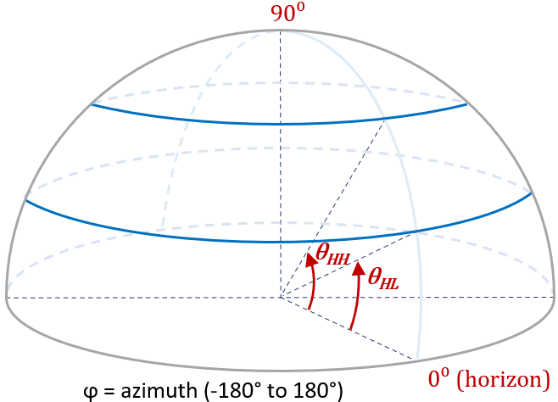
Figure 5-1: Definitions of θ_{HL} and θ_{HH} angles.

6 Conformance testing requirement and procedures

Annex <X> (informative):
Change history

Change history
Date | Meeting | TDoc | CR | Rev | Cat | Subject/Comment | New version
2024-08 | RAN4#112 |  |  |  |  | Approved TPs at RAN4#112 meeting  R4-2413575 TP to TR 38.908 Background of U6GHz EEIRP mask requirement  R4-2413576 TP to TR 38.908 U6GHz EEIRP mask requirement | 0.1.0

