3GPP TSG-RAN WG4 Meeting #112 R4-2412833

Maastricht, Netherlands,19 – 23 Aug, 2024

Agenda item: 8.20.4
Source: Moderator (CMCC)
Title: Topic summary for [112][131] FS_Ambient_IoT_solutions_part1
Document for: Information

Introduction
This summary focuses on the R19 ambient IOT study item under agenda 8.20, 8.20.1 and 8.20.2. The summary in previous meetings are in R4-2405289 and R4-2408945. The way forward agreed in previous RAN4 meetings are R4-2406714 and R4-2410567.
TDoc | Title | Source
R4-2411071 | Discussion on the AIoT LLS for passive devices in RAN4 | CATT
R4-2412879 | draft TP to TR 38.769 for Co-existence evaluation assumptions | Huawei, HiSilicon
R4-2412970 | A-IoT general overview | Ericsson
R4-2411770 | collection of calibration data for A-IoT | CMCC
R4-2411536 | AIoT deployment scenario for D1T1 | Sony
R4-2411606 | Discussion on the deployment scenarios and spectrum usage of Ambient IoT and NR | Xiaomi
R4-2411767 | Deployment scenario and spectrum usage | CMCC
R4-2411865 | Discussion on deployment scenarios and spectrum usage for ambient IoT | Spreadtrum Communications
R4-2412015 | Discussion on deployment scenarios and spectrum usage for AIoT | China Telecom Corporation Ltd.
R4-2412063 | Discussion on the deployment and spectrum usage of AIoT | vivo
R4-2412562 | Discussion on Ambient IoT deployment scenarios and spectrum usage | Samsung
R4-2412676 | Discussion on Ambient IoT deployment scenarios for D1T1 | NTT DOCOMO, INC.
R4-2412696 | Discussion on deployment scenarios and spectrum usage | ZTE Corporation, Sanechips
R4-2412727 | on deployment scenarios and spectrum usage for A-IoT | OPPO
R4-2412880 | Discussion on A-IoT deployment scenarios and spectrum usage | Huawei, HiSilicon
R4-2412917 | On AIoT deployment scenarios and spectrum usage | Qualcomm Incorporated
R4-2412969 | A-IoT deployment scenario and spectrum usage | Ericsson
R4-2411123 | Discussion co-existence evaluations for Ambient IoT in NR | CATT
R4-2411124 | Co-existence calibration results for Ambient IoT in NR | CATT
R4-2411607 | Discussion on the coexistence study of Ambient IoT and NR | Xiaomi
R4-2411765 | Discussion on A-IoT co-existence evaluation | CMCC
R4-2411866 | Discussion on co-existence evaluation for ambient IoT and NR-LTE | Spreadtrum Communications
R4-2412064 | Discussion on the co-existence of AIoT | vivo
R4-2412563 | Discussion on coex evaluation assumptions | Samsung
R4-2412697 | Discussion on Co-existence evaluations | ZTE Corporation, Sanechips
R4-2412881 | A-IoT co-existence evaluations | Huawei, HiSilicon
R4-2412918 | On Ambient IoT Coexistence Evaluation | Qualcomm Incorporated
R4-2412973 | Coexisting study simulation assumptions and initial results | Ericsson

TP
TDoc | Title | Source
R4-2412879 | draft TP to TR 38.769 for Co-existence evaluation assumptions | Huawei, HiSilicon

Issue 1-1: TP
Recommended WF:
TP for evaluation assumption can be updated during this meeting.

Deployment scenarios and spectrum usage

Topic 2-1: Deployment scenario
Issue 2-1-1: deployment scenarios for D1T1
Agreement in RAN4#110bis:
Issue 2-1-1: deployment scenarios for D1T1
Option 1-1: Legacy NR gNB are outdoor macro gNB while AIoT reader/CW/devices are all indoors. Legacy NR UE is only allowed outdoors.
Option 1-2: Legacy NR gNB are outdoor macro gNB while AIoT reader/CW/devices are all indoors. Legacy NR UE is indoor accessing to outdoor NR marco gNB
Option 2-1: Legacy NR gNB are co-located with AIoT reader and CW. All of NR and AIoT BS/UE/Reader/Device/CW are indoors. AIoT reader /CW and Legacy gNB share same hardware
Option 2-2: Legacy NR gNB are co-located with AIoT reader and CW. All of NR and AIoT BS/UE/Reader/Device/CW are indoors. AIoT reader /CW and Legacy NR gNB do not share same hardware. (less limitation on the power boosting)
Agreement:
- RAN4 to first evaluate co-existence for deployment scenario of option 1-1 and 1-2, and further study option 2-1 and 2-2.
Issue 2-3-2: Priorities of spectrum deployment mode for co-existence evaluation
Agreement:
- Prioritize the following spectrum deployment mode for RAN4 co-existence evaluation
  - A-IoT is located within a NR transmission bandwidth configuration
  - A-IoT which is operating indoor shares in-band spectrum with outdoor macro BS
Agreement in RAN4#111:
- Consider only adjacent RB/channel co-existence evaluation for in-band deployment scenario for NR and AIOT
- Encourage companies to provide the simulation results for option 1-1 and 1-2
  - FFS on co-site scenario (option 2-1 and 2-2)
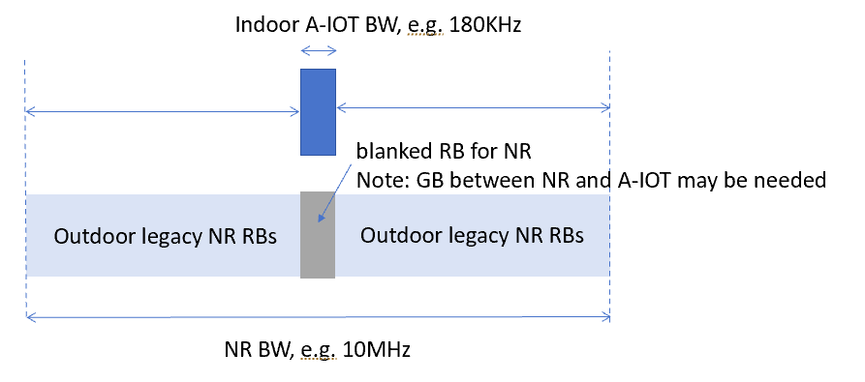

Proposal in RAN4#112:
Some companies propose to focus on evaluation of option 1-1 and option 1-2 in this study item:
- Proposal (vivo): During SI stage, focusing on finishing the co-existence platform calibration and the evaluation of option 1-1 and option 1-2.
- Proposal 2 (Huawei): Deprioritize to Option 2-1 and Option 2-2, due to very high PSD difference (24dB) and interference.
Some companies propose that the feasibility of indoor collocated scenario for device 1 and 2a needs further study.
- Proposal 1 (Sony): further study whether the indoor collocated scenario can be feasible for all device types.
- Proposal 2 (Ericsson): for device 1/2a, the option 2-1/2-2 may not be possible and this could be confirmed with LLS simulation.
For companies propose to study scenario option 2-1 and option 2-2, different considerations on the priorities are proposed:
- Proposal 1 (Spreadtrum): Option 2-2 needs to be prioritized for evaluation considering the feasibility.
- Proposal 2 (Samsung):
  - RAN4 to ask or wait for RAN1 to conclude how would the gNB (for Topology 1) and UE (for Topology 2) would split its transmitting power between the legacy NR and R2D links, and whether they will transmit the NR and R2D simultaneously or in TDM manner.
  - perform co-ex work with working assumptions that the gNB in topology 1 can boost its power or using separate hardware to fulfill the power demand for both NR and R2D links, and transmitting the R2D and NR DL simultaneously, i.e. option 2-2
- Proposal 3 (China Telecom, NTT DOCOMO): Both option 2-1 and 2-2 should be further studied in the same priority.
Recommended WF:
In previous RAN4 meeting, it was agreed to prioritize option 1-1 and 1-2 for co-existence study.
According to this meeting proposals, there are desire from companies to study option 2-1 and 2-2 as well. Consider the feasibility of option 2-1 and 2-2 needs further study, especially for device 1 and 2a. It is recommended that:
- Feasibility of option 2-1/2-2 for device 1 and 2a should be evaluated with LLS simulation. Parameters for LLS are based on company report.
Samsung: We propose to prioritize option 2 and do the co-existence study. We also propose the parameters for option 2.
Huawei: we support the recommended WF. Option 2-1 is very challenging because of high interference and difficulty to handle by using RF chain. We would like to focus on option 1-1/2.
NTT DOCOMO: support the recommended WF. 2GHz is added as optional.
China Telecom: We want to do co-existence study for 2GHz. Given the workload, we can compromise to prioritize option 1-1 and 1-2..
Moderator: The feasibility study should be done before co-existence study. Samsung propose some parameters for 2-2.

Agreement:
- Feasibility of option 2-1/2-2 for device 1 and 2a should be evaluated with LLS simulation. Parameters for LLS are based on company report.
  - Encourage companies to provide the co-existence simulation results.

Topic 2-2: Spectrum usage
Issue 2-2-1: Spectrum usage for R2D in D1T1
Agreement in RAN4#110bis:
- FFS on whether to prioritize FDD DL spectrum for R2D for D1T1 for co-existence evaluation.
Agreement in RAN4#111:
- Use FDD DL as starting point for co-existence evaluation for R2D in D1T1
  - FFS on FDD UL spectrum.

Proposal in RAN4#112:
Proposal 1 (Huawei, CMCC): R2D shall transmit in FDD downlink spectrum in D1T1.
Proposal 2 (Qualcomm): RAN4 can consider using FDD UL spectrum for R2D in D1T1 to solve the coexistence issue.
Proposal 3 (ZTE): both FDD DL or UL spectrum are fine for R2D transmission if there are no regulatory power limitation/restriction in the uplink spectrum.
Recommended WF:
In previous meeting, there was concern raised on the regulatory issue for reader transmission in the uplink spectrum.
It is recommended that:
- Only use FDD DL for co-existence evaluation for R2D in D1T1 in this study item.

Qualcomm: we want to consider uplink spectrum. We identify the co-existence issue. UL spectrum can solve the issue.
Samsung: Share the view as Qualcomm.
Huawei: in our opinion, for D1T1 the reader is BS and BS should transmit in DL. UL spectrum for reader cannot meet the spectrum regulation.
Qualcomm: There is no clear regulation for DL and UL for this new system.
Huawei: We understand A-IoT is the new system. But in WID, the reader D1T1 is the BS.

Agreement:
- Use FDD DL as baseline for co-existence evaluation for R2D in D1T1

Issue 2-2-2: CW spectrum for D2T2
For the case that D2R backscattering is transmitted in the same carrier as CW for D2R backscattering, and for topology 2, the following cases for CW transmission are studied.
· Case 2-2: CW is transmitted from inside the topology (i.e., intermediate UE), transmitted in UL spectrum
· Case 2-3: CW is transmitted from outside the topology, transmitted in DL spectrum
· Case 2-4: CW is transmitted from outside the topology, transmitted in UL spectrum
Agreement in RAN4#111:
- Use case 2-2 as starting point for co-existence evaluation for calibration.
- FFS on case 2-3
- Further discuss the difference of outside topology (case2-4) from co-existence study perspective.

Proposal in RAN4#112:
- Proposal 1(Xiaomi, vivo): Support to evaluate case 2-3
- Proposal 2 (CMCC): Focus on case 2-2. For case 2-3, D2R will transmit at DL spectrum, which will cause interference from device to legacy UE and NR DL to reader. Such two links have been analyzed in D1T1 scenario.
  - For interference from device to legacy UE, this is much like D1T1 scenario. No need to further simulation, the same conclude from D1T1 could be reused.
  - For interference from NR DL to reader, the main difference from D1T1 is intermediate UE have no directional antenna pattern in vertical domain. The interference from NR DL to UE reader would be larger than to gNB reader since gNB reader antenna gain is less than 0 dB due to height difference between outdoor gNB and indoor reader. But as stated, RAN4 workload is much high, it’s not suggested to increase simulation cases. If other companies think it is necessary, we can only add the interference from NR DL to reader for case 2-3. but according to calibration results, there is no interference for this link.
- Proposal 3 (Huawei): Choose Case 2-2 and Case2-4 as CW2D spectrum usage

Recommended WF:
It is recommended that:
- For D2T2, CW transmitted in UL is baseline for co-existence evaluation, CW transmitted in DL (i.e. case 2-3) can be considered once RAN4 agreed on the CW distribution for outside topology.

Agreement: For D2T2, CW transmitted in UL is baseline for co-existence evaluation, CW transmitted in DL (i.e. case 2-3) can be considered once RAN4 agreed on the CW distribution for outside topology.

Evaluation methodology and cases

Topic 3-1: Evaluation methodology
Issue 3-1-1: LLS to derive guard RBs
Proposal 1 (Spreadtrum): RAN4 needs to perform link level simulation for some cases, especially for worst cases, to drive guard RBs.
Proposal 2 (CATT): Link level simulation is needed to determine guard RB size to cancel ICI between A-IoT carriers and NR carriers in same cell for A-IoT in-band or guard band operation in NR spectrum and ensure A-IoT performance.
Recommended WF:
This is related to collocated scenario feasibility evaluation (scenario option 2-1 and 2-2). It is recommended to perform the study together with the feasibility study in issue 2-1-1.

Agreement: perform the study within the scope of the feasibility study in issue 2-1-1.

Issue 3-1-2: SINR vs BLER
Proposal 1 (Samsung): The SINR threshold for correct decoding D2R by receiver, especially when multiple D2R received with similar power level, need input from RAN1.
Proposal 2 (Qualcomm): The required minimum SINR values for the R2D and D2R links are needed. These minimum SINR values can be used to determine the maximum active reader ratio. RAN4 should send an LS to RAN1 check the required SINR for R2D and D2R links.
Proposal 3 (Ericsson): RAN4 conduct the LLS for the R2D SINR calculation.
Recommended WF:
Since RAN1 is collecting link level performance for both R2D and D2R, it is recommended that:
- RAN4 does not perform LLS to derive SINR values for R2D and D2R. Use RAN1 LLS results.

Ericsson: We think SINR is very important for co-existence. We understand that currently RAN1 is evaluating SINR. RAN4 should send LS if RAN1 reaches the consensus. We should not overlap the workload.
Samsung: The SINR mapping is crucial. At this moment, we can continue the evaluation. I agree with Ericsson.
CATT: if we do not use SINR threshold for metric, we may not need to have LLS. In WI, we may still need it for other evaluation.

Agreement:
- RAN4 does not perform LLS to derive SINR values for R2D and D2R.
- RAN4 can take RAN1 LLS as the reference to derive SINR values for R2D and D2R

Issue 3-1-3: Assumption of R2D transmission and CW transmission for evaluation
Proposal 1 (ZTE): Assume transmission timeline for R2D and CW signal among different A-IoT BS/CW node transmission are aligned
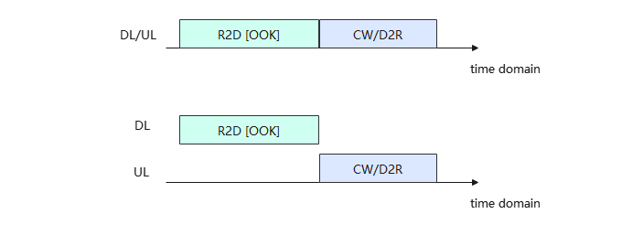
Recommended WF:
Proposal 1 is the assumption used for calibration.
It is recommended that:
- Assume transmission timeline for R2D and CW signal among different A-IoT BS/CW node transmission are aligned for co-existence evaluation.
Agreement: Assume transmission timeline for R2D and CW signal among different A-IoT BS/CW node transmission are aligned for co-existence evaluation.
Issue 3-1-4: Assumption of R2D and NR UL for D2T2
Proposal 1 (Samsung):
for topology 2, RAN4 could continue the co-ex work with working assumptions that UE in topology 2 would transmit the R2D and NR UL in TDM manner.
Recommended WF:
For calibration, we assume intermediate UE in D2T2 transmit R2D and NR UL in TDM manner.
It is recommended that:
- Assume intermediate UE in D2T2 transmit R2D and NR UL in TDM manner for co-existence evaluation.
Qualcomm: NR UL for intermediate UE.
Agreement: Assume intermediate UE in D2T2 transmit R2D and NR intermediate UE UL in TDM manner for co-existence evaluation.

Issue 3-1-5: whether to study interference mitigation scheme for scenario option 1-2
According to the calibration results, performance degradation had been observed for scenario option 1-2, i.e. legacy NR UE indoor accessing to outdoor NR Macro gNB. There is proposal to study the interference mitigation scheme.
Proposal 1 (Qualcomm): Further study the interference mitigation for the cases legacy NR UE indoor in D1T1 and D2T2.
  - For Option 1-2 in D1T1, micro gNB configures R2D/D2R resource to avoid or reduce the interference from R2D to proximity NR UE DL.
  - For Option 1-2 in D2T2, macro gNB configures R2D/D2R resource via intermediate UE to avoid or reduce the interference from NR UE UL to D2R.
Recommended WF:
Consider that RAN4 is still working on the co-existence evaluation, and interference mitigation scheme is not in the scope of RAN4 discussion.
It is recommended that:
- RAN4 focus on the co-existence evaluation in this study item.
Qualcomm: based on the current simulation results, for option1-2 D1T1 and D2T2 there is co-existence issue. It means that NR UE does not work. We need consider the interference mitigation to ensure such scenarios can work.
OPPO: We identify the same problem as Qualcomm. This is quite important. We need some place for discussion.
Moderator: in the next meeting, we will provide the formal simulation results. If the problem is identified, we can capture it in the TR. The mitigation scheme should not be discussed in RAN4.

Agreement: RAN4 focus on the co-existence evaluation in this study item.

Topic 3-2: Performance metric and SINR definition
Issue 3-2-1: Performance metric for AIOT
Agreement in RAN4#110bis:
- For NR system, use 5% throughput loss as performance metric as legacy.
- For AIOT system, including reader, device, intermediate UE, further discuss the performance metric:
  - Option 1: [10%] BLER, [Rx power]
  - Option 2: SINR degradation
  - Other options are precluded
Agreement in RAN4#111:
- Use SINR for calibration purpose
- FFS on performance metric for co-existence evaluation and requirements definition.

Proposal in RAN4#112:
- Proposal 1 (CATT): Use 1dB SINR degradation for 5% and 50% CDF SINR point as performance metric for A-IoT co-existence evaluation for DL and UL.
- Proposal 2 (Spreadtrum): For A-IoT system, use 10% BLER as a performance metric.
- Proposal 3 (CMCC):
  - when reader as victim
    - For the evaluation cases that inter-system interference is negligible compared with intra-system interference and noise, 1dB SINR degradation
    - For the evaluation case that inter-system interference is much greater compared with intra-system interference and noise, 1dB SINR degradation is not that intuitive. Instead, 10% BLER is suggested. Relationship between SINR and BLER are based on companies’ input with assumed LLS evaluation parameters.
  - When device is victim
    - 0dB SINR is reasonable performance metric when device as victim.
  - following list two options for outage probability, i.e. which point on the CDF should be used to evaluate interference. Considering A-IoT service usually is not urgent, average value seems more meaningful.
    - Edge 5%
    - Average value.
- Proposal 4 (Huawei):
  - CDF SINR degradation can serve as performance metric for A-IoT D2R. It is recommended 1dB for A-IoT BS and 1dB for A-IoT intermediate UE.
  - For A-IoT device with receiver based on RF envelope detector, it can correctly demodulate wanted signals only when the following conditions are met:
    - 1) SINR>= SINR threshold [7.5dB] for 10MHz RF BW;
    - 2) the wanted signal level>=demodulation sensitivity threshold [ -36dBm for Device 1, and -46dBm for Device 2a]
- Proposal 5 (Qualcomm): The impact of active BS/UEs ratio need to be considered in the coexistence criteria discussion and selection.
- Proposal 6 (Ericsson):
  - Collect the SINR CDF curve for individual adjacent RB to the A-IoT RB
  - Alternatively collect the SINR CDF for nearer NR BSs around A-IoT BS deployments

Huawei: at this stage, we may need more offline discussions. We want to keep options open.
Vivo: In the co-existence, why do we consider inter-system interference.
Moderator: based on the observation, even for some cases, the SINR is marginal. But the baseline SINR could be very low. For inter-system interference, in some case the performance loss can be neglected.
Ericsson: we need some offline discussions. For inter-system interference, SINR degradation is applied to A-IOT system.
CATT: IF SINR is larger than 1dB, both option 1 and 2 means the performance on single device. How to evaluate the performance of the whole system.

Tentative agreements:
For Performance metric for AIOT:
For inter-system interference (between AIOT and NR):
- If SINR degradation is smaller than [1]dB, it can be considered that no impact for the inter-system interference
  - SINR threshold for decoding should be taken into account
- If SINR degradation is lager than [1]dB, consider following criteria:
  - Option 1: [10%] BLER based on RAN1 LLS results
  - Option 2: wanted signal level or SINR level
For intra-system interference (between AIOT and AIOT), following criteria can be considered:
- Option 1: [10%] BLER based on RAN1 LLS results
- Option 2: wanted signal level or SINR level
Above SINR refers to the 5% and 50% CDF SINR

Issue 3-2-2: SINR definition for D2R
Agreement in RAN4#111:
Do not consider CW interference for calibration purpose for D1T1-A2 and D2T2-A2
FFS on how to consider CW cancellation capability in formal simulation

Proposals in RAN4#112:
- Proposal 1 (Huawei): The SINR includes CW interference is used as the baseline reference before any degradation.
  - SIR_D2R= Signal Power in [15kHz] transmission bandwidth / (Interference Power) in [15kHz] transmission bandwidth
- Proposal 2 (CMCC):
  - the SINR at reader is calculated as total power ratio, i.e.
$SINR=\frac{total received power within total receiver bandwidth}{{\left(noise + intra-system interference + inter-system interference\right)}_{within total receiver bandwidth}+{\left(CW power - self-interference cancellation\right)}_{in linear scale}}$

Recommended WF:
It is recommended that:
- SINR includes CW interference is used as the baseline reference before any degradation.
- SINR is calculated as total power ratio:
$$SINR=\frac{total received power within total receiver bandwidth}{{\left(noise + intra_system interference + inter_system interference\right)}_{within total receiver bandwidth}+{\left(CW power - self_interference cancellation\right)}_{in linear scale}}$$

CATT: we can use it for co-existence simulation.
Ericsson: For this formula, we also have other CW cancelation capability topic. Those two topics are relevant. What is the MSD degradation for CW interferer. We should consider them together.
OPPO: This is only for the reader. For NR UE the equation needs further discussion.

Agreement:
- SINR includes CW interference is used as the baseline reference for co-existence evaluation for CW reader.

Issue 3-2-3: SINR definition for R2D
Agreement in RAN4#111:
SINR for R2D for calibration purposes
- signal power of device to the noise and interference within 10MHz
  - Assume interference NR BW is 10MHz
- FFS on BB LPF

Proposals in RAN4#112
Proposal 1 (Samsung): By adopting LPF for R2D, the frequency selectivity on interference and noise can be applied to the SINR. Where the attenuation for received NR interference by the tag can be at least 4.3 dB and the noise can be reduced for SINR calculation of R2D.
SINR | R2D with LPF | R2D without LPF
Interference from NR | Frequency selectivity: > 4.3 dB | No frequency selectivity
Noise bandwidth | 180kHz | 10MHz
Proposal 2 (Spreadtrum): We need to consider BB LPF in formal simulation.
Proposal 3 (Huawei): SINR_R2D= Signal Power in [180kHz] transmission bandwidth / (Interference Power) in [10M] RF bandwidth)
Recommended WF:
In this issue, we focus on the assumption of noise bandwidth for R2D with LPF, frequency selectivity will discuss in topic 4-1.
It is recommended that
- signal power of device to the noise and interference within 10MHz is baseline assumption
- consider 180KHz noise and interference bandwidth if R2D with LPF is assumed.
  - Further discuss feasibility of R2D LPF

CATT: even with LPF, the noise cannot be within 180KHz. LPF cannot be that good that only 180KHz noise bandwidth to be considered.
Huawei: We provide the paper to analyze the input SNR and output SNR. As input of receiver, the noise and interference bandwidth can be 10MHz. It is only after output that 180KHz is feasible. Support recommondation.
Samsung: We have similar observation as Huawei. To CATT, the proposal is for simplification of value. It could not be ideal. But it can simplify the SNR calculation.
Sony: We have similar understanding as CATT. At least if we go forward of 180KHz, we need underlined assumption about LPF.

Agreement:
- signal power of device to the noise and interference within 10MHz is baseline assumption
- Consider [180KHz] noise and interference bandwidth as optional

Topic 3-3: CW considerations
Issue 3-3-1: Layout of CW for outside topology
- Option 1 (Huawei): assume that CW node is co-located with the neighbouring A-IoT Reader.
- Option 2 (vivo):
- Option 3 (Ericsson): Model a dedicated CWT node layer with a grid shift to the network layer.
Recommended WF:
More discussion is needed.

Issue 3-3-2: CW cancellation capability
Agreement in RAN4#111:
Do not consider CW interference for calibration purpose for D1T1-A2 and D2T2-A2
FFS on how to consider CW cancellation capability in formal simulation

- Proposal 1 (CMCC): we have following suggestions for self-interference if finally approve to simulate self-interference in final simulation
  - Total interference cancellation capability is based on companies report. Companies are also encouraged to show detailed analysis of each part of self-interference cancellation aspects, i.e. total interference cancellation capability = spatial isolation + RF cancellation + digital cancellation
- Proposal 2 (Spreadtrum): Refer to RAN1’s CW cancellation capability. Use formula as follow in formal simulation.
  - Remaining CW interference = CW Tx Power (dBm)+CW TX antenna gain(dBi)-Cabel,connector,combiner,body losses,(dB)+Receiver antenna gain (dBi)- Cabel,connector,combiner,body losses,(dB)-CW cancellation capability(dB)
- Proposal 3 (Qualcomm): The reader receiver sensitivity is essential for a reasonable D2R performance evaluation. This sensitivity is related to the reader’s CW cancellation capability. RAN1 and RAN4 should study the CW cancellation capability and provide the values for coexistence study.
- Proposal 4 (Huawei):
  - For monostatic (-A2), assume: [140dB for BS] and [120dB for UE]
  - For bistatic (-A1 and B), assuming CW has no impact to the receiver sensitivity loss.
Recommended WF:
For the CW cancellation capability, there are two alternatives. Discuss whether alternative will be used for evaluation.
- Alt. 1: Agree on one set of value for co-existence evaluation
  - e.g. [140dB for BS] and [120dB for UE] for -A2 and no impact for -A1 and B
- Alt. 2: Companies to report the CW cancellation capability used for co-existence evaluation
  - i.e. total interference cancellation capability = spatial isolation + RF cancellation + digital cancellation

Issue 3-3-3: CW unwanted emissions
- Proposal 1 (vivo): To avoid the impact from CW, an isolation distance between activated CW node and indoor NR UE can be defined. For D2T2, 41m can be the starting point, For D1T1, further discuss whether it is feasible to allow NR UEs locate inside factory.
- Proposal 2 (Huawei): Simulation is not needed for interference from CW to NR/A-IOT.
  - The reasons are as follows: The remaining interference after CW cancellation/suppression can be calculated, and the suppressed CW is used as the system's floor noise. CW deployment reuses Reader sites, and the interference path is similar to that of Reader. The CW output power does not exceed the Reader output power, and since CW is a single tone, interference from CW is no greater than that from Reader.
- Proposal 3 (Ericsson):
  - Use the ACLR for interference modelling for coexisting study.
  - Use the same ACLR characteristic of the device 1/2a for the CW transmission.
Recommended WF:
Discuss whether and how to model the CW unwanted emission.

Topic 3-4: Evaluation cases
Issue 3-4-1: Simplification of evaluation cases
Proposal 1 (Huawei): Remove redundant case 7, 10, 12, 17, and 19 from Table 6-1, since they share the same result with case 1, 4, 6, 13, and 15, respectively.
Proposal 2 (Huawei): No need to distinguish -A1, -A2 and -B for simulation. One case can be applied to all D1T1-A1, D1T1-A2 and D1T1-B (or D2T2-A1, D2T2-A2 and D2T2-B)
Deployment scenario and topology |  |  | Evaluation case No. | Note | (Aggressor -> Victim) | spectrum
1-1 | D1T1-legacy UE only outdoor | D1T1 option1-1， | 1 |  | device -> NR UL | R2D: DL  CW2D and D2R: UL
1-1 | D1T1-legacy UE only outdoor | D1T1 option1-1， | 2 |  | NR UL -> reader | R2D: DL  CW2D and D2R: UL
1-1 | D1T1-legacy UE only outdoor | D1T1 option1-1， | 3 |  | reader -> NR DL | R2D: DL  CW2D and D2R: UL
1-1 | D1T1-legacy UE only outdoor | D1T1 option1-1， | 4 |  | NR DL -> device | R2D: DL  CW2D and D2R: UL
1-1 | D1T1-legacy UE only outdoor | D1T1 option1-1， | 5 |  | device -> NR DL | R2D: DL  CW2D and D2R: DL
1-1 | D1T1-legacy UE only outdoor | D1T1 option1-1， | 6 |  | NR DL -> reader | R2D: DL  CW2D and D2R: DL
1-2 | D1T1-legacy UE indoor | D1T1 option1-2 | 7 | Redundant,  same with case 1 | device -> NR UL | R2D: DL  CW2D and D2R: UL
1-2 | D1T1-legacy UE indoor | D1T1 option1-2 | 8 |  | NR UL -> reader | R2D: DL  CW2D and D2R: UL
1-2 | D1T1-legacy UE indoor | D1T1 option1-2 | 9 |  | reader -> NR DL | R2D: DL  CW2D and D2R: UL
1-2 | D1T1-legacy UE indoor | D1T1 option1-2 | 10 | Redundant,  Same with case 4 | NR DL -> device | R2D: DL  CW2D and D2R: UL
1-2 | D1T1-legacy UE indoor | D1T1 option1-2 | 11 |  | device -> NR DL | R2D: DL  CW2D and D2R: DL
1-2 | D1T1-legacy UE indoor | D1T1 option1-2 | 12 | Redundant,  Same with case 6 | NR DL -> reader | R2D: DL  CW2D and D2R: DL
2-3 | D2T2-A2-legacy UE only outdoor | D2T2 option1-1 | 13 |  | device -> NR UL | R2D: UL  CW2D and D2R: UL
2-3 | D2T2-A2-legacy UE only outdoor |  | 14 |  | NR UL -> reader | R2D: UL  CW2D and D2R: UL
2-3 | D2T2-A2-legacy UE only outdoor |  | 15 |  | reader -> NR UL | R2D: UL  CW2D and D2R: UL
2-3 | D2T2-A2-legacy UE only outdoor |  | 16 |  | NR UL -> device | R2D: UL  CW2D and D2R: UL
2-4 | D2T2-A2-legacy UE indoor | D2T2 option1-2 | 17 | Redundant,  Same with case 13 | device -> NR UL | R2D: UL  CW2D and D2R: UL
2-4 | D2T2-A2-legacy UE indoor | D2T2 option1-2 | 18 |  | NR UL -> reader | R2D: UL  CW2D and D2R: UL
2-4 | D2T2-A2-legacy UE indoor | D2T2 option1-2 | 19 | Redundant,  Same with case 15 | reader -> NR UL | R2D: UL  CW2D and D2R: UL
2-4 | D2T2-A2-legacy UE indoor | D2T2 option1-2 | 20 |  | NR UL -> device | R2D: UL  CW2D and D2R: UL

Recommended WF:
From moderator perspective, even though the interference direction is the same for some cases, however, since option 1-1 and 1-2 has different NR legacy UE locations, the baseline SINR can be different. Not sure whether the cases can be removed.
Vivo: in current simulation, we consider both indoor and outdoor. Indoor can be considered as worst case. We do not need to do outdoor.
Ericsson: It is a bit early to preclude any cases now. We need some time to compare.

Issue 3-4-2: Whether to skip some cases that inter-system interference can be ignored for formal simulation
According to calibration results, some companies propose that for the cases that inter-system interference can be ignored, formal simulation can be skipped:
- Proposal 1 (Xiaomi): for both D1T1 and D2T2, only simulating the legacy UE indoor scenarios is enough to research the inter-system interference.
  - For D1T1, case 1 2 3 4 5 6 7 10 12 can be considered as no co-existence issue
  - For D2T2, case 13 14 16 17 can be considered as no co-existence issue
- Proposal 2 (vivo): To save efforts, for D2T2, the following cases of D2T2 can be marked as no co-existence issue and no need to further evaluate
3 | D2T2-A2-legacy UE only outdoor | 13 | device -> NR UL | R2D: UL  CW2D and D2R: UL | High | D2R
3 | D2T2-A2-legacy UE only outdoor | 14 | NR UL -> reader | R2D: UL  CW2D and D2R: UL | High | D2R
3 | D2T2-A2-legacy UE only outdoor | 15 | reader -> NR UL | R2D: UL  CW2D and D2R: UL | High | R2D
3 | D2T2-A2-legacy UE only outdoor | 16 | NR UL -> device | R2D: UL  CW2D and D2R: UL | High | R2D
4 | D2T2-A2-legacy UE indoor | 17 | device -> NR UL | R2D: UL  CW2D and D2R: UL | High | D2R
4 | D2T2-A2-legacy UE indoor | 19 | reader -> NR UL | R2D: UL  CW2D and D2R: UL | High | R2D

Recommended WF:
From moderator perspective, since some parameters are still under discusison for formal simulation, it may not easy to draw conclusion based on initial calibration results.

Issue 3-4-3: Device type
Agreement in RAN4#110bis:
- Prioritize device 1 and 2a without a frequency shifter for coexistence evaluation.

Proposals in RAN4#112:
- Proposal 1(Spreadtrum): Adopt Table 1 and table as the in-band co-existence evaluation scenarios for D1T1-C and D2T2-C.
Table 1: A-IoT co-existence scenarios with in-band NR deployment for D1T1
Deployment scenario and topology | spectrum | aggressor | victim
D1T1-C  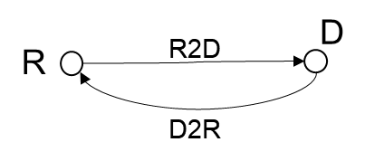 | R2D: DL  D2R: UL | Device | NR UL
 | R2D: DL  D2R: UL | NR UL | Reader
 | R2D: DL  D2R: UL | Reader | NR DL
 | R2D: DL  D2R: UL | NR DL | device
 | R2D: DL  D2R: UL | Device | NR DL
 | R2D: DL  D2R: UL | NR DL | Reader

Table 2: A-IoT co-existence scenarios with in-band NR deployment for D2T2-C
Deployment scenario and topology | spectrum | aggressor | victim
D1T1-C  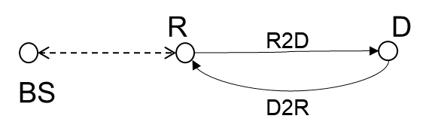 | R2D: UL  D2R: UL | Device | NR UL
 | R2D: UL  D2R: UL | NR UL | Reader
 | R2D: UL  D2R: UL | Reader | NR UL
 | R2D: UL  D2R: UL | NR UL | device

- Proposal 2 (CMCC): it’s suggested to focus on device 1 and 2a in study phase.
  - when device 2b as aggressor, if we assume the same IBE requirements as legacy UE, then the interference is much like legacy NR network intra-system scenario and the interference is almost acceptable. Due to device have less chip rate, i.e. narrower pass bandwidth, device 2b would have better leakage performance outside the 1PRB bandwidth. From this point of view, it seems at least current we can focus on device 1 and 2a at first.
Recommended WF:
Consider the workload of co-existence evaluation, it is recommended to keep the previous agreement:
- Prioritize device 1 and 2a without a frequency shifter for coexistence evaluation.

Agreement: Prioritize device 1 and 2a without a frequency shifter for coexistence evaluation.

Issue 3-4-4: Multi-operator scenario
Agreement in RAN4#111:
FFS on co-existence between AIOT system and adjacent operator NR system
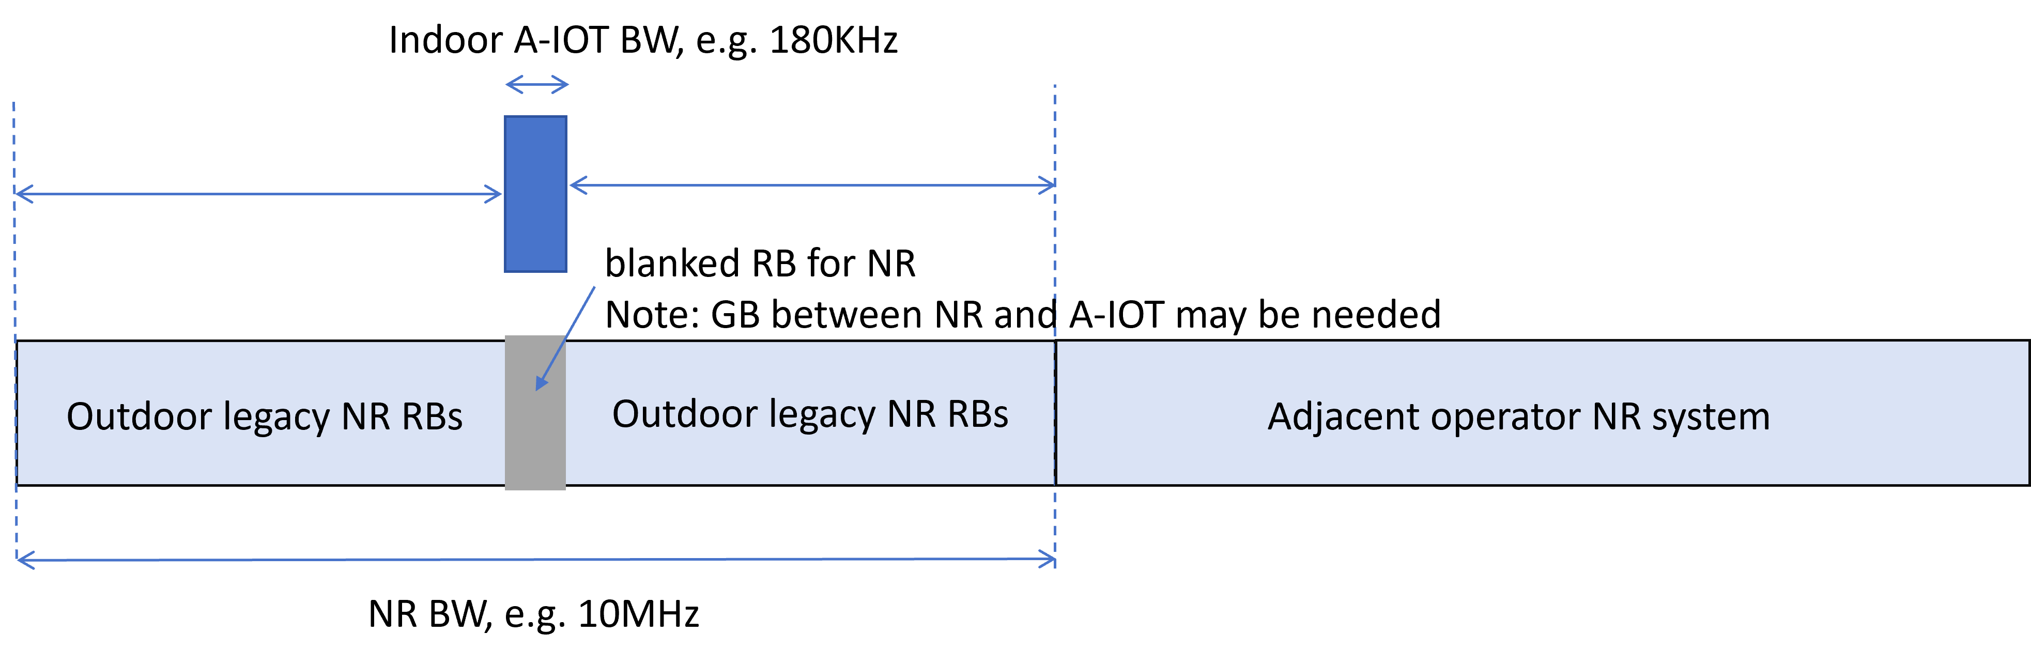

Proposals in RAN4#112:
- Proposal 1(Spreadtrum):
  - Multiple A-IoT operators co-existence scenario should be investigated and capture figure1 in TR.
  - How operators can co-ordinated needs to be further studied.
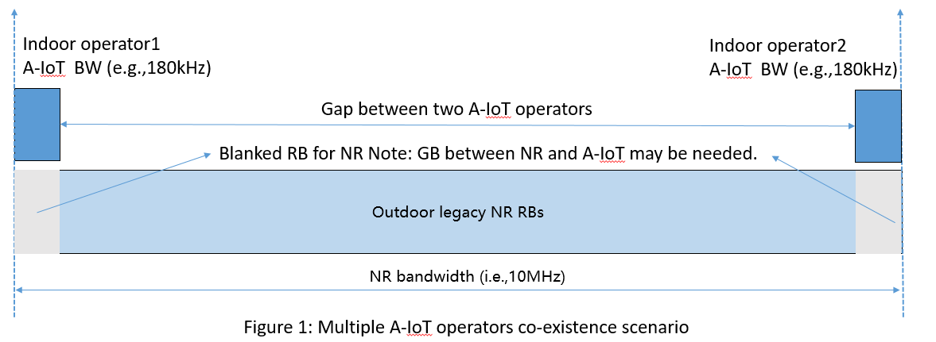
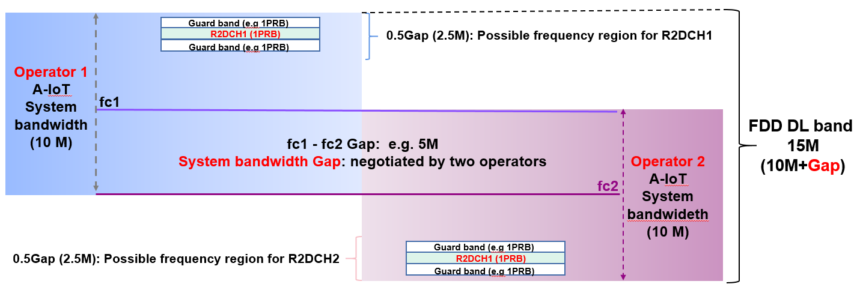
- Proposal 2 (Ericsson): RAN4 continue to discuss the A-IoT coexisting with A-IoT scenario.
- Proposal 3 (CTC): The coexistence between AIoT systems including necessity, feasibility and details need to be studied and evaluated.

Recommended WF:
Discuss whether to consider multiple A-IOT operator co-existence scenario in this study item.

Spreadtrum: we identify such scenario and it can improve the spectrum efficiency.
Ericsson: It is necessary to study. We need reduce the activated reader ratio. If you deploy multiple A-IoT channels, the efficiency can be improved.
Moderator: Ericsson proposal is one operator deploying multiple channels. Can we focus on the scenario that we have so far?

Agreement:
- Focus on the co-existence study between A-IoT and NR in this study item.
- The scenario of multiple A-IOT operators in the same band can be considered in the WI phase or in the study of the future release.

Evaluation parameters

Topic 4-1: Adjacent RB Tx and Rx characteristics
Issue 4-1-1: A-IOT reader and NR BS
Agreement in RAN4#111:
For calibration purpose, use 0RB guard band between AIOT and NR for in-band spectrum deployment mode
 |  | In-band
 |  | Tx | Rx
NR UE/A-IOT Intermediate UE | For calibration purpose | Legacy UE IBE | ACS
NR BS | For calibration purpose | ACLR of legacy gNB | ACS of legacy gNB
A-IOT BS | For calibration purpose | ACLR of legacy gNB (i.e. 45) | ACS of legacy gNB

Proposals in RAN4#112:
Proposal 1 (Huawei): A-IoT micro-BS ACLR (dB): ACLR1:40dB，ACLR2:50dB
Proposal 2 (Ericsson): Interference for case 6 and 12: NR BS IBE factor: 17 dBc relative to to the average NR transmission power.
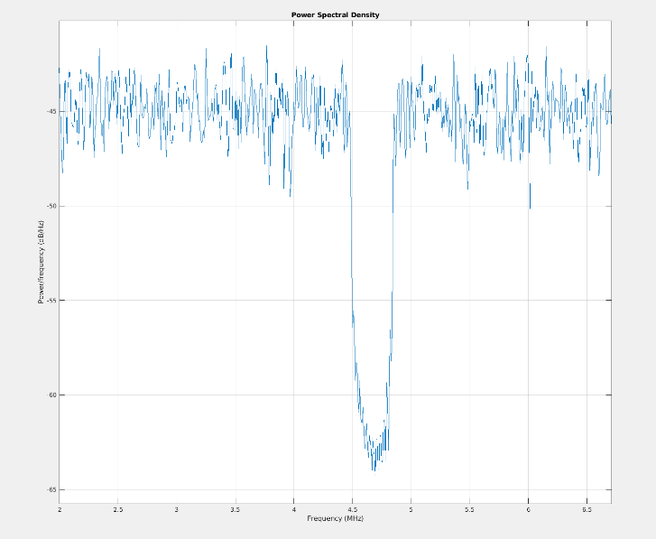
Recommended WF:
Need to check proposal2 first.
Check whether following values can be used for formal simulation.
 | In-band
 | Tx | Rx
NR UE/A-IOT Intermediate UE | Legacy UE IBE | ACS
NR BS | ACLR of legacy gNB | ACS of legacy gNB
A-IOT BS | ACLR of legacy NB -IOT gNB  (i.e. ACLR1:40dB，ACLR2:50dB) | ACS of legacy gNB

Issue 4-1-2: Tx for device 1 and 2a
Agreement in RAN4#111:
For device 1 and 2a, 25dBc is used for calibration purposes
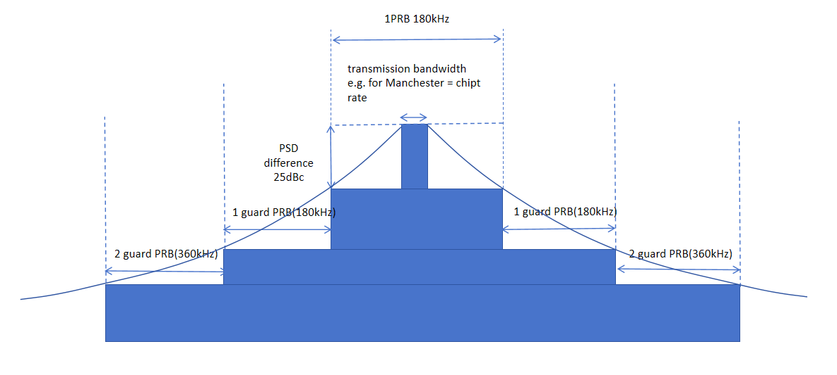

Proposal 1(CMCC): for device 1 and 2a, it’s suggested to use following value for IBE with assuming 7kbps D2R date rate, Manchester code, 1/3 code rate convolution code, BPSK modulation scheme. Following assumes that Tx signal is at frequency center
• 16dBc at the edge of center 1PRB, i.e. 90kHz offset from frequency center
Recommended WF:
- Discuss which one or both should be used for formal simulation
  - Option 1: 25dBc (based on 5kbps, Manchester code)
  - Option 2: 16dBc (based on 7kbps, Manchester code, 1/3 code rate convolution code)

Issue 4-1-3: Rx for device 1 and 2a
Agreement in RAN4#111:
Assume no frequency selectivity for co-existence evaluation for calibration purposes for device 1 and 2a.
Proposals in RAN4#112:
Proposal 1 (Samsung): By adopting LPF for R2D, the frequency selectivity on interference and noise can be applied to the SINR. Where the attenuation for received NR interference by the tag can be at least 4.3 dB and the noise can be reduced for SINR calculation of R2D.
SINR | R2D with LPF | R2D without LPF
Interference from NR | Frequency selectivity: > 4.3 dB | No frequency selectivity
Noise bandwidth | 180kHz | 10MHz
Proposal 2 (Spreadtrum): We need to consider BB LPF in formal simulation.
Proposal 3 (CMCC): it’s suggested to assume there is no in-band selectivity for RF-ED based device for formal simulation, which is the worst assumption. If final simulation show interference occurs, RAN4 can further focus on BB LPF performance analysis and conclude certain RF requirements if necessary to avoid interference.
Recommended WF:
Consider co-existence usually evaluate the worst case, it is recommended that:
  - Use R2D without LPF as baseline for co-existence evaluation, R2D with LPF in proposal 1 as optional.

Issue 4-1-4: Scaling factor
Proposal (Ericsson):
Interference for case 1 and 7: CW node aggressor ACLR scaling factor: ACLR_e_AIOT_xx = ACLR – 10*log10((9MHz/(# of NR users))/180kHz)
Interference for case 3 and 9: AIoT-BS aggressor ACLR scaling factor: tACLR_e_AIOT_BS = ACLR – 10*log10((9MHz/(# of NR users))/180kHz)

Recommended WF:
Discuss the above proposal.
In SBFD study, for the case where the aggressor’s bandwidth is narrower that the victims bandwidth, no scaling factor is applied. For the cases where the aggressor’s bandwidth is wider than the victim’s bandwidth, a bandwidth compensation factor is applied $10*log10\left(\frac{{BW}_{aggressor}}{{BW}_{victim}}\right)$
Following scaling factor is used for calibration, it is recommended to also use this for formal simulation.
- when A-IoT reader as victim, the scaling factor is suggested as below to compensate different aggressor and victim bandwidth when calculating inter-system interference.
- Scaling factor = $10*log10\left(\frac{{BW}_{aggressor}}{{BW}_{victim}}\right)$

Topic 4-2: General parameters and layout
Issue 4-2-1: Active rate of reader for D1T1
It has been observed that the intra-system interference is very high for the 18 BS layout of D1T1. Some companies propose to reduce the number of active BS and the proposals are:
- Proposal 1 (Qualcomm): 50% active rate (9 reader)
- Proposal 2 (Huawei): For D1T1, Readers transmit round-robin as the baseline, and concurrent transmission is not considered for co-existence simulation. (1 reader)
- Proposal 3 (ZTE): further study the assumption of A-IoT BS activation within the indoor factory in D1T1 scenario.
- Proposal 4 (vivo): For D1T1, at least 1/3 readers are activated in one snapshot is assumed. (6 reader)
- Proposal 5 (Xiaomi): For D1T1, adopting 2 readers are activated in one drop as the starting point to reduce the inter-system interference due to all reader are activated. (2 reader)
- Proposal 6 (CMCC): the activation ratio of topology 1 reader is suggested as below:
  - Divide all 18 readers into X blocks, 1 reader per block are activated simultaneously. Noted: we need to order the reader in each block, the reader that is located in the same relative location in each block would be blocked as the same index. only the reader with the same order index will be activated simultaneously.
  - X could be 1, 2, 3, if there is no consensus of X value, X could be based on companies report.
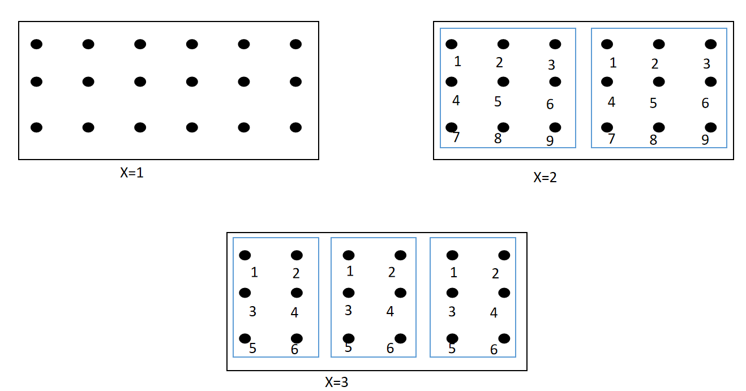
Recommended WF:
6 companies propose to consider an active rate for readers in D1T1 for co-existence evaluation, however, the proposed values are quite diverse (from 1 to 9).
More discussion is needed.

Issue 4-2-2: Active rate of reader for D2T2
The similar observation of intra-system interference as issue X-X-X is also observed for D2T2. The proposed active rate for intermediate UE for D2T2 are:
- Proposal 1 (Qualcomm): 1 or 2 UE at each drop should be used for the D2T2 coexistence study.
- Proposal 2 (Xiaomi, vivo, CMCC): For D2T2, adopting Option 1 (2 UE at one drop) as the starting point for the later simulation.
Recommended WF:
It is recommended that:
- Randomly choose 2 intermediate UEs simultaneously for D2T2 for formal simulation.

Issue 4-2-3: Indoor UE percentage for scenario option 1-2
Agreements in RAN4#111:
For scenario option 1-2, uniformly distributed, 80% indoor, 20% outdoor
Proposals in RAN4#112:
Proposal 1 (CMCC): for calibration purpose, 80% legacy indoor UE are unifrom distributed in the same factory/office as A-IoT system, i.e. there is no penetration loss between A-IoT system and legacy indoor UE.
Proposal 2 (vivo): it is suggested to modify the NR UE indoor ratio from 80% to 10%
Proposal 3 (Spreadtrum): 20% legacy indoor UE and 80% legacy outdoor UE in formal simulation.
Proposal 4 (Qualcomm): uniformly distributed, 100% indoor.
Recommended WF:
3 companies support to reduce the indoor UE percentage, while 1 company propose to increase the indoor UE percentage.
It is recommended that:
- Choose two options for co-existence evaluation, e.g. NR UE indoor ratio [10%], [80%]

Issue 4-2-4: transmission bandwidth of R2D
Agreements in RAN4#111:
Channel BW for AIOT | DL: 180kHz with 15KHz SCS  UL: 15KHz or 180KHz

Proposals in RAN4#112:
Proposal 1 (Huawei): 180KHz
Proposal 2 (ZTE): for the transmission bandwidth of R2D signal, propose to use 720KHz transmission bandwidth for formal evaluation.
Recommended WF:
If there is no big difference for co-existence evaluation results, it is recommended to keep 180KHz for formal simulation.

Issue 4-2-5: Minimum NR BS-NR UE distance (2D)
Agreements in RAN4#111:
Minimum NR BS – NR UE distance (2D): 35 m
Proposal in RAN4#112:
Proposal (Ericsson): Use MCL of 70 dB for Minimum NR BS – NR UE distance setting in coexisting simulation.
Recommended WF:
If there is no big difference for co-existence evaluation results, it is recommended to keep 35m for formal simulation

Issue 4-2-6: NR RB allocation
Agreements in RAN4#111:
NR UE number:
- DL active UE: 1 UE per cell
- UL active UE: 3UE per cell

Recommended WF:
Following RB allocation is used for calibration, it is recommended to reuse for formal simulation.
- For RB allocation, each UE is scheduled with 17PRB and A-IoT using 1PRB is located between the most two UEs. Detailed illustration is listed as below:
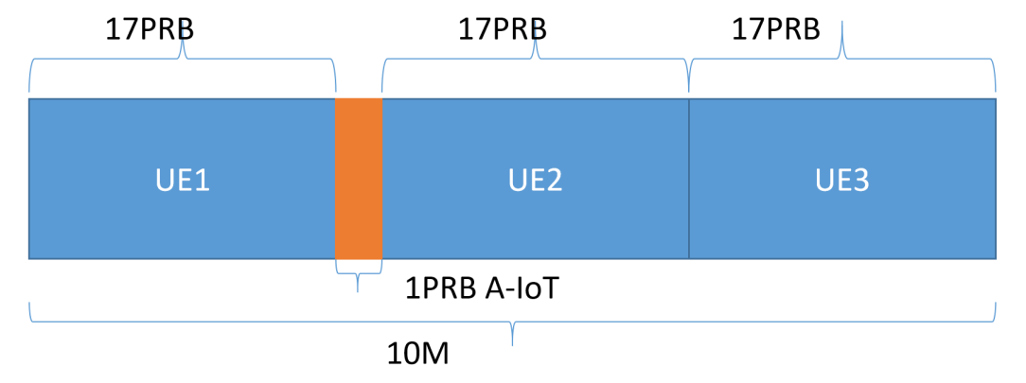

Issue 4-2-7: Penetration loss for O2I
Following is already used for calibration:
- Use the equation of 7.4-2 in 38.901
- PLin = 0.5 * d2D-in where d2D-in is the distance to nearest factory/office boundary on the line between Tx and Rx point.
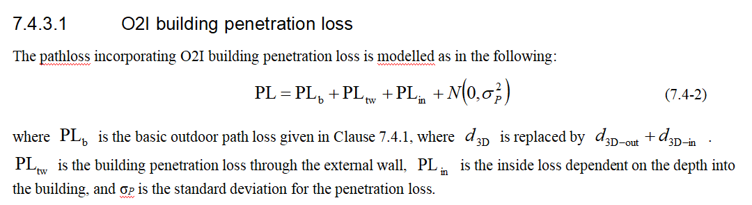
In this meeting, CMCC propose to set the max value of d2D-in as 25m, since if there is no upper bound limitation of d2D-in, the received power from NR macro gNB to existing UE would be low
Recommended WF:
- Use the equation of 7.4-2 in 38.901
- PLin = 0.5 * d2D-in where d2D-in is the distance to nearest factory/office boundary on the line between Tx and Rx point.
- Check whether to set maximum value of d2D-in as [25m]

Issue 4-2-8: Pathloss
Recommended WF: Following pathloss is used for calibration. It is recommended to reuse for formal simulation
 | D1T1 | D2T2
Indoor legacy UE <-> indoor device | Indoor office
Indoor legacy UE <-> indoor reader | Indoor factory DH | Indoor office
Outdoor macro gNB <-> indoor device/indoor reader | PLb: Uma
Outdoor UE <-> indoor device/ D2T2 UE, i.e. UE<->UE | PLb: Umi
Outdoor UE <-> indoor D1T1 reader, i.e. UE<-> micro gNB | PLb: UMi
Note: For other indoor factory related parameters that are not listed, it’s suggested to refer to 7.8.4 of TR 38.901.

Topic 4-3: Paramters for AIOT BS/intermedaite UE and device
Issue 4-3-1: AIOT micro-BS parameters for D1T1
Recommended WF:
Following parameters are used for calibration. It is recommended to reuse for formal simulation
A-IoT micro BS parameters | Values for calibration purposes
A-IoT micro-BS total Tx power | 33dBm
A-IoT micro-BS receiver Noise Figure（dB） | 10
A-IoT micro-BS antenna gain (dBi) | 6 dBi
Antenna pattern | Antenna Array Geometry：  - 1*1*1 antenna element  - equals to omni-directional antenna pattern in GCG in horizontal  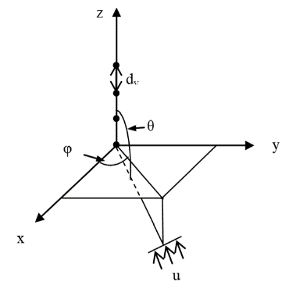
  Parameter | Assumption
  Antenna pattern (horizontal) | $A_{H}\left(ϕ\right)=-\min\left[12{\left(\frac{ϕ}{ϕ_{3dB}}\right)}^{2},A_{m}\right]$, = 90°, A_{m} = 15 dB
  Antenna pattern (vertical) | $A_{V}\left(θ\right)=-\min\left[12{\left(\frac{θ-90°}{θ_{3dB}}\right)}^{2},SLA_{v}\right]$, = 90°, SLA_{v} = 15 dB
  Combining method in 3D antenna pattern
  BS antenna gain (dBi) (including feeder loss) | 6

Issue 4-3-2: Intermediate UE parameters for D2T2
Recommended WF:
Following parameters are used for calibration. It is recommended to reuse for formal simulation.
intermediate UE parameters | Values for calibration purposes
intermediate UE total Tx power（dBm） | 23dBm
gain of antenna intermediate UE (dBi) | 0
intermediate UE receiver Noise Figure（dB） | 9
Antenna configuration | Omni direction antenna

Issue 4-3-3: AIOT device parameters
Recommended WF:
For device 1, confirm to use the values for formal simulation.
For device 2a, discuss the values for formal simulation
A-IoT device parameters | Device 1  Values used for calibration | Device 2a | RAN1 assumption  (R1-2406752)
A-IoT device effective antenna gain per Tx or Rx branch (dBi) | 0 | [0] | For A-IoT device, 0dBi
A-IoT device reflection （backscatter）loss (dB)  Note: due to, e.g., impedance mismatch | OOK: -6 dB | OOK: -6 dB | OOK: 6 dB  PSK: 0 dB  FSK: Y dB  It is applicable for device 1 and 2a.  Companies to report and justify their assumptions for Y.  Companies to report in row 3D if they assume any additional related loss.
A-IoT device power gain of reflection amplifier (dB) | N/A | 10(M),15(O) | 10 dB (M)  15 dB (O)  Note: Only for device 2a
A-IoT Device receiver sensitivity (dBm)  Use this value to determine whether device can camp on the cell. | -36 | [-45] | For Budget-Alt1  For device 1 (RF-ED), for example:  {-30 dBm, -36 dBm, -40 dBm, etc}  For device 2 (RF-ED), for example:  {-40 dBm, -45 dBm, etc}  For Budget-Alt2  Calculated (see note1)
A-IoT device noise figure (dB) | 24 | [20] | For RF-ED receiver  - 20dB, Device 2  - FFS other values
Guard band | 0PRB | 0PRB

Topic 4-4: Paramters for legacy NR
Issue 4-4-1: NR macro BS parameters
Recommended WF:
Following pathloss is used for calibration. It is recommended to reuse for formal simulation
NR macro-BS Parameter | Values for calibration purposes
Macro-BS Tx power (dBm) | 46
BS antenna gain (dBi) and antenna pattern | Antenna Array Geometry：  - 1*1*1 antenna element  - BS point at fixed beam direction  - vertical: θtilt + 90°  - horizontal: 0, 120, 240 °
  Parameter | Assumption
  Antenna pattern (horizontal)  (For 3-sector cell sites with fixed antenna patterns) | $$A_{H}\left(ϕ\right)=-\min\left[12{\left(\frac{ϕ}{ϕ_{3dB}}\right)}^{2},A_{m}\right]$$  = 65 degrees, A_{m} = 25 dB
  Antenna pattern (vertical)  (For 3-sector cell sites with fixed antenna patterns) | $$A_{V}\left(θ\right)=-\min\left[12{\left(\frac{θ-{90°-θ}_{etilt}}{θ_{3dB}}\right)}^{2},SLA_{v}\right]$$  = 10 degrees, SLA_{v} = 25 dB, = 9 degrees
  Combining method in 3D antenna pattern
  BS antenna gain (dBi) (including feeder loss) | 15
Height of macro NR BS (m) | 25
NR Macro-BS Noise Figure(dB) | 5
Network location | outdoor

Issue 4-4-2: NR UE parameters
Recommended WF:
Following parameters are used for calibration. It is recommended to reuse for formal simulation
NR UE Parameter | Values for calibration purposes
UE TX power in dBm | -40 to 23
NR UE Antenna gain (dBi) | 0
Height of UE antenna (m) | 1.5
NR UE ACLR（dB） | 30
NR UE Noise Figure（dB） | 9
Antenna configuration | Omni direction antenna

Topic 4-5: Paramters for CW
Issue 4-5-1: Other CW parameters
Recommended WF:
Following parameters are used for formal simulation.
CW parameters | D1T1 | D2T2
Tx power（dBm） | If UL spectrum is used, UE Tx power is assumed, i.e. 23dB  If DL spectrum is used, AIOT micro-BS Tx power is assumed. | Inter-mediate UE Tx power is assumed.
Antenna gain | Same as AIOT reader | Same as inter-mediate UE

Topic 4-6: Paramters for collocated scenario (option 2-1 and 2-2)
Issue 4-6-1: Simulation assumptions for collocated scenario
Proposal 1 (Samsung R4-2412563): It is proposed to re-use the previously discussed indoor reader antenna pattern for indoor gNB as a starting point for co-ex. (Issue 4-3-1: AIOT micro-BS parameters for D1T1)
Proposal 2 (Samsung R4-2412563): For D1T1 Option 2-1 and 2-2, we propose to amend information in above table for layouts, which include the following assumptions:
1) NR BS indoor gNB deployed co-site with A-IoT indoor reader;
2) ISD as 20m;
3) Min BS-UE distance: 0m;
4) NR indoor UE uniformly distributed.
Recommended WF:
- Discuss whether above proposals can be used for co-existence evaluation.
- Other deployment and assumptions can re-use existing agreements if not explicitly proposed.

