Hello all,

This is an invitation to RAN4#111 Webinar sessions on 20 – 24 May 2024. This invitation covers two sessions in two separate rooms: Main and RRM.

GoToWebinar (GTW) conference calls will be set in each session. And one-way remote participants can be supported.

Please remember that consistent registration format is important for session chairing and hence **use the following format when you register: BriefCompanyName - Firstname, Lastname. An example is shown below**

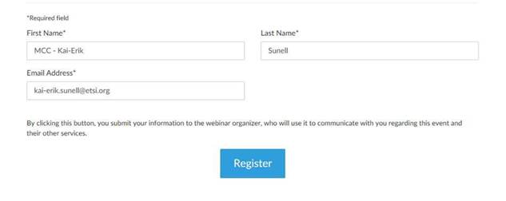

**where BriefCompanyName is ‘MCC’, Firstname is ‘Kai-Erik’ and Lastname is ‘Sunell’.**

Your email address for Webinar registration needs to be the same as for your 3GPP meeting registration.

Registration links are found below and they are session-specific. You may register to all sessions, e.g. if you plan to switch between sessions or if you are able to listen to all sessions at the same time. Once you have registered for a session your registration is valid for the whole week.

**The starting time for Main Webinar and RRM Webinar sessions (20 May) is 00:00 UTC (02:00 CEST) (09:00 local time) – 10:30 UTC (12:30 CEST) (19:30 local time)** but you can joiny already 15 minutes earlier, i.e. 23:45 UTC, to check that the equipment work fine. (Observe, registration links below show time in Paris time zone CEST). Webinars are scheduled to stop at 10:30 UTC (12:30 CEST) (19:30 local time).

**The starting time for Main Webinar and RRM Webinar sessions (21 – 23 May) is 23:30 UTC (01:30 CEST) (08:30 local time) – 10:30 UTC (12:30 CEST) (19:30 local time)** but you can join already 15 minutes earlier, i.e. 23:15 UTC, to check that the equipment work fine. (Observe, registration links below show time in Paris time zone CEST). Webinars are scheduled to stop at 10:30 UTC (12:30 CEST) (19:30 local time).

**The starting time for Main Webinar and RRM Webinar sessions (24 May)** **is 23:30 UTC (01:30 CEST) (08:30 local time) – 08:00 UTC (10:00 CEST) (17:00 local time)** but you can join already 15 minutes earlier, i.e.23:15 UTC, to check that the equipment work fine. (Observe, registration links below show time in Paris time zone CEST). Webinars are scheduled to stop at 08:00 UTC (10:00 CEST) (17:00 local time).

Note: One-way remote participants will be used as listen only mode.

Instructions on how to join the Webinars will be sent automatically every day.

|  |  |  |  |  |  |  |  |
| --- | --- | --- | --- | --- | --- | --- | --- |
| |  |  |  | | --- | --- | --- | | |  |  | | --- | --- | | |  | | --- | | **RAN4#111 RRM Webinar Sessions (20 May - 24 May)**  Mon, May 20, 2024 2:00 AM - 12:30 PM CEST | | | | |  |  |  | | --- | --- | --- | | **RAN4#111 RRM Webinar Sessions (20 May - 24 May)**  Join us for a webinar beginning on May 20, 2024 at 2:00 AM CEST.   |  |  | | --- | --- | | |  | | --- | | [Register now!](https://attendee.gotowebinar.com/register/8377235606380603737) | |   After registering, you will receive a confirmation email containing information about joining the webinar.  [View System Requirements](https://link.gotowebinar.com/help-system-requirements-attendees) | | |

|  |  |  |  |  |  |  |  |
| --- | --- | --- | --- | --- | --- | --- | --- |
| |  |  |  | | --- | --- | --- | | |  |  | | --- | --- | | |  | | --- | | **RAN4#111 Main Webinar Sessions (20 May - 24 May)**  Mon, May 20, 2024 2:00 AM - 12:30 PM CEST | | | | |  |  |  | | --- | --- | --- | | **RAN4#111 Main Webinar Sessions (20 May - 24 May)**  Join us for a webinar beginning on May 20, 2024 at 2:00 AM CEST.   |  |  | | --- | --- | | |  | | --- | | [Register now!](https://attendee.gotowebinar.com/register/7290976392254401888) | |   After registering, you will receive a confirmation email containing information about joining the webinar.  [View System Requirements](https://link.gotowebinar.com/help-system-requirements-attendees) | | |

Regards,

Carolyn