3GPP TSG-RAN WG3#128 R3-253926
St. Julien’s, Malta, 19-23 May 2025

Agenda item: 13.2 Support for inter-CU LTM
Source: Nokia, Samsung, Huawei, Ericsson, LG Electronics, CATT, Ofinno, ZTE, NEC, China Telecom, Google
Title: TP (BL CR TS 38.300) Remaining issues on Inter-CU LTM procedure
Document for: Discussion and Decision

1 Text Proposal for TS 38.300

<< First Change >>

9.2.3.5.2 C-Plane Handling
Cell switch command is conveyed in a MAC CE, which contains the necessary information to perform the LTM cell switch.
The overall procedure for LTM is shown in Figure 9.2.3.5.2-1 below. Subsequent LTM is done by repeating the early synchronization, LTM cell switch execution, and LTM cell switch completion steps without the need to release, reconfigure or add other LTM candidate configurations after each LTM cell switch completion. The general procedure over the air interface is applicable to SCG LTM. Further details of SCG LTM can be found in TS 37.340 [21].
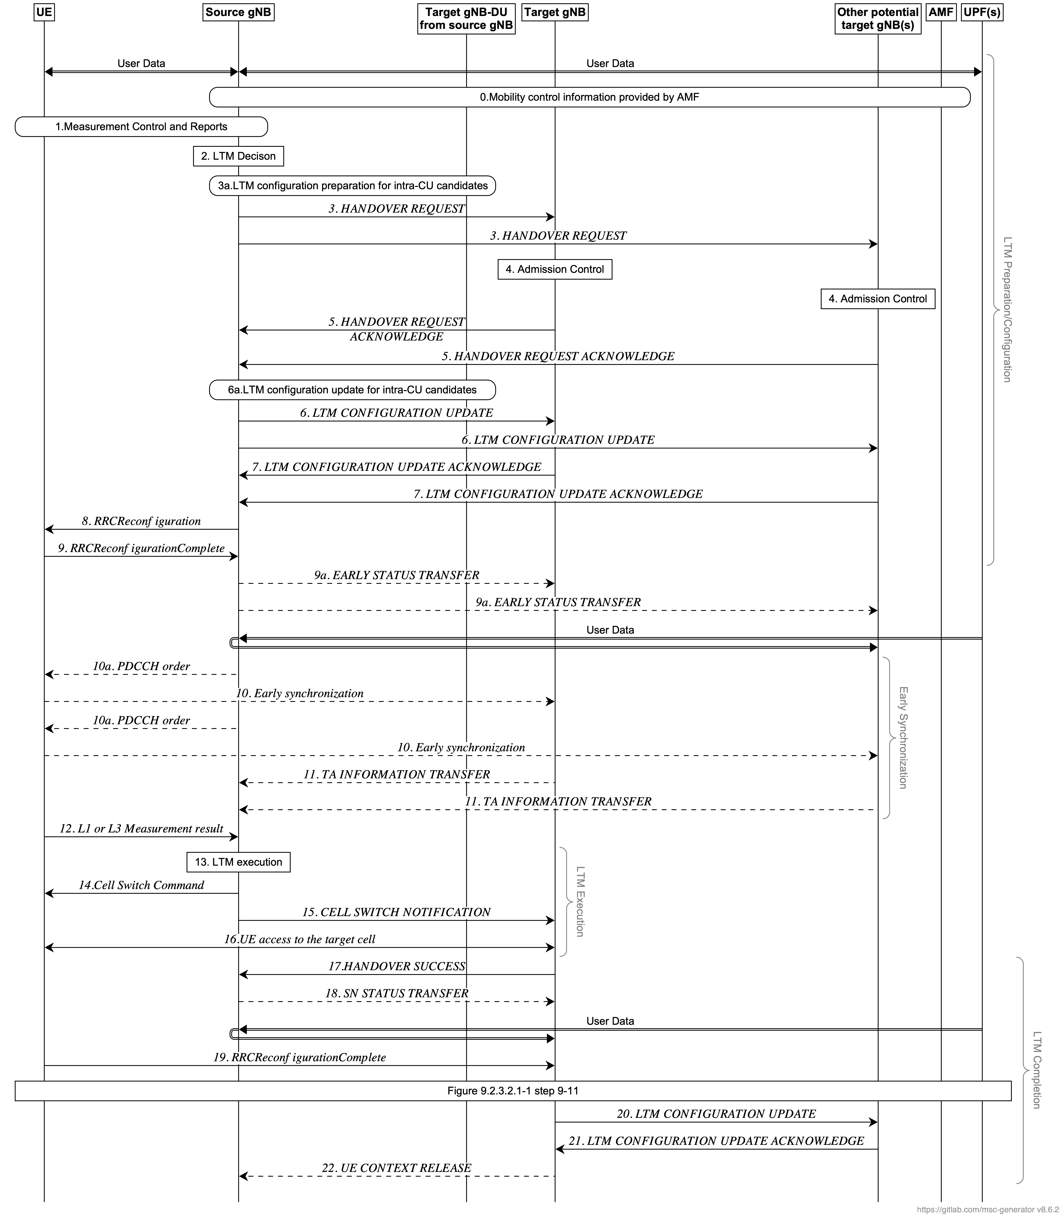
Figure 9.2.3.5.2-1. Signalling procedure for LTM
The procedure for LTM is as follows:
1. The UE sends a MeasurementReport message (L3 measurement result) to the source gNB containing measurements of neighbouring cells.
2. The source gNB decides to configure LTM.
3. The source gNB requests LTM for one or more candidate cells belonging to the source gNB and/or one or more candidate gNB(s). For inter-gNB LTM, the source gNB initiates a HANDOVER REQUEST message per candidate cell containing one candidate cell ID and may contain the CSI resource configuration for subsequent LTM. For both intra and inter-gNB LTM, the source gNB may request the candidate cell(s)/gNB(s) to provide the CSI-RS resource configuration.
4. Admission Control may be performed by the candidate cells(s)/gNB(s).
5. The candidate prepares and provides the LTM configuration(s) to the source gNB. For inter-gNB LTM, the candidate gNB(s) respond(s) with a HANDOVER REQUEST ACKNOWLEDGE message to the source gNB including the generated RRC configurations for the accepted candidate cell. For both intra and inter-gNB LTM, the candidate may also include additional information related to the CSI-RS resource configuration and early sync information upon request.
6. The source gNB sends an LTM CONFIGURATION UPDATE message to the candidate gNB(s) to update the LTM configurations of candidate cell(s). The source gNB may include the common CSI resource configuration and the LTM configuration ID mapping list.
7. The candidate gNB(s) sends the LTM CONFIGURATION UPDATE ACKNOWLEDGE message to the source gNB. The candidate gNB(s) may also provide the CSI report configuration.

NOTE : Step 6 may also be triggered after step 14, or after step 17 by implementation for subsequent LTM.
8. The source gNB sends an RRCReconfiguration message to the UE.
9. The UE stores the LTM candidate configurations and sends an RRCReconfigurationComplete message to the source gNB.
NOTE : The source gNB may initiate CSI-RS Coordination procedure to activate or deactivate CSI-RS resource(s) of some candidate cells(s).
9a If early data forwarding is applied, the source gNB sends the EARLY STATUS TRANSFER message to the candidate gNB(s).
10/11. Early DL and UL synchronization to some LTM candidate cell(s) may be performed. The source gNB may activate or deactivate the TCI states of the candidate LTM cells. The UE may perform UL synchronization with LTM candidate cell(s), by using UE-based TA measurement, if configured, and/or by transmitting a preamble towards the candidate cell, as triggered by the source gNB. With a NW triggered UL synchronization, a PDCCH order is received from the source cell to trigger CFRA to a candidate cell, the UE performs early TA acquisition by sending preamble towards the indicated candidate cell. In order to minimize the data interruption on the source cell due to CFRA towards the indicated candidate cell(s), the UE does not receive random access response from the network for the purpose of TA value acquisition. The candidate gNB(s) sends the TA INFORMATION TRANSFER message to the source gNB instead.
12. The UE performs L1 measurements on the configured LTM candidate cell(s) and transmits L1 measurement reports to the source gNB. L1 measurement should be performed as long as RRC reconfiguration (step 8) is applicable.
13. The source gNB determines to initiate LTM. L3 measurement can also be used to determine this step.
14. The source gNB decides to execute cell switch to a target cell and transmits an LTM cell switch command MAC CE triggering cell switch by including a target configuration ID which indicates the index of the candidate configuration, a beam indicated with a TCI state or beams indicated with DL and UL TCI states, and a TA command for the target cell. The UE switches to the target cell and applies the candidate configuration indicated by the target configuration ID.
NOTE : Up to implementation, data forwarding and SN Status Transfer may be initiated once the source gNB triggers the inter-gNB LTM cell switch for the UE in Step 14.
15. The source gNB sends the CELL SWITCH NOTIFICATION message to the target gNB to indicate the initiation of Cell Switch command to the UE.
16. The UE performs the random access procedure towards the target cell, if UE does not have valid TA of the target cell as specified in clause 5.18.35 of TS 38.321[6].
17/18. The target gNB sends the HANDOVER SUCCESS message to the source gNB to inform that the UE has successfully accessed the target cell. In return, the source gNB sends the SN STATUS TRANSFER message following the principles described in step 7 of Intra-AMF/UPF Handover in clause 9.2.3.2.1.
NOTE : Late data forwarding may be initiated as soon as the source gNB receives the HANDOVER SUCCESS message.
19. The UE completes the LTM cell switch procedure by sending RRCReconfigurationComplete message to target cell. If the UE has performed a RA procedure in step 16 the UE considers that LTM cell switch execution is successfully completed when the random access procedure is successfully completed. For RACH-less LTM, the UE considers that LTM cell switch execution is successfully completed when the UE determines that the network has successfully received its first UL data
20. The new source gNB (i.e., the target gNB) sends the LTM CONFIGURATION UPDATE message to the candidate gNBs. This message includes the new security key(s) to be used with the UE.
21. The candidate gNB(s) responds to the LTM CONFIGURATION UPDATE ACKNOWLEDGE message to the new source gNB.
22. The new source gNB may send the UE CONTEXT RELEASE message to inform the old source gNB to release radio and C-plane related resources associated to the UE context if no LTM candidate cell(s) exist in the old source gNB. Any ongoing data forwarding may continue.
The steps 10-22 can be performed multiple times for subsequent LTM cell switch executions using the LTM candidate configuration(s) provided in step 8.

The procedure over the air interface described in Figure 9.2.3.5.2-1 is applicable to both intra-gNB-DU LTM , inter-gNB-DU LTM and inter-gNB-CU LTM. The overall LTM procedures over F1-C interface are captured in TS 38.401[4].
<< End of Changes >>

