3GPP TSG-RAN WG3 #123bis R3-24xxxx
Changsha, China, 15 – 19 April, 2024

Agenda Item: 10.3.2
Source: ZTE
Title: Summary of Offline Discussion on Slicing
Document for: Approval

Introduction
CB: # SONMDT_Slicing
- Discuss the open issues above

For the Chairman’s Notes
Agreements:

Discussion

MDT User cases:
User case 1: Slice request rejection due to slice unavailable in current registration area
However, we find such rejection information valuable for network side to assess if there is a strong demand of a specific slice. If the operator observes a great number of UEs trying to launch a slice which is not supported in this area, the operator will deploy this slice in the near future to meet the customers’ requirements.

User case 2：Slice unavailable after HO (Hospital cells are lack of coverage, while the public cells are over coverage),slice rejection only if the UE is still inside the geographical area where the slice is intended to provide coverage.

Figure 1. The hospital cells are lack of coverage, while the public cells are over coverage
Figure 2. WLAN AP deployment in the hospital

User case 3: MDT for Slice coverage hole.

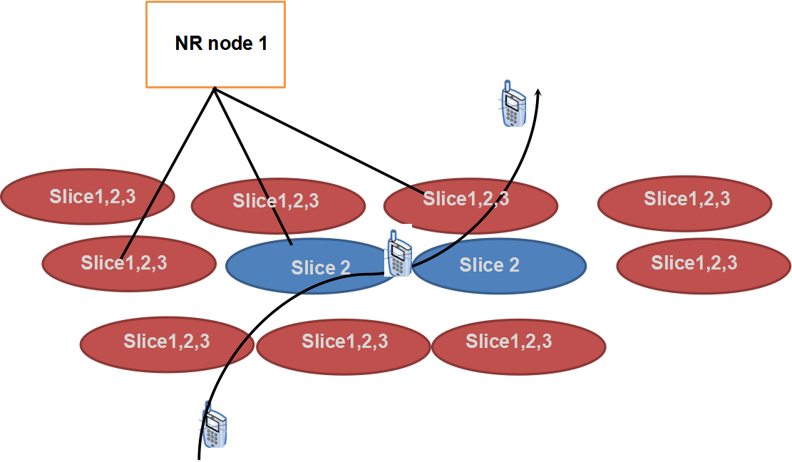
Figure 1：Problematic RAN slice deployment area

User case 4: Enable performance evaluation of dedicated S-NSSAI
The slice resources in some areas of the network are insufficient, so the performance of UEs for these slices in this area is degraded during mobility. For example, an Operator deploys a network slice S-NSSAI=1 in a network. In accordance with the network plan, the entire area fully supports the S-NSSAI=1 network slice. However, the resources of the network slice in some cells are insufficient, so in these cells the QoS of the S-NSSAI=1 network slice used by UEs is degraded. It is beneficial for Mobile Network Operator to evaluate performance of Network slice in a certain area.

User case 5: RAN3 to enhance network slice coverage observability by adding support of new MDT measurements to log the denied UEs slice service access requests due to:
- slice not being supported in the cell from which UE is making the request.
- slice not being available in the cell from which UE is making the request,
- Insufficient radio resource for the sluice in the cell from which UE is making the request.

User case 6: RAN3 discuss the following slice optimization in SONMDT.
- MDT:
Optimize slice deployment e.g., UE log and report slice related informatio

User case 7: Enhance logged MDT with slice related information e.g., to enable the operator to build slice-aware coverage maps.

User case 8: Support collection of slice related information during connection establishment failures.

Question 1: Please company provide clarification and preference during offline discussion on what user case should we support in Rel-19.
The following Scenarios for MDT for Slicing considered as start in Rel-19:
For immediate MDT:
1: Performance evaluation of dedicated S-NSSAI or List of S-NSSAI.
2: Identify the boundary of problematic RAN slice deployment.
3: Support to report the slice rejection only if the UE is still inside the geographical area where the slice is intended to provide coverage.

For logged MDT:
1: Slice request rejection due to slice unavailable in current registration area (slice not being supported/available in the cell from which UE is making the request)
2: NSAG: Enhance logged MDT with slice related information e.g., to enable the operator to build slice-aware coverage maps.
3: Study the means for evaluating the performance of network slice specific cell re-selection and RACH configurations

For CEF report:
Slice information during connection establishment failures.

For Slice-specific L2 measurements
Define slice specific L2 measurements at NG-RAN (e.g., Received RA Preambles per slice) that can be used at OAM for observability purposes.

LS need to RAN2 for related progress in RAN3 e.g. logged MDT?

Continue on clarification of user cases of MDT enhancement

SON user case:
user case 1: UE history information of NW slicing
user case 2: Study the possible service degradations due to mobility at network slice borders
While traditionally mobility optimization mechanisms like Mobility Robustness Optimization (MRO) focus mainly on minimization of radio link failures, with network slicing it is also important to look at the service impacts of the mobility decisions

user case 3: Study the means for evaluating the performance of network slice specific cell re-selection and RACH configurations

user case 4: Similar to voice fallback, the mobility decisions performed may be impacted by other aspects than radio reasons, in this case limitations due to slice availability. Therefore, it could be beneficial if this aspect could be analysed in the existing MRO mechanism.

user case 5: Reduce PDU session rejection caused by unsupported S-NSSAI in target by e.g., network based solution and/or UE based solution. Reduce replacement of old S-NSSAI and alternative S-NSSAI. Identify different track of UE due to different supporting slice of gNB
user case 6: Enhancements to SON observability for network slicing during handovers can provide valuable information about the offered performance over a slice.
Enhance Successful Handover Reports with network slice mobility information.

User case 7: RAN3 discuss the following slice optimization in SONMDT.
- SON:
  - Reduce PDU session rejection caused by unsupported S-NSSAI in target by e.g., network based solution and/or UE based solution.
  - Reduce replacement of old S-NSSAI and alternative S-NSSAI.
  - Identify different track of UE due to different supporting slice of gNB.
user case 8: SON observability considering the uplink and downlink user plane interruption times for a network slice during handovers
user case 9: RAN3 should discuss how to support slice-aware MRO, enable slice-aware mobility decisions

Question 2: Please company provide clarification and preference during offline discussion on what user case should we support in Rel-19.
To be continue clarification of user cases of slice aware MRO:

The following Scenarios for SON for Slicing considered as start in Rel-19:
For MRO:
1: Instead of failure case, R19 MRO also takes into account service impacts of the mobility decisions.
3: Reduce PDU session rejection caused by unsupported S-NSSAI in target by e.g., network-based solution and/or UE based solution.
4: Reduce replacement of old S-NSSAI and alternative S-NSSAI.
5: Identify different track of UE due to different supporting slice of gNB
6: SHR: Enhance Successful Handover Reports with network slice mobility information. Enhance SON observability considering the uplink and downlink user plane interruption times for a network slice during handovers.

For RA Report:
Study the means for evaluating the performance of RACH configurations

For UHI:
UE history information of NW slicing.

Other user case:

other 1: The enhancement of UL PDCP Packet Average Delay measurements with a shorter measurement interval.
other2: The possibility of a lower value for the Report Interval in the context of M6 MDT measurement configuration.

Question 3: Please company provide whether we need to support other user case in Rel-19.
Possible agreements:
Deprioritize?
other 1: The enhancement of UL PDCP Packet Average Delay measurements with a shorter measurement interval.
other2: The possibility of a lower value for the Report Interval in the context of M6 MDT measurement configuration.

References
R3-241560 | Considerations on SON enhancements for Network Slicing (Nokia) | discussion
R3-241572 | SON for Network Slicing (Huawei) | discussion
R3-241945 | Discussion on SONMDT for network slicing (CMCC) | discussion
R3-241968 | Discussion on SONMDT enhancements for network slicing (China Unicom) | discussion
R3-242010 | Discussion on network slicing for SONMDT (CATT) | discussion
R3-242022 | Initial consideration on SON/MDT for Slicing (ZTE) | discussion
R3-242027 | Network slicing observability enhancements for SON/MDT (Ericsson) | discussion
R3-241855 | SON MDT for network slicing (Qualcomm Incorporated) | Discussion  Move to 10.3.2

