3GPP TSG-RAN WG3 #123bis draft R3-242166
Changsha, China, 15-19 April 2024

Agenda Item: 12.3
Source: Ericsson
Title: TP to TR38.799 for Option3
Document for: Agreement

Text Proposal for TR 38.799
START OF CHANGES

5.2.x The SCTP Concentrator
An SCTP concentrator acts as an IP proxy between a HgNB and the AMF. It addresses the issue of reducing the number of SCTP connections toward the 5GC by leaving the NGAP layer untouched and by concentrating the SCTP layer. The SCTP concentrator is part of the transport layer, and it is transparent to the application layer. This solution was studied for E-UTRAN and is described in detail in TR 37.803 [y].
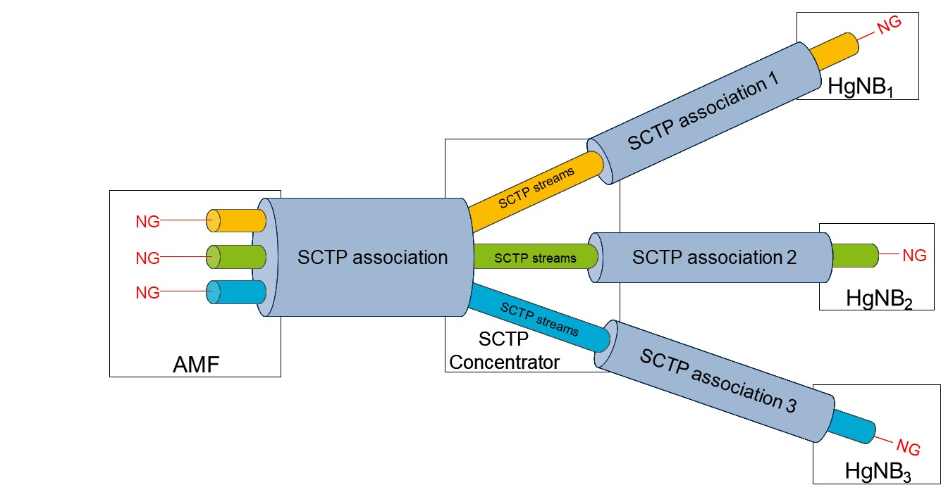
Figure 5.2.x-1: SCTP concentrator between HgNBs and the AMF.
A single SCTP association per NG-C interface instance is used with one pair of stream identifiers for NG-C common procedures. An SCTP concentrator terminates the lower layers so that the AMF does not need to be aware that several peers, with which it maintains NG interfaces, are actually behind the concentrator.
The key characteristics are:
1. There is a single NGAP association (application layer) between the AMF and each HgNB, so the gNB directly “sees” each neighbor.
2. There is a single SCTP association (transport layer) between the AMF and the SCTP concentrator.
3. There is a single SCTP association (transport layer) between the SCTP concentrator and each HgNB connected to it.
4. The SCTP concentrator does not touch the application layer and transports it transparently.
5. For each HgNB, the SCTP concentrator maps the NGAP signaling on the appropriate SCTP association, “switching” between the various SCTP streams from the NG interface between itself and the AMF.
6. The SCTP concentrator can also act as a “smart NAT”, in case the HgNBs are assigned private IP addresses.
Point 5 above descends from the multi-streaming capabilities of SCTP. The AMF can map NGAP signaling for different HgNBs on different streams over the same SCTP association. The concentrator receives the messages, terminates the SCTP connection, and maps each message on a new SCTP association toward the appropriate HgNB according to the stream number used. Since there can be up to 65535 streams in an SCTP association, in principle it is possible to address a large number of HgNBs from the same AMF through the same SCTP concentrator. The SCTP concentrator handles the appropriate switching between each stream number on the SCTP concentrator-AMF association and each HgNB-SCTP concentrator association (see Figure 5.2.x-1). This functionality is completely contained in the SCTP concentrator and only requires that the AMF and HgNBs map NGAP signaling to different peers, on different SCTP stream identifiers.
END OF CHANGES

