3GPP TSG-RAN3 Meeting #121 R3-234553
21th – 25th Aug 2023

Agenda Item: 26.3
Source: ZTE (moderator)
Title: Summary of Offline Discussion on CB: # R18Slice_Solution
Document for: Approval

Introduction
CB: # R18Slice_Solution
- Provide TP to capture the agreement above
- Identify the left issue to be solved in R18
(moderator - ZTE)
Summary of offline disc R3-234553

For the Chairman’s Notes

Discussion

Support of partially Allowed NSSAI

Impacts on NGAP signalling[12][16]:
- Add the Partially Allowed NSSAI in the following NGAP messages.
- Connection Establishment Indication
- AMF CP Relocation Indication
- UE Information Transfer
- Initial UE Message
- Reroute NAS Request
Q1: Companies are invited to show views on this .
Companies | Comments

Partially Allowed NSSAI over the XnAP
Companies provides the following proposal[13][14]:
Proposal 1: It is proposed to turn the following into agreement:
It is agreed that the Partially allowed NSSAI IE is not signalled over the Xn: Handover Request because the Partially Allowed NSSAI is signalled by the AMF to the target NG-RAN via the Xn: Path Switch Request Acknowledge message.
Q2: Companies are invited to show views on this proposal.
Companies | Comments

The company[13] also propose:
Proposal 2: It is proposed to add procedure text to all the NGAP messages where the Partially Allowed NSSAI has been added. Taking as an example the PATH SWITCH REQUEST ACKNOWLEDGE message the proposed procedure text to be added is as follows:
“If the Partially Allowed NSSAI IE is included in the PATH SWITCH REQUEST ACKNOWLEDGE message, the NG-RAN node shall, if supported, deduce from it the partially allowed network slices for the UE. Otherwise, the NG-RAN node shall, if supported, assume that there are no partially allowed network slices for the UE”
Q3: Companies are invited to show views on this proposal.
Companies | Comments

Stage 2 update:
One company in [16] provide the following update on stage 2 specification:
START OF CHANGE
16.3.4.3 UE Context Handling
Following the initial access, the establishment of the RRC connection and the selection of the correct AMF, the AMF establishes the complete UE context by sending the Initial Context Setup Request message to the NG-RAN over NG-C. The message contains the Allowed NSSAI, Partially allowed NSSAI and additionally contains the S-NSSAI(s) as part of the PDU session(s) resource description when present in the message. Upon successful establishment of the UE context and allocation of PDU session resources to the relevant network slice(s) when present, the NG-RAN responds with the Initial Context Setup Response message.
Figure 16.3.4.3-1: Network Slice-aware Initial Context Setup

END OF CHANGE
Q4: Companies are invited to show views on this proposal.
Companies | Comments

Steering the UE towards available cells [10]
One company in [10] provide the following proposal:
Observation 3: even though one can configure cells outside AoS with zero resources, this doesn’t mean, conversely, that receiving zero resources available from a neighbor cell in Resource Status Reporting guarantees that this cell is outside AoS.
The key point of SA2 is steering preferably the UE into the AoS which therefore cannot be satisfied entirely with existing codepoint of “slice available capacity” in Resource Status Reporting.
Observation 4: the current Resource Status Reporting cannot answer SA2 request.
Proposal 2: exchange the Slice Availability IE in Xn Setup/RAN Configuration Update to report neighbour cells configured outside or inside AoS in a TA.
Q5: Companies are invited to show views on this proposal.
Companies | Comments

Enhancing Slice Based Mobility[13]
One company provides the following proposal[13]:
Proposal 3: The AMF should be able to signal the Target NSSAI to the NG-RAN at any point in time for the purpose of enabling the NG-RAN to perform optimal slice-based mobility decisions. It should not be required that the Target NSSAI shall include a Rejected NSSAI.
Proposal 4: Send an LS to SA2 to state the benefits of enhancing the Target NSSAI usage and to request feedback on the solution described in Proposal 3

Q6: Companies are invited to show views on this proposal.
Companies | Comments

Which NGAP procedure to trigger deactivation/reactivation of PDU Session resources of partially allowed slice when UE moves in and out of supporting TAs[10]

Solution 1: Using NGAP Location Reporting procedure to deactivate/reactivate PDU session while UE moves in and out of the supporting TA
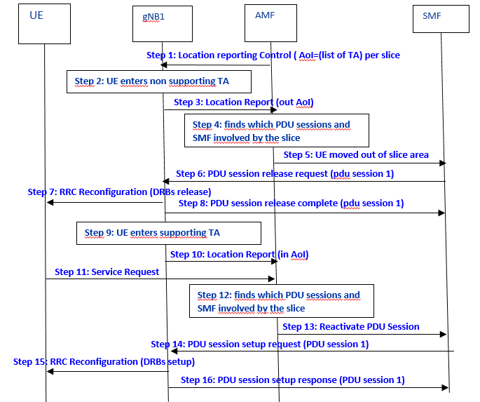

Solution 2: Using NGAP PDU Session Notify procedure to deactivate/reactivate PDU session while UE moves in and out of the supporting TA
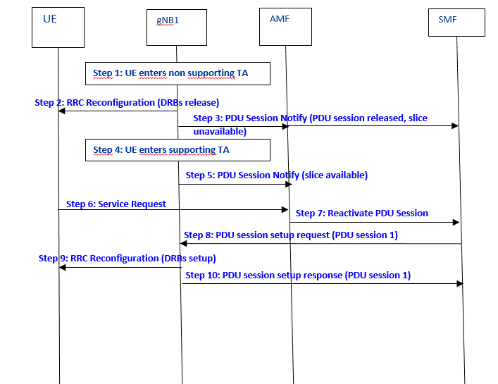

One company provide in [12] with following proposal:
- No need to restore the PDU session context during the handover procedure, unless with SA2/CT4 involved.
One company provide in [14] with following proposal:

No enhancement for the PDU session associated with Partially S-NSSAI when UE move from supporting TA to non-supporting TA
Use Path Switch Request Acknowledge or PDU session setup/modify procedure to setup the PDU session associated with Partially S-NSSAI when UE move from non-supporting TA to supporting TA
One company provide in [15] with following proposal:
If a UE in CM-IDLE moves to a cell outside the non-supporting TA for Partially Allowed NSSAI, PDU session is kept if the UE already has an established PDU session with that S-NSSAI

Q7: Companies are invited to show views on these proposals .
Companies | Comments

RAN impact on supporting Network Slice Service continuity scenario

Stage 2 update
One company [3] propose the following :
16.3 Network Slicing
16.3.1 General Principles and Requirements
In this clause, the general principles and requirements related to the realization of network slicing in the NG-RAN for NR connected to 5GC and for E-UTRA connected to 5GC are given.
A network slice always consists of a RAN part and a CN part. The support of network slicing relies on the principle that traffic for different slices is handled by different PDU sessions. Network can realise the different network slices by scheduling and also by providing different L1/L2 configurations.
Each network slice is uniquely identified by a S-NSSAI, as defined in TS 23.501 [3]. NSSAI (Network Slice Selection Assistance Information) includes one or a list of S-NSSAIs (Single NSSAI) where a S-NSSAI is a combination of:
- mandatory SST (Slice/Service Type) field, which identifies the slice type and consists of 8 bits (with range is 0-255);
- optional SD (Slice Differentiator) field, which differentiates among Slices with same SST field and consist of 24 bits.
The list includes at most 8 S-NSSAI(s).
The UE provides NSSAI (Network Slice Selection Assistance Information) for network slice selection in RRCSetupComplete, if it has been provided by NAS (see clause 9.2.1.3). While the network can support large number of slices (hundreds), the UE need not support more than 8 slices simultaneously. A BL UE or a NB-IoT UE supports a maximum of 8 slices simultaneously.
Network Slicing is a concept to allow differentiated treatment depending on each customer requirements. With slicing, it is possible for Mobile Network Operators (MNO) to consider customers as belonging to different tenant types with each having different service requirements that govern in terms of what slice types each tenant is eligible to use based on Service Level Agreement (SLA) and subscriptions.
The following key principles apply for support of Network Slicing in NG-RAN:
RAN awareness of slices
- NG-RAN supports a differentiated handling of traffic for different network slices which have been pre-configured. How NG-RAN supports the slice enabling in terms of NG-RAN functions (i.e. the set of network functions that comprise each slice) is implementation dependent.
--omit unchanged part
RAN slice replacement
- NG-RAN supports slice replacement for PDU session due to enable e.g . support Network Slice Service continuity or support the EPS to 5GC handover for home-routed roaming scenario as defined in TS 23.502 [22]. When receiving Alternative S-NSSAI for a PDU session, the NG-RAN may recycle of existing NG-RAN resource of the replaced S-NSSAI.

One company [4] propose the following :

16.3.1 General Principles and Requirements
<<<<<<<<<<<<<<<<<<<< Unmodified Text Omitted >>>>>>>>>>>>>>>>>>>>
Access control
- By means of the unified access control (see clause 7.4), operator-defined access categories can be used to enable differentiated handling for different slices. NG-RAN may broadcast barring control information (i.e. a list of barring parameters associated with operator-defined access categories) to minimize the impact of congested slices.
Slice Availability
- Some slices may be available only in part of the network. The NG-RAN supported S-NSSAI(s), NSAG(s) and NSAG related information such as NSAG associated Cell Reselection Priority and/or NSAG associated RACH resources are configured by OAM. Awareness in the NG-RAN of the slices supported in the cells of its neighbours may be beneficial for inter-frequency mobility in connected mode. In order to support the NSAG, the NG-RAN provides the AMF with the NSAG information per TA in the appropriate NG interface management procedures, as specified in TS 38.413 [26]. Awareness in the NG-RAN of the NSAG information supported in the list(s) of neighbour cells may be configured by OAM, or exchanged with neighbour NG-RAN nodes.It is assumed that the slice availability does not change within the UE's registration area (see TS 23.501 [3]).
- The NG-RAN and the 5GC are responsible to handle a service request for a slice that may or may not be available in a given area. Admission or rejection of access to a slice may depend by factors such as support for the slice, availability of resources, support of the requested service by NG-RAN.
- The NG-RAN may be signalled with the Partially Allowed NSSAI from the AMF when one or more slice(s) of such S-NSSAI is not available in the UE’s current TA so that the CN registration area includes TA where the requested S-NSSAI is not supported as specified in TS 23.501 [3]. The NG-RAN can decide to use the Partially Allowed NSSAI for RRM policies e.g., to redirect or handover the UE to TAs where the Partially Allowed NSSAI is supported.
<<<<<<<<<<<<<<<<<<<< Unmodified Text Omitted >>>>>>>>>>>>>>>>>>>>
16.3.3.2 Handling of Slice Resources
The NG-RAN node may use Multi-Carrier Resource Sharing or Resource Repartitioning to allocate resources to a slice during the procedures described in 16.3.4 to support the slice service continuity in case of slice resources shortage.
In Multi-Carrier Resource Sharing the RAN node can setup the dual connectivity or carrier aggregation with different frequency and overlapping coverage where the same slice is available.
The Resource Repartitioning allows a slice to use resources from the shared pool or/and prioritized pool when its own dedicated or prioritized resources are not available and the use of unused resources in the prioritized pool is as specified in TS 28.541 [49].
Slice RRM policies/restrictions associated with Resource Repartitioning are configured from O&M.
Measurements of RRM policy utilization according to resource types defined in TS 28.541 [49] are reported from RAN nodes to O&M and may lead O&M to update the configuration of the Slice RRM policies/restrictions.
The NG-RAN node may be configured with RRM policy defined in TS 28.541 [49] to support the Network Slice Replacement defined in TS 23.501 [3].
Editor’s Note: The above may be reformulated based on SA2 reply.
Q8: Companies are invited to show views on this proposal.
Companies | Comments

RAN impact of service continuity: NGAP impact
One company in [2] provides the following proposal:
Proposal 1: add a new S-NSSAI IE in the PDU session modification request message.

One company in [4] provides the following proposal:
- For PDU session resource setup procedure, the existing S-NSSAI per PDU session can be used to indicate the Alternative S-NSSAI.
- For PDU session resource modification procedure, the existing S-NSSAI per PDU session can be used to indicate the Alternative S-NSSAI.
One company in [5] provides the following proposal:
Proposal 2: Add Alternative S-NSSAI information as a separate IE in the following NGAP messages,
- PDU SESSION RESOURCE SETUP REQUEST
- PDU SESSION RESOURCE MODIFY REQUEST
- INITIAL CONTEXT SETUP REQUEST
One company in [6] provides the following proposal:
Conclusion 4: There is no need to introduce a new S-NSSAI IE in the NG: PDU Session Resource Modify message to address backwards compatibility problems because the criticality of the existing S-NSSAI IE is “Reject” and the receiver can generate an Error Indication for a logical error due to the procedure not being compatible with the state of the receiver.
Conclusion 7: There is no functional reason to add new IEs to the NG: PDU Session Resource Setup Request and NG: PDU Session Resource Modification Request, the existing S-NSSAI IE is sufficient to fulfil support of Network Slice Service continuity.
Proposal 1: It is proposed to correct Rel17 and Rel16 versions of TS38.413 with the following procedure text:
“For each PDU session, if the S-NSSAI IE is included in the PDU Session Resource Modify Request Item IE contained in the PDU SESSION RESOURCE MODIFY REQUEST message as a consequence of home-routed EPS to 5GS mobility, the NG-RAN node shall replace the previously provided S-NSSAI by the received S-NSSAI for the concerned PDU session and use it as specified in TS 23.502 [10].”
One company in [7] provides the following proposal:
Proposal 3: It is proposed to introduce a new slice IE representing the original slice in PDU SESSION RESOURCE SETUP REQUEST message and PDU SESSION RESOURCE MODIFY REQUEST message.
One company in [9] provides the following proposal:
Proposal 1: The current S-NSSAI IE in the PDU SESSION RESOURCE SETUP REQUEST message can be reused to indicate alternative S-NSSAI to the NG-RAN node.
Proposal 2: The current S-NSSAI IE in the PDU SESSION RESOURCE MODIFY REQUEST message can be reused to indicate alternative S-NSSAI to the NG-RAN node.
Q9: Companies are invited to show views on this proposal.
Companies | Comments

RAN impact of service continuity: XnAP impact
One company in [2] provides the following proposal:
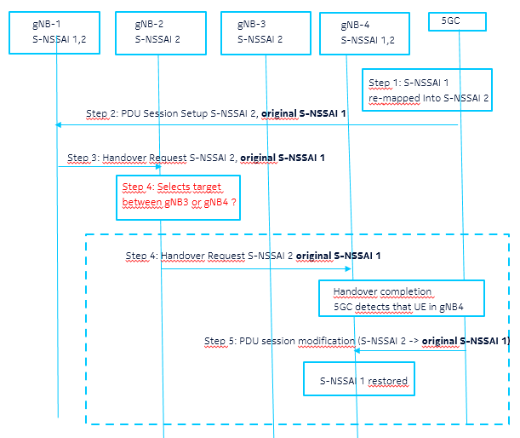
Proposal 2: add a new Original S-NSSAI IE in the NGAP PDU Session Setup Request and the XnAP Handover Request message.

One company in [3] provides the following proposal:
No enhancement for performing Network Slice Replacement during handover.

One company in [4] provides the following proposal:
- No need to introduce the Alternative S-NSSAI in the XnAP signalling since the Network Slice Replacement shall not take place during the handover procedure.
One company in [5] provides the following proposal:

Proposal 2: Add Alternative S-NSSAI information as a separate IE in the following NGAP messages,
- PDU SESSION RESOURCE SETUP REQUEST
- PDU SESSION RESOURCE MODIFY REQUEST
- INITIAL CONTEXT SETUP REQUEST
One company in [7] provides the following proposal:
Proposal 6: RAN3 should discuss how to eliminate the inconsistent behaviour between target NG-RAN node and CN for slice admission control during handover.
One company in [8] provides the following proposal:
Proposal 1: The NG-RAN node needs to know both original S-NSSAI and alternative S-NSSAI for supporting Network Slice Service continuity during Xn handover

Q10: Companies are invited to show views on this proposal.
Companies | Comments

Other issues

Q10: If any issue missing, companies are invited to list below
Companies | Comments

References
- R3-233747 Introduction of Enhancement of RAN Slicing for NR (Nokia, Nokia Shanghai Bell)
- R3-233860 (TP for TS 38.413 and TS 38.423) Support of Network Slice Service Continuity (Nokia, Nokia Shanghai Bell, Orange)
- R3-234419 (TPs for BLCRs for 38.413 38.423 38.473 38.300)RAN impact on supporting Network Slice Service continuity scenario (ZTE)
- R3-233962 (TP to eNS_Ph3 BLCR for TS 38.300) Enhanced network slicing phase 3 (Huawei)
- R3-234034 Further discussion on the enhancement of RAN slicing (Samsung)
- R3-234304 Clarifications and Way Forward on Network Slice Service Continuity (Ericsson)
- R3-234448 Discussion on network slice service continuity (CMCC)
- R3-234399 TP for 38.423 for supporting alternative S-NSSAI (CATT)
- R3-234005 Discussion on remaining issues for RAN Slicing enhancement (China Telecommunication)
- R3-233861 (TP for TS 38.413 and TS 38.423) Support of partially allowed S-NSSAI in RRC connected mode (Nokia, Nokia Shanghai Bell, Orange)
- R3-234420 (TPs for BLCRs for TS 38.413)RAN impact on support Partially Allowed NSSAI (ZTE)
- R3-233963 (TP to eNS_Ph3 BLCR for TS 38.413) Partially allowed NSSAI in a registration area (Huawei)
- R3-234303 Clarifications on Partially Allowed NSSAI (Ericsson, Deutsche Telekom)
- R3-234398 Discussion on supporting Partially Allowed NSSAI (CATT)
- R3-234449 Discussion on Partially Allowed NSSAI (CMCC)
- R3-234006 (TP to TS 38.300/38.413) Support of Partially Allowed S-NSSAI (China Telecommunication)

