3GPP TSG-RAN WG3 Meeting #120 R3-233375

**Incheon, Korea, 22nd – 26th May 2023**

**Agenda Item: 24.2**

**Source: Huawei**

**Title: Summary of offline discussions on CB: # 36_R18ES**

**Document for: Discussion and approval**

# 1 Introduction

**CB: # 36_R18ES**

**- Discuss the possibility to introduce the new cause value as “SSB not Available”?**

(moderator - HW)

Summary of offline disc [R3-233375](Inbox\R3-233375.zip).

# 2 For Chairman’s note

Proposal A: Note the TP for F1AP in **R3-233465** (revision of R3-232902).

Mark the following to be continued in the chairman notes:

* Resolve the FFS(es) in the BLCR including the criticality of the cell to be Activated List IE included in the GNB-CU CONFIGURATION UPDATE message, the maximum number of the SSB areas etc.

To be continued at the next meeting (by contribution driven):

**Inter-node Beam Activation**

* Cause value for SSB activation failure
* Beams deactivation: Whether to introduce a cause for beams deactivation (e.g. ‘energy saving’) over Xn/F1
* Timer for SSB activation

# 3 Discussion

## 3.1 Inter-node Beam Activation

1. Cause value for SSB activation failure
2. No need to introduce a new cause value (e.g., “SSB not Available” or “SSB activation not Allowed”) to indicate the SSB activation failure???
3. Update the BLCR for F1

Criticality of the new IE in GNB-CU CONFIGURATION UPDATE message

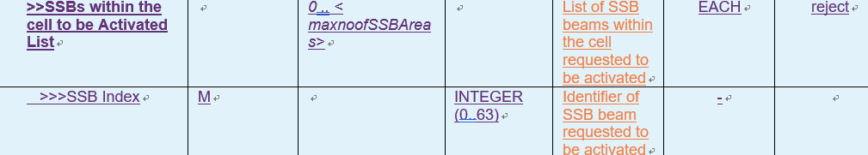

1. Change the criticality of the SSBs within the cell to be Activated List IE included in the GNB-CU CONFIGURATION UPDATE message to “ignore”, and remove the editor’s note “Editor’s Note: The SSBs within the cell to be Activated List IE may be further refined (e.g., the assigned criticality).”

The number of activated/disactivated SSBs



1. Remove the FFS on the maximum number of the SSB areas.
2. Beam activation: Whether the DU sends its own preferred beam activation to the CU
3. No need for the DU to send its own preferred beam activation to CU for final decision???
4. Beams deactivation: Whether to introduce a cause for beams deactivation (e.g. ‘energy saving’) over Xn/F1
5. Introduce a new cause in the Coverage Modification Notification for F1AP and in the Coverage Modification List for XnAP to indicate “network energy saving” for SSB beam deactivation???
6. Timer for SSB activation
7. No need to introduce an explicit timer for SSB activation???

## 3.2 Cell DTX/DRX parameters

**WA: Support the exchange of the Cell DTX/DRX configuration over Xn.**

**The detail infor of the Cell DTX/DRX configuration is pending to RAN1 and RAN2.**

1. in CU-DU split architecture, the Cell DTX/DRX parameters are finally decided by the gNB-DU

## 3.3 Paging on restricted area

**To be continued at the next meeting based on reply LS.**

## 3.4 Others

NES mode

**Pending at this meeting.**

# 3 Comments if any

|  |  |
| --- | --- |
| Company | Comment |
|  |  |
|  |  |

# 4 References

|  |  |  |
| --- | --- | --- |
| [R3-232577](Docs\\R3-232577.zip) | LS on Cell DTX/DRX activation/deactivation (RAN2(Huawei)) | LS in  noted |
| [R3-232589](Docs\R3-232589.zip) | (TP to TS 38.423) Support of network energy saving techniques (Nokia, Nokia Shanghai Bell) | other |
| [R3-232902](Docs\R3-232902.zip) | (TP to Netw_Energy_NR BLCR for TS 38.473, 38.470 and 38.300) Network energy saving techniques (Huawei) | other |
| [R3-233285](Docs\R3-233285.zip) | TPs to BL CRs for network energy saving (ZTE) | other |
| [R3-232594](Docs\R3-232594.zip) | (TP to TS 38.473) Beam deactivation decision and signalling for energy saving (Nokia, Nokia Shanghai Bell) | other |
| [R3-232813](Docs\R3-232813.zip) | Discussion on network energy saving (Samsung) | discussion |
| [R3-232814](Docs\R3-232814.zip) | (CR to 38.413) Introduction of Network Energy Saving for Paging IDLE UE (Samsung) | CR0993r, TS 38.413 v17.4.0, Rel-18, Cat. B |
| [R3-232853](Docs\R3-232853.zip) | Paging enhancements, Inter-node beam activation and Cell DTX/DRX (Qualcomm Incorporated) | discussion |
| [R3-232890](Docs\R3-232890.zip) | (TP to Netw_Energy_NR BLCR for TS 38.423) Network energy saving techniques (Huawei) | other |
| [R3-232968](Docs\R3-232968.zip) | Introduction of Network Energy Saving (Ericsson) | discussion |
| [R3-232969](Docs\R3-232969.zip) | Text Proposal on F1AP: Introduction of Network Energy Saving (Ericsson) | other |
| [R3-233045](Docs\R3-233045.zip) | Discussion on NES related issues (Lenovo) | discussion |
| [R3-233246](Docs\R3-233246.zip) | Discussion on Paging Enhancement (TP for 38.423) (CATT) | other |
| [R3-233284](Docs\R3-233284.zip) | Discussion on network energy saving (ZTE) | discussion |