3GPP TSG-RAN WG3 Meeting #119bis-e R3-231925
E-meeting, 17 – 26 April, 2023

Agenda item: 9.2.4
Source: Nokia - moderator
Title: Summary of discussions on CB: # 56_QoEALMC
Document for: Approval

1 Introduction
This paper provides summary of discussions at RAN#119bis-e on:
CB: # 56_QoEALMC
- Check the details with companies
(moderator - Nok)
This SoD collects comments on the use of the auxiliary "can" in stage 2 description for QoE, based on:
R3-231634 | Clarification of Application Layer Measurement Collection (Nokia, Nokia Shanghai Bell) | draftCR to TS 38.300 (cat. F, Rel-17)

Please provide your comments by Monday the 24th at 12 UTC.

2 For the Chairman’s Notes
updated changes in 21.2.3, reverted proposed changes in 21.4.

1634 revised in R3-232127 - agreed

3 Discussion

3.1 Use of ‘can’ vs. ‘may’ in TS 38.300 clause 21
The cover-page of R3-231634 provides background for the proposed changes in ‘reason for change’ as follows:
In the description of Application Layer Measurement Collection several occurrences of the auxiliary "can" don’t comply with TS 21.801 Specification drafting rules annex E: "Can" is used for statements of possibility and capability, whether material, physical or causal.

TS 21.801 also indicates for the auxiliary "may":
- “a course of action permissible within the limits of the 3GPP TS or 3GPP TR”.
- "May" signifies permission expressed by the standard, whereas "can" refers to the ability of a user of the standard or to a possibility open to him.

Due to the extensive use of the auxiliary "can", the user of the specification cannot determine whether the described course of action is permissible within the limits of the 3GPP TS for several aspects of Application Layer Measurement Collection.

Furthermore, the usage of "can" for Application Layer Measurement Collection is inconsistent with the rest of stage 2.
Relative to the latest statement, it can be observed a significantly higher ratio for the use of ‘can’ compared to ‘may’ in the stage 2 description of QoE (TS 38.300 clause 21) than in the other parts of TS 38.300.
In addition to the referred TS 21.801 annex E, further background can be found in TS 21.801 clause 6.6.1:

6.6.1 Verbal forms for the expression of provisions
A 3GPP TS does not in itself impose any obligation upon anyone to follow it. However, such an obligation may be imposed, for example, by legislation or by a contract. In order to be able to claim compliance with a 3GPP TS, the user needs to be able to identify the requirements that are obligatory. The user also needs to be able to distinguish these requirements from other provisions where there is a certain freedom of choice.
Clear rules for the use of verbal forms (including modal auxiliaries) are therefore essential. Annex E gives, in the first column of each table, the verbal form that shall be used to express each kind of provision. The equivalent expressions given in the second column shall be used only in exceptional cases when the form given in the first column cannot be used for linguistic reasons.
During the online discussion, some companies commented that some of the proposed changes of ‘can’ to ‘may’ were not needed.
Q1: Please indicate whether any of the proposed changes in R3-231634 should be kept as ‘can’.
Company | Comment
Ericsson | Do you have any exact stats about how much QoE chapter overdid ‘can’? 😊 We have marked the ‘cans to stay’ in the TP.
ZTE | Our view:  The use of “can” is commonly happening in a lot of sections in TS 38.300. because stage 2 TS is used to describe the capability of gNB/UE/ NW. We do not think the current correction shown in QoE is critical enough.  If majority companies confirm that this CR is critical and shall be corrected. We wonder whether 300 rapporteur can correct all “can” vs “may” issue in the rapporteur CR instead of using multiple CRs for all issues in current 300.  Further explanation:  We are generally fine for the modification in section 21.5 and 21.3. The rest of modification in this CR seems unnecessary.  The explanation of can and may in TS21801 is shown at the end of this comment. As we can see, “can” can be naturally change to “is possible” in the spec without any semantic loss. Meanwhile, “may” means permission. In other word, the pre-condition of “may”(give sb permission to do sth) is an entity has such capability. Based on our understanding, stage 2 specification is mainly used to describe the capability of entities like gNB, UE, OAM, etc. Detail regulations are described in the stage 3 specs like 331 or 413 accordingly.  We also expand our exploring out of the QoE related section in TS 38300. The raised issue on “MAY” vs “CAN” seems not only appear in QoE part.  For example:  The following sentence can be found in section 20.3:  The Network A can configure at most 4 gap patterns for MUSIM purpose: three periodic gaps and a single aperiodic gap.  This is the correction in this CR:  The gNB may release one or multiple RAN visible QoE measurement configurations from the UE in one RRCReconfiguration message at any time.  Based on Nokia’s view, just as similar as the modification shown above, the sentence in section 20.3 shall also be corrected to “The Network A may xxxx”.  Similar issue can also be found in section 9.2.3.2.1:  The source gNB can then release radio and C-plane related resources associated to the UE context.  In conclusion, the use of “can” is commonly happening in a lot of sections in TS 38.300. because stage 2 TS is used to describe the capability of gNB/UE/ NW. We do not think the current correction shown in QoE is critical enough.  If majority companies confirm that this CR is critical and shall be corrected. We wonder whether 300 rapporteur can correct all “can” vs “may” issue in the rapporteur CR instead of using multiple CRs for all issues in current 300.  Content in TS 21801:  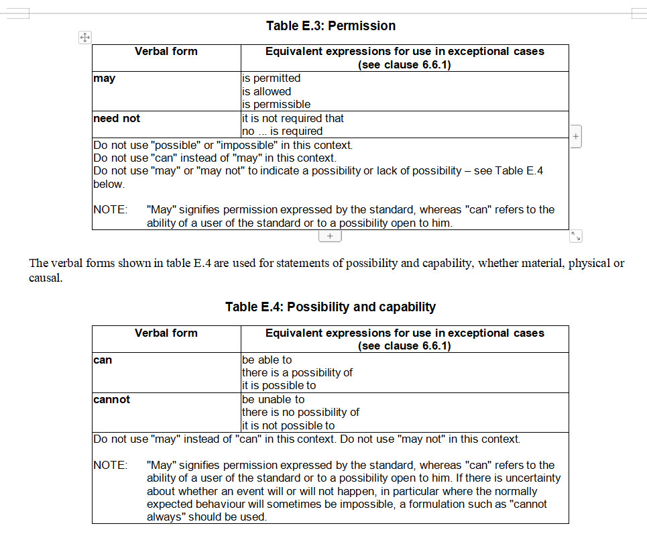
Huawei | We share similar view as ZTE. There can be indeed a lot of ‘wrongly’ used ‘can’ and ‘may’ in stage 2 specification. We acknowledge the intention of Nokia, so we don’t have strong view, but this is not an essential CR.
Nokia | As shown by some examples during this discussion, a “mechanic” replacement of ‘can’ by ‘may’ is not so simple, and while updates elsewhere could also be considered we saw a particular need for this update for the QoE description (but no time to look up the exact statistics now).

Moderator: We can make an attempt to agree a revised CR in the online session. Updates are: reverted proposed changes in 21.4, included comments from E/// in 21.2.3.

4 Conclusion, Recommendations [if needed]
If needed

