3GPP TSG-RAN WG3 #113-e R3-214456
Online, 16 - 26 August 2021

Agenda Item: 31.2.1
Source: Ericsson (moderator)
Title: Summary of Offline Discussion on Local NG-RAN Node Identifier
Document for: Approval

Introduction
CB: # 28_LocalNG-RANnode_Identifier
- 4 solutions: Option2 ZTE; Option4 Nok;
- One NG-RAN node can select as many Local gNB IDs as needed according to maximum number of Inactive UE Contexts to support or one NG-RAN node belongs to a specific group, according to a configured I-RNTI profile identifier? E///
- The NG-RAN node’s neighbour nodes should be informed when the old node identifier is still valid or becomes invalid? HW
(E/// - moderator)
Summary of offline disc in R3-214190

For the Chairman’s Notes
Four solutions have been proposed and discussed on how to resolve the conflicts of Local NG-RAN Node ID issue. Most of the companies tried to focus on feasible solutions which are able to fulfil the agreed requirements, however it is not possible to finalize this meeting. Several questions were raised regarding solution 4, though no technical answer is provided so far.

Propose to capture the following:
For next meeting, the group should provide detailed technical analysis on the solutions based on at least the following criteria:

- Minimum configuration effort via OAM
- Flexibility in allocation of maximum number of Inactive UE contexts per NG-RAN node
- Minimized number of signaling exchanges between neighbor nodes via Xn:
  - For initial ID exchange between nodes
  - After an ID change (this may also cover the case that the maximum number of inactive UE contexts has been changed) or addition of another ID for a node
  - For conflict resolutions in case neighboring nodes use the same IDs
- Interoperability between vendors
- Support for RAN sharing

WA: Down-selection will be based on the listed criteria above. Solution 3 might be considered as a potential enhancement in the next step.

More specific questions on the solutions can be considered.
- How many IDs should be allocated per NG-RAN node, one or multiple
- The length of Local NG-RAN Node ID is fixed or not
- If the length is flexible, which approach is the best for assignment

To be continued

Solutions proposed in RAN3#113e
The following WAs and agreements were made during RAN3#112e meeting.
WA: a solution based on exchanges of Local gNB-ID over Xn should be pursued; Xn signaling impact should be limited
Continue discussions on Solutions design and Local gNB-ID conflict resolution at the next meeting

Four solutions (with some of them have been refreshed) have been proposed on how to disambiguate a NG-RAN node from I-RNTI.

Solution 1: Multiple Local gNB Identifiers per NG-RAN node.
This solution is summarized and presented in [2][3].
- the I-RNTI is encoded as follow:
  - a fixed number of bits, common for all nodes, to encode a UE Context Identifier
  - a fixed number of bits, common for all nodes, to encode a Local gNB ID
- A NG-RAN node can allocate multiple Local gNB IDs.
- The Local gNB Identifiers are selected randomly, and exchanged between NG-RAN nodes.
- Each RAN node communicates its own local identifiers to its neighbour RAN nodes and updates them when change occurs.

Solution 2: One Local gNB Identifier with I-RNTI profile per NG-RAN node.
This solution is summarized and presented in [2][4][5].
- The I-RNTI is encoded as follows
  - A fixed number of bits is used, for all nodes in the network, to identify an I-RNTI profile
  - One Local gNB ID is assigned per NG-RAN node
  - For each I-RNTI profile identifier, a fixed number of bits is used to encode a Local gNB ID
  - For each I-RNTI profile identifier, a fixed number of bits is used to encode a UE Context Identifier
- The Local gNB Identifiers are selected randomly, and exchanged between NG-RAN nodes.
- Each RAN node communicates its own local identifiers to its neighbor RAN nodes and updates them when change occurs.

Solution 3: Up to 6 Local NG-RAN node identifiers per NG-RAN node.
This solution is summarized and presented in [6][7].
- Multiple (up to 6) Local gNB IDs can be maintained in one NG-RAN node at the same time.
- An old Local gNB ID is released when all the inactive UEs with the old local node identifier are relocated or released.
- A list of Local gNB IDs is signaled between NG-RAN nodes.

Solution 4: One Local gNB Identifier with undefined length per NG-RAN node.
This solution is summarized and presented in [8][9].
- The Local gNB Identifier is assigned corresponding to the first leftmost bits of I-RNTI values which it allocates.
- The NG-RAN node selects a Local gNB ID which doesn’t match any MSB of a neighbour NG-RAN node or a neighbour of neighbour NG-RAN Node.
- The Local gNB Identifiers and global gNB Identifiers are exchanged between NG-RAN nodes.

Evaluation of feasibility
It is worth noticing that all the solutions on the table now are focusing on a standardized way to enabling inter-vendor inter-operability, deployments of network supporting variable maximum number of Inactive UE Context.
The basic concept of Solution 1 and 2 have been discussed and the feasibility is recognized by the group. In this meeting Solution 3 and 4 are refreshed, though a clear positive feasibility statement is not there. To elaborate more, the node receiving the I-RNTI at RRCResume needs to know the length of the Global NG-RAN node ID to disambiguate. The problem is explained in the figure below.

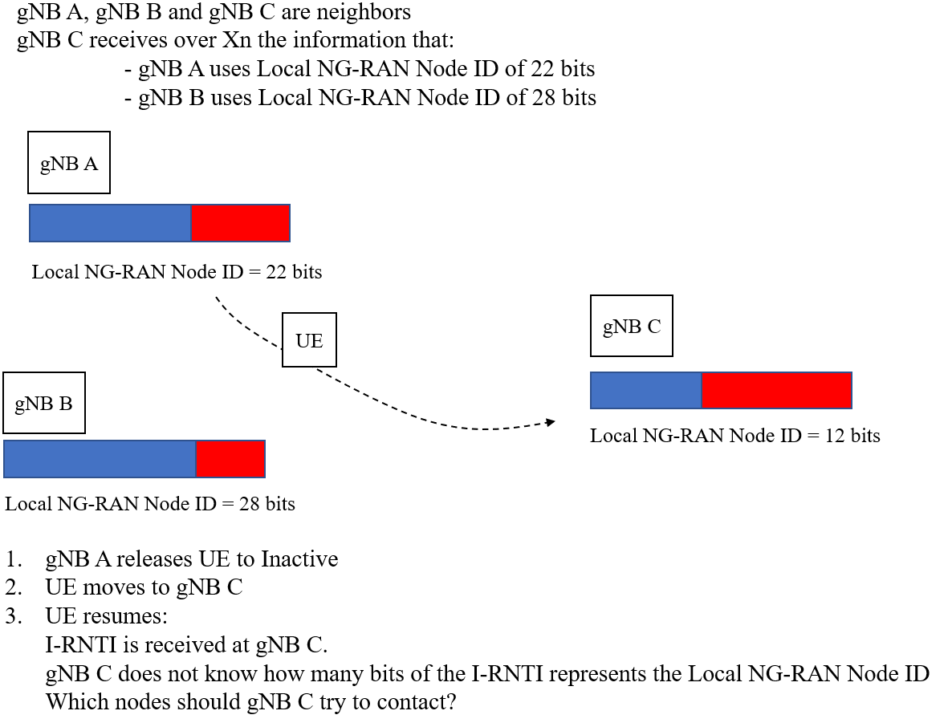

Further question was raised during email discussion about solution 4 as follows:

Here another example is given seeking for further explanation. There are three gNBs. For each gNB, based on the Solution 3, it can know the I-RNTI info about itself and about all the neighboring gNBs,

 | gNB_A | gNB_B | gNB_C
Local NG-RAN Node ID Length | 12 | 11 | 10
Local NG-RAN Node ID | 110100001110 | 11010000111 | 1101000011

Assumption: The MSB of 10 bit for the three gNBs is the same.
Step 1: A UE has suspended in the gNB_A and been assigned a real fullI_RNTI (with 12 bit for Local RAN ID length).
Setp 2: The UE moves to gNB_C and triggers RRC connection resumption. When gNB_C receives the fullI_RNTI, as it cannot know the exact length of Local NG-RAN Node ID in this fullI_RNTI, it will try all the possible structures and unfortunately, all the three gNBs can be matched.
So in solution 4, the new gNB sends multiple UE context retrieve request messages to multiple anchor gNB for UE context, is it correct?
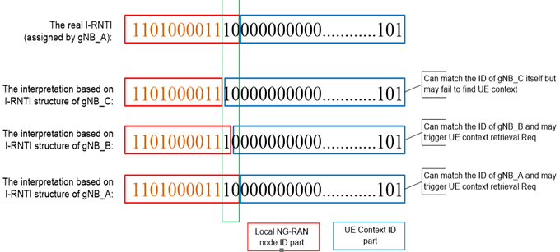

Companies are invited to provide their view on the feasibility of above Local gNB ID conflict resolutions.

Company | Comment
Ericsson | Solution 1 and 2 are feasible by explicitly sending the fixed Local NG-RAN Node ID split or combination with pre-defined I-RNTI profile.  Solution 3 and 4 cannot provide an effective way to indicate the bits of I-RNTI as the Local NG-RAN Node ID during exchange of such info.
ZTE | Agree with Ericsson, both solution 1 and solution 2 are feasible to resolve the Local gNB ID conflict issue.  Solution 3 can only work with other solution (e.g. solution 2) to resolve the Local gNB ID conflict issue.  Solution 4 is based on the OAM in the target gNB to decide the Local gNB ID length in I-RNTI, and cannot decide the Local gNB ID length definitely in the inter-vendor inter-operability case.
Deutsche Telekom | Solution 1 and 2 seem to be feasible, both with pros and cons.  For solution 3 we have the same understanding as ZTE that it works on top of other solutions in case of resolving Local gNB ID conflicts when I-RNTIs are already assigned to UEs based on a conflicting ID.  Solution 4 seems to be the one proposed in [8][9], but in contrast to ZTE we don’t see it as an OAM based solution. According to description given it also seems to be a feasible alternative to 1 and 2.
Nokia | Solution 4 has noting to do with O&M. It is a simplified variant of solution 1 and 2. It is as feasible as solution 1, but simpler. Compared to solution 2, it is more efficient because it benefits from a higher number of contexts by avoiding to dedicate some bits for an I-RNTI profile and compared to solution 1 it avoids the complexity of managing multiple identities and reduces the Xn signaling thereby. It also avoids conflicts like in the other solutions.
Huawei | May I ask a fundamental question? What is the benefits for the NG-RAN node to maintain multiple local IDs all the time?  Our view is that usually the NG-RAN node only have one local ID in most of time. And in case of capacity increase, the NG-RAN node will assign itself a short local ID to support more inactive UEs. And within a certain switch time, the node should have to maintain the old one until there is no inactive UEs using the old local ID.  We don’t see any need to maintain as much as possible local IDs for a RAN node. Such kind of flexibility from our view is not benefits but complexity.  Furthermore, we also don’t see the need to specify the format of the I-RNTI and to indicate the number of bits for the local ID.  This feature comes from the legacy OAM based solution.  Even without the length indication, the new node can still retrieve the local node ID from the IRNTI by longest MSB match. Because the node has received the local IDs from neighbors.
Ericsson 2 | Questions to Nokia: How Solution 4 works is not clear for us, could you clarify a bit more? For example:  - Which entity assigns a Local gNB ID?  - How is Local gNB ID assigned?  - How conflicts are avoided or dealt with?  The above comments “Even without the length indication, the new node can still retrieve the local node ID from the IRNTI by longest MSB match. Because the node has received the local IDs from neighbors.” are not correct.  Example: say that gNB1 is the “old” node, and gNB2 and gNB3 are two neighbor nodes from which the gNB1 has received the local IDs.  The UE resumes in gNB3, which also knows the local IDs of gNB1 and gNB2. The longest MSB match gNB3 can derive is the 24 bits of gNB2. So gNB3 attempts to fetch the UE context from gNB2 instead of gNB1 and the procedure fails (note: the failure will happen systematically, until the conflict is resolved, which is a waste of signaling).
Nokia | Again, solution 4 is not O&M. gNB selects its Local gNB ID. The Local gNB ID is selected so that it does not conflict with any MSB of a neighbour or neighbour of neighbour, otherwise it is reallocated (at the neginning). By so doing, there is no conflict, similar to solution 1 or solution 2.  [E///’s questions]: The above questions were not answered clearly.  Still:  - Where is the MSB coming from? Global NG-RAN node ID, or Local NG-RAN node ID? How to guarantee there is no conflict of MSB?  Nokia: MSB comes from the Local NG-RAN node ID.  - If any conflict is detected, then the NG-RAN node needs to inform its neighbor and neighbor of neighbor? Otherwise the neighbor of neighbor could have other nodes with the conflicted number when there is Xn signaling setup. Such kind of exchange will cause a lot of signaling overhead.  Nokia: not sure which conflict you are talking about. There will be no conflict when UEs resume because no confusion of the local NG-RAN node IDs in the area when UE reconnects. This is basically exactly the same mechanism as solution 1 and 2, without the useless optimizations.  E///: The technical details are still not clear. Figure and comments regarding the question are given below.
Radisys | We do not see a need to maintain multiple local gNB IDs. At any point in time only one local ID will be used by NG-RAN. When the IDs are exhausted, then NG-RAN shall signal the new local gNB ID over Xn.  We see the need to exchange IRNTI profile identifier, as different NG-RAN might have used different profiles (inter vendor). When IRNTI needs to be decoded by any NG-RAN, without using the right profile, the decoding might result in wrong UE context identifier. Few NG-RAN might use longest MSB match, few might use short. Hence, we think that IRNTI profile identifier needs to be present in the IRNTI.  We think Solution 2 is straight forward and simple.

1
3
4
Id=1
Id=3
Id=4
8
Id= 7->10
2
Id=2
5
Id=5
6
Id=6
7
Id=7
10
Id=10

In the above scenario, node 8 has the id 7 which conflicts with node 7. However, in solution 4, the node may reallocate it to 10 for example, and inform the neighbor and neighbor of neighbor, e.g., node 6. Then node 6 has another neighbor node 10, then another conflict will happen. Thus, we foresee Solution 4 will cause a lot of signaling overhead and a lot of efforts by resolving such conflicts repetitively.

Summary: Solution 1 and 2 are feasible. Solution 3 is seen to work as a complement but not a standalone way. The feasibility of Solution 4 is questionable.

Overall assessment
During comparison of the above, the following factors needs to be taken into account.
- Signaling exchange
- Minimized (zero) configuration effort
- Flexibility of the solutions
Company | Comment
Ericsson | Solution 1 is fully aligned with RAN3’s agreements, which are:  - When a Local gNB Identifier is no longer used by any Inactive UE context stored in the node, the Local gNB Identifier can be released.  - When a Local gNB Identifier is taken in use or its use is revoked, the NG-RAN node sends this information to the neighbor nodes via Xn signalling.  Regarding the flexibility, Solution 1 can offer the possibility to easily scale, compared to moving one bit less to local gNB ID. Furthermore, no signaling overhead is seen for Solution 1. To elaborate more, one thing to consider is that the split 10-30 in case of full I-RNTI is a suggestion which can be changed, e.g. a 12-28 (12 bits will mean 4096 users,) or a 14-26 (14 bits will mean 16384 users). It needs to be confirmed that allocation of a new Local gNB Identifier is on-demand, i.e. based on the need to serve the N-th+1 Inactive context (with N Inactive context admittable with a current allocation of Local gNB Identifiers), the need to release a Local gNB Identifier can follow a different principle, e.g. the evolution of the traffic over a long time scale.  In our opinion, Solution 3 should be left to implementation as a complementary meaning which requires to maintain more than one Local NG-RAN Node Identifier to account for the scenario where a current Local NG-RAN Node Identifier needs to be taken out of use.
ZTE | Since only Solution 1 and solution 2 can resolve the Local gNB ID conflict issue and in solution 1, the Local gNB ID is fixed to 30 bits, and multiple local gNB IDs are allocated per NG-RAN node. Different from the number of UEs in RRC_CONNECTED state, the number of UEs in RRC_INACTIVE state will be very large for no resource consumes in this state(e.g. maybe in the same level as that in RRC_IDLE state). So there are the following issues in Solution 1:  - Considering that only 10bits in I-RNTI is used to identify the UE contexts(e.g. 1024 UE contexts per Local gNB ID), lots of Local gNB IDs should be configured per NG-RAN node to match the larger number of UE contexts per NG-RAN node. Furthermore, to avoid Local gNB IDs exhausts, the Local gNB ID should be released so long as it is not used by any UE, which will trigger frequent Local gNB ID allocation and release. Thus, the signalling overhead to exchange Local gNB IDs between NG-RAN node will large. But in the last meeting, there is already WA that Xn signaling impact should be limited.  - Since multiple Local gNB IDs should be configured per NG-RAN node, the Local gNB IDs configuration and management will be complicated.  So, we prefer solution 2.
Deutsche Telekom | With solution 1 we see the drawback that a fixed number of bits have to be set for the Local gNB ID all nodes, independent if a node covers only few cells (D-RAN) or a high number of cell across a larger area (C-RAN). The selection of this bit number is certainly a tradeoff which may not fit well in all deployment cases.  With solution 2 there is more flexibility but due to the lost bits for I-RNTI profile identification only a limited number of profiles can be allowed (4 for long, 2 for short I-RNTI?).  Solution 4 is similar to solution 2 except that it relies on conflict resolution of x MSB which would fit at least for a certain number of neighboring cells connected via Xn.  None of the solutions is without drawbacks, therefore we don’t see a clear favorite, unfortunately.
Ericsson 2 | Response to DT:  In our view Solution 1 actually allows an operator to make the nodes of its network to work well in all deployments.  From a “coverage” point of view, i.e. nodes deployed for larger area/more cells vs nodes deployed for smaller area/fewer cells, all it’s needed for a node deployed for “larger area/more cells” is to select and exchange more Local gNB IDs compared to a counterpart node deployed for “smaller area/fewer cells”. The actual number of how many more Local gNB ID the bigger node would select and exchange will depend on the agreed split of bits (at network level), with very low impact in terms of signaling (as explained in our contribution).  From “capacity” point of view, there is no direct implication that “larger area/more cells” corresponds to “higher traffic”, we just consider that capacity requirements can change/evolve over time. Again, this case can apply both to a node covering “larger area/more cells” as well as to a node covering “smaller area/fewer cells”.  Take as an example a node controlling a number of cells around a stadium: the same node can handle both low traffic as well as high traffic (in terms of Inactive users). Afterall the selection and exchange of a different number of Local gNB ID can be based on the traffic situation.
Nokia | We fully acknowledge the analysis of Deutsche Telekom which is a very good summary.  Solution 1 has severe drawbacks mentioned by ZTE above and Deutsche Telekom, which will translate in more Xn signaling.  Solution 2 does not have the drawbacks of solution 1 but is less efficient because it suffers from limited number of profiles and taking out previous bits our of the 40 (or 20).  To that respect solution 4 seems the best compromise by avoiding the drawbacks of solution 1 and 2. Assuming a node does not have more than 1000 neighbours or neighbour of neighbours, the conflict resolution is perfectly fine.
Huawei | Similar view as DT and Nokia above.  We think solution 3 has some common with solution 4.  Basically, we think that the length of the local ID is determined by the maximum number of inactive UEs that the node supports.  We don’t see any benefits for the node to determine its local ID length based on the traffic load internally. This means that the length of the ID will be changed quite dynamically. The needed Xn signaling will be huge which is unacceptable for us.
Ericsson 2 | “We don’t see any benefits for the node to determine its local ID length based on the traffic load internally. This means that the length of the ID will be changed quite dynamically.” is also not correct.  In both Solution 1 and 2 the node does not determine the local ID length. The length of the local gNB ID depends on the split of bits of the I-RNTI decided beforehand and it does not depend on the traffic.  So, there is no extra Xn signaling due to dynamic change of local ID length.
Radisys | Agree with DT, that every solution has a drawback. However solution 2 is pretty straightforward and will not result in any ambiguity across different NG-RAN node from different vendors.  Flexibility shall be achieved in solution 2 by exchanging new local ID over Xn, when the IDs are exhausted. This shall overcome the drawback of solution 2.

Summary: Overall there is no consensus on which solution to go yet. Considering Solution 3 is not a work-alone solution, we would propose not to consider as one of the fundamental ways for now.

References
- R3-212633, SoD LocalNG-RANnodeID, Ericsson
- R3-213830, Node Identifier for RRC Inactive, Ericsson
- R3-213831, Addition of multiple Local gNB Identifiers per NG-RAN node, Ericsson
- R3-213247, Discussion on I-RNTI partitioning, ZTE
- R3-213248, CR for TS 38.423 on I-RNTI partitioning, ZTE
- R3-213558, Discussion on Local NG-RAN Node Identifier, Huawei
- R3-213559, Local NG-RAN Node Identifier, Huawei
- R3-213465, Support of Local NG-RAN node identifier, Nokia, Nokia Shanghai Bell
- R3-213466, Support of Local NG-RAN node identifier [Local_Node_ID], Nokia, Nokia Shanghai Bell

