3GPP TSG-RAN WG3 #112-e draft-R3-212756
Online, 17th -27th May 2021

Agenda Item: 9.3.8.1
Source: Ericsson (moderator)
Title: Summary of Offline Discussion on CB: # 120_PDCPduplicationIssue
Document for: Approval

Introduction

CB: # 120_PDCPduplicationIssue
- no challenge to Rel-16 decisions (I hope)
- formulate a shared “problem statement”
- Seems consensus to address this in Rel-17
- Is this a (part of) IIoT enhancement WI or TEI17?
(E/// - moderator)
Summary of offline disc R3-212756

For the Chairman’s Notes
RAN3 has agreed the blow:
TBD

Discussion
Rel 16 NR-IIoT agreement:
RAN2 has specified the MAC CE handling that related to the PDCP duplication:
The Duplication RLC Activation/Deactivation MAC CE is identified by a MAC subheader with eLCID as specified in Table 6.2.1-1b. It has a fixed size and consists of a single octet defined as follows (Figure 6.1.3.32-1).
- DRB ID: This field indicates the identity of DRB for which the MAC CE applies. The length of the field is 5 bits;
- RLC_{i}: This field indicates the activation/deactivation status of PDCP duplication for the RLC entity i where i is ascending order of logical channel ID of secondary RLC entities in the order of MCG and SCG, for the DRB. The RLC_{i} field is set to 1 to indicate that the PDCP duplication for the RLC entity i shall be activated. The RLC_{i} field is set to 0 to indicate that the PDCP duplication for the RLC entity i shall be deactivated.
Figure 6.1.3.32-1: Duplication RLC Activation/Deactivation MAC CE

RAN3 concluded that the timing inter node coordination is not feasible, the inter node coordination for PDCP duplication is not feasible.

Issue:
In some configuration, the node using MAC CE may not be able to de/activate the cell (RLCi) reside in another Node correctly.
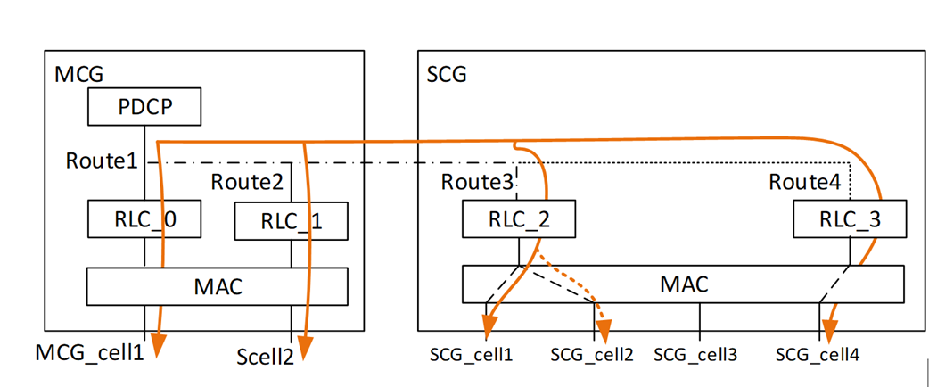

RAN3 Contributions:
Reference [1], [2], [3] are aiming to based on the Rel 16 NR-IIoT agreement, allow the MAC CE to be used.
Solution 1: PDCP entity indicate to the Node to use the MAC CE

Reference [4] is to rediscuss the inter-node coordination.
Solution 2: Introduce Assistance Information between Nodes via PDCP entity.

As way forward, companies are welcome to provide feedback on the following:

Question 1: The issue is in Rel 16, the Node may not be able to use MAC CE RLC de/activation correctly for NR-IIoT PDCP Duplication, do you agree?
Company | Comment
Ericsson | Yes

Question 2-1: Solution 1 does not challenge the Rel 16 decision, do you agree?
Question 2-2: Solution 1 can be discussed in Rel 16, do you agree?
Company | Comment to Question 2-1 | Comment to Question 2-2
Ericsson | Yes | Yes. Solution 1 enables the node to be able to use the MAC CE in Rel 16.

Question 3: Solution 2 challenges the Rel 16 decision, do you agree?
Company | Comment
Ericsson | Yes. Refer to the Rel 16 agreements above.

Question 4: If agreed to further discuss, should we discuss in TEI 17, or in Rel 17 NR-IIoT WID?
Company | Comment
Ericsson | Prefer in TEI17.

Conclusion

TBD

References
- R3-211769 Handling PDCP Duplication (Ericsson, Intel Corporation)
- R3-211770 Handling PDCP Duplication (Ericsson, Intel Corporation)
- R3-211771 Handling PDCP Duplication (Ericsson, Intel Corporation)
- R3-212550 Assistance information for UL duplication (Huawei, China Unicom)

