3GPP TSG-RAN WG3 #109-e R3-205471
Online, 17-28 August 2020

Agenda Item: 13.4.1
Source: AT&T (moderator)
Title: Summary of Offline Discussion on CLI Management
Document for: Approval

Introduction
CB: # 11_IAB_CLImgmt
- AT&T
Inter-donor and inter-IAB-node signaling to support the configuration and exchange of MT-MT and DU-DU CLI measurement reports should be considered in Rel-17
- E///
study the enhancement to legacy CLI management signaling to differentiate the TDD resources used for UE access traffic from the slots used for backhaul traffic
++ Suggested guidelines/topics for discussion from Chair (looking at possible consensus):
+ Start from Rel-16 CLI functionality: are any enhancements needed to work with IAB?
+ Possible information to be signaled inter-donor?
+ Attempt st2 and st3 TP?
(AT&T - moderator)

The discussion has two phases:
Phase 1 (Deadline Wednesday, August 20, 24:00 UTC): Discuss scenarios for CLI Management for IAB in Rel-17 and identify potential enhancements to Rel-16 CLI functionality
Phase 2 (Deadline Tuesday, August 25, 1300 UTC): TBD

For the Chairman’s Notes
Propose the following:

Discussion

Scenarios for CLI Management in IAB Rel-17
Support for CLI management was introduced in Rel-16 to enable coordination across neighboring cells in case of different DL/UL resources are configured resulting in performance degradation from CLI as well as support for UE-UE measurements to detect which resources are the most impacted.
For IAB there are several unique aspects related to CLI compared to conventional deployments. In [5226], it is highlighted that since backhaul resources may be associated with many downstream IAB nodes/UEs, protecting those resources may be of higher priority than resources only used for access links.
In [4869], in addition to TDM support in Rel-16 (where only the IAB-MT or IAB-DU were active in a given resource) new scenarios are considered in RAN1 to support more efficient access and backhaul link multiplexing: 1) spatial division multiplexing (SDM) and 2) multi-panel transmission/reception (MPTR), which result in the need for DU-DU as well as MT-MT measurements and reports for IAB nodes as shown in Figure 3.1.1 below.

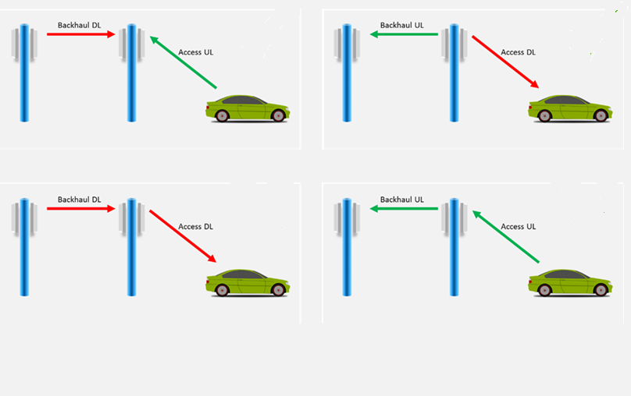
SDM
MPTR
SDM
MPTR
Figure 3.1.1: SDM and MPTR Rel-17 IAB Scenarios
Furthermore, since the IAB network is both multi-hop and relies on the use of “soft” resources configured by the Donor CU, but dynamically determined by a child IAB-DU, more frequent CLI measurements and reports may be needed. In addition, to reduce the overhead and latency of CLI related signaling, [4869] proposes that both inter-donor as well as inter-IAB-node exchange of CLI measurements may be considered in Rel-17.

Question 3.1: What scenarios should be supported in Rel-17 for IAB-specific CLI management?
Company | Comment
AT&T | Given the new multiplexing scenarios and the need for dynamic resource coordination, inter-donor and inter-IAB-node CLI management scenarios should be considered.

Identify potential enhancements to Rel-16 CLI functionality
As raised in [4869] and [5226], the existing Rel-16 CLI features support the exchange of TDD patterns and the reporting of UE-UE layer 3 CLI measurements. However, given the scenarios discussed in the previous section, this framework may be inadequate for IAB since it does not allow for the prioritization of resources used for backhaul vs. access links by differentiating the TDD resources used for UE access traffic from the slots used for backhaul traffic [5226]. In addition, it does not cover CLI measurements specific to the IAB-nodes (i.e. DU-DU and MT-MT measurements) [4869].
These aspects are proposed as the starting point for discussion to identify potential enhancements to Rel-16 CLI functionality.

Question 3.2 – What enhancements should be considered to the existing Rel-16 CLI functionality?
Company | Comment
AT&T | Existing UE-UE measurements only cover a subset of possible IAB CLI scenarios, and MT-MT/DU-DU measurements are critical to protect backhaul links in some cases. In addition the time scale of the measurement configuration and reports should be considered to support dynamic resource coordination (e.g. usage of “soft” resources) for IAB.  RAN3 should consider enhancements to support the configuration and exchange of MT-MT and DU-DU CLI measurement reports in Rel-17.

Conclusion, Recommendations
If needed

References

