3GPP TSG-RAN WG2 Meeting #130 R2-250xxxx
St.Julians, Malta, May 19th – 23rd, 2025

Agenda item: 7.0.2.21
Source: CATT
Title: [AT130][401][POS] CR on SRS resume case (CATT)
Document for: Agreeable CR

1 Introduction
This is to discuss the CR R2-2503497 [1] on RRC connection resume procedure initiated by activation or configuration of positioning SRS.
- [AT130][401][POS] CR on SRS resume case (CATT)
Scope: Check the CR in R2-2503497 and determine if some form of it is agreeable.
Intended outcome: Agreeable CR in R2-2504792, to Thursday CB session
Deadline: Wednesday 2025-05-21 1900 CEST

2 Discussion
Given the online progress, this section discusses several unresolved issues related to the CR R2-2503497.
R2-2503497 Corrections on RRC connection resume procedure initiated by activation or configuration of positioning SRS CATT, Samsung, Ericsson, vivo CR Rel-18 38.331 18.5.1 5338 - F NR_pos_enh2-Core

Discussion:
Xiaomi think the positioning and emergency service may be triggered separately, so the second change is not needed. CATT wonder what the upper layer situation would be to trigger this.
Samsung understand that if there are two separate cases, it would still be necessary to choose one resume cause.
Qualcomm think Xiaomi are right and we have the distinction between emergency services and all other services. Ofinno agree with Qualcomm and think we should not exclude emergency services as a positioning-specific change.
Huawei understand there is no emergency support for LPHAP, and the spec wrongly captured the agreements from Rel-18, so they think the CR is agreeable as it is.
Ericsson have the same understanding as Huawei and think LPHAP UEs would not be expected to support the emergency case. They think there may also be a case for RNA update.
Qualcomm understand there is no such thing as an “LPHAP UE”; it is just a UE.
ZTE checked the RRC specification and found that the emergency case is there for other cases, and this seems not a different situation and they see that the emergency service should be kept for the upper-layer-triggered case. Samsung think the emergency logic should not be there for the positioning case, and there are other upper-layer-triggered cases with no emergency part.
Nokia wonder about the first change; it seems to touch the MPS logic.
Ericsson think on the first change, we are adding logic outside of the MPS case. On the second change they agree with ZTE.
Huawei think for the emergency case we can rely on the legacy functionality.
ZTE think we could postpone the CR and they would like some time to discuss. They think a third change may be needed.

Change #1: 1st change in R2-2503497
Based on the online discussion, the change#1 given in R2-2503497 seems to be acceptable. Any additional feedback from companies would be appreciated.
Change#1: move the conditions of initiating the RRC connection resume procedure on activation/configuration of positioning SRS to before the branch:
2> else:
3> set the resumeCause in accordance with the information received from upper layers;
And change the “if” to “else if” for the first condition.
Q1: Do you agree with the 1st change of R2-2503497?
Company | Yes/No | Comments
Qualcomm | Yes
Ericsson | Yes
ZTE | Yes
CATT | Yes
Nokia | See comments | Still unsure if the change is affecting MPS logic or not. I am attaching below two docs showing the changes to Rel-17 baseline with and without this CATT corrections (1st change in R2-2503497). It seems to me there is some nesting level issue. Shouldn’t the RRC resume trigger for positioning start at level 1> ?  Rapp(CATT2): Thanks for your comments. But after checking, we still think the change 1 in R2-2503497 is logical and doesn’t affecting MPS at all. It use “else if” after the MPS condition, so they have no relationship. If it goes into MPS condition, then it will not consider the SPS related conditions. And the 1> condition is “1> else if the resumption of the RRC connection is triggered by upper layers:”(not multicast reception condition), the SPS related conditions which are triggered by upper layer should under this 1> level condition. So we think change 1 is correct and workable.
Huawei, HiSilicon | Yes
Summary:

Change #2: the emergency service judgement
Regarding change#2 outlined in R2-2503497, some companies argue that the emergency service and activation/configuration may be triggered by different upper layers (e.g., NAS layer and LCS layer) at the same time, which necessitates a judgement. However, some companies expressed that LPHAP UEs may not need to support the emergency service, thus no need for such a judgement.
There is no consensus among companies on whether UEs who transmits Positioning SRS in RRC_INACTIVE should support emergency service and whether the emergency logic should be there for the positioning case. Companies are invited to provide their views in the table under Q2-1 and Q2-2.
Change#2: remove the emergency service judgement from the conditions of initiating the RRC connection resume procedure on activation/configuration of positioning SRS.
Q2-1: Do you think UEs who transmit Positioning SRS in RRC_INACTIVE support emergency service?
Company | Yes/No | Comments
Qualcomm | Yes | All UEs that support voice services generally need to support emergency services.
Ericsson | No/Not compatible mode. | Voice is only supported in RRC Connected mode. So, both; 1: inactive mode transmission and 2: supporting emergency call may not be applicable.  Rapp: The question is asking ‘Do you think UEs who transmit Positioning SRS in RRC_INACTIVE support the emergency service’.  The UE in RRC_INACTIVE mode needs to send the RRC resume request for emergency call when both SRS transmission and emergency call are triggered from NAS layer and LCS layer simultaneously.  That is although UE is in RRC_INACTIVE, it still could enter RRC_CONNECTED mode by resume procedure triggered by emergency service. So the scenario should be considered.
ZTE2 | Yes | If upper layer does not provide resume cause, RRC should determine whether emergency service applies or not since this resumeCause of emergency has very high priority
CATT | Yes | An UE who supports LPHAP may also support emergency service. We should not exclude such UE in spec.
Nokia | Yes | In RRC specification, we do not distinguish between different upper layers. Also, we agreed to treat LPHAP UE as any other UE and did not differentiate LPHAP and non-LPHAP UEs in the specification. So, we assume that UE involved in LPHAP positioning also supports emergency services.
Huawei, HiSilicon | Yes | Agree with Nokia, UE supporting LPHAP could be any UE types that support the feature. There is no LPHAP UEs.
Summary:

If companies agree that these UEs who transmit Positioning SRS in RRC_INACTIVE support emergency service, then the emergency service judgement should be kept as existing specification, i.e. don’t remove emergency service part.
If companies agree that these UEs who transmit Positioning SRS in RRC_INACTIVE don’t support emergency service, the emergency service judgement under the condition “if the resumption of the RRC connection is triggered due to cell reselection as specified in clause 5.3.13.6” should also be removed.
1> else if srs-PosRRC-InactiveValidityAreaPreConfigList or srs-PosRRC-InactiveValidityAreaNonPreConfig is configured:
2> if the resumption of the RRC connection is triggered due to cell reselection as specified in clause 5.3.13.6:

3> select '8' as the Access Category;
3> set the resumeCause to srs-PosConfigOrActivationReq;
Q2-2: if you agree that these UEs who transmit Positioning SRS in RRC_INACTIVE don’t support emergency service, do you agree that the emergency service judgement under the condition “if the resumption of the RRC connection is triggered due to cell reselection as specified in clause 5.3.13.6” should also be removed?
Company | Yes/No | Comments
ZTE |  | The emergency service judgement under both ‘upper layer trigger’ and ‘cell reselection trigger’ should be kept
Summary:

Change #3: the missed trigger condition of resumption of the RRC connection
ZTE proposes offline that one trigger condition of resumption of the RRC connection may need to be added, which is due to the need for positioning configuration and no stored srs-PosRRC-InactiveValidityAreaNonPreConfig. TP is given in the following box.
2> else if the resumption of the RRC connection is triggered for activation of preconfigured SRS for positioning available in srs-PosRRC-InactiveValidityAreaPreConfigList and if the UE is camped in one of the cells indicated in one of srs-PosConfigValidityArea; or
2> if the resumption of the RRC connection is triggered due to the need for SRS for positioning configuration and no stored srs-PosRRC-InactiveValidityAreaPreConfigList or srs-PosRRC-InactiveValidityAreaNonPreConfig for the camped cell exists; or
2> if the resumption of the RRC connection is triggered due to activation of non-preconfigured SRS for positioning with type semi-persistent available in srs-PosRRC-InactiveValidityAreaNonPreConfig and if the UE is camped in the cells indicated in srs-PosConfigValidityArea:
With this modification, the UE could request srs-PosRRC-InactiveValidityAreaNonPreConfig via the RRC connection resumption procedure. However, we have not reached the agreement on this condition. Therefore, it is better to discuss it first. The rapporteur summarizes the differences in possible UE behaviour with and without this modification.
 | Follow legacy procedure | With the proposed modification
Case 1: UE only has preconfigured SRS for the camped cell | The UE cannot request non-preconfigured SRS via the RRC connection resumption procedure. | UE is allowed to request non-preconfigured SRS. NOTE 1
Case 2: UE only has non-preconfigured SRS for the camped cell | UE is allowed to request preconfigured SRS. NOTE 1 | UE is allowed to request preconfigured SRS. NOTE 1
Case3: UE has both preconfigured SRS and non-preconfigured SRS for the camped cell | N/A | N/A
Case 4: UE does not have preconfigured SRS or non-preconfigured SRS for the camped cell | When the UE initiate RRC connection resumption with resume cause srs-PosConfigOrActivationReq, the NW configures preconfigured SRS for the UE. | When the UE initiate RRC connection resumption with resume cause srs-PosConfigOrActivationReq, it is up to NW to configure preconfigured SRS or non-preconfigured SRS for the UE
NOTE 1: It is not allowed to configure both preconfigured SRS and non-preconfigured SRS in one cell for UE in Rel-18.
For the above cases, it seems that this modification is not just a correction of Rel-18. Companies are invited to provide their views in the table under Q3.
Q3: Do you agree that the UE may request SRS for positioning configuration when no stored srs-PosRRC-InactiveValidityAreaNonPreConfig for the camped cell via the RRC connection resumption procedure?
Company | Yes/No | Comments
Qualcomm | No | A UE need to have a SRS configuration with validity area received in the first place when sending RRC Resume Request. The proposed text seems to imply that whenever a SRS for positioning configuration is needed, the UE can simply send a RRC Resume Request.
ZTE |  | The question is, Whether UE can ask for the SRS configuration when camping on the red cell?  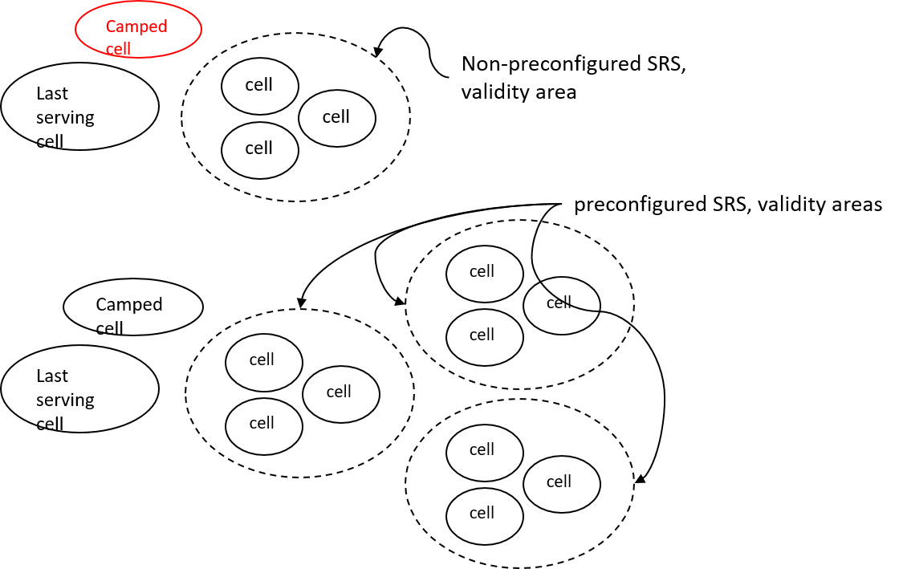  If yes, the proposed text should be agreed
CATT | See comments | We think this modification is an enhancement rather than a correction and a new UE capability may be introduced. If we want to support this case, this modification can be discussed in TEI 19.
Nokia | No | Agree with CATT. We also think this is an enhancement and not a correction. We don’t differentiate between validity area for preconfigured SRS and non-preconfigured SRS. The ZTE scenario seems to address the Case 3 in the summary table provided by the rapporteur?
Huawei, HiSilicon | No | The current text has already covered the non-preconfigured SRS case
Summary:

3 Conclusion
Based on company feedback, the following is proposed:

4 References
- R2-2503497 Corrections on RRC connection resume procedure initiated by activation or configuration of positioning SRS CATT, Samsung, Ericsson, vivo CR Rel-18 38.331 18.5.1 5338 - F NR_pos_enh2-Core

5 Participants

Company Name | Participant name/contact

