3GPP TSG-RAN WG2 Meeting #121 R2-2xxxxx

Athens, Greece, February 27th – March 3rd , 2023

Agenda item: 8.2.2
Source: Intel Corporation
Title: Summary of AI 8.2.2 Sidelink Positioning
Document for: Discussion, Decision

1. Introduction
This document summarizes the contributions submitted for Agenda Item 8.2.2 on Sidelink Positioning. The aim of this summary is the consolidate the most common aspects across the contributions and hopefully provide a starting point for further discussion. Note that not all proposals are exhaustively included in the discussion below, since the focus is on finding common ground among all the contributions.

2. List of Contributions
R2-2300117 Discussion on Sidelink Positioning Huawei, HiSilicon discussion Rel-18 NR_pos_enh2
R2-2300197 Discussion on sidelink positioning methods CATT discussion Rel-18 NR_pos_enh2
R2-2300198 Architecture and Signaling procedure on support of PC5-only and joint PC5-Uu scenarios CATT discussion Rel-18 NR_pos_enh2
R2-2300254 Considerations on SLPP broadcast / groupcast and related aspects Nokia Germany discussion Rel-18
R2-2300410 Support of sidelink positioning Intel Corporation discussion Rel-18 NR_pos_enh2
R2-2300455 Further discussion on sidelink positioning OPPO discussion Rel-18 NR_pos_enh2
R2-2300529 Sidelink Positioning Protocol (SLPP) Signaling and Procedures Qualcomm Incorporated discussion
R2-2300585 Considerations on anchor UE discovery, selection and utilization Nokia Netherlands discussion Rel-19
R2-2300586 Considerations on SL positioning sessions and related aspects Nokia Netherlands discussion Rel-18
R2-2300593 UE Positioning using Sidelink Fraunhofer IIS, Fraunhofer HHI discussion
R2-2300642 Discussion on transport layer of SLPP Samsung discussion Rel-18 NR_pos_enh2
R2-2300662 Discussion on potential solutions for SL positioning Spreadtrum Communications discussion Rel-18
R2-2300675 Discussion on sidelink positioning vivo discussion Rel-18 FS_NR_pos_enh2
R2-2300712 SL positioning groupcast and broadcast Apple discussion NR_pos_enh2
R2-2300715 [DRAFT] Reply LS on SL positioning groupcast and broadcast Apple LS out Rel-18 FS_NR_pos_enh2NR_pos_enh2 To:SA3 Cc:SA2
R2-2300810 Designing SLPP protocol in the session perspective Samsung Electronics Romania discussion
R2-2300932 Discussion on sidelink positioning ZTE Corporation discussion Rel-18 NR_pos_enh2
R2-2301048 Discussion on SL positioning Xiaomi discussion Rel-18
R2-2301067 On SL Positioning Protocol and Architectural Aspects Lenovo discussion Rel-18
R2-2301086 Considerations on sidelink positioning Sony discussion Rel-18 FS_NR_pos_enh2 Withdrawn
R2-2301262 Considerations on Sidelink positioning CMCC discussion Rel-18 NR_pos_enh2
R2-2301305 Sidelink positioning Ericsson discussion Rel-18
R2-2301350 Assistant UEs in Rel-18 MediaTek Inc. discussion Rel-18 NR_pos_enh2-Core
R2-2301410 Considerations on sidelink positioning Sony discussion Rel-18
R2-2301545 Considerations on Anchor UE selection in sidelink positioning LG Electronics Inc. discussion Rel-18
R2-2301546 Considerations on session-based SLPP operation LG Electronics Inc. discussion
R2-2301792 Discussion on Sidelink positioning InterDigital, Inc. discussion Rel-18
R2-2301885 View on SL ranging and positioning architecture and signalling procedures CEWiT discussion
R2-2301889 Procedures for Sidelink Positioning Philips International B.V. discussion Rel-18 Late
R2-2301890 Protocol considerations for Anchor UEs with(out) known location Philips International B.V. discussion Late

3. Discussion

3.1 SL Positioning Protocol Transport
Multiple contributions discuss the long-standing issue of how to transport the SLPP signaling. The two main options being considered in the last RAN2 meeting were PDCP based approach and PC5-U based approach.
The company proposals related to this topic are summarized in the Table below.
R2-2300117 Huawei | Proposal 1: RAN2 supports user plane protocol stack for SLPP protocol terminating between two UEs with PC5 interface.
R2-2300198 CATT | Proposal 3: SLPP over PDCP is supported. FFS SLPP over SDAP is also supported which depends on the definition of PQI-like QoS.
R2-2300410 Intel Corporation | Proposal 1: RAN2 is proposed to agree that UP based PC5-U solution is used for transport of SLPP.
R2-2300455 OPPO | Proposal 1: RAN2 to agree to choose the control plane PDCP as the transport player to support the SL positioning protocol.
R2-2300529 Qualcomm | Proposal 4: SLPP transport for Sidelink Positioning and Ranging is over the PC5 User Plane (PC5-U).
R2-2300642 Samsung | Proposal 1: RAN2 is kindly asked to discuss QoS-related aspect for down-selecting transport layer of SLPP signaling.  Proposal 2: RAN2 is kindly asked to agree that PDCP is transport layer of SLPP signaling.  Proposal 3: RAN2 is kindly asked to define new SL-SRB (e.g., SL-SRB5) to carry SLPP signaling.
R2-2300662 Spreadtrum | Proposal 8: CP-based protocol stack over PDCP may be more suitable for SL positioning signalling transmission between UEs.
R2-2300675 vivo | Proposal 7: For LMF-independent sidelink positioning, support SLPP over PDCP. Whether to also support SLPP over PC5-U is up to SA2.
R2-2300932 ZTE | Proposal 1: RAN2 to support control plane design of the SLPP message between UEs, i.e., SLPP over PDCP.  Proposal 2: For control plane design of SLPP message between UEs, RAN2 to support introducing new SL-SRB(s) dedicated for SLPP message, and consider the following options:  • Option 1: Introduce a new SL-SRB dedicated for SLPP message, the cast type of the SL-SRB is indicated by upper layer.  • Option 2: Introduce two new SL-SRBs dedicated for SLPP message, one is to convey broadcast/groupcast SLPP message, the other is to covey unicast SLPP message.  • Option 3: Introduce a new SL-SRB dedicated for SLPP message, the cast type of the SL-SRB is fixed as one of broadcast, groupcast or unicast.  Proposal 3: RAN2 to study the specification impact of introducing new SL-SRB(s) for SLPP message, may include SCCH configuration, PDCP PDU format, AM mode and UM mode, new LCID, receiving MAC entity filtering. Taking the legacy SL-SRB&cast type design as the reference.
R2-2301048 Xiaomi | Proposal 9 PC5-U is selected as the transport layer of SLPP.
R2-2301067 Lenovo | Proposal 1: RAN2 to follow SA2’s preference to use PC5-U as the SLPP transport layer.
R2-2301305 Ericsson | Proposal 8: RAN2 to discuss and select one of the options SLPP over PDCP or PC5-U.
R2-2301885 CEWiT | Proposal 3: For SL positioning and ranging related message exchange the control plane stack should be prioritised.  Proposal 4: In OOC scenario for SLPP following control plane protocol stack should be used,  1. Alt 1: SLPP over PC5-S  2. Alt 2: SLPP over PC5-RRC  Proposal 5: In partial coverage scenario, for SLPP over PC5-PDCP should be considered.
Summary:
It is worth noting that there was a reply LS from SA2 in [1] which provides the conclusion that SA2 prefers to use PC5-U as the SLPP transport layer.
SA2 Conclusion: SA2 has discussed this issue, and prefers to use PC5-U as the SLPP transport layer.

From the submitted contributions which discuss this aspect, it is clear that there is no clear majority on this issue. Five companies (Huawei, Intel, Qualcomm, Xiaomi, Lenovo) propose to go with SA2 preference to use the PC5-U based UP solution, while six (CATT, OPPO, Samsung, Spreadtrum, ZTE, CEWiT) propose to use the PDCP based CP solution. One company (vivo) thinks that for LMF independent SL positioning, PDCP should be used and whether to also support SLPP over PC5-U is up to SA2. Additionally, Ericsson proposes to discuss and select one of the two options.
The rapporteur thinks that while both options are feasible, there are pros and cons associated with both options as discussed at length in the contributions (and indeed in the past couple of meetings as well). The main distinguishing factor from previous meeting appears to be a direct recommendation from SA2 that they prefer to use PC5-S. Therefore, RAN2 is proposed to discuss whether SA2 recommendation is acceptable, i.e., PC5-U approach is used.

Proposal 1: With respect to the transport of SLPP signaling, RAN2 is proposed to discuss whether SA2 recommendation is acceptable, i.e. PC5-U is used as the SLPP transport layer.

3.2 Signaling between UE and LMF (for hybrid Uu-PC5 and PC5 only positioning)
There are several proposals related to the signaling between UE and LMF. Company proposals on this topic are summarized in the table as below:
R2-2300117 Huawei | Proposal 2: For hybrid PC5 and Uu positioning, SLPP can be transported as a container within LPP between UE and LMF.  Proposal 3: For PC5 only positioning, SLPP can be transported as a container within LPP between UE and LMF.  Proposal 4: SLPP can be contained within the ePDU field in the message body of the corresponding LPP message and an identifier of ePDU for SLPP can be added.
R2-2300198 CATT | Proposal 2：Enhancement of LPP whereby SLPP signaling is transported within LPP transparently and SLPP/RSPP is carried as a container in LPP message between UE and LMF.
R2-2300410 Intel Corp | Proposal 6: For the case of hybrid PC5+Uu positioning in coverage, RAN2 is proposed to agree with Option 2: SLPP/RSPP signaling is transported within LPP transparently, i.e. use the newly defined SLPP/RSPP to support sidelink based positioning and use the existing LPP to support Uu based positioning; and the SLPP/RSPP is carried as a container in LPP  Proposal 7: For the case of PC5-only positioning in coverage, RAN2 is proposed to agree that SLPP/RSPP signaling can be transported within LPP transparently, i.e. use the newly defined SLPP/RSPP to support sidelink based positioning; and the SLPP/RSPP is carried as a container in LPP
R2-2300529 Qualcomm | Proposal 12: Support hybrid Uu, SL, and RAT-independent positioning by jointly using the SLPP, LPP, and NRPPa procedures.  Observation 10: Using the LMF as an SLPP endpoint would not only allow embedding SLPP messages into Supplementary Services Operations (e.g., MT-LR, MO-LR, etc.), but would also enable joint sidelink and Uu positioning with minimal changes to existing protocols.  Observation 11: Using the LMF as an SLPP endpoint would allow sidelink-only positioning (with LMF support) without a requirement for LPP support, which would reduce complexity for sidelink-only capable positioning and ranging devices and LMFs.  Observation 12: Specifying the sidelink positioning functionality isolated within SLPP would require no modifications to LPP, and therefore, would not increase the LPP ASN.1 footprint for non-sidelink capable UEs and LMFs.  Proposal 13: The LMF should be a protocol endpoint for SLPP.
R2-2300662 Spreadtrum Communications | Proposal 9: For protocol between UE and LMF, SLPP/RSPP can be transported as a container within LPP.
R2-2300675 vivo | Proposal 1: For LMF-dependent sidelink positioning, support the enhancement of LPP, i.e., the SLPP is carried as a container in LPP.
R2-2300932 ZTE | Proposal 4: Support to use the RSPP/SLPP+LPP between UE and the LMF, i.e., SLPP is designed as a container in the LPP.  Proposal 5: RAN2 to discuss and down-select the two structures of the SLPP container in LPP: add several SLPP containers per LPP message type, or add one SLPP container within one LPP Message.
R2-2301048 Xiaomi | Proposal 10 LPP is used between UE and LMF.  Proposal 11 Extension of LPP is adopted
R2-2301067 Lenovo | Observation 1: For UEs wishing to only perform ranging in-coverage and without LPP capabilities, LMF involvement may be unnecessary.  Proposal 7: RAN2 to support both LMF-dependent (e.g., UEs supporting both LPP and SLPP/RSPP) for in-coverage scenarios and partial coverage scenarios and LMF-independent (e.g., UEs only supporting SLPP/RSPP) SL positioning architectures for all coverage scenarios including in-coverage, partial coverage and out-of-coverage.  Proposal 8: It is suggested that RAN2 to discuss the procedures and signalling design for partial coverage case in which a target UE is out-of-coverage and at least one of the anchor UEs is in coverage.
R2-2301262 CMCC | Proposal 3: If involved, LMF determines whether the hybrid PC5+Uu positioning or PC5-only positioning is performed. FFS the data reported by UE to assist the determination.
R2-2301305 Ericsson | Proposal 7: The baseline for developing ASN.1 to support SL operations between LMF and UE is by means of extension of LPP. The decision whether to use container solution or direct SLPP between UE and LMF is taken after evaluating the baseline extension.
R2-2301885 CEWiT | Proposal 1: As the protocol used between UE and LMF, SLPP should be used at least for OOC scenarios. Whereas in in coverage case LPP can be reused.  Proposal 2: For partial coverage case, as the protocol used between UE and LMF, following options should be considered,  1. Use LPP as positioning protocol.  2. Use both SLPP and LPP, LPP terminate as relay UE and SLPP terminate at remote UE.
R2-2301889 Philips International B.V. | Proposal 1: RAN2 should support the extension of the legacy positioning procedure to support ranging and sidelink positioning such that the LMF can actively support the Target UE with ranging and SL positioning and use the measurements in its estimate of the Target UE’s location.
Summary:
During the previous meetings, RAN2 reached the following conclusion on the signaling between UE and LMF to support sidelink positioning for the in-coverage case:
Agreement:
Protocol options between UE and LMF for hybrid PC5+Uu positioning and PC5-only positioning in-coverage are studied and RAN2 will down-select during normative work.
1) Extension of LPP, whereby new signaling shall be defined to support hybrid Uu and PC5 based positioning, i.e. extend the existing LPP to support sidelink based positioning between UE and LMF
2) Enhancement of LPP whereby SLPP/RSPP signaling can be transported within LPP transparently, i.e. use the newly defined SLPP/RSPP to support sidelink based positioning and use the existing LPP to support Uu based positioning; and the SLPP/RSPP is carried as a container in LPP
3) Use of SLPP/RSPP between the UE and the LMF

From the contributions submitted to this meeting, it can be seen that 6 companies (Huawei, CATT, Intel, Spreadtrum, vivo, ZTE) prefer option 2, i.e. enhancement of LPP to carry the SLPP signaling as a container within LPP while 1 company (Xiaomi) explicitly support Option 1, i.e. extension of LPP to support sidelink positioning signaling between UE and LMF, and 1 company (Qualcomm) explicitly support Option 3, i.e. Use of SLPP/RSPP between the UE and the LMF. In addition, [Ericsson] thinks that the baseline way can be by means of extension of LPP, but whether option 1 or 2 is ultimately used can be decided later. [Lenovo] thinks that for ranging in coverage, LMF involvement (and hence use of LPP signaling) may be unnecessary. [CEWiT] thinks that either LPP (end-to-end) or both LPP and SLPP terminating at relay UE and remote UE respectively should be considered for partial coverage case.
Considering the above-mentioned open aspect, rapporteur thinks it would be good to first focus on the in-coverage scenario for both hybrid (PC5+Uu) based and PC5 only positioning, and in this respect, there seems some majority for Option 2 above. The proponent companies think that this leads to avoid duplicated specification effort and both LPP and SLPP can be specified independently. On the other hand, companies supporting Option 1 think that this method ensures that LMF only needs to support LPP and would lead to minimal changes to existing protocols. From rapporteur’s perspective, all options seem feasible and can be supported, but option 2 has more support than other two options (6 vs 1). Therefore option 1 and 3 can be excluded since there seems to be limited support. Moreover, for the partial coverage scenario, it would be good to discuss if the same principle as for the case of in-coverage scenario can be applicable.

Proposal 2: [6 vs 1] Regarding the signaling options between UE and LMF for hybrid PC5+Uu positioning and PC5-only positioning in-coverage, it is proposed to agree option 2:
- Option 2: Enhancement of LPP whereby SLPP/RSPP signaling can be transported within LPP transparently, i.e. use the newly defined SLPP/RSPP to support sidelink based positioning and use the existing LPP to support Uu based positioning; and the SLPP/RSPP is carried as a container in LPP

Proposal 3: RAN2 discuss whether the same signaling option shall apply for the partial coverage scenario as in that for the in-coverage scenario.

3.3 Groupcast/Broadcast type support
Another open issue from previous discussions pertains to support of groupcast and broadcast, the applicability of various SL positioning signaling and the associated security issues. The company proposals related to this topic are summarized in the Table below.
R2-2300117 Huawei | Proposal 5: Broadcast/groupcast of SLPP assistance data can be useful for SL-PRS measurement for UE-based and UE-assisted SL positioning from RAN2’s perspective.  Proposal 6: Wait for R1’s progress for the broadcast/groupcast of SL-PRS.
R2-2300198 CATT | Proposal 6: Capture the following cases for SLPP transmission via broadcast/groupcast in the reply LS to SA3:  - Case 1: Anchor UE(s) transmits SL positioning capability/ assistance data;  - Case 2: Target UE transmits SL positioning capability/ assistance data;  - Case 3: Server UE transmits SL positioning capability;  - Case 4: Server UE transmits SL positioning capability/ assistance data of one or multiple anchor UEs;  - Case 5: Server UE transmits SL positioning capability/ assistance data of target UE.  Proposal 7: The signalling of unicast, groupcast (not including many to one) and broadcast of SL-PRS transmissions is SL-PRS configuration via unicast, groupcast (not including many to one) and broadcast. RAN2 to discuss whether SL-PRS configuration is included in SL positioning assistance data or not later based on the progress of RAN1.
R2-2300254 Nokia | Proposal 2: In addition to unicast, the SLPP RequestCapabilities message can be broadcast and / or groupcast.  Proposal 5: In addition to unicast, SLPP ProvideAssistanceData message can be broadcast or groupcast.  Proposal 7: In addition to unicast, the SLPP ProvideLocationInformation message can be broadcast or groupcast.  Proposal 8: RAN2 to reuse the LMF-oriented concept for securing assistance data broadcast in Uu positioning as a baseline for secure broadcast / groupcast in sidelink positioning.  Proposal 12: To protect sidelink positioning broadcast / groupcast, the LMF employs ciphering keys which are associated with a specific UE group, and distributed only to the members of this UE group to enable selective group-level protection.  Proposal 13: A default ciphering key is configured in all UEs capable of sidelink positioning to enable default PLMN-wide or similar protection.  Proposal 14: Explicit absolute location information is always encrypted such that at most only UEs directly involved in a given localization process (e.g. members of the same positioning session) can decrypt it.  Proposal 15: RAN2 to study how group-specific ciphering keys are distributed based on the indication of identity information such as UE / session / group identity.  Proposal 16: RAN2 to discuss  - other types of broadcast / groupcast payload that need to be protected by ciphering (including payload concerning capability information, assistance data, and PRS measurements for absolute positioning), as well as  - their protection scope, that is, define which UEs must / must NOT / may / may NOT have access to this information.
R2-2300410 Intel Corp | Proposal 14: Based on SA2 conclusions, it is confirmed that group management for group positioning is handled by the upper/application layer and no impact is foreseen in RAN2.  Proposal 15: The group ID and/or L2 Destination IDs for transmission of capability information, assistance information and location request/response shall be provided by the upper layers .
R2-2300455 OPPO | Observation 6: retrieving positioning capability in the unicast way for performing SL positioning introduces significant timing latency, since the SL positioning capabilities need to be collected from candidate UEs potentially more than the necessary UEs required for the SL positioning.  Proposal 7: RAN 2 to agree the positioning capability can be broadcast/groupcast periodically, similar with the SL discovery model A.  Proposal 8: RAN2 to agree that SL-PRS configuration could be broadcast/groupcast between anchor UEs and the target UE, after they autonomously determine the SL-PRS configuration.
R2-2300529 Qualcomm | Proposal 3: Sidelink Positioning and Ranging supports unicast, groupcast and broadcast operation for Capability Transfer, Assistance Data Transfer and Location Information Transfer.  Proposal 14: SLPP should indicate the transaction (communication) mode to be used for each SLPP message, i.e. whether broadcast mode, groupcast mode or unicast mode is to be used (e.g., in a common SLPP message header). At least the following common transaction modes shall be supported:  • Unicast transaction  • Group Transaction with Group Replies  • Group Transaction with Unicast Replies  • Broadcast Transaction.
R2-2300593 Fraunhofer | Proposal 2: Anchor UEs shall not broadcast the measurements to other UEs. The measurement shall only be transmitted in unicast or report free ranging shall be supported.
R2-2300675 vivo | Proposal 13: Support the broadcast and groupcast of SL positioning capability and assistance data, and reply LS to SA3 to work on the solutions to address the security issue.
R2-2300712 Apple | Proposal: It is proposed to communicate the method to cypher SL positioning groupcast/broadcast signaling outlined above to SA3 for further feedback and to allow them to discuss the additional details of this solution from the security perspective.
R2-2301048 Xiaomi | Proposal 4 : If RAN2 agrees to support group positioning, RAN2 agrees to support group positioning only for ranging.  Proposal 5 : RAN2 agrees not to introduce group management procedure in SLPP layer.  Proposal 6 : RAN2 agrees not to support groupcast for non-group positioning scenario.  Proposal 7: RAN2 provide with SA3 the above groupcast/broadcast use cases and operation flows as example.
R2-2301067 Lenovo | Proposal 3: Support SL group positioning including performing SL positioning or ranging for distance/direction among SL positioning group members.  Proposal 4: RAN2 to further discuss in which layer to support SL positioning Group management at the:  • Application Layer  • SLPP/RSPP Layer  Proposal 5: RAN2 starts to work on SL positioning signalling and procedure for groupcast/broadcast, with consideration of the following use cases and aspects:  • One target UE and multiple anchor UEs in one group  • Multiple target UEs and one or multiple anchor UEs in one group  • Session-based or session-less procedure
R2-2301545 LG | Proposal 4. RAN2 to consider cast types of SL Positioning Capability Transfer signaling if there are privacy and security issues in groupcast/broadcast;  1) via unicast only between target UE and Normal UE  2) via unicast/groupcast/broadcast between target UE and RSU-type UE
R2-2301792 InterDigital | Proposal 7 : Study mechanism to maintain the sidelink positioning group

Summary:
It is worth noting that there has been correspondence with SA2 and SA3 related to security aspects associated with support of groupcast and broadcast for sidelink positioning related signaling. As has been pointed out in several contributions, SA3 has responded to RAN2 LS with the following information [2]:
Q1: RAN2 requests feedback on potential security requirements (e.g., for ciphering and/or integrity) and feasibility of protecting SL positioning capability (e.g. the capabilities of physical layer) and assistance data signaling transferred using groupcast/broadcast.
A1: SA3 has preliminarily agreed that unprotected broadcast/groupcast signaling has security issue, therefore ciphering and integrity protection are required for the signaling transferred using groupcast/broadcast. Currently, ciphering and integrity protection are not supported for broadcast/groupcast on sidelink.
SA3 has also preliminarily agreed that it is feasible to work on the corresponding requirements and solutions for protecting broadcasted/groupcasted SL positioning signaling when the basic groupcast/broadcast procedure is stable. Therefore, SA3 would appreciate more information (e.g. user cases for broadcast/groupcast, detailed operations) from RAN2 for developing feasible solutions, if any.
In addition, SA3 would also appreciate feedback from SA2 on group management for SL positioning signalling groupcast.

Regarding the use cases requested by SA3 for broadcast/groupcast, [CATT] and [Xiaomi] propose several use cases for groupcast to be indicated to SA3, including scenarios where anchor UE and/or target (s) transmit SL positioning capability/assistance data in a groupcast or broadcast manner. Rapporteur notes that with respect to the SA3 LS in [2], it is also noting that SA2 has included the use cases for groupcast/broadcast for SL positioning, including V2X use cases involving RSUs and multiple vehicles and platooning, etc in [3], which can answer SA3’s question. Therefore, RAN2 does not need to provide further response on use cases.
Proposal 4: RAN2 does not need to provide use cases to SA3, considering SA2 already provided it in their reply LS in S2-2301786.
Regarding the signaling support, particularly the supported SLPP messages for groupcast/broadcast transmission, the following can be inferred in terms of company support:
- Capability exchange [Nokia, Qualcomm, CATT, OPPO, vivo, LG ]
- Assistance data transfer [Nokia, Qualcomm, Huawei, CATT, OPPO, vivo]
- Location information transfer[Nokia, Qualcomm], however [Fraunhofer] think only unicast should be used for measurement reporting.

Note that in the last RAN2 meeting, RAN2 already agreed that
Agreements:
Proposal 13 (modified) RAN2 confirm that from RAN2 perspective, it is feasible to send at least the following positioning signaling for groupcast/broadcast (in addition to unicast):
• SL positioning capability (5)
• SL positioning assistance data (6)
Location information is not excluded and can be further considered in normative work.
Proposal 14 (modified) RAN2 to further discuss in normative work:
- the security issues (e.g., requirements for ciphering and/or integrity) on specific information of SL positioning capability and assistance data in groupcast/broadcast and consult to SA2 and SA3.
- the use cases for applying groupcast/broadcast.
LS to SA2/SA3 to indicate the agreement, that we are aware of SA2’s security concern, and inquire what security constraints would apply to transmission of SL positioning capability and distribution of assistance data by groupcast/broadcast. Inquire of SA2 if they have identified groupcast/broadcast use cases.

From rapporteur perspective, sufficient support is seen from companies to support broadcast/groupcast of SLPP assistance data and capability, given SA3 conclusion that it is feasible to work on solutions for securing such signaling. Therefore, from RAN2 perspective, it would be good to work on the details of procedures and signaling flow to support use cases. From the contributions, the ones proposed by [Lenovo] can be used as a starting point.
Proposal 5: RAN2 starts work on SL positioning signalling and procedure for groupcast/broadcast on SL positioning capability, and SL positioning assistance data (FFS on location information), considering at least the following use cases/scenarios:
• One target UE and multiple anchor UEs in one group
• Multiple target UEs and one or multiple anchor UEs in one group

Regrading security aspects, [Nokia] proposes to reuse the LMF-oriented concept for securing SL positioning data. It also suggests using ciphering keys to protect broadcast/groupcast payloads and define which UEs should have access to this information. [Apple] propose to respond to SA3 LS by indicating a possible solution for ciphering protection of SL Positioning groupcast/broadcast signaling. [LG] thinks that since privacy and security issues in groupcast/broadcast are not yet resolved (which they think are unlikely to be fully addressed), UE capabilities should be exchanged via unicast.
From Rapporteur perspective, security is SA3 scope and SA3 is currently working on it. RAN2 should just wait for further inputs from SA3 before discussing security aspect on group/broadcast.
Proposal 6: RAN2 should wait for inputs from SA3 before discussing security aspect for group cast/broadcast.
Regarding the group management aspect, [Intel] and [Xiaomi] think that in order to support group positioning, the group management should not be handled at the SLPP layer (but rather the upper/application layer), while [Lenovo] and [InterDigital] proposes to further discuss this aspect.
SA2 has concluded the following in [4] [3]:
- The group management can be performed at application layer, and the application layer may provide group identifier information to the Ranging/SL Positioning layer.
NOTE 1: Potential group management within RSPP layer is out-of-scope of SA2.
If PC5-U is used, Ranging/SL Positioning signaling is carried over V2X/ProSe Layer as payload. The existing V2X/ProSe transport mechanism is reused to handle the Layer-2 ID and Application Layer ID information.
From Rapporteur perspective, we can follow SA2 decision on this, i.e.
Proposal 7: The group management can be performed at application layer, and the application layer may provide group identifier information to the Ranging/SL Positioning layer. RAN2 further discuss whether any AS layer impact is foreseen.

In addition, [Qualcomm] think that SLPP signaling should include a cast type mode for each message. The rapporteur thinks that based on SA2 conclusion, if V2X/ProSe mechanism is used for L2 ID, the SL UEs can anyway identify the cast type for each packet based on the L2 SRC/DST ID fields. In any case, RAN2 can discuss this once the signalling/procedure for broadcast/groupcast is clear.
Proposal 8: Postpone the discussion on whether transaction/cast type indication shall be associated with each SLPP message to indicate the transmission cast type until the signalling/procedure is clear on how to support broadcast/group cast.

3.4 Overall architecture and procedure/signaling flow for SL positioning (IC/PC/OOC)
.
R2-2300117 Huawei | Proposal 7: For OoC, the SL positioning can only be initiated by UE.  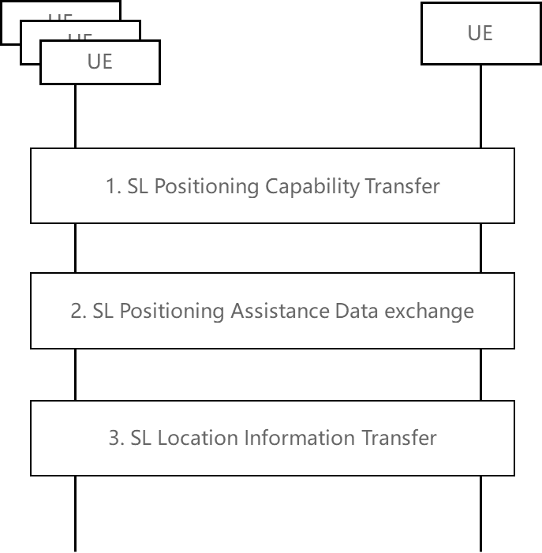  Proposal 8: For IC and PC, support the following procedures for the initiation of SL positioning:  (a) legacy MO-LR, MT-LR and NI-LR with LMF involvement (b) direct SL only positioning without LMF involvement.  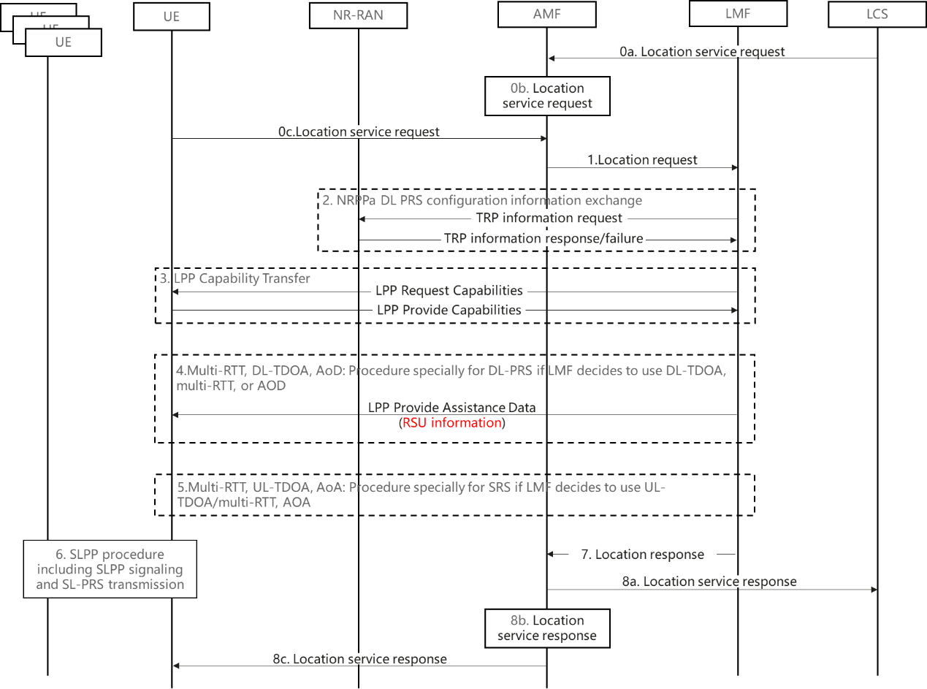  Proposal 9: RAN2 confirms that locating the target UE via its relay UE is supported
R2-2300198 CATT | Proposal 1: Capture Sidelink Positioning Architecture in Figure 1 in TS 38.305.  Proposal 5: Capture the SL above positioning procedure for hybrid PC5+Uu positioning into TS 38.305 as the baseline
R2-2300410 Intel | Proposal 9: In order to support sidelink based positioning for in coverage and out of coverage case, RAN2 to confirm the SL positioning architecture (including the concept of an anchor node/UE) shown in figure 1.  Proposal 10: To support sidelink based positioning, RAN2 to confirm the corresponding functionality of the anchor node, i.e. (interact with the target UE over PC5 to deliver assistance data, perform SL-PRS transmission/measurement and location estimation).  Proposal 11: Both MO-LR based and MT-LR based sidelink positioning procedures shall be supported for the in coverage case, using Uu based positioning design as baseline.  Proposal 13: RAN2 to confirm the procedure and signaling flow for UE based sidelink positioning for in coverage and out of coverage as captured in Figures 2 and 3 above.
R2-2300455 OPPO | Proposal 3: RAN2 to agree to capture the signaling procedure with LMF as a location server role as shown in the figure 1 in the SL positioning stage 2 specification.  Proposal 5: RAN2 to agree to capture the signaling procedure with UE as a location server role as shown in the figure 2 in the SL positioning stage 2 specification.
R2-2300529 Qualcomm | Proposal 1: The UE Positioning Architecture applicable to NG-RAN should be applicable to all coverage scenarios (e.g., no separate architecture for in-coverage or out-of-coverage scenarios is needed).  Proposal 2: Extend the UE Positioning Architecture applicable to NG-RAN as shown in Figure 2.  Proposal 10: Support a MO-LR or a new supplementary services operation for UE initiated SLPP transactions towards an LMF.  Proposal 11: Support a MT-LR or a new supplementary services operation for LMF-initiated SLPP transactions towards a UE.  Proposal 12: Support hybrid Uu, SL, and RAT-independent positioning by jointly using the SLPP, LPP, and NRPPa procedures.
R2-2300662 Spreadtrum | Proposal 1: Take procedure in Figure 1 and 2 for out-of-coverage and in-coverage SL positioning.  Proposal 2: When a UE initiates a location service request (like, MO-LR) within network coverage, UE can determine whether to trigger a sidelink positioning request or not.  Proposal 3: For OOC coverage, only UE can determine whether to trigger a sidelink positioning request or not.  Proposal 4: UE can determine whether to trigger a sidelink positioning request when Uu positioning is in progress.
R2-2300675 vivo | Proposal 5: For LMF-dependent sidelink positioning, take the above signaling procedures as the baseline for further discussion.  Proposal 11: For LMF-independent sidelink positioning, take the above signaling procedures as the baseline for further discussion.
R2-2300932 ZTE | Proposal 6: Support LMF to determine whether in/partial coverage target UE should adopt hybrid positioning or PC5-only positioning.  Proposal 7: Support to treat SL-PRS configuration transfer separately with other assistance data when RAN2 discusses ‘SL positioning assistance data exchange’ procedure, and wait for RAN1’s conclusion on SL-PRS configuration delivery.
R2-2301048 Xiaomi | Proposal 8 RAN2 to agree the architecture.  Proposal 12 RAN2 to discuss whether it is up to UE implementation to determine the SL positioning method.  Proposal 13 RAN2 to agree that LMF is not involved in SL positioning if target UE is out of coverage.  Proposal 20 RAN2 to agree that LMF is involved in SL positioning if target UE is in coverage.  Proposal 21 RAN2 to agree that if LMF is involved in SL positioning, anchor UE selection, SL positioning method determination is performed at LMF. Location calculation can be performed either at target UE or LMF.  Proposal 22 RAN2 to agree that target UE can provide candidate positioning methods, candidate anchor UEs and LCS QoS information to LMF.  Proposal 23 RAN2 to agree that target UE can provide candidate anchor UEs’ capability and whether in-coverage to LMF.  Proposal 24 RAN2 to agree that LMF can request target UE to provide candidate anchor UEs’ capability.
R2-2301262 CMCC | Proposal 2: The LMF is preferred to be involved in SL positioning when at least one of the participating UEs in the network coverage.
R2-2301305 Ericsson | Proposal 1 LPP session between UE and NW is extended to support UE to UE SL Operations and to allow LMF to execute hybrid Positioning procedures by obtaining Uu and SL measurements  Proposal 2 The target UE shall discover a reference UE/PRU and report to LMF and LMF setups LPP positioning session with the reference UE/PRU and SL session between reference and target UE.  Proposal 3 LMF setups LPP positioning session with multiple UEs and SL session among multiple UEs and obtains both Uu and SL measurements.
R2-2301792 InterDigital | Proposal 7: SL positioning server/SL-LMF optionally should be capable:  1. Determining the participating UEs  2. Determining positioning method  3. Gathering SL positioning and scheduling SL positioning resources  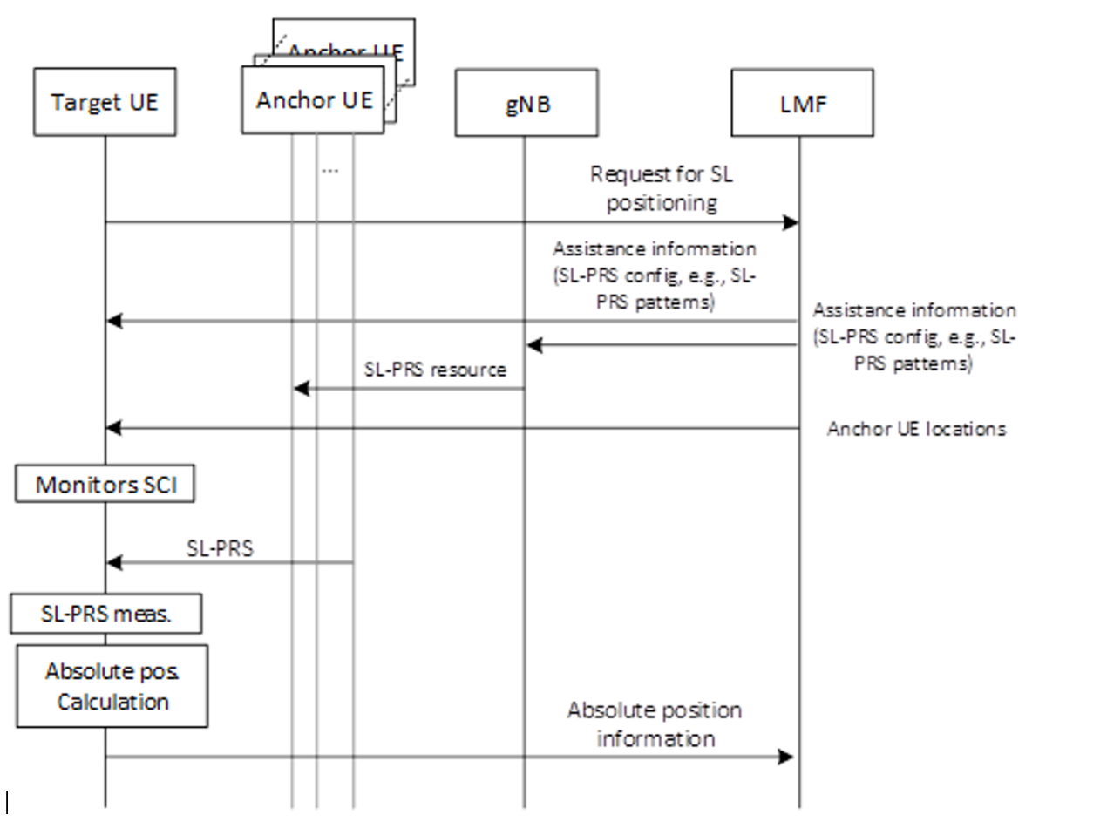  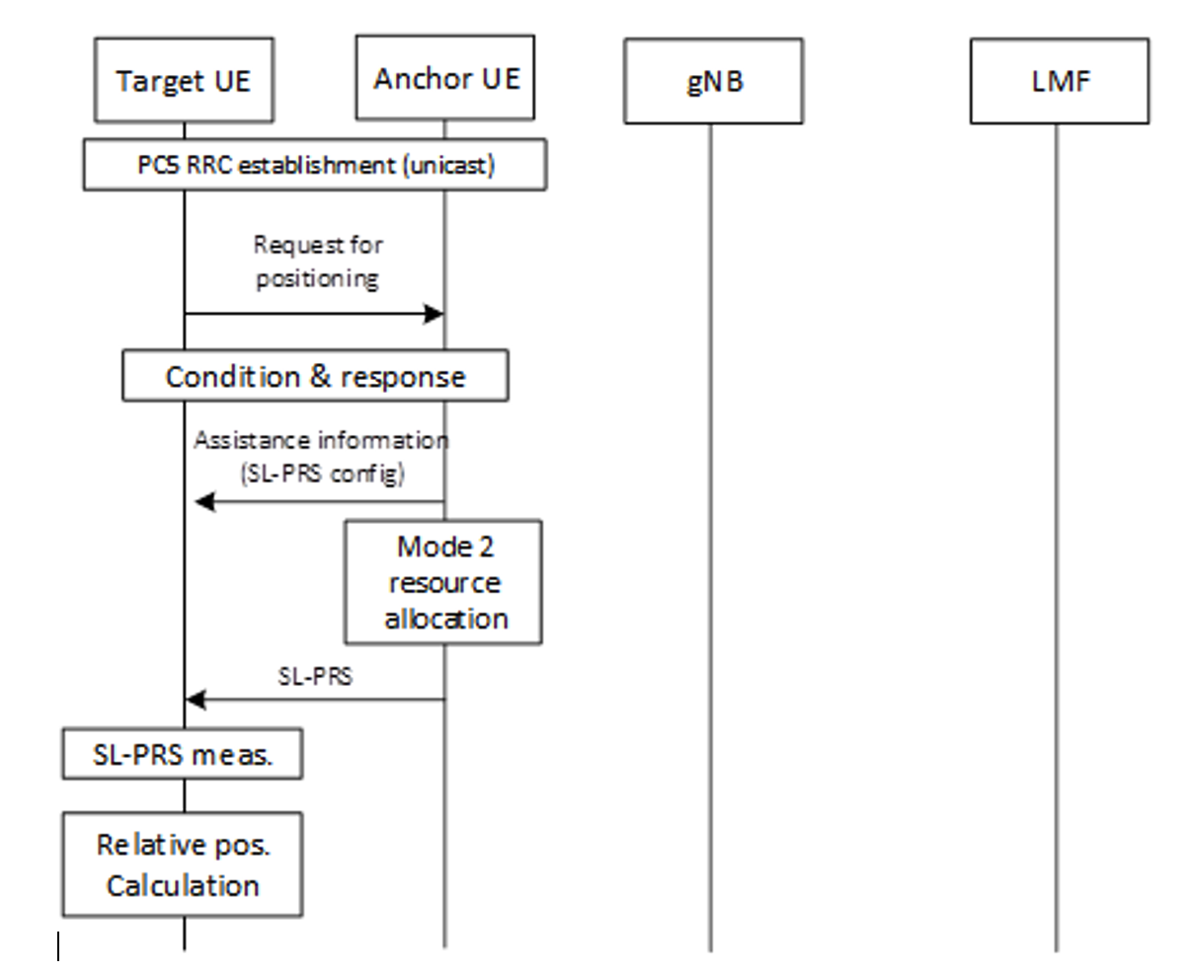

Summary:
This is by far the most popular discussion aspect among companies, with proposals aiming at defining the overall sidelink positioning architecture, procedures and signaling flows for SL positioning. Several companies including [CATT], [Intel], [Qualcomm] and [Xiaomi] have explicitly proposed candidate architectures to be agreed and captured. One aspect to consider in this regard is whether or not the UE roles (i.e. anchor UE, target UE, etc.) should be visible. So, the rapporteur thinks that we can downselect between the one proposed in [CATT], [Intel] and [Xiaomi] and use it as baseline for further discussion.
Proposal 9: With respect to the SL positioning architecture, RAN2 is proposed to downselect and agree between the options proposed in [CATT], [Intel] and [Xiaomi] as baseline for further discussion.
Similarly, there are proposals by several companies in [CATT], [Intel], [Qualcomm], [OPPO], [Spreadtrum], [vivo], [Xiaomi] [Ericsson] [InterDigital] containing signaling flows between LMF, Target UE and Anchor UE detailing the signaling procedure to be captured in stage 2 specification. Since there are several valid options to consider and no easy way to select the most suitable starting point, rapporteur thinks that as a starting point, RAN2 can try to agree to the series of steps that comprise the overall procedure which consist of at least the following:
- Location service request trigger from the Location server/AMF/UE
- Sidelink positioning capability exchange between the LMF/NG-RAN/Anchor and Target UE(s)
- Anchor UE discovery/selection
- Sidelink positioning assistant data transfer
- SL Positioning Request Location Information
- Measurement of SL-PRS
- Location calculation
- SL Positioning Provide Location Information

Note 1: FFS on whether there is separate session management procedure, e.g. session establishment, session modification, and session release.
Note 2: LMF/NG-RAN will be omitted for out of coverage scenario.

Proposal 10: With respect to the overall signaling procedure, it is proposed to agree that the sidelink positioning procedure comprises of at least the following series of steps:
- Location service request trigger from the Location server/AMF/Target UE
- Sidelink positioning capability exchange between the LMF/NG-RAN/Anchor and Target UE(s)
- Anchor UE discovery/selection
- Sidelink positioning assistant data transfer
- SL Positioning Request Location Information
- Measurement of SL-PRS
- Location calculation
- SL Positioning Provide Location Information

Note 1: FFS on whether there is separate session management procedure, e.g. session establishment, session modification, and session release.
Note 2: LMF/NG-RAN will be omitted for out of coverage scenario.

Rapporteur thinks that we can downselect between the one proposed in [R2-2300529] and [R2-2300410] and use it as baseline for further discussion.
Proposal 11: With respect to the SL positioning procedure, RAN2 is proposed to downselect and agree between the options proposed in [R2-2300529] and [R2-2300410] as baseline for further discussion.

There are some other proposals involving LMF’s role in selecting whether hybrid or PC5-only based positioning is used and anchor UE selection, but there is no majority view, so further discussion may be needed.

3.5 Assistant UE
The company proposals related to this topic are summarized in the Table below.
R2-2300117 Huawei | Proposal 10: Whether to support assistant UE can be left to SA2.
R2-2300198 CATT | Proposal 8: Assistant UE is not supported in Rel-18 since RAN1 only discuss the direct SL-PRS transmission/reception between target UE and anchor UE(s), and indicate it to SA2 in the reply LS.
R2-2300410 Intel | Proposal 3: RAN2 is proposed to down prioritize the discussion on the support of the assistant UE.  Proposal 4: If the assistant UE is agreed, on the role of the assistant UE, the anchor UE can fulfil the functionality of the assistant UE and no additional specification impact is foreseen.
R2-2300455 OPPO | Proposal 9: RAN2 to agree to reply to the SA2 to keep the use scenario of using assistance UE to perform ranging between two target UEs without any dedicated RAN2 impact is foreseen.
R2-2300662 Spreadtrum | Proposal 12: RAN2 does not support assistant UE in this release.
R2-2300675 vivo | Proposal 12: The assistant UE is transparent to RAN2, thus no need for RAN2 to decide whether to support it in Rel-18. It is up to SA2 to decide whether to introduce the assistant UE from SA2's view. Send the reply LS to SA2 to inform RAN2’s conclusion.
R2-2301048 Xiaomi | Proposal 3 RAN2 agrees not to support assistant UE in this release.
R2-2301067 Lenovo | Proposal 10: RAN2 to not support Assistant UE as a separate UE role in Rel-18.
R2-2301350 MediaTek | Proposal 1: RAN2 deprioritises support of the assistant UE functionality in Rel-18.
Summary:
[CATT], [Intel], [Spreadtrum], [Xiaomi], [Lenovo] and [MediaTek] think that there is no need to prioritize support of Assistant UE in Rel-18. [Huawei] thinks that it can be left to SA2 while [Intel], [vivo] and [OPPO] think that assistant UE role can be transparent to RAN2 and no specification impact is foreseen. Given the clear consensus in RAN2, rapporteur thinks it would be good to confirm this understanding and respond to SA2 LS.

Proposal 12: From RAN2 perspective, it shall be confirmed that assistant UE shall not be supported in Rel-18. If agreed, inform SA2 of this understanding.

3.6 Anchor UE discovery and selection/reselection
The company proposals related to this topic are summarized in the Table below.
R2-2300410 Intel | Proposal 5: With respect to the discovery procedure for the session based approach, AS layer parameters related to sidelink positioning are useful to include as part of the discovery message (e.g. supported positioning methods). Send LS to SA2 to inform them of RAN2 agreements.
R2-2300585 Nokia | Proposal 1: For SL positioning purposes, the discovery solicitation message and/or the discovery (response) message indicates the anchor service provisioning status / capability of the discovering / discovered sidelink UE.  Proposal 2: The discovery solicitation message and/or the discovery (response) message includes information on whether the absolute location of a sidelink (anchor) UE is required to be known and / or is known (irrespective by which network node).  Proposal 3: Anchor UE activity time (including PRS transmission) and / or anchor location validity time may be indicated.  Proposal 4: Signal / channel measurements are used during anchor UE discovery and / or selection.  Proposal 5: Anchor UEs are selected by considering signal strength / channel gain measurements or other similar measurements between at least two of the three types of network nodes: target UE, active anchor, candidate anchor.  Proposal 6: RAN2 to study procedures for UE anchor (re)-selection under the constraint of signaling overhead and latency minimization.  Proposal 7: Target UE is (pre-)configured to filter information acquired during anchor discovery procedures prior to its reporting to another node such as the LMF or server UE.  Proposal 8: For TDOA-based SL positioning, anchor UE provides sidelink synchronization information to other node(s) including target UE and LMF.  Proposal 9: RAN2 to discuss if  - anchor service provisioning status / capability  - the knowledge of absolute location of an anchor UE  can also be indicated in any post-discovery procedure including capability exchange, as well as the associated triggers (when applicable).  Proposal 10: RAN2 to study conditions under which candidate anchor UEs must or may not respond to (discovery) signaling from other UEs, including the presence of NLOS conditions to other UE.  Proposal 11: Anchor UEs should be (pre)-configured to transmit and / or receive SL PRS under pre-defined conditions, including conditions derived from location, time, and direction.  Proposal 12: SL PRS transmission parameters as well as their suspension / resume should be re-configurable depending on the dynamic link conditions between the anchor and target UEs.  Proposal 13: Anchor UE may indicate to a target UE the inability of the anchor UE to continue to serve as anchor UE for the target UE.  Proposal 14: RAN2 to study whether a target UE can indicate to another target UE on interruption in receiving SL PRS from an anchor UE.  Proposal 15: UEs may notify the network about conditions impacting successful reception and transmission of SL PRS, and request reconfiguration or suspension of SL PRS transmissions or switch to a new anchor to avoid / minimize the impact of interruptions with respect to give positioning QoS requirements.  Proposal 16: RAN2 to study enabling anchor UE to acquire the configurations of other anchor UEs for expediting the (re)-establishment of its positioning session.
R2-2300675 vivo | Proposal 3: For LMF-dependent sidelink positioning, if needed, the target UE performs the discovery of anchor UEs and reports their UE IDs to the LMF.  Proposal 4: For LMF-dependent sidelink positioning, the LMF can provide a list of candidate anchor UEs to the target UE for anchor UE discovery.
R2-2301048 Xiaomi | Proposal 15 RAN2 to agree that anchor UE selection criterion is not left to UE implementation.  Proposal 16 RAN2 to discuss which of the following conditions can be used for anchor UE selection：  - the UE is capable of being anchor UE;  - the SL RSRP of the UE is above the threshold;  - the intended positioning methods are supported by the UE;  - the UE is location known.  - the UE is in coverage.  Proposal 17 Anchor UE reselection is supported.
R2-2301067 Lenovo | Proposal 2: RAN2 to support discovery procedures for at least anchor UE(s) and target-UE. FFS the AS layer impacts of discovery procedures.
R2-2301305 Ericsson | Proposal 10 Inform SA2 via LS that indicating positioning QoS requirement for SL positioning/ranging is supported in the ProSe Discovery process.  Proposal 11 The assistance data about a candidate anchor UE can include: Sidelink positioning capabilities, state information, stationary UE indicator, UE type, Battery status, Serving cell ID and travelling path.  Proposal 12 A candidate anchor UE can provide assistance data about its neighbours, including their sidelink positioning capabilities, state information, stationary UE indicator, UE type, Battery status, Serving cell ID and travelling path. Most importantly, relative positioning information between the UEs can be included.
R2-2301545 LG | Proposal 1. RAN2 to discuss following considerations for anchor UE selection;  1) Ability of SL-PRS transmission/measurement  2) Supported frequency range (e.g., FR1, FR2, NR-U, etc)  3) Supported roles of UE (e.g., anchor UE, server UE, …)  4) Supported sidelink positioning methods  5) Coverage information (e.g., inside of network coverage, outside of network coverage)  6) Providing location information  7) RSRP and/or LOS/NLOS  8) Location accuracy and/or integrity  9) Synchronization reference (e.g., GNSS, gNB, etc)  Proposal 2. RAN2 to discuss following capabilities for AS layer criteria on SLPP procedures;  1) Ability of SL-PRS transmission/measurement  2) Supported frequency range (e.g., FR1, FR2, NR-U, etc)  3) Supported roles of UE (e.g., anchor UE, server UE, …) – can be considered as higher layer criteria  4) Supported sidelink positioning methods  5) Coverage information (e.g., inside of network coverage, outside of network coverage)  6) Providing location information  7) RSRP and/or LOS/NLOS  8) Location accuracy and/or integrity  9) Synchronization reference (e.g., GNSS, gNB, etc)  Proposal 3. RAN2 to confirm that UE capabilities for anchor UE selection are exchanged through SL Positioning Capability Transfer procedure.
R2-2301890 Philips | Proposal 1: RAN2 should define criteria by which the LMF and/or an Anchor UE can determine if the Anchor UE’s location is sufficiently stable and/or sufficiently accurate to be used for SL positioning.  Proposal 2: RAN2 should define criteria by which the Anchor UE can determine if it can announce itself as Located UE or as SL Reference UE.  Proposal 3: RAN2 should define mechanisms to compensate for the time difference between determining the location of an Anchor UE and performing the SL positioning measurements and calculations.  Proposal 4: RAN2 should as part of the SLPP/RSPP protocol provide a capability exchange mechanism to enable an Anchor UE to provide more details related to the stability and accuracy of the location of the Anchor UE, and also enable the ability to notify or express to the Target UE or LMF or SL positioning server UE about a change to this capability.

Summary:
There were some contributions focusing on the role of the anchor UE and specifically on the discovery and selection/reselection of anchor UEs as part of the sidelink positioning procedure. Most companies think that some criteria need to be defined in order to enhance the legacy SL/ProSe discovery procedure for the purpose of anchor UE selection/reselection as part of the positioning procedure. [Nokia] proposes incorporating information about anchor service provisioning status/capability, absolute location of an anchor UE and anchor UE activity time into the legacy SL discovery message and using signal/channel measurements to select anchor UEs. Similarly, [LG] and [Xiaomi] propose a list of AS layer criteria for anchor UE selection and propose that UE capabilities for anchor UE selection are (instead) exchanged through SL Positioning capability exchange procedure. [Intel] [Ericsson] and [Philips] also propose to consider AS layer criteria as part of the discovery procedure in consultation with SA2.
From rapporteur’s perspective, the common thread among the proposals is a need to define and specify some AS layer criteria for selection/reselection of anchor UE(s) as part of the SL positioning procedure. Whether it is incorporated as part of the ProSe discovery procedure from upper layer or additionally e.g. as part of the SL Positioning capability exchange also needs to be discussed. Criteria for which some support is observed are proposed below as a starting point.
Proposal 13: RAN2 is proposed to discuss whether anchor UE selection is incorporated as part of the upper layer discovery procedure or SLPP capability exchange procedure.
Proposal 14: RAN2 is proposed to agree that some AS layer criteria shall be defined and specified for selection/reselection of anchor UE(s) as part of the SL positioning procedure.
Proposal 15: At least the following criteria is considered for anchor UE (re-)selection:
- Supported sidelink positioning methods
- Ability to transmit SL-PRS and perform measurements
- Coverage information (e.g., inside of network coverage, outside of network coverage)
- Providing absolute location information

3.7 Session-based vs sessionless operation
The company proposals related to this topic are summarized in the Table below.
R2-2300198 CATT | Proposal 4: capture the above SLPP session-based signaling procedures into TS 38.305 as the baseline.
R2-2300410 Intel Corporation | Proposal 2: Postpone the discussion on support of the sessionless operation until the handling of broadcast/groupcast (and the associated security aspects) are clear.
R2-2300529 Qualcomm | Proposal 6: The SLPP Layer may assign an SLPP Session ID unique to the specific sidelink positioning session, and assign to each UE participating in that session an individual SLPP ID. The SLPP ID may be an integer (e.g. in the range 1 to n). The SLPP Session ID could be an integer value or might comprise a unique indication of UE1 plus a UE1 assigned local numeric ID.  Proposal 7: In order to support sidelink positioning/ranging in a structured and coordinated manner, SLPP shall support at least the following message types for SLPP Session Operation:  • SLPP Create Session Request/Accept/Reject  • SLPP Session Start Request/Response (*)  • SLPP Session End Request/Response (*)  • SLPP Session Modify Request/Accept/Reject (*)  Proposal 8: Session-less operation is established without mutual exchange of SLPP session establishment signaling via transmission of the SLPP Provide Assistance Data message.  Observation 9: UE-based (distributed) sidelink positioning and ranging enables UE position calculation without the reliance on a separate UE, and can reduce overall SLPP signaling required for sidelink positioning.  Proposal 9: SLPP should support UE-based (distributed) sidelink positioning enabling UEs to determine position and range based on exchanged location information.
R2-2300586 Nokia | Proposal 1: Session-based SL positioning ensures service continuity, timely signalling, satisfactory resource provisioning with the goal to obtain predictable and reliable positioning outcomes / performance.  Proposal 2: Session-based SL positioning involves  - session setup and termination,  - dedicated allocation and/or reservation of anchor UEs  - uninterrupted PRS activity,  - error / recovery handling,  - session-specific security provisioning (not precluding generic non-specific protection).  Proposal 3: Session-less sidelink positioning primarily focuses on minimization of overhead and latency, and offers only best-effort positioning services.  Proposal 4: Session-less sidelink positioning is characterized by absence of the following:  - session setup and termination,  - engagement in non-mandatory signalling,  - two-way interaction between UEs (not precluding one-way communications)  - dedicated anchor service,  - guaranteed PRS activity,  - error / recovery handling,  - selective security provisioning (not precluding generic non-specific protection).  Proposal 5: RAN2 to study mandatory and optional conditions for selecting session-based and session-less positioning, as well as the decision-making node represented by  - Alternative 1: LMF or the server UE  - Alternative 2: target UE.  Proposal 7: To enable session-less SL positioning, the network can (pre-)configure SL PRS transmissions and proactively announce the (pre)-configuration to potential target UEs via broadcast or groupcast messages.
R2-2300593 Fraunhofer | Proposal 6: A session may be formed by combining of one or more deferred location requests. A session may have more than one request and more than one LCS response.  Proposal 7: Session-based operation shall rely on monitoring the parameters needed for ensuring quality of service. Parameters such as line-of-sight conditions, DOP, multipath scenario at the receiver may be monitored.  Proposal 8: Initial parameters for selecting the UEs for a session shall rely on measurements done in a sessionless operation.
R2-2300662 Spreadtrum | Proposal 6: A SLPP session can be associated with a service request (e.g., MT-LR or MO-LR) as in LPP.  Proposal 7: Any explicit session management SLPP procedure is not necessary.
R2-2300675 vivo | Proposal 14: One UE can simultaneously participate in multiple sidelink positioning sessions.  Proposal 15: SLPP session is maintained in the SLPP layer, i.e., introduce SLPP session ID in SLPP messages.  Proposal 16: For LMF-dependent sidelink positioning, RAN2 to discuss the relationship between the SLPP session and LPP session.
R2-2300810 Samsung | Proposal 1-1. For session-based SLPP, RAN2 agree that an SLPP session is used between or among UEs in order to obtain location related measurements or a location estimate or to transfer assistance data.  Proposal 1-2. For session-based SLPP, RAN2 agree that a single SLPP session is used to support a single location request for sidelink positioning.  Proposal 1-3. RAN2 agree to send LS to SA2 to inform the agreed session-based SLPP definitions and ask for the procedure on how a single SLPP session is invoked by the LCS service request for sidelink positioning.  Proposal 1-5. For session-based SLPP, RAN2 agree that SLPP transactions are indicated at the SLPP protocol level with a transaction ID in order to associate messages with one another (e.g., request and response).  Proposal 1-6. For session-based SLPP, it is FFS that Messages within a transaction are linked by a common transaction identifier.  Proposal 2-1. RAN2 agree that there is no need to restrict the used cast type for session-less SLPP.  Proposal 2-2. RAN2 agree that session-less operation can work with security.  Proposal 3. RAN2 agree that both the session-less and session-based SLPP operation are necessary to be described in the SLPP protocol specification.
R2-2301546 LG | Proposal 1. RAN2 to discuss following mechanisms for SLPP session management;  1) SLPP session management with reestablishment  2) SLPP session management with modification  3) SLPP session management with multiple sessions  Proposal 2. RAN2 to discuss following mechanisms for SLPP QoS management;  1) SLPP QoS management with single-class QoS structure  2) SLPP QoS management with Multi-class QoS structure

Summary:
Based on the contributions on this topic, it seems company views are quite diverse. [Qualcomm] proposes to define a SLPP session ID for a given SL Positioning session and support SLPP session management signaling; the latter is also proposed by [LG]. [Vivo] also proposes to use a session ID within SLPP and proposes to discuss relationship between SLPP session and LPP session for the case of LMF dependent positioning. [Nokia] provides characterization of session-based and session-less operation and proposes to study conditions for selecting between the two. [Fraunhofer] posits that a session may be formed by combining of one or more deferred location requests and a session may have more than one LCS request/response, while [Samsung] thinks that a single SLPP session is uses to support a single location request. [Spreadtrum] mentioned “A SLPP session can be associated with a service request (e.g., MT-LR or MO-LR) as in LPP”.
The background on LPP session concept is provided in contribution by [Spreadtrum] and copied below:
In Uu-based positioning, LPP session is a service layer concept, and LPP has no explicit procedures to establish, modify, or terminate a session, it is implemented implicitly by AMF, which includes a routing identifier in the additional information IE of the DL NAS TRANSPORT message which identifies the LMF and the positioning session between the AMF and LMF when a positioning session is being used.

From the above contributions, two distinct approaches seem to be proposed:
Option 1: Dedicated session management operation: Supported by [Qualcomm, Nokia, LG]
Option 2: Service request associated session management (LPP like): Supported by [CATT, Spreadtrum, Fraunhofer]
In addition, [Samsung] proposes to send LS to SA2 to check how a single SLPP session is invoked by the LCS service request for SL positioning.
From rapporteur perspective, the common theme among the proposals seems to be defining a SLPP session ID. However, there is no consensus on whether SLPP session can be associated with LCS request or dedicated SLPP session management operator (i.e. session creation, modification and teardown). So, it is proposed to address and resolve this in RAN2.
Proposal 16: SLPP shall support association of a unique SLPP session ID to a specific SL Positioning session, which is assigned to all UEs involved in that session.
Proposal 17: RAN2 to discuss how to manage SLPP session:
Option 1: SLPP supports a SLPP session management operation, comprising of at least the following:
• SLPP Create Session Request/Accept/Reject
• SLPP Session Start Request/Response (*)
• SLPP Session End Request/Response (*)
• SLPP Session Modify Request/Accept/Reject (*)
Option 2: A SLPP session can be associated with a service request (e.g., MT-LR or MO-LR) as in LPP; FFS on whether legacy LCS service request cases (i.e., MT-LR, MO-LR or NI-LR) can be applied to sidelink positioning cases. LS to SA2 is needed.
Regarding sessionless SLPP, [Qualcomm] proposes to support session-less operation without mutual exchange of SLPP session establishment signaling. [Intel] proposes to postpone the discussion on support of the sessionless operation until the handling of broadcast/groupcast (and the associated security aspects. [Samsung] proposes that sessionless operation can work with security and that there is no need to restrict cast type for sessionless SLPP. [Nokia] show clear benefit of sessionless SLPP as “Session-less sidelink positioning primarily focuses on minimization of overhead and latency and offers only best-effort positioning services”.
From rapporteur perspective, RAN2 already agreed the following in the last meeting:
Agreement:
At least in the case that positioning methods are supported that do not require a mutual exchange of SLPP messages associated with one another among UEs, SLPP sessionless operation can be supported. FFS if sessionless operation can be operated with security.

Therefore, Rapporteur would suggest the following proposal:
Proposal 18: RAN2 confirm the support of sessionless SLPP. The detailed procedure can be discussed once the whole procedure, e.g. broadcast/groupcast/unicast is clear.

3.8 SL Positioning Server UE

R2-2300410 Intel Corporation | Proposal 8: At least for out of coverage scenario, agree that the following functionalities need to be supported by the Positioning Server UE (FFS for partial coverage case):  a) Managing the overall co-ordination and scheduling of resources  b) Determining type and number of position methods  c) Location calculation  Proposal 12: RAN2 discuss whether the LMF or the SL positioning server UE is responsible for managing the positioning session for the partial coverage scenario (when target UE is not directly in NW coverage).
R2-2300455 OPPO | Proposal 2: RAN2 to agree that LMF should take the role of location server when the LCS request comes from an entity connected with or within 5G network.  Proposal 4: RAN2 to agree that a SL positioning server UE should take the role of location server if LCS request comes from an entity not connected with 5G network.
R2-2300675 vivo | Proposal 8: For LMF-independent sidelink positioning, the positioning server UE receives the positioning service request, obtains the (candidate) anchor UE information and then determines the positioning method/ measurement metric, the participating anchor UE(s) and the assistance data, similar to the LMF in the case of LMF-dependent sidelink positioning.  Proposal 9: With specific capability, the target UE or one of the anchor UE can act as positioning server UE.
R2-2301048 Xiaomi | Proposal 18 Target UE performs server UE selection.
R2-2301067 Lenovo | Proposal 9: RAN2 to consider support of “SL Positioning Server UE” as a functionality which is part of an Anchor UE or Target-UE.
R2-2301262 CMCC | Proposal 4: RAN2 to confirm that SL positioning server UE could support resource coordination and scheduling functionality.
R2-2301889 Philips | Proposal 4: RAN2 should consider a procedure for SL positioning with an SL Positioning Server UE that takes into account whether the Target UE has measurement data or not

Summary:
There was some discussion on the role of the positioning server UE in the last meeting and the following was sent in the response LS to SA2 [5]:
Regarding issue 7), RAN2 thinks that, for out-of-coverage scenario, the functionalities of method determination, assistant data distribution and anchor UE selection can be performed by SL positioning server UE.

[Intel] point out that for the OOC, positioning server UE needs to coordinate the use of SL resources for positioning [CMCC], selection of positioning methods and location calculation. [vivo] have similar view and think that server UE is also responsible for selection of the anchor UE(s). [vivo] [Lenovo] think the target or one of the anchor UEs may act as the server UE. [OPPO] think that SL Positioning server UE should take the role of the location server UE if LCS request does not come from the CN. [Xiaomi] think that target UE can perform the server UE selection.

As pointed by [Intel], SA2 has concluded additional functionalities for server UE:
For the partial coverage scenario, the following is captured in pCR included as part of LS from SA2 [S2-2301782], which implies that even for the case when the LMF is reachable, it may still decide that the Positioning server UE may perform some of the functionality proposed above:
- A SL Positioning Server UE can be discovered and selected for result calculation, method determination, assistant data distribution and SL reference UE selection in case of out-of-coverage or for UE-only Operation if no Ranging/SL Positioning capable LMF is available. If LMF is capable for Ranging/SL Positioning and is reachable by Target UE and/or Reference UE, the LMF can still decide that SL Positioning Server UE executes the result calculation.
NOTE 8: Functionalities of the SL Positioning Server UE will be determined by RAN WGs.

The rapporteur thinks that it would be good to agree that in addition to what was captured in the previous meeting the SL Positioning server UE may also perform SL resource coordination and location calculation for the out of coverage case and that either the target or the anchor UE(s) may perform the server UE functionality,

Proposal 19: For out of coverage scenario, besides method determination, assistant data distribution and anchor UE selection (agreed in RAN2), the SL positioning server UE may perform the following additional functionalities:
• SL resource coordination
• Location calculation
Considering the UE side, the target UE does not need to distinguish when the server UE is used. To align with SA2 conclusion, to cover more scenarios (e.g. for UE-only Operation if no Ranging/SL Positioning capable LMF is available) and to provide flexibility to network, Rapporteur would like to check the following:

Proposal 20: RAN2 to discuss whether the SL positioning server UE may still be involved in sidelink positioning procedure for in coverage and partial coverage based on LMF decision.

Proposal 21: Either the target UE or the anchor UE may handle the functionality the SL positioning server UE.

3.9 Issues related to SA2

R2-2300410 Intel | Observation 1: The session-based concept in SLPP (defined in RAN2) aligns with the Ranging/SL Positioning layer concept used in SA2, in order to handle service request received from application layer and to control the Sidelink Positioning and Ranging operation.  Proposal 5: With respect to the discovery procedure for the session based approach, AS layer parameters related to sidelink positioning are useful to include as part of the discovery message (e.g. supported positioning methods). Send LS to SA2 to inform them of RAN2 agreements.
R2-2300810 Samsung | Proposal 1-3. RAN2 agree to send LS to SA2 to inform the agreed session-based SLPP definitions and ask for the procedure on how a single SLPP session is invoked by the LCS service request for sidelink positioning.
R2-2301305 Ericsson | Proposal 10 Inform SA2 via LS that indicating positioning QoS requirement for SL positioning/ranging is supported in the ProSe Discovery process.
R2-2300198 CATT | Proposal 8: Assistant UE is not supported in Rel-18 since RAN1 only discuss the direct SL-PRS transmission/reception between target UE and anchor UE(s), and indicate it to SA2 in the reply LS.
R2-2300455 OPPO | Proposal 9: RAN2 to agree to reply to the SA2 to keep the use scenario of using assistance UE to perform ranging between two target UEs without any dedicated RAN2 impact is foreseen.
R2-2300675 vivo | Proposal 12: The assistant UE is transparent to RAN2, thus no need for RAN2 to decide whether to support it in Rel-18. It is up to SA2 to decide whether to introduce the assistant UE from SA2's view. Send the reply LS to SA2 to inform RAN2’s conclusion.

Summary:

Considering the tight interaction between RAN2 and SA2 on sidelink positioning, and as proposed by many companies, it would be good to send LS to SA2, including in the LS with following questions/conclusions:

- SLPP transport: PDCP or PC5-U;
- Overall Positioning Architecture;
- Functionality of SL Positioning Server UE;
- Assistant UE;
- The procedure to support Sidelink Positioning over unicast, broadcast/groupcast (check SA2 whether we align with their assumption)
- How a single SLPP session is invoked by the LCS service request for sidelink positioning.
- Any AS layer parameters related to sidelink positioning expected to be included as part of the discovery message (e.g. supported positioning methods)?
- Any others?
Proposal 22: RAN2 agree to send LS to SA2 to inform them of RAN2 agreements and the collected SA2 related questions.

- Summary of Proposals for Discussion
Based on the discussion above on contributions related to sidelink positioning, the following is proposed:

Proposal 1: With respect to the transport of SLPP signaling, RAN2 is proposed to discuss whether SA2 recommendation is acceptable, i.e. PC5-U is used as the SLPP transport layer.
Proposal 2: [6 vs 1] Regarding the signaling options between UE and LMF for hybrid PC5+Uu positioning and PC5-only positioning in-coverage, it is proposed to agree option 2:
- Option 2: Enhancement of LPP whereby SLPP/RSPP signaling can be transported within LPP transparently, i.e. use the newly defined SLPP/RSPP to support sidelink based positioning and use the existing LPP to support Uu based positioning; and the SLPP/RSPP is carried as a container in LPP

Proposal 3: RAN2 discuss whether the same signaling option shall apply for the partial coverage scenario as in that for the in-coverage scenario.
Proposal 4: RAN2 does not need to provide use cases to SA3, considering SA2 already provided it in their reply LS in S2-2301786.
Proposal 5: RAN2 starts work on SL positioning signalling and procedure for groupcast/broadcast on SL positioning capability, and SL positioning assistance data (FFS on location information), considering at least the following use cases/scenarios:
• One target UE and multiple anchor UEs in one group
• Multiple target UEs and one or multiple anchor UEs in one group
Proposal 6: RAN2 should wait for inputs from SA3 before discussing security aspect for group cast/broadcast.
Proposal 7: The group management can be performed at application layer, and the application layer may provide group identifier information to the Ranging/SL Positioning layer. RAN2 further discuss whether any AS layer impact is foreseen.
Proposal 8: Postpone the discussion on whether transaction/cast type indication shall be associated with each SLPP message to indicate the transmission cast type until the signalling/procedure is clear on how to support broadcast/group cast.
Proposal 9: With respect to the SL positioning architecture, RAN2 is proposed to downselect and agree between the options proposed in [CATT], [Intel] and [Xiaomi] as baseline for further discussion.
Proposal 10: With respect to the overall signaling procedure, it is proposed to agree that the sidelink positioning procedure comprises of at least the following series of steps:
- Location service request trigger from the Location server/AMF/Target UE
- Sidelink positioning capability exchange between the LMF/NG-RAN/Anchor and Target UE(s)
- Anchor UE discovery/selection
- Sidelink positioning assistant data transfer
- SL Positioning Request Location Information
- Measurement of SL-PRS
- Location calculation
- SL Positioning Provide Location Information

Note 1: FFS on whether there is separate session management procedure, e.g. session establishment, session modification, and session release.
Note 2: LMF/NG-RAN will be omitted for out of coverage scenario.

Proposal 11: With respect to the SL positioning procedure, RAN2 is proposed to downselect and agree between the options proposed in [R2-2300529] and [R2-2300410] as baseline for further discussion.
Proposal 12: From RAN2 perspective, it shall be confirmed that assistant UE shall not be supported in Rel-18. If agreed, inform SA2 of this understanding.
Proposal 13: RAN2 is proposed to discuss whether anchor UE selection is incorporated as part of the upper layer discovery procedure or SLPP capability exchange procedure.
Proposal 14: RAN2 is proposed to agree that some AS layer criteria shall be defined and specified for selection/reselection of anchor UE(s) as part of the SL positioning procedure.
Proposal 15: At least the following criteria is considered for anchor UE (re-)selection:
- Supported sidelink positioning methods
- Ability to transmit SL-PRS and perform measurements
- Coverage information (e.g., inside of network coverage, outside of network coverage)
- Providing absolute location information

Proposal 16: SLPP shall support association of a unique SLPP session ID to a specific SL Positioning session, which is assigned to all UEs involved in that session.
Proposal 17: RAN2 to discuss how to manage SLPP session:
Option 1: SLPP supports a SLPP session management operation, comprising of at least the following:
• SLPP Create Session Request/Accept/Reject
• SLPP Session Start Request/Response (*)
• SLPP Session End Request/Response (*)
• SLPP Session Modify Request/Accept/Reject (*)
Option 2: A SLPP session can be associated with a service request (e.g., MT-LR or MO-LR) as in LPP; FFS on whether legacy LCS service request cases (i.e., MT-LR, MO-LR or NI-LR) can be applied to sidelink positioning cases. LS to SA2 is needed.
Proposal 18: RAN2 confirm the support of sessionless SLPP. The detailed procedure can be discussed once the whole procedure, e.g. broadcast/groupcast/unicast is clear.
Proposal 19: For out of coverage scenario, besides method determination, assistant data distribution and anchor UE selection (agreed in RAN2), the SL positioning server UE may perform the following additional functionalities:
• SL resource coordination
• Location calculation
Proposal 20: RAN2 to discuss whether the SL positioning server UE may still be involved in sidelink positioning procedure for in coverage and partial coverage based on LMF decision.

Proposal 21: Either the target UE or the anchor UE may handle the functionality the SL positioning server UE.
Proposal 22: RAN2 agree to send LS to SA2 to inform them of RAN2 agreements and the collected SA2 related questions.
- References
[1] | "S2-2301464, Rely LS on Reply LS on RAN dependency for Ranging/Sidelink Positioning, SA2".
[2] | "S3-230430, Reply LS to LS on SL positioning groupcast and broadcast, SA3".
[3] | "S2-2301786, Reply LS on SL positioning groupcast and broadcast, SA2".
[4] | "S2-2301782, Update to conclusions for KI#4: Control of Operations for Ranging/Sidelink positioning, Qualcomm".
[5] | "R2-2213131, Reply LS on RAN dependency for Ranging & Sidelink Positioning, RAN2".

