3GPP TSG-RAN WG2 Meeting #117-e R2-22xxxxx

Online, February 21 – March 3, 2022
Agenda Item: 8.7.1
Source: Apple
Title: [DRAFT] Summary Report of [AT117-e][613][Relay] Open issues of Relay CR to 38.321 (Apple)
Document for: Decision

1. Introduction
The following document is to provide and collect input about the way forward in resolving the remaining open issues present in the running CR for 38.321 for SL relay. Also, this is related to the following email discussion:
 [AT117-e][613][Relay] Relay running CR to 38.321 (Apple)
Scope: Review and update the CR in R2-2202543.
Intended outcome: Agreeable CR
Deadline: Tuesday 2022-03-01 1200 UTC

2 Contact information
Company | Name | Email address
Apple(Rapporteur) | Zhibin Wu | zhibin_wu@apple.com
Ericsson | Min Wang | Min.w.wang@ericsson.com
Xiaomi | Xing Yang | Yangxing1@xiaomi.com
OPPO | Boyuan Zhang | zhangboyuan@oppo.com

3. Discussions

3.1 Editor’s Notes
There are two remaining editor’s notes in the noted MAC Running CR R2-2201956 [1].
The first editor’s note is in subclause 5.22.1.2 ,
Editor’s Note: FFS the above change is needed, depending on “according to the associated priority” phrase is needed in Rel-16 specification.
This editor’s note is related to a legacy text in TS 38.321 [2] which assumes the PDB (packet delay budget) is derived from logical channel priority. In SL relay work, the PDB of relayed data is not associated with LCH priority, so a separate “if” branch is added for the Rel-17 SL relay case, as shown below.

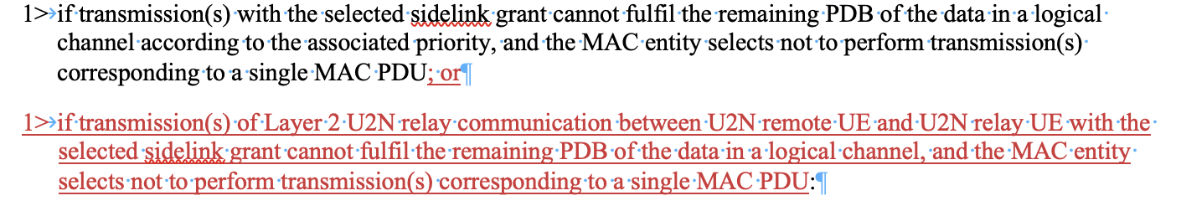
Figure 1. Changes in 5.22.1.2 related to “PDB associated to LCH priority”
However, if we examine the Rel-16 agreements for NR V2X, we can see that PDB is part of QoS profile represented by PQI provided by upper layer for TX UE. In RRC configuration [3], each SLRB is configured with SL-SDAP-Config, which includes the mapping of QoS profile to SLRB. So, UE knows the PDB(s) associated with SLRB. Hence, there is no “deriving PDB from LCH priority” behaviour in Rel-16 NR V2X UE. Apple has submitted a Rel-16 CR [4] to fix this issue. Once the CR is agreed, the above change is no longer needed.
Proposal 1 For editor’s note in 5.22.1.2 of MAC CR[1]: Once Rel-16 V2X CR to remove “according to the LCH priority” is agreed, the change in 5.22.1.2 in MAC CR [1] is not needed.

Question 1: Do companies agree with Proposal 1?
Company | Yes/No | Comments
Ericsson | Yes
Xiaomi | Yes
OPPO | Yes

The second editor’s note is in subclause 5.22.1.4,
Editor’s Note: The assumption that Sidelink discovery and Sidelink data transmissions are associated with different destination L2 IDs is pending SA2 confirmation.
This editor’s note is related to the discussion on how to ensure “not multiplexing SL data and SL discovery in the same MAC PDU”. This RAN2 agreement is supposed to be applicable to both relay and non-relay case. In lieu of this, RAN2 have sent an LS to SA2 [5] to check if SA2 has guaranteed that all the L2 destination addresses involved in SL discovery procedure will be “different” from the L2 destination addresses for SL data (including DCR messages in PC5-S). This editor’s note can be removed if SA2 can ensure that. Otherwise, further changes in LCP procedure are needed to separate the discovery and data traffic in different TBs.
Proposal 2 For editor’s note in 5.22.1.4 of MAC CR [1], RAN2 can wait for SA2 reply to decide if any further change is needed to ensure UE’s MAC layer not multiplexing SL data and SL discovery in the same. MAC PDU.

Question 2: Do companies agree with Proposal 2?
Company | Yes/No | Comments
Ericsson | yes
Xiaomi | Yes
OPPO | Yes

3.2 Other potential issues

3.2.1 PDB requirements for SL discovery
It has been discussed in RAN2#116bis that the following issue can be handled by MAC CR rapporteur:

O3.07 | [EN from running CR of 38.321] whether to apply PDB restriction when performing MAC PDU transmission | CR rapporteur handled | Due to the following EN in 38.321 running CR:  Editor’s Note: FFS the above change is needed, depending on “according to the associated priority” phrase is needed in Rel-16 specification.  We have the corresponding open issue.  Based on further input from companies, this issue include PDB aspect of discovery message as well.

However, SL-SRB4 (discovery), as similar to other Sidelink SRBs inherited from Rel-16 NR SL, has never been configured or associated with latency requirements in earlier specifications or RAN2 agreements. It will be strange to only apply PDB restrictions to SL-SRB4, but not other SL-SRBs. So, this issue has been handled in “[Pre117-e][602][Relay] Open issues on relay QoS” as a general question about whether PDB is applicable to all SL-SRBs. Depending on the outcome of that discussion, RAN2 can decide if any MAC change is needed.
Proposal 3 Depending on the outcome of QoS discussion on PDB requirements for SL-SRBs, RAN2 decide whether any further change to meet PDB requirements is needed or not.

Question 3: Do companies agree with Proposal 3?
Company | Yes/No | Comments
Ericsson | yes
Xiaomi | Yes
OPPO | Yes

2.2.2 Preemptive BSR for relayed traffic
It is discussed in “[Pre117-e][602][Relay] Open issues on relay QoS” that preemptive BSR may be supported in Rel-17 SL relay. If yes, then triggering condition of Sidelink BSR in Uu interface. Also, potential signaling enhancements (e.g. SIdelink MAC CE) may be needed if the exchange of buffer information between remote UE and relay UE is needed, instead of relying on SCI information. So, depending on whether/how to support this feature, MAC layer changes may be needed. But it is not easy to predict how big the impact will be.
Proposal 4 Pending SL relay QoS discussion, MAC layer change would be needed if preemptive BSR is supported. Depends on which solution is adopted, MAC change may involve adding triggering condition(s) and/or introduce new signaling.

Question 4: Do companies agree with Proposal 4?
Company | Yes/No | Comments
Ericsson | Yes | But, we prefer to reword the proposal so that  Pending SL relay QoS discussion, MAC layer change would be needed if preemptive BSR is supported. Depends on which solution is adopted, MAC change may involve adding triggering condition(s) and/or introduce new signaling.  it is sufficient with the first half, if RAN2 agrees that up to relay UE implementation to determine when to trigger pre-emptive BSR, the spec change would be rather limited.
Xiaomi | Yes
OPPO | See comment | We think this proposal is meaningless at this stage, suggest to skip the discuss at current stage.

2.2.3 Destination Index in Sidelink BSR
The destination index field in Sidelink BSR is based on a single list of SL-DestinationIdentity in SUI message.
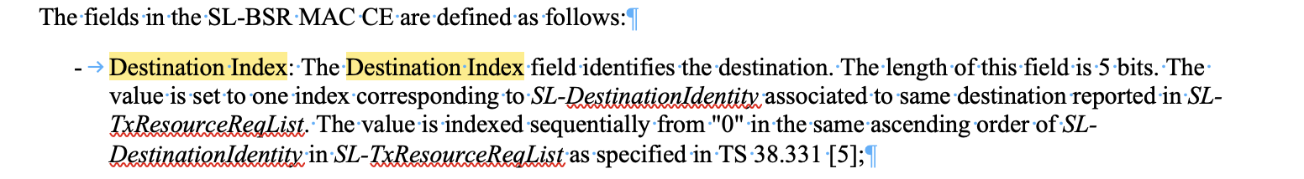
Figure 2. Determining Destination Index in subclause 6.1.3.33 of TS 38.321
However, in RAN2#117, the following has been agreed:
Recommendation 3-2c [16/19]: For the destination L2 ID reporting for discovery and for established PC5 link for relay, add a new IE (i.e., instead of reusing the existing field sl-DestinationIdentity).

It is agreed to add discovery L2 destination(s) in a separate IE so that gNB is aware of that this L2 destination ID is for the sake of relay discovery or non-relay discovery. As a result, the above method to determine destination index is to be amended and how the list of SL discovery address can be combined with SL-DestinationIdentity to determine the ranking order of SL destination address needs to be discussed. The change is to determine the order/index by append the discovery destination list to the regular list. For example, we propose to add the sentence “If an extra list of SL discovery destinations is reported separately, the value is indexed sequentially across both lists assuming the discovery destination list is appended to the list containing SL-DestinationIdentity” . The running CR [7] is modified to reflect this change. Please check the CR in the draft folder for your reference.
Proposal 5 Add “If an additional list of SL discovery destinations is reported, the value is indexed sequentially across both lists assuming the discovery destination list is appended to the list containing SL-DestinationIdentity” in 6.1.3.33.

Question 5: Do companies agree with Proposal 5?
Company | Yes/No | Comments
Ericsson | Yes
Xiaomi | Yes
OPPO | see comment | We agree with the spirit, yet  - Wr.t the order of indexing between multiple list, we can simply reuse the 36.321 approach by referring to 331 structure: “If multiple such lists are reported, the value is indexed sequentially across all the lists in the same order as specified in TS 36.331 [8];  - The change is not only for discovery but also for relay-based communication as well, since the agreement is “For the destination L2 ID reporting for discovery and for established PC5 link for relay, add a new IE (i.e., instead of reusing the existing field sl-DestinationIdentity).”

3. Conclusions
TBD

4. References
[1] R2-2201956 38.321 CR to introduce Sidelink Relay draftCR Apple Rel-17 NR_SL_relay-Core
[2] TS 38.321 v16.7.0
[3] TS 38.331 v16.7.0
[4] R2-2202534 Correction on the PDB derivation from LCH priority, CR 38.321 Apple, OPPO.
[5] R2-2201780 LS to SA2 on discovery and data associated to different L2 IDs
[6] R2-2202955 Summary of [Pre117-e][602][Relay] Open issues on relay QoS
[7] R2-220xxxx Draft Rel-17 CR for TS 38.321 of [AT117-e][613]
[8] R2-2202543 Introduction to Sidleink Relay, Apple.

